Lab 4: “Oh How Bitter a Thing is”
CHM1311

November 5th, 2018

Introduction:
Lab 4 is based off of a few key concepts, including acids, bases, pH, titration, and neutralization. The pH scale is used to measure the concentration of H+ ions in a solution, from a range of 0-14 (7 is neutral). Solutions which measure closer to 0 are known as acidic solutions, which are often sour in taste and have the possibility of being corrosive. Solutions which measure closer to 14 are known as basic solutions, and are often bitter in taste, slippery to touch and can also be corrosive.
Neutralization is a chemical reaction with an acid and a base as reactants and yields water and a salt as products. An example of this could be when someone takes an antacid (basic) to sooth heartburn caused by stomach acid (acidic). A titration is the process where a solution with known concentration is slowly added to a solution with a known volume, until neutralization occurs, which is often observed through a colour change.
The goal of this lab is to use the results from the standardized base titrated with HCl to find the concentration of another acid from titrating the unknown acid with the standardized base and comparing the two titrations. It is crucial to perform at least 3 trials of each titration, in order to insure accurate and reproducible results are being attained.

Procedure: Refer to lab manual “Oh How Bitter a Thing is”

Observations:

Table 1: Observations when diluting NaOH
 | Volume (mL)
Volume of NaOH | 5.00
H₂O | 250.00

Table 2: Observations when standardizing NaOH with HCl (trial 1)
 | Volume (mL)
Volume of HCl | 10.17
Volume of NaOH added during titration when colour change was initially observed | 9.72
Volume of NaOH added during titration | 11.21

Table 3: Observations when standardizing NaOH with HCl (trial 2)
 | Volume (mL)
Volume of HCl | 10.16
Volume of NaOH added during titration when colour change was initially observed | 9.12
Volume of NaOH added during titration | 12.28

Table 4: Observations when standardizing NaOH with HCl (trial 3)
 | Volume (mL)
Volume of HCl | 10.20
Volume of NaOH added during titration when colour change was initially observed | 9.21
Volume of NaOH added during titration | 12.84

Table 5: Observations when titrating unknown acid 2 (trial 1)
 | Volume (mL)
Volume of unknown acid | 10.76
Volume of NaOH added during titration when colour change was initially observed | 11.91
Volume of NaOH added during titration | 14.88

Table 6: Observations when titrating unknown acid 2 (trial 2)
 | Volume (mL)
Volume of unknown acid | 10.01
Volume of NaOH added during titration when colour change was initially observed | 11.58
Volume of NaOH added during titration | 14.88

Table 7: Observations when titrating unknown acid 2 (trial 3)
 | Volume (mL)
Volume of unknown acid | 10.24
Volume of NaOH added during titration when colour change was initially observed | 10.90
Volume of NaOH added during titration | 14.19

Figure 1: The pH and first derivative of pH for the standardization of NaOH with HCl (trial 1)
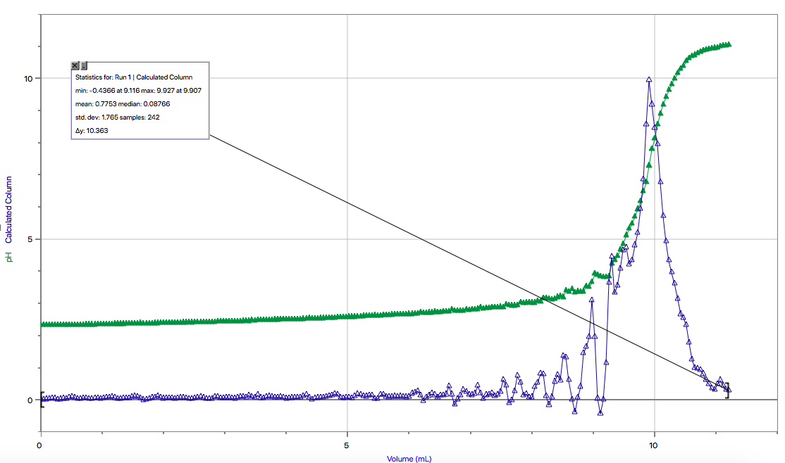

Figure 2: The pH and first derivative of pH for the standardization of NaOH with HCl (trial 2)
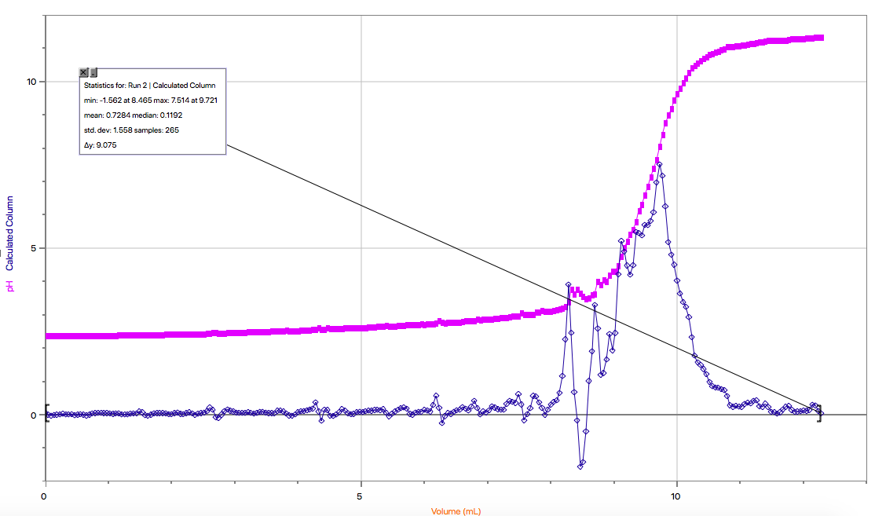
Figure 3: The pH and first derivative of pH for the standardization of NaOH with HCl (trial 3)
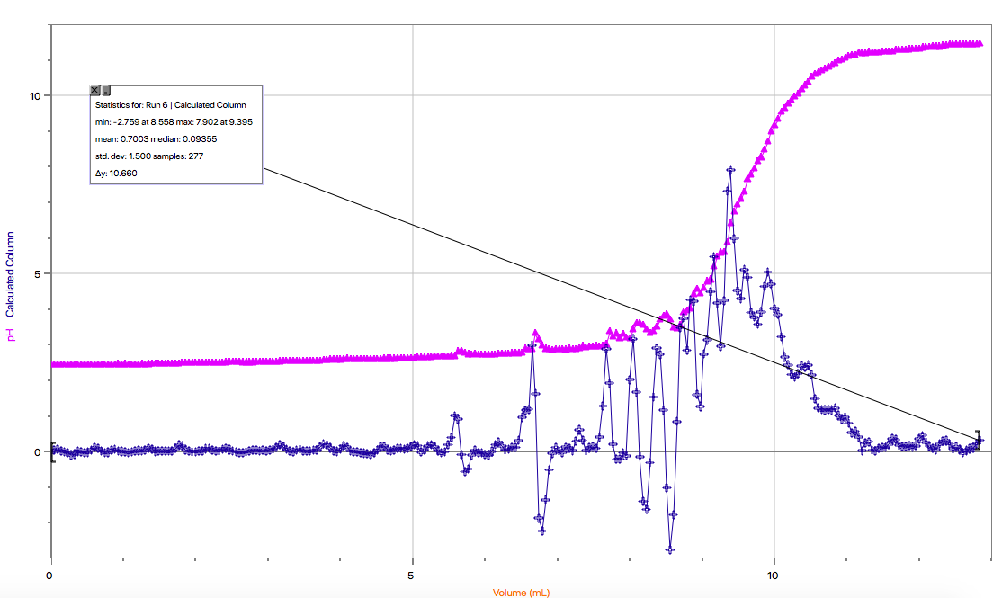
Figure 4: The pH and first derivative of pH for the titration of NaOH with an unknown acid 2
(trial 1)
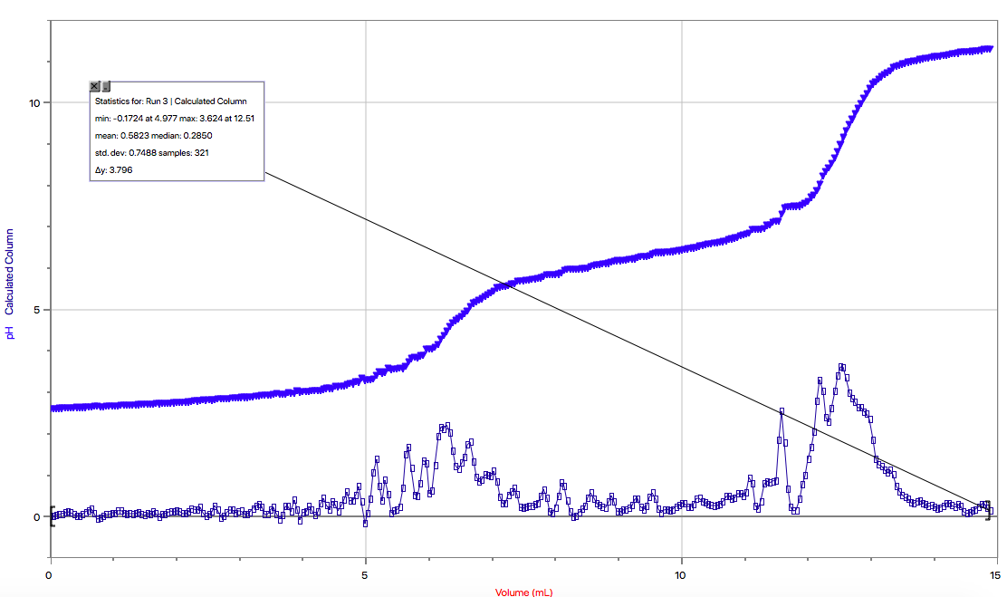
Figure 5: The pH and first derivative of pH for the titration of NaOH with an unknown acid 2
(trial 2)
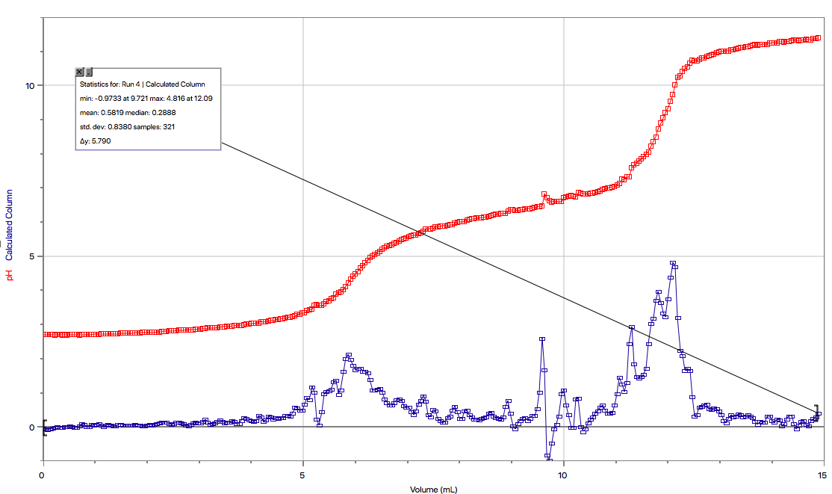

Figure 6: The pH and first derivative of pH for the titration of NaOH with an unknown acid 2
(trial 3)
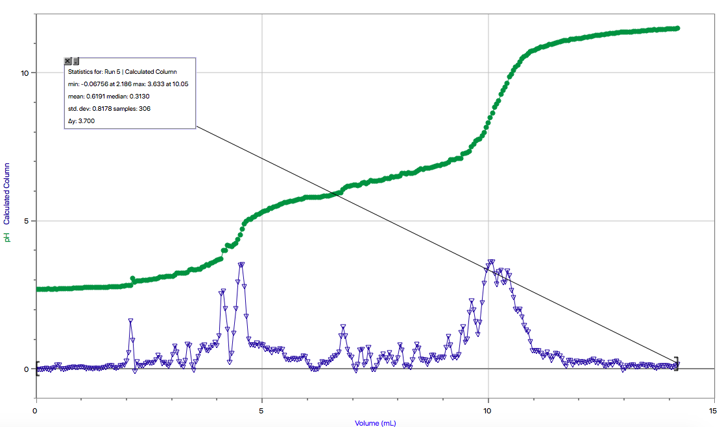
Calculations:
- C₁V₁ = C₂V₂
- mol/L)(0.005L) = C₂ (0.250L)
C₂ = 0.12 mol/L
- Trial 1:
CNaOH = (VHCl·CHCl)/ VNaOH
C_{NaOH}= (0.01017 L) (0.1 mol/L) / (0.009907 L)
C_{NaOH}= 0.1027 mol/L
Trial 2:
CNaOH = (VHCl·CHCl)/ VNaOH
C_{NaOH} = (0.01016 L) (0.1 mol/L) / (0.009721 L)
C_{NaOH} = 0.1045 mol/L
Trial 3:
CNaOH = (VHCl·CHCl)/ VNaOH
C_{NaOH} = (0.01020 L) (0.1 mol/L) / (0.009395 L)
C_{NaOH} = 0.1085 mol/L
Average C_{NaOH} = (0.1027 + 0.1045 + 0.1085) / 3
= 0.1052 mol/L
- CH2A = (VNaOH·CNaOH) / (2·V_{H2A})
Trial 1:
C_{H2A} = (0.01251 L) (0.1052 mol/L) / [(2) (0.01076 L)]
= 0.0612 mol/L
Trial 2:
C_{H2A} = (0.01209 L) (0.1052 mol/L) / [(2) (0.01001 L)]
= 0.0635 mol/L
Trial 3:
C_{H2A} = (0.01005 L) (0.1052 mol/L) / [(2) (0.01024 L)]
= 0.0516 mol/L
Average C_{H2O} = (0.0612 mol/L + 0.0635 mol/L) / 2
= 0.0624 mol/L
(Trial 3 was not included in the average because it was an outlier and would have skewed the results)

Discussion:
The volume of the base (NaOH) matters because the concentration is dependent on the volume. This measurement of volume is used to calculate the concentration of the standardized base and without it, the concentration would not be able to be solved. In addition to this, the concentration of the base is determined beforehand, because it is needed for figuring out later equations. Even though it may not look to be an important part, it is actually crucial in many of the proceeding steps.
The equivalence points determined by Logger Pro 2 were slightly different from the points recorded from observing colour change during the lab. This could be due to a number of reasons, from the fact that there is a delay in human reaction time, the software may be more sensitive to change then visible to the human eye, or that not enough indicator was added in order to obtain a quick and obvious colour change.
Other sources of error can include the drop counter’s accuracy during the titration, as well as the continuity of the drops. At a few moments, the drops would slow or speed up, due to the instability of the lab bench, which is supporting numerous experiments simultaneously, causing the bench to shake.

