Introduction Class (September 7th)

4 parts of critical thinking:
- Statement
- Premise
- Conclusion
- Argument

Problem with our thinking

Self-interested thinking : Accepting a claim solely on the grounds that it advances, or coincides with our interests (or even just helps us ‘save face’)

Group thinking: Working with a group is fine, but it is dangerous to fall into a group and blindly believe what is being told.

Peer pressure: Pressure from one’s peers to believe or do the things the group does.

-----------------------------------------------------

Critical thinking rejects relativism.

- Subjective Relativism: The view that truth depends solely on what someone believes; truth is relative to persons.

According to subjective relativism, what’s true for you might not be true for me; instead, truth is what each individual believes it to be.

- Social relativism: The view that truth is relative to societies or groups. Also known as cultural relativism: Different cultures believe different things. Who are we to say that other societies are wrong?

Class #2 (Sept. 12)
(read 4 parts of critical thinking in last class)

- A statement is a simple sentence that has just one meaning, expresses one thought. A statement asserts also that is something is the case or is not the case. When it asserts that something is the case, it is called an affirmation; when not, it is also called a negation or denial.

A single sentence can contain within it more than one statement:
Ex: It’s raining today, and I’m not feeling well. (2 statements)

NOTE: An argument needs at least two statements.

- Premise: A statement given in support of another statement; a claim put forth as a reason for a conclusion.

- Conclusion: A statement that premises are meant to support; a claim meant to be supported by reasons offered in the argument.

- Argument: A group of statements in which some of them (the premise(s)) are intended to support another of them (the conclusion). A set of claims, one which is meant to be supported by others.

How do we recognize arguments?
- Look for a conclusion, and look for the supporting premises.
- Look for ‘inference indicators’. There are two types of these inference indicators...

Premise indicators are followed by a premise.
(Because, since, in view of the fact, given that, for, for the reason that, due to the fact that, seeing as, or the reason is that)
Ex: ‘We should go back to Joe’s Diner, because we had fun there last week.’

Conclusion indicators are followed by a conclusion.
(Therefore thus, so, consequently, it follows that, we can conclude that, ergo, this entails, or hence.)
Ex. ‘The quiz is tomorrow, so we should study.’

Enthymemes: Arguments with missing aspects.

There are always exceptions, but questions, commands, exclamations, etc, will not be part of an argument.

Simple and Complex Arguments

Example of a simple argument:
‘Since you’re not having a good time, therefore we should leave.’

Note: A simple argument only has one inference. A simple argument only has one conclusion.

Example of a complex argument:
‘You’re a student. So you’re probably broke. So, you likely don’t have money for beer.’

This complex argument is distinguished from a simple argument because it has an intermediate conclusion.

An intermediate conclusion is a statement that has a dual purpose. It serves as a conclusion, but it also serves as a premise in a continuing chain of reasoning:
‘You’re a student. So you’re probably broke. So, you likely don’t have money for beer.’

A complex argument will always have one intermediate conclusion.

-----------
Don’t confuse arguments with explanations.
An explanation tells us why something happened. An explanation tries to show why or how something is the way it is, whereas an argument provides a reason or reasons for a claim.

Example of an explanation:
‘I already know Adam stole the money because Jane told me that Steve told her so.’
- Note: I’m not trying to convince you of this, I’m explaining how I know, or why he did it.

If we encounter an explanation within an argument, then we treat it as just making one claim. An explanation can serve either as a premise or conclusion.
Ex: James is very ill because he was bitten by a rabid dog. So James will only get better if he is quickly given a fast acting shot.

Other statements that just make one claim:

Conditionals: (“If… then…”)
Ex: ‘If I study hard, then I’ll pass PHI 1101.

Disjunctive Sentence or Statements: (“Either… or…”)
Ex: ‘Either I’ll pass PHI 1101 or I’ll fail it.

Unless
Ex: ‘There will be no baseball tomorrow unless the sun is shining.”

Class #3 (Sept 14)

Analyzing arguments

There are many different methods to analyze arguments, and we’re only using one.

Our goal is to present arguments in what is known as standard form and provide a diagram for the argument.

Our method begins like this:
- Probably, the best piece of advice is to see if we can first detect what the conclusion is first.
- If they are present, identify any inference indications.
- Identify if the argument is simple or complex.
- If it is a simple argument, identify what the conclusion is.
- If it’s a complex argument, determine what the final conclusion is, along with the intermediate conclusion or intermediate conclusions.
- NOISE: Ignore or get rid of elements that are not relevant to the argument.
… (Also, reformulate claims when necessary.)

Two possibilities of argument structure

Multiple premises can support a conclusion in one of two ways: Separately, or together.
- Independent premises each lend some support to the conclusion, on their own.
- Dependent premises must be combined in order to support the conclusion.

1) An argument with independent premises:
- ‘Jake is a philosopher. And Jake studies hard. Therefore, Jake is smart.

We put this argument into standard form:

1. Jake is a philosopher
2. Jake studies hard.
-------------------------------------------
3. Jake is smart.

Next, we draw a diagram for the argument...

1
2
3

2) Arguments with dependent premises

Standard Form:

1. I am taller than Rahul
2. Rahul is taller than you.
--------------------------------------
3. I must be taller than you.

We then draw the diagram...
1
2
3
In identifying an argument and its parts, what matters is the speaker’s intention:
- Premises are still premises even if they don’t do a good job of supporting the speaker’s conclusion or claim just as so long as the speaker thinks they do.
- In other words, a weak or bad argument is still an argument.

Lying is wrong and you told a lie. So you’ve done something wrong. All wrongdoers deserve to be punished. So, you deserve to be punished.

This is a complex argument.
- Lying is wrong
- You told a lie
- You’ve done something wrong. 1, 2
- All wrongdoers deserve to be punished.
- You deserve to be punished. 3, 4

1---2
3---4
5

Class #6 (Sept 26)

Non-deductive Arguments
- An argument intended to provide probable (but not conclusive) support for its conclusion.
- The premises of a nondeductive argument are meant to make the conclusion probable or likely.
- Support for the conclusion is a matter of degree.
- Nondeductive arguments can be described as successful or unsuccessful
- The degrees of probability for a successful nondeductive argument can be described along these lines:
- If the premises of the argument make the conclusion almost certain, then we can describe the argument as successful, and describe the degree of support which the premises lend the conclusion as close to certain.
- On the other hand, if the premises of the argument do not render the conclusion close to certain, but quite plausible, the argument is still successful, but we can describe the support which the premises lend the conclusion as very likely (a great deal more likely than not)
- If the premises of the argument provide some basis for the conclusion, but no great support, then it’s still successful, but we describe the matter of degree upon which the premises support the conclusion as being somewhat likely (barely more likely than not).

Accordingly, we can describe a successful nondeductive argument as having premises that make the conclusion close to certain, very likely, or somewhat likely.

An unsuccessful nondeductive argument:
- If the degree of support that the premises give the conclusion is little or none at all, the we describe the argument as being unsuccessful.
- A non deductive argument is unsuccessful when its premises are not relevant to the conclusion, do not adequately support the conclusion, or do not provide sufficient information that is relevant for the conclusion.

Three types of nondeductive arguments:

1) Inductive Generalizations: Most often with inductive generalizations, we start with premises about individual members of a group and reason to conclusions about the group as a whole.
- The movement is from the particular (the sample size) to the general.

- So, whenever we begin with observations about some member of a group, and end with a generalization about all of them, it’s called an ‘inductive generalization’.
- An inductive generalization allows us to make general claims, despite being able to actually observe every single member of a class or group in order to make a general statement that is probably true.

Ex: ‘I’ve owned 2 Dell computers, and both sucked. I’m starting to think all Dell computers are crap.’

We can sense that inductive generalizations can be used to predict the future.

Sample Size
- The reliability of a generalization depends partly on the size of the sample used.
  - Basing a conclusion on an inadequate sample size is the fallacy known as the the ‘hasty generalization’
    - Generally: The larger the sample, the more likely it is to reliably reflect the nature of the larger group.
- To be useful in an inductive generalization, a sample must be representative.
  - It must represent the target group, the group that a generalization will be made about.
  - If it doesn’t, then it’s a biased sample.
    - Worse case scenario: ‘We examined 1,000 horses. From this we conclude that no cows have mad cow disease.’

2) Statistical Syllogisms
- Sometimes we have good, but incomplete knowledge of some group of people or things…
- And based on that, we reach a conclusion about some member of that group.
- Ex: ‘80% of professors at the University of Ottawa are bilingual. So, your biology prof is probably bilingual.’

With a statistical syllogism the movement is from the general to the particular.

Statistical Syllogisms follow this pattern:
- Premise 1: A proportion X of the group M have characteristic P.
- Premise 2: Individual S is member of group M.
- Conclusion: Individual S probably has characteristic P.

To analyze a statistical syllogism, we need to be able to identify:
- The individual being examined
- The group which that individual is said to belong
- The characters being attributed and
- The Proportion of the group said to have that characteristic
- And the source of information

3) Plausibility Arguments
- The premises of a plausibility argument are meant to work together to build a case for the conclusion being plausible or reasonable.

To discern the amount of support that the premises of a plausibility argument provide, we should ask: Is the number of confirming instanced relatively high? Is there a disconfirming instance?

Example:
- Jones had a strong motive to murder Smith
- Jones had an opportunity to murder Smith
- The murder weapon had Jones’ fingerprints on it.
- Jones was psychologically capable of killing Smith.
- Therefore, Jonas murdered Smith.

But conclusive proof reveals that Jones was in another country at the very time that Smith was murdered… It now becomes unsuccessful.

Class #7 (Sept. 28)

To Study (Most Important):
- Implicit Arguments
- Inference Indicator Words
- Simple Argument (One conclusion)
- Complex Arguments (Intermediate Conclusion)
- Non-deductive Arguments
  - Inductive Generalizations
  - Statistical Syllogisms
  - Plausibility Arguments
- Successful / Unsuccessful arguments

Class #8 (Oct. 3)
MIDTERM

Class #9 (Oct. 5)

Deductive Argument
- An argument intended to provide logically conclusive support for its conclusion.
- The defining characteristic of a deductive argument is that it is valid or invalid.
- A deductive argument is intended to provide conclusive support for its conclusion.
  - Final, definitive, undeniable support.
  - The structure of some arguments is deductive.
  - When arguments are structured this way they are good, since they guarantee their conclusion.
    - Ex:
- All philosophers are smart.
- MacDonald is a philosopher.
- So, MacDonald must be smart.

- In each case of the three arguments above, if the premises offered really are true, then the conclusion must also be true, and we can therefore describe these three arguments as being valid.
- Accordingly, if an argument has a combination of false premises and a false conclusion, it is still valid, as long as the premises support the conclusion.
- A deductively valid argument with true premises is said to be sound.
- Valid:
- False premises and a false conclusion
- False premises and a true conclusion
- True premises and a true conclusion.
- The only combination of premises and a conclusion that a valid argument cannot have is a true premise(s) and a false conclusion, and are therefore invalid.

Sentential Form

- Conjunction (‘and’) = •
- Ex: Alice rode her bike, and John walked.
- P • q

- Disjunction (‘or’) = v
- Ex: Either Alice rode her bike, or John walked.
- P v q

- Negation (‘not’) = ~
- Ex: Alice did not ride her bike.
- ~p

- Conditional (‘if-then’) = →
- Ex: If Alice rode her bike, then John walked.
- P → q

Eight valid argument forms

1) Modus Ponens (MP)

Ex:
- If Spot barks, then a burglar is in the house.
- Spot is barking.
- Therefore, a burglar is in the house.

- If p, then q.
- P.
- Therefore, q.

P → q
P
-----
Q

(There’s many variations of MP)

2) Modus Tollens (MT)

- If p, then q.
- Not q.
- Therefore not p.

Ex:
- If you work in a bar, then you’re over 19.
- You’re not over 19.
- So, you must not work in a bar.

P → q
~q
-------
~p

3) Hypothetical Syllogism (HS)

- If p, then q.
- If q, then r.
- Therefore, if p, then r.

P → q
Q → r
--------
P → r

Ex:
- If Guy steals the money, then he will go to jail.
- If Guy goes to jail, then his family will suffer.
- Therefore, if Guy steals the money, then his family will suffer.

4) Disjunctive Syllogism (DS)

Ex:
- Either Ralph walked the dog or he stayed home.
- Ralph did not walk the dog.
- Therefore, he stayed home.

P v q
~p
--------
Q

5) Constructive Dilemma (CD)

P v q
P → r
Q → s
--------
R v s

Ex:
- Either it is forecasted to rain tomorrow, or it is forecasted to rain today.
- If it is forecasted to rain tomorrow, then we will play the baseball game today.
- If it is forecasted to rain today, then we will play the baseball game tomorrow.
- Therefore, either we will the baseball game today or we will play it tomorrow.

6) Conjunction (Conj)

P
Q
------
P • q

Ex:
- The class is large.
- The students are noisy.
- Thus, the class is large, and the students are noisy.

7) Simplification (Simp)

P • q
----------
P

Ex:
- I am an optimist, and I am a fair individual.
- Therefore, I am an optimist.

8) Addition (Add)

P
--------
P v q

Ex:
- It is raining.
- Therefore, it is raining or it is sunny.

Two Invalid Argument Forms

1) Denying the antecedent.

Ex:
- If my car is out of gas, then it will stop running.
- My car isn’t out of gas.
- Therefore, my car will not stop running.

P → q
~p
--------
~q

2) Affirming the Consequent

Ex:
- If my car is out of gas, then it will stop running.
- My car stopped running.
- Therefore, my car is out of gas.

P → q
Q
---------
P

Class #11 (Oct. 12)

A special type of deductive argument is a Categorical Syllogism:
- All S are M
- All M are P
- Therefore, all S are P.

Categorical Statements
- In categorical reasoning the statements, of claims of interest are categorical statements.
- Categorical statements make simple assertions about categories, or classes of things.
- ‘All cows are herbivores’.
- ‘Some business people are cheaters.’
- ‘Some business people are not moral.’

- Four standard forms of categorical statements:
- All S are P.
- No S are P.
- Some S are P.
- Some S are not P.

Two Types of Categorical Statements
- Universal
- Particular
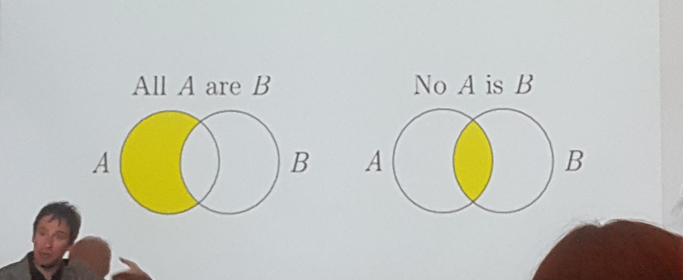
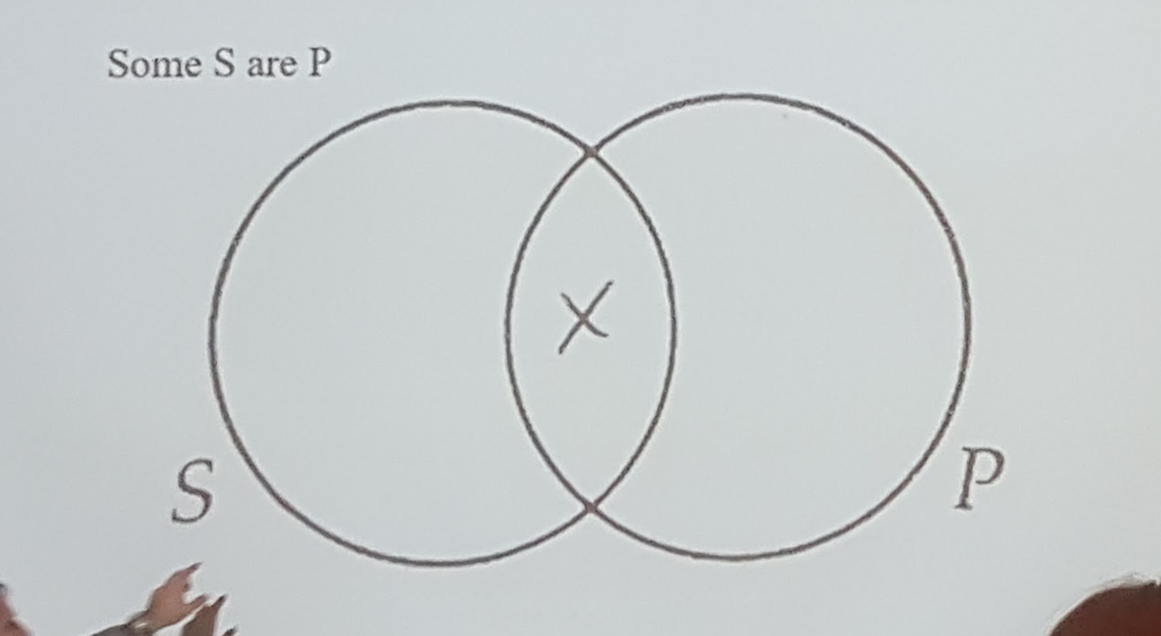
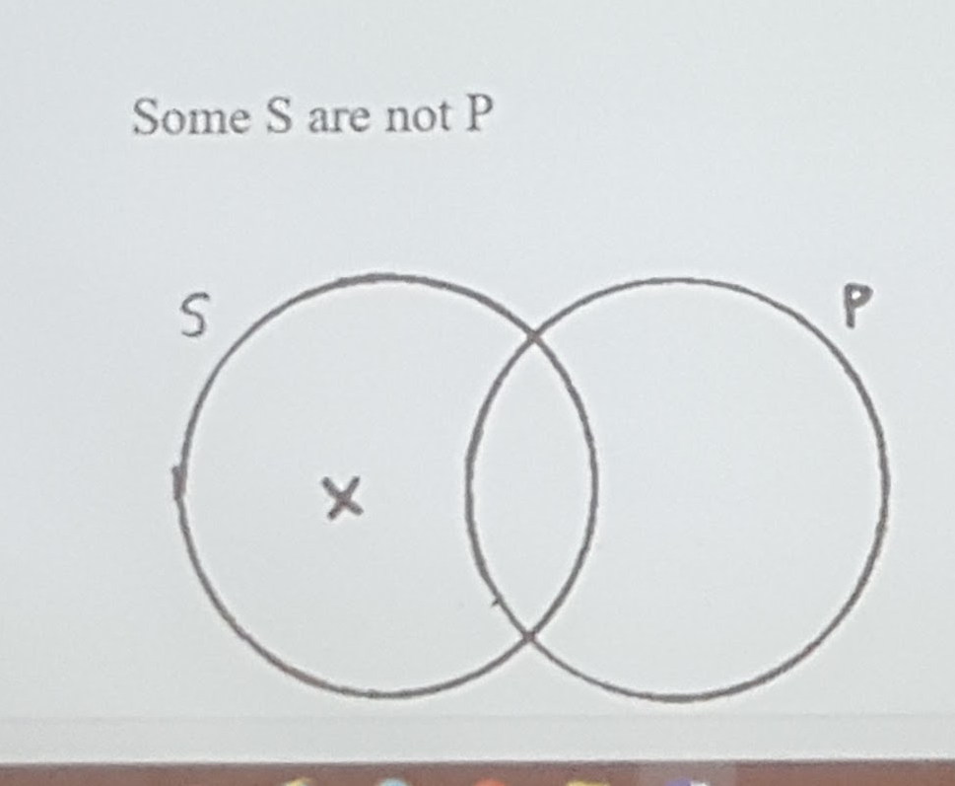

- Examples of universal categorical statements:
- ‘All students are trouble-makers.’
- ‘No “A-students” are slackers

- Examples of particular categorical statements:
- ‘Some people are liars.’
- ‘Some professors are not mean.’

A valid categorical syllogism is such that if its premises were true, then its conclusion must be true.
- We can check the validity of categorical syllogisms using the Venn diagram method.
- Using the Venn diagram method involves:
- Drawing a circle for each category or class in the argument, and diagramming or drawing the premises onto the circles.
- ‘If, after drawing or diagramming the two premises onto the Venn diagram, the conclusion is represented or present on the diagram, then argument is deductively valid.’
- Draw the premises.
- Stop drawing.
- Do you also see the conclusion represented there?
  - If so, then the argument is valid.
- On the other hand, if the conclusion is not represented or present after having drawn the two premises onto the Venn diagram, then the argument is invalid.
- The universal premise is always drawn in the diagram first before the particular premise if both types of statements are being used in an argument, whether the particular premise comes first in the sentence or not.

Examples
7. All tortoises are terrestrial, and some turtles are not terrestrial. So, some turtles are not tortoises.
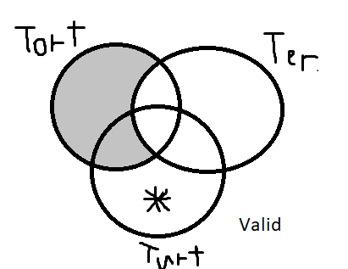

Class #13 (Oct. 19)

Causal claims
- A causal claim is an assertion about the cause of something.
- A causal argument justifies, or supports, such a claim.
- John Stuart Mill devised methods for evaluating causal arguments.
- Mill’s Methods are quite commonsensical.

1) Method of Agreement
- If two or more occurrences of some event or phenomenon have only one relevant factor in common, then that factor is likely the cause.

The method of agreement involves comparing situations in which the same kind of event occurs. If the presence of a certain factor is the only respect in which the situations are the same (that is, agree), then this factor may be identified as being probably the cause of the event.

Form:
- If we’re trying to explain effect ‘E’...
- Instance 1: Factors a, b, c are followed be E.
- Instance 2: Factors a, c, d are followed by E.
- Instance 3: Factors a and c are followed by E.
- Instance 4: b and c are followed be E.
- Therefore, factor c probably causes E.
- Why? Only one factor - namely, c - consistently accompanies the effect E.

2) Method of Difference
- The relevant factor that is present when the event or phenomenon occurs, and absent when it doesn’t occur, is likely the cause.

The method of difference involves comparing situations in which an event of interest occurs with similar situations in which it does not. If the presence of a particular factor is the only difference between two kinds of situations, that factor may be said to be probably “the cause” of the event.

- Look for the cases that are different.
  - What’s missing in those cases?

Form:
- Instance 1: Factors a, b, c are followed by E
- Instance 2: Factors a, b are not followed by E.
- Therefore, factor c is probably the cause of E.

3) Joint Method of agreement and difference
- Both the method of agreement and the method of difference combine the two previous reasoning patterns.

The joint method of agreement and difference involves the simultaneous application of the previous two methods. We compare cases in which an event of interest occurs with ones in which it does not occur. The cause of the event will be the only factor present in each in which the event occurs and absent in each case in which the event does not occur.

- This increase the chances that our conclusion is right.
  - This likely is isolated when you:
    - Identify relevant common factors that are observed in various occurrences of E.
    - Discard any that are present when there is no occurrence of E.

Always think of the Join Method of Agreement and Difference involving two distinct groups. (Read class slides for example)

4) Method of Concomitant Variation

In many cases, relevant factors aren’t merely present or absent during the occurrences of the phenomenon they are closely correlated with the occurrences.

- Sometimes the relevant factor is correlated with phenomenon being examined.
- Correlate: place or to be placed in a mutual relationship

Concomitant means occurring at the same time. The method of concomitant variation involves varying a factor and determining whether a change in it is accompanied by variation in some other factor that interests us. If the two factors vary together , this is a reason to consider that the first factor is probably causally related to the second.

Form:
- Instance 1: When P increases in a population, Event E occurs more often.
- Instance 2: When P decreases in a population, Event E occurs less often.
… Also, there can be an inverse relation between P and E.

Class #14 (October 31)

Argument by Analogy
- An analogy is a comparison of two or more things that are like in specific ways.
- Analogies can also be used to argue inductively for a conclusion.
  - Such arguments are known as ‘analogical induction’ or ‘argument by analogy’.
  - It works like this: ‘Because these two (or more) things are similar in several ways, they must be similar in some further way.’
- Example:
- ‘Animals, like humans, have nerves, a spinal cord, and a brain. So, like humans, animals must feel pain.’
- Formally:
- Thing A has properties PI, P2, P3, and P4.
- Thing B alo has properties PI, P2, and P3.
- Therefore, thing B likely has property P4.
- How well does it work?
- Like all non deductive reasoning, good arguments from analogy only provide probable support for their conclusions.
  - The more similarity there is between the things being compared, the more likely the conclusion is.

Evaluating or judging arguments from analogy
- Consider:
- Relevant similarities
- Relevant dissimilarities
- Number of instances compared
- Diversity among cases
- Relevant Similarities
- The more relevant the similarities are between the things being compared, the more probable the conclusion.
- Relevant similarities are important, but it’s not the sheer number of similarities that matters, it’s how relevant the similarities are matters of importance too.
- Relevant Dissimilarities
- The more relevant the dissimilarities between the two things compared, the less probable the conclusion is.
- Number of Instances Compared
- For the most part, the more comparisons the better.
- Diversity among Cases
- The greater the diversity among cases showing relevant similarities, the better.

Fallacies
- Certain types of defective arguments happen so frequently that they have been given names.
  - These are known as fallacies, and such arguments are to be ‘fallacious’ or ‘erroneous’.
- Fallacy: An error in reasoning.
- Fallacies can seem plausible.
- They are psychologically persuasive, though logically powerless.

Two Categories of Fallacies
- Irrelevant premises. (They try to use ‘reasons’ that have nothing to do with the conclusion.)
- Those that have unacceptable premises. (They use premises that are relevant, but don’t support the conclusion well.)

1) Genetic Fallacy
- Arguing that a claim is true or false solely because of its origin (i.e., where it came from).
- Ex: ‘Selena’s argument regarding the existence of God can’t be right because she’s an atheist.’
- These arguments fail because they reject a claim based solely on where it comes from, not on its merits.

2) The Fallacy of Composition
- Arguing that what is true of the parts of something must be true of the whole thing.
- Ex: ‘The atoms that make up the human body are invisible. Therefore, the human body is invisible.’
- The error here is thinking that the characteristics of the parts are somehow transferred to the whole. However, this is not always the case.

3) The Fallacy of Division
- Argues that what is true of the whole must be true of the parts.
- It’s the flip-side of the fallacy of composition.
- Ex: ‘This machine is heavy. Therefore, all the parts of this machine are heavy.’
- These arguments are fallacious because they assume that characteristics of the whole must transfer to the parts, or that traits of the group must be the same as the traits of individuals in the group.

4) The Red Herring Fallacy
- The deliberate raising of an irrelevant issue during an argument.
- The basic pattern is to put forth a claim and then couple it with an additional claim or claims that may seem to support it but in fact are mere distractions.
- Ex: ‘Climate change is the most important issue facing humanity in the 21st century!’
- …
- ‘We can’t be worrying about the environment when the economy is tanking!.’

5) Faulty Analogy
- An analogy draws a comparison between two things.
- An argument from analogy compares two things, and then suggests they must be alike in some further, less-obvious way.
- The fallacy of faulty analogy: when the items being compared are not sufficiently similar in relevant ways.

Class #15 (Nov. 2)

6) Appeal to Ignorance: arguing that a lack of evidence proves something.
- In one type of this fallacy the problem arises by thinking that a claim must be true simply because it hasn’t been shown to be false.
Example: ‘No one has shown that ghosts aren’t real, so they must be real.’
- The problem is that a lack of evidence is supposed to prove something – but it can’t.
o A lack of evidence alone can neither prove nor disprove a claim.
o A lack of evidence simply reveals our ignorance about something.

7) When a claim comes from someone deemed to be an expert who in fact is not an expert, we commit the fallacy known as the appeal to inappropriate authority.
- Because someone is an expert in one field does not mean that he or she is necessarily an expert in another.
o This point is not that these experts can’t be right, but that their expertise in a particular field doesn’t give us reason to believe them in all things.
Example: My lawyer says that the new treatment for MS is no good. I guess she’s right.

8) The fallacy of appeal to general belief: Arguing that a claim must be true merely because a substantial number of people believe it.
Examples:
- ‘Of course the war is justified. Everyone believed that it’s justified.’

· These arguments are fallacious because they assume that a claim is true merely because a great number of people believe it. In other words, popular opinion makes something true.
o As far as the truth of a claim is concerned, what many people believe or popular opinion is irrelevant.

9) The fallacy of appeal to popular attitudes and emotions:
- Peer pressure: pressure, from one’s peers, to believe or do the things the group does.
Example: All your friends think your views on politics are ridiculous. That should be proof enough that you are wrong.
- Another kind of group influence is the belief ‘our group’ is the ‘best’.
o Our religion, political party, generation, social class, country, ethnic group, etc.
§ Usually this is based on too little; that is, it is based on prejudice.

10) The gambler’s fallacy
- Thinking that previous events can influence probabilities in the random event at hand.
Example: ‘Jose Bautista hasn’t hit a homerun in 8 games. He’s due to hit one tonight.’

11) The false cause fallacy (post hoc): Confusing cause with temporal order.
- This is a very common logical fallacy.
o Causes do precede their effects.
§ But that doesn’t mean that one thing following another is always a case of causation.
Example: I ate a loaf of bread, and got a cold a few days later.

12) The fallacy of the hasty generalization.
- When a conclusion is made about a whole group based on an inadequate sample of the group.
Example: ‘You shouldn’t buy a Dell computer. They’re awful. I bought one last year, and it has given me nothing but trouble.’
- Hasty generalizations provide evidence that is relevant but that isn’t sufficient to justify a strong conclusion.
o When applied to groups of people, hasty generalizations tend to result in stereotyping.

13) The fallacy of the false dilemma: asserting that there are only two alternatives to consider in some issue when there are actually more than two.
Example: ‘Look, either you support the war, oy you are a traitor to your country. You don’t support the war. So you’re a traitor.’
- If you are presented with an ‘either/or’ statement and you can think up more possibilities then just two, then you may be looking at a false dilemma.

14) The fallacy of the loaded question: Consists of attempting to get an answer to a question that assumes the truth of an unproved assumption.
Example:
o Person 1: ‘Have you stopped beating your dog?’
§ When the person says yes or no, it implies he has beat his dog.

15) The fallacy of begging the question (or arguing in a circle): the attempt to establish the conclusion of an argument by using that conclusion as a premise.
Example:
o Bungee jumping is dangerous. Therefore, it is unsafe.
· Problem: The premise and the conclusion say the same thing.
16) The slippery slope fallacy: arguing without good reasons that taking a particular step will inevitably lead to a further, undesirable step (or steps).
· Slippery slope arguments are often fallacious not just because they assert that one event or state of affairs can inevitably lead to others, but because there is no good reason to believe the assertions.
Example: ‘If I give you an extension on your essay just because you had the flu, next you know people will want extensions because they will have had hangovers!’

17) The fallacy of against the person: rejecting a claim by criticizing the person who makes it rather than the claim itself.
· Sometimes called an ‘ad hominem’ attack.
Example: ‘We should reject Chen’s argument for life on other planet. He dabbles in the paranormal.’
· These arguments are fallacious because they attempt to discredit a claim by appealing to something that’s almost always irrelevant to it: a person’s character, motives, hobbies, or personal circumstances
o They say nothing about the quality of the argument itself since they do not talk about the argument.

18) You too (tu quoque): When an argument is put forth as a charge of hypocrisy.
Example:
- ‘Don’t you know that cheating on income taxes is wrong?
- ‘How can you tell me that? You cheated on your income taxes last year!’

19) The pooh-pooh fallacy: involves a refusal to examine an argument seriously and evaluate it fairly.
Example: ‘We don’t have to waste time dealing with Miss Jones’ claims about women not being promoted to executive positions. She’s just giving us more of the usual feminist wish-wash. Let’s move on!’

20) The straw man fallacy: involves distorting, weakening, or oversimplifying someone’s position so that it can be more easily attacked or refuted.
Example: ‘The opposition is opposed to the new military spending bill, saying that it’s too costly. Why does the NDP always want to slash everything to the bone? They want a pint-sized military that couldn’t fight off a crazed band of terrorists, let alone a rogue nation!’

21) The loaded words fallacy: Using highly charged words to assume the truth of a conclusion.
Example: ‘That man is a filthy, lying, sleaze-ball! Case closed, he’s guilty!’

22) The definitional dodge fallacy: consists of redefining a crucial term in a claim to avoid acknowledging a counter-example that would falsify the claim.
Example: ‘A doctor without knowledge of philosophy has no right to call himself a doctor.’

Class #17 (Nov. 21)

Vagueness as Fuzziness
- Terms that have blurry boundaries can be described as fuzzy.
- Specifically, a word or term is vague when its meaning is fuzzy, blurry, or inexact.
- For instance, what if I were to say “I was making minimum wage last year.”
- Is “minimum wage” vague?
  - Yes, minimum wages can vary per province, etc.
- Which set of claims is vaguer?
- The trees served to make shade for the patio.
- He served his country proudly.
- #2 is more vague, we don’t know how he served his country exactly, while #1 is specific.

Vagueness of Quantity and Type
- An individual walks into a pub that has dozens of brews on tap. When asked what he would like, he responds, “I would like to order some beer.”
- That’s not a specific quantity of beer or what kind of beer he wants.

Word Ambiguity
- Relates to the fact that many words have more than one meaning
- A word is ambiguous when (1) it has more than one meaning and (2) it is not obvious which one is intended in a situation in which the word is used.
- Example: Joe went to the bank

An error in reasoning, a fallacy occurs when two distinct meanings of a word are used.
- Example
- Man is the only rational animal.
- No woman is a man.
- Therefore, no woman is rational.
- Two different senses of ‘man’ here: human versus adult male
- The fallacy of equivocation occurs whenever a word has one meaning in one premise and another meaning in another premise or the conclusion.
  - This switch of sense always invalidates the argument; thus making it erroneous or faulty.

Grammatical Ambiguity
- Grammatical ambiguity occurs when a sentence has (1) a grammatical structure allowing it to be understood in more than one way and (2) it is not clear from the context which understanding is the intended one.
- Example: A sign outside of a nightclub reads “Smart is the most exclusive club in town, everyone welcome.”
  - Is it exclusive or is everyone welcome to to the club?
Reasonable beliefs
- Self-evident or necessary truths:
- Examples:
- A triangle has three sides
- 2+2=4
- Self-evident or necessary truths such as analytic statements are of utmost importance since we recognize that because they must be true, they cannot be subject to doubt.
- The examples above are known analytic statements: statements that are true or false because of their form or by the way they're made up.
- On one hand:
- A triangle has three sides
- If this is a book, then it is a book.
- Statements such as these can be described as analytically true in that that truth of the first statement relates to the meaning of the triangle, while the logical structure of the second statement renders it true.
- On the other hand:
- 2+2=5
- A triangle has four sides
- These statements are analytically false or contradictions since they contradict the very essence or meaning of the terms.

Experience
- We accept a great many beliefs because they are based upon senses.
- Factors that can give us good reason to doubt the reliability of personal experience or our senses:
- Impairment
- Expectation

Impairment
- If our perceptual powers are somehow impaired,we have reason to doubt them.
- The following are reasons to doubt the trustworthiness of what we experience.
  - Situation: too dark, too bright, too hazy,or too noisy.
  - Senses: sick, injured, tired, stressed, excited, drugged, distracted, disoriented, or drunk.

Expectation
- We often perceive exactly what we expect, regardless of whether there’s really anything there to detect.
- We may hear scary sounds in the woods, just because we expect to hear them.

Reliance on Others: Experts and Evidence
- Sometimes our beliefs conflict with background information
- Sometimes, rather than two conflicting claims, we see a conflict between a claim and our own ‘background information’.
- ‘Background information’ includes:
  - Facts about everyday things.
    - ‘The sky is blue.’
  - Beliefs based on very good evidence.
    - ‘Cigarettes aren’t good for you.’
  - Justified claims that we would regard as ‘common sense’ or ‘common knowledge’.
    - ‘If you study, then you will do better on the quiz.’
- When an unsupported claim doesn’t conflict with what we already know, we are often justified in believing it because it comes from experts.In other words:
- If an expert makes a claim, then we are generally justified in believing it...
  - Even if no evidence is given...
    - as long as it doesn’t conflict badly with background knowledge.

Who is an Expert?
- Someone who is more knowledgeable in a particular subject area than other people. For example...
- In law?
  - Lawyer, judge, or law professor
- In philosophy?
  - Philosopher
- In car repair?
  - Mechanic

What Good is an Expert?
- In their specialty areas, experts are more likely to be right than we are because:
- they have access to more information on the subject, and
- they are better at judging that information than we are.
  - This is primarily because of their greater experience and practice.
- In a complex world, people must rely on experts.
- You can’t be a doctor, AND a lawyer, AND a mechanic, engineer, botanist, toxicologist, etc.
- But good critical thinkers are careful about expert opinions. Expert opinion is never a guarantee of truth.

Have you found the right expert?
- When a claim comes from someone deemed to be an expert who in fact is not an expert, we commit the fallacy known as the appeal to inappropriate authority.

Class #18 (Nov. 23)

The Moral Domain
- Ethics, or moral philosophy, is the study of morality using the methods of philosophy, and morality consists of our belief about and right and wrong actions and good and bad persons or character.

Moral Theories (There are two types)
- Consequentialist theories: The position that people’s actions are right or wrong because of their consequences or results
- Perhaps, the most influential consequentialist theory is utilitarianism.
- A consequentialist moral theory is typically contrasted with a deontological moral theory.
- Deontological moral theory holds the view that results or consequences of actions are morally irrelevant. Instead, they pertain to duty or obligation in that we did the right thing for no other reason that it is the right thing to do.
- Most influential deontological moral theory = Kantian ethics

Utilitarianism
- As a consequentialist moral theory the result or consequence that utilitarianism seeks to achieve is to maximize happiness.
- Bentham introduces what is known as the utility principle or the principle of utility, which tells us that greatest happiness of the greatest number is the correct measure of right and wrong.
- This is also known as the greatest happiness principle, which tells us that a morally good act is one that results in the most happiness.
- On the other hand, a morally bad act is one that produces more pain than happiness.
- In the eyes of Bentham, everyone affected by some action must be counted equally, and our happiness counts no more than that of others. Again, the correct is to maximize happiness and minimize pain.
- Scenario:
- Act A makes me happy and two other people happy.
- Act B makes me unhappy but twelve others happy.
- Which act would Bentham’s utilitarianism endorse as the morally right or proper act?
- Mill seeks to rehabilitate or improve the moral theory of utilitarianism that Jeremy Bentham puts forth.
- Saying that, Mill like Bentham maintains that a morally good act is one that results in or promotes happiness a morally bad act is one that reverses or takes away happiness.
- Also, Mill, again like Bentham, stresses the importance of pleasure and happiness with pain for his moral theory.
- In other words, Mill, like Bentham before him, advocates or the principle of utility or the greatest happiness principle.
- However, he claims it is is absurd to say pleasure depends upon quantity alone compared to Bentham.
- He argues that quantity but also quality of pleasure must be take into consideration.
- In making this claim, Mill distinguishes between pleasures of the intellect and pleasures of sensation.

Kantian Ethics by Immanuel Kant
- He claims: Duty is the necessity of an action from respect for law.
- Kant is not using law in a legal sense; rather for him a law is a general rule concerning conduct.
- Also, dutiful individuals do them not because they feel like doing it, but because it is their duty, it is what the moral law requires of them.
- To act out of duty is to do what is right simply because it is right and for no other reason.
- Kant maintains that they can use their reason to discover what type of moral world they want to live in.
- Kant elaborates that reason desires to discover good laws.
- Again, law is not understood in a legal sense; rather, it is to be thought of as a general rule concerning conduct.
- The best law will be one that is so general that it allows for no exceptions at all, a universal law, a law that applies across the board all the time and everywhere, a law that is absolute.
- In the eyes of Kant, any law, command, or order that can be universal and that can be willed or chosen is morally good and breaking it or going against it must be morally wrong or bad.
- This is what Kant means by a categorical imperative.
- It is absolute and universal. It means to be used at all times (universal), and we have the duty to abide by what it tells us if we want to do the morally right thing, and this duty allows for no exceptions (absolute).
- The first formulation of the categorical imperative provided by Kant goes like this:
- Act only in accordance with that maxim through which you can at the same time will that it become a universal law.
  - Maxim: The general rule in accordance with which the individual intends to act.
  - Law: An objective principle, a maxim that passes the test of being universal.
- We can think of Kant’s categorical imperative along these lines:
- When you are thinking of doing a certain action, you are to ask yourself what rule would be following if were to do that action - this is the maxim of the act.
- Next, you are to ask whether you would be willing for that rule to be followed by everyone all the time - this is what makes it a universal law.
- If you rationally decide that the rule may be followed by everyone, then the act is morally good.
- However, if you would not be willing for everyone to follow the rule, then you must not follow it, as the act would be morally wrong.
- A second formulation of the categorical imperative that Kant provides goes like this:
- So act that you use humanity, whether in your own person or in the person of any other, always at the same time as an end, never merely as a means.
- From this second form of the categorical imperative Kant maintains that humans and objects are not one and the same, that is, they do not share the same moral value.
- Objects, such as houses, cars, computers, pens, pencils, and so on, have instrumental value since they are a means to something else, specifically, another end.
- Humans have moral dignity and, accordingly, cannot be treated as solely having instrumental value, a means to an end.
- Kant maintains that humans are valuable in themselves, regardless of whether they are useful or loved or valued by others.
- The sheer fact that one is a human, according to Kant, guarantees that one has intrinsic value (one is valuable in and of oneself), and this intrinsic value must be respected and recognized.

Class #20 (Nov. 30)

Animal Rights - Peter Singer
- Peter Singer, on the topic of animal rights, makes the case for the view that animals’ interests are the basis for their having rights and rights that are equal to humans.
- Animals may have different interests than we do, but that does not mean that their interests are to be taken lightly.
- According to Singer, not to respect the interests of animals is speciesism, which is an objectionable attitude similar to racism or sexism – objectionable because it treats animals badly simply because they are a member of a different species and gives preference to members of our own species simply because we are human beings.
- George Orwell, in Animal Farm, wrote: ‘All animals are equal, but some animals are more equal than others.’
- Tongue and cheek as Orwell’s statement is, it implies that equality does not exist among animals.
  - In his essay, “All Animals are Equal,” as its title suggests, Peter Singer seeks to dispel such a notion, and argue that all animals are equal.
- In this work, Singer acknowledges that when Mary Wollstonecraft, a forerunner of feminism, published her Vindication of the Rights of Women in 1792, her views were widely regarded as absurd.
- In fact, Wollstonecraft’s Vindication of the Rights of Woman was parodied in 1792 by an anonymous author of the time (Thomas Taylor), as the Vindication of the Rights of Brutes.
  - The argument put forth in a Vindication of the Rights of Brutes was that if the idea of equality was a sound one when applied to women, why should it not be extended to other brutes like dogs, cats, and horses?
    - The sexism aside in such an argument, at the same time we can note that historically, the idea of animal rights arose as a joke or a lark to make fun of women’s rights.
- Singer observes that when one studies liberation movements throughout history, one discovers that they reveal the latent prejudices of the society of the day, prejudices that are reflective of the status quo and taken to be normal.
- On the topic of women’s rights, one could certainly argue that there is more work to be done, but at the same time, one can recognize that women’s rights are accepted nowadays. For instance, there is no dispute in our Canadian culture about such rights; they are constitutionally protected.
- Yet, while women like men may enjoy rights, Singer argues that the basic principle of equality does not require equal or identical treatment.
  - Rather, it requires equal consideration.
- Equal consideration, as argued by Singer, may lead to different treatment and different rights for different beings.
- For example, women have right to abortion, but men do not have this right, and it would be absurd or pointless to argue that they should.
  - Along these lines, Singer notes that it would be meaningless to argue that animals should have a right to vote, or even should not be given rights because they cannot talk.
- On the topic of equality, he elaborates:
- Like it or not, we must face the fact that humans come in different shapes and sizes; they come with differing moral capacities, differing intellectual abilities, differing amounts of benevolent feeling and sensitivity to the needs of others, differing abilities to communicate effectively, and differing capacities to experience pleasure and pain. In short, if the demand for equality were based on the actual equality of all human beings, we would have to stop demanding equality. It would be an unjustifiable demand.
- Equality for Singer is a moral idea. It is not an assertion of fact.
- Specifically, it is a prescription of how we should treat other human beings.
  - For example, most, if not all of us, cherish the idea that we should not discriminate based upon gender or race.
    - An existence free from sexism and racism is one we ought to strive for.
      - But how do we ground this idea of equality that we should strive for?
      - And what makes us so special and different from other animals?
- According to Singer, the only characteristic that every single human being has in common, that no other animal has is membership in the human species.
- Singer observes that if you want to say that every human is morally important, and that humans are the only creatures that are morally important, your criteria for moral importance must be based simply on species membership.
  - All the same, he argues that using simple membership in the species Homo sapiens as a criterion of moral importance is completely arbitrary.
- He maintains that if there is, in fact, no relevant difference between your group and some other group, then there is no rational ground for thinking that those who belong to your group deserve greater consideration than those who belong to the other group.
- Although it is fairly natural for people to use species membership as a criterion of moral importance, Singer thinks the obvious parallels with racism are so strikingly similar that he introduces the term speciesism.
- He defines speciesism as, “a prejudice or attitude of bias in favor of the interests of members of one's own species and against those of members of other species.”
- To bolster his argument for animal rights, Singer cites the utilitarian thinker Jeremy Bentham who in the 18th century had wrote:
- The day may come when the rest of animal creation may acquire those rights which never could have been withholden from them but by the hand of tyranny. The French have already discovered that the blackness of the skin is no reason why a human being should be abandoned without redress to the caprice of a tormentor. It may one day come to be recognized that the number of legs, the villosity of the skin, or the termination of the os sacrum are reasons equally insufficient for abandoning a sensitive being to the same fate. What else is it that should trace the insuperable line? Is it the faculty of reason, or perhaps the faculty of discourse? But a full-grown horse or dog is beyond comparison a more rational, as well as a more conversable animal, than an infant of a day or a week or even a month old. But suppose they were otherwise, what would it avail? The question is not, Can they reason? Nor Can they talk? but, Can they suffer?
- Picking up where Bentham left off, Singer elaborates:
- If a being suffers, there can be no moral justification for refusing to take that suffering into consideration. No matter what the nature of the being, the principle of equality requires that its suffering be counted equally with the like suffering—in so far as rough comparisons can be made—of any other being. If a being is not capable of suffering, or of experiencing enjoyment or happiness, there is nothing to be taken into account. This is why the limit of sentience (using the term as a convenient if not strictly accurate, shorthand for the capacity to suffer or experience enjoyment or happiness) is the only defensible boundary of concern for the interests of others. To mark this boundary by some characteristic like intelligence or rationality would be to mark it in an arbitrary way. Why not choose some other characteristic, like skin color?
- The racist violates the principle of equality by giving greater weight to the interests of members of his own race, when there is a clash between their interests and the interests of those of another race. Similarly the speciesist allows the interests of his own species to override the greater interests of members of other species. The pattern is the same in each case. Most human beings are speciesists.
- The idea that most humans are speciesists entails that we don’t bat an eye in our treatment of animals we don’t recognize that they are sentient beings, beings capable of feeling.
- As argued by Singer, we are barking up the wrong tree if we argue that since animals can’t reason or talk, they should not have rights.
- Animals, like human, can suffer and therefore equal consideration entails that they have a right not to be subjected to pain.

