Verifying Charles’ and Boyle’s Law

Written by: Yasmin Elkalish
Student number: 300068482
Section: CHM 1301 Z08

TAs: Stephanie Ton and Christian Tessier

Charles’ law
Theory:
In an effort to verify Charles’ law which states that “Charles' Law is a special case of the ideal gas law. It states that the volume of a fixed mass of a gas is directly proportional to the temperature. This law applies to ideal gases held at a constant pressure, where only the volume and temperature are allowed to change.” (ThoughtCo, 2018).My partner and I measured the volume (mL) of air using the water displacement method as we vary the temperature (°c).

Experimental Procedure:
Safety protocol: wear goggles during the experiment
- Collect a 125mL Erlenmeyer flask from a drying apparatus and place a one-hole rubber stopper in it.
- Mark the position of the bottom of the stopper with adhesive paper.
- Fill a 600mL beaker with 400mL of tap water.
- Place the beaker on a hot plate and clamp the Erlenmeyer flask so that it is fully submerged in the beaker filled with water.
- Make sure that water doesn’t enter the Erlenmeyer flask.
- Turn on the hot plate and heat the water to boiling.
- During this time, prepare a large ice bath to be below 6°c.
- Place a thermometer in the beaker and record the temperature. (T1)
- Place a finger over the hole on the stopper and put the flask in the ice bath facing downwards. Then, remove your finger.
- Keep the flask in the ice bath for 6 minutes to equilibrate with the temperature of the water and record the temperature of the ice bath. (T2)
- Place your finger over the hole and remove the flask from the water bath.
- Transfer the water in the flask to a graduated cylinder and note the volume. (Vcw)
- Fill the flask to the adhesive paper mark with tap water and transfer this volume to a graduated cylinder. Finally, note the volume (V1)
- Repeat the experiment.
Results:
variables | T1(°C) | T1(K) | V1(mL) | T2(°C) | T2(K) | Vcw(mL)
Trial A | 100 | 373.15 | 174 | 5 | 278.15 | 32
Trial B | 100 | 373.15 | 174 | 6 | 279.15 | 31
Average | 100 | 373.15 | 174 | 5.5 | 278.65 | 31.5

Calculations:
Volume of gas at T2=V2=V1-Vcw
V2 (Trial A) =174-32=142mL
V2 (Trial B) =174-31=143mL
V2(average)= (142+143)/2 =142.5mL
Observations:
As the temperature decreases from 373.15K to 278.65K the volume of the gas decreases by 31.5mL
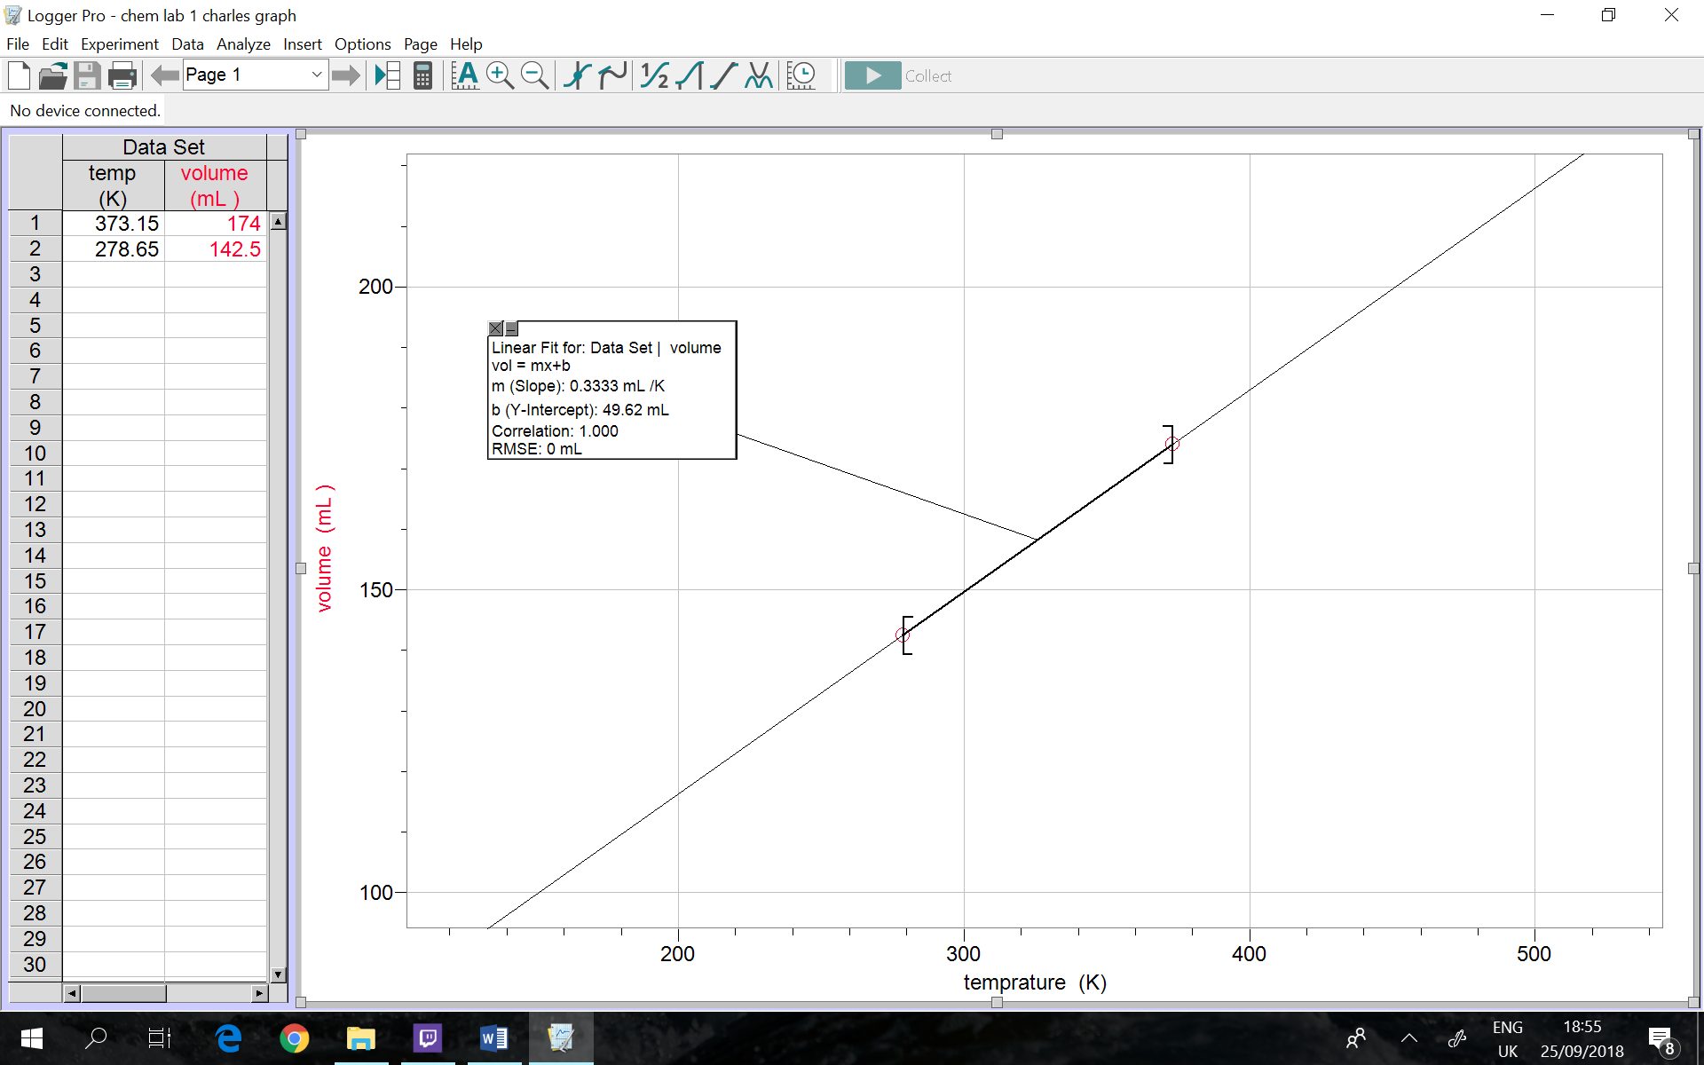
Graph:
Discussion:
The results successfully demonstrated Charles’ law as seen from the logger pro graph the gradient is positive (0.3333mL/K) as well as the correlation (1). Therefore, this shows direct proportionality.
Experimental shortcomings:
%error = (V1/T1) - (V2/T2) x100
(V1/T1)

= (174/373.15) - (142.5/278.65) x100
(174/373.15)

= ±9.67% (to 2 dp)
The percentage error could be due to the following:
- Inconstant pressure: although the experiment was done in the same lab environment the pressure was not monitored therefore it might have fluctuated.
- Parallax errors: when measuring the volumes using the graduating cylinder.
Conclusion:
As temperature in kelvin decreases, the volume of the gas decreases. As temperature in Kelvin increase, the volume of the gas increases. Similarly, VαT and Charles’ law has been verified.

Boyle’s law
Theory:
In an effort to verify Boyle’s law which states that “the pressure (p) of a given quantity of gas varies inversely with its volume (v) at constant temperature.” (Encyclopedia Britannica, 2018). My partner and I measured the pressure in kPa using a gas pressure sensor as we vary the volume in mL of an ideal gas in a gas syringe.
Experimental Procedure:
- Connect the gas pressure sensor to labQuest 2
- Move the plunger of a 20ml syringe to 2ml by lining up the end tip of the plunger with the volume mark.
- Attach the 20ml syringe to the valve of the gas pressure sensor
- After the pressure reading stabilizes, record that value
- Move the plunger to change the volume of the air in the syringe
- Repeat the experiment for different volumes
- Add 0.8 to each volume reading

Results:
Volume (ml) +0.8 | Pressure (kPa)
2.80 | 103.08
4.80 | 71.31
6.80 | 53.17
8.80 | 39.62
10.80 | 34.47
12.80 | 29.68
14.80 | 26.30
16.80 | 23.96
18.80 | 21.29
20.80 | 19.82

Observation:
As the volume doubles from 2.80ml to 20.80ml the pressure decreases
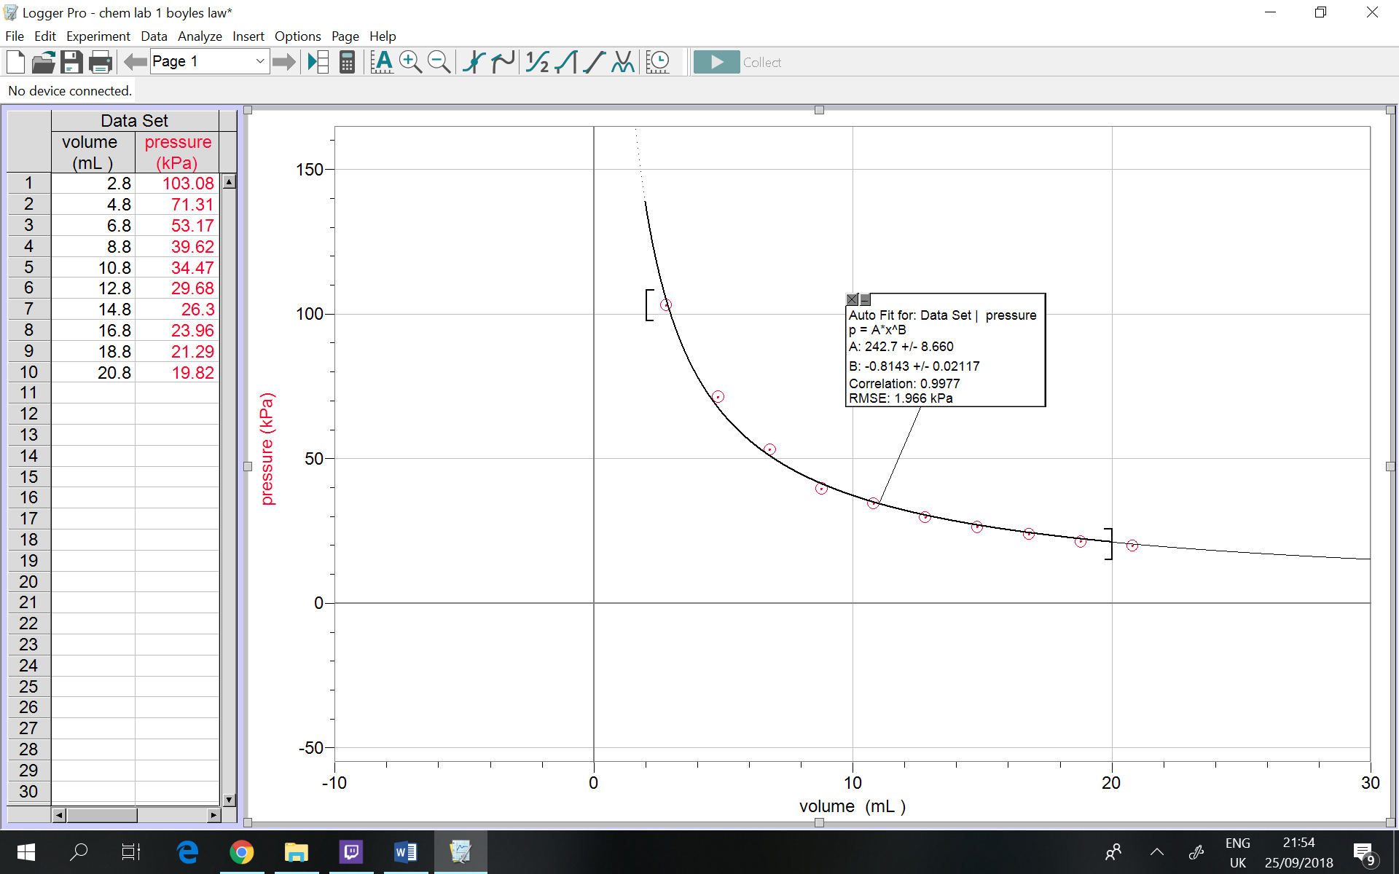
Graph:
Discussion:
The results successfully demonstrated Boyle’s law as seen from the logger pro graph the gradient is negative in addition it is a decreasing function which shows inverse proportionality.
Experimental shortcomings:
% error = (P1*V1) – (P2*V2) *100
(P1*V2)

= (103.08*2.80) – (71.31*4.80) *100
(103.08*2.80)

= ±18.59% (to 2 dp)
The percentage error could be due to the following:
- Inconstant temperature: although the experiment was done in the same lab environment (at room temperature) the temperature was not monitored therefore it might have fluctuated.
- Parallax errors: when setting the lab syringe plunger to the chosen volumes.
- Recording the pressure values before it stabilizes
- The experiment wasn’t repeated therefore an average wasn’t calculated
Conclusion:
As volume increases, the pressure of the gas decreases. As volume decreases, the pressure of the gas increases. Similarly, Vα (1/P) and Boyle’s law has been verified.
Bibliography:

ThoughtCo. (2018). Know the Formula for Charles' Law. [online] Available at: https://www.thoughtco.com/formula-for-charles-law-604281 [Accessed 26 Sep. 2018].

Encyclopedia Britannica. (2018). Boyle's law | chemistry. [online] Available at: https://www.britannica.com/science/Boyles-law [Accessed 26 Sep. 2018].

