Enthalpy of various reactions
(A tall cold drink of water-Uottawa Gee Gee’s sport and health drinks)

Written by: Yasmin Elkalish
Student number: 300068482
Section: CHM 1301 Z08

TAs: Stephanie Ton and Christian Tessier

Introduction:
The aim of this experiment is to produce a can that when desired, can be activated to cool the drink it contains .The product should cool ${100cm}^{3}$ of drinkable water by 5°c in no more than 5 minutes. Therefore, to accomplish this aim, the principles of enthalpy was applied essentially the enthalpy of solution.
‘A solution is a homogeneous mixture of two or more substances and can either be in the gas phase, the liquid phase, the solid phase. The enthalpy change of solution refers to the amount of heat that is released or absorbed during the dissolving process (at constant pressure). This enthalpy of solution (ΔHsolution) can either be positive (endothermic) or negative (exothermic)’ (Chemistry LibreTexts, 2018)
Based on this we focused on the theory of producing an enthalpy of solution that is endothermic using ammonium chloride.
‘Endothermic reactions are reactions that require external energy, usually in the form of heat, for the reaction to proceed. Since endothermic reactions draw in heat from their surroundings, they tend to cause their environments to cool down. They are also generally non-spontaneous, since endothermic reactions yield products that are higher in energy than the reactants. As such, the change in enthalpy for an endothermic reaction is always positive.’ (Courses.lumenlearning.com, 2018)
Ammonium chloride was chosen as it was chemically and economically favourable in comparison with other salts –for example ammonium nitrate. It is cheaper than ammonium nitrate by $2.22 per 500g and less soluble by 154.8g per 100g of water which indicates that a mass of ammonium chloride would dissolve faster and cost less.
In addition to that, the hazards related to ammonium chloride are less harmful than ammonium nitrate.
‘The substance decomposes on heating producing toxic and irritating fumes (nitrogen oxides, ammonia and hydrogen chloride). The solution in water is a weak acid. Reacts violently with ammonium nitrate and potassium chlorate causing fire and explosion hazard.’ (Cdc.gov, 2018)
‘Heating may cause violent combustion or explosion. The substance decomposes on heating or producing toxic fumes (nitrogen oxides ) The substance is a strong oxidant and reacts with combustible and reducing materials.’ (Cdc.gov, 2018)
The experiment design is a calorimeter, consisting of an aluminium can inside a Styrofoam cup with a lid and a digital thermometer, was the best approach to reach the goals of this experiment. In result, the heat escaped to the environment was kept to a minimum. Aluminium is a conductor so it absorbed as much heat possible to supply the solution with energy leaving the surroundings cool. The Styrofoam cup and lid has a low specific heat capacity therefore it wouldn’t take much energy or time to cool. The digital thermometer eliminated any human parallax errors leading to more accurate results.
Procedure:
- Wear lab coat and goggles
- Record the mass of the aluminium can using an electronic balance
- Add 100ml of water to the aluminium can and 85ml in the Styrofoam.
- Calculate the enthalpy of aluminium and add it the enthalpy of water by using the formula Q=mcΔT(Al) + mcΔT(H2O)
- Find the number of moles of NH4Cl by using the formula n=Q/ΔHsol(NH4Cl)
- Calculate the mass of NH4Cl needed to reach 5°c by using the formula mass= n*molar mass
- Find the initial water temperature by using an electronic thermometer
- Add the mass of NH4Cl calculated in step 6 to the aluminium can and place it in the Styrofoam cup
- Stir it and close the lid. Then, measure the temperature every 10s for 5 minutes
- Repeat the experiment for several masses above and below the calculated mass of NH4Cl.
Table:
Experiment number | Mass of NH4Cl (grams) | Initial temperature (°c) | Final temperature (°c) | ΔT (°c)
1. | 11.3 | 19.5 | 15.7 | 3.8
2. | 12.3 (calculated) | 23.2 | 18.4 | 4.8
3. | 12.5 | 22.9 | 18.4 | 4.5
4. | 12.8 | 23.3 | 20.4 | 2.9
5. | 13.3 | 21.4 | 17.8 | 3.6
6. | 14.3 | 22.9 | 19.2 | 3.7

Observation:
On doing the experiment, the calculated mass of 12.3g of NH4Cl gave the closest temperature change to 5°c that is 4.8°c. Decreasing the mass decreases the temperature below 4.8°c. Increasing the mass increases the temperature above 4.8°c.
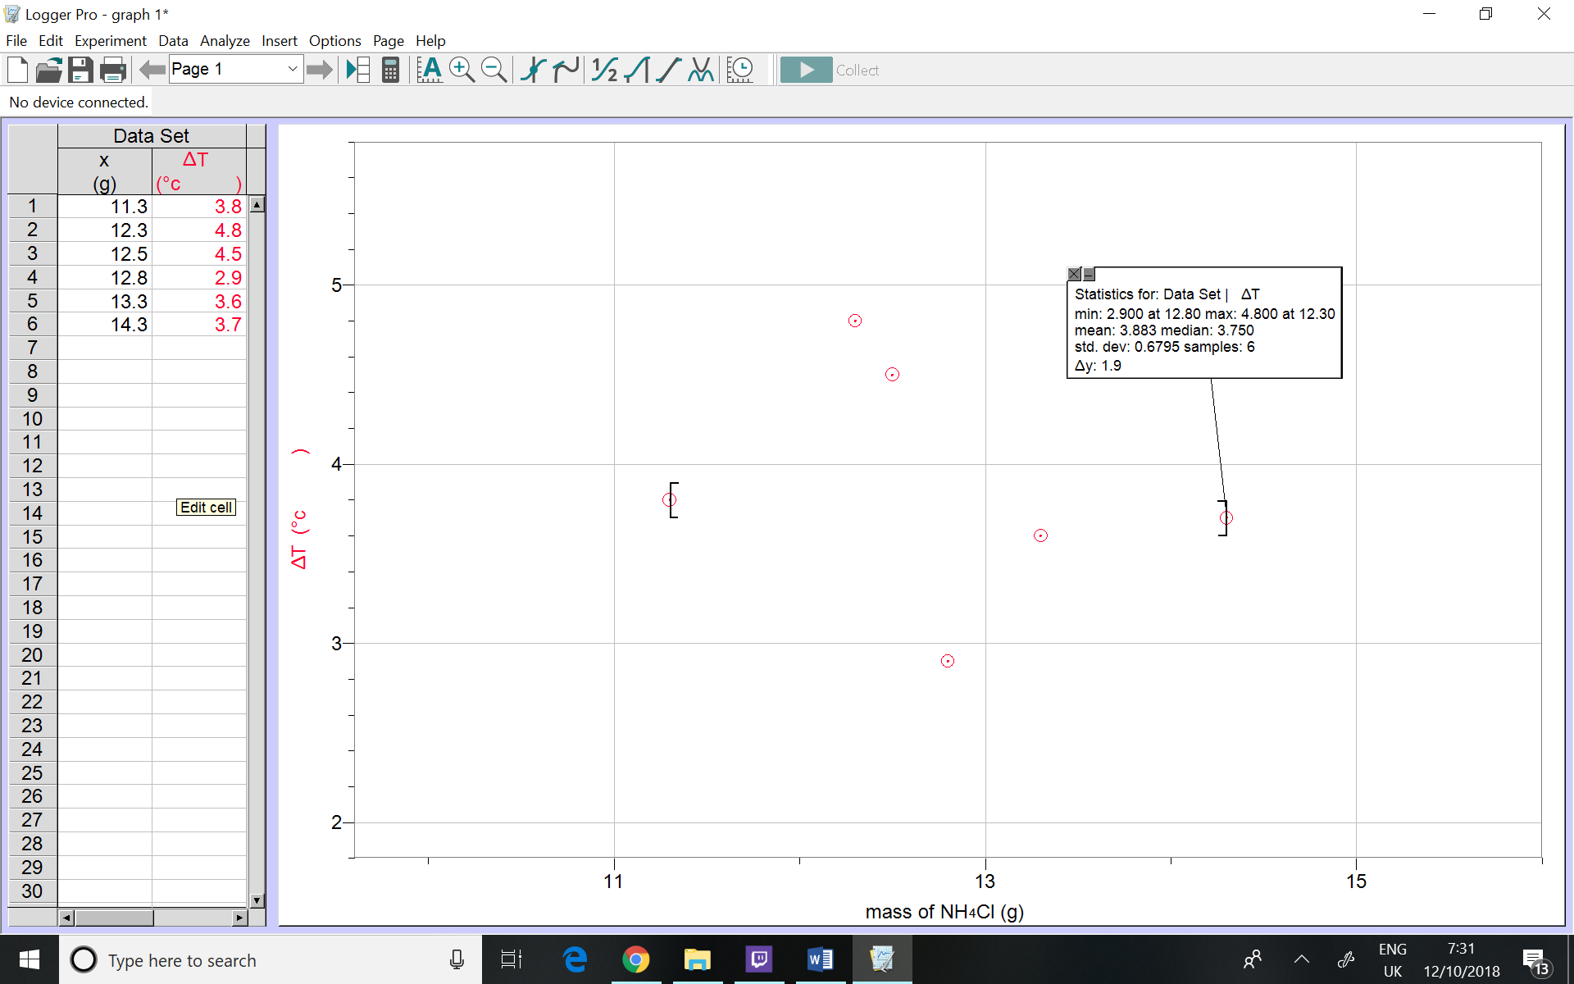
Graph:
Calculations:
Finding the mass of NH4Cl required:
Q=mcΔT(Al) + mcΔT(H2O)
Q = (8.18*0.9*5)+(185*4.18*5)
Q =3903.31J or 3.9KJ
n=Q/ΔHsol(NH4Cl)
n= 3.9/17
n =0.23mol
mass= n*molar mass
mass= 0.23*53.5
mass=12.3g
finding the enthalpy of solution of NH4Cl
ΔHs(NH4Cl) =Q(sol)/n(NH4Cl)
=3.9/0.23
=17KJ/mol

Discussion:
The data from the graph shows that the calculated mass of 12.3g of NH4Cl gave the closest temperature change to 5°c that is 4.8°c. Decreasing the mass by 1g decreases the temperature by 1°c. Increasing the mass by 0.2g increased the temperature by 0.3°c. As proved by the results, the design worked as NH4Cl was able to cool $100cm^{3}$ of a drink by 4.8°c.
The 0.2°c difference evident and a possible inaccuracy with the rest of the results could be due to a human error where the play button on LabQuest2 wasn’t pressed fast enough. Therefore, the recorded raw data of the initial temperature was recorded before the thermometer was put inside the can. This could be improved by using more lab partners to place and record the temperature as fast as possible.in addition to repeating the experiment for each mass more often.
Some of the NH4Cl salt wasn’t crushed into fine powder therefore some of the salt didn’t dissolve. To improve this crushing the salt using a mortar and pestle before adding it to the water as well as stirring it for longer would eliminate the error in the values.
Finally, parallax errors in measuring the volume of water could have caused inaccurate results to improve this the measuring cylinder should be at eye level and the volume should be checked by other lab partners to confirm the value.
Conclusion:
The experiment was a success proving that the product design is suitable as the experiment showed that NH4Cl gave the desired effect by cooling the drink by 4.8°c. By repeating this experiment with a larger variety of masses a temperature change of 5°c could be easily achieved.

Bibliography:
Chemistry LibreTexts. (2018). Enthalpy of Solution. [online] Available at: https://chem.libretexts.org/Textbook_Maps/Physical_and_Theoretical_Chemistry_Textbook_Maps/Supplemental_Modules_(Physical_and_Theoretical_Chemistry)/Physical_Properties_of_Matter/Solutions_and_Mixtures/Solution_Basics/Enthalpy_of_Solution [Accessed 11 Oct. 2018].

: Courses.lumenlearning.com. (2018). Exothermic and Endothermic Processes | Introduction to Chemistry. [online] Available at: https://courses.lumenlearning.com/introchem/chapter/exothermic-and-endothermic-processes/ [Accessed 11 Oct. 2018].

Courses.lumenlearning.com. (2018). Exothermic and Endothermic Processes | Introduction to Chemistry. [online] Available at: https://courses.lumenlearning.com/introchem/chapter/exothermic-and-endothermic-processes/ [Accessed 11 Oct. 2018].

Cdc.gov. (2018). CDC - AMMONIUM NITRATE - International Chemical Safety Cards - NIOSH. [online] Availabl:e at: https://www.cdc.gov/niosh/ipcsneng/neng0216.html [Accessed 11 Oct. 2018].

