Equilibria

Written by: Yasmin Elkalish
Student number: 300068482
Section: CHM 1301 Z08

TAs: Stephanie Ton and Christian Tessier

Date: 27th October 2018

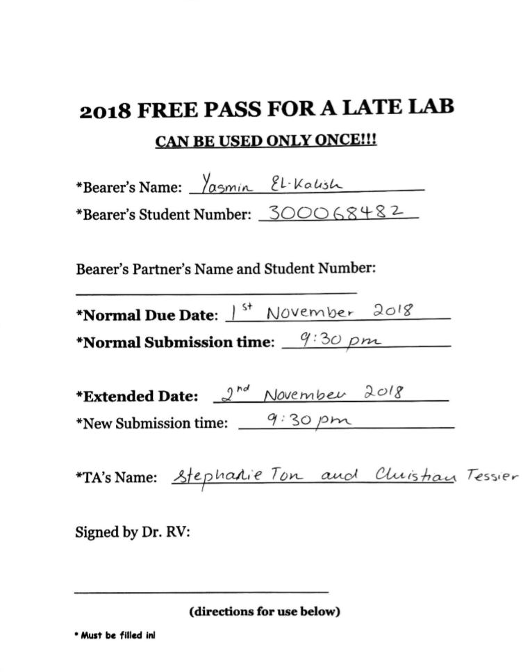

*I have Emailed Dr.Rashmi for her signature please contact her if conformation is required

Introduction:
In this experiment, there are 3 main concepts that has been tested for. Firstly, the equilibrium shift which is observed by increasing and decreasing the concentration of the reactant. Secondly, establishing multiple equilibria by using the common ion effect. Finally, preparing a buffer solution by altering the pH. All using the le Chatelier principle.
“Le Chatelier’s principle is an observation about chemical equilibria of reactions. It states that changes in the temperature, pressure, volume, or concentration of a system will result in predictable and opposing changes in the system in order to achieve a new equilibrium state. Le Chatelier’s principle can be used in practice to understand reaction conditions that will favor increased product formation. This idea was discovered and formulated independently by Henri Louis Le Chatelier and Karl Ferdinand Braun.” (Courses.lumenlearning.com, 2018)
Observation:
During the first experiment (equilibrium shift), a colourless solution of concentrated NH3 is added to 1ml of 0.1mol/L pale blue CuSO₄ until the solution turned dark blue. In addition, a pungent smell was evident. By adding 1 mol/L of HCl to the dark blue solution it gets paler until the solution is colourless. Then, adding more of the concentrated NH3 solution a dark blue layer appears on top of the colourless solution. By adding drops of HCl again, a layer pale blue coloured appears on top of the dark blue layer.
During the second experiment (multiple equilibria), 0.5 ml of 0.01 mol/L colourless AgNO₃ solution was added to 0.5ml of 0.1mol/L colourless Na₂CO₃ solution which resulted in a milky-beige coloured solution. After adding 6mol/L of colourless HNO₃ dropwise the solution turned back to colourless. On adding 0.1mol/L of HCl, a less dense milky-white solution is formed. Then, adding concentrated NH₃ solution, smoke with a pungent smell is observed and a white precipitate is formed at the bottom of the test tube. In addition, the solution turns clear. By adding more HNO₃ the dense white precipitate disappears and the solution is completely transparent. Adding more HCl produces no change similarly with NH_{3(aq)}. A few drops of 0.1mol/L of KI produces a cloudy layer on top of the clear solution and adding Na₂S produces a third translucent grey layer on top of the cloudy layer.
During the third experiment (buffer solution), the initial pH of 100ml distilled water was 5.53 however when 2.5g of NaHCO₃ is dissolved completely the pH increases to 8.17. On adding 30 mL of 0.1mol/L HCl, it decreases the pH to 7.16. Then, adding 0.85% of lactic acid decreases the pH more to 7.06. Nevertheless, increasing the rate of stirring increased the pH to 7.09. Next, adding 0.5g of NaHCO₃ increases the pH to 7.12. In addition to that, another 0.5g of NaHCO₃ increases the pH further to 7.24. In contrary, adding a pellet of CO₂ floats on the solution and decreases the pH to 7.31. Finally, adding 0.4g of NH₄Cl decreases the pH back to 7.24.

Tables of observations:
Experiment 1
Chemicals added | Observations
CuSO₄ | Pale blue
+NH₃ _{(aq)} | Dark blue
+HCl | colourless
+NH₃ _{(aq)} | Dark blue layer and colourless layer
+HCl | Pale blue layer, dark blue layer and colourless layer

Experiment 2
Chemicals added | Observations
Na₂CO₃ | colourless
+AgNO₃ | Milky beige
+HNO₃ | colourless
+HCl | Milky white
+NH_{3(aq)} | Pungent smell and white ppt
+HNO₃ | Colourless and no ppt
+HCl | No change
+NH_{3(aq)} | No change
+KI | Cloudy layer and colourless layer
+Na₂S | Grey layer, cloudy layer and colourless layer

Experiment 3
Experiment steps | pH
H₂O | 5.53
+ 2.5g of NaHCO₃ | 8.17
+ HCl | 7.16
+ lactic acid | 7.06
+ stirring | 7.09
+ 0.5g of NaHCO₃ | 7.12
+0.5g of NaHCO₃ | 7.24
+ CO₂ | 7.31
+NH₄Cl | 7.24

Discussion:
Experiment 1: Equilibrium shift
Net ionic equation: [Cu(H₂O)₄] ²⁺ _{(aq)} + 4 NH₃ _{(aq)} ⇌ [Cu(NH₃)₄] ²⁺ _{(aq)} + 4 H₂O _{(l)}
As observed, the colour change from pale blue to dark blue occurred as the equilibrium shifts to the right due to the addition of NH_{3 (aq)}. The concentration of the reactants increases thus increasing the frequency of successful collisions favouring the forward reaction and producing more product. In this case, [Cu(NH₃)₄]SO₄ is the product and the dark blue colour evident is due to the complex ion [Cu(NH₃)₄] ²⁺. By adding HCl a double displacement reaction occurs “A double displacement reaction, also known as a double replacement reaction or metathesis, is a type of chemical reaction where two compounds react, and the positive ions (cation) and the negative ions (anion) of the two reactants switch places, forming two new compounds or products.” (Study.com, 2018). The colour change from dark blue to colourless was observed as the equilibrium shifted to the left since the concentration of the weak base NH_{3(aq)} decreased as a result of the presence of the strong acid HCl which dissociated completely. Plus, the colour of NH_{3(aq)} ion is colourless the solution changes to that colour. On adding more NH₃(aq) the equilibrium shifts to the right producing more products, but as the limiting reagent CuSO₄ was saturated, the production of a layer of dark blue solution and a layer of colourless was seen as there was some unreacted NH_{3(aq)}.By adding more HCl the equilibrium shifts to the left and more reactants are produced the pale blue layer indicates that some [Cu(NH₃)₄]²⁺ was converted to [Cu(H₂O)₄]²⁺ but due to the limited amount of [Cu(NH₃)₄]²⁺ not all of the solution was converted leaving a dark blue layer as well.
Experiment 2: Multiple Equilibria
This reaction is an example of a precipitation reaction “A precipitation reaction refers to the formation of an insoluble salt when two solutions containing soluble salts are combined.” (Courses.lumenlearning.com, 2018) therefore the colour change from colourless to milky beige was due to the presence of Ag₂CO₃ which occurred by the addition of AgNO₃ increasing the concentration of the reactant. In result, the equilibrium shifts to the right producing more products.
2AgNO₃ _{(aq)} + Na₂CO₃ _{(aq)} ⇌ Ag₂CO₃ _{(s)} + 2 NaNO₃ _{(aq)}
When HNO₃ is added to Ag₂CO₃ the equilibrium shifts to the right producing more AgNO₃ where the Ag⁺ ion is responsible for the colour change as well as water and carbon dioxide. This reaction is an example of double displacement.
Ag₂CO₃ _{(s)} + 2 HNO₃ _{(aq)} ⇌ 2AgNO₃ _{(aq)} → H₂O _{(l)} + CO₂ _{(g)}
On adding excess HCl to AgNO₃ the equilibrium shifts to the right due to the high concentration of HCl producing AgCl and HNO₃ with the Cl⁻ ion responsible for the milky white colour. This reaction is another example of a precipitation reaction.
AgNO₃ (aq) + HCl (aq) ⇌ AgCl (s) + HNO_{3 (aq)}
Adding a concentrated solution of NH₃ also shifts the equilibrium to the right therefore dissolving the Ag+ ions producing a complex ion responsible for white colour change. This reaction is an example of another double displacement
2AgCl _{(s)} + 4NH₃ _{(aq)} ⇌ 2Ag(NH₃)_{2 (aq)}+ Cl₂ _{(g)}
Adding more HNO₃ shifts the equilibrium to the right producing NH₄⁺ ions which is responsible for the colourless solution. No change occurs when adding more HCl or NH_{3(aq)} as the solution is saturated.
2HNO₃ _{(aq)} + [Ag(NH₃)₂]Cl _{(aq)} ⇌ NH₄NO_{3 (aq)} +AgCl_{(s)}
Adding KI shifts the equilibrium to the right producing more AgI and ICl which produces a cloudy coloured layer due to the Cl⁻ ion but as AgCl is a limiting reagent therefore not all products are converted to reactants and the reaction is reversed to an extent resulting in a layer of the colourless solution below the cloudy layer.
AgCl _{(s)} + KI _{(aq)} ⇌ AgI _{(s)} + ICl
Adding Na₂S shifts the equilibrium to the right in result producing Ag₂S and NaI which produces a grey coloured layer due to the I⁻ ion but as AgI is a limiting reagent therefore not all products are converted to reactants and the reaction is reversed to an extent resulting in a layer of the colourless solution and a cloudy layer below the grey layer.
2AgI _{(s)} + Na₂S_{(aq)} ⇌ Ag₂S _{(s)} + 2NaI

Experiment 3: The Buffer Solution
“When an acid concentration is increased, the system tends to the opposite and thus flows towards the base, to increase its concentration (Beran, 2009). To prevent any changes in the acid-base pH, buffers are mainly used to sustain the equilibrium. Buffers have to consist of a weak or strong acid or base and its conjugate species (Tro, 2010).” (UKEssays, 2018)
The initial pH of distilled water 5.53 which is not expected as the pH of water should be around 7(neutral). This shows that the water is acidic and this could be due to an unknown error in the pH probe.
NaHCO₃ is a weak base and therefore the equilibrium shifts to the left producing more HCO₃ ions and decreasing the concentration of the acidic CO₂ thus the pH increases by 2.6 making the solution more basic.
NaHCO₃ + H2O ⇌ Na + H₂O + CO₂
By adding HCl the pH decreases by 1.01 making the solution more acidic. That is because the equilibrium shifts to the right away from the strong HCl acid producing more CO₂ which is acidic. Due to that there would be insufficient amount of oxygen in the body
NaHCO₃ + HCl ⇌ NaCl + CO₂ + H₂O

In response “Formation of lactic acid in muscles occurs when insufficient oxygen is supplied to the muscles, resulting in the release of energy via anaerobic cellular respiration instead of by aerobic cellular respiration.” (Lactic-acid.com, 2018). Therefore, by adding lactic acid the pH decreased further by 0.1.

CH₃CH(OH)CO₂H ⇌ H⁺ + CH₃CH(OH)CO₂⁻

“The body tries to compensate (or raise the blood pH) when it feels the blood pH is low by increasing the rate of respiration, causing more CO2 (g) to be expired. Simulate this action by increasing the rate at which the solution is stirred” (rashmi,2018). This increased the pH by 0.03.

“In a critical clinical situation where the blood pH is low, intravenous sodium bicarbonate may be given after careful calculation of the amount required.” (rashmi,2018) increasing the concentration of NaHCO₃ shifts the equilibrium to the right to produce more CO₂ and therefore making the solution more alkaline by 0.03.

In case of addition of excess NaHCO₃ more CO₂ is produced and the solution becomes too alkaline. Therefore, to cancel this effect CO₂ is added shifting the equilibrium to the left and increasing the pH by 0.07. In case the pH is too high a diluted weak acid can be given to the patient for example NH₄Cl

NaHCO₃ + NH₄Cl ⇌ H₂O + NaCl + NH₃ + CO₂

Answers to the questions:
- A. The ammonium ion is a weak acid while HCl is a strong acid therefore the ammonium ion will be safer to use as its less hazardous and will not cause the solution to be too acidic in fact it will produce a slight decrease in pH which is required.
- B. Other ammonium ions are toxic when dissolved in water, explosive when heat is supplied, strong oxidants and undergoes combustion in the presents of O₂ meanwhile ammonium chloride is far more safe.
- As an acidic substance was added the equilibrium would shift to the more basic or less acidic side.
- The ability to transport O₂ would decrease as the more acidic the blood the more CO₂ it contains therefore the haemoglobin will bind to more CO₂ creating deoxy- haemoglobin molecules leaving no space for O₂ to bind.
- The solution on the left has a high pH value as the concentration of H+ ions decrease because the equilibrium shifts to the left side. Therefore, a dark red colour is shown indicating that there are a lot of O₂ molecules binding with haemoglobin and less number of acidic CO₂ molecules binding.
The right solution containing HCl decreasing the pH as more H+ ions are formed making the blood acidic with CO₂ molecules binding to haemoglobin therefore decreasing the concentration of oxy haemoglobin which gives the red colour. Indicating the equilibrium shifts to the right and the pale red colour is evident.
- Higher
- The chicken’s blood will be kept alkaline as its panting increases the rate of respiration therefore increase pH and increase the concentration of oxygen at which haemoglobin can bind to. Calcium carbonate keeps the egg shell alkaline it is also found in bones of animals and ceramic therefore it helps increase its tensile strength.
Conclusion
All 3 experiments were successful. For experiment 1 The results showed that increasing the concentration of the reactants shifts the equilibrium to the right side to produce more products and increasing the concentration of the product shifts the equilibrium to the left side to produce more reactants. For experiment 2 the results showed the effects of different ions on the equilibrium especially in double displacement reactions. Finally, for experiment 3 , it showed the functions of the buffer in increasing or decreasing pH specifically in the blood where when the concentration of acidic ions increase the equilibrium shifts to the side which is less acidic.
Bibliography:
Courses.lumenlearning.com. (2018). Le Chatelier’s Principle | Introduction to Chemistry. [online] Available at: https://courses.lumenlearning.com/introchem/chapter/le-chateliers-principle/ [Accessed 2 Nov. 2018].
Study.com. (2018). Double Displacement Reaction: Definition & Examples - Video & Lesson Transcript | Study.com. [online] Available at: https://study.com/academy/lesson/double-displacement-reaction-definition-examples.html [Accessed 2 Nov. 2018].
Study.com. (2018). Double Displacement Reaction: Definition & Examples - Video & Lesson Transcript | Study.com. [online] Available at: https://study.com/academy/lesson/double-displacement-reaction-definition-examples.html [Accessed 2 Nov. 2018].
UKEssays. (2018). Effects of Concentration and Temperature on Equilibrium: Lab. [online] Available at: https://www.ukessays.com/essays/biology/common-ion-effect-on-a-dynamic-equilibrium-biology-essay.php [Accessed 2 Nov. 2018].
Lactic-acid.com. (2018). LACTIC ACID - lactic acid & lactate. [online] Available at: http://www.lactic-acid.com/lactate_and_lactic_acid.html [Accessed 2 Nov. 2018].

