Acid Base Titrations

Written by: Yasmin Elkalish
Student number: 300068482
Section: CHM 1301 Z08

TAs: Stephanie Ton and Christian Tessier

Introduction:
To complete this experiment -which aims to cover the principles of acidity, basicity, concentration, equivalence point, end point and mass percentage- it was instructed to prepare a solution of NaOH by dilution. This highlighted the concept of concentration by using the equation c₁V₁=c₂V₂ which shows that the number of moles after and before dilution is the same. Then, to determine the concentration of the NaOH solution -which highlighted the principles of acidity and basicity. The determination was accomplished by a titration consisting of phenolphthalein indicator to determine the endpoint. This shows the relationship between the moles of acid(HCl) and base(NaOH) through the equation c_{base}*V_{base}= b/c (c_{acid}*V_{acid}). Finally, by finding the concentration of NaOH, a volumetric titration consisting of phenolphthalein indicator to determine the end point was used to find the concentration of an unknown diprotic acid.
“Acid-Base titrations are usually used to find the amount of a known acidic or basic substance through acid base reactions. The analyte (titrand) is the solution with an unknown molarity. The reagent (titrant) is the solution with a known molarity that will react with the analyte” (Chemistry LibreTexts, 2018)

Tables/Data:

Initial Concentration of concentrated NaOH (mol/mL) | Volume of concentrated NaOH (mL) | Volume of water added (mL) | Final volume of diluted NaOH(mL)
6.00 | 5.00 | 250.00 | 255.00
Table 1. Preparing a solution of NaOH by dilution

Determining the concentration of the NaOH solution:

Initial Volume of HCl (mL) | Final volume of HCl (mL) | Exact volume of HCl (mL) | Added water (mL) | Final volume (mL) | Concentration of HCl (mol/mL)
0.30 | 10.40 | 10.10 | 89.90 | 100.00 | 0.10
Exact volume of HCl (mL) | Volume of NaOH titrated (mL)
10.10 | 7.754
Table 2. preparing the acid trial 1*

Table 2a. trial 1 results*
Initial Volume of HCl (mL) | Final volume of HCl (mL) | Exact volume of HCl (mL) | Added water (mL) | Final volume (mL) | Concentration of HCl (mol/mL)
10.40 | 20.30 | 9.90 | 90.10 | 100.00 | 0.10

Table 3. preparing the acid trial 2*
Exact volume of HCl (mL) | Volume of NaOH titrated (mL)
9.90 | 7.270
Table 3a. trial 2 results*

Initial Volume of HCl (mL) | Final volume of HCl (mL) | Exact volume (mL) | Added water (mL) | Final volume (mL) | Concentration of HCl (mol/mL)
2.25 | 12.25 | 10.00 | 90.00 | 100.00 | 0.10
Exact volume of HCl (mL) | Volume of NaOH titrated (mL)
10.00 | 8.200
Table 4. preparing the acid trial 3*
Table 4a. trial 3 results*
Initial Volume of HCl (mL) | Final volume of HCl (mL) | Exact volume (mL) | Added water (mL) | Final volume (mL) | Concentration of HCl (mol/mL)
12.25 | 22.35 | 10.10 | 89.10 | 100.00 | 0.10
Exact volume of HCl (mL) | Volume of NaOH titrated (mL)
10.10 | 8.500
Table 5. preparing the acid trial 4
Table 5a. trial 4 results
Initial Volume of HCl (mL) | Final volume of HCl (mL) | Exact volume (mL) | Added water (mL) | Final volume  (mL) | Concentration of HCl (mol/mL)
5.90 | 15.90 | 10.10 | 89.10 | 100.00 | 0.10
Exact volume of HCl (mL) | Volume of NaOH titrated (mL)
10.10 | 8.185
Table 6. preparing the acid trial 5

Initial Volume of HCl (mL) | Final volume of HCl (mL) | Exact volume (mL) | Added water (mL) | Final volume (mL) | Concentration of HCl (mol/mL)
5.50 | 15.50 | 9.50 | 90.50 | 100.00 | 0.10
Table 6a. trial 5 results

Table 7. preparing the acid trial 6
Exact volume of HCl | Volume of NaOH titrated
9.5 | 9.500
Table 7a. trial 6 results
Initial Volume of HCl (mL) | Final volume of HCl (mL) | Exact volume(mL) | Added water (mL) | Final volume (mL) | Concentration of HCl (mol/mL)
8.60 | 16.50 | 9.99 | 90.10 | 100.00 | 0.10
Table 8. preparing the acid trial 7 (bonus)
Exact volume of HCl (mL) | Volume of NaOH titrated (mL)
9.99 | 8.893
Table 8a. trial 7 results (bonus)

Titration of an unknown acid solution:

Initial Volume of unknown acid (mL) | Final volume of acid (mL) | Exact volume (mL) | Added water (mL) | Final volume (mL)
7.95 | 18.00 | 10.05 | 89.95 | 100.00
Exact volume of acid (mL) | Volume of NaOH titrated (mL)
10.05 | 14.593
Table 9. preparing the acid trial 1
Table 9a. trial 1 results
Initial Volume of unknown acid (mL) | Final volume of acid (mL) | Exact volume (mL) | Added water (mL) | Final volume (mL)
1.02 | 11.12 | 10.10 | 89.90 | 100.00
Exact volume of acid (mL) | Volume of NaOH titrated (mL)
10.10 | 11.470
Table 10. preparing the acid trial 2
Table 10a. trial 2 results
Initial Volume of unknown acid (mL) | Final volume of acid (mL) | Exact volume (mL) | Added water (mL) | Final volume (mL)
10.10 | 20.10 | 10.00 | 90.00 | 100.00
Exact volume of acid (mL) | Volume of NaOH titrated (mL)
10.00 | 13.786
Table 11. preparing the acid trial 3
Table 11a. trial 3 results
Initial Volume of unknown acid (mL) | Final volume of acid (mL) | Exact volume (mL) | Added water (mL) | Final volume (mL)
2.90 | 12.92 | 10.02 | 89.98 | 100.00
Table 12. preparing the acid trial 4
Exact volume of acid (mL) | Volume of NaOH titrated (mL)
10.02 | 14.970
Table 12a. trial 4 results

Key:
*those trials have been excluded as they are anomalous results due to human errors.
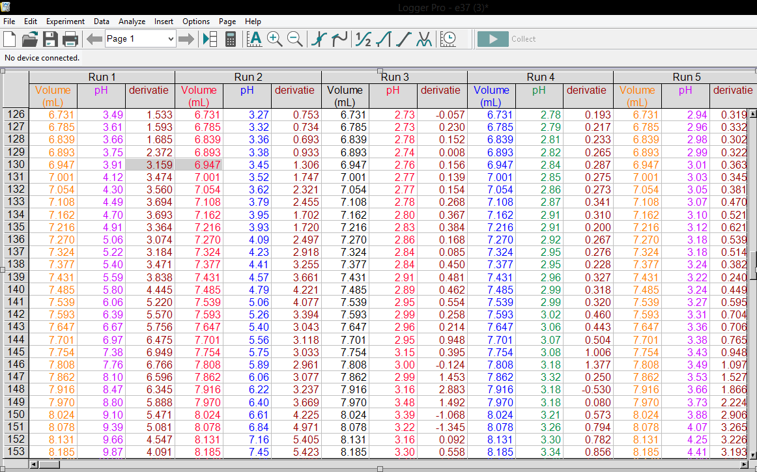
Partial representation of the data collected in the standardization of a dilute NaOH solution using 0.100mol/L HCl:
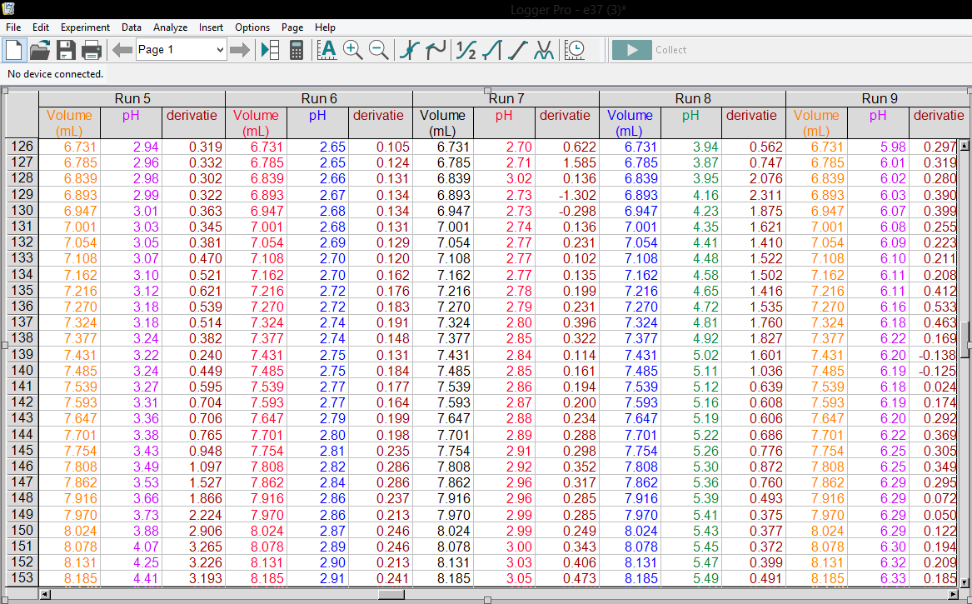

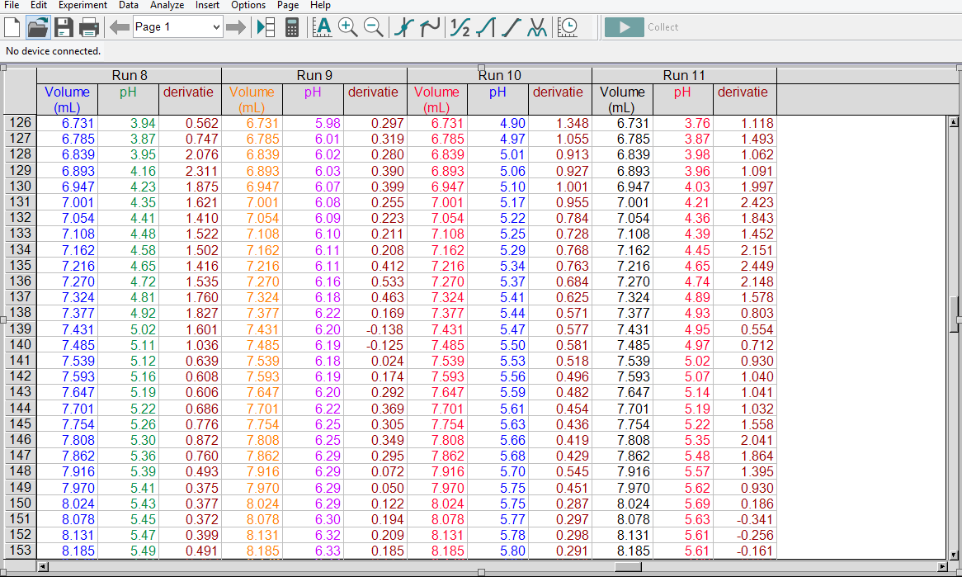

Observations:
There were 2 significant observations spotted. Firstly, when determining the concentration of the NaOH solution and titration of an unknown acid solution in both experiments the solution changed colour from colourless to pink indicating that the solution was acidic and has been neutralized by the base reaching to the end point. Secondly, during the titration of an unknown acid solution the end point took longer to reach which could be due to the diprotic nature of the acid.
Calculation:
Approximate concentration of NaOH solution:
c₁V₁ = c₂V₂
6*5=C₂*255
C₂= 0.1 mol/mL (to 1 dp)
Exact concentration of NaOH solution:
NaOH +HCl NaCl+H₂O

Trial 4:
c_{base}*V_{base}= b/c(c_{acid}*V_{acid})
c_{base} = (0.1*10.1)/9.532
=0.1 mol/mL (to 1 dp)

Trial 5:
c_{base}*V_{base}= b/c(c_{acid}*V_{acid})
c_{base} = (0.1*10.1)/9.155
=0.1mol/mL (to 1 dp)

Trial 6:
c_{base}*V_{base}= b/c(c_{acid}*V_{acid})
c_{base}= (0.1*10)/10.66
=0.09 mol/mL (to 1dp)

Average:
= (0.1+0.1+0.09)/3
=0.1 mol/mL (to 1dp)

Concentration of unknown acid:
H₂A+2NaOH Na₂A+2H₂O

Trial 1
c_{base}*V_{base}= b/c(c_{acid}*V_{acid})
c_{acid}=0.1*15.4/2*10.05
=12.6 mol/mL (to 1 dp)

Trial 2
c_{base}*V_{base}= b/c(c_{acid}*V_{acid})
c_{acid}=0.1*11.63/2*10.1
=16.8 mol/mL (to 1 dp)

Trial 3
c_{base}*V_{base}= b/c(c_{acid}*V_{acid})
c_{acid}=0.1*13.95/2*10
=13.9 mol/mL (to 1 dp)

Average
= (12.6+16.8+13.9)/3
=14.3 mol/mL (to 1dp)

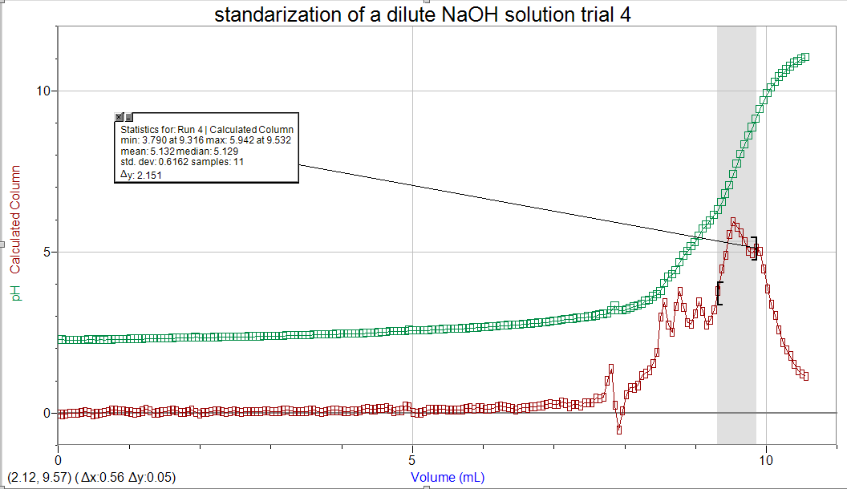
Graphs

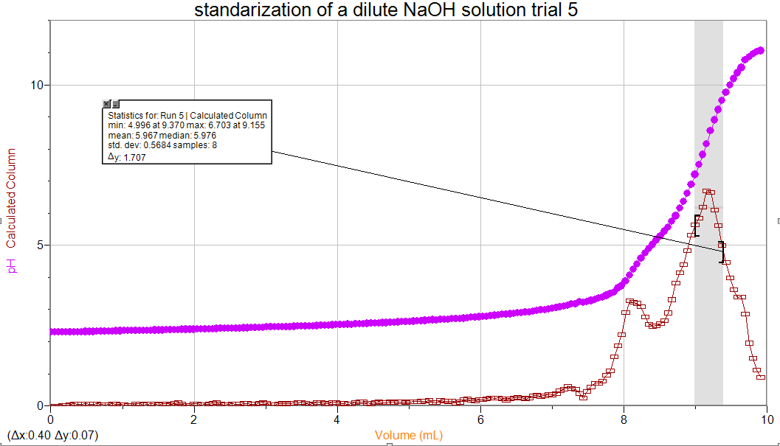
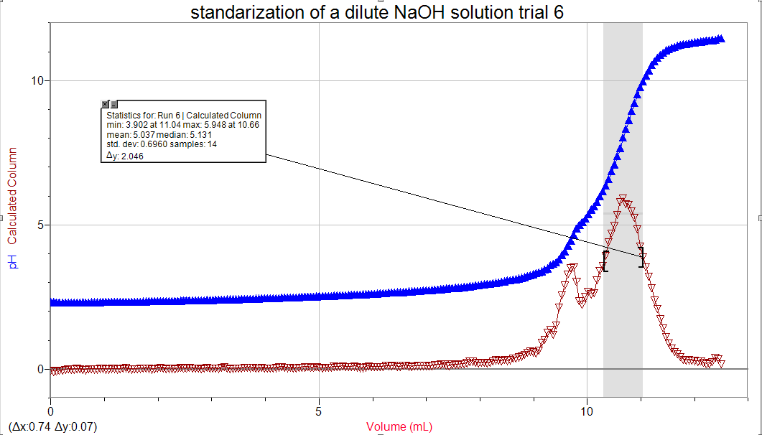

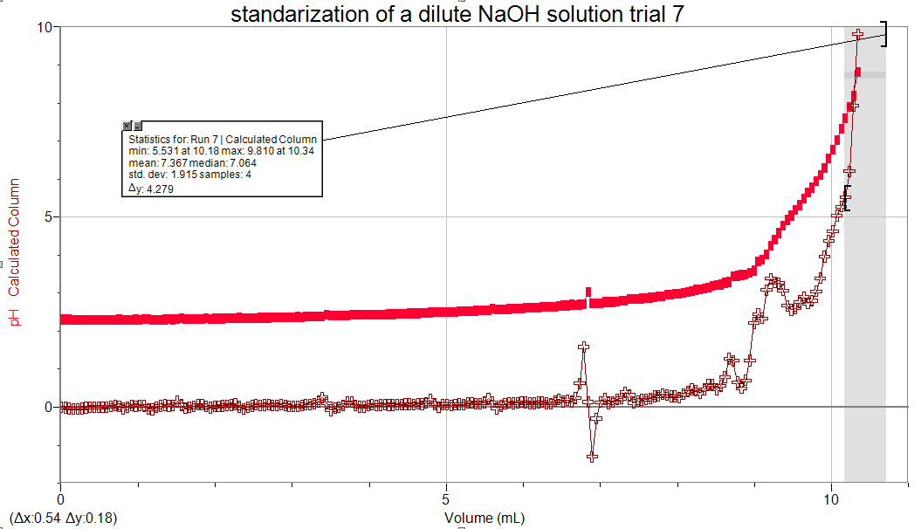
(Bonus graph)
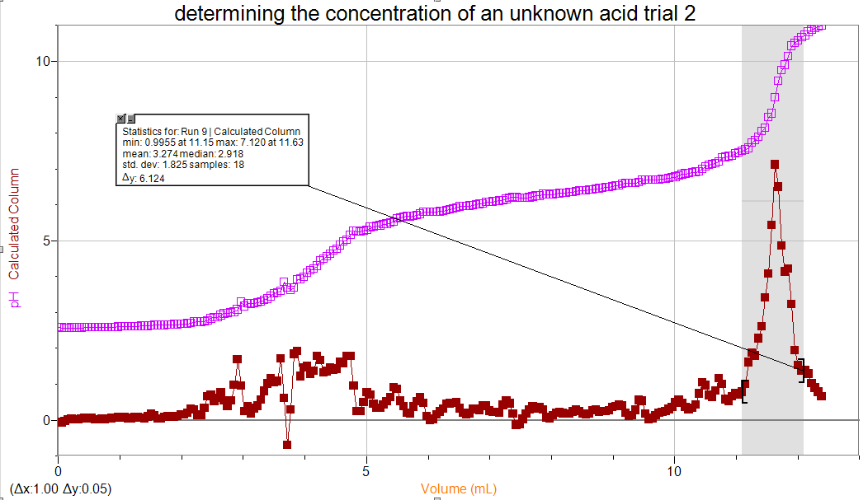
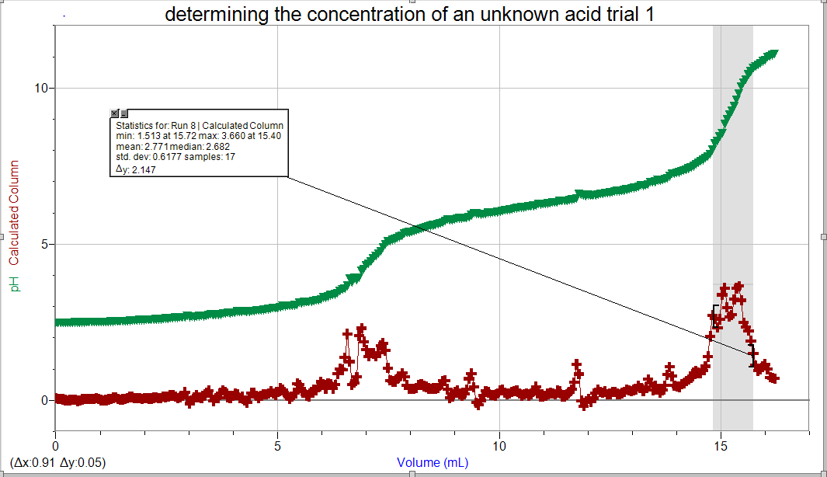

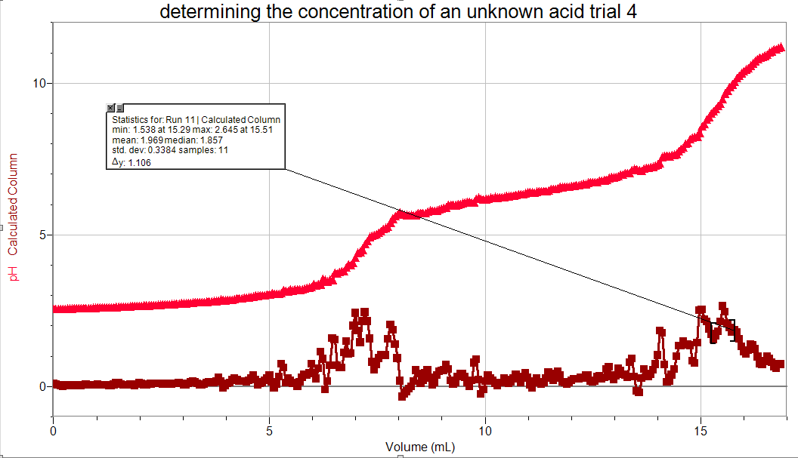
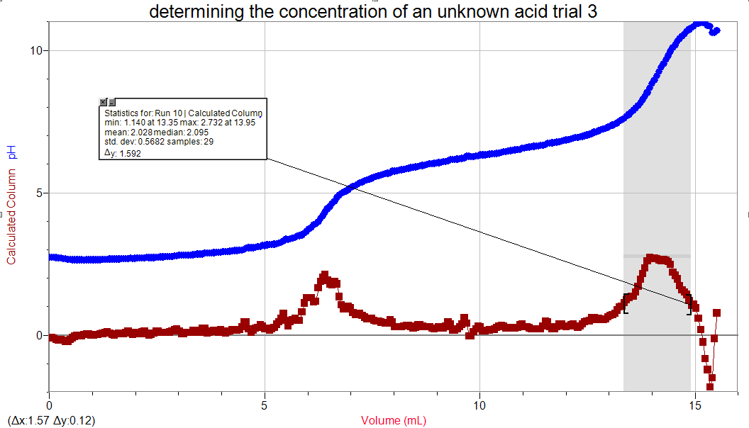
Discussion:
(Bonus graph)

The volume of concentrated NaOH used in the beginning matters as a higher volume of concentrated NaOH would produce a larger concentration of diluted NaOH. In result, the concentration of NaOH was determined before dilution. In addition, to be able to calculate the concentration of NaOH after dilution which standardizes the solution to keep the concentration the same throughout the experiment as it’s the control variable in the titration. The volumes observed at the colour change were lower than the volumes of logger pro this could be due to the errors associated with this experiment. They are mainly the human errors when observing the colour change and recording the time as there could have been a reaction delay as well the volumes fluctuating quickly on LabQuest2 which could have increased the volume therefore increasing the concentration. As well as the volume noted is the end point which isn’t exactly the equivalence point this could increase the concentration value.
“Equivalence point, also called stoichiometric point, in a nutshell, is a point where the moles of the two solutions, acid and base, are equivalent or equal. The stage occurs before the endpoint, which signals the completion of the reaction” (Differencebetween.net, 2018)
Secondly, the drop counter wasn’t accurate and could have missed some drops this would decrease the volume intern decrease the concentration.
In the titration of unknown acid, it is expected that at 0ml of base will produce a solution only contain the diprotic acid H2A as no reaction would occur. At midway to the 1st equivalence point, the solution is expected to have Na and H₂O where no H+ ions reacted yet. At the 1st equivalence point, there would be NaA and H₂O in the solution as the first H+ ion reacted corresponding to the first peak seen on the graph. At midway to the 2nd equivalence point, NaA would be still present but with 2H₂O species would form. At the 2nd equivalence point, 2 H+ ions are reacted and the species in the solution would finally be Na₂A and 2H₂O corresponding to the second peak shown on the graph.
Conclusion:
Both experiments were successful, where the NaOH solution was standardized and the exact concentration of the NaOH solution was determined to be 0.1 mol/mL. In addition, the concentration of the unknown diprotic acid was also found to be 14.3 mol/mL.
Bibliography:
Chemistry LibreTexts. (2018). Acid-Base Titrations. [online] Available at: https://chem.libretexts.org/Demos%2C_Techniques%2C_and_Experiments/General_Lab_Techniques/Titration/Acid-Base_Titrations [Accessed 13 Nov. 2018].
Differencebetween.net. (2018). Difference Between Endpoint and Equivalence Point | Difference Between. [online] Available at: http://www.differencebetween.net/science/difference-between-endpoint-and-equivalence-point/ [Accessed 13 Nov. 2018].

