HROB* 2010 Brooke Corradetti

PLP 1-Leadership Learning Objectives (Part 1)

- Self-Assessment—Attached in dropbox.

Strongest Assets

The Qualities of Leadership
I know myself, my values and skills, my strengths and weaknesses
I possess high integrity and intellectual honesty.
I understand the nature of power, I exercise and respect power

The Skills of Leadership
I listen actively to colleagues and those with whom I work; I hear their words and their feelings

I elicit information and ideas by asking open-ended questions
I help groups maintain discipline and direction toward achievement, while suggesting ways in which all members of a group can participate.

Task Accomplishment Skills
I coordinate ideas, activities, relationships, making sense out of the piece
I evaluate progress, process and products, holding them up to comparison with standards or expectations
I analyze the idea, task or whole process, developing an understanding of each piece and its relationship to the whole

Assets that need to be improved

The Qualities of Leadership
I call my group, community or organization to act out of values that transcend the day-to-day, business-as-usually, garden-variety norms of operation

The Skills of Leadership
I maintain an open, warm relationship with others, encouraging them with praise and genuine respect of their views and feelings

Task Accomplishment Skills
I elaborate on ideas, using examples and definitions

- Understanding of Leadership
When it comes to understanding leadership, I believe that leadership is where a person influences others in order to accomplish a certain objective in mind and directs that objective in an organized fashionable way, so others can follow the same lead, mainly trying to achieve a common goal.
- Leadership Learning Objectives
Throughout the course I hope to gain knowledgeable insight on three main objectives involving:

1.Communication
What needs to be done and why it matters that it is done. Effectively communicating and staying in touch constantly with the updates and plans so no one is left out and everyone is on the same page.

2.Organizations core value
Align decisions and actions based on the organizations specific values and goals in mind. Making sure that everyone has the same goals in mind and is on the same page, with the same values in the future.

3.Influential, effective and motivated
Maintaining an effective motivated team is key to success, while being a very influential figure to those looking up to you. By having a successful team, you are setting yourself up for success. Always staying motivated is a positive so that the team does not fall apart.

- Intended Learning
I personally believe that my intended learning will be significant for my personal growth and development because it will allow myself to become a stronger more effective leader for my future roles in the employment world. Without this knowledge that the course will teach me, I feel as if I would not be able to apply as much to the role of HR that I hope to have within the next few years.

- Future Endeavours
I expect to apply or anticipate applying this learning I will be taught throughout the course to my future endeavours, because once I am finished my undergrad at the University of Guelph I hope to further extend my education into a college diploma. I hope to get into for Human Resource Management and Marketing. So, by taking this course it will help me further understand how to work better with coworkers and in group settings, ending with a result of me benefiting highly in the workforce involved with dealing with others issues and concerns.

PLP 2- Reflections on Leadership

- Brooke- My manager at my current job
My manager has made me into the employee I am today, by motivating me and pushing me to exceed in my fullest potential. Always teaching me and helping me grow as a server.
1. Patience (M)
2. Caring (L)- “Hands”
3. Understanding (L)- “Hands”
4. Good with time management and communication (M)

- John-My dad
My dad has significantly impacted my life by constantly being my rock and support system, whenever I have a problem or need guidance, he is the first person I turn to. I chose my dad because he always has the right answer to help me become the best version of myself.
1. Loving (L)-“Heart”
2. Patient (M)
3. Compassionate (L)- “Heart”
4. Dominant (M)
5. Confident (M)

- Bryce -my boyfriend
My boyfriend has significantly impacted my life in the past few months by always listening and being there for me when I need him the most. He is always pushing me to do the right thing. Some days when I have no motivation to go to work or to get work done he is always there to remind me what will come out of it.
1. Patient (M)
2. Caring (L)- “Heart”
3. Provides stability (M)
4. Reliable support system (L)-“Heart”

My total list is predominately categorized by Heart. This tells me that I need heart and people who I have a close relationship with, and respect in order to be fully motivated and empowered. By having such supportive and loving people close to me helps me succeed further, compared to someone who I have no relationship with.

PLP 3- Leadership Traits and Skills

After doing the Leadership Trait Questionnaire and the Skills Inventory (posted below) I concluded that the significance of the skills inventory was too identify what your strongest skills are and what maybe needs some improvement. It is a way to help you realize where you are the strongest and weaknesses regarding your skills in leadership roles. By seeing the results, it provides a better understanding of where you need to improve, and where you are comfortable. For me, it was interesting to sit there and actually think hard about these things, determine where I excel and where I lack skills. For example, one of the skills I believe are very true is that I am good at completing the things I’ve been assigned to do. If I am assigned something and have a time frame, I almost never miss that time frame, time management is important to me. As well, I understand how to do the basic things required of me, which I think everyone should have this skill. There is a difference though between being able to do the basic things, and being told something basic and finding a way to advance that request.

In regard to the leadership trait questionnaire, I asked one of my roommates to complete this questionnaire and really reflect on how strongly she agrees or disagrees with characteristics of leadership. Majority of her answers were between agree and strongly agree. Thus, indicating she agrees with the fourteen characteristics of leadership. She strongly agreed with the persistent, friendly and diligent characteristics. Comparing her answers to mine, after I completed the questionnaire, I strongly agreed with the persistent, conscientious and dependable. Although, when I did the questionnaire my areas where I can apply the application of learning were in sensitive and self-assured. Those two traits I can definitely improve in and work on.

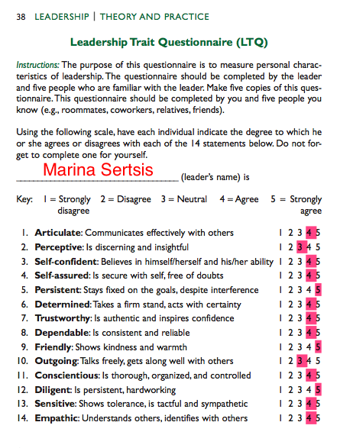
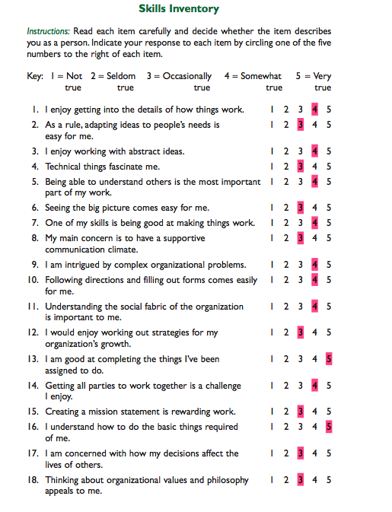
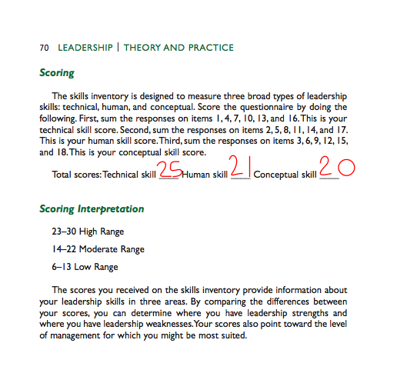

PLP 4- Leadership Styles and Approaches

Total Scores:

Task: 36- Moderately high range
Relationship: 44- High range relationship

After taking this survey, it was concluded that through my relationships with groups, I have a high range relationship with taking in the measure of the degree to which I try to make subordinates feel comfortable with themselves, each other and the group itself. I have a high range when it comes to how oriented I am with people. Moreover, when it comes to the task portion, I have a moderately high range when it comes to being task directed towards others when I am in a leadership position.
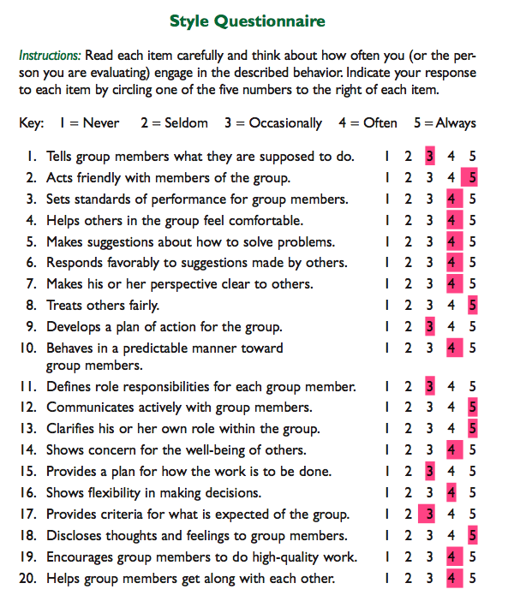

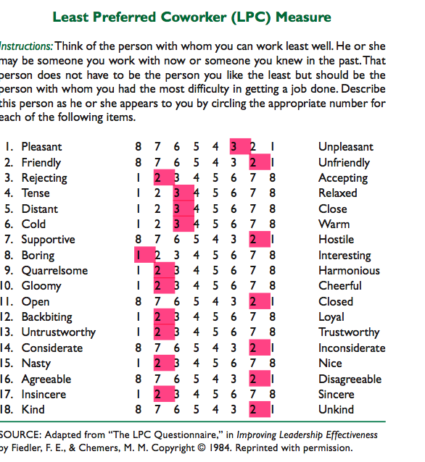

LPC score final: 39

Low LPC
this suggests that I am indeed task motivated.

Through analyzing both of these surveys, it has allowed me the opportunity to reflect on certain situations where I interact with people daily, even those that may not be the easiest to work with.

PLP 5-Special Skills
Throughout my working career, I have encountered many leadership positions, including working in dynamin teams to complete tasks effectively. It is significant in many jobs to have a solid team that you can rely on and look up to for guidance.
A few of the skills I will be reflecting on will be my skills involving my fitness personal training certificate and what I have acquired being a server/bartender in many restaurants. By having my personal training certificate, I believe that I am showing leadership in achieving fitness goals and aspirations. Although right now I am not currently training anyone, I have in the past helped a few customers achieve personal goals. At that time, I was someone for them to look up to and turn to for guidance. As well, reflecting on skills I have acquired with being a server and bartender, I have been able to master working under pressure and working in small teams during stressful situations. Being one of the senior bartenders/servers at my current job now, I have also taken on the leadership role by training new staff and portraying what I have learned and experienced over the years. I have become someone at my job now that the new staff turns to and looks up to when they need help, being a busy restaurant that gets a few rushes throughout the day, it is important for new staff to have a leader to look up to and feel comfortable turning to. I believe that I am an easily approachable model.
Although, while going through the PLP it has helped me realize and notice aspects where I can improve with being a leader. I would like to believe that I am mostly relationship motivated throughout my leadership style, benefiting by becoming a more balanced leader. I wish to become more of a reliable leader as a I grow, I can only go up from here and it is important for me to take all criticism so that I can develop more. I enjoy all criticisms and reflecting on how I can improve for future positions.

PLP 6- Addressing Task and or Relationship

Having balance and a relationship in the leadership role are two very important qualities to have when it comes to leadership. Sometimes it is hard to achieve both of these, depending on the situation. Relating to my current job now as a server, I believe that it is important to find a balance between the two, by being task oriented it helps get the job done in a timelier matter without fooling around or being distracted. While on the other hand, the relationship aspect can help improve the overall environment you work in. Having a good relationship with your coworkers and superiors is important in succeeding further. I do try to focus on both at the same time while I am working, in certain situations with certain customers it is more important to have a relationship role over a task role, because it is easier to relate with them. For example, I have many regular customers at my job, so when they come in, I treat them differently than I would treat the university president. The president is someone superior who deserves more of a task approach. While, my regular customers prefer a more relationship approach, they want to know about my day, and new things going on, whereas the president comes in and wants proper service, food and to leave satisfied.

PLP 7- Leadership Mission Statement

Statement

My purpose in this life is to achieve my goals to the best ability I can. I am here to provide positivity and spread my creativity. Being thankful for everything I receive and come across in my daily life is important. Living in the present and not dwelling on the past is something that I try to practice. Constantly living in the moment, and having a bright smile on my face. Living my best life, every minute of every day. Learning from my mistakes and growing as an individual. Persevering through the hard times and only reflecting on the good. Forgiving yourself for the times where you might have made mistakes, making the best of the worst situations. Helping the less fortunate, being thankful for what the world has to offer, taking the world head on. Live the life you dreamed of since being a little girl. Be the princess you always wanted to be, and never let anyone take your tiara off. You are your own person and have the power to dictate the best version of yourself.

Discussion

While writing this mission statement, it took me a lot of time to think about what I exactly wanted to say and portray. Being positive throughout my daily life is very important to me and it is hard to become negative in certain situations, so I wanted to include this in my mission statement. By having a mission statement that includes a lot of positivity and making the best of your life, will definitely be helpful in stressful situations when I forget to be thankful for everything else. In my statement, I mention the word positivity a lot because that is something very important to me, I try my best to remain positive even in the worst situations. By looking at negatives all the time won’t help you better yourself, and you are only given one life, one chance to make the best of what you were given, all those skills and qualities. This mission statement reflects on the fact that even though you may have a million things going on wrong in your life, it is important for yourself to stay positive and upbeat. As cliché as it may count, living life in the moment is the best way for a happy successful life, I can definitely account for not always living life in the moment, I think a lot about the future and try to control it. As much as you try, you can’t control what the future will hold, you can only do your best in the present and let fate take the rest.

PLP 8- Personal Values and Beliefs

Values

Success, Love, Family, Happiness, Power, Truth, Friendship, Influence, Wealth, Justice

Reflection

The top 5 beliefs and values that are left remaining on my list include success, love, family, happiness and truth. These 5 beliefs and values are more internal factors in comparison to the ones I crossed out being more external and relating more to signs of status, more materialistic beliefs. I am the least concerned with wealth in comparison to my success with love and family and overall happiness. My family right now is one of the most important things in my life, I wouldn’t be the person I am today without them, they are the reason for my happiness and the constant love I am filled with every day. Being successful is also something that is very important, everyone wants to be successful and have tons of money but honestly that’s not what success means to me. To me success is being able to satisfy yourself and everyone important to you, I feel successful when my boyfriend, friends and family are all satisfied, I feel successful when I know I have done everything I can to make someone happy and content. Success doesn’t always involve money. Truth is another important belief to me because being a trustworthy individual is a very important quality and trait to have. A liar will get nowhere, being truthful with yourself and others is prominent in future success. All of these traits come back and relate with each other, you get love and happiness out of family. Success out of happiness and truth.

While reflecting and focusing on my personal values/beliefs I believe that they have all impacted my leadership in the past and even the future. Happiness is something I come across every day at work, it is a simple compliment that can create the belief of happiness. When someone acknowledges that you have done a good job it reflects on your happiness. Throughout doing this assignment, I have realized that happiness is something I want in my future workplace, being in a positive happy environment every day is important, and realizing how I can facilitate a happy environment for others as well.

As mentioned before, family and love is a very important quality for a person to value. Family and love can also be in relation to leadership, in leadership roles having a love for what you are doing and a love for the job is important in order to be a successful devoted leader. As well, honesty and trust are very prominent in leadership roles. You need to be able to trust a leader and be positive that they are honest people.

Being aware that there is room for personal growth and the application of learning is something that should be taken into consideration as well. You can always learn and grow as a leader and as a person. Realizing where you need to improve and how you can achieve that is one of the things that makes for a good leader. Everyone makes mistakes, it’s how you take those mistakes and learn from them. Personally, I believe that I can grow on my success by dedicating more time to the things that are important to me. I do not see my family as much as I used to due to school and work, I need to realize that I have to make time for them and money isn’t what makes me happy, it’s my family.

PLP 9- My Leadership Vision

Throughout this portion of my PLP I will be reflecting on my leadership vision and answering a few questions in order to reflect on my vision as a leader and what I want to accomplish and create as a leader.
- Who am I as a leader?
As a leader, my goal is to be well balanced. I believe I can achieve that by following 3 simple things.
  - 1. Someone who is able to motivate my team on both a personal and professional level.
  - 2. Able to stay on track with my morals and ethics, not letting others/things affect me
  - 3. Making sure my surroundings are in a safe and productive work environment.
- Who do I want to be as a leader in the long term?
I would like to be a strong dependent leader that many people admire and look up to, a strong base for others to turn to in difficult situations. I would like to be a team leader, someone who works with a team and doesn’t rely on others to get my jobs done. I want to grow with my team and come out with solutions together.
- What do I do as a leader?
As a leader, I believe I am very honest, I will tell you how I feel, how I would do something, what I want done. I am a very open person that way. If I think you are doing something wrong I will be the first to tell you, not just to criticize you but rather to help you find a solution to fix it. I am also a reliable leader, I am where I need to be, when I need to be and will go the extra mile if needed be.
- What guides my actions as a leader?
Something that particularly guides my actions as a leader is my dedication and motivation and ability to apply myself to certain situations. I am able to adjust myself to be the appropriate leader at the time needed. Having motivation is important, you cannot lead a group without being the most motivated member. It is your group and responsibility to set the standard and the bar high for dedication and motivation.
- Where am I headed, as a leader?
Currently, in my life I am unsure of where I want to be headed career wise, so in order to say where I am headed as a leader is hard. I hope that after I am finished my degree in university and go to college for marketing, that I secure a job in a well-rounded company working alongside a strong group of employees. I hope to be the best leader I can be and set a good example for those who have to look up to me.
- What is my role as a leader?
My role as a leader is to be a team leader. Someone who is responsible for guiding a group of individuals or employees to complete a specific task or project. My role is to assign certain tasks and ensure their goals are reached.
- What do my followers expect of me?
As a leader, I believe my followers expect me to be reliable, and driven. I should have a desire to want to inspire and teach, and lead my members down the right path. They need someone who is reliable to be able to look up to and follow.
- What are the outcomes I will strive for as a leader?
The outcomes I strive for as a leader is to be respected. I will strive for my followers to have respect for me, as I will return the same respect. No one wants a leader who thinks they are better than everyone else and has superior power. I will strive for personal relationships with my followers and help them achieve and conquer goals. We are a team and I will make that my priority as a leader to ensure we stay that way.

PLP 10- Ethics

Part I

After working in the restaurant business for over 6 years now, it has become a second nature to me dealing with difficult customers. As a waitress, you are taught and trained to treat everyone with equal respect and dignity, even those who may not give that same respect back to you. Now just think back to the show with Gordon Ramsey and how the chefs act. I can remember when it was my first time serving, and I was working in this very busy restaurant, that was very high paced. The chef started screaming at me to get out of the way, and I have never been so shocked that an employee would talk to another employee like that. Although, sadly if this is brought up too many managers or higher authority tell you to turn a blind eye at the situation and just carry on. Another situation in a restaurant I worked at was one of my friends having a really tough day and she of course being so unlucky that day became the one-person kitchen wanted to pick on, leaving her in shambles. I decided to take matters into my own hands this day, because I knew what she was going through and it just wasn’t fair. Sometimes it is all fun and games but they just took it to far that day. I told one of the kitchen guys to take it easy and leave her alone and he responded that he didn’t care and if she couldn’t take it to leave. This response was not what I wanted to hear and it did not sit well with me, so I brought it to the attention of the manager. I was motivated to act on this because it is not fair for them to play the tough boy act and think they have superior power. I believe that I reacted properly in this situation, however the kitchen’s unwillingness to listen made it a less than ideal situation. An ideal situation would have been him listening and acknowledging what had happened was wrong, and then going up to her and simply apologizing for not knowing what was going on with her day.

Part II

Thinking about a time that I was at my job and my values were conflicted with what I was expected to do in a particular, non-trivial decision and I did not speak up or act to resolve the conflict was when I saw one of my fellow employees stealing from the cash register during a wedding bar shift we had to do. She was under pouring alcohol and charging more, so then at the end she was making more tips. She had been there 3 years longer than for me, so it was a very uncomfortable situation for me to stand up and say something. I had just started at this job, and was still the “newbie”. No one likes when the newbie tattle’s, and I definitely did not want to be known as that person. So as the night went on, I continued to let it happen without saying anything and she walked out with a lot of extra money that night. The reason why I didn’t speak up is that I was ultimately scared to confront her, because of her age and her being more superior than I was. What would have motivated me to say something would have been confidence and knowing it was the right thing. I didn’t have much experience in the industry back then. I would have liked to stand up to her right then and there, but unfortunately that wasn’t the case. The ideal situation would have been if someone else was working with us that night and I could have asked for their opinion as well.

PLP 11- Gender and Leadership

Trial 1 (23 Seconds)
Male or Leader |  | Female or Supporter
 | Emily | x
x | Josh
 | Supporter | x
x | Leader
x | Brandon
x | Ambitious
x | Peter
x | Determined
 | Donna | x
 | Debbie | x
 | Helpful | x
x | Dynamic
 | Understanding | x
 | Katherine | x
x | Ian
 | Sympathetic | x
 | Compassionate | x
 | Jane | x
x | Andrew
x | Assertive

Trial 2 (27Seconds)
Male or Supporter |  | Female or leader
 | Emily | x
x | Josh
x | Supporter
 | Leader | x
x | Brandon
x | Ambitious
x | Peter
 | Determined | x
 | Donna | x
 | Debbie | x
x | Helpful
x | Dynamic
x | Understanding
 | Katherine | x
x | Ian
x | Sympathetic
x | Compassionate
 | Jane | x
x | Andrew
 | Assertive | x

After completing both of the IAT test, it was interesting to come across how the test was made in order to determine and validate the associations of words, whether or not they are in a conscious association or not. The test was meant to show that people may be prone to holding a certain association and be totally unaware of the stereotype. The first test was rather easy, I felt that I completed it quickly and got all of the checks in the right boxes. However, when I was completing the second test I found it more difficult and that it took me a longer time. As a female myself, I was leaning more towards the female leadership, but although on a few because I was rushed, I would associate things like “ambitious” with the male. Thus, proving exactly what the test wanted, people are often blind to associating leadership qualities more with males.

I do not believe that this test is accurate and reflects my gender associations. I come from a strong independent family, where all the women are hardworking and motivated. Just because I may have chosen a male for ambitious, does not take away from the fact I believe women are highly ambitious and devoted. My mother has always taught me to be my own person and stand for what I believe in. She is a female CEO of a company and has inspired me to one day be as strong and devoted as she is. I also believe that I was very non-bias in this survey. Just because I am a female, does not mean I chose a female for all of them, I know when a male is stronger in something than when a female is, vice a versa.

PLP 12- Revisiting Leadership Learning Objectives (Part II)

Throughout the course of the semester, I have learned a lot about theories and practices involved with leadership. I learned a lot about myself as a leader and how to simply identify myself as a leader. The weekly quizzes and assignments kept me up to date with the textbook. As well, this course has helped me with my goals and being able to set goals out and the proper ways to improve on them. At the beginning of the semester, I was really unsure about this case and thought it had no benefit for me at all, but that has tremendously changed. I loved every minute of this course, and have definitely seen my progress excel throughout the course. As well, the self-assessments were a perfect way for me to reflect and personally think on myself as a leader and how I can improve/ be a positive example to those around me.

The leadership learning objectives that I set out at the beginning of the semester in hopes to improve on were;

` 1. The Qualities of Leadership
I call my group, community or organization to act out of values that transcend the day-to-day, business-as-usually, garden-variety norms of operation

2.The Skills of Leadership
I maintain an open, warm relationship with others, encouraging them with praise and genuine respect of their views and feelings

3.Task Accomplishment Skills
I elaborate on ideas, using examples and definitions

The first thing I wanted to improve on was my qualities of leadership and the skills of leadership, by maintaining a warm relationship with others, encouraging them. Throughout this course, I have learned ways to do this, and what ways don’t work. In the textbook, we had to read scenarios at certain jobs and situations and that was very eye opening and taught me a lot. Another learning objective I had was the task accomplishment skills, simply just wanting to be task oriented and being able to elaborate on ideas, coming to my group with all the information so if they have questions I am there to help. I know that I struggle with communication sometimes and ideas. So, by this semester, having the group project it was very crucial for me. I learned how to cope and communicate my ideas better, we met a few times in person and got along very well. I did not expect this, and was pleasantly surprised with how it all turned out in the end. This semester, with a combination of the assignment and both my serving jobs I was able to become better at formulating and communicating how I felt about things, and things that could be changed for the better. I have grown as a leader and an employee because of this course and this course will forever help me improve with becoming a leader.

Identify and briefly describe your future learning goals surrounding Leadership.

My future learning goals surrounding leadership are to simply be the best leader I can be. I know that is very vague and cliché, but it’s true. I have learned many things in the course but the main thing I took from this is that, you need to be yourself and personal, honest. Be yourself, and be the best you can, and people will notice and respect you for that.

