OB Midterm Study Notes

Lecture 1: Introduction to Organizational Theory – Chapter 1

An Organization is…
- A social entity
- That is goal directed
- And deliberately structured and coordinated
- And linked to the environment
Theory: “sphere of abstract knowledge,” ideas about what something is and how it works
Organizational Theory: ideas about what organizations are and how they work

Systems Thinking – Closed vs. Open
Closed: environment is assumed to be stable, focus is on internal efficiency
Open: must interact with (and adapt to) environment

Mintzberg’s 5 Organizational Parts

Structural Dimensions: describe the internal characteristics of an organization
- Formalization – written documentation
- Specialization – job scope
- Hierarchy of authority – reporting relationships span of control
- Centralization – location of authority for decisions
- Professionalism – education/training
- Personnel ratios – number (percentage) of employees in certain classifications

Contextual Dimensions: characterized the whole organization and elements of the environment

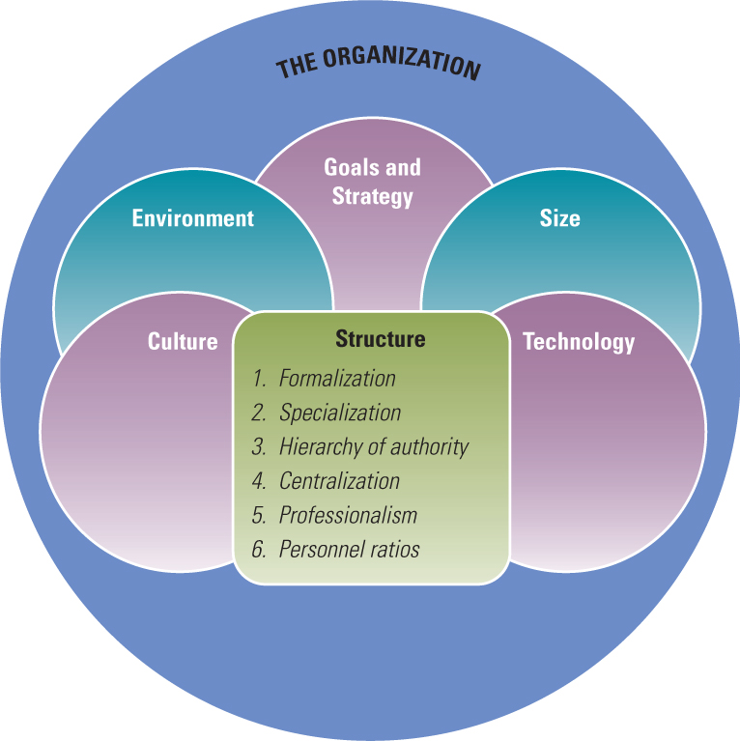
Efficiency vs. | Learning
- Vertical, functional groupings  - Tasks are routine, narrow  - Formal control systems to manage complicated info  - Top management strategy is competitive  - Culture may become rigid from being successful in a stable environment | - Structured around horizontal workflows  - Empowered roles  - Widespread sharing of info / open channels  - Collaborative strategy based on relationships  - Culture adaptive to external environment

Lecture 2: Organizational Design and Effectiveness – Chapter 2 (70-80)

Organizational Goals: represent the reason for organization’s existence and outcomes it seeks to achieve
Organizational Effectiveness: the degree to which an organization realizes its goals
Efficiency: more limited concept, the amount of resources used to produce a unit of output
(i.e. the ratio of inputs to outputs)

Efficiency vs. Effectiveness
Efficiency: doing things right (the first time)
Effectiveness: doing the right thing

Assessing Effectiveness – Models
- Contingency Perspective: maps on to open system model of organizations, assumes a focus on only one of these approaches (unrealistic), this model can be applied to organizational sub-units (departments, teams) and processes (projects, etc.)

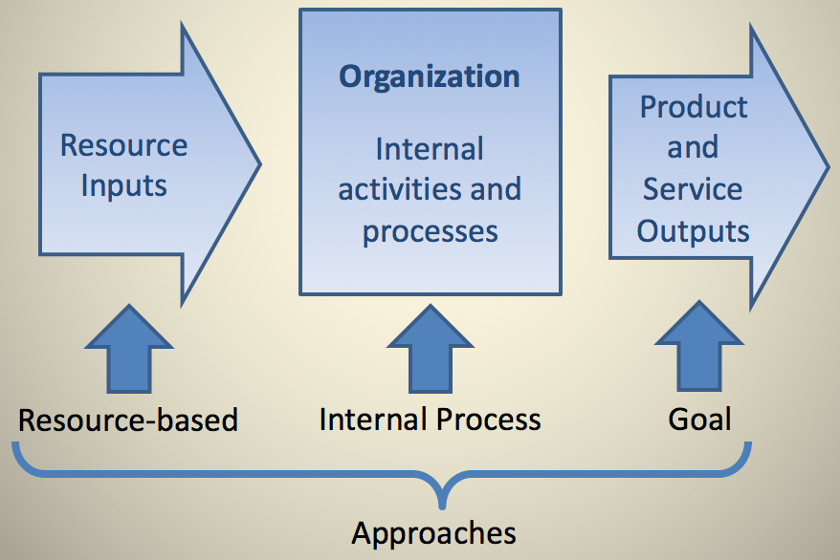

- Resource-Based Approach: ability of the organization in either absolute/relative terms, to obtain scarce/valuable resources and successfully integrate and manage them. Assessing effectiveness by observing the beginning of the process and evaluating whether the organization effectively obtains resources necessary for high performance.
Indicators:
- Understanding of external environment: ability of the firm’s decision makers to perceive/interpret real properties of the external environment
- Use of resources to achieve superior performance
- Organization responds to environment: ability to respond to changes in the environment

- Internal Process – Based (strong HR focus – as opposed to others): Looks at internal activities and assesses effectiveness by indicators of internal health and efficiency.
Indicators:
- Strong organizational culture/positive work climate
- team spirit, group loyalty, teamwork
- confidence/trust/communication between workers and management
- undistorted vertical/horizontal communication/sharing of relevant facts and feelings
- interaction between the organization and its parts, with conflict that occurs over projects resolved in the interest of the organization

- Goal – Based: measured by performance and output. Whether the organization achieves its goals in terms of desired level of output.
Indicators:
- Performance assessed against organizational/operative goals (activities performed). Identifies the organization’s output goals and assesses how well it has attained those goals.

- Competing Values Model: tries to balance a concern with various parts of the organization rather than one – based on the assumption that there are disagreements and competing viewpoints about what constitutes effectives within an organization.

4 Approaches to Effectiveness Values
- Balanced Scorecard: comprehensive management control system that balances traditional financial measures with operational measures relating to an organizations critical success factors. 4 major perspectives:
- Financial Performance: reflects a concern that the firm’s activities contribute to improving short and long term financial performance
- Customer Service Indicators: how consumers view the firm, customer retention and satisfaction
- Business Process Indicators: focus on production and operating statistics
- Potential for Learning and Growth: how well resources and human capital are being managed for the company’s future

Integrated Reporting: focus on sustainability, CSR – integrated report on variety of measures

Choosing Effectiveness Indicators – many possibilities
-company goals
-stakeholder goals
-contingency perspective approaches
-values in the competing values model

How should (or how will) and organization decide what to measure?
Organizations should assess effectiveness broadly, but typically whatever gets measured is what management believes is important/what management values, so what gets measured is what gets managed, which can mean that some things are overlooked.

Designing an Organization for Success
Principle of Fit: an organization is more likely to be effective when there is a good fit between the organization and its environment and within organizational elements. (Goals and strategy should be a good fit with the environment. Organization’s design (structure/climate) should fit with the goals and strategy)

Lecture 3: Analyzing the External Environment – Chapter 4 (138-151)

Relationship between business, society and nature – three possible views in conceptualizing these relationships.
- Disparate View: business is the highest priority, s and n considered if aligns with B’s interests. Environmental Scan: perceive narrow range of issues.
- Intertwined View: B,S, and N are equally important and interconnected. See multiple connected and conflicting issues between B,S, and N.
Environmental Scan: attend to broad variety of issues.
- Embedded View: nature takes priority, followed by society and last business. Business is nested within society, which is nested within nature.
Environmental Scan: to broad variety of issues.

Organizational Environment: all elements that exist outside the boundary of the organization that have the potential to affect all of part of the organization

Domain: the chosen field of action – defines the firm’s niche and defines those external sectors with which they will interact to accomplish goals

Sectors: subdivisions of the external environment that contain similar elements. There are 10 sectors for each organization: industry sector, raw materials sector, HR sector, Financial Resources sector, Market sector, Technology sector, Economic Conditions sector, Government sector, Socio-Cultural sector, and the International sector.

Sectors can be further divided into the task environment and the general environment:
Task Environment: sectors with which the organization interacts directly and that have a direct impact on the firm’s ability to achieve its goals
General Environment: sectors that might not have a direct impact on the daily operations of a firm but will indirectly influence it
Task Environment
General Environment

Opportunities and Threats (swOT): Socio-Cultural, Government, Economic Conditions, Technology

PESTEL Analysis: Identifies the political (more general to political environment the business operates in), economic, socio-cultural, technological, environmental and legal (specific to individual business) factors that might affect the success of your business.

SWOT Analysis: tool to brainstorm strengths, weaknesses, opportunities or threats for an organization, a project a team, etc.
When to use: when developing a strategy, or other instance of decision making.
Why: get an overview of where you stand that allows you to create better strategies.
Note: SW are internal, OT are external.
Output: get insights into what differentiates your product, service or business
Steps:
- Consider the organization’s capabilities and resources – place them under with S or W. Strengths and weaknesses can be found in critical resources such as: financial, physical, intellectual, legal, human, organizational, relational, reputational, informational.
- Consult your PESTEL analysis – identify the factors likely to have effect on the firm.
- Examine each factor with each of the organization’s strengths and weaknesses and decide if the PESTEL factors is an opportunity or a threat.

Stakeholder Analysis: not every stakeholder needs/wants to same info. This matrix helps to manage the relation and needs to be done early.
Note: involve stakeholders.
Output: know how much time you need to invest in keeping stakeholders satisfied.
Next: make a communication schedule.
Steps:
- List all stakeholders (people & organizations who affect your business/are affected by your business)
- Identify their power and interest.
- Draw a matrix with 2 parameters, power and interest.
- Map the stakeholders on the matrix depending on their characteristics.

2 ways the environment influences organizations:
- The need for information about the environment
- The need for resources from the environment
Determining an organization’s environmental uncertainty generally means focussing on sectors of the task environment. (Dimension: stability/instability, degree of complexity)

Simple/Complex Dimension: refers to heterogeneity, or the number of dissimilarity of external elements relevant to organization’s operations

Stable/Unstable Dimension: whether environmental elements are dynamic

Lecture 4: Goals & Strategy (Organizational Design and Effectiveness) – Chapter 2 (50-70)

The primary responsibility of top management is to determine an organization’s goals, strategy, and design, therein adapting the organization to a changing environment.

The Purpose of Business: Business is a social invention. The purpose is whatever people decide it is. “Social constructionist perspective.”

Organizational Forms: (1) for-profit business, (2) Government, public sector, (3) non-profit, NGO, Civil Society
Co-operatives: internationally recognized business form.
Premise: owned/operated by and for members. Democratically controlled, one-member=one vote, regardless of business/investment done with co-op
Principles: (1) voluntary and open membership, (2) democratic member control, (3) member economic participation, (4) autonomy and independence, (5) education, training and information, (6) co-operation among co-operatives, (7) concern for community

Social Entrepreneurship: the application of entrepreneurial business skills to the creation of an enterprise whose primary purpose is to solve social and environmental problems. Social entrepreneurs are a mix of: (1) traditional business entrepreneurs: see and act upon what others miss – opportunity to create value. (2) Traditional social workers and environmentalists – understand and care about social justice and quality of life and conserving and improving the natural environment.

Benefit Corporations (B Corps): new class of corporation that voluntarily meets higher standards of corporate purpose, accountability and transparency. B Corps have a corporate purpose to material positive impact on society and the environment, (2) are required to consider the impact of their decisions not only on shareholders but also workers, community and the environment, and (3) are required to make available to the public an annual benefit report that assesses their overall social and environmental performance against a 3rd party standard. Becoming this gives entrepreneurs and investors an additional choice when determining which corporate form is most suitable to achieve their objectives.

CIC’s (community interest companies): new legal form of company 1st introduced in the UK in 2005. Corporations in BC or NS can become CCCs (in BC) or CICs (in NS).
Problem: regular limited liability companies, and their shareholders, who have a desire to work toward social good, may find it difficult to ensure that their assets are dedicated to public benefit. Requirements: community purpose, cap on ROI, restrictions on asset transfer, asset lock
NOTE: (in contrast to social enterprises and b corps), only corporations can become CICs

Top Management’s Role in Organizational Direction, Design and Effectiveness
Direction-Setting Process
- Assessment of “OT” (in SWOT) in environment, degree of change, uncertainty, and resource availability. Assessment of “SW” to define distinctive competence compared with other firms. (Based on past performance and leadership style)
- Define mission and goals to fit assessment
- Specific goals and strategies formed
- Evaluate effectiveness

Mission: purpose of the firm, overall goal; describes organization’s vision, its shared values/beliefs and reason for being.

Many types of goals exist in an organization and each performs a different function. 1 major distinction is between officially stated goals, or missions of the organization and the operative goals the organization pursues.

Official Goals: formally stated definition of business scope and outcomes organization is trying to achieve

An organization’s vision and mission are different.
Vision: captures the core ideology and the envisioned future for an organization
Mission Statement: communicates to current and prospective employees, customers, investors, suppliers and competitors what the organization stands for and what it is trying to achieve

Operative Goals: designate the ends sought through the actual operating procedures of the organization and explain what the organization is trying to do (short-term, primary tasks). Specific measurable outcomes. Quantify the official goals. (SMART goal-planning)
(e.g. overall performance reflected by profitability (net income, EPS, ROI) for for-profit firms)

Informal Goals: these goals are not written down but characteristic of the organization.
Resource Goals: pertain to the acquisition of need material and financial resources from the environment
Market Goals: market share/standing desired by the organization
Employee Development Goals: training, promotion, safety and growth of employees
Innovation Goals: pertain to internal flexibility and readiness to adapt to unexpected changes in the environment, often defined in terms of the development of specific new services, products or processes
Productivity Goals: the amount of output achieved from available resources, describe in terms of the amount of resource inputs required to reach desired outputs, “cost for a unit of production”

Goals: where the firm wants to go
Strategy: how it will get there

Porter’s Competitive Advantage

Miles and Snow Typology: based on the idea that managers seek to formulate strategies that will be congruent with the external environment (prospector, defender, analyzer, reactor)

- Prospector: strategy is to innovate, take risks, seek out new opportunities, and grow. This strategy is suited to a dynamic, growing environment, where creativity is more important than efficiency.

- Defender: strategy is almost the opposite of protector. Rather than taking risks and seeking out new opportunities, the defender strategy is concerned with stability. This strategy seeks to hold onto current customers, but it neither innovates nor seeks to grow. This can be successful when the organization exists in a declining industry or a stable environment.

- Analyzer: tries to maintain a stable business while innovating on the periphery. It seems to lie between prospector and defender. Some products will be targeted toward stable environments in which an efficient strategy designed to keep current customers is used. Others will be targeted toward new, more dynamic environments, where growth is possible.

- Reactor: strategy is not really a strategy. Rather, they respond to environmental threats and opportunities in an ad hoc fashion. In this strategy, top management has not defined a long-range plan or given the organization an explicit mission or goal, so the organization takes whatever action seems to meet immediate goals.

Lecture 5: Fundamentals of Organizational Structure – Chapter 3 (90-108), Chapter 8 (304-311)

Nearly every firm needs to undergo structural reorganization at some point to meet new challenges.

3 Components in the definition of Organizational Structure:
- Formal Reporting Relationships: Organizational structure designates formal reporting relationships, including the # of levels in the hierarchy and the span of control of managers and supervisors.
- Grouping: Organizational structure identifies the grouping together of individuals into departments and departments into the total organization.
- Systems Design: Organizational structure includes the design of systems to ensure effective communication, coordination, and integration of efforts across departments.

Organizational chart: visual representation of a whole set of underlying activities and processes in an organization at a point in time

Information Processing Perspective on Structure
If structure doesn’t fit the information requirements of the organization people will either have too little information or will spend time processing information not vital to their tasks.
Key Claim: the contingency perspective – based on the assumption that organizations are open systems

“The structure of an organization should match or fit characteristics of certain variables both inside and outside the organization system”

Assumption:
- Organizations create subunits to benefit from economies of scale and specialization
- Variables inside and outside the organization are uncertain
- Org structure should create configuration of subunits and the connection between them to effectively collect, process, and distribute information and manage the uncertainty.

Inter-unit task interdependence: the extent to which a subunit is dependent upon other subunits to perform effectively. The higher the more need for effective coordination and joint problem solving

Centralized Decision Making: problems/decisions are funnelled to top levels of the hierarchy for resolution
Decentralized Decision Making: authority is pushed to lower organizational levels

Managers are always searching for the best combination of vertical control and horizontal collaboration.

Linkage: the extent of communication and coordination among organizational elements

Vertical Linkages: used to coordinate activities between the top and bottom of the organization, and are primarily for control of the organization. Structural Devices used:
- Hierarchical Referral: (chain of command) if a problem arises that employees don’t know how to solve, it can be referred up to the next level. When the problem is solved, the answer is passed back down to lower levels.
- Rules and Plans: to the extent that problems and decisions are repetitious, a rule or procedure can be established so employees know how to respond. This provides a standard information source so employees can be coordinated without communicating.
- Vertical Information Systems: strategy for increasing vertical information capacity, includes periodic reports, written information and computer-based communication distributed to managers.

Horizontal Linkages: refers to the amount of communication and coordination horizontally across departments. (Often not drawn on the organizational chart). Structural Devices used:
- Information Systems: cross-functional information systems, computerized information systems. Used to share information across borders, and departments.
- Direct Contact: between managers or employees affected by a problem. One way to promote this is to create a special liaison role.
- Task Forces: temporary committee composed of representatives from each organizational unit affected by a problem, typically disbanded after the problem has been resolved. Solve problems using direct horizontal coordination and reduce the information load on the vertical hierarchy.
- Full-Time Integrator: position or department solely for coordination, does not report to 1 department but is located on the outside departments and has the responsibility for coordinating several departments. Can be responsible for an innovation or change project.
- Teams: strongest horizontal linkage mechanism. Permanent task forces, often used in conjunction with a full-time integrator. (cross-functional)

Departmental grouping affects employees because they share a common supervisor, are jointly responsible for performance and tend to identify/collaborate with one another.
Types of grouping (2 primary types):

- Functional: places employees who perform similar functions or work processes together and who have similar knowledge or skills
Strengths | Weaknesses
- Allows economies of scale within functional departments  - Enables in-depth knowledge and skill development  - Enables org. to accomplish functional goals  - Is best with 1 or few products | - Slow response time to environmental changes  - Leads to poor horizontal coordination among departments  - Results in less innovation  - Involves restricted view of organizational goals

- Divisional: people are organized per what the organization produces
Strengths | Weaknesses
- Suited to fast change in an unstable environment, flexible  - Involves high coordination across functions  - Allows units to adopt to differences in products, regions and customers  - Best in large firms with several products | - Eliminates economies of scale  - Leads to poor coordination across product lines  - Eliminates in-depth competence and technical specialization  - Makes integration and standardization across product lines difficult

- Multi-focused: organization embraces 2 structural grouping alternatives simultaneously, AKA Matrix design. (ex. group by function and product division)

- Horizontal: workers are organized around core work process, the end-to-end work, information and material flows that provide value directly to consumers.

- Virtual network grouping: most recent approach, the organization is a loosely connected cluster of separate components. Departments are separate organizations that are connected electronically to share information and complete tasks.

Size and Structural Control
Large organizations are different from small along several dimensions of structure:
- Formalization: rules, procedures and written documentation that prescribe the rights and duties of employees
- Centralization: the level of hierarchy with authority to make decisions. Large organizations permit greater decentralization.
- Personnel Rations: the ratio of top administration to total employees is smaller is large organizations. Clerical and professional support staff ratios increase in proportion to the organization’s size.

Lecture 6: Organizational Structure II & International Organizations – Chapter 3 (109-128) & Chapter 6

These structures have functional and divisional elements.

- Geographical Structure: grouping based on users and customer’s location, each unit includes all functions required to product and market products or services there. Strengths/weaknesses are like divisional. The firm can adapt to specific needs of its own region, employees identify with regional goals instead of national. Netherlands

- Matrix Structure: strong form of horizontal linkage, the unique characteristics of the matrix organization is that both product division and function structures are implemented simultaneously. Product and functional managers have equal authority; employees report to both. 3 conditions for matrix (duel hierarchy):
- Condition 1 – Resource Sharing: Pressure exists to share scarce resources across product lines. The organization is typically medium sized and has a moderate number of product lines.
- Condition 2 – Multiple Critical Outputs: Environmental pressure exists for 2 or more critical outputs, such as for in-depth technical knowledge (function structure) and frequent new products (divisional structure).
- Condition 3 – Complex/Unstable Environment: The environmental domain of the organization is both complex and unstable. Frequent external changes and high interdependence between departments requires a large amount of coordination and information processes in both vertical and horizontal directions.

Under these 3 conditions, the vertical and horizontal lines of authority must be given equal recognition. A dual-authority structure is thereby created so the balance of power between them is equal.
Two variations have evolved:
- Functional Matrix: functional managers have primary authority and the project/product managers coordinate project activities
- Product Matrix: project/product managers have primary authority and functional managers assign technical personnel to projects and provide advisory expertise as needed.

Strengths | Weaknesses
- Achieves coordination necessary to meet dual demands from customers  - Flexible sharing of HR across products  - Suited to complex decisions and frequent changes in unstable environment  - Provides opportunity for both function and product skill development | - Causes participants to experience dual authority, which can be frustrating and confusing  - Means participants need good interpersonal skills and extensive training  - Is time consuming; involves frequent meetings and conflict-resolution sessions  - Great effort to maintain power balance

Re-Engineering: the redesign of a vertical organization along its horizontal work flows and processes
Process: an organized group of related tasks and activities that work together to transform inputs into outputs that create value for customers

- Horizontal Structure: organizes employees around core processes. Team based, customer focused, and process oriented.

Strengths | Weaknesses
1. Promotes flexibility and rapid response to changes in customer needs  2. Directs the attention of everyone toward the production and delivery of value to the customer  3. Each employee has a broader view of organizational goals  4. Promotes a focus on teamwork and collaboration  5. Improves quality of life for employees by offering the opportunity to share responsibility, make decisions and be accountable for outcomes | - Determining core processes is difficult and time consuming  - Requires change in culture, job design, management philosophy, and information and reward systems  - Traditional managers may balk when they must give up power and authority  - Requires significant training of employees to work effectively in a horizontal team environment  - Can limit in-depth skill development

- Vertical Network Structure (modular structure): the firm subcontracts many or most of its major processes to separate companies and coordinate their activities from a small HQ organization (strategic central hub). More like a functional structure, centralized decision making.
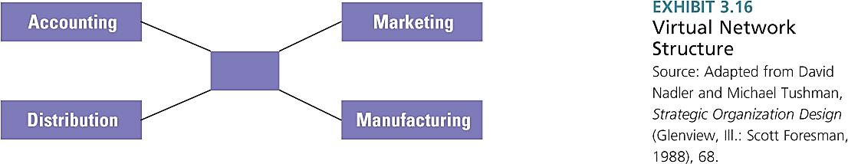
Strengths | Weaknesses
- Enables even small organizations to obtain talent and resources worldwide  - Gives a company immediate scale and reach without huge investments in factories, equipment, or distribution facilities  - Enables the organization to be highly flexible and responsive to changing needs  - Reduces administration overhead costs | - Managers don’t have hands-on control over many activities and employees  - Requires a great deal of time to manage relationships and potential conflicts with contract partners  - There is a risk of organizational failure if a partner fails to deliver or goes out of business  - Employee loyalty and organizational culture might be weak because employees feel they can be replaced by contract services

- Hybrid Structure: combines characteristics of various approaches tailored to specific strategic needs. Used in rapidly changing environments, allows for greater flexibility.
  - Functional/Divisional Hybrid: often used in large organization with many products and markets, and self-contained divisions. Contains function for each product or market

Structural Alignment: the most important decision managers make about structural design is to find the right balance between vertical control and horizontal coordination, depending on the organization’s needs

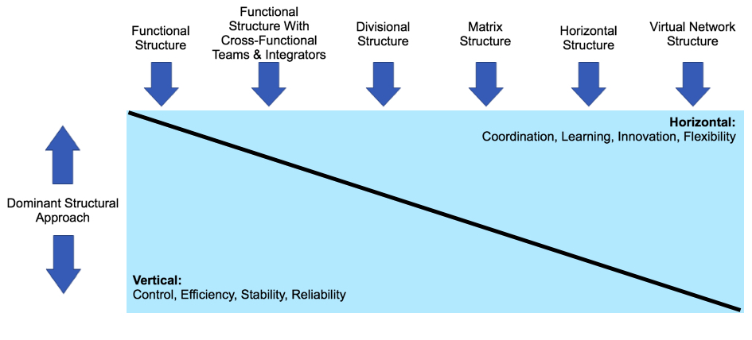
Symptoms of Structural Deficiency
Organizational structure is not aligned with needs, try to find a balance between internal reporting relationships and needs of the external environment. Symptoms are:
- Decision making is delayed or lacking in quality
- The organization doesn’t respond immediately to a changing environment
- Employee performance decreases and goals are not being met

Morgan’s Eight Metaphors for the Organization
- Machines: Efficiency, waste, maintenance, order, clockwork, cogs in a wheel, program, inputs/outputs, standardization, production, measurement and control, design
- Organisms: living systems, environmental conditions, adaptation, life cycles, recycling, needs, homeostasis, evolution, survival of the fittest, health, illness
- Brains: learning, parallel information processing, distributed control, mindsets, intelligence, feedback, requisite variety, knowledge, networks
- Cultures: society, values, beliefs, laws, ideology, rituals, diversity, traditions, history, service, shared vision/mission, understanding, qualities, families
- Political Systems: interests and rights, power, hidden agendas and back room deals, authority, alliances, party-line, censorship, gatekeepers, leaders, conflict management
- Psychic prisons: conscious and unconscious processes, repression and regression, ego, denial, projection, coping/defence mechanism, pain and pleasure principle, dysfunction
- Flux and Transformation: constant change, dynamic equilibrium, flow, self-organization, systemic wisdom, attractors, chaos, complexity, butterfly effect, emergent properties, dialectics, paradox
- Instruments of Domination: alienation, repression, imposing values, compliance, charisma, maintenance of power, force, exploitation, divide and rule, discrimination, corporate interest

The Boundary-less Organization – Jack Welch (1980s)
He believed that boundaries in organizations prevent them from achieving high levels of success as organizations become consumed by turf wars. There are 4 types of boundaries: the vertical or hierarchical, the horizontal or interunit, the geographic, and the external or inter-organizational. Boundary-less organizations learn to permeate their boundaries so that they can be more flexible and responsive to their stakeholders. They are also able to generate good ideas as they are nimble in structure.

Chapter 6 – Designing Organizations for the International Environment

Motivations for Global Expansion
- Economies of scale: lowest possible cost/unit
- Economies of scope: refers to the number or variety of products or services a company offers as well as the number or variety of regions, countries or markets it serves
- Low-Cost Production Factors: raw materials, labour, capital, energy, reduced government intervention

Globalization Issues: job losses, decrease in working conditions, environmental concerns

Stages of International Development
Multi-domestic: competitive issues in each country are independent of others
Multi-national: extensive experience in a # of international markets and has established marketing, manufacturing and R&D facilities in several foreign countries
INTERNATIONAL

Designing Structure to Fit Global Strategy
Globalization Strategy: product design, manufacturing, marketing strategy standardized across world
Multi-Domestic Strategy: competition in each country is handled independently of competition in others, tailored to each

Segments of Global Organizational Challenge
- Increased complexity and differentiation
- Need for integration – quality of collaboration across units
- Transfer of knowledge and innovation

Most organizations tap only a fraction of the potential that is available from the cross-border transfer of knowledge and innovation. There are several reasons for this:
- Knowledge often remains hidden in various units because language, cultural, and geographic distances prevent top managers from recognizing it exists
- Divisions sometime view knowledge and innovation as power and want to hold onto it to gain an influential position within the global firm
- Much of an organization’s knowledge is in the minds of employees and cannot be easily written down and shared with other units

Global Coordination Mechanisms
- Global Teams (transnational): cross-border work groups made of multi-skilled and multi-national members whose activities span multiple counties. Usually, teams are of 2 types
- Stronger Headquarters planning
- Specific Coordination Goals: benefits from interunit collaboration: cost-savings, better decision-making, greater revenues, increased innovation

The GLOBE Project’s 9 Cultural Dimensions
Dimension | Characteristics
Power Distance | Extent to which a society expects power to be distributed equally
Gender Egalitarianism | Degree to which society discourages gender role differences and inequality
Uncertainty Avoidance | Extend to which society relies on rules, procedures, and policies to minimize ambiguity and unpredictability of the future
Collectivism 1 (institutional) | Degree to which society encourages and rewards collective action and resource distribution
Collectivism 2 (in-group) | Extent to which members express pride and cohesiveness in their relations with others
Future Orientation | Extent to which members engage in such behaviours as planning for/investing in the future
Assertiveness | Extent to which members are confrontational toward each other
Performance Orientation | Extent to which a society rewards for innovation
Humane Orientation | Extent to which a society encourages altruism and caring for others

Different Management Structures – 4 Cultural Value Patterns
- Deal vs. Relationship focused
- Informal vs. formal
- Rigid vs. fluid time
- Expressive vs. Reserved

3 National Approaches to Coordination and Control
- Centralized coordination in Japan
- Decentralized firms in Europe
- North America: coordination and control through formalization

Transnational Model: complex, many diverse units, mechanisms for integrating parts, useful for large companies, based on interdependence. Goal is to maximize efficiency, responsiveness, and learning.
- Assets/resources dispersed worldwide; highly specialized operations linked through interdependent relationships
- Flexible/ever-changing structures
- Subsidiary managers initiate strategy that gets adopted at top corporate level
- Coordination achieved primarily through organizational culture, shared values, management style

Lecture 7: Adapting to the External Environment – Chapter 4 (152-167)

Environmental Uncertainty
- Simple to Complex: # of different factors or forces
- Stable to Unstable: rate of change, predictability of change

Adapting to Uncertainty
- Positions and departments (relate to environmental sectors)
- Buffering and boundary-spanning
- Differentiation and integration (between departments)
- Mechanistic vs. organic management (efficiency vs. learning)

How does variety relate to uncertainty?
The higher the variety (the number of possible system states), the more uncertain the system is, and the more information is required to specify the current state of the system.

Positions and Departments: as the complexity and uncertainty in the external environment increases, so does the # of positions and departments within the organization, which in turn increases internal complexity. This relationship is part of being an open system.

Buffering: the traditional approach to coping with environment uncertainty is to establish buffer departments, whose role is to absorb uncertainty from the environment. Buffers surround the technical core and exchange materials, resources, and money between the environment and organization.

Boundary Spanning: link and coordinate an org. with key elements in external environment. Boundary Spanning is primarily concerned with the exchange of information to (1) detect org. information about changes in the environment and (2) to send to the environment that present the org. in favourable light.

Differentiation: the differences in cognitive and emotional orientations among managers in different function departments, and the difference in formal structure among these departments. Each department has a different orientation or structure to deal with specialized parts of the external environment.

Integration: the quality of collaboration among departments. Also known as liaison personnel, project or brand managers, coordination. “Organizations perform better when the levels of differentiation and integration match the level of uncertainty in the environment.

Framework for Environmental Uncertainty

Requisite Variety in Organizations - Organizations are dynamic systems

Disturbance Variety in Organizations: can include both external and internal disturbance.
Source of external disturbance: customers, competitors, and other environmental sectors.
Sources of internal disturbances: employees, technology, structure.

Coping with Variety in Organizations – 2 Options
- Reduce the disturbance variety – techniques: constraints/rules, filters, grouping of the input, eliminate variety, resource dependence, environmental control.
- Increase the response variety – techniques: buffer between organization and source of variety, increase information processing capacity, slack resources, expertise, innovation

Organic vs. Mechanistic Management Processes
Mechanistic Organizational System: when the environment is stable, the internal structure is characterized by rules, procedures, and a clear hierarchy. Organizations are formalized and centralized.
Organic Organizational System: rapidly changing environment, internal much looser, free-flowing and adaptive. Rules and regulations often not written down, of it so, ignored. Hierarchy is not clear, decentralized decision making.

Mechanistic | Organic
- Tasks are broken down into specialized, separate parts  - Tasks are rigidly defined  - Strict hierarchy of authority and control, and there are many rules  - Knowledge and control of tasks are centralized at the top | - Employees contribute to the common tasks of the department  - Tasks adjusted or redefined through employee teamwork  - Less hierarchy or control, few rules  - Knowledge and control of tasks is decentralized

Framework for Organizational Responses to Uncertainty
Resource Dependence: organizations depend on the environment, but strive to acquire control over resources to minimize their dependence – try to be as independent as possible, especially to other organizations who many have resource control, this has negative effects on performance.

To survive, organizations try to reach out and change/control elements in the environment. 2 strategies for managing resources in the environment (both entail responding to the need for resources):
- Establish favourable linkages with key elements in the environment
- Shape the environment domain

Establishing Inter-Organizational Linkages: favourable linkages with key elements in the environment.
- Ownership: companies use this to establish linkages when they buy a part of or a controlling interest in another company. This gives access to tech, products or other resources not available before. These forms of ownership decrease uncertainty in area important to the acquiring company.

- Formal Strategic Alliances: when there is a high level of complementarity between the business lines, geographic positions or skills or 2 companies. Formed through contracts or joint ventures. These decrease uncertainties through a legal and binding relationship. Contracts are license agreements that contract for the sale of one firm’s output to another. Contracts provide long term security by tying customers/suppliers to specific amounts or prices.

- Cooptation: leaders from important sectors in the environment are made part of a firm. These influential people are introduced to the needs of the company and are more likely to include the company’s interest in their decision making.

- Interlocking Directorate: formal linkage that occurs when a member of the BOD of one company sits on the BOD of another company. They are a communication link between companies and can influence policies and decisions.

- Executive Recruitment: the transfer or exchange of executives, also offers a method of establishing favourable linkages with external firms.

- Advertising and PR: advertising is the traditional way, extremely important in highly competitive consumer industries and those that have variable demand. PR is similar but free and aimed at public opinion, it is an attempt to shape the company’s image.

Controlling the Environmental Domain: shaping the environment

- Political Activity, Regulation: techniques to influence government legislation and regulation. (Erect regulatory barriers against new competition or quash unfavourable legislation). Also try to influence the appointment to agencies of people who are sympathetic to their needs.
- Change of Domain: an organization can seek new environmental relationships or drop old ones. They may try to find a domain where there is little competition, no government regulation, abundant suppliers, affluent customers, and barriers to keep competitors out.
- Trade Associations: other organizations that have similar interests
- Illegitimate Activities: conditions such as low profit, pressure from Sr. managers, or scarce resources may lead managers to adopt behaviours that are illegitimate.

Lecture 8: Inter-Organizational Relationships – Chapter 5

In the new economy, organizations think of themselves as teams that create value jointly rather than as autonomous companies that are in competition with all others.

Inter-Organizational Relationships: the relatively enduring resource transactions, flows, and linkages that occur among two or more organizations
Organizational Ecosystems: a system formed by the interaction of a community of organizations and their environment. An ecosystem cuts across traditional industry lines. A company can create its own ecosystem.

Theoretical Perspectives

- Resource Dependence Theory: organizations do not want to become vulnerable to other organizations because of negative effects on performance. The amount of dependence on a resource is based on 2 factors. (1) The importance of the resource to the organization, (2) how much discretion/monopoly power those who control a resource have over its allocation and use.

Resource Strategies: when firm’s feel resource/supply constraints, the resource-dependence perspective says they will maintain their anatomy by using the following strategies:
- Adapt/alter business relationships: by purchasing ownership in suppliers, developing long-term contracts or joint ventures to lock in necessary resources, etc.
- Use interlocking directorates: BODs include members of the boards of supplier companies. Firm’s may also join trade associations to coordinate their needs, sign trade agreements or merge with another firm to guarantee resources and material suppliers.

Power Strategies: in this theory, large, independent companies have power over smaller suppliers. When one company has power over another, it can ask suppliers to absorb more costs, ship more efficiently, and provide more services (without a price increase). Often suppliers feel as though they have no choice.

- Collaborative Network Perspective: an emerging alternative to resource-dependence theory. Companies join to become more competitive and to share scarce resources.

Why Collaboration? Major reasons are sharing risks when entering new markets, reducing costs, and enhancing organizational profile in selected industries/technologies. Cooperate is prerequisite for greater innovation, problem solving, and perform.

From Adversaries to Partners – Changing Characteristics of Inter-Organizational Relationships
Traditional Orientation: Adversarial - Competition | New Orientation: Partnership - Cooperation
- Low dependence  - Suspicion, competition, arm’s length  - Performance measures, closely monitored  - Price, efficiency, own profits  - Limited information and feedback  - Legal resolution of conflict  - Minimal involvement and up-front investment, separate resources  - Short-term contracts  - Contract limiting the relationship | - High dependence  - Trust, addition of value to both sides, high commitment  - Loose performance measures  - Equity, fair dealing, both profit  - Electronic linkages to share key information, problem feedback  - Involvement in partner’s product design and production, shared resources  - Long-term contracts  - Business assistance beyond the contract

Cooperative Relationships: based on trust -> willingness to be vulnerable (based on positive expectations of organizational actions.
Trustworthiness: judgement based:
- Competence (Ability): can the other organizational help us? (knowledge and skills)
- Benevolence: does the other organization want to do good for us? (loyalty, openness, caring, supportiveness)
- Integrity: does the organization have consistent morals or principles? (fairness, justice, consistence, promise fulfillment)

- Population-Ecology Perspective: Differs from the others because it focuses on organizational diversity and adaptation within a population of organizations.

Population: set of organizations engaged in similar activities with similar patterns of resource utilization and outcomes (compete for similar resources or customers)

Why are new organizational forms that create such diversity constantly appearing?
Individual organizational adaptation is severely limited compared to the changes demanded by the environment. Innovation and change in a population of organizations take place through the birth of new forms and kinds of organizations more so than by the reform and change of existing ones. New organizations meet the needs of society more than established ones that are slow to change.

Why do established organizations have such a hard time adapting to a rapidly changing environment?
There are many limitations on the ability of organizations to change. The limitations come from heavy investment in plants, established viewpoints of decision makers; the organization’s own successful history that justifies current procedures; and the difficulty of changing organizational culture.

Organizational Form and Niche
Organization Form: an organization’s specific technology, structure, products, goals and personnel, which can be selected or rejected by the environment.
Each new organization tries to find a niche (domain of unique environmental resources and needs) sufficient to support it. The niche is usually small in the early stages of an organization but may increase over time if the firm is successful.

Process of Ecological Change

Variation: means the appearance of new, diverse forms in a population of organizations. These new forms are initiated by entrepreneurs, established with venture capital by large corporations, or set up by a government seeking to provide new services.

Selection: refers to whether a new organizational form is suited to the environment and can survive. Only a few variations are “selected in” by the environment and survive over the long term. Some variations will suit the environment better than others. Some are beneficial and thus can find a niche and acquire the resources from the environment necessary to survive.

Retention: the preservation and institutionalization of selected organizational forms. Certain technologies, products, and services are highly valued by the environment (e.g. schools, hospitals, etc.)

Strategies for Survival

Struggle for Existence: (competition) firms and populations of firms are engaged in a competitive struggle over resources, and each form is fighting to survive.

Generalist: organizational with a wide niche or domain, those that offer s broad range of products/services or that serve a broad market

Specialists: organizations that provide a narrower range of goods or services or that serve narrower market

Specialists are generally more competitive than generalists in the narrow area in which their domains

- Institutional Perspective: describes how organizations survive and succeed through congruence between an organization and the expectations from its environment.

Institutional Environment: composed of norms and values from stakeholders (customers, investors, associations, boards, government, and collaborating firms). This view believes that organizations adopt structures and processes to please outsiders, and these activities come to take on rule-like status in orgs.

Legitimacy: defined as the general perspective that an organization’s actions are desirable, proper and appropriate within the environment’s system of norms, values, and beliefs. This theory is then concerned with the set of intangible norms and values that shape behaviour, as opposed to tangible elements of technology and structure.

The Institutional View and Organizational Design
Technical Dimension: day-to-day work, technology and operating requirements, governed by norms of rationality and efficiency.
Institutional Dimension: the part of the firm most visible to the public, governed by expectations from the external environment.

Institutional Similarity (Isomorphism): the emergence of a common structure and approach among organizations in the same field. Isomorphism is the process that causes one unit in a population to resemble other units that face the same set of conditions. There are 3 core mechanisms that cause this:

- Mimetic Forces: in the face of uncertainty, the pressure to copy or model other firms occurs. One certain benefit is that management’s feeling of uncertainty will be reduced and the company’s image will be enhanced because the firm is using the latest techniques.

- Coercive Forces: external pressures exerted on an organization to adopt structures, techniques, or behaviours like others.

- Normative Forces: pressures to change to achieve standards of professionalism, and to adopt techniques that are considered by the professional community to be up-to-date and effective. Changes may be in any area, such as information technology, accounting requirements, marketing techniques or collaborative relationships.

