Surveys and interviews
- survey
-is a data collection method used to gather information from individuals on facts, opinions, or experiences

2. Response rate
-percentage of the survey sample that completes the survey, the item response rate is the percentage of respondents who answer a particular question

3.interview
-is a conversation with structure and purpose eliciting a person’s point of view and the meaning he or she gives the experience

4. Strengths of surveys
-effective for collecting information from a large group of people
-surveys provide flexibility- you can ask many questions on the same topics
-survey questions are standardized so that everyone who completes the survey is asked the same questions in the same order and is given the same response options, increasing the reliability of the data

5. Weaknesses of surveys
-standardized questions: can lead to missing info that is important to the respondents, increase reliability but can reduce the validity of data
-not appropriate for understanding, the context in which attitudes form or behavior occurs

6.face-to-face survey
-survey administered by a researcher, who asks respondents questions in person

7.telephone survey
-survey in which an interviewer asks respondents questions over the telephone. Reducing the costs in comparison to face-to-face surveys and enabling a representative sample

8.mail survey
-allows researchers to ask more questions than they can in a face-to-face or telephone survey
-issues:they scan the whole survey before answering, low response rate, question interpretation

9.online survey
-can be part of an e-mail message or an attachment
-not ideal if questionnaire is longer than 3 or 4 pages
-flexible, inexpensive

10. Close-ended question
-is a survey question in which respondents select an answer from a pre-defined list of options
-multiple choice questions
-inappropriate for complex issues

11. Open-ended question
-is a survey question in which respondents answer the question in their own words
-ideal for complexe issues

12. Double-barreled question
-question that includes 2 or more ideas, resulting in more than one possible answer

13.Double negative question
-question that includes 2 negative words, making it difficult to understand

14. Leading question
-question that indirectly encourages respondents to answer in a certain way regardless of their true opinion
15.social desirability bias
-tendancy for respondents to answer questions in a manner that makes them look socially acceptable particularly common with sensitive questions on deviant and criminal behavior

16. Loaded question
-question that assumes the respondent has experienced or done something

17.mutually exclusive
-is a response option that doesn’t overlap, allowing respondents to choose only one answer

18.skip pattern
-set of filter and contingency questions used to ensure that the appropriate respondents are answering the questions

19. Filter question
-question that identifies whether a respondent should answer the contingency questions or be directed to a question later in the survey

20.matrix question
-series of questions with the same response option

21,response set effect
-tendency for respondents to answer multiple matrix questions in the same way

22.vignette question
-question placed in the context of a hypothetical scenario

23. Telescoping
-recall problem in which respondents have trouble accurately remembering when, for how long, or how often something occurred in the past

24.structured interview
-interview in which questions are read verbatim to all respondents and are asked in the same order

25. Semi-structured interview
-type of interview, that, when responses are substantively significant,gives the interviewer the flexibility to ask questions that are not on the interview schedule

26. Unstructured interview
-type of interview in which the question content, wording and other vary each time

27.3 parts associated with interviewing
-preparation(take notes, be respectful, good impression, location)
-interview(review informed consent, research purpose, if the person has any questions,active listening)
-post-interview activities(transcribing your interview)

28. Tell-me-more probe
-invites the person to go into greater depth or to expand on additional issues of the topic

29. Long-question probe
-provide more focused responses-ideal for sensitive questions

30.interviewer characteristics that may affect responses
-how they dress
-how they speak
-how they carry themselves
-how professional they act
*age
*gender
*race
*education
**match interviewers to interviewees with similar characteristics

31. Focus group
-group of respondents who are interviewed together in order to facilitate discussion

Workshops
32. What is the purpose of NVivo?
Organize and analyse data, Brainstorm ideas,Map connections,Visualize concepts and share findings
-text, audio,video surveys social or online data

33. What data sources can be imported to NVivo?
-Documents and PDF
-audio files
-video files
-pictures
-datasets
-web and social media

34. How do you transcribe directly within NVivo?
Bring transcriptions as external sources
-Use styles in Word, for instance
Transcribe directly within NVivo
-Use the “Media” tab
-Set mode to “transcribe”
- F4 – to play or to pause
- F8 – to stop
- F9 – to skip back
35. What are nodes used for in NVivo?
Nodes are used for coding
-any amount of data can be coded at a node
-same data can be coded at more than one node
-open a node to view all references to it

36. What are the two basic queries in NVivo?
- Word frequency
  - Identify the most frequently used word
- Text search
  - Find occurences of one or more words

37. How do you use advanced queries in NVivo?
-Coding
-identify relationships between nodes
-understanding how nodes have been used
-Coding comparison
-compare how different researchers used the same nodes

38. NVivo assists with what type of analysis?
Qualitative data

39. What does SPSS stand for?
Statistical Package for the Social Sciences

40. What is the purpose of SPSS?
Data management tool used to perform quantitative analysis

41. What statistics are included in the base SPSS software?
1- descriptive statistics: cross tabulation, frequencies, descriptives, explore, descriptive ratio statistics
2-bivariate statistics: means, t-test, ANOVA, correlation(bivariate, partial, distances), nonparametric tests
3- prediction for numerical outcomes: linear regression
4- prediction for identifying groups: factor analysis, cluster analysis(two-step, K-means, hierarchical, discriminant)

42. The many features of SPSS statistics are accessible via what?
Via pull-down menus or can be programmed with a proprietary 4GL command syntax language

43. The command syntax programming in SPSS has the benefits of what?
Has the benefits of reproducibility, simplifying repetitive tasks, and handling complex data manipulations and analyses
-some complex applications can only be programmed in syntax and are not accessible through the menu structure
44. SPSS datasets have what type of a table structure?
A two-dimensional table structure
-rows represent cases(ex. Individuals or households)
-columns represent measurements(ex. Age, sex, or household income)

45. What are the two data types defined in SPSS?
Numeric and text

**ask46. The graphical user interface has two views: what are they?
-can be toggled by clicking on one of the two tabs in the bottom left od the SPSS Statistics window
-’Data view’ shows a spreadsheet view of the cases(rows) and variables(columns)
-unlike spreadsheets, the data cells can only contain numbers or text, and formulas cannot be stored in these cells
- Spreadsheet 2. Data cells

47. How is the data view displayed?
Data view’ shows a spreadsheet view of the cases(rows) and variables(columns)

48. How is the variable view displayed?
The variable view displays the metadata dictionary where each row represents a variable and shows the variable name, variable label, value label(s), print width, measurement type, and a variety of other characteristics.
-Cells in both views can be manually edited, defining the file structure and
allowing data entry without using command syntax.
-This may be sufficient for small dataset

49. How are large datasets read into SPSS?
Larger datasets such as statistical surveys are more often created in
data entry software, or entered during computer-assisted personal interviewing, by
scanning and using optical character recognition and optical mark recognition software, or by direct capture from online questionnaires. These datasets are then read into SPSS

50. SPSS can read and write to external relational database tables via what?
Via ODBC(open database connectivity) and SQL (structured query language)

51. Statistical outputs from SPSS can be exported to what types of software?
Can be exported to text or Word, PDF, Excel and other formats

52. What is ethnography?
Ethnography is a research method that uses the research subjects’ perspective to describe a culture and alternate way of life

53. What is field research?
Field research is a research approach that collects data to understand a natural setting in which the behavior being investigated actually occurs

54. What is participation observation?
Is a data collection technique in which researchers immerse themselves in the culture and collect observational data to produce descriptions of everyday life and how it is understood by participants

55. What is tacit knowledge?
Is a person’s unconscious or unwritten knowledge
(you develop an insider point of view while maintaining an analytical perspective)

56. Who is the research instrument in field research?
In field research, the researcher is the data collection instrument
The quality of the data depends on observational skills and how well the vents and behaviors are recorded
Being the research instrument means that his or her reactions and feeling are part of data themselves

57. What are the appropriate topics for field research?
Meaning: the importance of beliefs, social norms, and cultural practices and the ways in which they are interpreted. Similarities and differences likely exist between social actors in that setting.
Practice: an interest in behavioral patterns
Episodes: routine or exceptional events
Encounters:a focus on interactions between two or more people (eg. content and how the interaction occurs)
Roles:the types of roles taken on by subjects and their associated behaviors
Relationships: interactional behavior between two individuals who have similar or different roles
Groups:an understanding of the behavioral and interaction dynamics of small groups
Organizations: Formal organizations, such as the police, that consist of more than one small group(e.g. platoons)
Settlements:Groups within larger settings (e.g city neighborhoods)

58. What are the steps associated with getting started in field research?
1- develop a research statement and description
-research description:short statement describing the research purpose and the researcher’s preferred involvement in the field setting
-must be simple and uses everyday language
2- review the scholarly literature
` -use previous research to help avoid disasters
-when you place yourself in a setting out of your comfort zone, you need to know:
-your limits
-the potential impact of previous personal experiences
-ways to overcome self-doubt
-part of preparing for data collection is determining your ethical boundaries and the length of time spent in the field

3-choosing a field site
-some settings are easier to access
-all carry varying ethical and personal challenges
-the easiest are public places
-the most challenging are closed communities, dangerous settings, and active criminal groups
-develop plan(how to access community and group members)
What field role will you adopt? To what extent to participate in daily activity?

59- what is field relations?
Field relations is the logistics, procedures, ethics and personal dimensions related to informants, gatekeepers, and social actors in the field setting
-impression you leave on other(appearance, actions, words) need to be carefully managed
-develop a relationship with participants(increase authenticity)
-data collection: observing and documenting field experiences in the form of field notes

60- What is field role?
Is a role that defines the degree to which a researcher participates in the research setting’s activities

61-What is a complete observer?
Is a field role in which the researcher is an unobtrusive observer (i.e does not interact with group members in any way)

62-What is observer as participant?
Is a field role in which the status of researcher is known to the group members and the researcher participates minimally in group activities

63- What is participant as observer?
Is a field role that involves the groups’ members knowing the status of researcher and the researcher actively participating in group activities

64- What is going native?
Is the situation of a researcher becoming too immersed in the research setting and losing objectivity by adopting the participants’ worldview

65- What is complete participant?
Is a field role that involves the researcher adopting and active role as a full-fledged group member and participants being unaware of his or her researcher status

66-What is a gatekeeper?
Is a person who has informal or formal authority that influences or controls whether a researcher has access to the research site

67-what are the three things associated with entering the field?
1- Sampling
2-Using informants
3-Managing interpersonal dimensions

68-what is theoretical sampling?
-non-probabilistic sampling technique
-you start to see certain issues, interpersonal dynamics, or events as significant for addressing your research question
-you looks for participants that allow you to test your hunches
-you are looking for typical or deviant cases
-used to flush out ideas that are developing during data collection

69- what is snowball sampling?(or respondent-driven sampling)
-non probabilistic sampling technique
-method that is ideal and effective for subcultures or hard-to-reach populations
-is used to find group members
-researchers use both techniques when conducting participant observation

70- what is participatory action research?
Is a research design that empowers a community through collaboration at all stages in the research process in order to create change and understand social reality

71- what is thick description?
Is a description that explains behavior, the context in which it occurs, and understandings that make it meaningful to participants

72- what are reflection notes or personal notes?
They are field notes on the researcher’s feelings while in the field and his or her personal reactions to observations

73- what does Argot mean?
Argot shared terminology, which signals group membership
-the argot demonstrate how members interact with one another and their interpretation of the world and helps the researcher fit into the setting

74- What are the emotional issues associated with disengaging from the field?
-guilt
-loss
-disorientation
-culture shock
-depression
-readjustment to everyday routines

75- what is systematic social observation?(SSO)
Is a mixed methods structured observation that uses explicit rules for observing, categorizing, and recording behavior data

76-What is netnography?
Is the use of field research methods to study online communities
-advantage is the ability to investigate hard to reach groups
-nonverbal communication is harder to understand and interpret
-good idea to combine internet-based field research with other data collection techniques

77-Ethnomethodology
Is a field research method focusing on how social actors create meaning in everyday life
-individual level: research examines how and wy deviant behavior is normalized, ignored, or justified by community members
-it attempts to understand whether acts are planned or spontaneous
-organizational level: ethnomethodologists argue that deviance reflect organizational priorities and routine behavior exhibited by agents of social change

78- what are the 5 limitations associated with field research?
1-reactivity in which participation affects group behavior
-if you spend extended periods of time in the field, it desensitizes participants

2- the concern of distortion
-triangulation of methods helps to counteract this limitation

3- the imposition of beliefs and opinions
-researchers have to avoid ethnocentrism and the imposition of their cultural beliefs(affects data interpretation)

4-as beneficial as gatekeepers and informants are to the research process, they have limitations
-you need gatekeepers to gain access to the field site
-The gatekeepers may become informants who guide you through
the resocialization process and gain access to members of the group
-But a gatekeeper’s social status in the research setting affects his
or her ability to access certain group members

5-there are the demands on the researcher
-the quality of data hinges on the researcher’s skills

Unobtrusive Methods and Secondary Data

79. What is nonparticipant observation?
Has no direct interaction with research subjects or collect data at a distance from a neutal location

80. What is physical trace evidence?
It occurs when researchers examine physical evidence left behind by humans (eg. bones, pottery shards, arrowheads) - has roots in archeology

81. What is historical data or archival data?
Are existing records that contain information on the past; usually stored in libraries and depositoiries
Types of archival data include:
-running records, chronological - such as organizational meeting minutes, judicial records, or police-reporting crime statistics are chronological
-episodic reflecting a period instead of continuous documentation (e.g. media accounts)
-personal documents can be a running record (e.g. diary) or episodic (suicide notes or photographs)

82. What is content analysis?
Is the systematic analysis of communication found in text, audio, video, or images

83. What is secondary data analysis?
Secondary data analysis analyzing, reclassifying, and interpreting data collected by other researchers
-researchers can replicate previous findings with a different approach or use the data for a different research purpose

84. What are the three reasons for using unobstructive methods?
1- all data collection methods have methodological weaknesses
- With interviews and surveys, researchers acknowledge that the data collection instrument is
affected by reactivity, a social desirability bias which are not issues with unobtrusive methods

2- Everything is culturally, socially, and temporally situated
-This approach uses multiple methods, collects data that express cultural meaning that other data collection methods are unable to do adequately by themselves

3- Unobtrusive measures are adaptable
-Hard-to-reach populations where snowball sampling is appropriate are ideal sources for collecting non-reactive data

85. What is primary data?
Are original sources and data collected by the researcher
E.g. eyewitness accounts, original copies or letters, or interview recordings

86. What is secondary data?
Are data collected by someone other than the researcher

87. What are personal documents?
Include diaries, letters, and autobiographies

88. What is a life history account?
Life history is an account of a person’s life story, told using his or her own words and placed within a specific larger context.

89. What are photographs?
Provide a rich data source but are not without challenges for historical researchers
-often reflect ceremonial occasions and not routine life
-like personal documents
-what is not captured in pictures potentially gives you information about the photographer

90. What are official documents?
Are appropriate for any number of topics in crim and crim justice
-two sources of official documents: private(press releases, corporate annual reports) and public(Stats Canada)

91. What is quantitative content analysis?
It objectively and systematically describes the content of a message, numerically assessing its frequency and intensity
-can analyze a large amount of data and detect patterns and trends

92. What is qualitative content analysis?
It systematically describes the content with more of an emphasis on meaning
-repeatedly analyze them until patterns and themes emerge

93. What is a coding system?
A coding system is a classification system or set of rules to code words, phrases, symbols, sounds, or images

94. What is intra-rater reliability?
Stability reliability or intra-rater reliability is the extent to which assigned codes for the same text are equivalent and stable when coded by the same person at two different periods of time

95. What is inter-coder reliability?
Reproducibility or equivalence reliability test for inter-coder reliability the extent of agreement between two or more coders to ensure that the code is assigned in the same way .

96. What are agency records?
Agency records are records created by a criminal justice agency as part of normal operations

97. What are the three types of research problems evaluated in legal researcher?
1- research that aims to understand a legal controversy, such as what can arise when new sections of the Canadian Criminal Code are enacted
2- occurs in a situation of legal ambiguity, how the courts or police interpret laws, such as zero tolerance requirements for domestic violence or the circumstances under which evidence is considered admissible in court
3- of legal research examines the implementation of the law; which could analyze police practices used with prostitution or understanding proposed legislative change

98. What is meta-analysis?
Is a systematic analytical strategy used to statistically combine and summarize the results from more than one study

Interpreting Quantitative data

99. What are descriptive statistics?
Are statistics that describe sample characteristics and relationships between variables

100. What is univariate analysis?
Is a statistical analysis that describes one variable

101. What is bivariate analysis?
Is a statistical analysis of two variables that assesses the empirical relationship

102. What is inferential statistics?
Are techniques that use sample observations to make inferences about the population

103. What is multivariate analysis?
Is a statistical analysis of three or more variables that assesses the empirical relationship between them

104. What is data entry?
Is a process of entering data usually using a statistical software program such as SPSS or Stata

105. What is data coding?
Involves transforming the data from a raw state into a format that can be analyzed with the level of measurement considered.
-rule of thumb: enter the data at the highest level of measurement possible
-open-ended survey questions: identify patterns to make coding categories
-rule of thumb: revise your codes when more than 10% are classified as other

106. What is a codebook?
Is a document outlining the structure, layout, and content of a data file, used by researchers for data entry and analysis

107. What is data cleaning?
Is important because data entry errors occur and lead to problems of validity, missing data, and misleading conclusions

108. What is a frequency distribution?
Is a distribution that summarizes nominal and ordinal variables, in a table by presenting the total number and percentage for each score in the dataset.
-e.g. Describe typical characteristics of the group
-e/g total time is useful info(7 arrests, 34 hours.. 4.8 hours per DUI)
109. What is a rate?
Rate is a standardized value assigned to frequency to allow comparisons between groups ona particular measure.

4 ways to present univariate analyses graphically...
110. What is a bar graph?(1)
Is a visual depiction using bars to represent the categories of nominal or ordinal variable frequency distributions

111. What is the schematic for a bar graph?
Axe Y et Axe X avec des barres verticales

112. What is a pie chart?(2)
Pie chart is a circular graphic that visually represents a variable’s frequency distribution, using percentages of the total.

113. What is the schematic for a pie chart?
Its a circle with different colors for different categories

114. What is a histogram?(3)
Histogram is a graph that uses vertical bars on the horizontal axis to represent a continuous variable’s frequency distribution.

115. What is the schematic for a histogram?
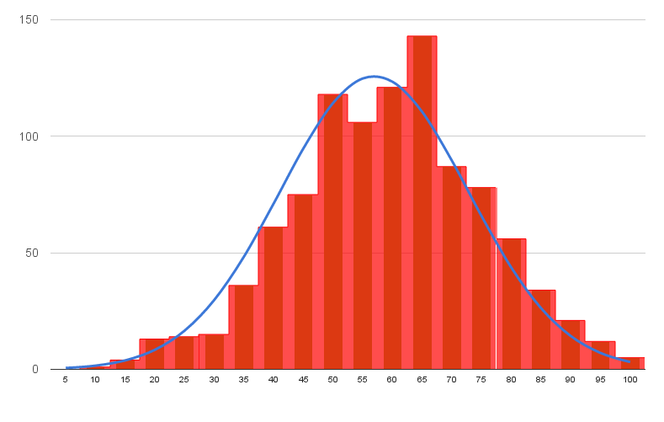
116. What is a frequency polygon?(4)
Is a graph with a continuous line used to present the frequency distribution of interval/ratio variables visually; also known as a line graph.

117. What is the schematic for a frequency polygon?
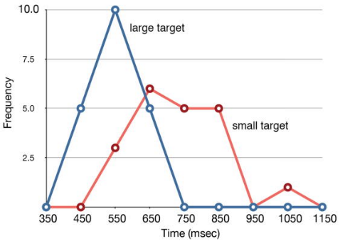

118. What is the measures of central tendency(MOCT)?
Is a typical description of a data set, based on how the numbers compare mathematically to each other, including the mean, median, mode, and standard deviation

119. What is the mode?
Mode is a measure of central tendency that is the most frequent value found in a frequency distribution.
-the number that shows up the most

120. What is the median?
Median is a measure of central tendency that is the middle point found in the distribution when the values are listed from lowest to highest
-(78 + 79)/2 = 78.5
-45, 56, 59, 67, 72, 72, 72, 72, 77, 78, 79, 79, 86, 89, 91, 92, 93, 99, 99, 100

121. What is the mean?
Means is a measure of central tendency that provides the average score in a frequency distribution; calculated by adding the scores and then dividing the total by the number of
Cases
-arrange the numbers in rank order from lowest to highest…
-add all numbers together, divide by the number of numbers there are

122. What is a positive skew?
Positive (or right) skew are distributions with a long tail on the right side, a large number of low scores, and- from lowest to highest - the mode, median, and mean
-from high to low
123. What is a negative skew?
Negative (or left) skew are distributions with a long tail on the left side, a large number of high scores, and - from lowest to highest - the mean, median, and mode
-from low to high

124. What is the range?
Range is a measure of dispersion that is the difference between the highest and lowest value found in a frequency distribution
-the range is calculated for interval and ratio variables, as it has more meaning
-the range reveals the spread of the data
-it cannot tell us how dispersed the scores are within the distribution

125.What is the interquartile range(IQR)
In a frequency distribution, is a measure of dispersion that is the distance between the twenty-fifth and seventy-fifth percentile.

126. What is the box-and-whisker plot (or boxplot)?
Is a graphical representation of a distribution’s shape, central tendency, and dispersion; based on the interquartile range

127. What is the schematic for the box-and whisker plot?
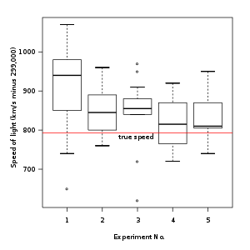
128. What is standard deviation?
Is an estimate of how widely the scores are spread around the mean in a frequency distribution
-most commonly used
-As the average amount of distance between all scores and the mean, it illustrates the heterogeneous or homogenous nature of the data and estimates how much the average
case in the sample differs from the population
-standard deviation is small,the mean can be interpreted as an accurate measure of central tendency
-the standard deviation is subject to the same limitations as the mean in that it is influenced by outliers or an extremely skewed distribution

129. What is the formula for standard deviation?
Standard deviation is a measure of dispersion showing how the scores relate to the mean
The standard deviation (SD) is the square root (√) of the variance
S =√Ʃ (x-mƩx)2
---------------------
N

130. What is variance?
Variance is a measure of dispersion indicating the average squared deviations of each case from its mean value.
-to calculate the variance, square the actual deviations from the mean and add them together
-variance is really the mean sum of squares

131. What is the formula used to determine the sample variance?
-for a sample, divide this number by the total N of cases minus 1
S2=Ʃ (x-mx)２
_________
N-1

132. What is the formula used to determine the population variance?
For a population, divide by the total N for the entire population
σ2 = Ʃ (x-mx)2
_________________
N

133. What does statistical significance mean?
Is a coefficient that indicates the chances of a relationship found in the sample occurring by chance and not existing in the population
-statistical significance is stated as the level of confidence, or the probability, that the results are not caused by chance
-it tells us whether the observed difference is due to chance or is a real result between the varaibles
-commonly used levels of stats significance (001, .01, .05)
-2 types of errors that can occur when calculating and interpreting statistical significance

134. What is a Type I error?
Is the rejection of the null hypothesis when it is true, also known as an alpha(a) error

135. What is a Type II error?
Is acceptance of the null hypothesis when it is false (i.e. the relationship found in the sample did not occur by chance) also known as beta error.

136. What is chi-square?
Is a test of statistical significance determining the degree of confidence that an association between two categorical variables did not occur by chance(i.e the null hypothesis can be rejected)
-most used with contingency tables
-tests the probability that the difference between what is expected and wat is actually observed is by random chance due to sampling error
-chi-square test is sensitive to sample size
-larger the sample, more likely to find statistical significance

137. What is the schematic for a contingency table?
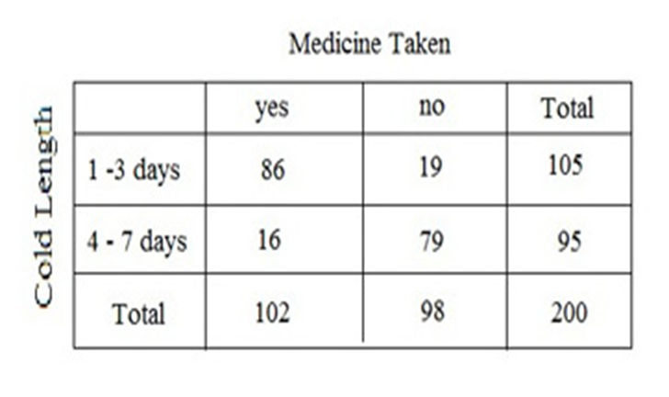
138. What is a t-test?
Is a test of statistical significance determining whether the means for two groups differ from one another beyond what would occur by random chance
Two types of t-tests:
•A one-tailed t-test used when you have a directional
hypothesis
•A two-tailed t-test used when you have a non-
directional hypothesis

We can measure a bivariate relationship in several ways:
-cross-tabulation
-scattergram
-correlation coefficient
139. What is a cross-tabulation?(1)
Is a contingency table that displays the frequencies and percentages for specific combinations of at least two categorical variables
-also known as contingency tables because the values of the dependant varirable are contingent on the values of the independent variable

140. What is a schematic of cross-tabulation?
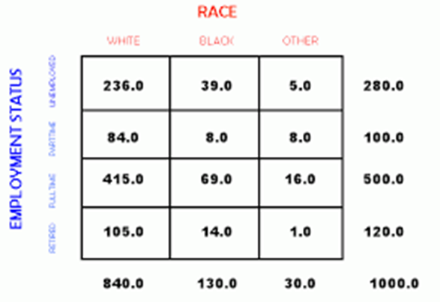

141. What is a scattergram?
Is a graphical representation of scores for two continuous variables distributed across the range of all possible values, used to indicate a relationship’s strength and direction
•Can identify the type and form of the relationship
•Can identify the direction of the relationship
•Indicates precision in terms of how close the data are to the line

142. What is the schematic for a scattergram?
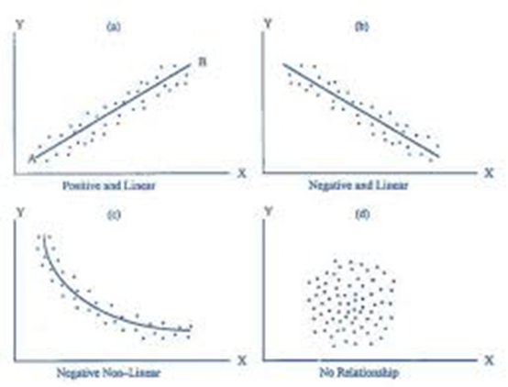
143. What is a correlation coefficient or Pearson’s product-moment correlation coefficient?
Is a statistic that describes the association between two variables in terms of strength and direction
•For the direction of the relationship, a positive correlation coefficient occurs when the values of two
variables increase at the same time
•A negative correlation occurs when high values on one variable are associated with low values on another
-strength of a correlation coefficient(value from 0 to 1, closer to 0=weak relationship, closer to 1=stronger relationship

144. What is bivariate regression?
Is a statistical analysis used to assess the relationship between one independent(predictor) and one dependent (criterion) variable.
-primary purpose: predict values of the dependent variable, it is also used to explain causal relationships

145. What is regression line?
Regression line is the line running through points on a scattergram that shows the direction of the relationship; used to understand the relationship between an independent and dependent relationship

146. What is the schematic for regression line and scattergram?
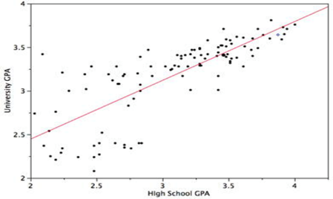

147. What is multivariate analysis?
Involves assessing the effects of multiple variables on the outcome variable(s) in order to determine cause and effect relationships
-dependant variable: variable you are trying to explain
-independent variable: what explains or causes the change is referred to as the independent variable
-use multiple independent variables to explain variance in the dependent variable

148. What is regression analysis?
-is a statistical procedure designed to determine whether the values of the dependent variable can be predicted by knowing the values of the independent variables. It is a measure of association(existence, strength, and direction) between multiple variables. There are many types including Logit and Negative Binomial, although the most common is Ordinary Least Squares.

149. What is causality?
In other words to determine what factors cause a particular outcome
Central principle associated with multivariate analysis
For causality to occur three conditions must be met:
-association
-temporal order
-spuriousness
150. What is association?
Occurs as one variable moves, so does the other
-it can be either positive or an inverse relationship but the variables must be statistically correlated

151. What is temporal order?
Means the cause must come before the effect
-the influencing variable must come prior to the outcome
-e.g.: alcohol consumption precedes the hangover

152. When does spuriousness occur?
When a relationship between an independent and dependent variable is actually caused by a third variable, spuriousness occurs.
-third variable is referred to as an extraneous variable and means it is the real reason there is a relationship between X and Y

153. What is path analysis?
Is a type of regression analysis that graphically presents the paths of causality

154. What is factor analysis?
Is a statistical technique used to assess whether a number of indicators tend to group together and are interrelated to form a latent construct

155.What is analysis of variance (ANOVA)?
Is a statistical technique that uses a continuous dependent variable to investigate whether the means of two or more groups are different from one another

156. What is normal bell-shaped curve?
Is based on the normal distribution of the data. If the data are normally distributed, scores will evenly distribute with few high and low scores and most scores in the middle or average range

157. What is the schematic for a normal bell-shaped curve?
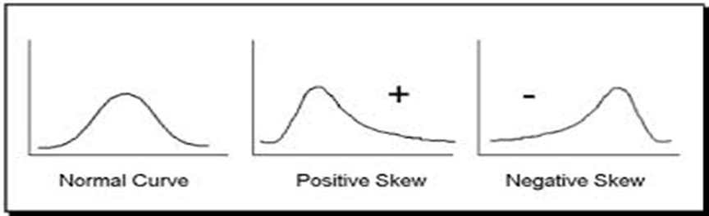

158. What is mesokurtic curve?
Refers to a normal shaped curve when the data are plotted on a graph

159. What is leptokurtic curve?
Refers to a skewed distribution where scores are tightly grouped together. When the data are plotted on a graph it appears as a high, thin distribution.

160. What is a platykurtic curve?
Refers to a flatter curve where the scores are spread out evenly. When the data are plotted on a graph the line relatively flat.

Interpreting Qualitative Data

161. What is analytical induction?
Is an iterative process in which hypotheses develop early in the data analysis process and subsequent evidence is compared to either support or refute themes and relationships between concepts

162. What are the four activities involved in qualitative data analysis?
- Data collection
- Reduction: finding and choosing text segments, as well as simplifying and transforming the data into a format that can be analyzed further
- Display: organization of the data but in a way that allows for drawing conclusions by coding
- Drawing conclusions: create meaning, patterns, clusters,etc. Are identified from the data (verified for plausibility and validity)
You collect data; you reduce, display, and categorize them; you draw conclusions about them; and consistent with analytical induction, you collect additional data and make comparisons to verify and modify the theoretical explanations

163. What is the ideal type?
Is an abstract description of the social phenomenon that is a model used to compare data
-highlight common features of the event,situation, person or process

164. What is the illustrative method?
Is a qualitative method that applies an existing theory to a situation, setting, group, or experience and uses the data as theoretical examples

165. What is analytical comparison?
Is the development of theoretical ideas, using the methods of agreement and difference, based on patterns in existing theories when compared to alternative explanations in a particular social context

166. Method of agreement
Is an analytical technique that involves comparing data characteristics that are similar to other cases and results in the same or similar outcome

167. Method of difference
Is an analytical technique that involves comparing data characteristics that are different for cases that have the same or similar outcome

168. What is constant comparison method?
Is a comparison of empirical indicators that describe people, events, and situations to other data for similarities and differences

169. What is fracturing the data?
Involves pull it it apart, organizing it, and putting it all back together in a meaningful way so that we can tell a story

170. What is coding?
Is a systematic process of categorizing groups of text segments together and assigning a term or phrase to summarize that topic, event, or person.

171. Deductive coding
Is an approach to the data in which coding occurs with certain concepts and themes in mind

172. Inductive coding
Is a type of coding that elaborates on meaning by creating larger conceptual categories

173. What is a memo?
Is a document that explains coding, defines concepts, brainstorms theories, and records methodological issues that arise during data analysis
-code notes(labels and definitions
-theoretical memos (your thoughts on dimensions within a concept, relationship between concepts,outcomes,etc.
-methodological memos (document things that occur during data collection and how it is interpreted in analysis

174. What is an annotation?
Is a type of memo associated with a particular text segment rather than a large concept

175. What is first-cycle coding?
Is the coding cycle stage during which text segments are assigned to descriptive, process, in vivo, and emotion codes

176. What is second-cycle coding?
Is the coding cycle stage that creates categories’ grouping codes and identifies patterns in the data

177. What is grounded theory?
Is an emergent theory and method that uses constant comparison and coding procedures to develop a theoretical explanation grounded in the data
-the explanation is grounded in the data
-memos are important
-using the constant comparison method to compare the emerging theory to new data
-induction and deduction are used

178. What is discourse analysis?
Is a form of analysis that examines language to understand communication patterns that occur during social interactions

179. What is narrative analysis?
Is a form of analysis that uses an interpretation of stories in terms of organization, development, and function within the context of the experiences as they are described in the social interaction

180. What is conversation analysis?
Is a form of analysis that examines verbal interchanges to understand the structure of social interactions

Evaluation Research
181. What is evaluation research?
Evaluation research is research that assesses the consequences (intentional and unintentional Of a policy, practice or programs and the extent to which its particular goals and objectives are Met. It is a type of explanatory research because it looks at a cause and effect. To evaluate means to make a judgement on the value of what something does and how well it does it.
182. What is a stakeholder?
Stakeholder is a person or organization invested in the program being evaluated or interested in what will be done with the results.
183. What is program theory
Program theory is a theory that specifies what needs to be done to accomplish program goals, what (if any) additional anticipated outcomes exist, and how these goals and outcomes are achieved.
184. What is evaluation theory?
Evaluation theory is a theory about how evaluation research should be conducted in order to be valid.
185. What is prospective cohort study?
Prospective cohort study is a study involving a group of similar individuals who differ only on factors related to the outcome under investigation and who are followed as the program or policy is implemented.
186. What is a retrospective cohort study?
Retrospective cohort study is a study involving a similar group of individual who differ only on factors related to the outcome under investigation and are followed using data from past records after the policy or program was implemented.
187. What does quantitative data tell us?
Quantitative data tells us how much or how many, most commonly used in evaluation research.
188. What does qualitative data tell us?
Tells us how individuals feel and behave or why things are done in a certain way. Increasingly popular to use in evaluation research because it allows the researcher to collect detailed in-depth information.
189. What does mixed methods allow evaluation research to do?
Mixed methods allows evaluation studies to use both types of methods increasing the comprehensiveness of the findings. Using mixed methods is decided by the purpose and role of the evaluation.
190. What are the research steps involved in an evaluation?
-Engage stakeholders
-Describe the program
-Develop an appropriate research design gather valid evidence
-Draw inferences from data
-Support and justify conclusions
-Play an active role in the use of the findings and share any lessons learned
191. What is a logic model?
Logic model proves a graphic overview of a program, outlining the outcomes to be accomplished along with how they are to be achieved and for what groups.
192. What is a formative evaluation?
Formative evaluation is a type of evaluation research that investigates what is and is not working so that actions can be taken to improve the program or intervention functions.
193. What is summative evaluation?
Summative evaluation is a type of evaluation research that investigates the effectiveness of or the extent to which a program achieves its objectives and the value of a program or process.
194. What is needs assessment?
Needs assessment is a process that investigates the nature of the problem to be addressed by the program the clients who need the program, the level of need for the program, and the requirements for meeting this need.
195. What is evaluability assessment?
Evaluability assessment is a process that investigates the feasibility of conducting an evaluation and how findings have utility for the stakeholders.
196. What is process evaluation?
Process evaluation is a process that evaluates the systematic collection of information to document and assesses program operation and whether it functions as intended.
Process evaluation asks six fundamental questions:
-To what extent is the program implemented as a design
-Is the program functioning and operating as intended?
-To what extent are the target individuals reached by the program?
-What resources are expended and required to operate the program?
-Which parts of the program process are associated with intended outcomes?
-Under what conditions is the program achieving its outcomes? If it fails to meet its objectives due to problems with program implementation, a process evaluation seeks to stipulate why.
197. What is outcome evaluation?
Outcome evaluation is a process that assesses the progress toward achieving the short-term and intermediate outcomes that a program is designed to address.
198. What is impact evaluation?
Impact evaluation is a process that investigates the long-term effects of participating in a program to make a judgement on whether the intervention goal is achieved.
199. What is an experimental evaluation design?
An experimental evaluation design is a research design that measures program effectiveness by randomly assigning individuals to a group that receives the intervention or to one or more groups that do not receive the intervention.
200. What is quasi-experimental evaluation design?
Quasi-experimental evaluation design is a research design that measures a programs effectiveness by using comparison groups that are as similar to each other as possible. Individuals are not randomly assigned to a group.
201. What is a cost-effectiveness evaluation?
Cost effectiveness evaluation is a process that systematically examines the relationship between program costs and outcomes for two or more different interventions with similar desired outcomes.
202. What is a cost-benefit evaluation?
Cost-benefit evaluation is a process that systematically compares the expected monetary benefits or savings from an intervention with its expected costs.
203. What does conflict of interest mean?
Conflict of interest is a situation in which the influence of a secondary interest (ex continued funding) affects a person’s professional judgement and decision-making about a primary interest (ex program success)
Mixed Methods: An integrated approach
204. What is methodological pluralism?
Methodological pluralism is the view that no one method is superior than another as multiple approaches are legitimate scientific methods of acquiring knowledge.
205. What is methodological exclusivism?
Methodological exclusivism is in contrast (opposite) to method. Pluralism, it holds the position that there is only one credible method of inquiry to acquire knowledge. This approach defines much of the research published in criminology and criminal research.
206. What are we trying to do with mixed methods?
There is one or more types of triangulation. There are four reasons to use mixed methods:
-Complementary
-Initiation
-Development
-Expansion
207. What is triangulation?
Triangulation is a research strategy that uses more than one theory, method, or investigator in order to increase the validity of the findings.
208. What is investigator triangulation?
Investigator triangulation is a research strategy in which more than one researcher is involved in data collection, analysis, and interpretation to improve credibility of the findings.
209. What is theoretical triangulation?
Theoretical triangulation is a research strategy that uses more than one theory to inform research questions, data collection, analysis, and interpretation.
210. What is methodological triangulation?
Methodological triangulation is a research strategy that uses more than one method to study a research problem with the objective of overcoming the weaknesses associated with one method by using an additional method.
211. What is multimethod research?
Multimethod research is a form of methodological triangulation that uses more than one type of quantitative method or multiple quantitative methods in one research study.
212. What is analytical triangulation?
Analytical triangulation is a research strategy that analyzes data in more than one way, using quantitative and qualitative techniques.
213. What is complementarity?
Complementarity is the use of quantitative and qualitative methods with non-overlapping weaknesses in the same study to provide more meaningful and holistic (incorporating the concept of holism, or the idea that the whole is more than merely the sum of its parts, in theory or practice) understanding of a social phenomenon through the different types of knowledge created by each data type.
214. What is initiation?
Initiation is the use of quantitative and qualitative methods to uncover contradictions, understand why they occur and develop new perspectives on the social phenomenon.
215. What is the development strategy?
The development strategy is a strategy of using one method to inform decisions about research questions, sampling, data collection, and analysis of a second method.
216. What is expansion?
Expansion is the use of quantitative and qualitative methods in the same study to assess different phenomena.
217. What are the four characteristics that describe all mixed methods research designs?
1. The data strands have a particular order or sequence
2. Each data strand is given the same or different priority in terms of the inclusion purpose and weight when drawing information from the data.
3. The research project is either independent or part of a series of studies.
4. Data collection and analysis can be participatory and classified as a transformative mixed methods research design.
218. What is the purpose statement?
Purpose statement: (1) Must address the research intent and objectives. (2) Specify the role played by each data strand (qualitative and quantitative) in the research design. (3) Clarify why both types of data are needed to achieve the research objective.
219. What are research questions?
Research questions drive the method with separate quantitative and qualitative questions. Each study has 1 overarching research question that bridges qualitative and quantitative questions. The central mixed methods research question guides the creation of a meta-inference.
Research questions play a pivotal role in mixed methods research because it provides the framework for how the data are combined to address the research problem.
220. What is the sampling strategy?
The sampling strategy is dictated by the research question. The most appropriate technique collects the information required to address the research questions and is consistent with the type of data. It uses more than one sampling technique in the same study.
221. What is unique about data analysis and inferences?
Research questions
-central mixed methods research question guides the creation of a meta-inference(provides framework for how the data are combined to address the research problem
Sampling strategy
-uses more than one sampling strategy in one study
-probability sampling is needed(to generalize to larger population)
-in depth info, non probability sampling is needed
Data analysis
-An analytical challenge in many mixed methods research designs is creating a meta-inference
from each data strand’s inferences
-If qualitative is dominant, those findings play a larger role in creating the meta-inference by virtue of the fact that the research problem predominantly requires a qualitative approach
-If it is an equivalent-status design, inferences from both strands are equally important in developing a meaningful understanding of the issue or problem investigated

222. What is embedded or nested mixed methods design?
Embedded or nested mixed methods design is a design that has a primary data strand but it contains a smaller secondary method for convergence, exploratory or explanatory reasons.
223. What is multiphase mixed methods design?
Multiphase mixed methods design is a research design that conducts more than one study within a larger project: the studies share a common research objective.
224. What is transformative mixed methods design?
Transformative mixed methods design is a type of participatory action research that combines methods for the purpose of improving the condition of marginalized populations.
225. What is equivalent status design?
Equivalent status design is a mixed methods research design in which each data strand is given equal priority and findings from each to create one overall conclusion.
226. What is dominant-less-dominant design?
A mixed methods research design in which one data strand is dominant and the findings play a larger role when creating an overall conclusion.
227. What is convergent parallel design?
A mixed methods research design in which both data strands are collected and analyzed concurrently and the overall conclusion is based on a comparison of each data strands findings.
228. What is Exploratory sequential design?
Exploratory sequential design is a sequential mixed methods research design that conducts the study in two stages, with the qualitative data strand first in sequence and the findings used to inform the collection and analysis of quantitative data.
229. What is Explanatory sequential design?
Explanatory sequential design is a sequential mixed methods research design that conducts the study in two stages with the qualitative data strand first in sequence and the findings used to inform the collection and analysis of qualitative data.
230. What is fully integrated design?
Fully integrated design is a research method in which both data strands mix interactively at all stages in the research process.

