;./Macroeconomics Review

Chapter 20:
GDP (Gross domestic product): Market value of final goods/services produced in a country (Canada), usually annual
Final Good: bought by final user
Intermediate good: produced by one firm, bought by another, component
Economy: Firms, Households, Governments, Rest of World
Aggregate economic markets: Goods (and Services) Markets, Factor (Productive resources) Markets
Y: Income – Received by households for selling factors of production to Firms
C: Consumption expenditure – households spent on goods/services produced by firms
I: Investment – firms produce goods and services for other firms
G: Gov. expenditure – government spending in the goods/service market
NX: Net exports = X (exports) – M (imports) – interactions buy/sell with the rest of the world

Measuring GDP:
Expenditure approach: Y = C + I + G + NX

Income approach: Sums Incomes paid by firms to households
- Wages, salaries, supplementary labour income + other factor incomes = Net domestic income at factor cost
- + Indirect taxes – Subsidies = Net domestic income at market prices
- + Depreciation = GDP (income approach)
- + Statistical discrepancy = GDP (expenditure approach)

Chained-Dollar Real GDP:
- Calculate value of GDP in both years in base year prices
- Determine % increase in production in base year price
- Calculate production in both years at 2017 prices (current)
- Percentage increase in current prices
- Average of both percentage increases
- Real GDP (base year) x average percent inc = Real GDP (current)

Nominal GDP: The value of GDP at the given year’s currency (measures price and value)
Real GDP: the value of GDP valued at base year currency (measures volume)
Potential GDP: amount of Real GDP when all factors of production
Business Cycle: up and down movement of economic activity
Recession (growth rate negative for 2+ quarters), Expansion, Peak, Trough
Growth Recession: Slowdown in growth rate of Real GDP, but not negative
Lucas Wedge: accumulated loss of output from the slowdown of growth rate of real GDP/person after the high growth in 1960’s/70’s
Standard of Living: Usually determined by GDP per capita, however there are factors missing in GDP:
Household production, Underground economic activity, Health and life expectancy, leisure time, environment quality, political freedom and justice
International GDP comparisons: 1. Convert to one currency 2. Value goods/services at the same price
Chained-Dollar GDP:
- Calculate value of production (GDP=QxP) using [base] year prices, for both years
- Determine % increase at [base] year prices
- Calculate value of production using current prices for both years
- Determine % increase at current year prices
- Calculate the average % increase between both years
- Use percentage to determine the real increase or GDP

Chapter 21:
Labour Force survey: survey to track the state of Canada’s labour market
Working-age population: total number of people over 15
WAP divided into: Those in the labour force, those not in the labour force
Labour force divided into: Those employed, those unemployed
Employed: Full-time or part-time jobs
Unemployed: Without work but made efforts in the last 4 weeks to find, waiting to be called back from layoff, waiting to start work in the next 4 weeks
Unemployment Rate = #unemployed / # labour force x 100%
Increases in recession, decreases in expansions
Involuntary Part-time rate = # Involuntary part time workers / # labour force x 100%
Labour Force Participation rate = Labour force / Working age population x 100%
Employment to Population ratio = # employed / Working age population x 100%
Excluded form unemployment:
Discouraged searchers, Long-term future starters (over 4 weeks), Involuntary part-timers
Unemployment Types:
Frictional: between jobs, normal market turnover
Structural: arising from changing technology and international competition changing skills and locations of jobs
Cyclical: fluctuating unemployment over the business cycle
Full employment: 6-7% natural rate of unemployment, only Frictional and Structural unemployment, results in Potential GDP
Output gap (in GDP)
+ when unemployment < natural rate
- when unemployment > natural rate
0 when unemployment = natural rate

Consumer Price Index (CPI): measure of average prices paid by URBAN consumers for a fixed “basket” of consumer goods and services
- 2.8% Alcoholic beverages/tobacco
- 4.9% Health and personal care
- 5.8% Clothing and footwear
- 11.0% Household operations and furnishings
- 12.7% Recreation, education, reading
- 16.6% Food
- 20.0% Transportation
- 26.3% Shelter
CPI = 100 for the base period
CPI = Cost of CPI basket at current prices / Cost of CPI basket at base period prices x 100
(use the quantities of the base period, since only calculating price change)
Inflation Rate: % change of price level from one year to another
Inflation rate = [CPI current year – CPI last year] / CPI last year x 100%
CPI biases:
New goods bias: newer technology and goods not included
Quality change bias: older products quality vs newer products quality (ex. laptops)
Commodity substitution bias: inflation drives substitutes
Outlet substitution bias: cheaper goods at outlets, expensive at corner stores, convenience…
Consequences: Distorting private contracts (COLA), Increases government outlays
Alternatives:
GDP Deflator: index of all the prices of the items included in GDP and ratio of nominal to real GDP
GDP Deflator = Nominal GDP / Real GDP x 100
Take GDP inflator from two years, Yr2-Yr1/Yr1 x 100% to find inflation rate
Chained price index for consumption: index of prices of all the items included in consumption expenditure in GDP and is the ratio of nominal to real consumption expenditure
Chained Price Index for Consumption (CPIC) = Nominal Consumption / Real consumption x 100
Take CPIC from two years, Yr2-Yr1/Yr1 x 100% to find inflation rate

Chapter 22:
Economic Growth is the expansion of production possibilities
Standard of living depends on Real GDP per person
Real GDP per person = Real GDP / population
Change in standard of living = GDP growth rate – Population growth rate
(approximates growth rate of Real GDP per person)
Rule of 70: the number of years it takes for a variable to double
70 / growth rate (%) = time to double
Economic growth will shift the country’s PPF outwards (scale y: capital, x: consumption ?)
Technology, increased labour, increased labour productivity
Average GDP growth = 2.0% (1926-2014)

Real wage rate = nominal (money) wage rate / price level (CPI/100 or GDP deflator (text))
Labour Productivity: the quantity of real GDP produced by an hour of labour
= Real GDP / aggregate labour hours
Increases if: Increased physical or human capital, advance in technology

Growth of Potential GDP:
Growth of labour supply, growth of labour productivity]
Growth of labour force
- Labour force increases, dropping wage rate
- Labour hour increase moves potential GDP along the curve
- Real GDP per person decreases, due to the diminishing returns of Production function
Growth of labour productivity
- Labour productivity shifts the PF (production function) upwards
- More productive labour brings firms to increase demand, increasing wages, thus increasing Labour supplied
- Further GDP increase as the labour equilibrium shifts rightwards
Growth Theories:
Classical Growth Theory: Thomas Robert Malthus, real GDP growth is temporary, growth increases population which reduces GDP per person back to equilibrium
New growth Theory: GDP per person grows from choices made, can grow indefinitely
Discoveries Result from choice
Discoveries bring profit and competition destroys profit
Discoveries are public capital goods
Knowledge is capital not subject to diminishing returns
Therefore, more discoveries, more knowledge, spreading knowledge grows, thus increasing the economy
Illustration:
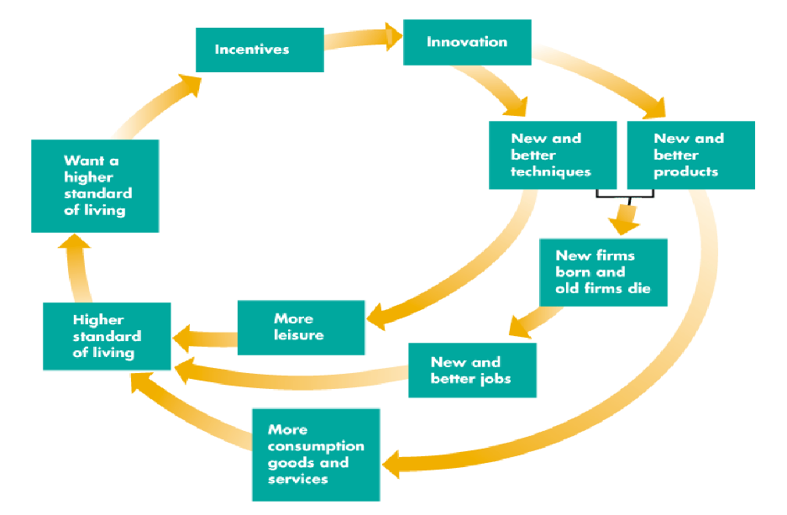

Chapter 23:
Physical Capital: tools, instruments, machines, buildings…. To produce goods and services
Financial Capital: funds used to purchase those
Financing investment (usually by saving) brings new capital and grows the economy
Interest rate = interest payment / price of the bond x 100%

Loanable funds Market:
Investment (I) = S + (T-G) – NX
S (private savings), T (tax revenue), G (gov expenditure), NX (net exports)
S + (T-G) = National saving
Nominal interest rate: amount paid/received as % of amount borrowed/lent
Real Interest rate: removes the effects of inflation
= Nominal interest rate – inflation rate

Demand curve for Investments, x: real interest rate, y: loanable funds, line: investments (borrowing funds to buy physical capital)
Increase in investment = increase in quantity demand for loanable funds (v.v.)
Demand curve shifts right: when expected profits (from new capital) increase (v.v.)
Increased interest rate = decreased investments
Decreased interest rate = increased investments
Default risk: risk of loan not being repaid

Supply curve for Savings: x: interest rate, y: loanable funds, line= the total funds of private savings, gov surplus, international borrowing
Increase in savings = Increase in supply of loanable funds (v.v.)
Supply curve shifts right when:
Disposable income increases
Expected future income decreases
Wealth decreases
Default risk decreases
Increased interest rate = increased loanable funds supplied (v.v.)
Supply = demand, when investments = savings
(assumed the government balance is balanced, taxes = expenditures)
Surplus of funds = interest rate decrease
Shortage of funds = interest rate increase
Supply and demand curve shifts act normally

Government budget surplus: Increases supply, adds funds on top of PSLF, the gap = gov surplus
Investment increases, personal savings decrease

Government budget deficit: Increases demand, adds needed funds to PDLF, the gap = gov deficit
Creates Crowding out effect: When personal demand, and therefore investment is pushed out by the government demand: Interest rate increases, investment decreases

Ricardo-Barro Effect
When government budget is in a deficit, rational taxpayers increase savings (shifting supply right) and keep interest rates stable. Thus, has no effect on investments and interest rate.
Not always used, may be partial, use when specified.

Chapter 24
Money, the Price Level and Inflation
Money: commodity accepted as settling debt/payment
- Means of payment: settling debt
- Medium of exchange, unit of account, store of value
- In Canada: currency (coins/notes) in circulation (not in banks, ATMs….) and bank deposits
- M1: currency held by people and businesses, chequable deposits (personal & non-personal)
- M2: non-chequable deposits (savings?, personal & non personal), fixed term deposits, and M1

Depository Institutions
Bank of Canada (B): Canadas central bank, supervises, independent, lender of last resort, sole issuer of bank notes, money policy
- Assets: Government Securities (bonds used to pay Gov deficits), Loans to Institutions
- Liabilities: BoC notes ($bills), not coins!, Depository Institution Deposits
- Monetary base: All BoC notes, Coins, Depository Institution Deposits at BoC (All coins/notes + liabilities)
Changing monetary Base: (Open market operations)
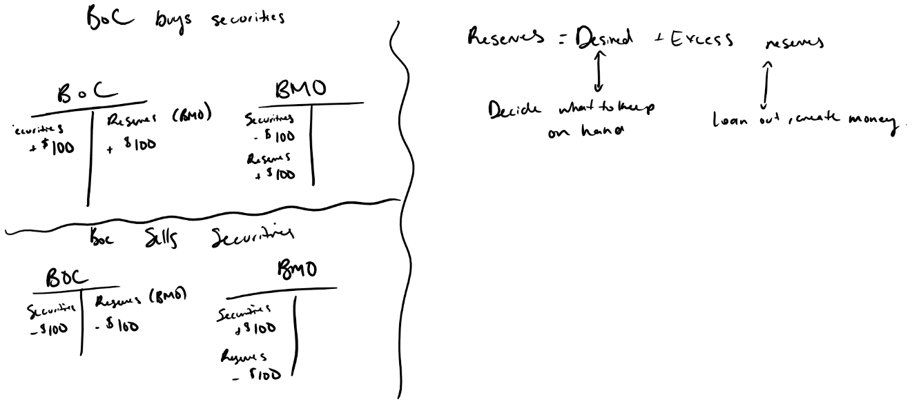
Buying and Selling Government Securities
Creating Money:
By loaning out money
Desired Reserve Ratio: the % of deposits the bank holds
- Desired reserves/Deposits
Actual Reserves – Desired Reserves = Excess reserves (to loan)
Currency drain: leakage of currency from the banking system, the new money that does not return to the bank in deposits
- Ratio = Currency/Deposits
Money Multiplier = (1 + Currency drain ratio) / (Currency drain ratio + desired reserve ratio)
Creating Money:
- Banks have excess reserve
- Lend the excess reserves
- Quantity of money increases
- New money makes payments
- Some goes on deposits, some is currency drain
- Desired reserves increase due to increased deposits
- Excess reserves decrease, but positive

Money Market
Quantity of money held: determined by price level, nom interest rate, Real GDP, Financial innovation
Measured in dollars = Nominal Money
Measured in constant dollars = Real Money
- Real Money = Nominal Money / Price Level
- Real money is independent of the price level
Nominal Money held is proportional to the price level
Quantity of real money held is dependant on the interest rate (the opportunity cost of holding money)
- High rates = more missed out, higher opp. cost, thus hold less
- MOVEMENT ALONG THE MONEY DEMAND CURVE

Quantity of Real money held depends on Real GDP, higher GDP, more transactions, more held
- GDP increase shifts Demand curve right, decrease = left

Quantity of real money held depends on Financial Innovation (ATMs, interest chequing accounts, Debit/Credit cards, Internet banking)
- GENERALLY decreases the demand for money to ease and less need to hold money

Demand for Money curve:
Real money demanded vs Nom Interest Rate

Money Market Equilibrium

Interest rate: amount received by a lender and paid by borrower, as percentage of the loan
When high, people economize and put holding money into bonds, opposite when low

Quantity of real money supplied depends on the price level and the quantity of Nom Money the BoC enables banks to create, thus determined by BoC actions

Interest Rate is determined by the where D=S

- If rate above equilibrium, people buy bonds, bond prices rise, but it means interest rates on the bonds decrease back to equilibrium
- If below equilibrium, people don’t buy bond or sell, bond prices fall, meaning the interest rates on bonds goes up, back to equilibrium

Quantity Theory of Money
In the long run, an increase in the quantity of money brings an equal percentage increase in the price level: Supply right, interest rates fall, more spending and borrowing, since at full employment, the excess demand for goods is not met with supply thus prices rise to bring equilibrium, thus Price up same % as money increase
Velocity of circulation: average number of times a dollar is used annual to buy goods/services that make GDP
- Velocity (V) = Price level (P) x Real GDP (Y) (=Nom GDP) / Quantity of Money (M)
- Rearrange: Equation of Exchange, MV = PY (rate)
- Thus, Inflation rate (P) = M + V – Y (Rates)
- Change in V in the long run = 0

Chapter 25:
Exchange Rates and Balance of Payments
Foreign exchange market
Foreign currency: foreign notes, coins, deposits
Currency appreciation/depreciation: when one currency’s value goes up/down compared to another currency
Exchange rate: value of one currency for the other, determined by supply and demand on the foreign exchange market
Factors of Canadian Currency Demand
- Exchange rate
  - Higher the exchange rate, less quantity demanded
  - Lower the rate, more quantity demanded
    - Due to Exports effect (cheaper/more expensive), Expected profits (if low there is high potential for profits and gains, expecting the currency to appreciate and make profit, vv if low)
  - Demand for Canadian exports up, more currency circulated, when exchange rate low
Supply
- Exchange rate
  - Imports effect, when the exchange rate is high, canadians have more buying power and buy more imports, vv
  - Expected profits effect, when exchange rate high, can buy more foreign currency (cheaper relative) and make profits
Exchange rates fluctuations
Demand
- Interest rates in Canada and in the world
  - Canadian interest rate differential = Can interest rate – foreign interest rate
    - Point basis for every 0.01 percent difference +/-
    - Larger differential, more investment in Canada, the more currency bought
- Demand right if
  - Demand for exports increase, interest rate differential increases, expected future exchange rate rises
- Left if vv
Supply
- Increases when import demand increases, interest differential decreases, expected future exchange rate falls
- Decreases when import demand decreases, interest rate differential increases, expected future exchange rate increases
EFFECTS ARE OPPOSITE AND EQUAL IN AMOUNT (interdependent), except for the change in exchange rate
Differences:
- Demand only will increase/decrease when world income increases/decreases
- Supply only will increase/decrease when Canadian income increases/decreases

Purchasing power parity: equal value of money, same amount of goods should be able to be bought with either currency, not always the case, but it is expected to adjust if there is a difference
Interest Rate parity: equal interest rates, after adjusted for risk, always prevails

Exchange rate policy
- Flexible exchange rate: leave exchange rates to supply and demand forces
- Fixed exchange rate: gov or central bank decides on exchange rate (link with another currency?)
- Crawling peg: target path for exchange rate with intervention to achieve
Recall:
- Nom GDP / Price level = Real GDP
- Nom Interest Rate – Inflation Rate = Real Interest Rate

- Real Exchange rate (RER) = Nom ER x Price level (domestic) / Price level (foreign)

Financing International Trade
Balance of payments: international borrowing, trading and lending (+ when CAD enters canada, - when leaving)
- Current account: exports (+), imports (-), net interest (+/-), Net Transfers (-) (foreign aid)
- Capital and Financial Account: Foreign investment in Canada (+), Cnd investment in world (-), Statistical discrepancies (+/-)
- Official settlements Account: changes in official reserves (- if increased, + if decreased, gov holdings of foreign currency, spend or get back CAD when exchanging)
- All accounts MUST add to zero
Extra:
Income approach: Y = C + I + G + X – M
Y = C + S + T
Thus, C + I + G + X – M = C + S + T
X – M = (S – I) + (T – G),
with S – I being private sector balance (relatively constant), and T – G being government sector balance
_____________________________________________________________________________________
Chapter 26:
Aggregate Supply and Demand
Aggregate Supply
Long run aggregate supply: relationship between quantity of real gdp supplied and price level (when money wage rate changes in proportion to price level to achieve full employment, potential GDP)
- Movement along: changes in price levels, the money wage rate/resource prices
- Since both Price level and factor prices change, REAL FACTOR PRICES remain constant
- Real wage rate remains at the level that achieves full employment
- Rise in price level and money wage rate that maintains full employment brings movement along LAS
Short run aggregate supply: quantity of real GDP supplied, and price level when:
- Money wage rate, prices of other resources and potential GDP remain constant
- Real wage rate decreases as quantity supplied goes up, since money wage constant and price level increases, thus supplying more when production is cheaper
- Rise in price level at constant money wage rate that maintains full employment brings movement on SAS
LAS Changes when potential GDP rises, which rises when:
- Change in full-employment quantity of labour
- Change in quantity of capital
- Advance in technology
When potential GDP rises, both LAS and SAS shift rightwards equally
LONG TERM CHANGES CHANGE SHORT TERM, NOT ALL SHORT TERM CHANGES CHANGE LONG TERM
SAS shifts when:
- Money wage rate changes (left if increases)
- Change in oil prices
- Change in factors of production
  - These do not affect LAS

Aggregate Demand
Quantity of real GDP demanded, Sum of C+I+G+X-M
Depend on:
- Price level
- Expectations
- Fiscal Policy and Monetary policy
- The world economy

Quantity of GDP demanded, influenced by price level, changes when Y=C+I+G+X-M changes
AD slopes downward due to
- Wealth effect (when price rises, all being constant, real wealth decreases, thus less spending), substitution effect (when price level rises, interest rates rise due to less money in circulation as people save, thus loan at higher rates, increase saving to substitute for future spending over current)
Other influences:
- Expectations
  - About future income, D up when expected to go up, vv
  - About inflation, D up when increases, vv
  - About profits, D up when increases, vv
- Fiscal Policy: gov attempt to influence economy (taxes, transfers, purchases)
  - D up when: increased G expenditure, decrease T, increase transfer payments
  - D down when: decrease G expenditure, increase taxes, decrease transfer payments
- Monetary Policy: change of interest rates, quantity of money by BoC
  - D up when: increased Monetary base, decreased interest rates
  - D down when: decrease monetary base, increase interest rates
- Foreign Exchange rates
  - D up when: foreign exchange rates decrease (more exports as our goods are cheaper, less imports), and foreign incomes increase
  - D down when: foreign exchange rates increase (more expensive exports, cheaper imports) and when foreign income decreases

Explaining Macroeconomic Trend Fluctuations
Short run Macro equilibrium, when SAS = AD
Long run Macro equilibrium
- When Real GDP = Potential GDP, and economy is on the LAS curve
- When AD increases, the money wage rate adjusts so that the SAS curve passes through the LAS at the same point
  - Business cycle occurs because money wage rate does not adjust enough to keep real GDP at potential
- When AD increases by more than LAS, then inflation occurs, Price level up
  - LAS increases over time via economic growth, as labour grows, capital accumulates, technology advances
Short run:
- Above full employment equilibrium, when AD shifts right
  - Where Real GDP exceeds potential GPD, inflationary gap
To bring back to equilibrium, since money wage rate is fixed on SAS, the real wage rate will fall due to price increase, higher wages demanded and money wage rate will rise, shifting SAS left back to equilibrium (long run)
- Below full employment equilibrium:
  - Where potential GDP exceeds Real GDP, recessionary gap
Stagflation: when Real GDP decreases, and price level increases (caused by factor price increase, oil)
Occurs until the price change is reversed or AD increases

Government intervenes by increasing G and shifting AD right?

(both create output gaps, when theres a difference in real and potential GDP)

Chapter 27: Expenditure multiples

Most direct factor influencing expenditure and saving:
- Disposable income: real GDP/aggregate income minus net taxes (taxes minus transfer payments)
  - Y – T = YD = C + S
Relationship between expenditure and disposable income is the consumption function
Relationship between saving and disposable income is the saving function
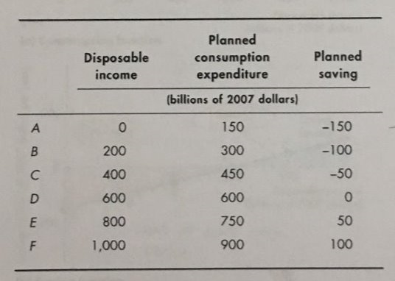
When income 0, still spend money to live, not saving therefore borrowing

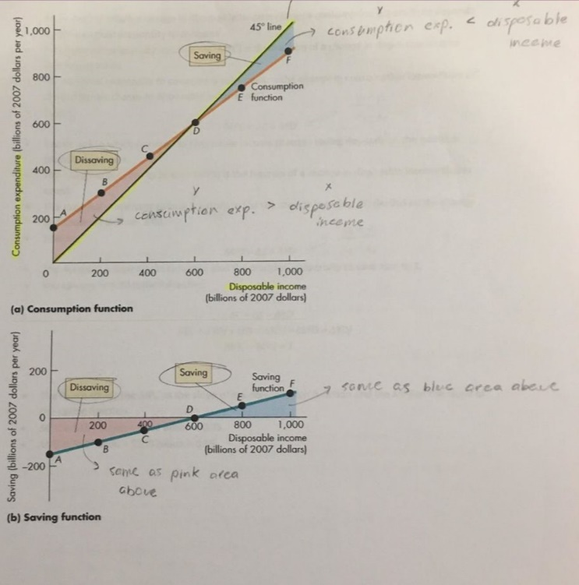
There is a 45-degree line for consumption
Y=x
(because marginal consumption + marginal savings = 1, their slopes)
The red line is the consumption function
When greater than 45, saves, when less, dissaving

Saving function is blue, start saving when passing y=0 at the same point as consumption function

The extent to which a change in disposable income changes consumption/saving depends on marginal propensity to consume/save
- Marginal propensity to consume (MPC), slope of consumption function, change in disposable income that is consumed
- Change in consumption expenditure / change in disposable income
  - Y2 – Y1 / X2 – X1

- Marginal propensity to save (MPS), slope of saving function,
- Change in savings / change in disposable income
MPS +MPC = 1
- C+S=YD
- ΔC+ΔS=ΔYD
- Divide all by ΔYD
- MPC+MPS=1
The relationship between imports and real GDP determined by the marginal propensity to import
- Change in imports / change in real GDP

Real GDP and a Fixed Price Level
Aggregate planned expenditure = [planned] consumption + investment + gov expenditure + exports – imports
- As a curve (AE)
  - Two parts:
  - Autonomous expenditure: necessities, investments/gov ex/exports that do not vary with GDP
  - Induced expenditure: wants, changes as income changes, consumption expenditure minus imports
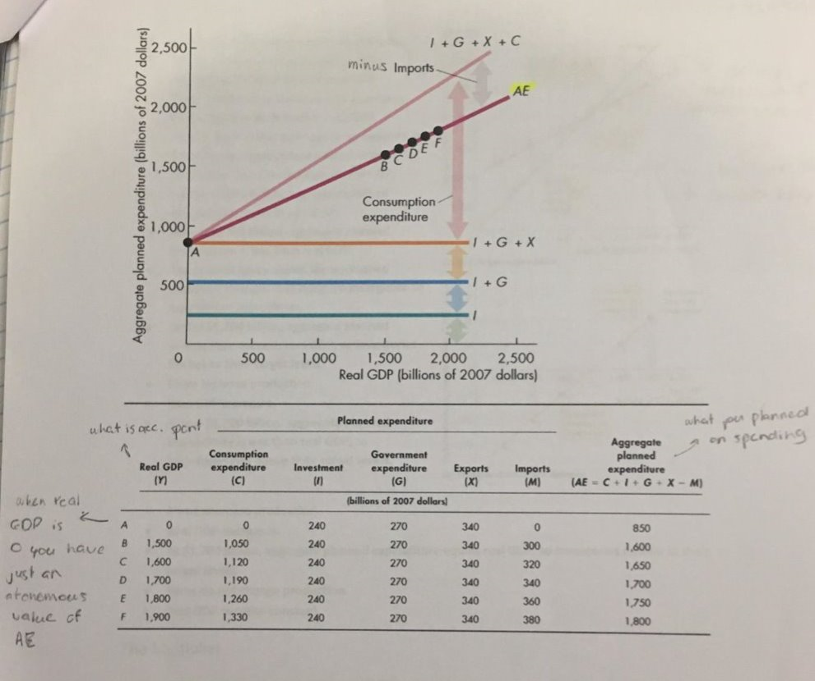

Actually spent vs what was planned

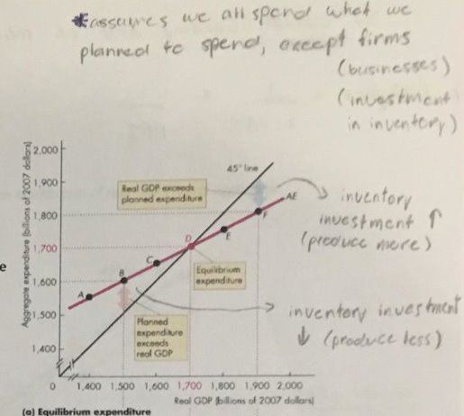
AE curve, is what we pan, 45 degree y=x is what is actually spent at each level of real GDP

When below, planned expenditure is less than RGDP thus inventory investments fall

When above, RGDP is above planned AE, thus inventory investments increase

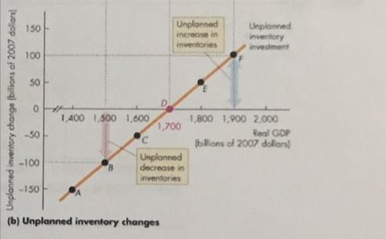
the changes in the inventory levels

To get to equilibrium, we spend more/less on inventories

The multiplier
Change in expenditure generates a change in income
Change in income induces a change in Consumption expenditure
Change in consumption expenditure increases income…
The multiplier is the amount by which a change in autonomous expenditure is magnified/multiplied to determine change in equilibrium expenditure and RGDP
- Multiplier = ΔRGDP / ΔAggregate planned expenditure
- 1 / 1-slope of AE curve
A change in investment vertically shifts the AE upwards/downwards, changing the new aggregate expenditure and RGDP equilibrium up/down by the investment change multiplied by the multiplier
Also, a change in price level changes the AE curve, and creates a shift of the equilibrium along the AD curve
- Decrease in price level increases AE and moves up along the AD
- Increases in price level decreases AE and moves down along the AD
Increase in investment, shifts the AE curve up, but also shifts the AD curve by the multiplier

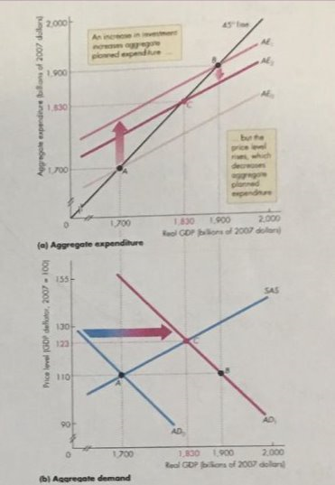
Short run, increase in investment increases the AE curve up, multiplying and shifting the AD curve right, which creates movement up the SAS curve, thus raising the price level

The rise in price level then decreases the AE curve down to a lower equilibrium
Short run multiplier, change in RGDP / change in AE, after the fluctuations

In the long run, same thing, AE increase (autonomous expenditure increases), shifting AD, raising price, lowers AE, but then the Short run equilibrium is above Potential GDP, so money wage rate rises, and SAS curve shifts left due to increased costs, this then returns to potential, raising the price level again, lowering AE back to its original position
The increases in autonomous expenditure just created a temporary increase in real GDP, but a permanent increase in price level
Therefore, since GDP returned, the long run multiplier is always ZERO
Extra work:
If closed economy: marginal tax rate, Multiplier = 1/1-MPC = 1/MPS

Chapter 29

Federal Budget: made up of government revenues and outlays
Fiscal policy: use of the federal budget to achieve macroeconomic objectives (full employment, sustained long-term economic growth, price level stability
Government Revenue: Personal Income tax, Corporate income tax, Indirect and other taxes, Investment income
Highest: Personal income tax, indirect taxes, corporate, and investment?
Outlays: Transfer payments (payments to provincial governments), expenditures on goods and services, Debt Interest (highest to lowest)
Difference in revenues and outlays: surplus, deficit, balance
Relatively Balanced (1960s – 1975), Deficit (1975 – 1995), Surplus (1995 – 2007), deficit until now
Government borrows to finance debt
Supply-Side Effects of Fiscal
Decrease in taxes:
- Cut in income taxes = increase in supply of labour
- Cut in capital taxes = increase in investment and saving
Increase in Income tax an labour = decrease in equilibrium quantity of labour
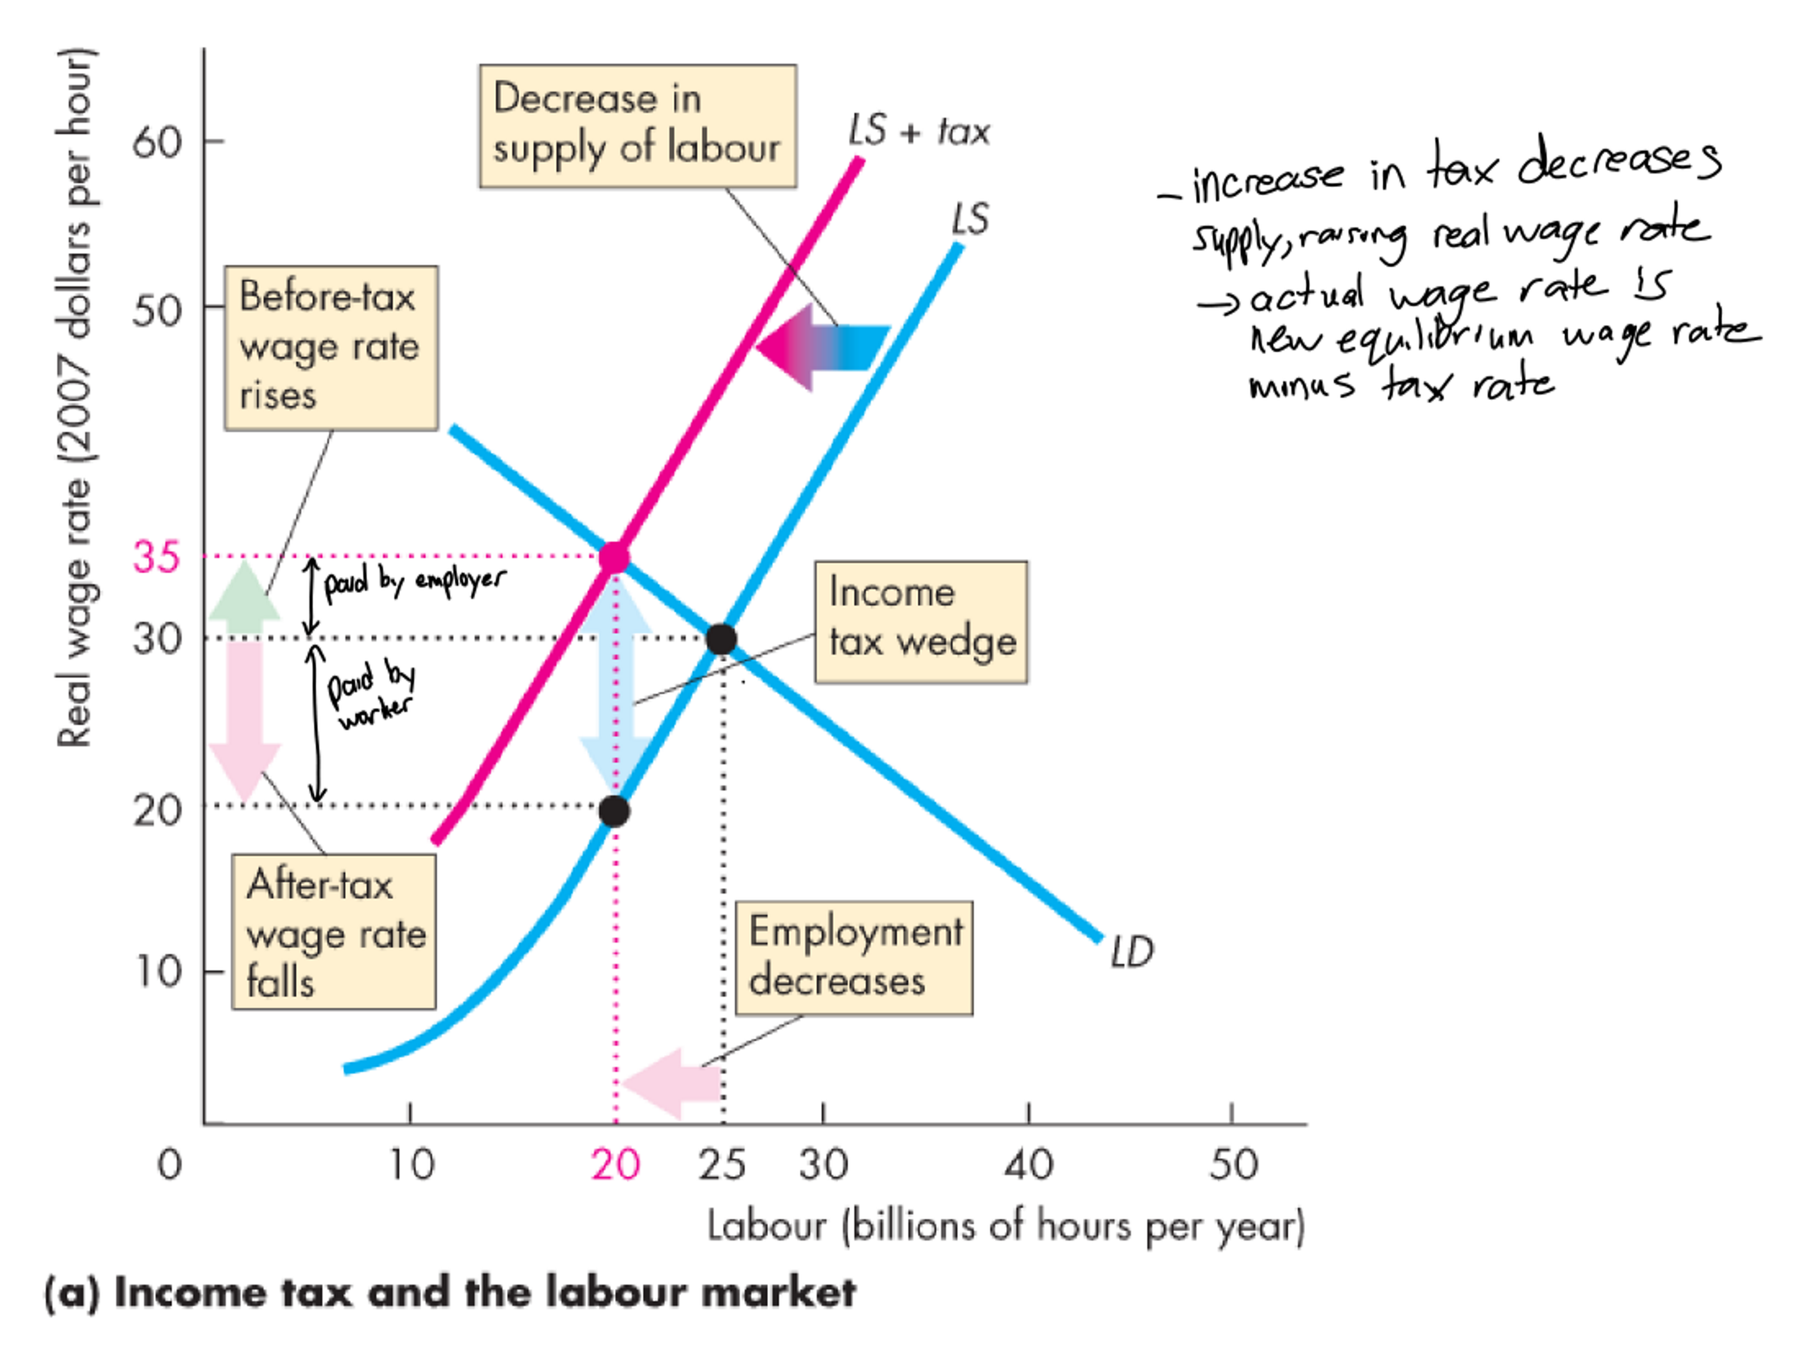
Less labour = decrease in potential GDP
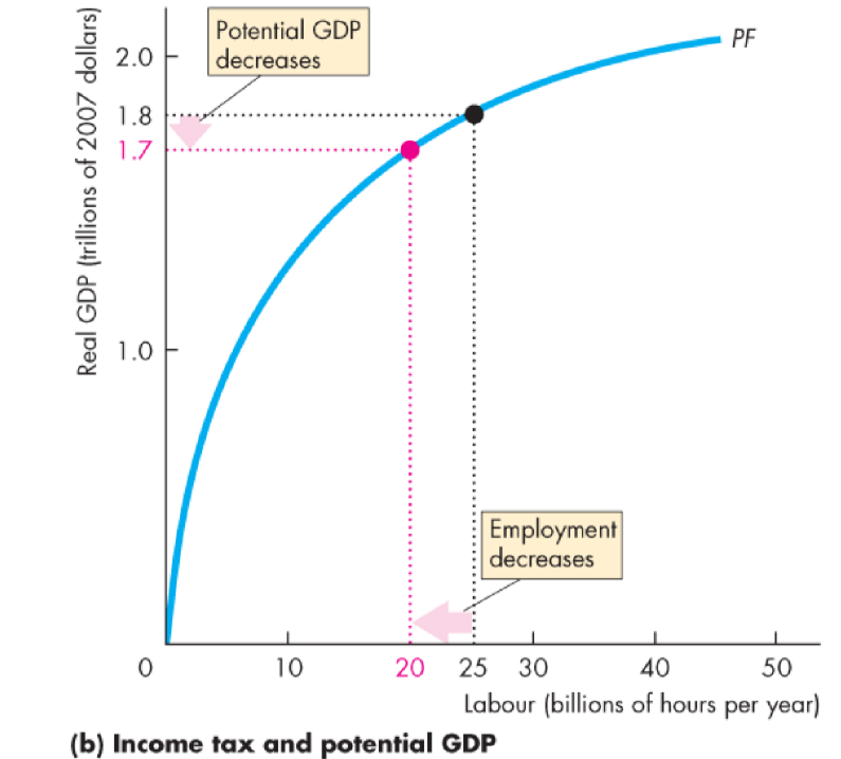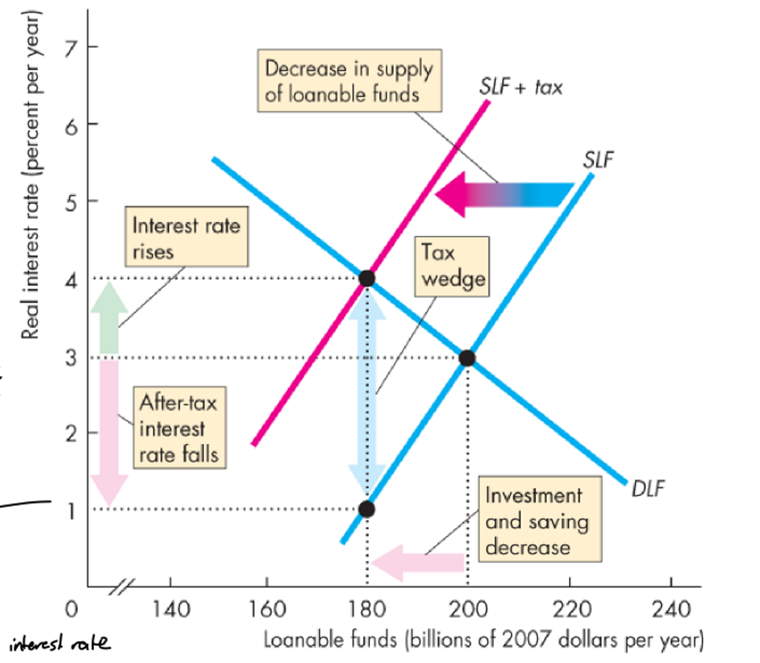
After tax interest rate:
- Nominal interest rate x tax rate (decimal)
- Nominal interest rate – (above number)
- (above) – inflation rate
- = Real interest rate after tax
Laffer curve: shows how tax revenue increases until it drops
Automatic Fiscal policy: change in fiscal policy triggered by the state of the economy
Discretionary Fiscal policy: action that is initiated by parliament
Government expenditure multiplier:
- Change in government expenditures on goods and services on equilibrium aggregate expenditure and real GDP
- 1 / (1-AE slope)
Tax multiplier:
- Magnification of change in taxes on aggregate expenditure and real GDP
- Autonomous tax multiplier = -MPC / 1-AE slope
Increase in taxes = decrease in disposable income = decrease in equilibrium expenditure
(magnitude dependant on MPC curve and slope of AE curve)

Structural surplus/deficit: budget balance resulting when economy @ full employment and RGDP = potential
Cyclical surplus/deficit: budget balance resulting when potential in not moving, but RGDP is more or less than potential
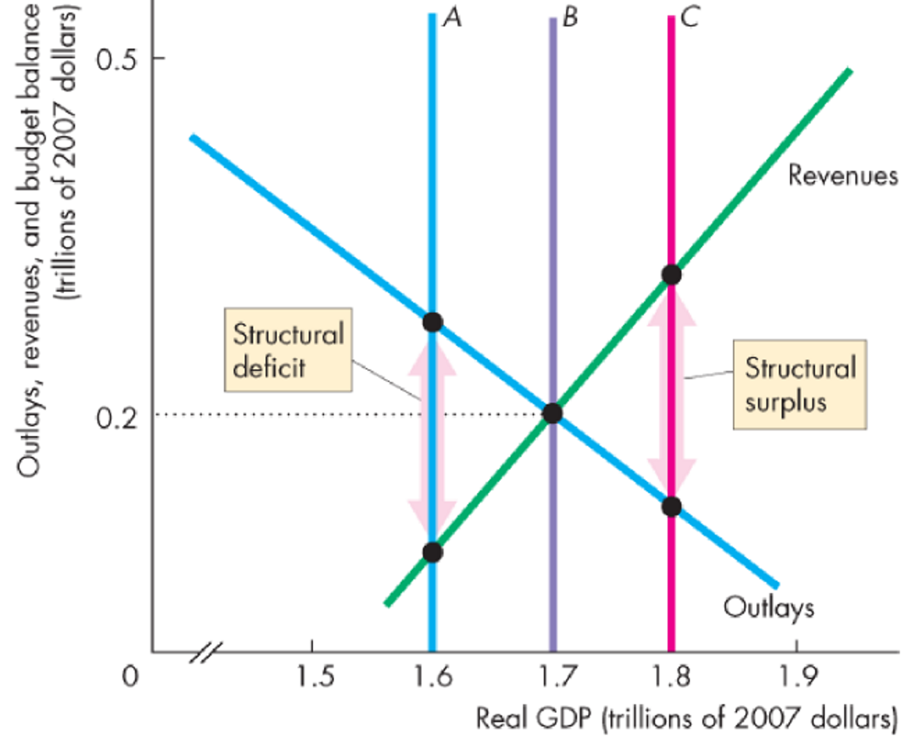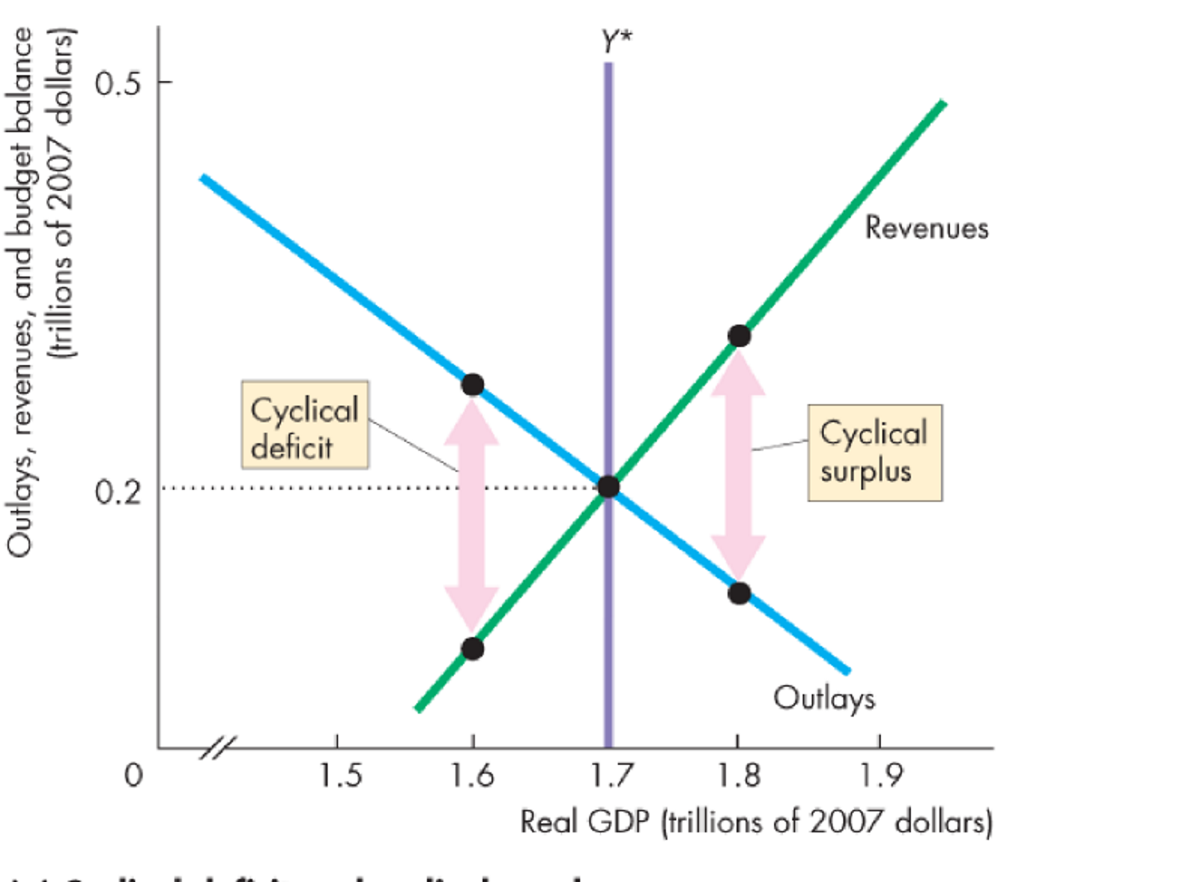

Chapter 30
Objective of Monetary Policy: given in Bank of Canada Act 1935
- Regulate credit and currency for the best of the economy
- Main goal is to avoid inflation
- Inflation control target between 1 and 3 percent, aiming for 2
  - Doesn’t use core CPI inflation rate
  - Core Inflation: % change in CPI excluding 8 most volatie prices
- Inflation Rate Targeting: strategy to commit to target and explaining how
Conduct of Monetary Policy
Bank controls quantity of money, price of CAD on foreign markets, opp cost of holding money (interest rate)
Specific rate the Bank targets is the overnight loans rate
- Interest rate on overnight loans that big banks make to e/o
- Rate adjusted by changing reserves of Banks
Operating Band: target overnight rate (+/- 0.25 percentage points)
- Created by setting two other rates: bank rate and interest rates on reserves
  - Bank Rate: interest rate BoC charges big banks on loans
- The settlements balance rate = interest rate on reserves
Open Market Operations: purchase/sale of government securities, treasury bills/gov bonds
- BoC buys securities, it injects reserves into Banks
- Thus, the monetary base increases
- Banks increase lending, quantity of money increases (multiplier)
- Overnight rate falls

- BoC sells securities: reduces bank reserves
- Monetary base decreases
- Reduced/recalled lending, quantity of money decreases
- Overnight rate increases

Ex 1.75 ---------------------------Bank rate (0.25 above target inflation rate)
1.50----------------------------Overnight loans rate
1.25----------------------------Settlement Balance rate (interest rate on reserves)
Instrument rule: sets policy instrument based of current state of economy
Targeting rule: sets policy instrument at level that can forecast to equal the target in future

Increase overnights loan rate to counter Inflationary gap, vv

When quantity of money decreases (selling), the interest rate rises and so does the exchange rate
- High interest rate = decreased consumption expenditure and investment
- Higher exchange rate = exports more expensive, imports cheaper, = net exports decrease
- Aggregate demand decreases = RGDP decreases = price level decreases
- 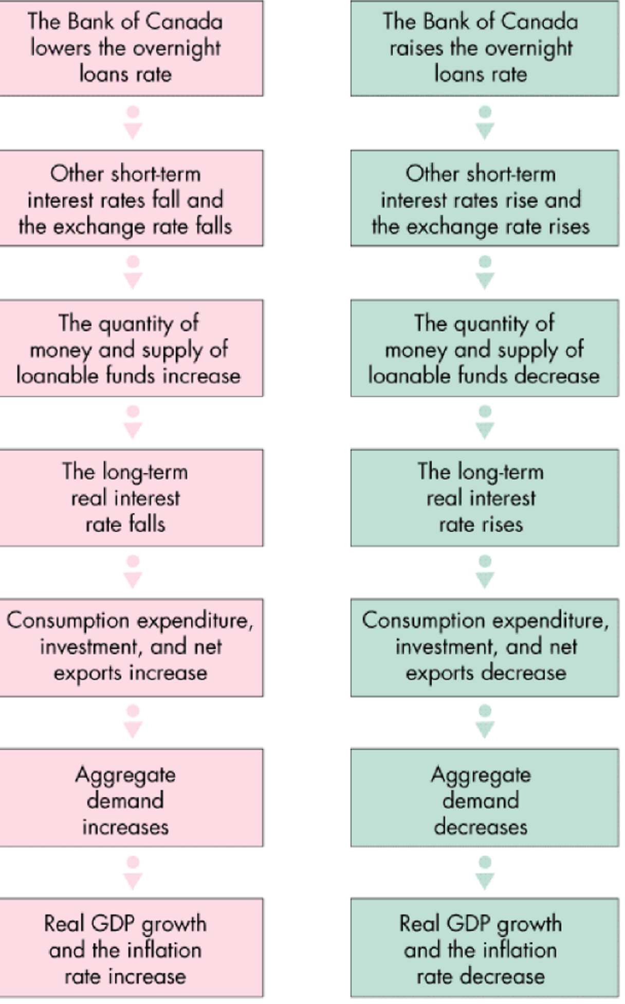Red = Purchase, green = sale
- Change in aggregate demand = increase in planned expenditure + change in autonomous expenditure (influenced by the multiplier effect ch 27)

Taylor Rule: theoretical formula used to set the overnight loans rate
R = 2 + Inflation rate + 0.5(Inf rate – 2) + 0.5(output gap)

Chapter 31
Global Markets
Comparative advantage: when one can perform activity or produce at lower opp cost than another
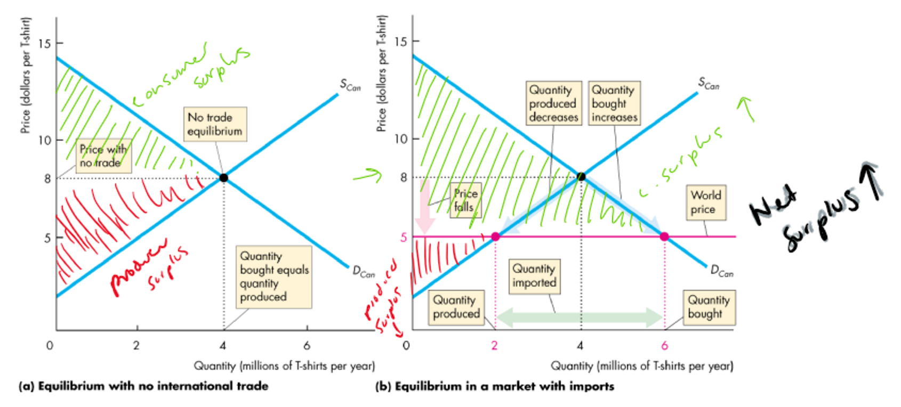
World price below domestic, thus comparative advantage to the world, we import the gap of QD and QS in domestic market, consumers gain, producers lose
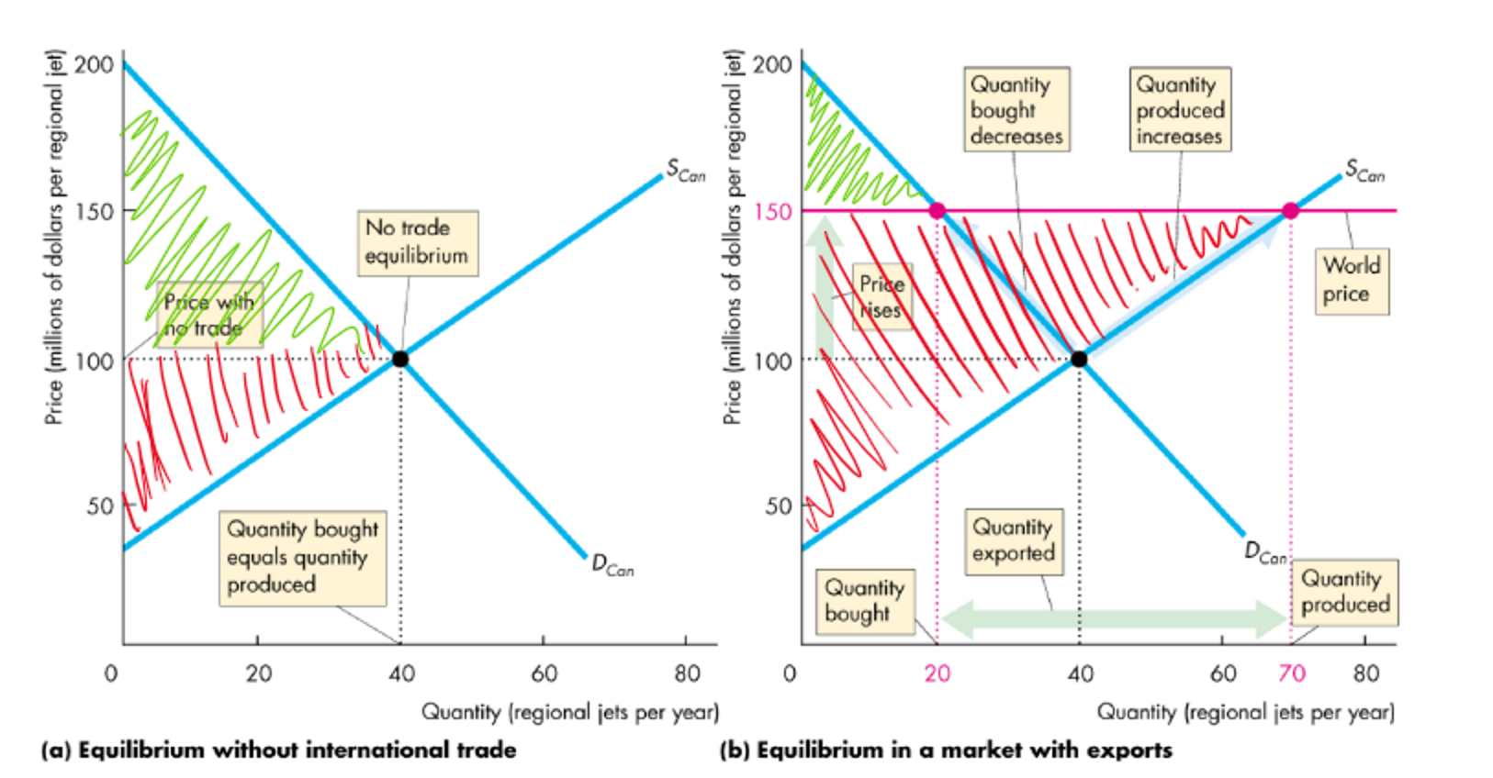
World price above domestic, thus we have comparative advantage, we export the gap of QD and QS, consumer lose, producers win

Both cases: net surplus increases in economy

Tariffs, added on top of world price (below domestic equilibrium, hence we are importing and taxing imports)
Amount imported decreases as gap between QD and QS shrinks
Producers gain (increase Q and charge more), Consumers lose (decrease Q and pay more)
Revenue = QD/QS gap x the tariff amount
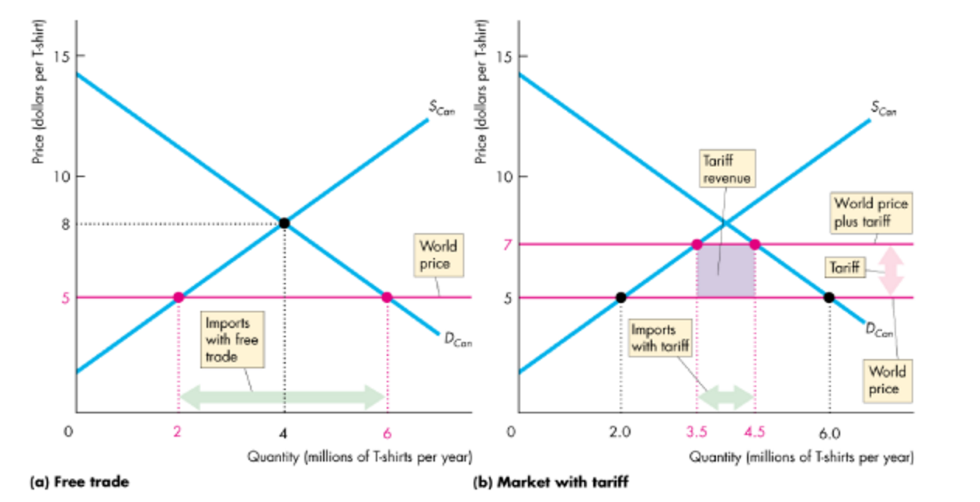
Import Quota (Protectionism): restriction limiting the quantity of goods imported in a period
Protects the domestic producers, S domestic increases by the quota amount, the price rises to new equilibrium from the world price
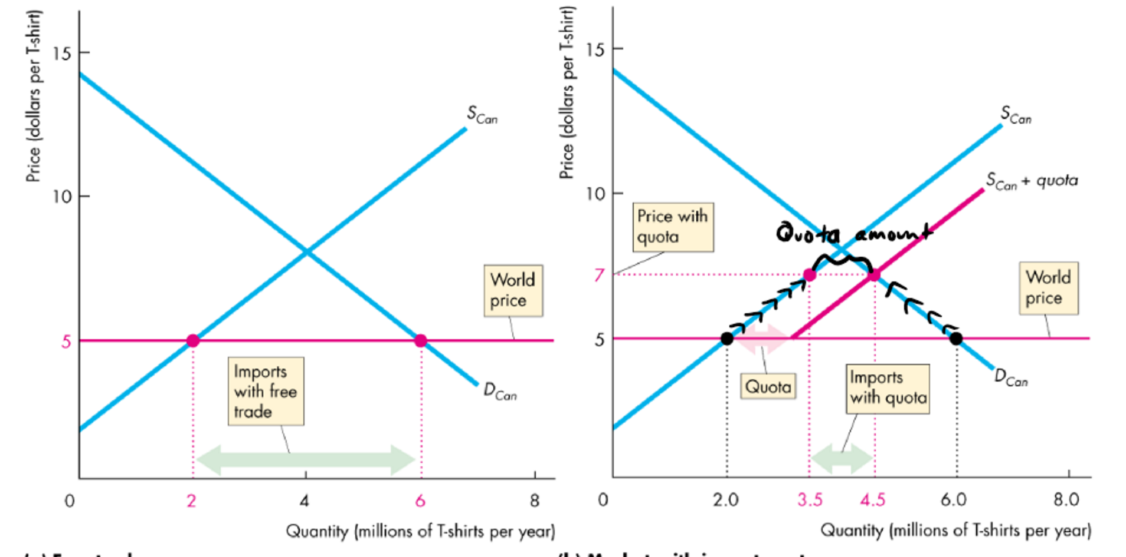
Cases against protection:
Infantry Industry Argument: protect new industry to help grow against world markets
- Subsidy is more efficient,
- The profit potential is enough incentive for owners to mature the growth of industry
Dumping: when foreign firm sells exports at price below production cost
- Impossible to detect
- No global monopolies, if there was, anti-monopoly rules are necessary
  - (she said something about different countries’ markets having different elasticity for products, so hard to compare)
Other flawed arguments:
- Allows us to compete with cheap labour
- Penalizes lax environmental standards
- Saves jobs
- Prevents rich countries form exploiting poor (actually raises standard in the countries as S shifts right, increases wages thus standard)
Major reason for restriction: Rent Seeking,
- Lobbying gov for special treatment to create profit/divert consumer/producer surplus from others

