Exp 1: Thin Layer Chromatography

Lab Section:
TA:
January 15th, 2018

Protocol:
See laboratory manual pages 17-19
Observations:
-Majority of the liquids were clear, and non-viscous.
-Any chemical with acetate smelled like acetate, and had a very strong and pungent smell
-The unknown liquid XX was slightly yellow
-The sample A (ortho bromonitrobenzene) was also slightly yellow and appeared similar to unknown sample XX
-The hexane substances had a different smell unlike the rest and was much more mild similar to that of gasoline
-The silica layer on the TLC strips were easily worn off and scratched
TLC:
Part A:
Figure 1: Unknown Sample #71 and Benzophenone in EtOAc:Hexanes (2:8)

Figure 2: Unknown Sample #71 and Biphenyl in EtOAc:Hexanes (2:8)

Part B (Ethyl Acetate):
Figure 3: Unknown Sample #71 and Benzophenone in EtOAc

Figure 4: Unknown Sample #71 and Biphenyl in EtOAc
Part B (Hexanes):
Figure 5: Unknown Sample #71 and Benzophenone in Hexanes

Figure 6: Unknown Sample #71 and Biphenyl in Hexanes
Part C:
Figure 7: Unknown Sample XX and Compound A in Hexanes:EtOAc (9:1)

Figure 8: Unknown Sample XX and Compound B in Hexanes:EtOAc (9:1)
Figure 9: Unknown Sample XX and Compound C in Hexanes:EtOAc (9:1)

Calculations:
Part A: Sample Rf calculation (Biphenyl):
Rf = d1 / ds
Rf = 3.0 / 4.1
Rf = 0.73

Figure 10: TLC Spot Analysis of Sample XX (3rd lane) in para-bromonitrobenzene

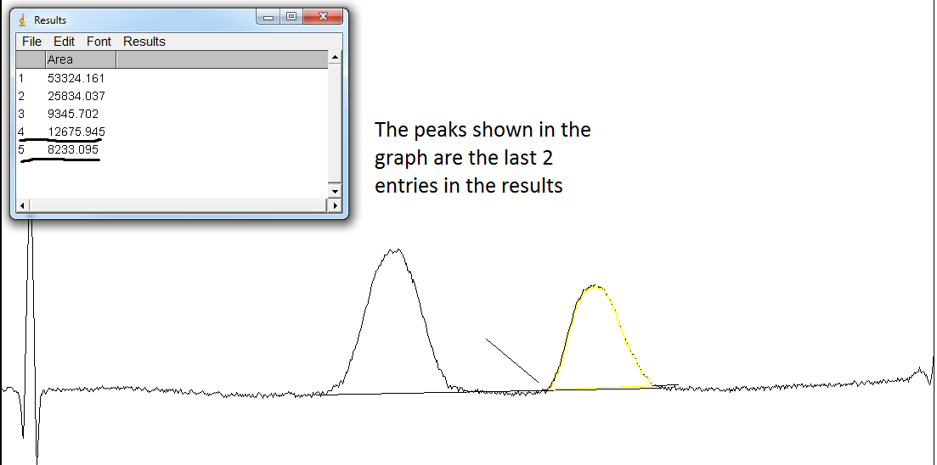

Percent Absorbance

Absorbance of ortho-bromonitrobenzene (peak 2) = 8233.095 Absorbance of para-bromonitrobenzene (peak 1) = 12675.945

- Absorbance of ortho-bromonitrobenzene

  - [Absorbanceortho / (Absorbanceortho + Absorbancepara)] x 100%

  - [8233.095 / (8233.095 + 12675.945)] x 100%

  - (8233.095 / 20909.04) x 100%

  - 0.39375 x 100%

  - 39.4% ortho-bromonitrobenzene

- Absorbance of para-bromonitrobenzene

  - [Absorbancepara / (Absorbanceortho + Absorbancepara)] x 100%

  - [(12675.945/ (8233.095 + 12675.945)] x 100%

  - (12675.945 / 20909.04) x 100%

  - 0.60624 x 100%

  - 60.6% para-bromonitrobenzene
  - 69.5% para-bromonitrobenzene

Mole Percentage

y = Absorbance of ortho-bromonitrobenzene = 39.4% y = 1.0114x - 2.0208

x = (y + 2.0208) / 1.0114

x = (39.4+ 2.0208) / 1.0114

x = 41.4208 / 1.0114

x = 40.9539

- Mole ortho-bromonitrobenzene = 40.9539%

- Mole para-bromonitrobenzene = 100% - 40.9533% = 59.0461%

Discussion Questions:
1. Increasing the polarity of the solvent system should slow down the travel time of the spots on the TLC plates. This is due to intermolecular forces, where the polar solvent will get attached to the chemical that is the spot. This will cause the chemical to not travel as far and will decrease the Rf (retention factor). If a non-polar molecule is used it should get unaffected by this polar solvent as there will be little to none interactions between the polar and non-polar molecules.
2. 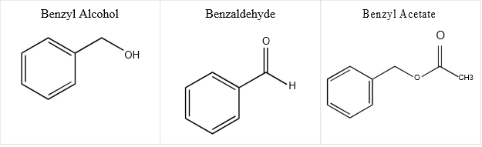

- Benzyl alcohol will have the smallest Rf value as the exra hydroxyl group makes the molecule more polar.
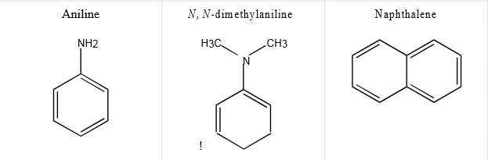

- Aniline will have the smallest Rf value as NH2 is very polar and can form most hydrogen bonds.

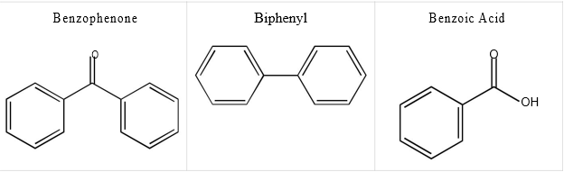
- Benzoic acid will have the smallest Rf value as the hydroxyl group and the double-bonded oxygen increase polarity.

The goal of this experiment was to separate and identify different compounds by using a method known as thin layer chromatography. TLC allows chemicals to be separated by their polarity, and with the use of a reference chemical and calculate the Rf (retention factor). Throughout the experiment several different eluents were used to test different mixtures and see which ones interacted the most. In Part B (EtoAc) the solvent was way too weak and allowed for all of the solutions to move up the TLC plate. The solvents used in parts A and B (hexanes) were much more effective as they had different polarities and therefore provided different Rf factors. In part C, a sample was tested and compared with 3 different isomers of bromonitrobenzene; ortho, meta, and para. 3 different tests were carried out to see which of the isomers were present in the unknown sample.

Based on the results from this experiment, the sample 71 was found to be benzophenone and for part C the unknown sample XX was found to be a 40-60 ratio of ortho to para bromonitrobenzene. Sample 71 was found to be benzophenone as it had the same Rf as the stock solution of benzophenone. This result was proven across both different eluents and reference solutions in parts A and B. Sample XX was concluded to be the ortho-para mixture as its Rf matched with that of the sample solutions of the different isomers of bromonitrobenzene.

Errors throughout the experiment could be due to human error or carelessness. One of the biggest causes is spotting too much solution on the plate. As the solutions were mostly clear it is very difficult to track their behaviour. This could result in double spotting or not spotting at all as well as leaks which would all cause the result to be inaccurate. Adding too much eluent was also a source of error as there was a possibility of the plate being submerged in the solvent. This would result in splotching of the spots and a result will not be able to be concluded. Both of these errors can be solved by ensuring and practicing the techniques utilized during the lab including proper use of the capillary tubes and of the proper placement of the TLC plates in the eluent.

Appendix 1: Drawn T LC plates with measurements:
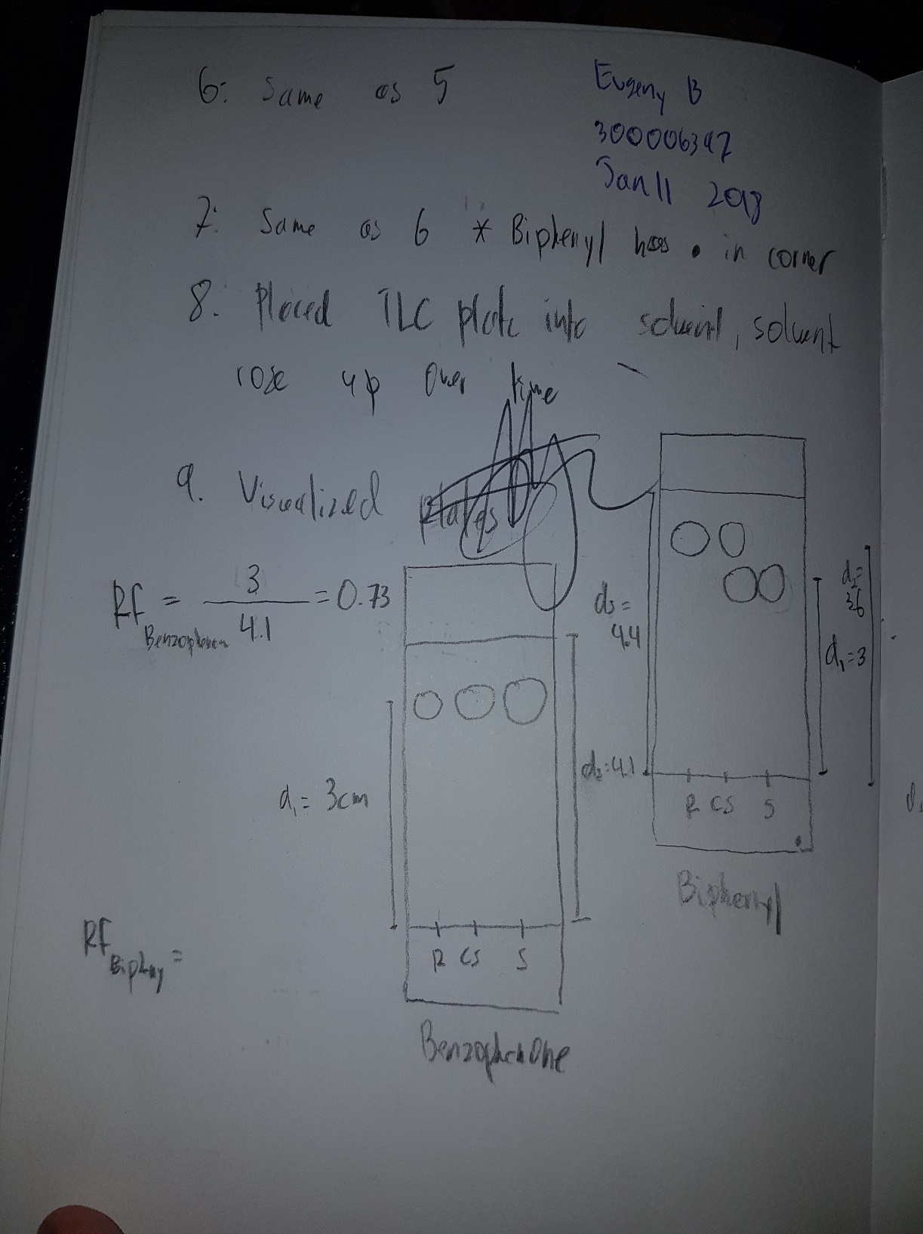
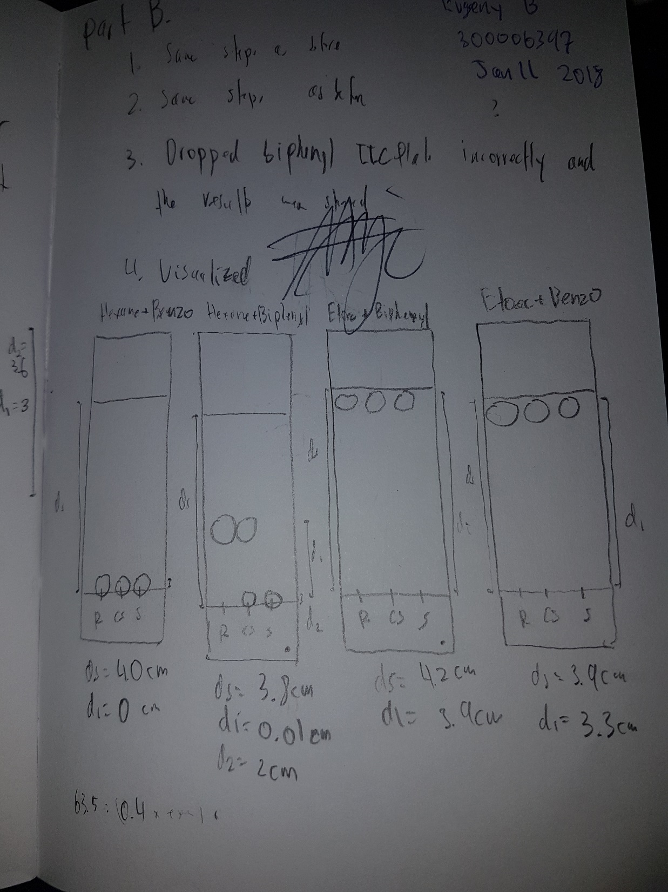

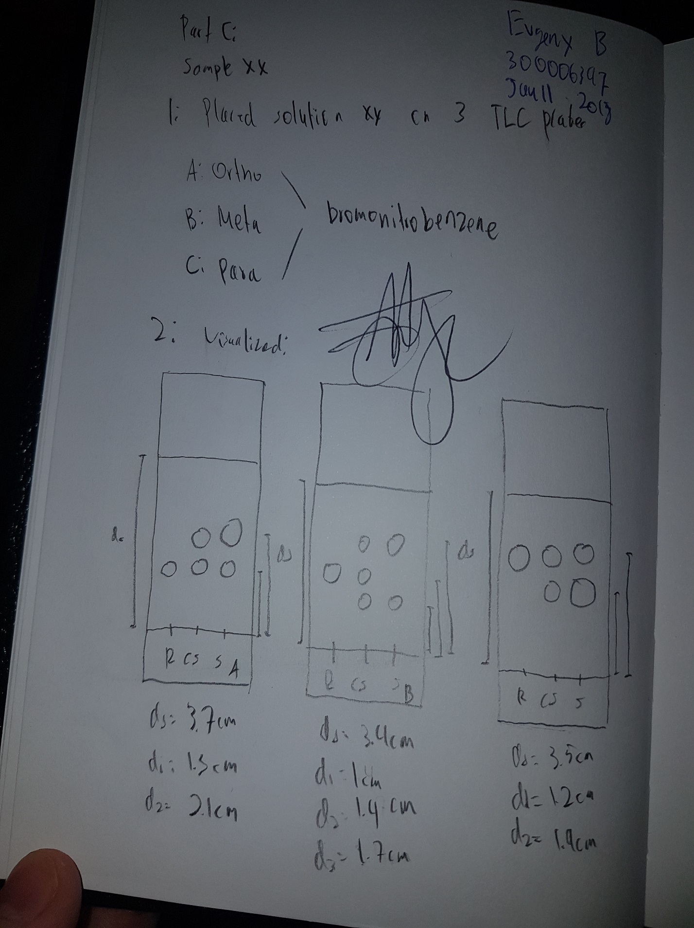
Appendix 2: Raw TLC Plates:
Part A:
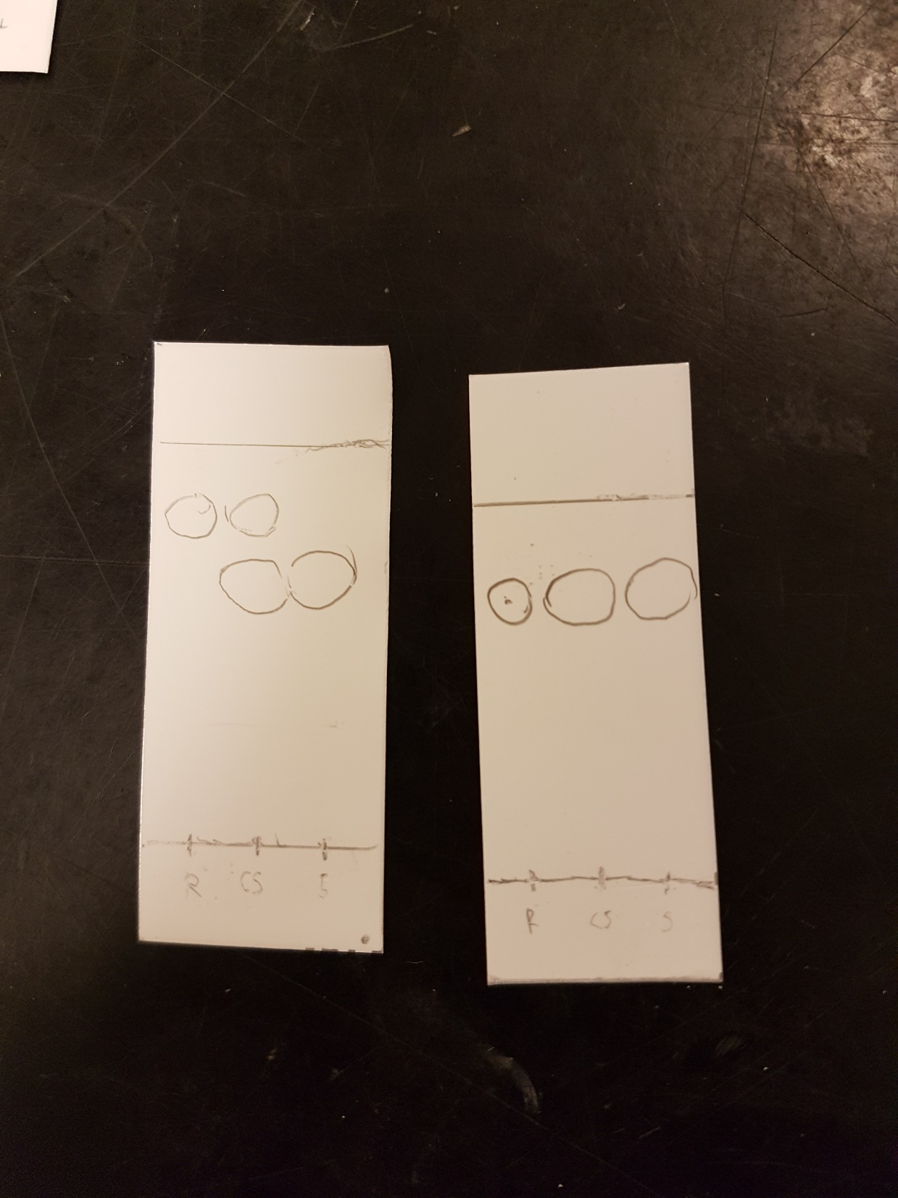

Part B:
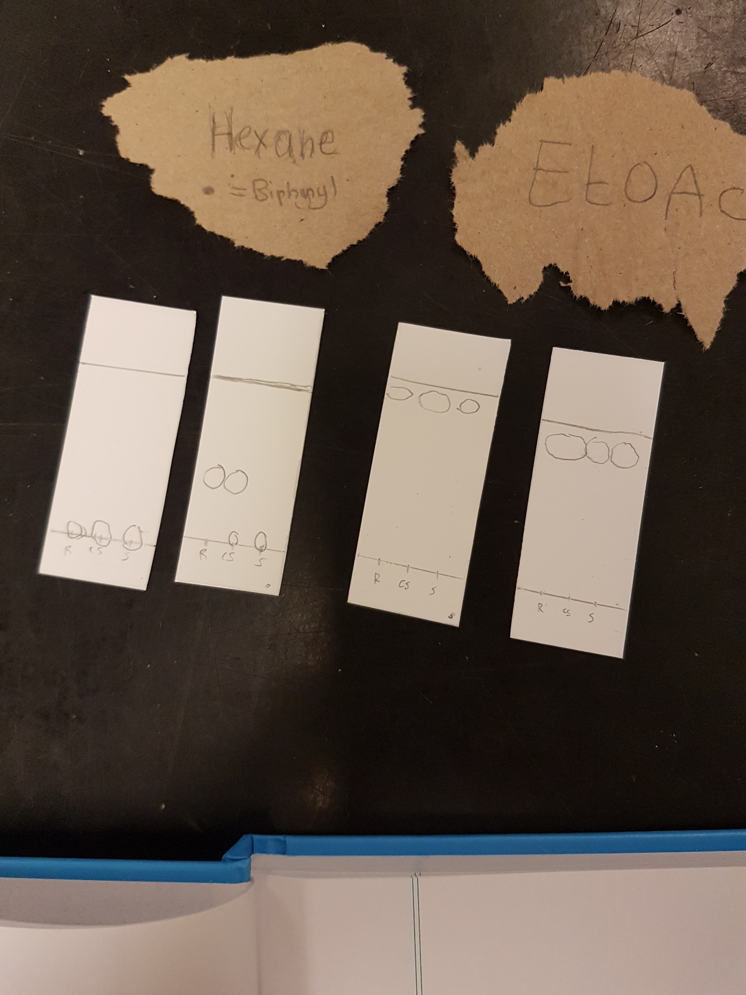

Part C:


