Name: __________________________

Student ID: ______________________

University of Ottawa
ANP1105C: Human Anatomy and Physiology I. Fall 2018
Professors: J. Copeland and W. Staines
Midterm 1. Version1

Friday, October 5th, 2018

Exam time: 1 hour, 20 minutes
1) 44 multiple choice questions (1 mark/1 correct answer per question) plus 11 marks for True/False and diagram-labeling for a total of 55.

2) Please answer the multiple choice questions on the computer sheet that is provided and answer the remaining questions right on the exam.

3) Please put your name and student number at the top of this page, on the top of pages 9 and 10 and on the computer sheet. Hand in everything when you have finished.

4) Make sure you clearly indicate Version 1 or Version 2 on the front of your computer sheet!!

5) Make sure this exam is complete. This exam contains 10 pages and is printed double-sided. The excuse of missing a page will not be accepted after the examination.

- Cilia and flagella contain a core of:
- microfilaments
- intermediate filaments
- microtubules
- tRNA
- phospholipids

- Which of the following statements is TRUE?
- Simple cuboidal epithelial are usually associated with secretion and absorption.
- Endocrine glands are often called ducted glands.
- Connective tissues that possess a large quantity of collagen fibers often provide the framework for organs such as the spleen and lymph nodes.
- Cartilage tissue tends to heal more rapidly than bone tissue.

- Which of the following statements is TRUE?
- Merocrine glands produce their secretions by accumulating their secretions internally and then rupturing the cell.
- Connective tissues that possess a large quantity of collagen fibers often provide the framework for organs such as the spleen and lymph nodes.
- Most connective tissues have regenerative capacity while most epithelial tissues do not.
- Most exocrine glands in humans are apocrine glands.
- Blood is considered a type of connective tissue.

- Which of the following is TRUE about the mode of secretion of exocrine glands?
- Merocrine glands are not altered by the secretory process.
- Apocrine glands are destroyed, but then replaced after secretion.
- Holocrine cells are slightly damaged by the secretory process, but repair themselves.
- All of the above are correct.

- Which of the following statements is TRUE of connective tissue?
- Elastin fibers are sometimes called white fibers.
- When connective tissue is stretched, collagen gives it the ability to snap back.
- All connective tissues arise from mesenchyme.
- Reticular fibers form thick, ropelike structures.

- Fine branching fibers that construct a supportive network are:
- collagen fibers
- osteoblasts
- reticular fibers
- chondrocytes
- osteoclasts

- Select the correct statement concerning epithelia:
- Stratified epithelia are tall, narrow cells.
- Stratified epithelia are present where protection from abrasion is important.
- Stratified epithelia are seldom found in the human body.
- Pseudostratified epithelia consist of at least two layers of cells stacked on top of one another.
- Characteristics of epithelial tissue include all of the following EXCEPT:
- an actively dividing layer of cells
- cells attached to underlying basement membrane
- a well-developed blood supply
- presence of very little extracellular material

- What type of connective tissue prevents muscles from pulling away from bones during contraction?
- dense irregular connective tissue
- dense regular connective tissue
- areolar connective tissue
- elastic connective tissue
- hyaline cartilage

- Which type of junction is an anchoring junction that is linked to the cytoskeleton and designed to provide strength of cell-to-cell attachment?
- tight junction
- desmosome
- glycocalyx
- integral junction
- gap junction

- The function of cholesterol in the plasma membrane is to
- Increase membrane fluidity (make it less rigid)
- Decrease membrane fluidity (make it more rigid)
- Make the inside of the cell negative with respect to the outside
- Act as an energy store for nerve and muscle activity

- Which of the following is a characteristic of a graded potential?
- produced at axon hillock
- carries nerve impulses over long distances
- current decreases with distance travelled
- always induces membrane hyperpolarization

- The Na+/K+ ATPase:
- pumps 3 Na+ ions outside the cells and 2 K+ ions inside.
- pumps 3 Na+ ions outside the cell and 3 K+ ions inside.
- pumps 3 Na+ ions inside the cell and 2 K+ ions outside.
- pumps 2 Na+ ions inside the cell and 3 K+ ions outside.

- In an axon, newly synthesized proteins move due to
- Retrograde transport
- Anterograde transport
- Carrier mediated transport
- Action potentials

- Regarding the membrane potential.
- In their resting state, all of the body’s cells exhibit a negative membrane potential.
- The resting membrane potential occurs due to active transport of ions across the membrane due to the sodium-potassium pump (ATPase).
- The resting membrane potential is determined mainly by the concentration gradients and differential permeability of the plasma membrane to K+ and Na+ions.
- All of the above are true

- Action potentials travel along the axon because of the presence of:
- receptor potentials
- chemically gated ion channels
- hyperpolarization
- voltage-gated sodium and potassium channels

- Dendrites:
- conduct action potentials away from the cell body
- are the site of neurotransmitter release
- are generally long and unbranched
- produce only graded potentials

- The area on axon between 2 Schwann cell sheaths is the:
- Nissl body
- soma
- node of Ranvier
- axon hillock

- Creatine phosphate functions in the muscle cell by
- forming a temporary chemical compound with myosin
- forming a chemical compound with actin
- storing energy that will be transferred to ADP to resynthesize ATP
- inducing a conformational change in the myofilaments

- What is the role of tropomyosin in skeletal muscles
- tropomyosin serves as a contraction inhibitor by blocking the myosin binding site on the actin molecules
- tropomyosin serves as a contraction inhibitor by blocking the actin binding site on the myosin molecule
- tropomyosin is the chemical that activates the myosin head
- tropomyosin is the receptor for the motor neuron neurotransmitter

- The major function of the sarcoplasmic reticulum in muscle contraction is to:
- make and store creatine phosphate
- synthesize actin and myosin myofilaments
- provide a source of myosin for the contraction process
- regulate cytoplasmic (sarcoplasmic) calcium concentrations

- Skeletal muscle tissue has all of these properties except
- secretion
- excitability
- contractility
- extensibility

- The function of myoglobin is to:
- serve as an intracellular reservoir for oxygen for aerobic respiration
- bind actin to shorten myofibrils
- block the myosin binding sites on thin filaments
- store ATP

- What is the role of calcium ions in muscle contraction?
- form hydroxyapatite crystals
- reestablish glycogen stores
- bind to regulatory sites on troponin to remove contraction inhibition
- increase levels of myoglobin

- Of the following muscle types, which has only one nucleus, no sarcomeres, and has gap junctions?
- voluntary muscle
- smooth muscle
- cardiac muscle
- skeletal muscle
- What part of the sarcolemma contains acetylcholine receptors?
- motor end plate
- end of the muscle fiber
- part adjacent to another muscle cell
- any part of the sarcolemma

- Which of the following statements is most accurate?
- Muscle tension remains relatively constant during isotonic contraction.
- T tubules may be sliding during isotonic contraction.
- The sarcomere lengthens during isotonic contraction.
- Myofibrils slide during isometric contractions.

- Which of the following statements concerning the resting membrane potential is TRUE?
- Na+ tends to diffuse out of the cell.
- The resting membrane potential exists because the cell membrane is more permeable to Cl- than it is to K+.
- K+ tends to diffuse out of the cell.
- The cell membrane is more permeable to Na+ than to K+.

- Phospholipids
- Line only the intracellular surface of the plasma membrane
- Line both the intracellular and extracellular surfaces of the plasma membrane
- Represent a barrier to diffusion of most substance across the plasma membrane
- (B) and (C) are correct

- Some functions of plasma membrane proteins are
- transport
- receptors for signal transduction
- enzyme activity
- all of the above

- In carrier mediated transport
- Membrane proteins assist in solute (dissolved molecules) diffusion down their concentration gradient
- Membrane proteins assist in solute (dissolved molecules) diffusion against their concentration gradient
- Require ATP to permit solute (dissolved molecules) diffusion down their concentration gradient
- Require ATP to permit solute (dissolved molecules) diffusion against their concentration gradient

- In a CNS neuron action potentials are generated
- At the post synaptic membrane
- In the neuronal dendrites
- At the axon hillock (initial segment)
- In the nerve terminal

- The key to changes in the membrane potential in a positive or negative direction from the resting membrane potential are
- Ligand gated ion channels
- Voltage gated ion channels
- Mechanically gated ion channels
- All of the above

- The relative refractory period of the action potential results from
- Slow closure of the voltage gated sodium channels
- Slow closure of the voltage gated potassium channels
- Activation of acetylcholine receptors
- The presence of myelination on the axon

- The release of neurotransmitters at the nerve terminal depends on
- Voltage gated sodium channels
- Voltage dependent calcium channels
- Neurotransmitter vesicle release
- Both B and C

- A motor unit is defined as
- The group of neurons in the motor cortex required for movement
- The group of neurons in the spinal ventral horn required for movement
- A single motor neuron in the spinal ventral horn and all of the muscle cells it innervates
- All of the muscle cells that coordinate to produce a muscle movement

- The basis of the latent period of excitation-contraction coupling is
- Slow axonal conduction along unmyelinated axons
- The slow reactivity of myosin ATPase in some fiber types
- The time for diffusion of Ca++ after being released from the sarcoplasmic reticulum
- The rate of Ca++ reuptake into the sarcoplasmic reticulum

- Cerebrospinal fluid
- Surrounds and cushions brain and spinal cord
- Is separated from the blood by the blood-brain barrier
- Exchanges materials with interstitial fluid within the brain
- All of the above

- Peripheral membrane proteins are
- Proteins that are attached to integral membrane proteins (usually on the intracellular side of the plasma membrane)
- Proteins of the cytoplasm far from the plasma membrane
- Proteins that only associate with axons in peripheral nerves
- Proteins of the extracellular matrix that don’t interact with the plasma membrane

- Which of these features does not distinguish neurons from most other cells
- Extreme longevity
- Amitotic (they don’t divide)
- High metabolic rate
- Negative potential across the plasma membrane

- The resting membrane potential is characterized by
- The cytoplasm contains more K+ and less Na+ than does the extracellular fluid.
- A charge separation exists at the plasma membrane.
- The membrane is more permeable (leaky) to K+ than to Na+.
- All of the above

- Activation of the motor end plate leads to contraction because of
- Excitatory postsynaptic potential at the motor end plate
- Action potential along the sarcolemma
- Release of Ca++ from the sarcoplasmic reticulum
- All of the above

- The blood brain barrier
- Features tight junctions to prevent diffusion across the capillary wall
- Maintains a much more strict fluid homeostasis in brain interstitial fluid than that found in blood
- Consists of endothelial cells
- All of the above

- Which of the following is correct and important for determining stimulus intensity?
- The frequency of action potentials increases with increasing stimulus intensity.
- The magnitude of action potentials increases with increasing stimulus intensity.
- The frequency of action potentials decreases with increasing stimulus intensity.
- None of the above

Name:____________________________ ID Number:___________________________________

True or False

- Troponin is the calcium sensitive protein triggering (initiating) muscle contraction T__

- Ca++ is pumped out into the extracellular space to end muscle contraction _F__

- Secondary active transport relies directly on the concentration gradient for Na+ _T__

Short Answer

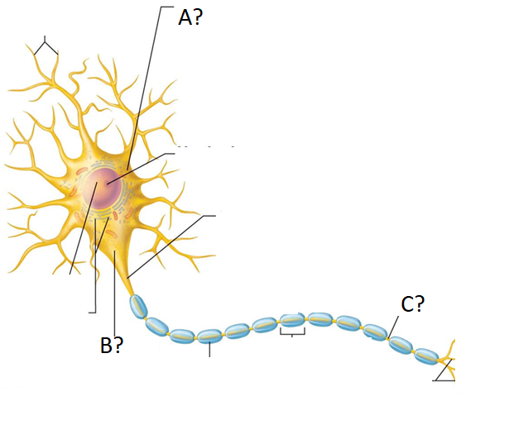

- cell body

- axon hillock

- node of ranvier

Name:____________________________ ID Number:___________________________________
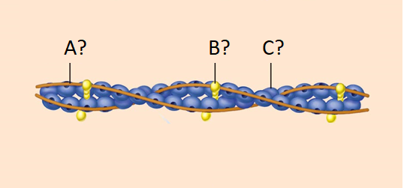

- tropomyosin

- troponin

- actin

- Use the image to answer. (2 marks)

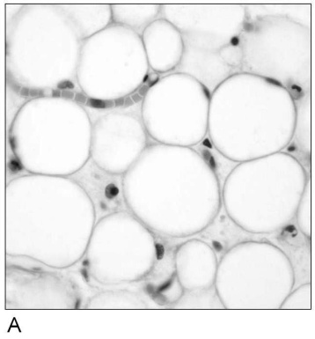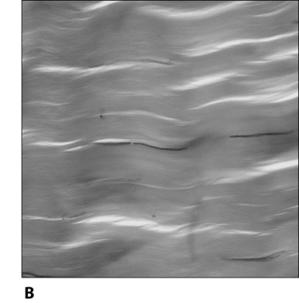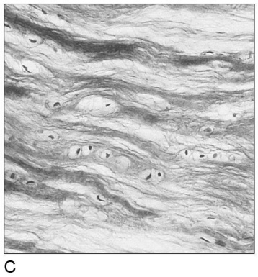

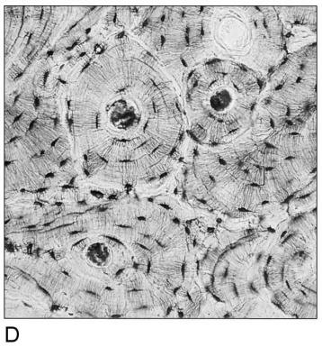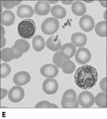
Shown above are 5 types of connective tissue.

- Which example forms tendons and ligaments? B
- Which example is composed of cells in a fluid matrix? E

