Enthalpy of Various Reactions

Names

TA:

CHM1311

University of Ottawa
October 9th, 2018

Introduction:

Abstract:

Hess’s Law states that the sum of all changes in a reaction is the total enthalpy change. In a reaction of solid ammonium chloride (NH₄Cl_{(s)})with water, surrounding energy from the system must be absorbed in order to trigger the reaction. When that energy is absorbed it causes the temperature of the system to decrease. Using this concept to decrease the temperature of an open system by 5°C. An open aluminum can containing 100 mL of water surrounded by 130 mL of water in a calorimeter can be cooled by adding NH₄Cl_{(s)} to the surrounding water. In order to achieve this in a isolated system a theoretical value was calculated suggesting, 15.2g of NH₄Cl_{(s)} must be added. This would not work as the apparatus does not provide an isolated system and as such various estimates were made based on the theoretical value in order to achieve the goal of a -5°C change in the temperature of the water contained inside the open can. The result of the experiment represent the amount of NH₄Cl_{(s)} needed for a product to achieve the goal of cooling a 100mL can of water within 5 minutes by 5°C.

The three different types of enthalpy change used in this experiment were:

- Enthalpy of solution of the ionic compound
Heat energy change (Q) at a constant pressure when one mole of the X+ Y – compound has been entirely dissolved in water.
XY – _{(s)} + H₂O_{(l)} → X_{(aq)} + Y– _{(aq)} (1)

2. Lattice energy of the ionic compound
Enthalpy change when a solid ionic compound is formed from its two gaseous ions. Therefore, the equation for the lattice energy of an ionic compound would be:
X_{(g)} + Y⁻_{(g)} → XY ⁻_{(s)} (2)

3. Enthalpy of hydration of the gaseous ion
Amount of energy released when a mole of a gaseous ion dissolves in a large amount of water forming one mole of an aqueous ion in the process.
Z⁺_{(g)} → Z ⁺_{(aq)} +energy (3)

In order to measure the specific heat capacity, water was placed in and/or around the apparatus/calorimeter and was measured in set intervals. Next, since the specific heat capacity of water was known, as well as the change in temperature, one can use the following formula to determine the amount of heat released/absorbed.
q=mCΔT

*q is heat energy gained or lost by a substance, m is mass (g), C is the specific heat and ΔT is change in temperature

https://uottawa.brightspace.com/d2l/le/content/79012/viewContent/1845028/View, Brightspace, University of Ottawa

Materials:

- Aluminum Can
- Styrofoam Calorimeter
- Digital Thermometer
- 100 mL Beaker
- Weighing Scale
- 50 mL Graduated Cylinder
- NH₄Cl_{(s)}
- Labquest

Procedure:

Problem: Identify the correct masses of salt that are required to lower the temperature of the water in the can by 5℃.

- Obtain the mass of the aluminum can (g) by weighing it on a scale.
- Place the can in the styrofoam container.
- Measure 100 mL of water (using the 50 mL graduated cylinder) and carefully pour it into the can.
- Measure 130 mL of water (using the 50 mL graduated cylinder) and carefully pour it into the styrofoam container.
- Measure the initial temperature of the water in the can (using the thermometer/LabQuest provided) when zero grams of the salt is added.
- Measure 15.2 grams of the NH₄Cl, add it to the water in the styrofoam container, cover the container with the lid, swirl the solution gently until the salt has completely dissolved then wait until 5 minutes has passed and record the temperature of the water in the aluminum can.
- Replace the water inside the styrofoam container (130 mL) and the aluminum can (100 mL) then repeat step 6 for values of 10 grams, 13 grams and 18 grams of NH₄Cl.
- After all results have been obtained return all equipment used and insure work area is clean and dry.

Results/Observations:

Qualitative Observations:
Observation of NH₄Cl
White, crystal salt form.
Dissolved quickly when added to water and stirred, large masses did not dissolve completely.
Temperature of water decreased throughout the 5 minutes within calorimeter.
Table 1: Observation of effect of various amounts (g) of NH₄Cl on temperature (^{O}C) when added to 130 mL of H₂O.

Quantitative Observations:
Mass of NH₄Cl (g) | Initial Temperature (^{O}C) | Final Temperature (^{O}C) | Temperature Change (^{O}C)
10.06 | 22 | 19.5 | -2.5
13.02 | 21.7 | 18.9 | -2.8
15.01 | 21.8 | 18.2 | -3.6
19.16 | 21.8 | 17.5 | -4.3
Table 2: Effect of various amounts (g) of NH₄Cl on temperature (^{O}C) when added to 130 mL of H₂O

Graphs:
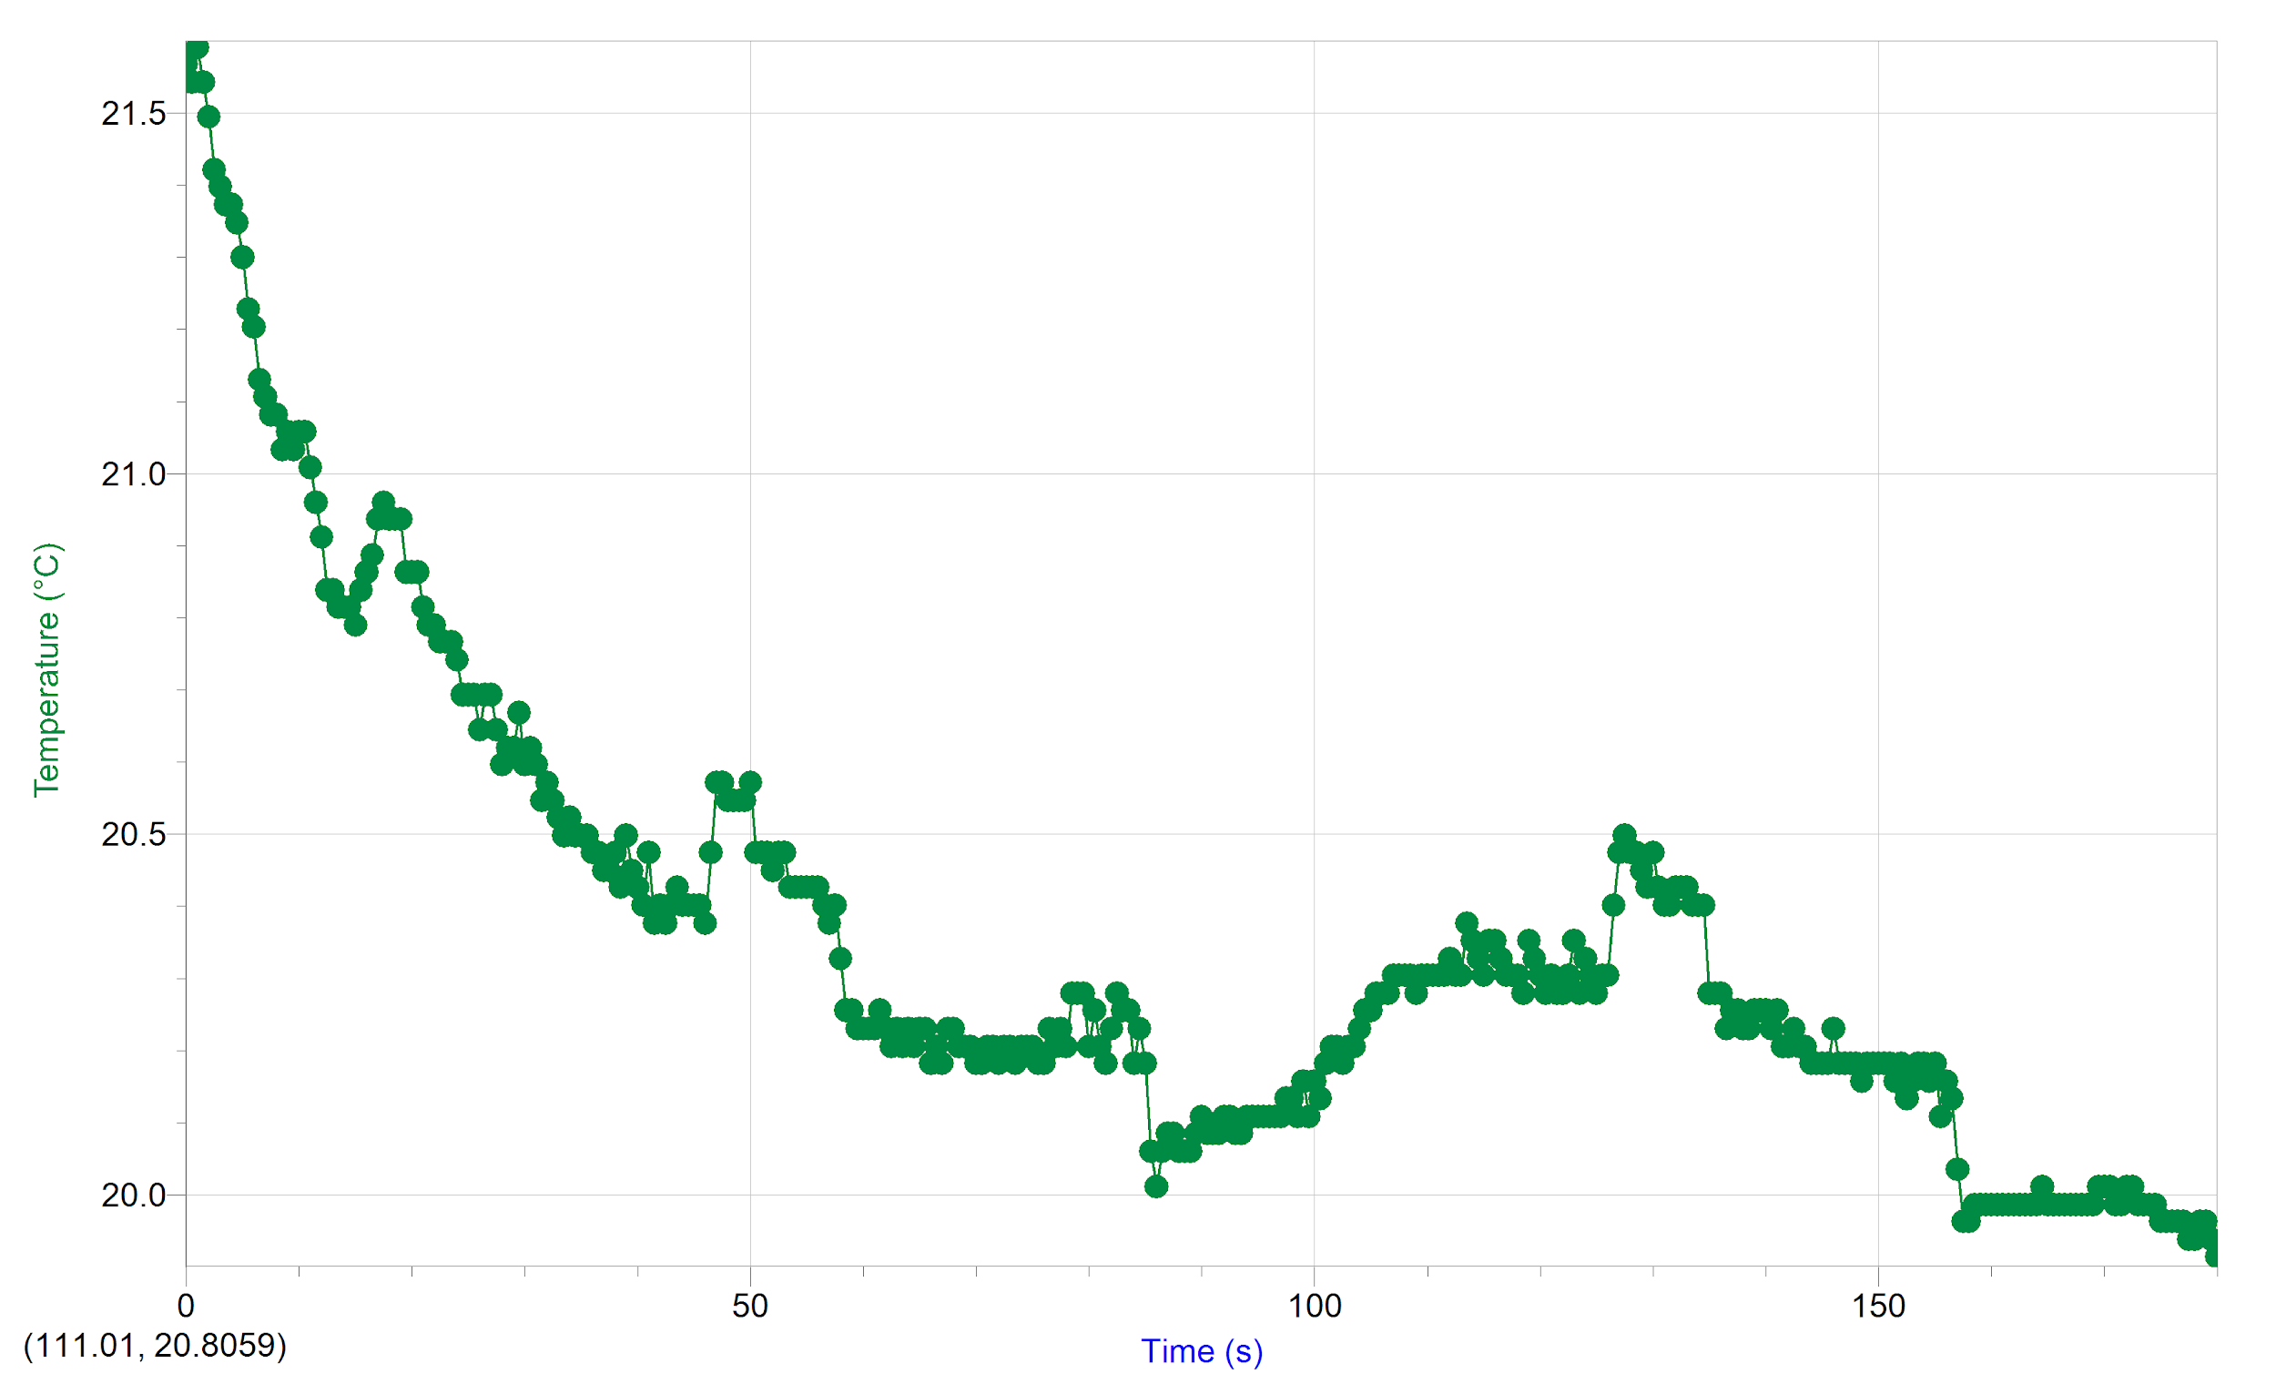
Figure 1 (run 1) : Initial and Final Temperature (^{O}C) of Ammonium Chloride Solution Using 10.06 Grams of Solute.

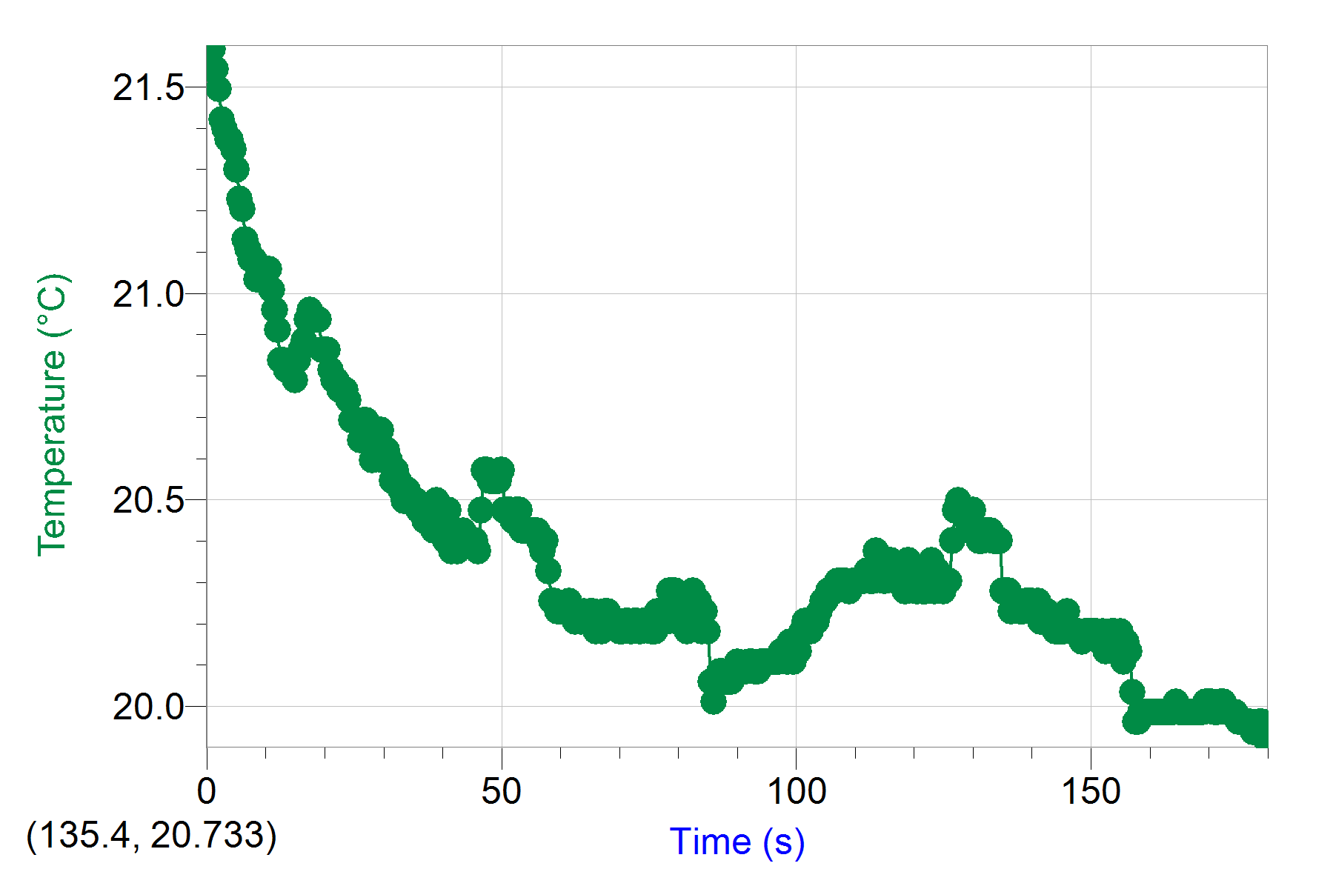
Figure 2 (run 3)Initial and Final Temperature (^{O}C) of Ammonium Chloride Solution Using 13.02 Grams of Solute.

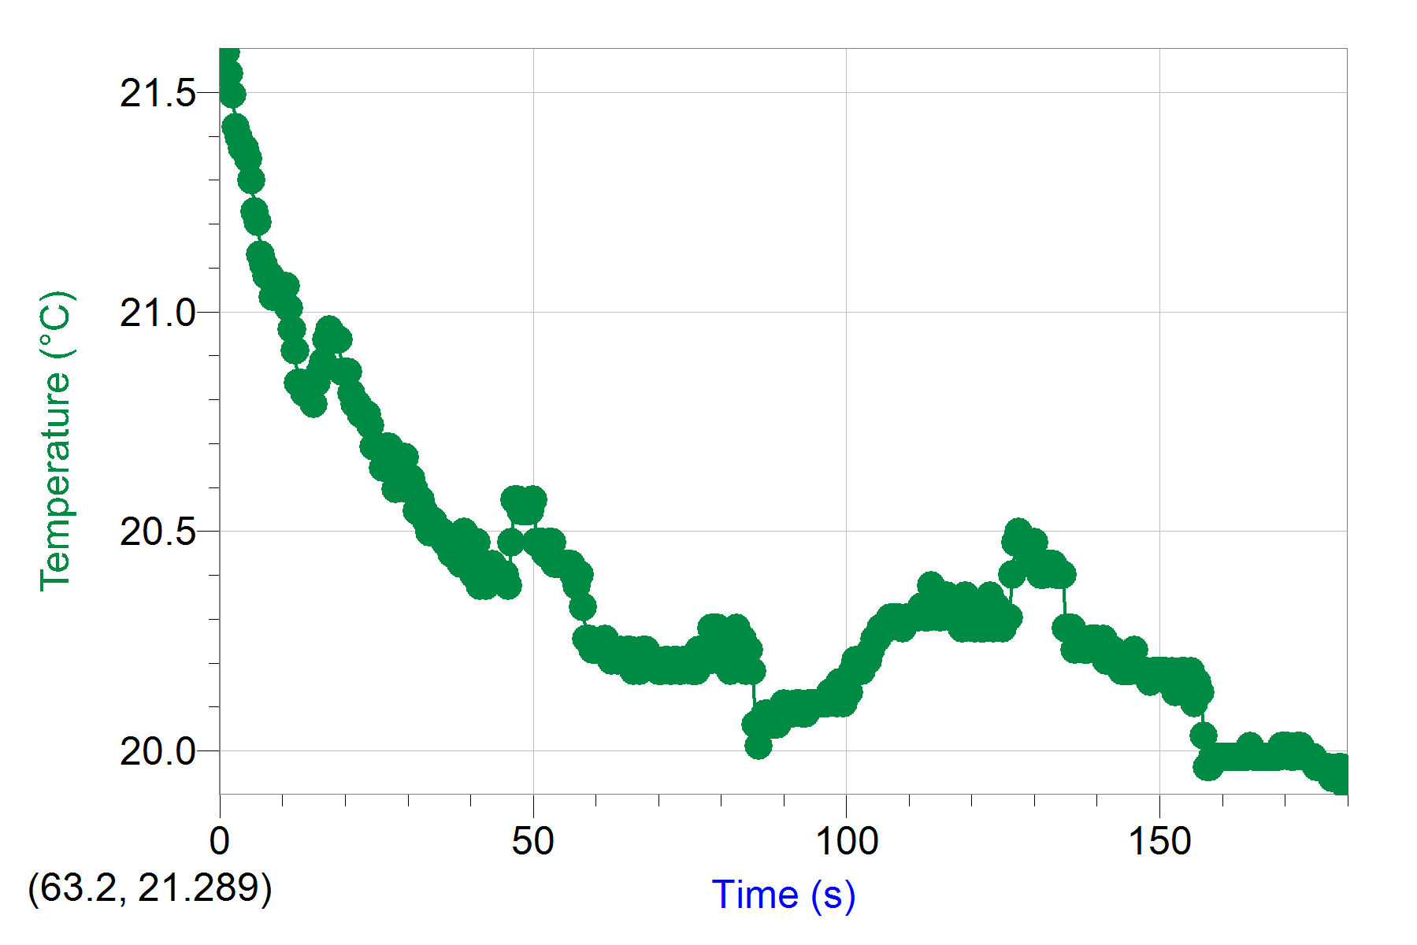
Figure 3 (run 5)Initial and Final Temperature (^{O}C) of Ammonium Chloride Solution Using 15.01 Grams of Solute.

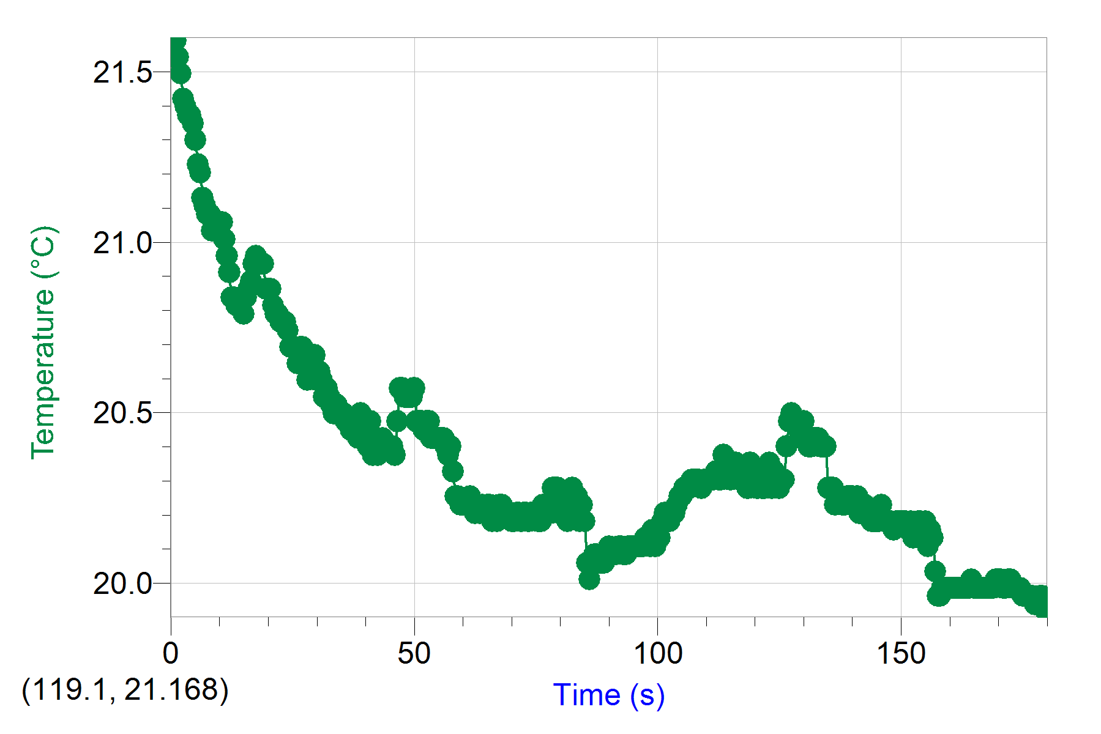
Figure 4 (run 7)Initial and Final Temperature (^{O}C) of Ammonium Chloride Solution Using 19.06 Grams of Solute.

Calculations:

The total energy needed by the cooling system: q_{T}= q(water)+ q(aluminum can). By using the equation of heat capacity q=mc△T, the amount of mass of ammonium chloride salt (in grams) was calculated.

q=[m(outside water)+m(inside water )]*c(water)*△T + m(metal)*c(metal)*△T
=(130ml+100ml)*1$\frac{g}{mL}$*4.18$\frac{J}{g*℃}$*(-5)℃+8.62g*0.9$\frac{J}{g*℃}$*(-5)℃
=-4845.79J

n(NH₄Cl)=$\frac{q}{ΔH(NH_{4}Cl)}$
=$\frac{4845.79KJ}{17KJ}$
=0.285mol

m(NH₄Cl)=n(NH₄Cl)*M(NH₄Cl)
=0.285mol*53.49g/mol
=15.2g

Therefore, the mass of ammonium chloride needed was 15.2g

Percent yield=Actual yield / Theoretical yield*100%
=(19.06/15.2) *100%
=125.4%

Percent Error = (Actual - Theoretical)/Theoretical *100%
=(19.06-15.2)/15.2*100%
=25.4%

Discussion:

For this lab, ammonium chloride was used to carry out the experiment instead of ammonium nitrate. The reason for that is because ammonium nitrate is an oxidizer, meaning it has the ability to combine with oxygen. The purpose of this lab was to calculate the amount of solid NH₄Cl needed to decrease the temperature of water, in a styrofoam calorimeter, by 5 degrees celsius after 5 minutes. The mass calculated was 15.2 grams. Although this was the theoretical value, it did not cause the temperature to drop by 5 degrees celsius during the experiment. The temperature dropped by 3.6 degrees celsius when 15.01 g of NH₄Cl was used. A possible reason of why it did not drop by 5 degrees celsius could have been the fact that some of the NH₄Cl did not completely dissolve and therefore did not take in the maximum heat from the surrounding to allow for the 5 degrees celsius drop. Another factor could be the styrofoam that was used as a calorimeter. The styrofoam cup could have lost heat to the surrounding as it was not completely closed and that could have messed up with the results of temperatures. 4 different masses were used to try to identify the mass needed to achieve the goal of the experiment. When masses lower than the theoretical were used, the temperature dropped by 2.5 to 3 degrees celsius. However when 18.06g of NH₄Cl was used, the temperature dropped by 4.3 degrees celsius. The reason why the higher the mass, the larger the temperature drop could be that a higher amount of the NH₄Cl is being dissolved, even though some chunks still remain after. Or maybe, the cup was stirred more thoroughly after each trial, allowing more of the NH₄Cl to be dissolved. Due to the fact that it was only 4 trials, the goal of decreasing the temperature of the water by 5 degrees celsius was not achieved. However, if a slightly higher mass of NH₄Cl was used, then the goal could have been achieved. Also, if the styrofoam was closed completely and stirred well after the salt has been added, then the mass of 18.06 g or lower could cause the temperature to drop by 5 degrees celsius after 5 minutes. All this process occurred because NH₄Cl dissociates in water when it is added and it uses energy from the water to dissolve. This take up of energy causes the water to decreases in temperature, causing an endothermic reaction.

Conclusion:

In conclusion, the temperature did decrease when ammonium chloride was put in the water but not by 5 degrees. Although it was not by 5 degrees, it was really close to it. The temperature dropped by 4.5 degrees when 18.06g of ammonium chloride was used. If the mass was a little bigger, the 5 degree temperature drop would have been achieved.

