Enthalpy of Various Reactions

Written by:
Steven Marshall, 300076829
Lawson Leclaire, 300076712
Maureen Ali, 8599616
Brandon Rodrigues, 300074156
Helen Zhang, 300098706

TA: K M Taufiqur Rahman

Date: September 30th, 2018

Introduction:
Chemistry, more specifically the study of calorimetry can be seen in many different forms in our everyday life, from the production of electrical energy to the heating/cooling of drinks. Calorimetry is the study of heat gained or lost in chemical or physical reaction which boils down to the transfers of energy. This transfer of energy can be explained by equation [1].
[1] Q=mcΔT
The formula above is used to calculate the quantity of heat energy needed in order to change the temperature of an object, with (m) representing the mass of the object, (c) representing the specific heat capacity (the amount of heat needed to change 1 Kg of material by 1°C) of the material measured in kJ/kg · °C and finally (ΔT) as the change in temperature.

Figure 1:
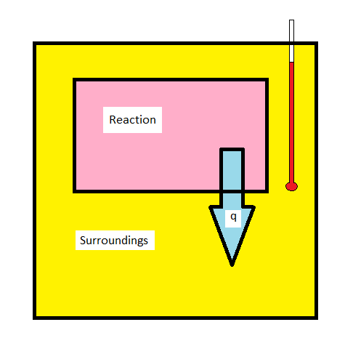

The image shown in figure 1 is a basic visual example of how a calorimeter works. When a reaction occurs, heat will either be transferred to the surroundings from the system or to the system from the surroundings, based on if the reaction is exothermic or endothermic, respectively. This change in temperature is recorded with a thermometer

Procedure:
- Gather an aluminum can, calorimeter, and water.
- Weigh and record the mass of the can.
- Fill the can with 100 ml of water, which acts as the drink.
- Fill the styrofoam container with 130 ml of water.
- Weigh 15.25 grams of the salt, ammonium chloride, and mix it with the 130 ml of water inside the styrofoam container.
- Once the salt becomes completely dissolved, place the can inside the new mixture and place the styrofoam lid onto the calorimeter.
- Put a thermometer through the lid of the container
- Measure and record the initial temperature on Lab Quest 2, and then allow the reaction to continue for 5 minutes (300 seconds), ensuring all data is being recorded.
- Save data from Lab Quest 2 to a USB drive.

Data and Observations:
Given/Measured Variables:

Data: please see Figure 2 for a sample of each run.
Volume: | 100cm³
Change in Temperature: | -5ºC
Mass of Water: | 100g
Heat Capacity of Water: | 4.18 J/Kg
Molar Mass of Ammonium Nitrate | 80.01 g/mol

Trial # | Initial Temperature(ºC) | Final Temperature(ºC) | Change in Temperature(ºC) | Mass of Ammonium Chloride(g)
1 | 22.6 | N/A | N/A | 15.25
2 | 19.6 | 16.2 | 3.4 | 15.25
3 | 21.4 | 16.1 | 5.3 | 16
4 | 21.9 | 16.8 | 5.1 | 15.65
All of these trials except for trial 1 were conducted over a time of five minutes. Trial 1 had a problem with Lab Quest in which the data stopped collecting after 150 seconds, invalidating the data.

Observations:
Trial One:
Failed due to the lid of the calorimeter opening slightly, allowing for energy and gas to escape. This was most likely caused by pressure accumulating inside the calorimeter due to changes in enthalpy, which caused the lid to come open.

Trial Two:
Observed that the run began choppy, as seen on graph between 60 seconds to 80 seconds.

Trial Three:
Run was comparably better than first and second; as seen how the run was not choppy, slope in graph held a smooth decreasing value, no climbs or dips, unlike in first and second run slopes.

Figure 2:
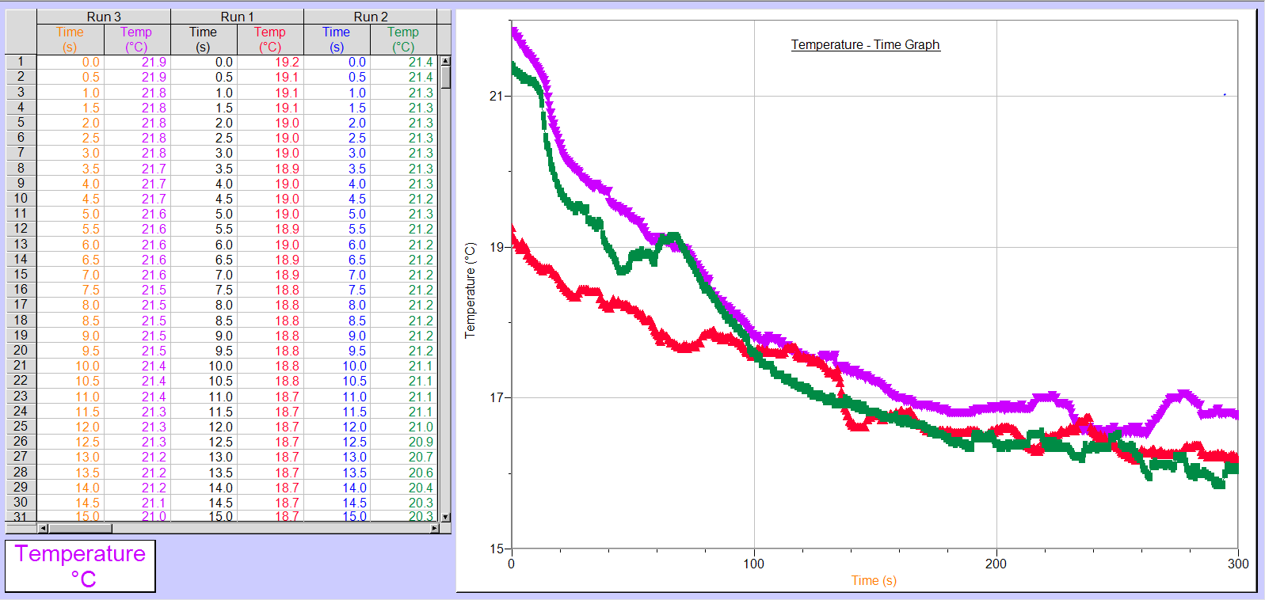
Calculations:
q=mc∆T
q = ∆H - At constant pressure

Discussion:

Run 1 was not valid because the lid became loose, allowing for an unknown amount of gas and energy to escape the calorimeter as it was not a closed system( A system where mass and heat cannot be exchanged between the system and the surroundings. (p.243 of Gaffney, Jeffrey S, and Nancy A Marley. “General Chemistry for Engineers.” NeuroImage, Academic Press, 2018, www.sciencedirect.com/book/9780128104255/general-chemistry-for-engineers.) The first law of thermodynamics states that energy cannot be created or destroyed, it can only be transformed from one form to another form. Because this is true, the change in volume of the system when the lid pops up results in a corresponding transfer of this energy to the system’s surroundings. (-q, where heat is released from the system/ this system became exothermic). In order to measure enthalpy, it must be ensured that the system is closed so no moles of products or reactants escape. In order to ensure this does not happen again, the lid was kept secured shut, ensuring that enthalpy change is accurately measured on calorimeter. As a result of having human contact with the styrofoam calorimeter, there may have been some interference in terms of body heat affecting the temperature of the system.

Conclusion:
In this lab, a design was produced which was able to cool a drink by 5 degrees celsius in under five minutes. This was accomplished by adding fifteen grams of ammonium chloride to 130mL of water inside of an insulated container.

References:
http://www.scienceclarified.com/everyday/Real-Life-Physics-Vol-2/Heat-Real-life-applications.html , science clarified
https://chem.libretexts.org/Textbook_Maps/Physical_and_Theoretical_Chemistry_Textbook_Maps/Book%3A_Physical_Chemistry_(Fleming)/3%3A_First_Law_of_Thermodynamics/3.3%3A_Calorimetry , Patrick E. Fleming, libreTexts
Gaffney, Jeffrey S, and Nancy A Marley. “General Chemistry for Engineers.” NeuroImage, Academic Press, 2018, www.sciencedirect.com/book/9780128104255/general-chemistry-for-engineers


