Due date:
Purpose: Demonstrate successfully installing and updating the VM and Ubuntu Desktop 18.04 as a virtual machine. (1.8 GB)
Marks: 10
Procedure: The following instructions will guide you through the installation process for VMware Workstations 12 and Linux Ubuntu 18.04
Important Note: Some laptops such as HP or Lenovo the virtualization are not enabled, therefore you should go to your BIOS and enable it. (F2 or F10)
Downloading Ubuntu 18.04
Go to http://www.ubuntu.com/download/desktop and download Ubuntu 18.04 to a directory on your local hard drive. (Download folder)
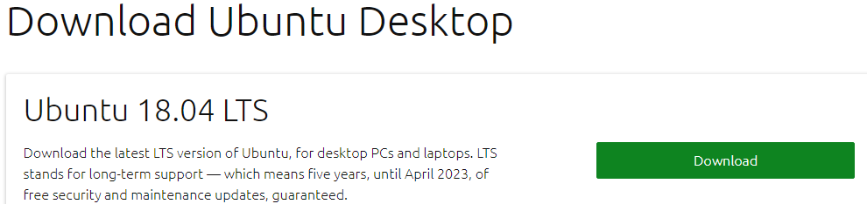
Scroll down to see this message


1-Instruction for Acquiring and installing VMware workstation 12


Login to your BS and click on Digital Resources

Login to Algonquin College with your user id and password


Click on Continue to Digital Resource Portal
Click on Your Software tab and choose VMware
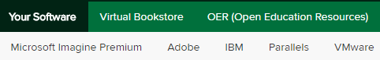

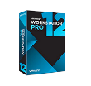

Select workstation 12 for Windows and click on Express checkout
Note: for Mac machine choose VMware fusion 8

Click on the Add to cart tab

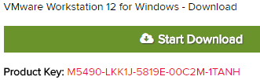
The next screen presents you with VM product key.
Make sure to save this CD-Key number. You need it for later.

(Important note: Do not change the default directory for download
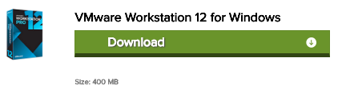
(The Default folder is Downloads)
Click on Start Download to download the file.
Files size: 400 MB

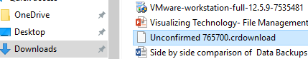

2-Installing Workstation 12 (VMware )
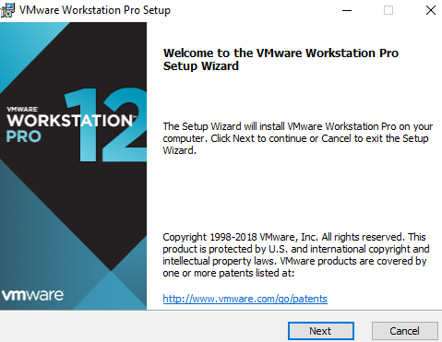
Locate the downloaded file and launch the application.
(Usually, it is in the downloads folder) VMware will load
and the installation wizard will start. Click next

Choose Typical click Next
License agreement click Next
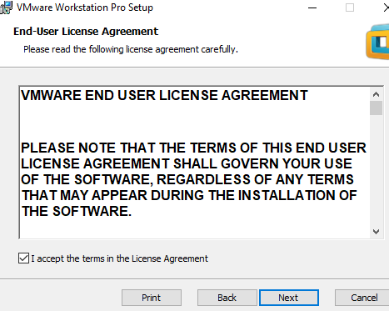

Select the fold to install and click Next

Select what shortcuts you want and click Next.

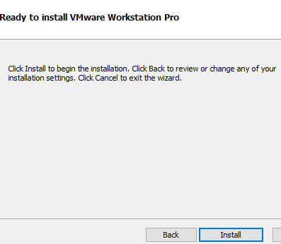

On the Ready to perform requested operation page click Install

As packages are installed, the status bar will indicate their progress.
Wait for all tolls to be installed and don’t be impatient if the status
bar doesn’t change for a minute or two

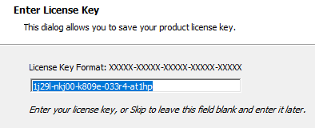

Enter the license key found on the order sheet you saved. Press
Enter when you’ve done this. Now click on finish

3-Creating a Virtual Machine (installing Ubuntu)
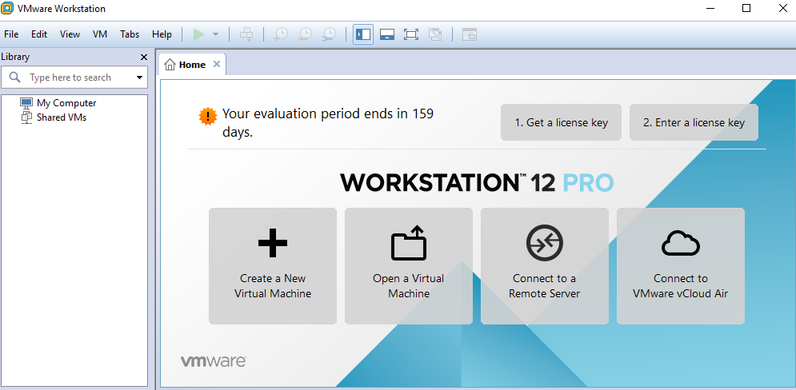

Start VMware Workstation (shortcut on your desktop)

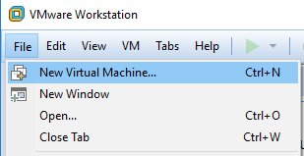

Select FileNew Virtual Machine, choose Custom, click Next

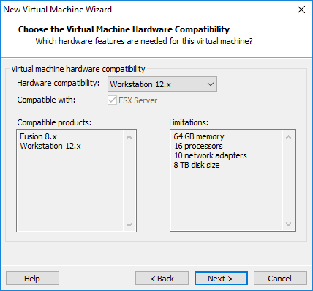
Click next

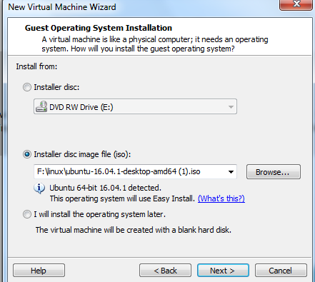
In the Guess operating installation page
Choose installer disc image files (ISO) radio button
And then click on the Browse tab to find your Ubuntu file

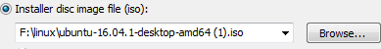
You should see this path

Then select I will install the operating system later radio button (the same page)
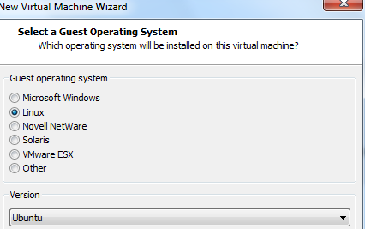

Select Ubuntu click Next

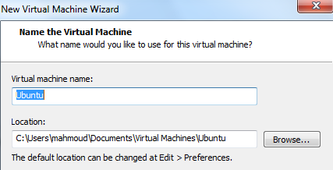

Name the virtual machine (Ubuntu 18)

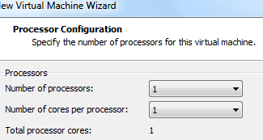
Process configuration page, keep the default valueclick next
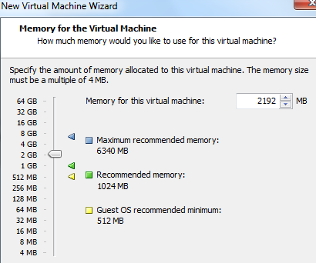
Specify 2 GB or more of memory click Next

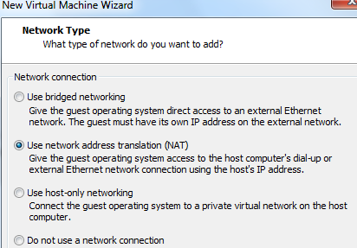

Network type; keep the default value Use Network address
Translation (NAT) and click Next

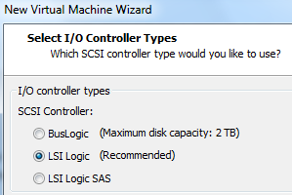

Select I/O Controller types. Keep the default settings.
Click Next

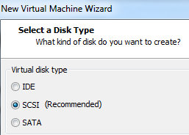
Select a Disk Type. Keep the default setting .Click Next (Exam)

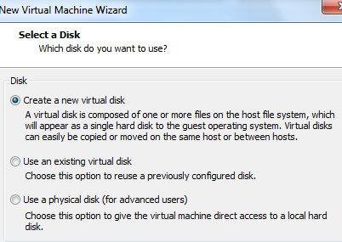
Select a Disk (default)
Create a New virtual disk

Specify Disk Capacity set the Maximum disk size (GB): Field to 30
GB. Keep the default Store virtual disk as a single file option. Click
Next

Specify Disk File. Keep the default settings. (i.e. Ubuntu.vmdk)
clickNext

Ready to Create Virtual Machine, Verify the information in the
table is correct and if so click Finish. Otherwise, click the Back
button and make corrections.

The summary page for the Ubuntu virtual machine is now visible
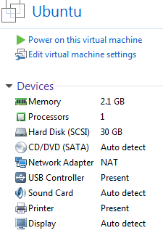
Follow part 4 now
Mount (installing) the Ubuntu image file

4-Mount (installing ) the Ubuntu image file
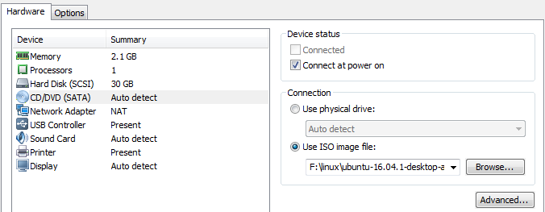
Mount the ISO image to the Ubuntu virtual machine,
From the Summary page, double click on the
CD?DVD (SATA) device . This brings up the virtual
Settings dialog

In the Virtual Machine setting dialog box under
Connection, select the Use ISO image files radio
Button and browse to the location of the Ubuntu ISO (downloads folder) file. Click OK
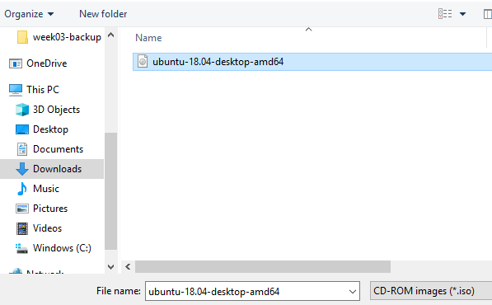

Under Ubuntu click on power on this virtual machine to turn on the virtual machine
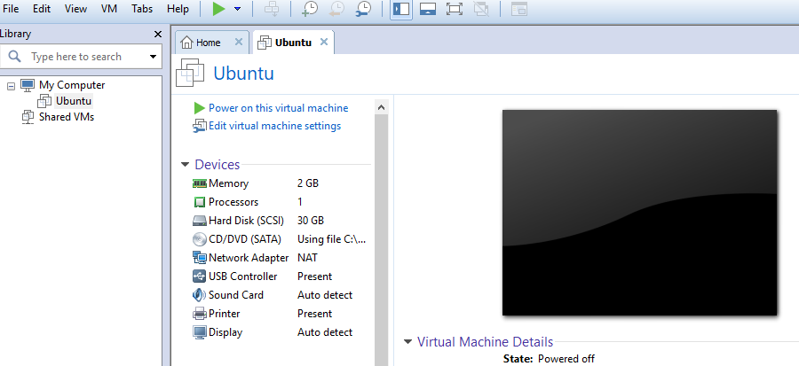

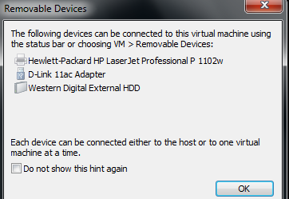
Note: If you see this page just click ok

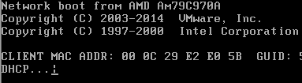
Note: if you got a black screen with a slash is spinning,
That means virtual machine did not find the Ubuntu file.
In your VM machine on the menu bar (blue color) click
On the VM tab and choose Power and click on Power off

shut off your virtual machine.
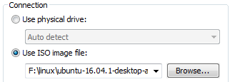
Go back to the summary page and under connection select
Use ISO image file again click on browse and locate your
Ubuntu ISO image files and click ok
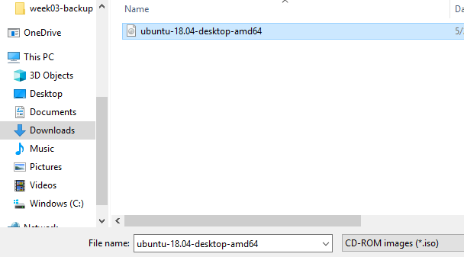

5-Installing the Ubuntu into the Virtual machine
In the Ubuntu tab, go to the Commands section and
click on Power on this virtual machine. If a pop-up window
emerges about the "keyboard hook timeout", click OK
in the Welcome page click on the Install Ubuntu tab

choose Linux click next
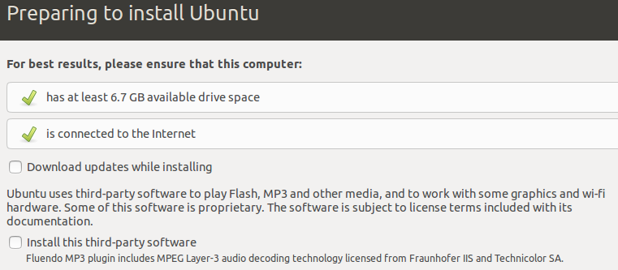
In the Preparing to install Ubuntu page just click Continue

Installation type, choose something else, click Continue

In the installation type, click on New partition table

You may get this message, click Continue

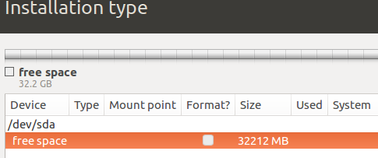
In the installation Type under free space (orange)
Click on the plus + sign

Create partition choose these settings:
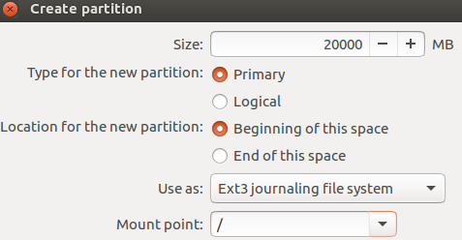
Size: 20000MB
Type for the new partition: Primary
Location for the new partition: Beginning of the space
Use as: Ext3journalling file system
Mount point: /
Click OK

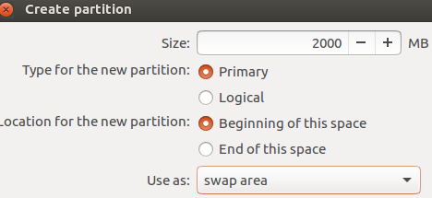
Highlight the free space again and click on the Plus + sign
To create a swap area partition
Size: 2000 MB
Type for the new partition: Primary
Location for the new partition: Beginning of the this space
Use as: swap area
Click OK
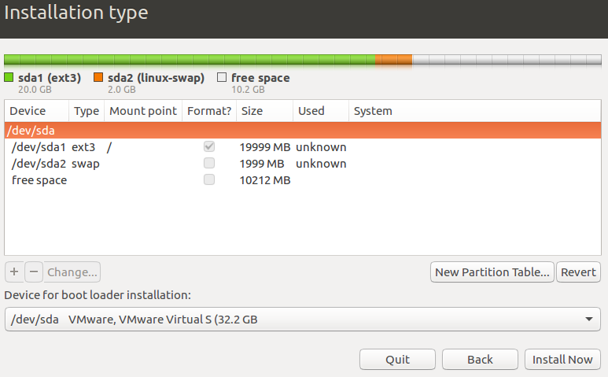

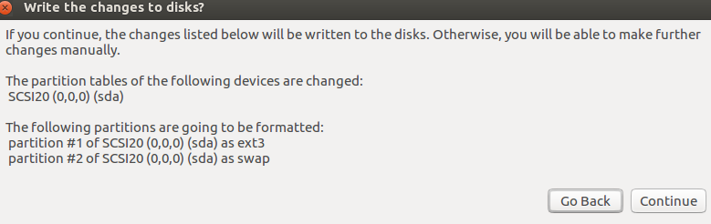
Click on Install Now

warning: write the change disk?
Click Continue
In where are you? Type: Ottawa and click continue

Keyboard layout English, click Continue

Click and drag
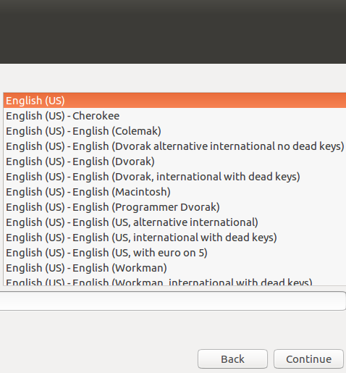

Important note: If you don’t see the Continue tab
Move your mouse on top of the screen (the black/gray area)
and move the page to the left. You should be able to
see the Continue tab now.

Setup the username
Provide a username and password
Goto the default settings
Click Continue

Welcome to Ubuntu screen begins to install the Ubuntu files
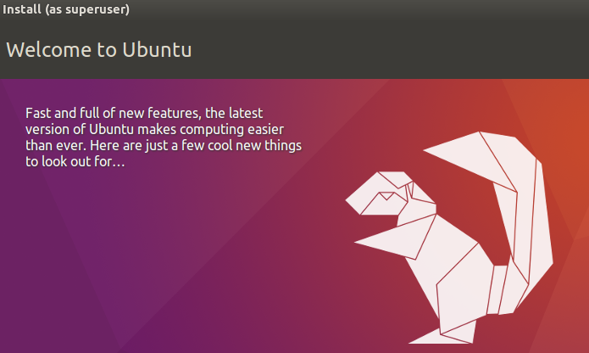
Note: this part takes a few minutes

Once Ubuntu is finished, it would ask you to restart your machine
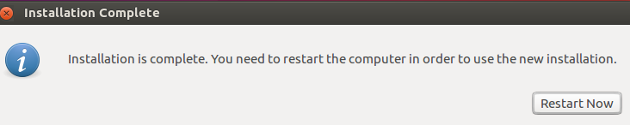
Just click on Restart now

You are done. Press Enter
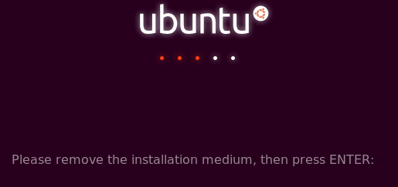

Note: When the new operating system boots, you may/may not
see errors such as these. If so, click I Finished Installing
on the bottom of the Ubuntu tab in VMware Workstation.
Click on the error screen and press 1 to reboot, or power off/on the
Ubuntu again, Be patient……

Ubuntu should boot normally. When the Ubuntu boot screen
Appears, click on the account you have created and log in as that user.
Important note: if you are missing your mouse inside of your computer
(Virtual machine) just press Ctrl+Alt

Update Ubuntu Linux 18.0

Open your Ubuntu, choose show Applications and then click on software update

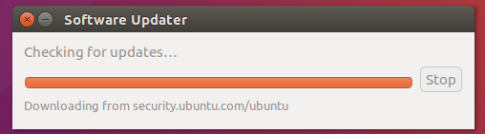

How to install VM tools
In your VM login to Ubuntu and find Terminal by clicking on this icon show application

In the search box type Terminal
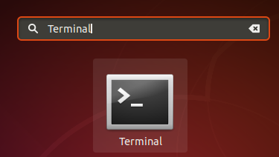
Now in the terminal screen type
mike@mike-virtual-machine:~$ sudo apt-get install open-vm-tools
Provide the password
Ubuntu would ask you to continue press yes
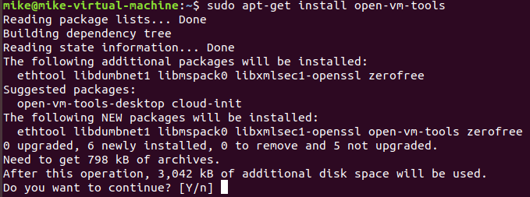
Now retype sudo apt-get install open-vm-tools-desktop
When it is finished reboot your Ubuntu

Login to your Ubuntu and click on this icon on the top of your virtual machine
Now click on this icon (Full screen) and expand your screen to full

