Due Date:
At the end of your lab period,

Marks: 10
Purpose:
To create, implement and test a backup system.
Important Note: Make sure you backup your files in multiple places. Backup location must contain enough free space to store all the backed up files.
1-Your computer,
2-USB drive or External hard drive,
3-Online: Gmail, Hotmail, Yahoo, One drive, Drop box, Algonquin college email
4- Answer to the questions be in red color.

Requirements:
- Windows 10
One of the following:
- An external Hard drive
- A USB thumb drive
- Online email account (Gmail, Hotmail, Algonquin College, Yahoo, one drive ….)

Procedure:
Companies and people are very dependent on data. Whereas a person cannot survive without air, water, and food; businesses and people cannot survive without data. Sixty-eight percent of companies do not have a reliable data backup and recovery plan in place. In an academic setting such as the College, eighty-eight percent of students do not have proper data backup or recovery plan. As a result, many students end up failing a course(s) or their entire term due to a major data loss.

Figuring Out a Backup Plan
It takes time to create and implement a backup and recovery plan. You'll need to figure out what data needs to be backed up, how often the data should be backed up, and more. To help you create a plan, consider the following questions:
How important is the data on your systems? The importance of data can go a long way in helping you determine if you need to back it up—as well as when and how it should be backed up. For critical data, such as a database, you'll want to have redundant backup sets that extend back for several backup periods. For less important data, such as daily user files, you won't need such an elaborate backup plan, but you'll need to back up the data regularly and ensure that the data can be recovered easily
What type of information does the data contain? Data that doesn't seem important to you now may be very important in the future.
How often does the data change? The frequency of change can affect your decision on how often the data should be backed up. For example, data that changes daily should be backed up daily.
How quickly do you need to recover the data? Time is an important factor in creating a backup plan. For critical systems, you may need to get back online swiftly. To do this, you may need to alter your backup plan.
Do you have the equipment to perform backups? You must have backup hardware to perform backups. To perform timely backups, you may need several backup devices and several sets of backup media. Backup hardware includes tape drives, optical drives, and removable disk drives. Generally, tape drives are less expensive but slower than other types of drives.
Who will be responsible for the backup and recovery plan? Ideally, someone should be a primary contact for the organization's backup and recovery plan. This person may also be responsible for performing the actual backup and recovery of data.
What is the best time to schedule backups? Scheduling backups when system use is as low as possible will speed the backup process. However, you can't always schedule backups for off-peak hours. So you'll need to carefully plan when key system data is backed up.
Do you need to store backups off-site? Storing copies of backup tapes off-site is essential to recovering your systems in the case of a natural disaster. In your off-site storage location, you may want to include copies of the software you may need to install to reestablish operational systems.
There are many different methods to create reliable data backups, each system has its’ own distinct advantages and disadvantages. This lab outlines two different ways of performing data backups using Windows 10. You can use either method or if you already have a data backup plan already in place, you can continue to use it.

Method 1: Using Windows 7 Backup & Restore in Windows 10 to create a selective backup.
Before using this method, ensure that you have a partition available on a hard drive or an external hard drive or a USB thumb drive plugged into the computer.

- Access the Control Panel by right-clicking on the Start button in the bottom left-hand corner and selecting Control Panel from the menu. You may also type "Control Panel" into the search box and select Control Panel from the results.
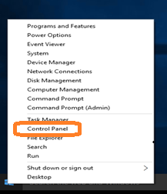
Figure 1. Selecting the Control Panel
- In the control panel, click Backup and Restore (Windows 7).

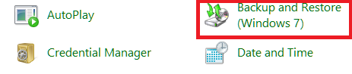
Figure 2 Choosing Backup and Restore
- Click Set up backup and wait for Windows Backup to start.

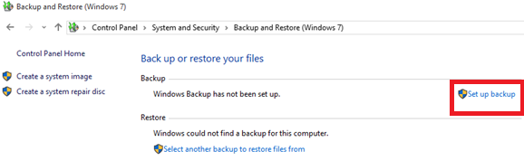
Figure 3. Set up Backup
- Select a destination for your backups.

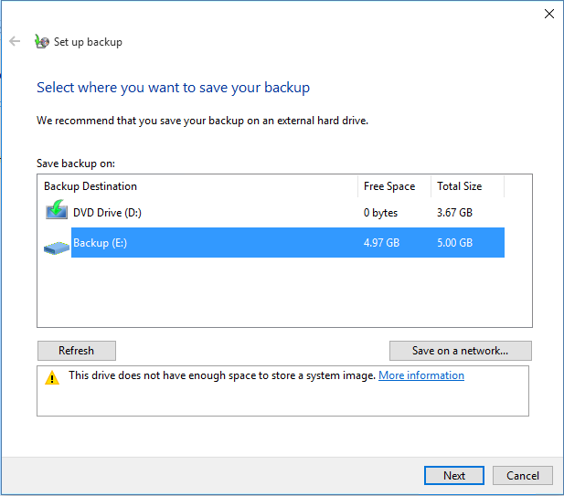
Figure 4. Select a destination for your backups
- Next, select the Let Me Choose radio button so that you can specify exactly what directories or files you want to backup.

- Check any folder that you would like to backup such as your school projects, work files, resume, tax files, etc.…

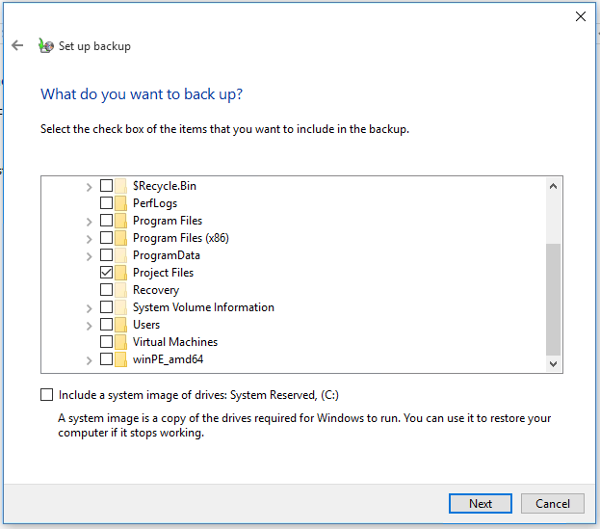
Figure 5. Choosing which folders to backup.
- Create a schedule for when you wish your backups to take place. Make sure that the backup schedule occurs when the PC will be turned on and when the destination drive will be connected.

- Select Change a schedule.
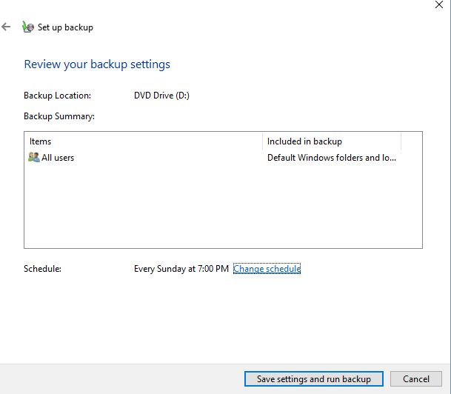
Figure 6. Changing the Backup Schedule
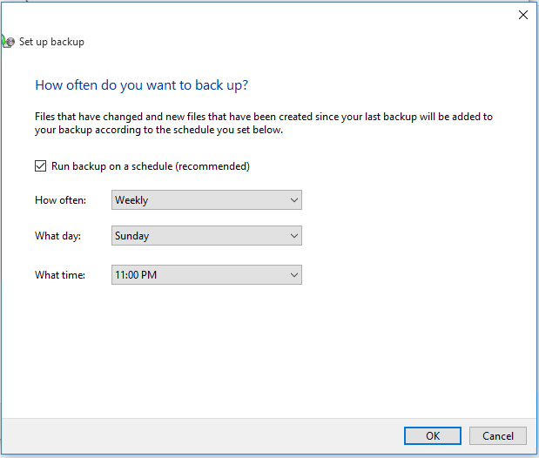
Figure 7. Setting up the Backup Schedule
- The first full backup will occur when you have completed all the steps. This process may take some time so ensure that you can wait until the process is completed before having to move your laptop.

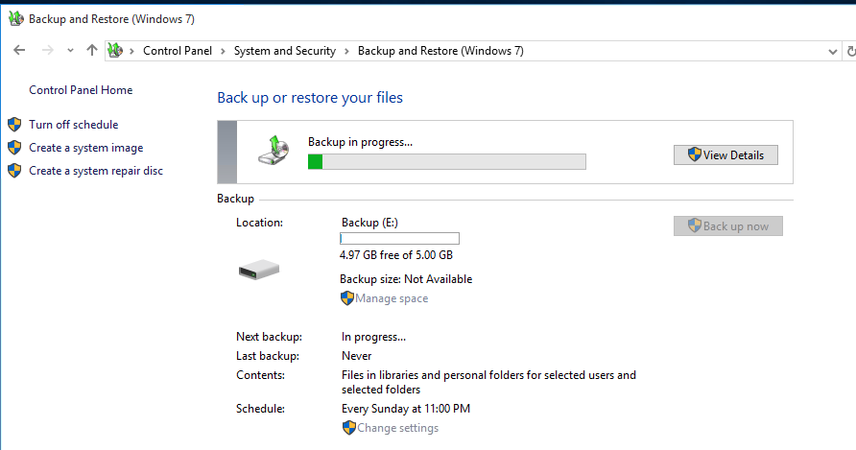
Figure 8. First Full Back up in Progress
When the backup has been completed successfully, you should practice a File Restore so you know that you can restore your files should you ever have to.

- Restore a copy of your backup to a folder called Restored Files on a hard drive. This does not have to be done on your source disk. Ensure that you restore your backup to the Restored Files directory so that you do not accidentally overwrite any files in your source directory.
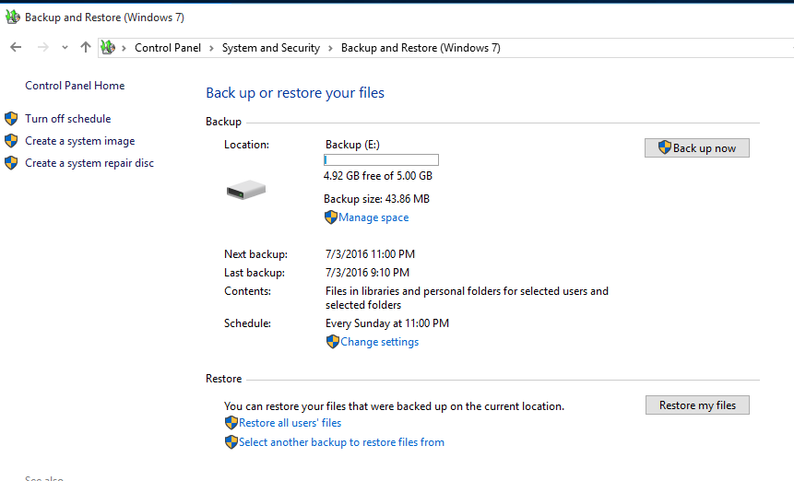
Figure 9. Restoring Files

Method Two: Using File History
Before you start using File History to back up your files, you first need to select where your backups will be saved to. You can select an externally connected drive, such as a USB drive, or to an external hard drive, or you can save to a drive on a network.

File History, by default, only backs up files that are in the Documents, Music, Pictures, Videos, Desktop folders and the OneDrive files available offline on your PC. If you have files or folders elsewhere that you want to backed up, you must add them.

If you're going to use a new external drive, connect it to your PC. If you see a notification asking if you want to configure the drive for File History, select it, and then turn on File History on the screen the appears.

Accessing File History
- Access the Settings Panel by left-clicking on the Start button in the bottom left-hand corner and selecting Control Panel from the menu. You may also type "Settings" into the search box and select Settings Panel from the results.
- Click on the Update and Security Icon

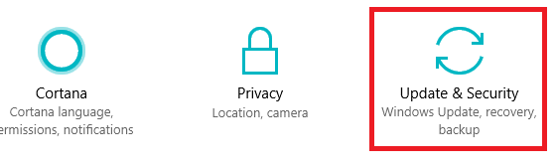
Figure 10. Update & Security
- Select Backup from the menu, located on the left-hand side of the screen.
- From the Backup screen chose the more options link
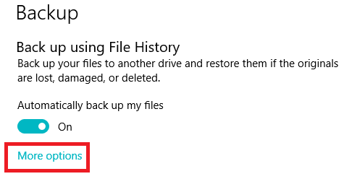
Figure 11. Selecting more options from the Backup menu

File History: Adding Folders
- To add other folders to File History, click on + icon in the Back up these folder section.
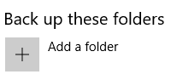

Figure 12. Add folders to File History
- Choose the folder you wish to add, then click on the Choose this folder button. If there are other folders that you wish to include, repeat steps one and two until you have selected all the folders you want to add to File History.
If you accidently add a folder, you can remove the folder by left-clicking on the folder you wish to remove and clicking on the remove button as seen in Figure 13.
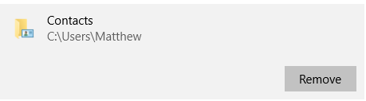
Figure 13. Removing a folder from file History.

Excluding a folder from File History
If there are folders that you wish to exclude from File History, scroll down until you see Exclude these folders
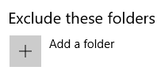
Figure 14. Excluding Folders from File History.
- To exclude folders from being backed up in File History, click on + icon.
- Choose the folder you wish to exclude, then click on the Choose this folder button.
If there are other folders that you wish to exclude, repeat steps three and four until you have selected all the folders you want to exclude from File History.
If you make a mistake, simply left-click on the folder that you don’t wish to exclude and click on the remove button.

Choose a date and time to back up in File History:
By default, File History will back up files every hour and keep them forever which may not be ideal for a student given their school schedule and limited funds available for backup devices.
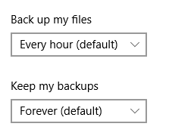
Figure 15. Default back up schedule in File History.
- To change the frequency of how often File History runs, click on the arrow under the Back up my files and select a more appropriate option. Remember to schedule a time when the system use is as low as possible to speed the backup process.
- To change the frequency of how long to keep the data backup, click on the arrow under the Keep my backups and select a more appropriate option. Six months may be an appropriate option if you are backing up data to a USB thumb drive, it really depends on the size of your drive and how long you want to keep the data.
Once you have finished with your selections, click on the Back up now button. This process may take some time so ensure that you can wait until the process is completed before having to move your laptop.

Restoring Files with file History.
There are many different ways you can restore your files from File History, the method described below is just one of them. Before you begin practicing restoring files, create a folder on your desktop called Restored Files to ensure that you do not accidentally overwrite any files.

Next, we will want to start the File History program. To do so, access Settings from the Start menu, select the Upgrade & Security tile in the Settings window, then select Backup. Once you are on the Backup Options page, scroll down the page until you see Related Settings.

In the Related settings, click on the Restore files from a current backup link.

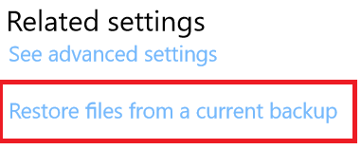
Figure 16. Restoring Files using File History
Clicking the Restore files from a current backup shows the File History program, shown in Figure 17 below. The program looks much like a plain old folder. For example, the figure shows what happens if you click the History button in any folder and then click File History’s Home button: That button lets you see all of your backed up folders.
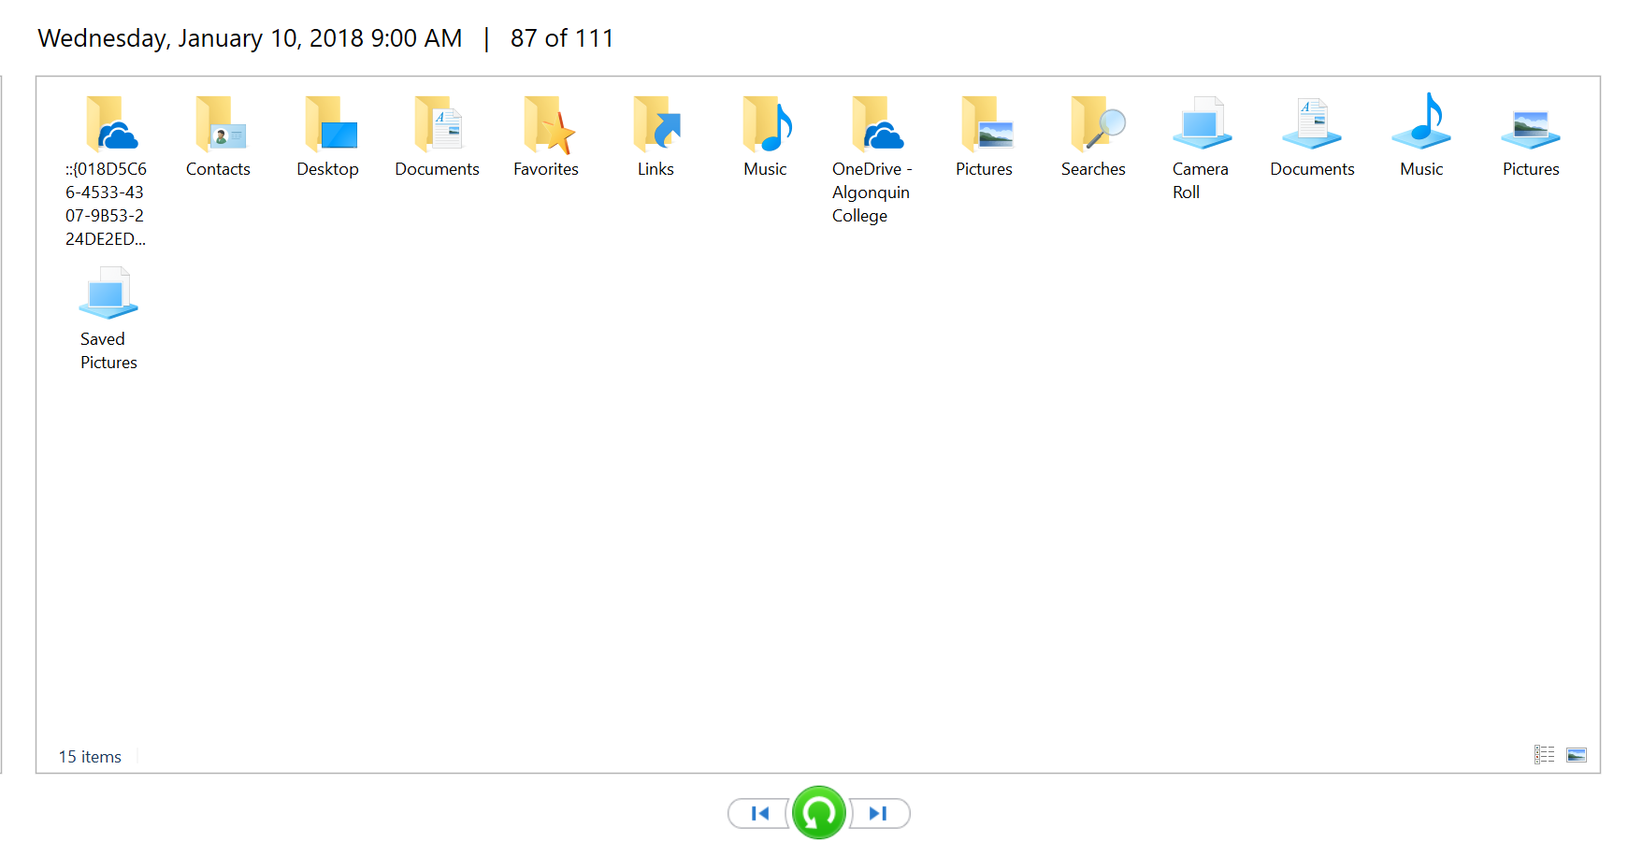
Figure 17. File History
Select the folder or file that you want to restore by left-clicking on them. If you want to restore multiple files or folders, you will have to hold down the CTRL-key and left-click on the files/folders that you want to restore.
Go to the settings icon, located at the top right-hand corner of the page, see Figure 18 below, and left click on it.

Figure 18. Settings icon.
Select the Restore to option, as seen in Figure 19. Select the Restored Files folder on your desktop. Your files should now automatically restore to the Restored Files folder on your desktop.
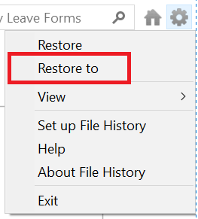
Figure 19. Restore to option
If it does not automatically start to restore, press the green restore button, located at the bottom of the page.

Lab Questions:
Create a Microsoft Word document, save it using your last and, first name and Lab 3 as the file name. Example: Mayyahi_Laith_lab 3. Answer the following questions using your own words.

- What is your data backup and restore plan? Use the questions below and at the beginning of the lab to help you formulate and articulate your plan.
  - What data did you backup? While I am not looking for every file name and folder, your answer should be more descriptive than school work, pictures, games, etc.…
  - What type of Backup strategy did you implement? Full, Differential, Incremental, one off? A combination of all of them?
  - When are you going to perform your data backups? Day and time is acceptable answer.
  - Where & how are you going to store the backup files?
    - Are backups in a secure location or can anyone get to them?
    - If anyone has access to your data backups, are you going to encrypt your data backup files? If so, why? If not, why?
  - Is your backup strategy going to include your mobile devices as well?
  - Are your data backups performed automatically?
    - What is your recovery strategy? Have you thought of how long, approximately, would it take you to recover from a catastrophic data loss? For example, if you lost your laptop or someone stole your laptop?
    - Approximately how long will it take you to recover a file that was deleted accidently?
- If no data loss has occurred; why might you want to restore a copy of your backup?

Deliverables
When you have completed the lab, show it your lab professor. Do not copy answers from your friend(s). Ensure that your answer file is in Microsoft Word.docx format.

CST8101 Lab 3 Marking Guide
3 Mark | Backup plan is well thought out  -The reader has confidence that should a data loss occur, the student has critical data backed up and will be able to restore the data quickly and easily
5 Marks | Answer all questions
2 Mark | Lab 3 was submitted on time in the class and in the correct format.
10 Marks | Total

