Due Date: One week after your lab period.

Marks:
10 Marks

Submission Guidelines:
Open a blank Microsoft Word document. Save the file using your Last and First name.
Example: mayyahi_laith_CST8101_Lab 1.docx.

Objective:
The purpose of this lab is to:
- Learn how to take screen captures
- Connect to the ACSecure Network Wirelessly
- Connect to other printers in the College
- Install any Operating System Essential Updates
- If you already don’t have an anti-virus product installed, install one and ensure that its’ virus definitions are updated.

Tools:
- Laptop running Microsoft Windows 10.x
- Algonquin College Network User Id and Password
- Network Connection to the World Wide Web

Procedure:
The following instructions will show you how to take screen captures, connect to ACSecure Network wirelessly, connect to the printers at the College, install any operating system updates, and scan your laptop for viruses. If at any time that you are unsure about what to do, feel free to ask your lab instructor for help.

Using the Snipping Tool to capture Screen Shots
To open Snipping Tool, select the Windows Start button, type Snipping Tool, and then select it from the search results.
The window of the Snipping Tool application looks similar to the screenshot below.
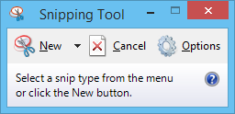
Figure 1. Windows Snipping Tool.

Snipping Tool's Main Interface
The Snipping Tool window has three important buttons: New, Cancel and Options.
- The New button allows you to select the type of screenshot that you want to take and then take a screenshot.
- The Cancel button allows you to cancel the current action.
- The Options button allows you to customize different aspects of the application.

How to Take a Custom Screenshot
There are four types of captures available when pressing the New buttonThe Free-form Snip enables you to draw an irregular line around an object or area.
- The Rectangular Snip allows you to take a screenshot shaped as a rectangle, by dragging the cursor around an object.
- Window Snip allows you to select a window (e.g. your Internet browser) or dialogue box (e.g. error message received from an application) and capture it.
- Full-screen Snip enables you to capture the entire screen, like the old-fashioned Print Screen key.

Saving Screen Captures:
To save the screenshot, press the Save Snip button,
- Select the location where you want it stored
- Give the screen capture an appropriate file' name
- Choose the file type: PNG, GIF, JPEG or HTML. The, press Save.
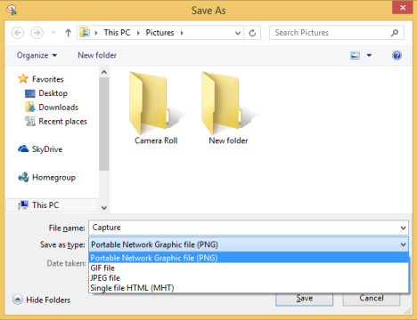
Figure 2. Saving a screen
Once you have saved your screen captures, you can insert them in your Microsoft Word documents at a later date.

Connecting to the Wireless Network
*Note: These Instructions assume that you have an Algonquin College Network User Id and password.
Once you have a network account, you can connect to the College networks including the wireless networks. Wireless networking is provided throughout the Woodroffe campus. To connect to the campus wireless network, you require:
- Your network account username and password
- A wireless laptop with updated wireless drivers
- A connection profile set up on the device
- A strong wireless signal
The wireless network on Campus that we will be using for your course is: ACSecure - the wireless network
To connect to the wireless network:
- Click on the wireless icon on your lower desktop or upper right icon
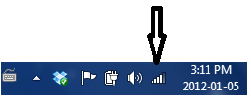
Figure 3. Wireless Icon
- Select ‘ACSecure‘, then ‘Connect’
- Once you’re connected, you will be prompted to enter your Algonquin network username and password
- Accept the certificate when you are prompted
- Once you sign in with your network ID, the device will be configured to connect to ‘ACSecure’. This should only take a minute or two.
- Once you have connected to the ACSecure Network, take a screen capture using the Windows Snipping and paste it into your Lab 1 Word document.

To connect to other Wireless Printers at the College
You will need to install the drvier for the printer ( room T-111)t and the Findme print queue to print on campus – the steps below show you how to install the printer.
Installing T-111 printer
On your computer, select Start > Run. Note: On Windows 10, select the Windows key +”r”.
- In the text area, enter \\woprint2 and press enter. Note: You may be prompted to login at this point. When you enter your username, include woodroffe. For example if your username is smit0123, you would enter woodroffe\smith0123.
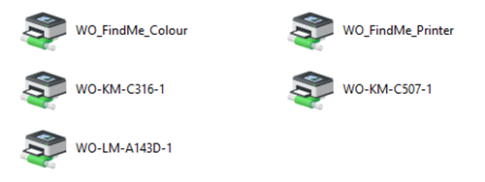
Figure 4.. List of Printers on woPrint1
- Double click on T-111 printer, and select Install Driver from the menu.
- Follow the prompts to install the print queue.
You now have successfully installed the print queue. Once you have connected to the print queue, try to connect to the printer in room T-111 and print a test page.

Updating the Operating System
In this exercise, you will be installing any outstanding Operating System updates, you must keep the operating system up to date at least weekly.
In Windows 10, select the Windows key + “I” to open the settings menu then select Update & Security.
If any updates are found, you can review them before you apply the updates to your OS and software. Once the updates are installed; you can take a screen capture, like the one in shown in Figure 5 below.
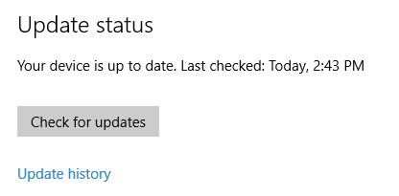
Figure 5. Windows Update Status

Some Windows 10 editions will allow you to defer upgrades to your PC. If your version of Windows 10 allows you to defer upgrades, continue to the next paragraph below. If your version of Windows 10 does not allow you to defer updates, you can skip ahead to next section of the lab entitled Anti-Virus Software. If you are not sure whether your version of Windows 10 defers updates; consult with your lab instructor.
When you defer upgrades, new Windows features won’t be downloaded or installed for several months. Deferring upgrades doesn’t affect security updates. Note: deferring upgrades will prevent you from getting the latest Windows features as soon as they’re available.
One reason to defer updates is to prevent them from being installed and your laptop being automatically restarted at an inconvenient time. For example, it would be very inconvenient for you if your laptop downloaded and installed updates when you are in the middle of writing an online test or exam!
To defer updates, select the Advanced Options from the Windows update menu.
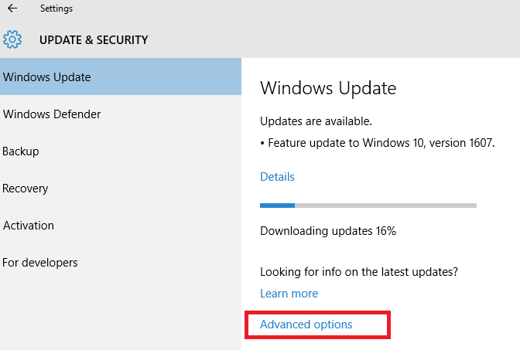
Figure 6. Windows Update Advanced Options
In the advanced options menu, select the Notify to schedule restart option from in the choose how updates are installed drop down menu.
Ensure that the Defer upgrades check box has a check mark
When you have completed both tasks, take a screen capture showing your upgrades are deferred and you are notified before your laptop is re-started and paste it into your Microsoft Word document. Your screen capture will be similar to Figure 7 below.
Once you have taken your screen capture, you may close the window Advanced options window.
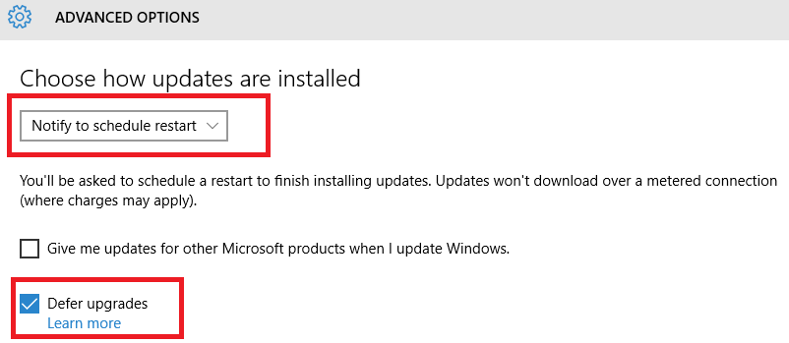
Figure 7. Deferring Upgrades

Anti-Virus Software
A number of anti-virus products are on the market, some better than others. Things to consider are:
- The ability to detect viruses. Some free A/V products do not update their virus definitions very often.
- The ability to scan new files on your computer. New things on your computer can come from the network, a USB key or even from PDFs or pictures on web pages. This is sometimes called “real-time” protection.
- The resources used. Some products will use a lot of memory, CPU or disk I/O possibly interfering with normal computer use. This may encourage you to disable the product.

If you already have a non-trial version of a fully featured anti-virus product, you will use it in place of Microsoft Windows Defender. You must show the virus definitions is fully up to date and a recent full scan (within two days) has been done.
If your system came with a trial version of anti-virus software, you should uninstall it, unless you plan to purchase it. If you need to uninstall the anti-virus program, open the “Control Panel” and choose “Uninstall a program” or “Programs and Features” depending on your Control Panel view.
If you are using another anti-virus program, ensure that its’ virus definitions are up to date then you can perform a full virus scan on your hard drive. Once the scan is complete, you can take a screen capture showing the scan is complete.
This portion of the lab is going to assume you are using Microsoft’s Windows Defender program that came with installed with Windows 10. If you are using another anti-virus product, you can skip this portion of the lab exercise and continue to the next part of the lab, Lab 1 submission
Start the Defender program and choose “Settings” (the tab furthest right). Verify the following options are on:
- “Real-Time” protection.
- Cloud-based based protection I leave it to you if you want to turn on this option.
Once you have finished choosing your settings, click on the Update tab, if your virus definition’s need updating, click on the Update button located on the right-hand side.
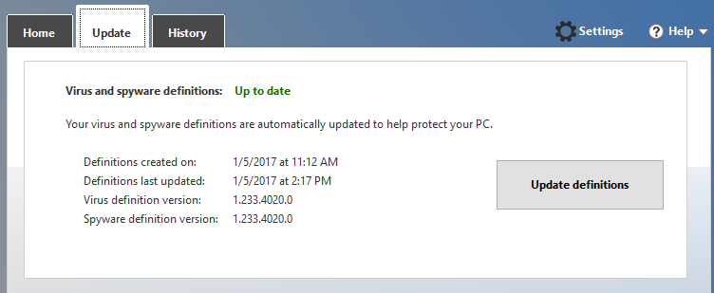
Figure 8. Virus definition
Once your virus definitions are updated, click on the home tab and perform a Full Scan on the hard drive.

Once a Full Scan of the hard drive has been having been completed, take a screen capture of the completed scan, like one in Figure 8, and place it into your Lab 1 document and save your Lab 1 document.

Lab 1 Submission
Once you have completed the lab, you are going to show it to your lab instructor in the class.

CST8101 Lab 1 Marking Guide
2 Mark | Installed printer (Test page)
2Mark | Screen capture showing your laptop is connected to the ACSecure network
2 Marks | Screen capture showing all windows essential operating system updates are  installed on the laptop and the operating system is up to date  Installed
2 Mark | Screen capture showing an anti-virus program is installed, and the hard drive has been scanned and is virus free
2 Mark | Lab 1 was submitted on time and in the correct format
10 Marks | Total

