Question 1 (1 point)

A simple step to take when protecting files is to periodically ________ (one word) or copy your files to another drive, DVD, or a flash drive.
Question 1 options:
Backup
Delete
Earse
Do nothing
Save

Question 2 (1 point)

You can protect your files by periodically backing them up.
Question 2 options:
True
False
Save

Question 3 (1 point)

Which of the following backup methods would generally give you the greatest protection?
Question 3 options:
Backup all your data files as they are changed to a USB flash drive and nightly on to remote or off-site storage.
Back up all your data files hourly onto a USB flash drive.
Back up all your data files nightly on to remote or off-site storage.
No backups, nothing ever fails.
Save

Question 4 (1 point)

Why should you back up your data files? (Choose all that apply)
Question 4 options:
The world is not perfect
Hardware is not perfect
People are not perfect
Everything is perfect
Save

Question 5 (1 point)

Select all the attributes of a "Proper" backup, according to the slides presented. Choose three
Question 5 options:
Making multiple backups on a schedule
Automatic
Not stored in only one place
delete backup
Save

Question 6 (1 point)

An incremental backup depends on a ____ (one word) backup.
Question 6 options:
FULL
One off
Deffenital
All the above
Save

Question 7 (1 point)

Which of the following are suitable media to store a backup? (Choose all that apply)
Question 7 options:
Another computer(server or workstation)
On a USB flash drive or removable hard drive
Email, In the "cloud"
CD/DVD, Tape files
Save

Question 8 (1 point)

Which of the following are unnatural (intentional) disasters? (choose three)
Question 8 options:
Virus or Malware
My account was hacked
Someone stole/vandalized my laptop
Hurricane Katrina caused to delete my pictures
Save

Question 9 (1 point)

Choose three types of backup method.
Question 9 options:
Images
Full
Incremental or Differential
printer back
Save

Question 10 (1 point)

According to the lecture which of the following is a primary storage?
Question 10 options:
memory
Hard drive
Optical drive
Robotic (Archival use)
Save

Question 11 (1 point)

Choose three natural disasters
Question 11 options:
Tornado
Fire
Car accident
Virus or Malware
Flood
Save

Question 12 (1 point)

It is a good idea to mess up the registry in your Windows OS.
Question 12 options:
True
False
Save

Question 13 (1 point)

An image backup is a full backup of the entire structure of the hard drive
Question 13 options:
True
False
Save

Question 14 (1 point)

Which of the following backup methods is quicker to restore the data?
Question 14 options:
Incremental
Differentials
Image backup
None of the above
Save

Question 15 (1 point)

Which of the following backup methods takes longer to backup the data?
Question 15 options:
Incremental
Differentials
Image backup
None of the above
Save

Question 16 (1 point)

According to the lecture Norton Ghost and paragon are the two imaging backup method.
Question 16 options:
True
False
Save

Question 17 (1 point)

Please specify this backup.
Question 17 options:
Mon Tues Wed Thurs Fri.
Full (50) N+C(20) N+C(28) N+C(30) N+C(35)
5+15 5+8+15 5+8+2+15 5+8+ 2+5+15
Differenitals backup
Image backup
Full backup
Incremental backup
Save

Question 18 (1 point)

It is a computer system (Operating system) on which application programs can run. It is a base for hardware and software. Example: MS 2000 and Mac OS X
Question 18 options:
Platform
Process
Thread
CPU
Save

Question 19 (1 point)

The main objectives of virtualization
Question 19 options:
Portability of applications
Isolation
Integration /deployment
All the above
Save

Question 20 (1 point)

I have a 16 bit game (wolf stein). I want to play it in my Windows 10 OS. Which of the following virtualization technique allows me to run this game.
Question 20 options:
Emulator
Linux os
Bare metal (Type 1)
Hosted (Type 2)
Save

Question 21 (1 point)

Example of full virtualization technique are? (Choose two)
Question 21 options:
IBM's VM family,
VMWare Workstation
Bare metal (Type 1)
Hosted (Type 2)
Save

Question 22 (1 point)

By looking this picture, what am I trying to do?

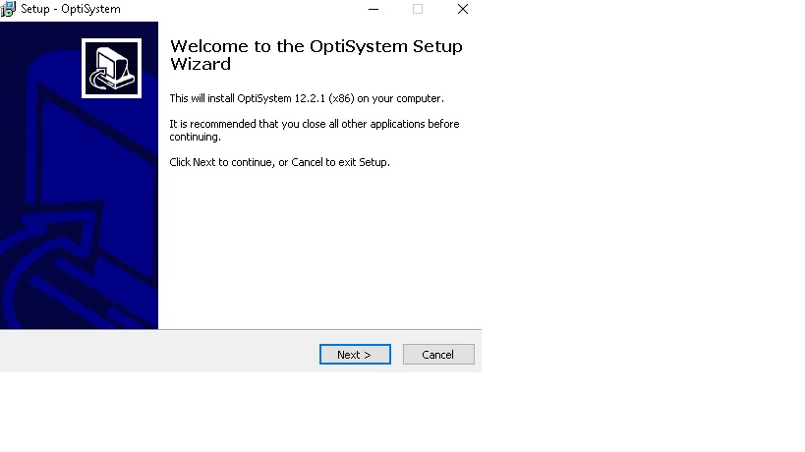
Question 22 options:
Install an application
Delete an application
Move an application
None of the above
Save

Question 23 (1 point)

The command to install an application in Ubuntu is:
Question 23 options:
mike@mike-virtual-machine:~$ select apt-get install open-vm-tools
mike@mike-virtual-machine:~$ search apt-get install open-vm-tools
mike@mike-virtual-machine:~$ sudo apt-get install open-vm-tools
mike@mike-virtual-machine:~$ asus apt-get install open-vm-tools
Save

Question 24 (1 point)

Linux always shows the password when you type it in.
Question 24 options:
True
False
Save

Question 25 (1 point)

During the VM 12/14 installation, What was the default disk type?
Question 25 options:
IDE
SCSI (recommended)
SATA
BIOS
Save

Question 26 (1 point)

During the Ubuntu OS installation you saw this screen; what is the problem?

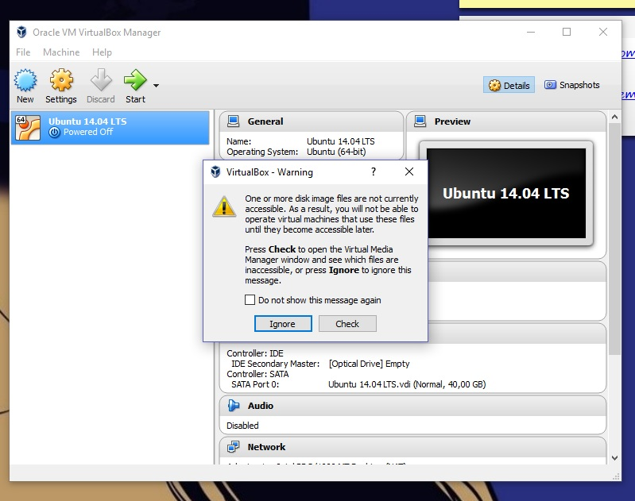
Question 26 options:
You forgot to turn on your Virtualization
VM can not find the path to the Ubuntu ISO file image
You have downloaded the wrong Linux version
All of the above
Save

Question 27 (1 point)

Name three virtualization techniques (Select all that apply)
Question 27 options:
Server virtualization
Para- virtualization
Emulation
Bare metal virtualization
Save

Question 28 (1 point)

After you have downloaded and installed VM workstation 12/14, in your computer, you can share your product key with your classmate.
Question 28 options:
True
False
Save

Question 29 (1 point)

Choose two types of Hypervisor.
Question 29 options:
Host
DOS
Bare Metal
para-virtualization
Server virtualization
Save

Question 30 (1 point)

What is usually controlled by the Hypervisor?�
Question 30 options:
CPU, Memory
Printer Cable
Email address
MS Office
Save

