“Violent Fires Soon Burn Out Themselves Small Show’rs Last Long, But Sudden Storms are Short”

By:

CHM1311 Section Z01

Demonstrators:

October 14th, 2017

Department of Chemistry

University of Ottawa

Introduction:
Chemical reactions can proceed in one direction as well as go through a reverse reaction. When this occurs, there is a forward and reverse reaction constantly happening. Equilibrium is achieved when the rate of reaction of the reactants equals the rate of reaction of the products. At this point during the chemical reaction, the concentration of the products and the reactants remains the same. This can be defined as a Dynamic state due to the fact that at this stage of the reaction, the flow of reactants and products is equal.

A ⇌ B

A is the starting substance, therefore its initial concentration will decrease. As for B, we assume there is none of it to begin with and that its initial concentration of zero will increase until it is constant with the concentration of A. When both concentrations are constant, this is when the state of equilibrium is achieved. The equilibrium constant, “K”, can be written for each equilibrium chemical reaction as:

K = [products]
[reactants]

In this equation, K is a ratio for the products and reactants. When K is a large value, it is clear that the reaction would favour the products. When K is a small value, then the reaction would favour the reactants. Below is an example of the ratio between the products and the reactants (K), in a general chemical reaction:

aA + bB ⇌ cC + dD
K = [C]^{c}[D]^{d} ÷ [A]ª[B]^{b}

Le Chatelier’s Principle allows us to alter the relationship between the products and the reactants. It states that the reaction will always shift in the direction that minimizes the effects change may have on a system at equilibrium. Therefore a new equilibrium will be established if a change occurs, simply by the reaction adjusting. This adjustment includes the concentrations of a reactant or product adjusting due to a change in pressure, volume, or temperature. A change in pressure or volume will not affect the value if K because the ratio will level itself. Yet a change in temperature will affect the value of K because it will cause one side of the reaction to be favoured over the other.

Equilibrium can also be used as a tool when analyzing acid-base reactions. While observing the interactions between acids and bases, their behaviours can clearly be seen. Acids are regarded as proton donors while bases are seen as proton acceptors. Every acid has a conjugate base and every base has its own conjugate acid, therefore each acid and base are paired together in conjugate pairs. These pairs are made through the loss and gain of protons of each acid and base. During a chemical reaction, the direction flows to the weaker conjugate pair from the stronger conjugate pair. The strength of the conjugate pair is determined by how well it ionizes in water and whether or not it dissociates completely. A strong acid/base will completely dissociate while a weak acid/base will partially dissociate or only partially ionize. The ionization of a conjugate pair can be calculated by using the expression of the K_{a} or K_{b} constant:

For example:
The K_{a} constant for:
CH₃CO₂H + H₂O ⇌ CH₃CO₂⁻ + H₃O⁺
Would be:
K_{a} = [CH₃CO₂⁻ ][H₃O⁺] ÷ [CH₃CO₂H]

In order to calculate the concentration of H₃O⁺ and OH⁻, the pH scale must be used because their concentrations are so small. Their concentrations can be calculated by using:
pH = -log[H₃O⁺]
and
pOH = -log[OH⁻]
Water, a neutral solution, has a pH of 7 which can be found in the middle of the pH scale. A more acidic solution would have a pH lower than 7 and a more basic solution would have a pH higher than 7. Indicators, which are organic compounds, are used in reactions on order to determine the pH of a solution. Instead of having to calculate the pH, these indicators are added and change colour in accordance with the pH of the solution.

Acid-base reactions can be found throughout the human body, especially in the blood. The blood in the human body has to keep a pH of 7.35 to 7.45 or else there will be serious health consequences. This ideal pH is maintained through a buffer system, where various chemicals are introduced into the bloodstream in order to adjust small changes in the pH. One example is a carbonate ⇌ carbonic acid buffer system that produces an equilibrium and is used in some situations.

Procedure:
Please refer to the procedure in the lab manual. The procedure was followed as written and no changes were made.

Observations and Questions:
Table 1: Equilibrium shift
Steps | Observations
Add 1mL of 0.1mol/L CuSO₄ to a clean test tube (a) | ● CuSO₄ :Blue and translucent liquid  ● Has no definitive scent  ● Clear, pale blue
Dropwise add NH₃ until change(b) | ● NH₃ : Clear liquid  ● 2 drops turned it into a dark, vibrant blue  ● Reaction is instant  ● Intense odour
Dropwise add 1mol/L HCl until change (c) | ● HCl: clear, liquid  ● 20 drops = lighter and clearer  ● 40 drops = clear with a slight blue tint  ● Some precipitate
Repeat steps 2-3 (1) | ● NH₃  - Back to dark sapphire blue  ● Translucent again  ● Strong odour  ● 25 drops: back to a light blue tint  ● HCL  - Slowly became clear again

(a) In step one, a pale, blue colour was observed and the Cu²⁺ ion is responsible for the blue colour.
(b) In step two, the colour change that was observed was the colour of the solution in the test tube changing from a pale blue to a vibrant dark blue. This is caused by the copper-ammonia reaction intensifying the colour of the copper:
[Cu(H₂O)₄]²⁺(aq) + 4NH₃(aq) ⇌ [Cu(NH₃)₄]²⁺(aq) + H2O(l)
(c) The change of the ammonia into ammonium Is caused by the introduction of the H⁺ ions, which then causes the removal of ammonia from the precedent reaction. The addition of HCl created more products, which then caused the reaction to favour the reactants and shift to the left. This caused the Cu²⁺ ions to create the pale blue tint.
H⁺(aq) + NH₃(aq) ⇌ NH₄⁺
(1) With the re-addition of the NH₃ and HCl, the same changes were observed as earlier in the procedure. The reintroduction of the NH₃ created the dark blue colour again because the reaction shifted in favour of the products once again. The reintroduction of the HCl caused the reaction to shift in favour of the reactants once again, causing the need for equilibrium to create the removed NH₃

Table 2: Multiple equilibria
Steps | Observations
0.5mL of 0.1mol/L Na₂CO₃(d) | ● Na₂CO₃ : Clear liquid with no odour
0.5mL of 0.1mol/L AgNO₃ (e) | ● AgNO₃ : Clear as it is being dropped  ● Became a light brown colour  ● Opaque  ● Colour changed quickly  ● No odour
Dropwise add 6mol/L HNO₃ until change(f) | ● HNO₃ : clear liquid  ● 3 drops: Turned into a clear liquid  ● No odour  ● Reaction was almost instant
Dropwise add 0.1mol/L HCl until change (g) | ● HCl: Clear liquid  ● 4 drops: Became cloudy  ● No odour  ● Solution is opaque  ● White colour  ● Slower reaction
Dropwise add NH₃ until change (h) | ● NH₃: Clear  ● Strong odour  ● 3 Drops: Solution is clear again
Repeat steps 7-9 (2) | ● +HNO₃ :  - Solution is smoking at the top  - Exothermic, tube is hot  - Opaque  - +HCl:  - Endothermic, tube is cold  - Solution is slightly less opaque  ● +NH₃ :  - Solution became clear again  - Strong odour
Dropwise add 0.1mol/L KI until change (i) | ● KI: clear liquid  ● 3 drops: solution turned yellow  ● No odour  ● Opaque
Dropwise add 0.1mol/L Na₂S until change (j) | ● Na₂S: clear liquid  ● Opaque  ● Fast reaction
(d) The solution is a clear liquid with no odour. The mixture is clear because the carbonate ions have dissolved in the water, forming an aqueous solution.
(e) A change of colour to an opaque brown was observed. This can be explained by the double displacement reaction that occurred and the silver ions that are responsible for the colour change:
2AgNO₃(aq) + Na₂CO₃(aq) ⇌ Ag₂CO₃(s) + 2NaNO₃(aq)
(f) An almost instant reaction of the solution turning into a clear liquid was observed. The reaction is not reversible due to the fact that one of the products is a gas, which will most likely not be contained and will not be present for the reverse reaction. The introduction of HNO₃ causes a reaction between an acid and a base, which then forms the carbonic acid ion. This carbonic acid ion decomposes to form water and carbon dioxide. The carbonic acid ion will choose to take carbonate ions from the Na₂CO₃ or Ag₂CO₃, leaving one of them behind in the solution:
2H⁺(aq) + CO₃²⁻(aq) ⇌ H₂CO₃ (aq) → H₂O(l) + CO₂(g)
(g) A colour change of the solution turning white and opaque was observed. This can be explained by the introduction of HCl attracting free silver ions to bind with its chlorine ions. This causes a precipitate to form, which can be seen through the opaque white colour observed:
Ag⁺(aq) + Cl⁻(aq) ) ⇌ AgCl(s)
(h) A colour change of the solution becoming clear again was observed as well as a strong odour. The introduction of NH₃ caused the ammonia to bind with silver ions that were either from the solution or the silver chloride. Once all the silver chloride reacts, this creates a clear solution and causes the change of clarity:
Ag⁺(aq) + 2NH₃(aq) ⇌ [Ag(NH₃)₂]⁺ (aq)
(2) The same changes were observed when steps 7-9 were repeated, which was to be expected since the same chemicals and concentrations were used.
(i) A colour change to a clear, yellow liquid was observed, and it was caused by the formation of the Agl molecule. This was caused by the introduction of KI and its reaction with the silver from [Ag(NH₃)₂]⁺:
Ag⁺(aq) + I⁻(aq) ⇌ AgI(s)
(j) A colour change to an opaque solution was observed, and this was due to the introduction of the Na₂S which caused the formation of Ag₂S. This is a very sudden reaction as the sulfur from the Na₂S reacts with the silver:
2Ag⁺(aq) + S²⁻(aq) ⇌ Ag₂S(s)

Table 3: Buffers
Steps | Observations
100mL of H₂O on stir plate (k) | ● H₂O: Clear liquid  ● Initial pH = 4.73
Add 2.50g of NaHCO₃ (l) | ● NaHCO₃ : White and crystal  ● pH = 7.04  - pH increased dramatically  ● NaHCO₃ dissolved slowly in water
Add 30mL of 0.1M HCl (m)(n) | ● HCl: Clear liquid  ● pH = 6.91  - pH dropped slowly
Add 10 mL of 0.85% lactic acid (o) | ● Lactic acid: Clear liquid  ● pH = 6.29  - Slight decrease in pH
Increase rate of stirring (p) | ● No change in pH  - Stirring created some bubbles
Add 0.50g NaHCO₃ (q) | ● Increasing the speed of the stirring increase the dissolving rate of the NaHCO₃  ● pH = 6.52  - Small increase of pH at a slightly faster rate
Add 0.50g NaHCO₃ again (r) | ● pH = 6.76  - Slight increase of pH
Add pellet of CO₂ (s) | ● Dry ice: White pellet  - Smoking at the top of the beaker  - pH = 6.88  - pH is increasing at a much slower rate  - Pellet is slowly dissolving
Add 0.40g of NH₄Cl (t) | ● NH₄Cl: white and crystal  ● pH remained constant and then began increasing at a slower rate  - pH = 7.00

(k) The pH was measured to be 4.73, which was not expected because water is a neutral substance that normally has a pH of 7. This tells us that this water is slightly more acidic than normal water. This is due to the fact that it is distilled water, which normally has a pH of 5, therefor it is a pH in a suitable range.
(l) The pH observed rose to 7.04 as the solution became more basic. This was caused by the introduction of NaHCO₃, which then dissociated to become the HCO₃⁻(aq) ion. The formation of this ion is what caused the rise in pH:
NaHCO₃ + H₂O ⇌ Na⁺(aq)+ HCO₃⁻(aq)
(m) The HCl was added to the solution because it became far too basic and the pH needed to be lowered. H₂CO₃ was created through the addition of the acid through the H⁺ ions bonding with the current HCO₃⁻ ions in the solution. The addition of the acid causes the equilibrium to shift in order to make H₂CO₃, which lowers the pH:
2H₂O(l) + CO₂(g) ⇌ H₂CO₃(aq) + H₂O(l) ⇌ HCO₃⁻(aq) + H₃O⁺(aq)
(n) When the acid was added to the hydrogen carbonate ion, some small bubbles appeared on the inside of the test tube and the pH slowly dropped to 6.91. This occurred because the reaction shifted to the left in order to make more H₂CO₃, which decreased the pH. At this point, the pH of the solution is more basic than the distilled water measured in the beginning. The current pH is closer to the pH of blood, but it is still too acidic to compare as the Ph of blood falls in-between 7.35 and 7.45. The current species present in the solution are bicarbonate ions, hydronium ions, carbonic acids, water molecules, and chlorine ions which do not contribute to the reaction. Since the solution is considered to be slightly acidic in terms of the pH, the assumption is that there are more carbonic acid molecules than bicarbonate ions. According to the blood buffer theory, this needs to be improved as there needs to be a higher ratio of bicarbonate ions in the blood compared to carbonic acid molecules in order for blood to remain slightly basic:
2H₂O(l) + CO₂(g) ⇌ H₂CO₃(aq) + H₂O(l) ⇌ HCO₃⁻(aq) + H₃O⁺(aq)
(o) The pH of the solution went through a slight decrease to 6.29, which stimulates the introduction of lactic acid into the blood. This makes the blood more acidic and causes equilibrium to shift to the left in order to produce carbon dioxide. The carbon dioxide is then released from the body through respiration. In this chemical reaction, equilibrium shifts to the left after the dissociation of lactic acid into H₃O⁺ in order to deal with the increase in acidity:
2H₂O(l) + CO₂(g) ⇌ H₂CO₃(aq) + H₂O(l) ⇌ HCO₃⁻(aq) + H₃O⁺(aq).
(p) The pH of the solution did not change, which does not match the information that was given. The increasing of the stirring rate would cause more carbon dioxide to be lost and equilibrium would shift to the left in order to make up for it. This should decrease the pH because the concentration of bicarbonate ions would have also decreased:
2H₂O(l) + CO₂(g) ⇌ H₂CO₃(aq) + H₂O(l) ⇌ HCO₃⁻(aq) + H₃O⁺(aq)
(q) The pH increased to 6.52, showing that the solution is slowly becoming more basic after the introduction of NaHCO_{3.} The increase in pH is caused by the higher concentration of bicarbonate ions, which in turn is caused by the NaHCO₃ molecules dissociating in the solution.
(r) The pH of the solution increased to 6.76 after adding more NaHCO₃, which makes sense because a base was added to the solution and this is supposed to increase the pH. At this point, the pH of the blood would still be a little too acidic because the normal range for the pH of blood is from 7.35-7.45.
(s) The pH of the solution increased the slightest to 6.88 after adding the pellet of dry ice (carbon dioxide) to the beaker. The addition of the dry ice caused smoking at the top of the solution, which was gas caused by its extensive change of temperature. Later on, the pellet of dry ice slowly dissolved into the solution to produce carbonic acid with the water. The introduction of the pellet was used to simulate a decrease in pH from slow breathing when alkalosis occurs. Even though the pH of the solution increased instead of decreasing, this can still simulate slow breathing for alkalosis because the pH was still incredibly below the desired pH of blood:
2H₂O(l) + CO₂(g) ⇌ H₂CO₃(aq) + H₂O(l)
(t) The pH of the solution increased to 7.00 and remained mostly at this constant value. This value of pH is very close to the value at the beginning of the procedure after adding NaHCO₃ for the first time. Normally, the introduction of NH₄Cl in the blood is used to treat alkalosis by decreasing its pH. In the solution, the pH remained constant, before increasing, when the NH₄Cl was first introduced because normally the pH should decrease when an acid is introduced. After, the NH₄Cl dissociated into the solution created ammonium and chlorine ions before dissociating even more to form H₃O⁺ and NH₃. This creates an increased concentration of hydronium ions which needs to be compensated by an equilibrium shift. This creates more H₂CO₃ and causes the pH to drop as it is an acid:
2H₂O(l) + CO₂(g) ⇌ H₂CO₃(aq) + H₂O(l) ⇌ HCO₃⁻(aq) + H₃O⁺(aq)

Questions:
1. Why is NH₄Cl is used instead of HCl? Technically NH₄Cl already consists of HCl. If you decompose NH₄Cl you get the reaction as shown:
NH₄Cl (s) ⇋ NH₃(g) + HCl(aq)
Ammonia is a base, and once it reacts with hydrogen chloride, hydrochloric acid is formed NH₄Cl. Ammonia then forms ammonium after its reaction with hydrogen chloride taking a proton from it. This is allowed to happen because hydrogen chloride is strong acid, it exist in the form of H+ and Cl- ion. You also just can’t add ammonium to chlorine just like that since ammonium is highly unstable.

Ammonium chloride helps with the maintenance of pH levels within the bloodstream. The molecule itself is colourless and has a crystalline structure. It is highly soluble in water (and into our bloodstream), forming a slightly acidic solution. Since ammonium chloride forms an acidic solution once dissolved into the bloodstream, this allows for it to quickly act as a buffer and lower the blood pH of ones blood. If ammonium Iodide were to be used instead it would not have the same effect because even though it is soluble in water, it will form crystals later on blocking our blood channels such as arteries, veins, etc.

2. Whenever an acidic material was placed inside the beaker the entire mixture turned transparent. Because of the acidic substance the pH should have had a drop, but this was not the case in this trial, in fact the pH stayed relatively the same. If things were to have gone as planned, and a drop had occurred, the equilibrium would have moved to the right in favour of the products producing more H₃O⁺ due to the CO₂ (dry ice) that was added to it.
SA + H₂O → H₃O⁺ + OH + S⁻
(SA is a Strong acid)

3. The reaction for the movement of oxygen via hemoglobin can be shown as:
Hb₄(aq) + 4O₂ (aq) ⇋ Hb₄O₈ (aq)
Within the lungs is where there is the most abundance of oxygen, and according to Le Chatelier's principle the equilibrium will shift towards the right (favouring products) to make Hb₄O₈ (aq), also known as oxyhemoglobin. The concentration of oxygen is much lower in tissues and thus the equilibrium will shift to the left (favoring reactants). Oxyhemoglobin will be now used to make more hemoglobin.

Hemoglobin is used in numerous parts of the equilibrium reaction. The net reaction is::
HbH⁺(aq) + O₂(aq) ⇋ HbO₂(aq) + H⁺(aq)
Regular metabolic (such as digestion & respiration) reactions will create many acids as a by-product. This result will increase the amount of hydrogen ions, which in turn will lower pH, and will cause the equilibrium to shift once again towards the left side. This is commonly known as acidosis.
The result of acidosis plays a toll on the body due to the reduced amount of oxygen available for the body causing headaches and weariness. Acidosis is very common when working out (only temporally) the body needs an immense amount of energy and this surpusasses the capacity for oxygen to complete the task of converting glucose to carbon dioxide. Instead glucose is rather converted into lactic acid.
(Collins, J., Rudenski, A., Gibson, J., Howard, L., & O’Driscoll, R. (2015, September))

4. By dropping small amounts of HCl (hydrochloric acid) in the blood samples caused the original blood sample to go from a red colour to a blackish colour. Hydrochloric acid is very powerful and once it comes into contact with blood it prevents the task of HbO₂ (oxyhemoglobin). Oxyhemoglobin is packed with oxygen and is essentially just hemoglobin bonded to oxygen molecules, and without oxyhemoglobin working the transport of oxygen is slowed. This in turn moves the equilibrium to favor the products in order for the reaction to create more HbH (giving black colour due to lack of oxygen).

5. The pH of the flat soda is going to be higher than the fresh soda. In the fresh soda can there is pressurized CO₂ within the mixture, giving us that enjoyable fizz, The carbon dioxide in the soda creates a by-product of carbonic acid. Carbonic acid is what precisely gives us that fizz, and as the CO₂ diminishes away over time the drink becomes flat and loses its fizz. The remains of the CO₂ are still there in the form of weak acid and water. And since acid has a lower pH than the water the overall soda should have a pH that is higher.

6. Since chickens can not sweat once they get hot the begin to pant. In hot weather when chickens lay their eggs their shells appear to be more thin than usual and are easily broken. This can be explained using Le Chatelier’s principle along with the equilibrium of the CO₂ system as follows:
CO₂ (g) ⇋ CO₂ (aq) ⇋ H₂CO₃(aq) ⇋ H⁺ + (CO₃)²⁻(aq) ⇋ CaCO₃(s)
As the chickens begin to pant the equilibrium begins to shift because of the depletion of CO₂. And since all of these equilibriums are connected all of them begin to change and shift one way or another to compensate. A major shift is in terms of the loss of CaCO₃(s), thus giving the egg shells a thinner barrier. But if you were to inject or just feed the chickens some carbonated water the equilibrium will shift again and revert back to normal provided us with hard shells in return.
H₂O+CO₂ ⇋ H₂CO₃ ⇋ H⁺ + HCO₃⁻
Since the painting of the chickens cause a drop in carbon dioxide levels, the equilibrium above will shift to favour the reactants, thus using up more H⁺ and HCO₃⁻ ions . Because of this the result both H⁺ and HCO₃⁻ ions end in a increase in the blood pH levels.
(Adithya, S. (n.d.). The bicarbonate/carbonic acid buffer is also present... | Chegg Tutors)
Discussion:
Equilibrium is one of the most important ideas in chemistry, every reaction can be explained using this convention. A reaction is at equilibrium once the reaction that is going forward is equal to the reaction that is going in it’s opposite direction. The amount of concentration of each of the molecules (species) is not the same, yet they are continuous once the reaction takes place. Once equilibrium is reached the reaction does just not stop the forward and its opposing reactions are still occuring at the same rate. There is a constant value that ties the concentration (in the case of this particular lab) of the products to the reactants this value is known as K. When writing an equilibrium equation only aqueous solutions and gases are included, not solids or liquids. This is because the concentration of solids and liquids remain the same.
Equilibrium only changes in three scenarios, it is either when their temperature, pressure or concentration is change. For the purpose of this lab we will mainly focus on concentration because that was the controlled variable. Just to note that temperature is the only variable that can change the equilibrium constant. All of theses changes can be represented by Le Chatelier's Principle which says that a reaction will revert back to its equilibrium state after being affected by outside stress (more detailed cases in the introduction). After any encouternment with the outside world the reaction will try to prevail the changes and go back to when the forward and opposite reactions are equal to one another.
Now the purpose of this lab was to see how concentration and buffers affect the equilibriums of three various reactions. The first reaction showed that after placing CuSO₄ into a test tube along with NH₃ caused a reaction which turned the solution to a dark blue colour. Then in that same test tube adding in HCl caused the solution to revert back to its original colour hich was a light blue colour. Thus proving Le Chatelier's Principle on how after a reaction is missed with it will revert back to when the forward reaction is equal to the reverse reaction.

The second experiment showed that by adding Na₂CO₃(clear) to AgNO₃ created a brownish colour. Then by adding HNO₃ it revered the process reverting the Na₂CO₃ back to its clear solution. After adding HCl to the solution turned it back to a brownish colour. The solution was then followed by NH₃ once again reverting the whole mixture back to a clear solution. Once steps 7 to 9 were repeated the test tube began to smoke after the addition of HNO₃ and there was no real colour change within the test tube. After NH_{3,} KI and Na₂S were added the solution remained to stay clear. Therefore this experiment proves the theory of multiple equilibrium which states: that a reaction that contains acids and bases has to have a minimum of two equilibrium. One of those equilibrium must be water since the reaction takes place in an aqueous environment. For example:
NH₃(aq) + H₂O (l) ⇋ NH₄⁺(aq) + OH⁻(aq)
2 H₂O (l) ⇋ H₃O⁺ (aq) + OH⁻(aq)
(Robichaud, D., & Olmsted, J. (2002). Student solutions manual, Chemistry, 3rd edition, John Olmsted, Gregory M. Williams)

The third experiment showed that by adding NaHCO₃ to the beaker filled with H₂O the solutio began to turn to a white/cloudy colour forming some crystals towards the bottom of the beaker. The by adding HCl the solution became clear again. Shorty after adding lactic acid the mixture began to decrease in pH to approximately a pH of 6.29. As the stirring intensity increased nothing happened to the solution other than forming numerous bubbles. After adding NaHCO₃ for the second time the pH began to slightly increase to a value of 6.52. Then NaHCO₃ was added for a third time once again slightly increasing the pH level to 6.76. After adding in the dry ice (CO₂ pellet) the pH went up once again to 6.88. Finally NH₄Cl was added to return the mixture to a neutral pH of 7. Therefore this experiment proves the theory of buffers by adding weak acids and bases reactions are able to resist changes in pH imbalance. That's why at the end of the reaction the pH returned to a neutral pH of 7.

There were not a lot of sources of error in this lab, this is because this lab was not a quantitative but more so a qualitative experiment. This is why there isn’t as much precision in the amount of materials being used. For example the the amount of dry ice was not indicated because we are just waiting for a reaction to occur in order to record the observations being seen. A possible source of error in the lab could have been cross contamination. There could have been leftover residue in the test tubes prior to the beginning of this lab from previous ones. This would tamper with the results of the first to experiment giving weird results. Another cross comatmation error could have been due to the fact that the container that the dry ice was in was not properly closed and the lid was slightly open for particles and other substance to enter. Another errors was the pH probe and recording the pH value. When a new measurement was recorded the probe would give a irregularly low reading, but then slowly raised to a certain pH reading and just plateaued. So it is possible to have assumed that the probe leveled out when it fact the pH could still be increasing at a slow rate, so a lower pH would have been recorded.
This goes to show that equilibria and Le Chatelier's Principle explain the science behind chemical reactions. The majority of reactions that take place in the world can be related to equilibria in one way or another. From things in our body like homeostasis to chemical reactions within nature such as photosynthesis. All in all, equilibrium is a fundamental concept in chemistry.
Conclusion:
To conclude, the three experiments showed, and proved Le Chatelier's Principle on equilibria. The observations that were recorded for each experiment coincided with that of the results and showed that Le Chatelier's Principle holds up true along with buffers.

References:
Adithya, S. (n.d.). The bicarbonate/carbonic acid buffer is also present... | Chegg Tutors. Retrieved from https://www.chegg.com/tutors/Chemistry-questions/The-bicarbonate-carbonic-acid-buffer-is-also-present-in-chickens-However-chickens-also-combine-the-carbonate-in-their-blood-with-calcium-ions-to-make-calcium-carbonate-for-their-eggshells-Since-chickens-do-not-sweat-they-pant-in-hot-weather-What-effect-wo--36849/
Collins, J., Rudenski, A., Gibson, J., Howard, L., & O’Driscoll, R. (2015, September). Retrieved October 16, 2018, from https://www.ncbi.nlm.nih.gov/pmc/articles/PMC4666443/

Robichaud, D., & Olmsted, J. (2002). Student solutions manual, Chemistry, 3rd edition, John Olmsted, Gregory M. Williams (3rd ed.). New York: Wiley.
Peer Evaluation:
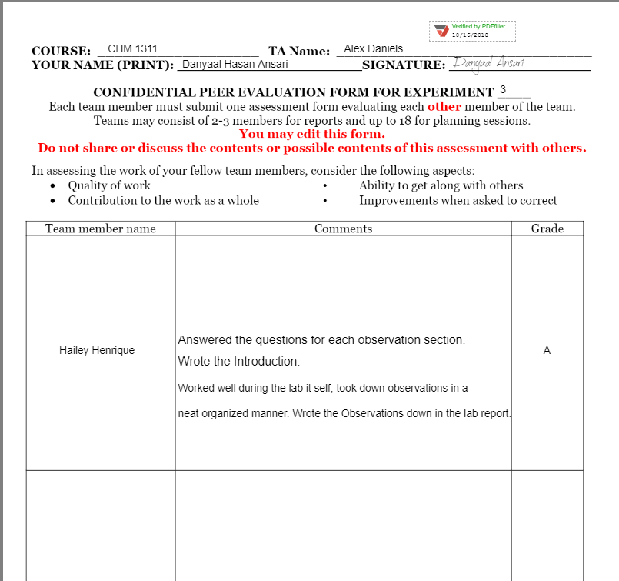

Raw Data:
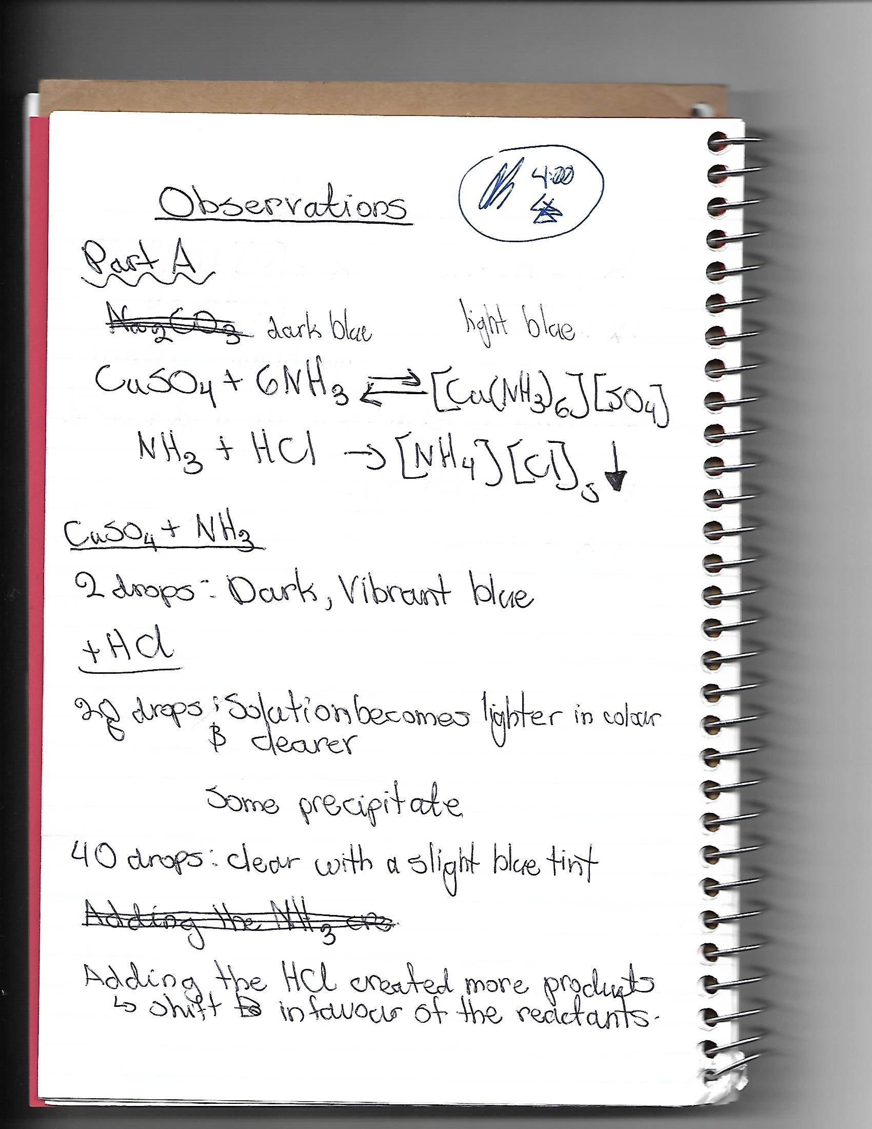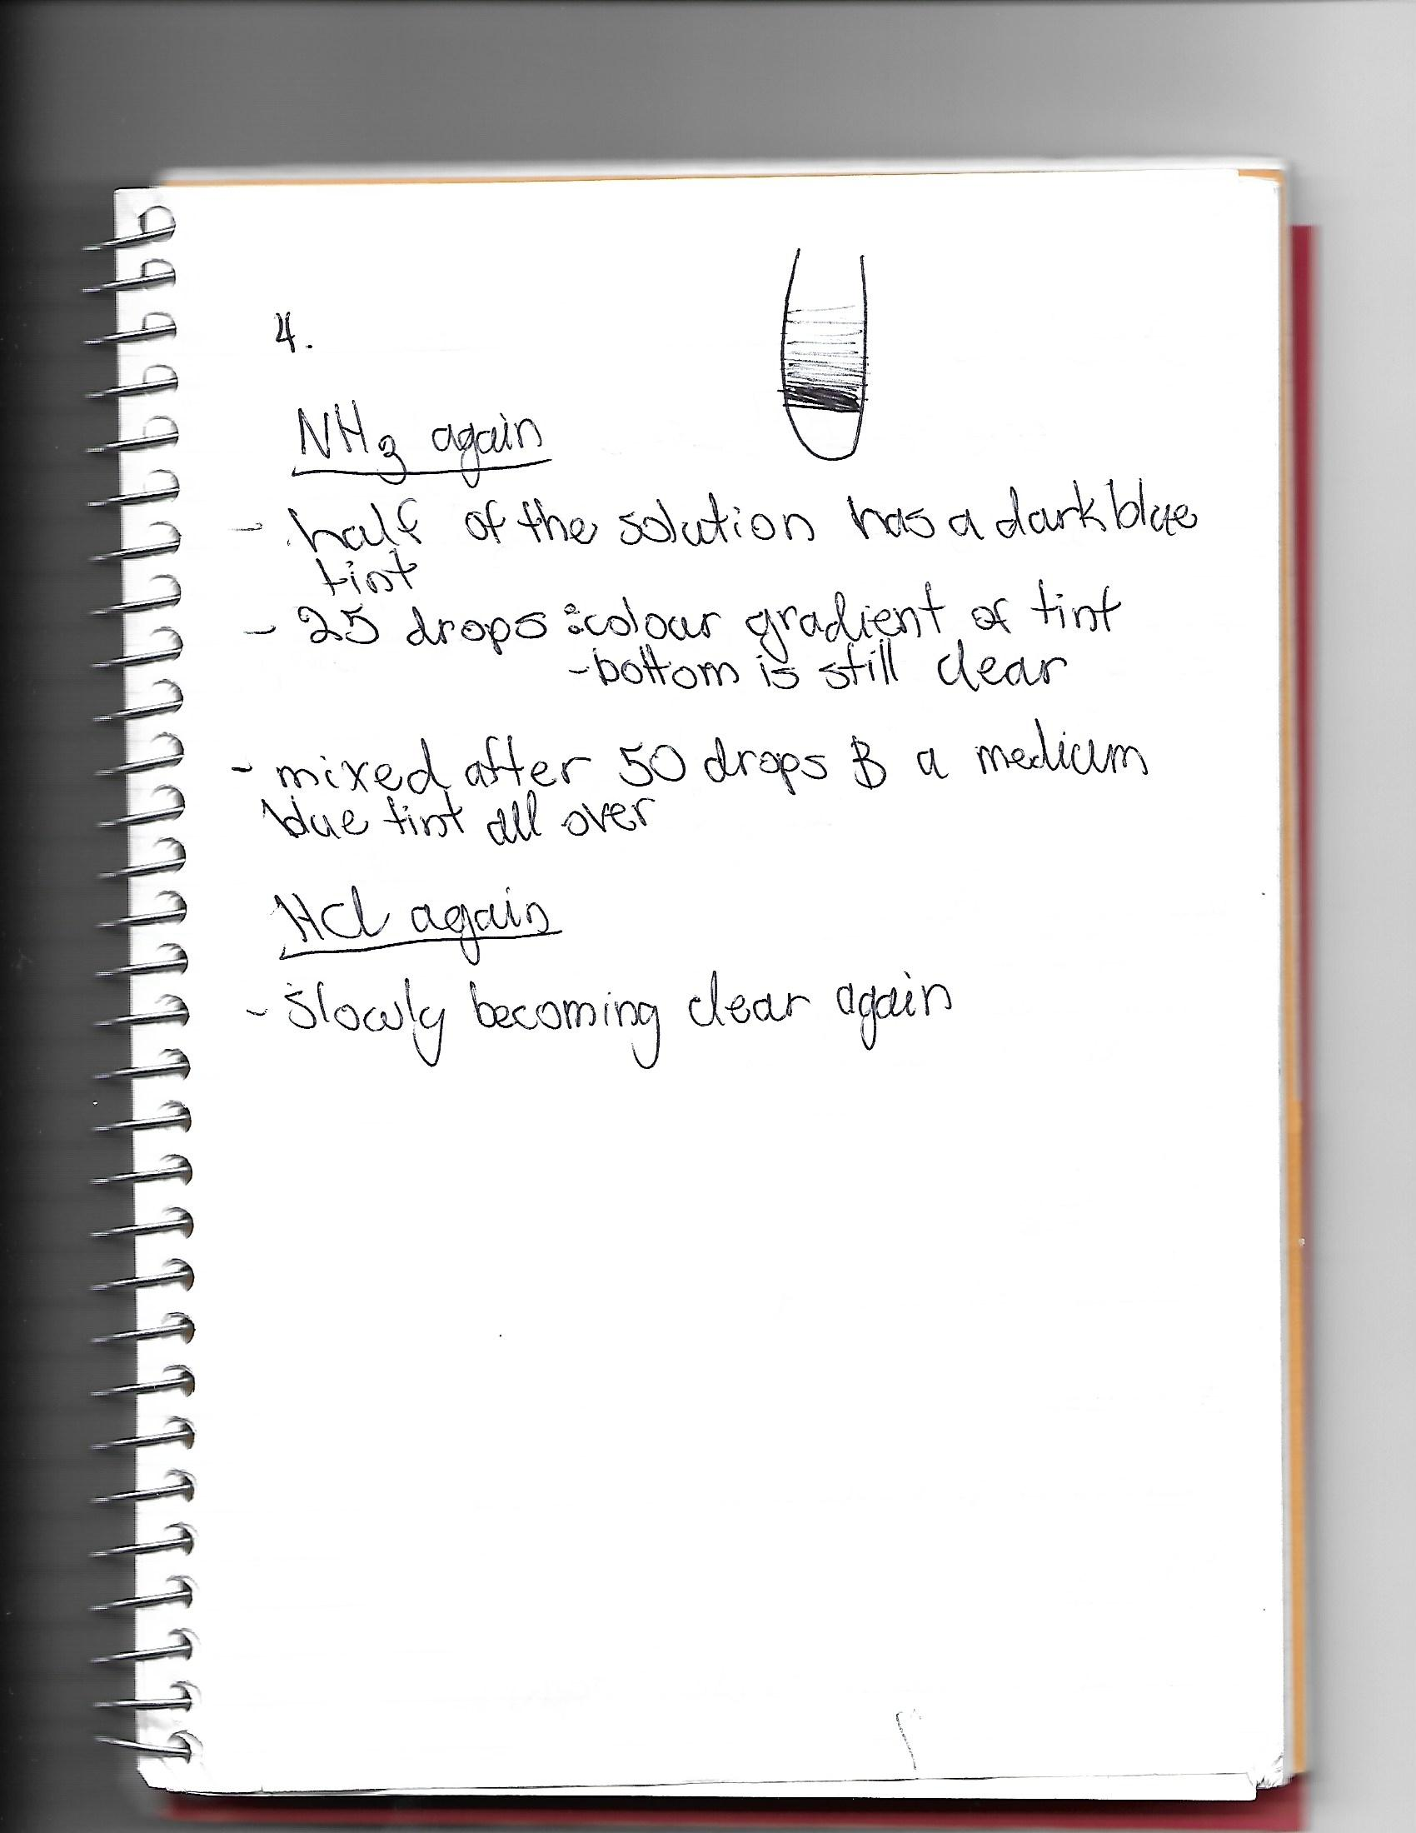

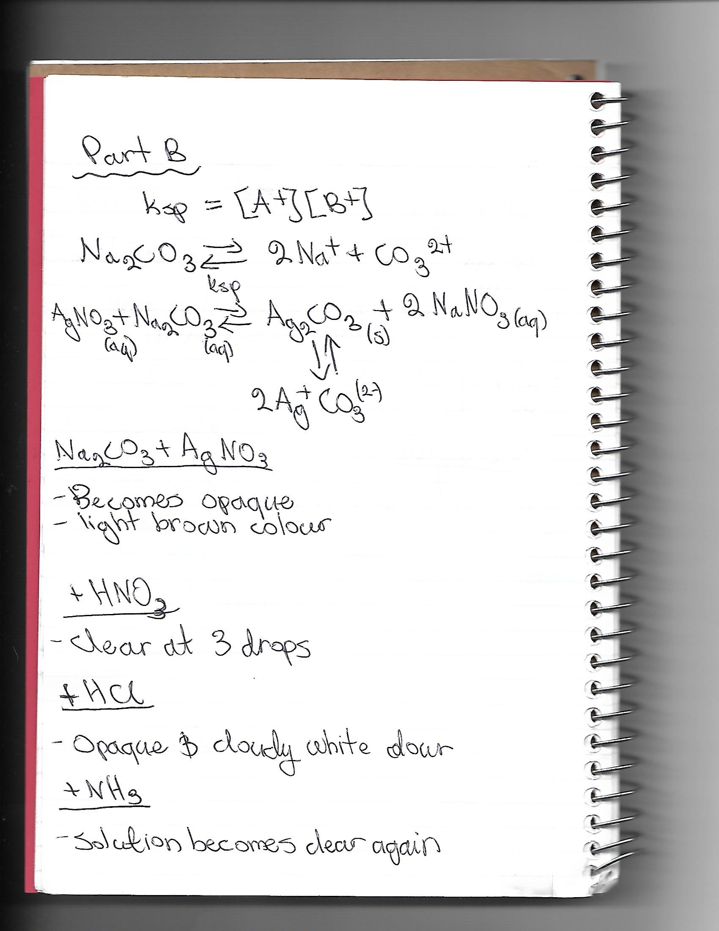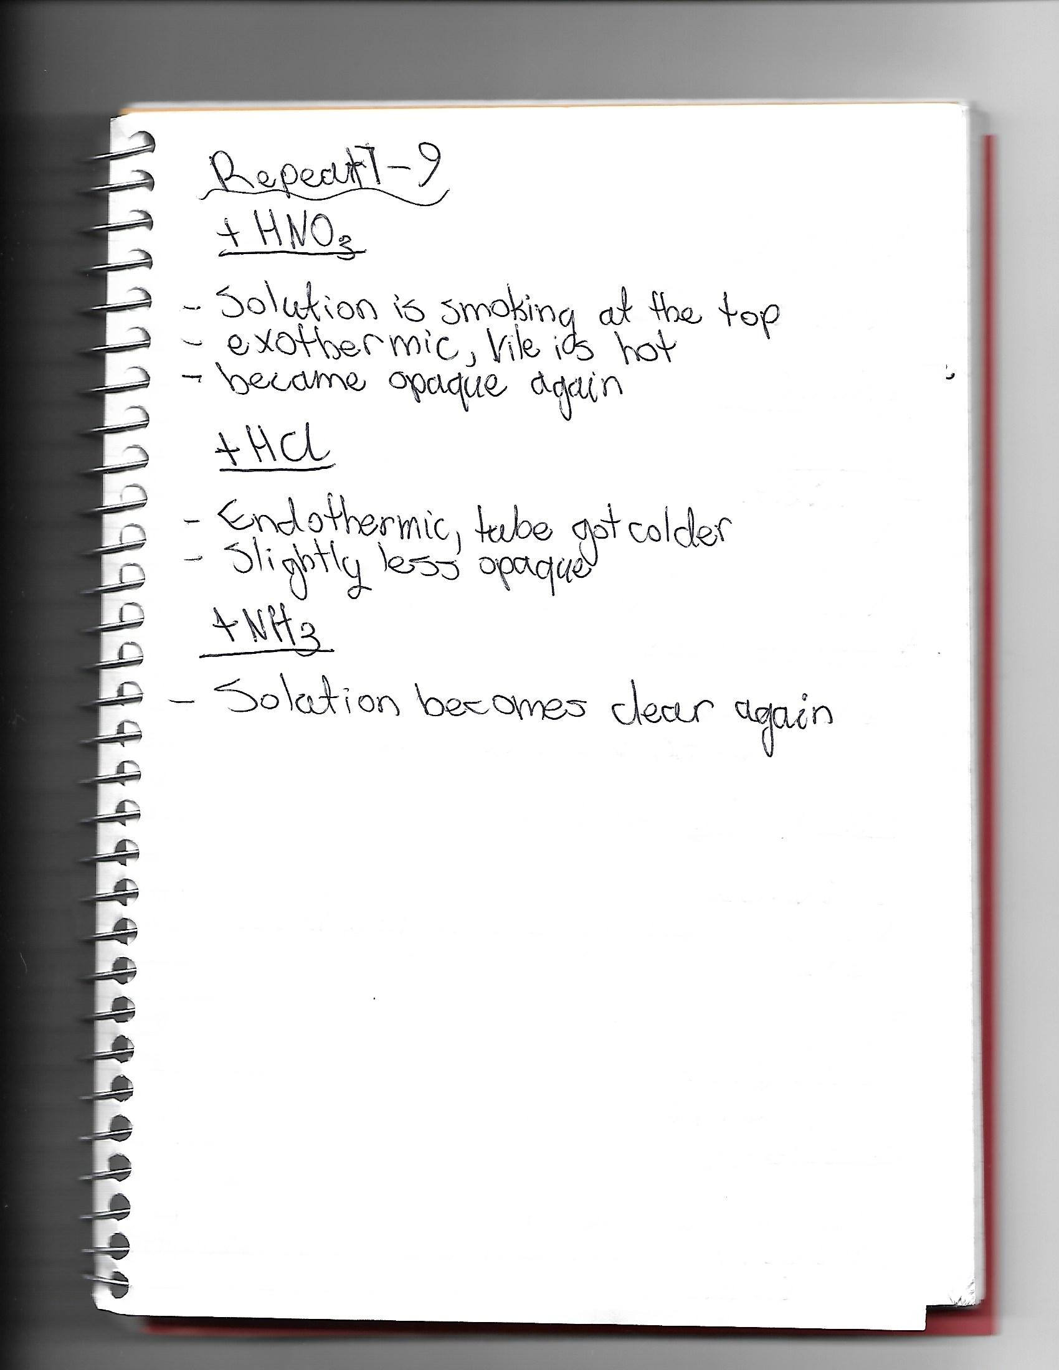

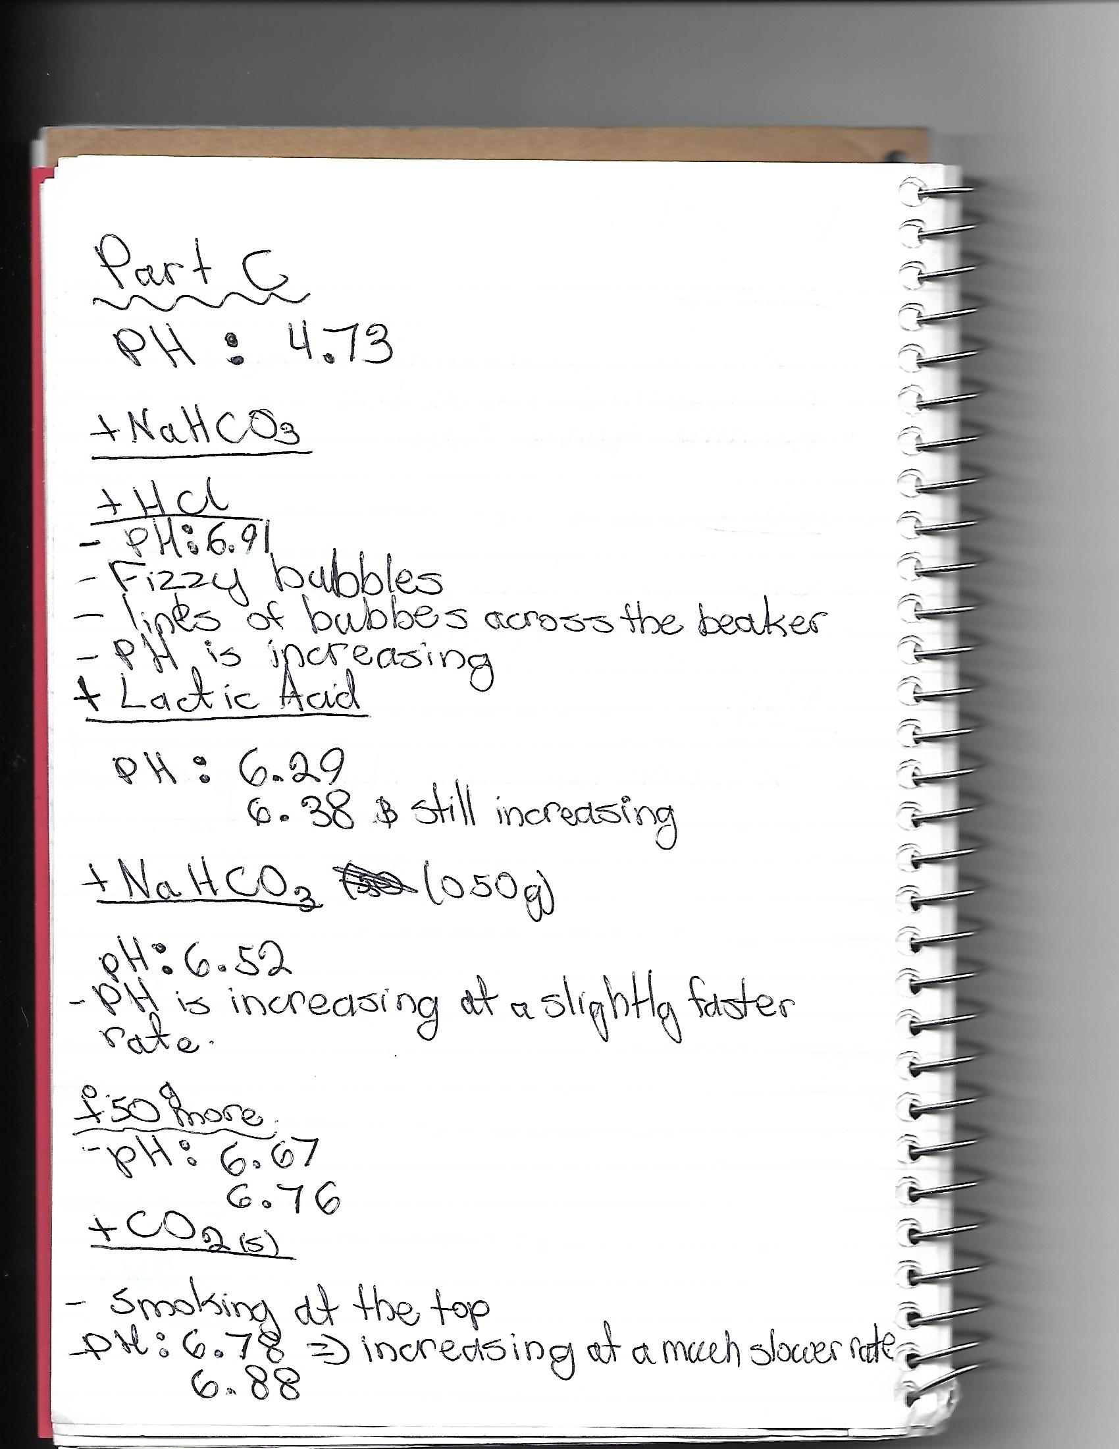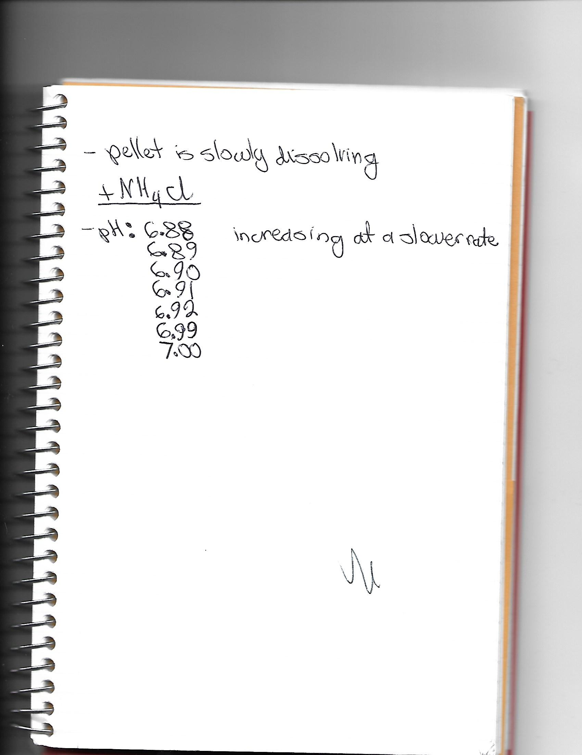

Late Submission Approval:


