Cellular respiration

- C6H12O6 +6O2 → 6CO2 + 6 H2O + ENERGY (-DELTA G)
- A negative delta G means that there products contain less energy than the reactants and that the chemical reaction can occur spontaneously (without an input of energy).
- The summary equation for respiration indicates that hydrogen is transferred from glucose to oxygen
- In general, organic molecules that have an abundance of hydrogen are excellent fuels because their bonds are a source of “hilltop” electrons-whose energy may be released as these electrons “fall” down an energy gradient when they are transferred to oxygen.
- Glycolysis occurs in the cytoplasm:
- Breaks down glucose into 2 pyruvate molecules
- Produces 2 NADH, 2 ATP

- When oxygen is present, the pyruvate in eukaryotes enters a mitochondrion, where the oxidation of glucose is completed. (in prokaryotes this occurs in the cytosol).
- Upon entering the mitochondrion (via active transport) → pyruvate is converted into acetyl coA
- Pyruvate’s carboxyl group is removed and this is the first step in which CO2 is released during respiration
- The remaining two carbon fragments are oxidized and form acetate
- 6 NADH, 6 H+, 2 FADH2, 2 ATP (KREB’S)

- Electron transport chain: collection of molecules embedded in the inner membrane of the mitochondria in eukaryotic cells.
- The folding of the inner membrane to form cristae increases its surface area, providing space for thousands of copies of the chain in each mitochondria.
- Chain is composed of proteins labeled I to IV, tightly bound to these proteins are PROSTHETIC GROUPS= non protein components essential for the catalytic functions of certain enzymes.
- Complex I gets NADH converts it to NAD+ to take its electron.
- Complex I is a flavoprotein, named so because it has a prosthetic group called flavin mononucleotide (FMN).
- FMN passes the electron to FeS, FeS passes the electron to ubiquinone, the only member of the ETC that is not a protein.
- Most of the remaining electron carriers between ubiquinone and oxygen are called ELECTRON CARRIERS
- Complex II takes FADH2’s electron and converts FADH2 to FADH+
Chemiosmosis:
- Energy stored in the form of hydrogen ion gradient across a membrane is used to make ATP
- ATPase uses H+ gradient: difference in concentrations of H+ on opposite sides of the inner mitochondrial membrane.
- Chemiosmosis steps:
- H+ flowing down their gradient (intermembrane space) enter a half channel in a stator, which is anchored in the membrane
- H+ enter binding sites, change the shape of each subunit (alpha) so that the rotor spins within the membrane
- H+ flushes out to mitochondrial matrix
- Turning of rod (caused by spinning of rotor) activates the production of ATP from ADP and Pi
- ATPase can also run in reverse: ATP hyrolyzes to ADP because you need ADP for Krebs!! To pump H+ back into intermembrane space active transport
- 32 ATP formed

Photosynthesis
- Leaves are the major sites of photosynthesis in most plants
- Chloroplasts are found in mesophyll, the tissue in the interior of the leaf
- stomata = microscopic pores where oxygen exists leaf, carbon enters
- Chloroplasts convert solar energy into food, contain stacks of thylakoids inside
- Mitochondria and chloroplast have separate set of DNA
- Inside a chloroplast there are many thylakoids
- Thylakoid membrane surrounds a dense fluid called the stroma
- ATP synthesis happens in the stroma
- Thylakoids are stacked in columns called grana
- Chlorophyll II= gives leaves their green colour, resides in the thylakoid membrane (inside chloroplast)
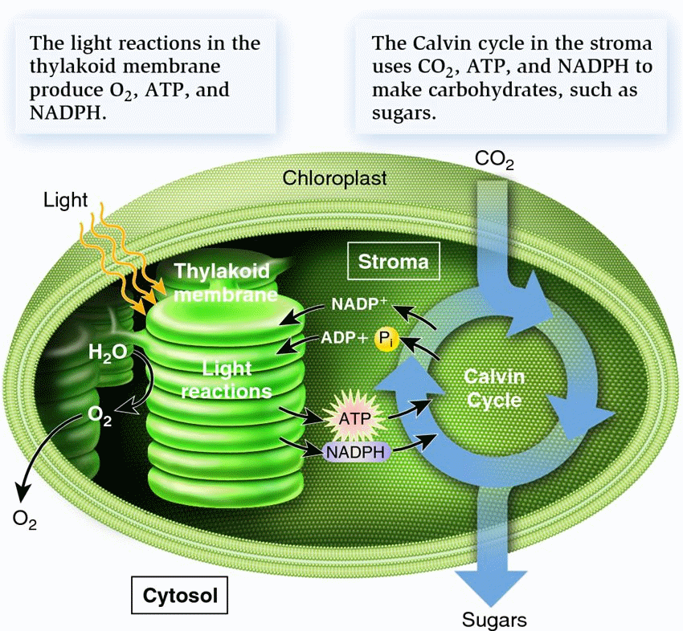
- The light reactions happen in the thylakoid membrane, where they convert solar energy to chemical energy. Water is split, providing a source of electrons and protons (H+) and giving off O2 as a by-product.
- Protons and electrons are driven to NADP+ (outside of the thylakoids) where they are temporarily stored.
- The electrons and protons reduce NADP+ to NADPH.
- Photophosphorylation: The light reactions also generate ATP using chemiosmosis (to power ADP→ ATP)
- The Calvin Cycle happens in the stroma, the cycle begins by carbon fixation= taking CO2 from the environment and converting it to organic carbon.
- ATP synthesis happens in the stroma
- The calvin cycle then uses NADPH and ATP from light reactions to produce carbohydrates
- Chlorophyll absorbs violet-blue and red light while transmitting and reflecting green light.
- Chlorophyll a = the key light capturing pigment, participates directly in light reactions
- Chlorophyll b= work with carotenoids, hydrocarbons that are photoprotectiv= compounds that absorb and dissipate excessive light that may damage the chlorophyll, absorb violet and blue green light because they are of orange colour.

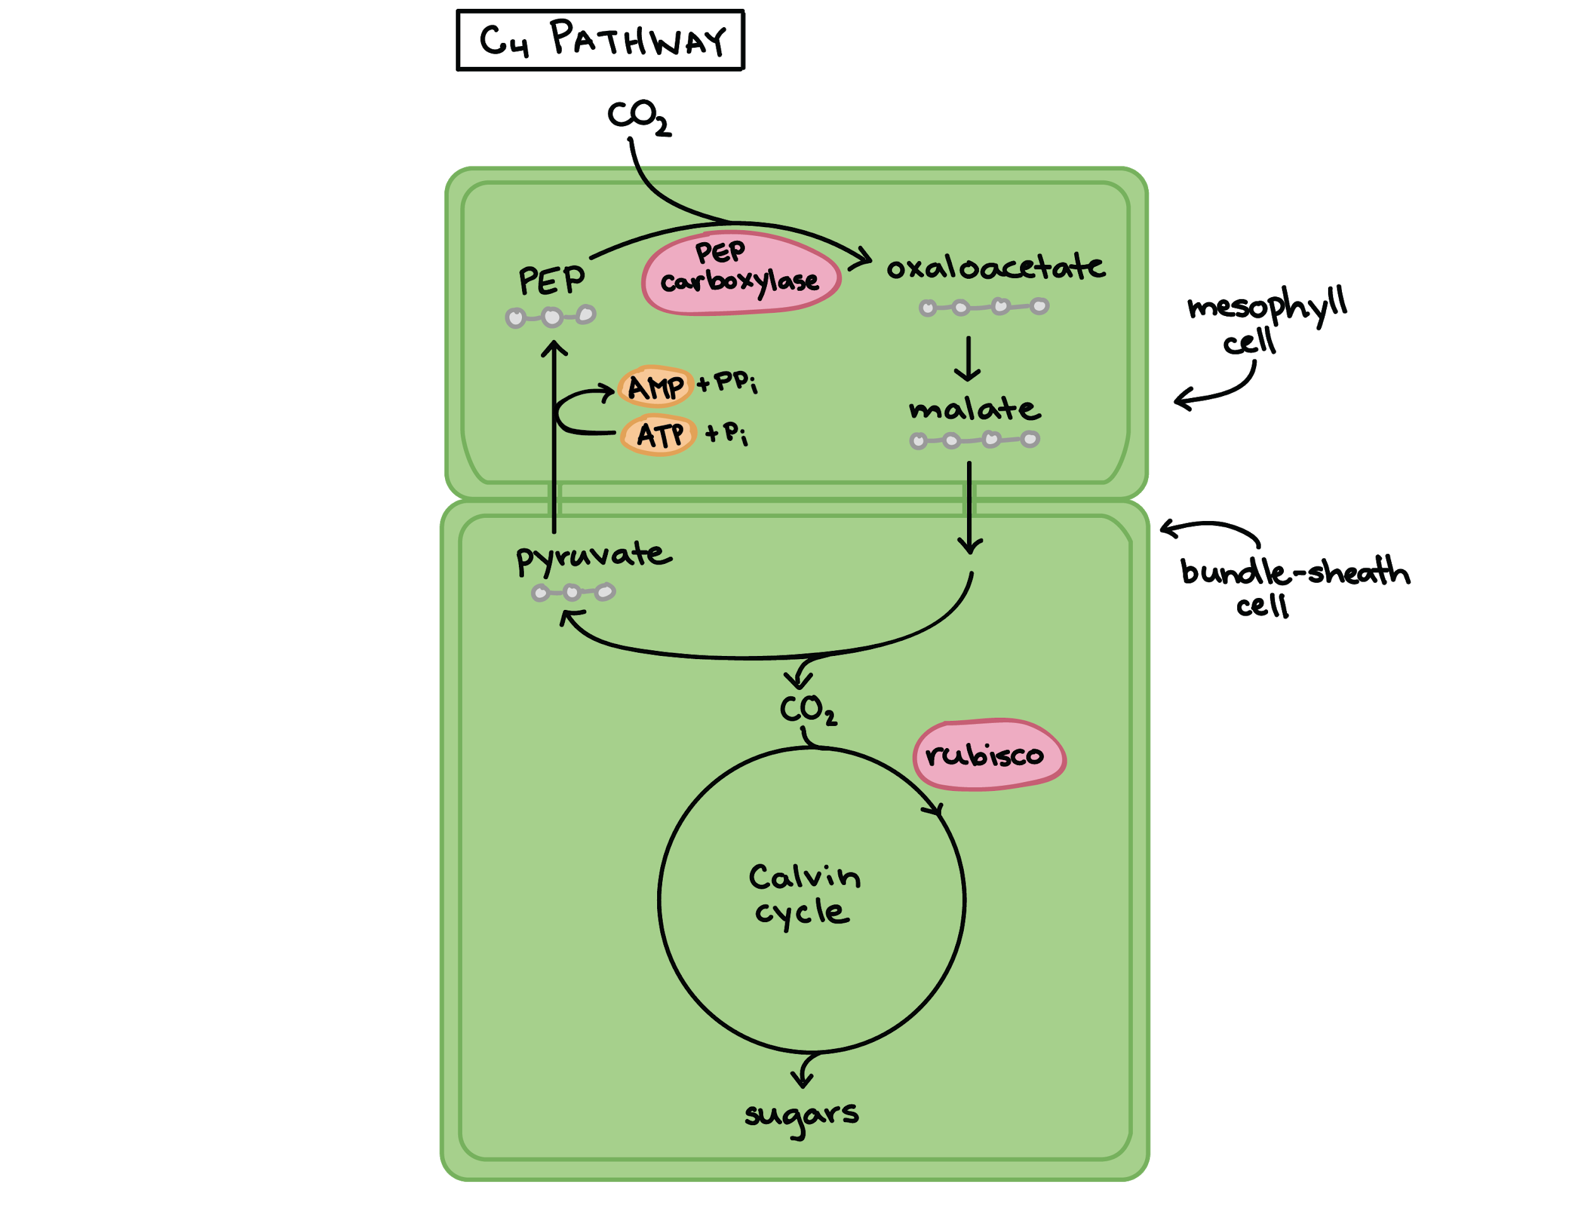

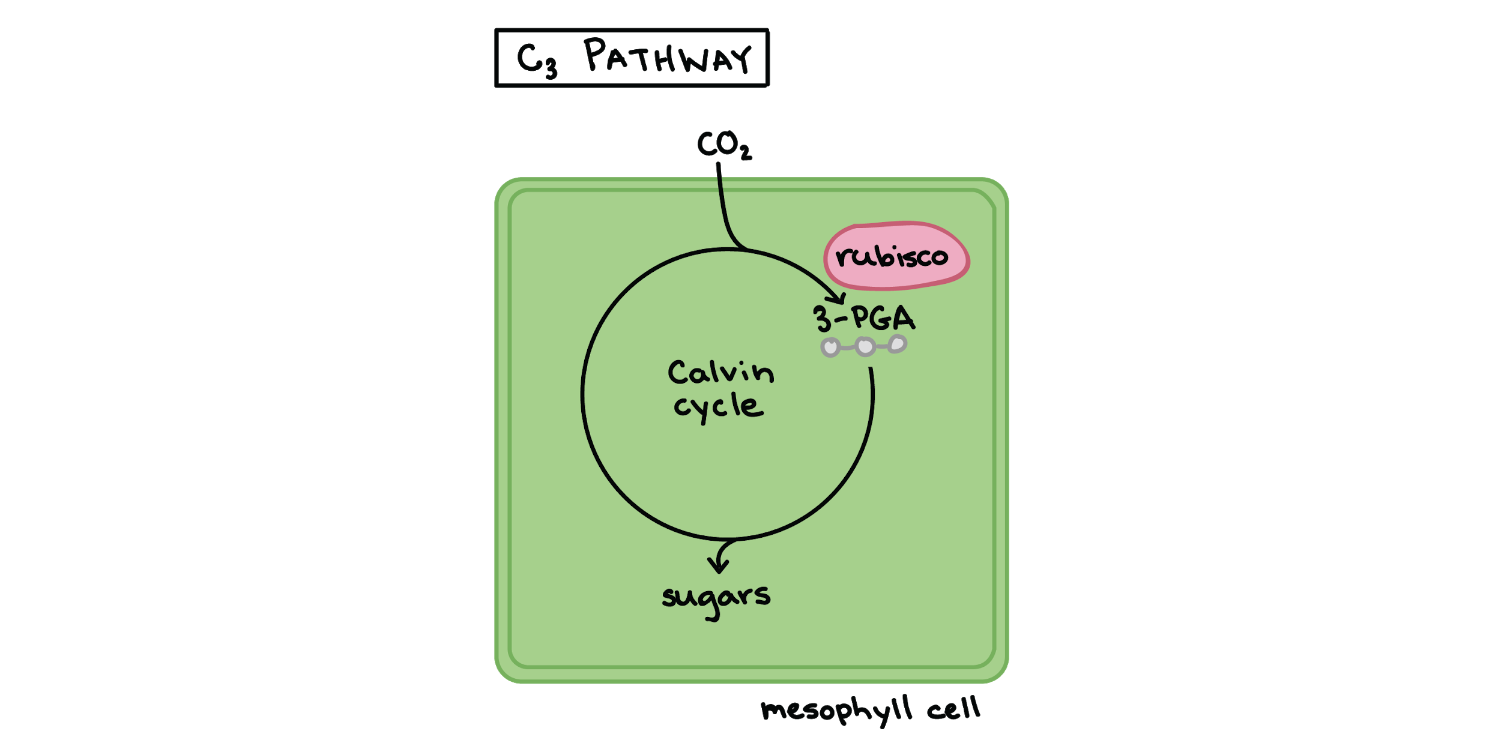

Chemical messenger classes:
- 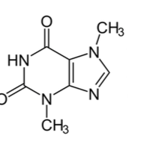 Purines 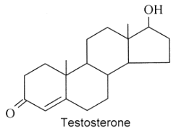steroids
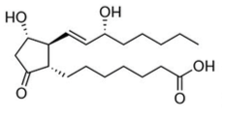Ecoisanoids 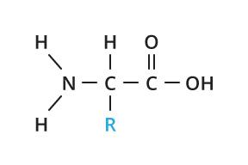proteins

- 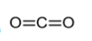 Gas 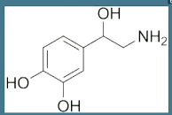 amine

- Unlike necrosis, where the cell dies by swelling and bursting its content in the area, which causes an inflammatory response, apoptosis is a very clean and controlled process where the content of the cell is kept strictly within the cell membrane as it is degraded. The apoptotic cell will be phagocytosed by macrophages before the cell’s contents have a chance to leak into the neighbourhood

- Enzymes (protease and nuclease) chop up DNA and fragment organelles, cell shrivels up in a change called “blebbing”. the cell’s parts are packaged into vesicles that are engulfed by specialized cells called scavenger cells.

- Apoptosis can be triggered in a cell through either the extrinsic pathway or the intrinsic pathway. The extrinsic pathway is initiated through the stimulation of the transmembrane death receptors, such as the Fas receptors, located on the cell membrane. In contrast, the intrinsic pathway is initiated through the release of signal factors by mitochondria within the cell.

Intrinsic: caspases= a family of proteases can shut down:
- protein kinases, which will as a result disrupt cell adhesion
- Lamms, which will disassemble the nuclear envelope
- cytoskeleton, the microtubules will then shrink and the whole cell will shrink too
Caspases will also activate DNAse = an enzyme that cuts DNA into smaller fragments. Caspases are known to cleave essential proteins at a cysteine-aspartate site.

- Researchers have used a nematode called Caenorhabditis elegans to study apoptosis.
- 2 genetic genes in this nematode called ced-3 and ced-4 encode for proteins essential for apoptosis. These proteins are always present in cells but in an inactive form.
- Ced-9 is a protein in the outer mitochondrial membrane that serves as a master regulator of apoptosis, a brake for cell death.
- When a death signal is received by the cell, it overrides the brake and activates proteases and nucleases.
- The main proteases of apoptosis are called caspases (executioner proteins).
- In the nematode, the main caspase is Ced-3.

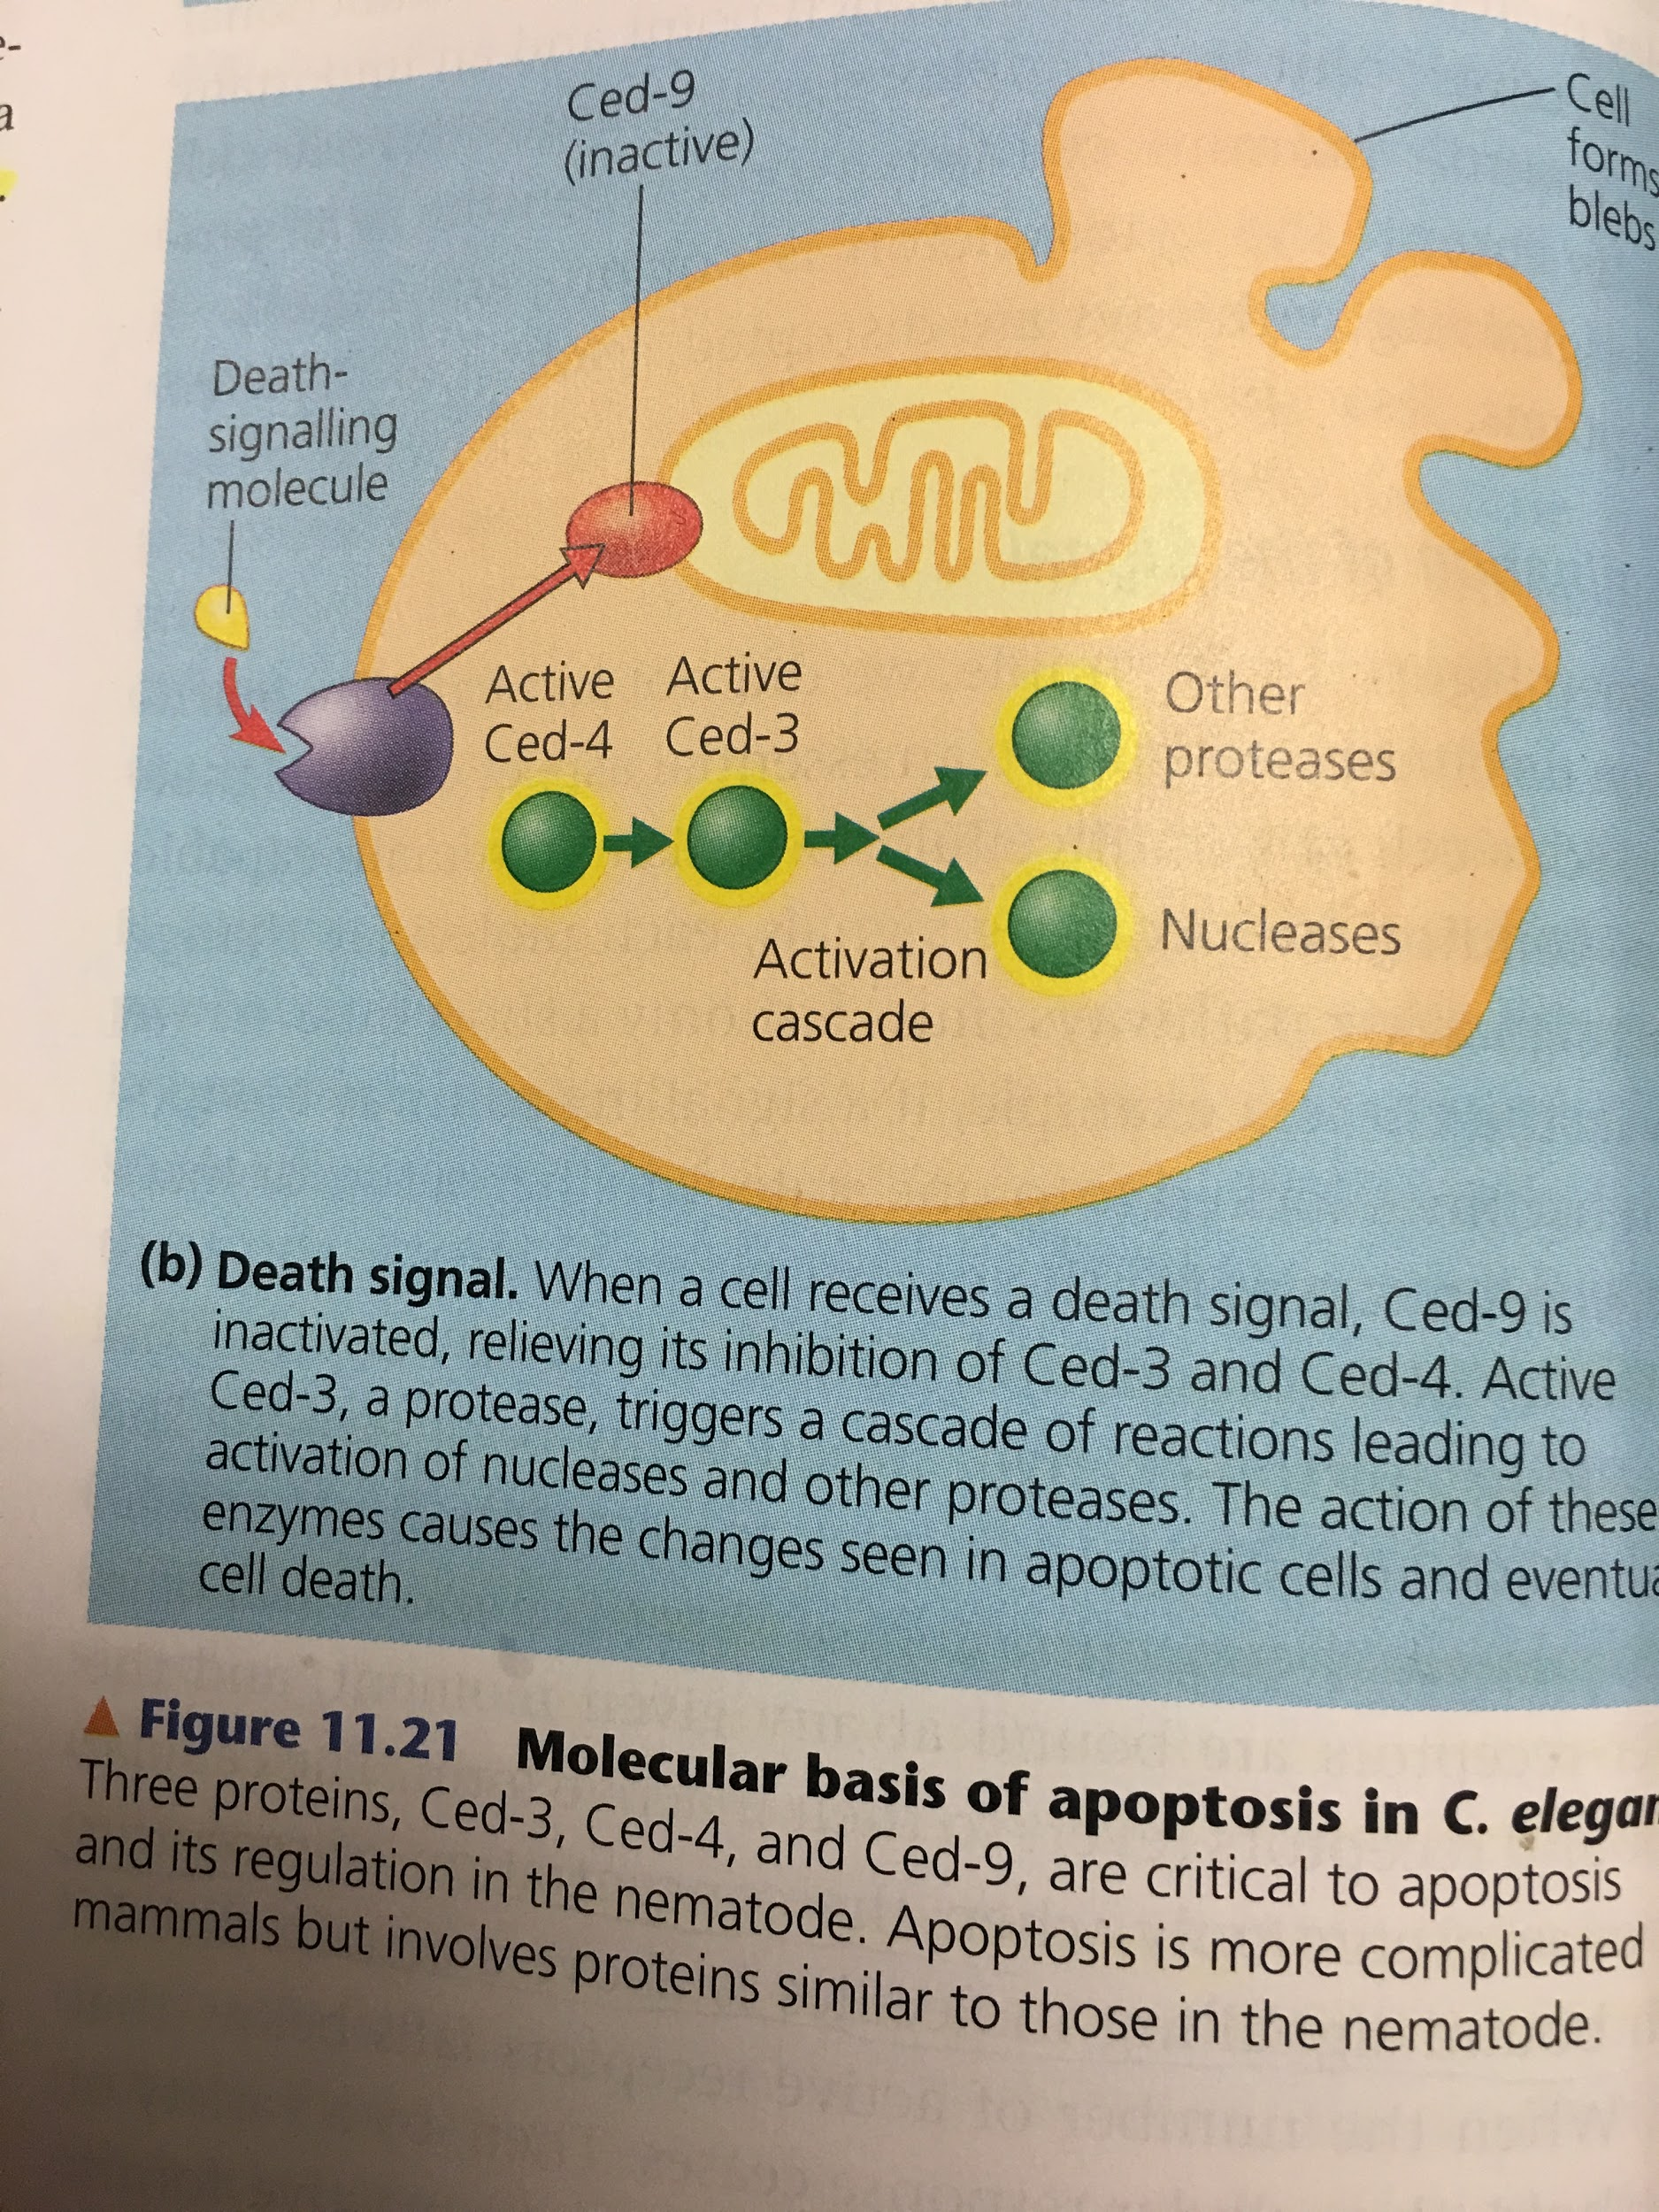

- Mitophagy is the selective degradation of mitochondria by autophagy. It often occurs to defective mitochondria following damage or stress.

Triggers of mitophagy:
- Membrane integrity damaged
- Mitochondrial membrane permeabiltiy affected
Apoptosis:

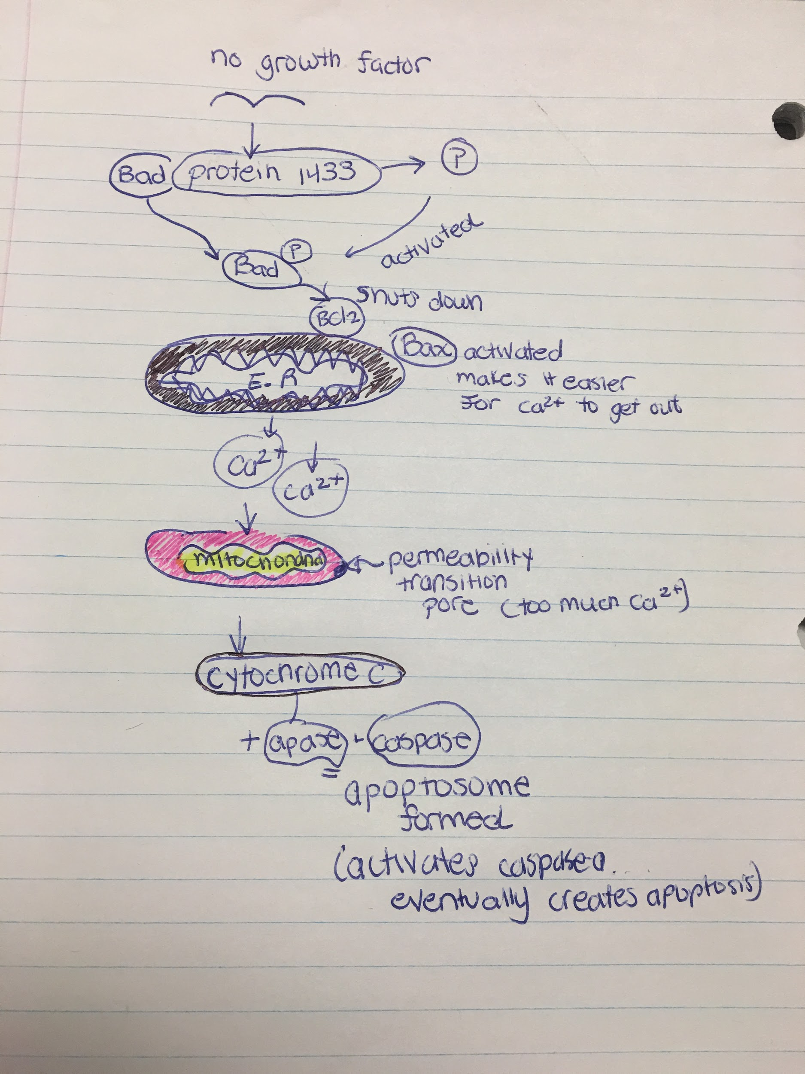

- STRESS
- PINK attached to mitochodnria and recruites MFN2
- MFN2 recruites PARKIN which attaches to ubiquitin
- Lysosome digests mitochondria
When mitochondria become damaged, what proteins, in order, will they express on their surface to trigger their transfer to the lysosome?
- Pink and Parkin

A mouse’s liver cells are under an unusual amount of oxidative stress. Many of the mitochondria within these cells become damaged. How will thee cells respond to ensure their survival and the survival of the liver? Be sure to name the process and provide an explanation of the key steps involved.
- The damaged mitochondria will undergo mitophagy
- Specific proteins will promote fission of the healthy and damaged portions of the mitochondria.
- The healthy portions will fuse together to form functional mitochondria
- The damaged portions will induce the expression of PINK on the outer mitochondria membrane.
- This will recruit ubiquitin/Parkin
- Which will promote the addition of ubiquitin groups (ubiquitination) of the membrane
- This will label the damaged portion of the mitochondria and signal the lysosome to conduct autophagy.

Roles of calcium:
- Response to stimuli
- Muscle contraction
- Signalling
- Enzymatic cofactor
- Bones
- Closing of stomata
- Metabolism

- A rodent is given an intramuscular injection of acetylcholine. Which of the following choices corresponds to the sequence of events that occurs after binding of the ligand molecule to its iontropic receptor?
- Sodium influx from extracellular fluid
- Membrane depolirization
- Calcium release from SR
- Calcium binds to troponin
- Conformational change of tropomyosin to expose myosin binding site
- Myosin binds actin
- Muscle contraction

Cell signaling

3 stages of cell signaling:
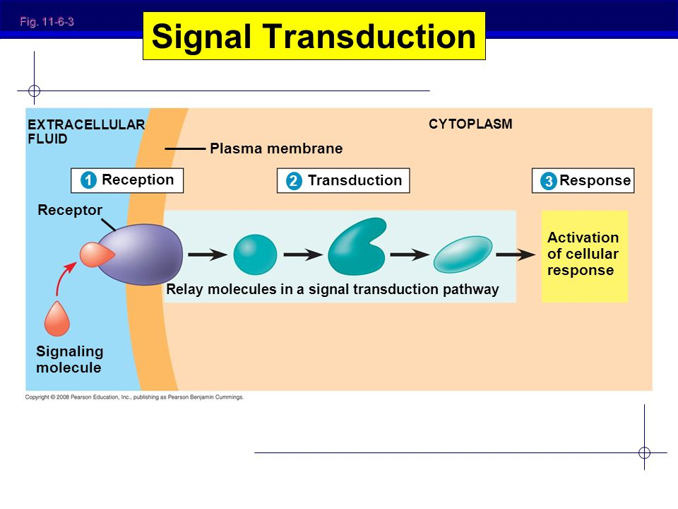

3 types of receptors:
- Transmembrane (span plasma membrane)
- Intracellular : steroids. Found in either the cytoplasm or the nucleus of target cells. To reach such a receptor, a chemical messenger passes through the target cell’s plasma membrane. A number of important signalling molecules can do this because they are either hydrophobic enough or small enough to cross the hydrophobic interior of the cell membrane. Such hydrophobic molecules include steroid hormones and thyroid hormones of animals. NO (nitric oxide) can also pass. Nitric acid is able to interact with transmembrane AND intracellular receptors. The ligand and receptor are both part of transduction in intracellular receptors.
- Extracellular

Transmembrane:
- G proteins (used by neurotransmitters)
- RTK (used by growth factors)
- Ion channels: multiple protein subunits within the membrane are the ideal candidate to act as a ligand-gated ion channel.

- G proteins: g protein receptor, g protein, enzyme
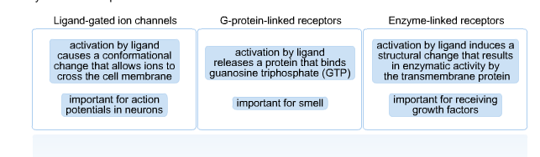
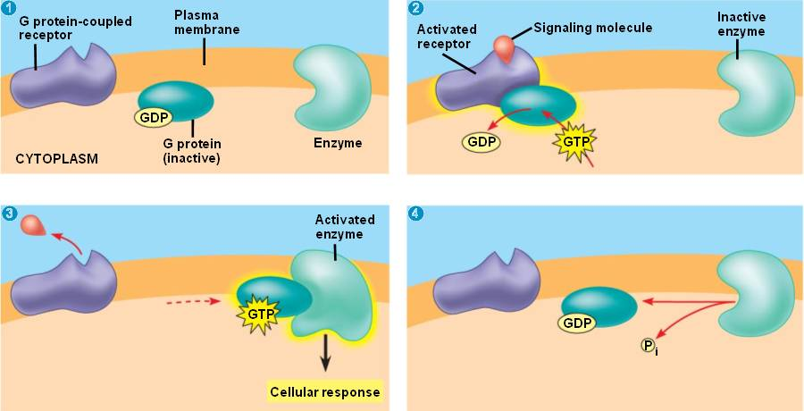

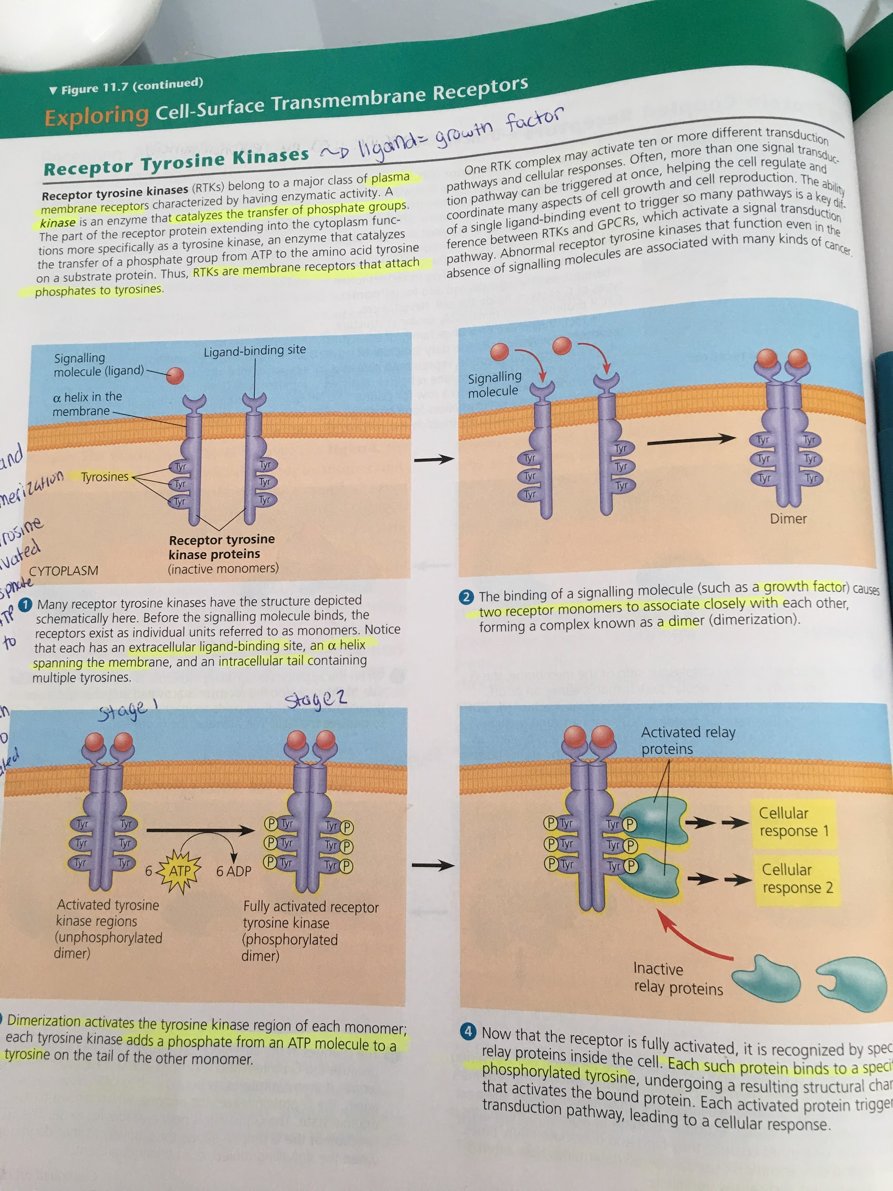
2) RTK: receptor tyrosine, dimerization, dimerization activates tyrosine kinase region, P added to tyrosine kinase, protein attaches to phosphorylated tyrosine kinase .
- RTK receptors are special because they’re found as monomers in the lipid bilayer
- When they bind with another monomer (As a result of the other monomer being activated by a ligand) they form a DIMER. Dimerization leads to autophosphorylation.
- Now can autophosphorylate. Phosphorylation changes the shape of the protein to which it is added, allowing the protein to interact
- Signaling is initiated via an area called an SH2 domain. These are conserved regions that bind to phosphorylated Tyrosine. Examples include Grb2, PLCy, PI3K as shown in the picture: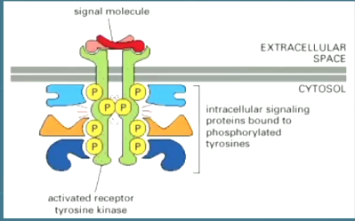

- Main second messenger: Ras
- Ligand examples: growth factor, insulin
- Tyrosine kinase receptor activation leads to transduction of 2 possible pathways: the Ras-MAPK pathway and the PI3 kinase pathway. The Ras pathway promotes the translation of Bcl2 , an anti apoptotic protein, while the PI3 kinase pathway maintains Bad in an unphosphorylated and inactive state (Bad is pro-apoptotic) as well as maintain Bcl2 active.
- In the absence of NGF, a ligand, Bad would no longer be phosphorylated and would inactivate Bcl2 leading to initiation of the apoptotic cascade.
- Ligand (NGF) binds to TRK receptor 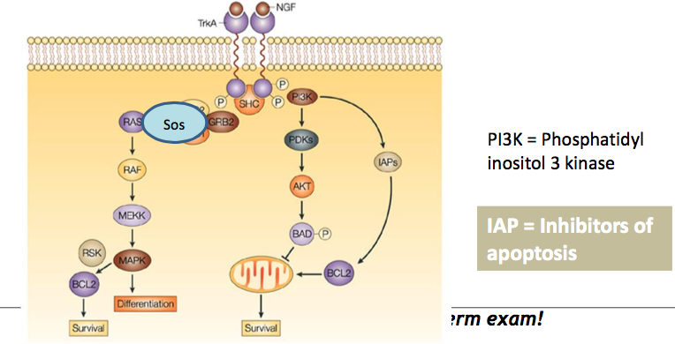
- TRK receptor dimerize
- TRK receptor dimer autophosphorylate
- Activated TRK dimer recruits effectors RAS, SOS, GRB2, PI3K
- PI3K pathway: end of cascade results in inactive Bad because it gets phosphorylated

RTK response: Growth factors
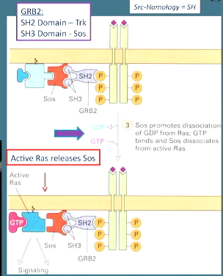

- Ras= GTPase switch protein
- Ras is not directly linked to RTK
- Needs an intermediate= adapter protein= Grb2, PLCy, PI3 K
- Grb2 needs a SH2 domain
- Ras STILL can’t interact with SH2, needs SOS!
- SOS activates Ras by:
- Attaching to Ras
- Guanine exchange factor: makes Ras get rid of GDP and replace it with GTP by changing the conformation of Ras, which decreases Ras’ affinity for GDP
- Ras then detaches from SOS
- As long as SH2 is attached to receptor and SOS, SH2 can bind to many other Ras molecules= relay and amplification occurs here
- Once Ras detaches, the first thing to interact with it is Raf
- Raf then activates other proteins -> transcription
- SOS promotes GDP→ GTP but can also do the reverse!
- Can deactivate Ras by making it hydrolyze GTP to GDP.

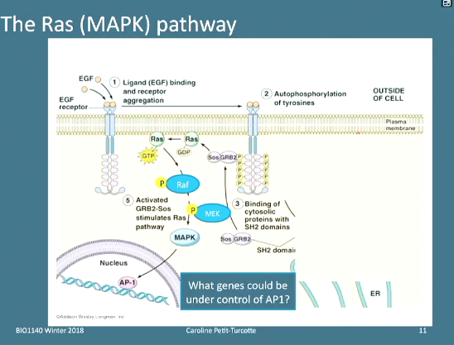

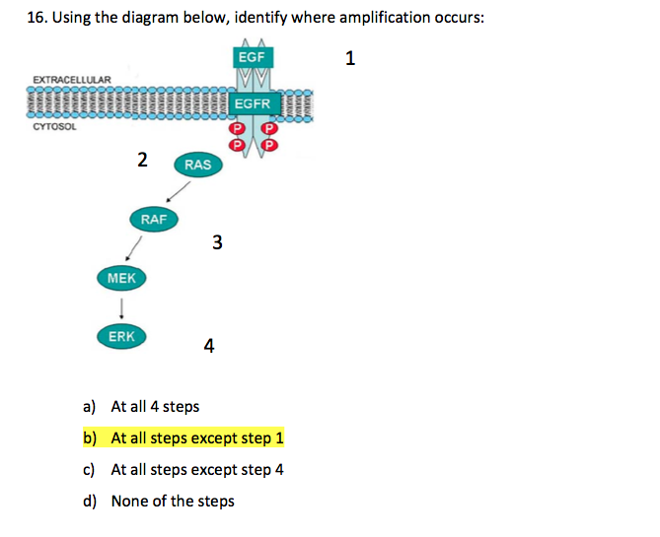

- Transmembrane receptors depend on membrane structure for stability and efficiency: the receptors are located in areas with similar fluidity but increased thickness.

- Second messengers used in signal transduction:
- cAMP
- Ca2+
- Inositol triphosphate

- Second messengers and protein dephosphorylation relay external signal during signal transduction.
- Protein kinase transfers a phosphate group to a protein and binds ATP
- Protein phosphatase dephosphorylates a protein and releases an inorganic phosphate

Local and Long distance cell signaling:
- Signalling substances dissolved in cytoplasm can pass freely between adjacent cells.
- Cells can communicate through cell junctions or through cell-cell recognition
- Short distance cell signaling:
- Paracrine signaling: growth factors: stimulate nearby cells
- Synaptic signalling: occurs in animal nervous systems, synaptic cleff.
- Direct: junctions between adjacent plant cells connect their cytoplasms and allow them to share molecules
- Long distance signalling:
- Endocrine signaling: through the blood, hormones

- Scaffolding protein: big protein to which numerous relaying proteins are attached to. Increases efficiency of signal transduction.
- Inactivation of receptors: if extracellular concentration of ligand falls, receptors are less activated and cellular response stops. Cellular response only occurs when a certain threshold of receptors bound to ligands is met. Then as a result, relay molecules return to their inactive form: GTPase hydrolyzes GTP back to GDP, phosphodiesterase converts cAMP back to AMP. protein phosphatase inactivates protein kinase A...

G Protein coupled receptors

Receptor interacts with g proteins
Bind to ligands of all sorts (unlike before when ligands were mor focused)
Ligands can be excitatory or inhibitory, hormones…
2 key signaling cascades:cAMP and PIP

cAMP Pathway

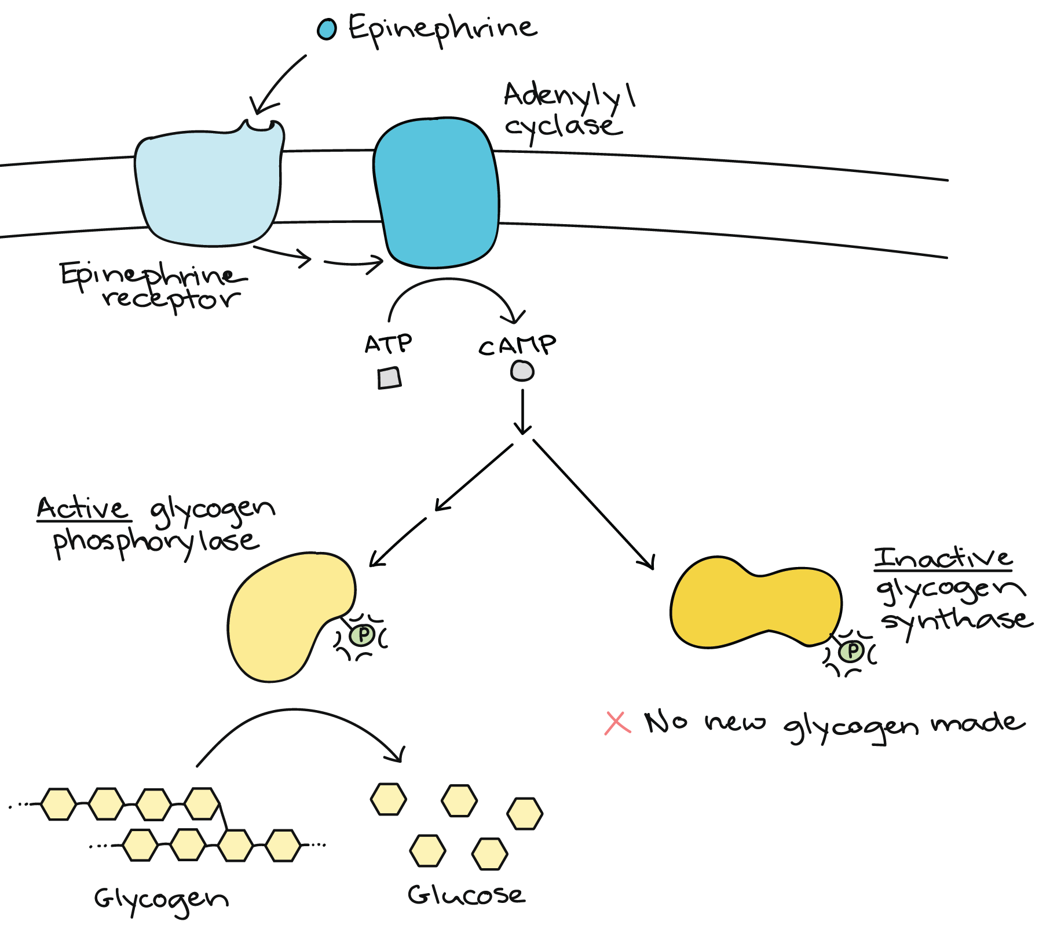

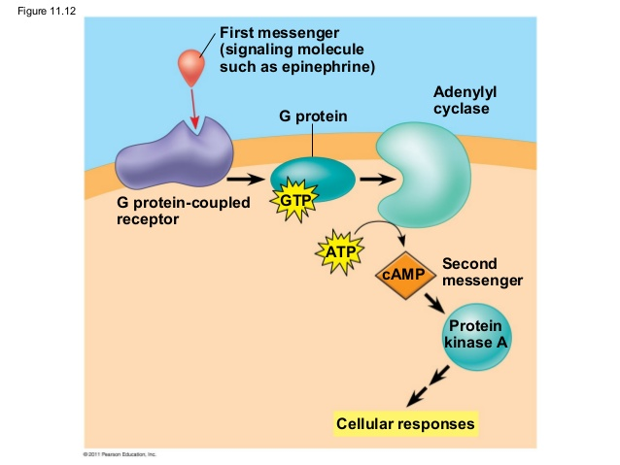

- Calcium ions and IP3 is an example of a cascade that uses G-proteins

7 transmembrane domains
Extracellular binding domain
All change conformation
heterotrimaric= trimer of 3 different proteins: alpha, beta, gamma
Were going to be focusing on alpha
Once our ligand binds to the receptor, recruits our heterotrimer. The alpha subunit is a lipid anchored protein and is the part of the G protein that is the molecular switch. Acts a lot like Ras. here, we use the alpha subunit, not Ras. we dont need SOS, the interaction wit the receptor will promote change in conformation of alpha subunit, lose its affinity for GDP and increase its affinity for GTP (GDP-->GTP) alpha subunit now active. Once its activated, it separates from beta and gamma.
Next, the alpha subunit activates the enzyme that produces cAMP, its called an ampliphier enzyme called adenylate cyclase-> this converts ATP to cyclic AMP.
Cyclic AMP then activates protein kinase A (PKA) its made of 4 protein subunits: 2 regulatory, 2 catalytic. kinase phosphorylates protein targets inside the cell involved in different cellular responses. Some of these proteins can be transcription factors, which can then go to the nucleus, look for cyclic amp response elements, look for genes in control of cAMP and influence the expression of those genes.
To deactivate alpha subunit, hydrolize GTP to GDP

Summary of amplification levels: 1) alpha subunit 2) adenylyl cyclase 3)cAMP 4)Protein kinase A 5) proteins affected by protein kinase A.

To stop cascade: alpha has Gi subunit. In the normal cascade, alpha has Gs, which is G protein stimulating. Gi stands for G INHIBITING. Inhibit enzyme (adenodade cyclase) from making ATP into cAMP.

PIP pathway

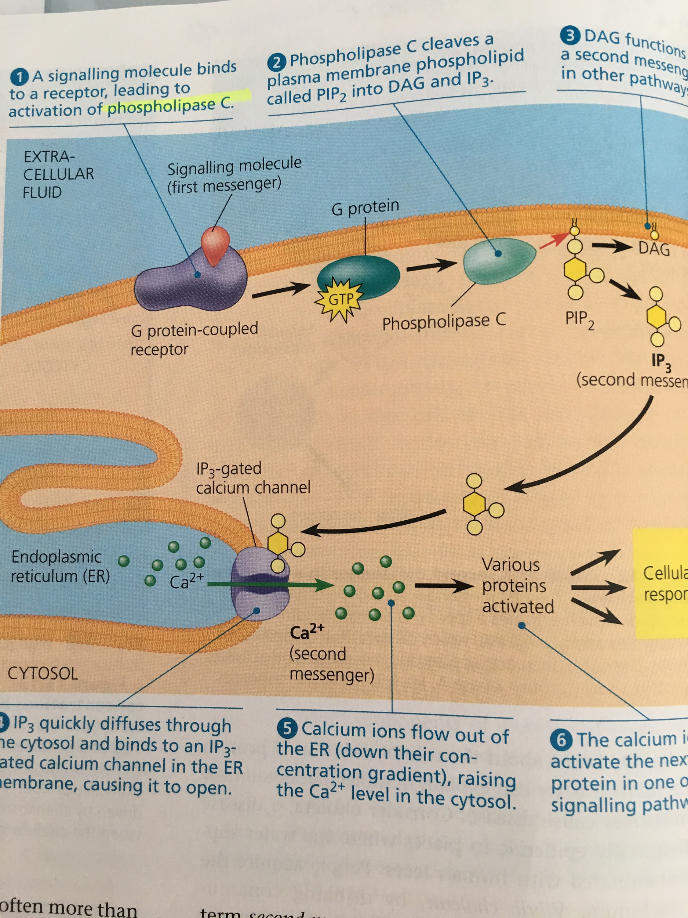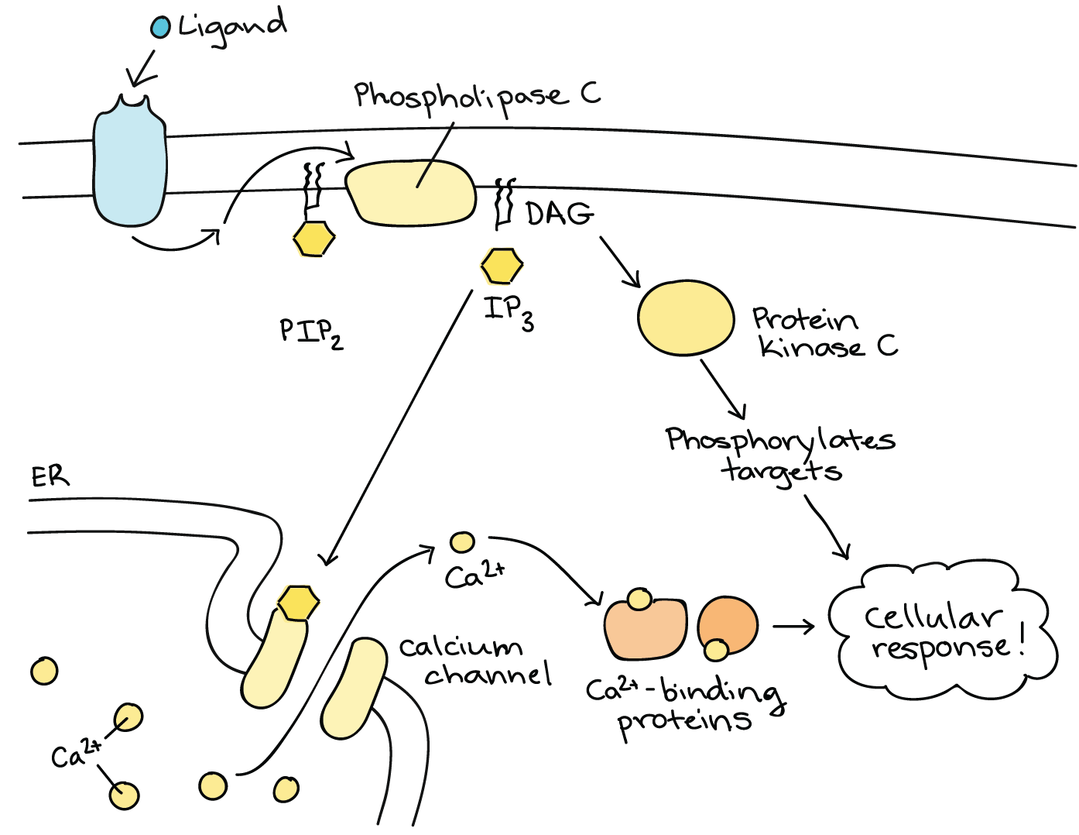

The amplifier enzyme is phospholipase C (phospholipase C gamma is in TRACK receptors), it is membrane bound. Receptor binds to alpha, which binds to phospholipase which binds to PIP3. As a result , PIP3 makes IP3 and DAG, IP3 is released into the cytoplasm while DAG stays in the membrane to make Arachnoid Acid. IP3 can phosphorylate into iP2, or it can bind to IP3 channels which release calcium from the endoplasmic reticulum into cytoplasm. From the cytoplasm, the Ca2+ binds to calmodulin which does many things. Along with calcium, also activates PKC, protein kinase C, which can phosphorylate other proteins, just like protein kinase a in cAMP, pKC activated can produce eicosanoids= primary messenger. Ecoisanoids are molecules that are responsible for signaling for pain and inflammation. They are only produced when there is pain.

First amplification: producing your activated sub unit, as long as ur receptor is bound to its ligand u can activated 10,20 alpha
Second amplification: phospholipase enzyme
Third level: second messengers: DAG and IP3

DAG remains membrane bound because it is a membrane fatty acid.
One particular ligand, Ach, can bind to different types of G type protein receptors and wont have the same response.
Norepinephrine is a ligand that belongs to the ligand class of amines. Adrenaline receptors are G protein coupled receptors, not all of them trigger the same signaling cascades: some are stimulatory and some are inhibitory, both bind to norepinephrine. In some cells u want the response to be positive, in some cases u want it to be negative, inhibit the cells activity i.e inhibitng digestive system during fight or flight mode. It is inhibitory if you shut down a cascade, stimulating if you activate a cascade.

- What would be the consequence if the IP3 gated channel of the ER became insensitive to IP3 which is produced following the activation of the GCPR by an amine such as norepinephrine? Use the key steps of the transduction pathway to support your answer:
- Activated PLC cleaves PIP2 into DAG and IP3
- IP3 is directed to the IP3-gated Ca2+ channel on ER
- If that channel is insensitive to IP3 then Ca2+ is not releasd
- Therefore unable to activate PKC along with DAG, DAG will be the main second messenger

G-protein receptors cascade

cAMP cascade | PIP cascade
First messenger= ligand | First messenger=ligand
G protein | G protein
Adenylyl cyclase | Phospholipase C
cAMP | PIP2
Protein kinase A | IP3 or DAG
*DAG goes to act as a second messenger in other pathways, IP3 goes to E.R IP3 gated calcium channels and releases Ca2+ into cytosol→ various proteins activated → cellular response
Lipid Rafts
- What are lipid rafts and why are they relevant for cellular signaling?
They are microdomains (accept small areas or regions) of the membrane that are rich in sphingolipids and cholesterol. They accommodate long or large transmembrane domains/proteins/ receptors.
- A cell can accommodate very long transmembrane domains of receptor monomers with lipid rafts which are rich in unsaturated sphingolipids (which have long FA tails) and cholesterol (to maintain fluidity).

Coordination of response : when u have confllicting cascades, there is within the cascade, there is a step that acts on the opposite cascade that prevents them from being active at the same time. For example, insulin, blood glucose, and glucagon: eating a lot of sugar: pancreas releases insulin, which decreases blood glucose level by binding to TRACK cascades, the outcome is to allow the cell to take glucose transporters that are lying in the cytoplasm and direct them to the plasma membrane. Any cells that receives insulinhmore readily enter the cell. The cell is now filled with all this glucose and will store it as glycogen. But if a cell receives a different hormone, like glucagon, the cell inerperts that message as breaking down glycogen and releases glucose. This would be bad if this happened while insulin was active= futile cycle. So when insulin binds to TRACK receptors, protein kinase B gets activated through insulin, acts on phosphodiesterase which is responsible for breaking cAMP into AMP, that prevents protein kinase A from being activated and therefore prevents the activation of the enzyme that breaks down glycogen into glucose. The reverse is true. If you activate glucagon, you will inhibit the insulin pathway as well.
BOTTOM LINE: ***protein kinase B activates phosphodiesterase which inhibits cAMP from activating PKA.

2 ways by which cascade signaling can be terminated:
- Removal of ligand by distant tissues
- Removal of ligand by adjacent/neighbouring cells
- Enzymatic degradation of ligand
- Receptor-ligand internalisation by endocytosis
- Inactivation of receptor
- Inactivation of signal transduction pathway

TRANSCRIPTION

PHOSPHODIESTER BOND= orientation of bond,

DNA vs RNA:
- RNA is: ribose (not deoxyribose)
- Uracil (not thymidine)
- Single strand (not double strand)
- It can leave the nucleus
- It can act as an enzyme
- DNA more stable than RNA
- RNA does not have histone

Our genomes are organized in the same manner: genes separated by intergenic regions, nucleotides, genes have regulatory portion and coding portion.

Transcription: DNA→ RNA
Eukaryotes vs. prokaryotes
Cells can derive genes from any given protein. True or false? False! Why?
Dna is in nucleus in eukaryotes, cytoplasm is prokaryotes.

A cell knows when to code: signal transduction leads to activation of transcription factor.

- transcription factor: in eukaryotes, a collection of proteins that mediate the binding of RNA polymerase and the initiation of transcription.
- transition initiation complex:
- 1) a eukaryotic promoter: TATA box, 25 nucleotides from start point
- 2) transcription factors: once recognizing the TATA box, must bind to DNA before RNA polymerase does in order to put RNA polymerase in the correct position and orientatiom.
- 3) Additional transcription factor : bind to DNA along with RNA polymerase. RNA polymerase then unwinds DNA and RNA synthesis begins.

Step 1: Initiation
Initiation is the beginning of transcription. It occurs when the enzyme RNA polymerase binds to a region of a gene called the promoter. This signals the DNA to unwind so the enzyme can ‘‘read’’ the bases in one of the DNA strands. The enzyme is now ready to make a strand of mRNA with a complementary sequence of bases.

Step 2: Elongation
Elongation is the addition of nucleotides to the mRNA strand. RNA polymerase reads the unwound DNA strand and builds the mRNA molecule, using complementary base pairs. There is a brief time during this process when the newly formed RNA is bound to the unwound DNA. During this process, an adenine (A) in the DNA binds to an uracil (U) in the RNA.

Step 3: Termination
Termination is the ending of transcription, and occurs when RNA polymerase crosses a stop (termination) sequence in the gene. The mRNA strand is complete, and it detaches from DNA.

DNA can be replicated into DNA, be transcribed into RNA. In prokaryotes, RNA polymerase only one, distinct enzymes in eukaryotes.
Transport RNA builds tRNA
Ribosomal RNA builds ribosomal proteins, this happens in nucleolus
mRNA is built into protein DNA->mRNA= Transcription
Which of these corresponds to one difference between eukaryotes and prokaryotes? Theyre the same thing! Same arrangement of nucleotides, 5’ to 3’, two strands, anti parallel
5’ -> 3’ direction: you can attach nucleotides only in a certain direction because of polymerase: 5’ to 3’ always. This is because the bond in a phosphodiester happens from a 5th sugar to 3rd carbon on next nucleotide. It is the only free interaction with the phosphate. Nitorogenous base is facing inwards if youre looking at DNA, outward if youre looking at RNA.
RNA polymerase is an enzyme involved into making long chain of ribonucleotides.
In replication, we use DNA polymerase.
What tells the cell its time to transcribe a gene into mRNA? Transcription factors. They are going to bind to sequences right before regulatory region, calls in RNA polymerase.

Differences in prokaryotes and eu:
Structure
Location: you can transcribe any time you want as long as u have the transcription factor
In prokaryotes, when u build mRNA in transcription, it is immediatley mature and ready to be translated into a protein. In eukaryotes, you have a pre mRNA after transcription, it needs to have caps added etc and then becomes mature mRNA and then needs to leave the nucleus. To get mRNA out of the nucleus through nuclear pores. These nuclear pores make sure that at 3’ end we have a specific sequence.

RNA polymerase is able to separate both strands of DNA, reads one, and then makes a complementary strand made out of mRNA. RNA polymerase uses the 3’ to 5’as a template to read since you need to make a 5’ to 3’!
The promoter is the on/off stage, need proteins to bind there for transcription to be initiated or surpressed. In addition, Activator protein bind to enhance a region, repressor proteins bind to inhibit a region. This always to either get less or more RNA/ Coding region starts at end of promoter: this is where u need to start reading and transcribing the information. You make sure you start reading EXACTLY at that first nucleotide. To make sure RNA polymerase starts transcribing at first nucleotide..
In your gene itself, you have portions that we call CODING. Those are exons. We have non coding= INTRONS. These are in the coding region one after the other. The introns need to be ridden of, this is involved in maturation process of mRNA.
There’s going to have to be a way to let the polymerase know it has reached the end of the gene and finished transcribing.

What is the role of sigma factor in transcription? (looks like a telophone)
Protein that works alongside RNA polymerase. RNA polymerase+sigma= hollow enzyme. Sigma factor is what will interact with promoter of gene, its going to do 2 things:
- Unwind DNA so that RNA polymerase can be positioned correctly
- Places RNA correctly at start site. Helps RNA polymerase line itself up and attach to DNA so polymerase can SEPARATE THE TWO STRANDS and START TRANSCRIBING
Sigma factor ensures RNA polymerase starts at first nucleotide. Once you’re there, transcription from 3’ to 5’ starts and 5’ to 3’ RNA is made.
Sigma factor detaches and binds another RNA polymerase,

In eukaryotes, there is more than 1 RNA polymerase ,For mRNA,, RNA Polymerase II is used.
POLYMERASE III= tRNA
POLYMERASE III= rRNA

HOW DOES IT GET STARTED? EUKARYOTES

Step 1: TBP (TATA box binding protein) binds to the TATA sequence on DNA. TATA box is on promoter region. This positions the helix for transcription. Regulatory region stretches upstream. In that regulatory region that have enhancers or silencers. Enhancers can bind specific proteins that turn up transcription= activator proteins. Silencers bind repressors that slow transcription down. Depending on the combination, which transcription factors, activators vs repressors, all of those are computed to calculate how fast or how long are you going to transcribe that gene i.e how long it takes RNA polymerase to find first nucleotide and start transcription.

- Response elements are short sequences of DNA within a gene promoter region that are able to bind specific transcription factors and regulate transcription of genes. Under conditions of stress, a transcription activator protein binds to the response element and stimulates transcription.

From exam:
- Transcription factor binds to TATA box in promoter region
- TATA binding proteins recruited to promoter/ TATA box
- Additional transcription factors/ repressors/ enhancers/activators bind to response elements (proximal or distal)
- RNA polymerase II is recruited to promoter

Transcription initiation protein structure:

Step 2: once our TATA box binding protein is binded to TATA box, we add more transcription factors, activators and repressors and then were going to begin trasncription. additional protein comes and completes the transcription initiation complex (transcription factors). This provides stability and allows RNA Polymerase to attach and start transcription.
**NO T’S AND A’S IN RNA.
RNA polymerase II is very fast, can add nucleotides very fast, however it doesnt proof read its work so it slips up and makes a mistake. Those mistakes can be of consequence or not.

Provide one key difference between eukaryotes and prokaryotes transcription

PROKARYOTES | EUKARYOTES
Rho (p) dependent = extrinsic mechanism. Requires Rho protein, recognizes sequences of DNA after coding sequence, Polymerase catches up to it and acts as stopper to stop transcription. | Specific sequences that differ depending on which RNA polymerase
ATP dependent unwinding enzyme at 3’ end. | For example, for mRNA, sequence of AAUAAA to which proteins bind, this triggers end of transcription (this is related to polyA tail)
Rho independent, GC rich sequences at end
Hairpin loop which pulls RNA away from DNA : sequence at very end of transcript ery rich in G’s and C’s. as transcript is growing out of RNA polymerase, G.s and C’s want to match and form a structure called a hairpin loop. Polymerase right now is holding two strands of DNA as it is making the second strand, with additon of hairpin loop, becomes very heavy and strand detaches from DNA. THEREFORE INTRINSIC MECHANISM.

Prokaryotes- mature mRNA immediatley
Eukaryotes: pre mRNA created after transcription. Capping enzymes added to 5’ end of transcript,and at 3’ end. remove one nucleotide and replace it with 5-7 guanines, this portion won’t be translated, not part of coding region of transcript.

UTR- untranslated regions between caps and coding portions. Important to make sure that when we assemble with ribosome so that we can position the ribosome to start translating at the first codon.

We get rid of introns: molecular scissors: splicing.first you need to recognize which part is the intron and which is the exon. Second part is breaking phosphodiester bonds to remove nucleotides, while holding on to your exons and putting them together. This process is called splicing, accomplished by splicosome, made of proteins, small nuclear RNA (short RNAs that have a particular sequence that will remain in the nucleus)= SNRNP
Other proteins assemble with snRNPS and allow to recognize, cut, and attach exons together.
Your introns are ribonucleotides. Small nuclear RNAs can recognize these sequences and attach to them, make complementary base pair, align and attach to beginning and end of introns and position proteins that cleave between nucleotides to get rid of introns, small proteins+small RNA = snRNPS. At the beginning and end of your exon there are specific sequences that small RNAs recognize.
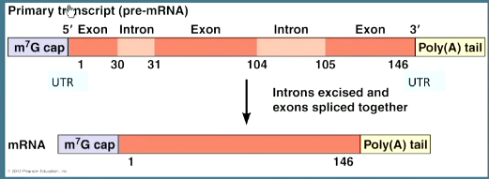
Alternative splicing= taking the same mRNA transcript and splicing it in different ways. This yields different proteins from the same gene. different combination of snRNPS that recognize different introns. Example: troponin, exon 1 2 and 5 are mandatory, exons 3 and 4 carry the same role but have slight differences which means that structurally you’re going to get a troponin but a slightly different troponin, differences in structure: those troponins won’t be sensitive to calcium at the same degree which means they will be able to contribute to muscle construction better or not as well. How do u get those 2 different proteins? You need snRNPS that will recognize different sequences in our introns. One snRNP recognizes beginning and end of first intron, another snRNP recognizes beginning of second intron, but recognizes the end of the NEXT intron when the splicosome removes that portion, it also removes exon 3! So both introns and exon removed! Then u end up with exons 1 2 4 and 5. As a result, you get troponin. This you will find in slow skeletal muscles. In FAST: snRNPS recognize first intron, second intron, the BEGINNING OF THE THIRD INTRON AND THE END OF THE FOURTH INTRON, along with exon 4. So you end up with exons 123 and 5. As a result, calcium sensitivity is different and looks a little different, but is still troponin.

- The pattern of splicing is dependent on snRNPS present in spliceosomes in the cells, because they recognize different docking (complimentary/consensus) sequences in introns.
A spliceosome contains snRNPS(small nuclear RNAs) and proteins that:
- Recognize specific sequences at the beginning and end of introns
- Cut the nucleotide bond at the exon-intron position
- Release the intron
- Ligase the exons so that the matured mRNA is a continuous sequence of coding RNA

The difference between mRNA #1 and #2 is the sequence the snRNPs recognized:
mRNA #1: intron 1, intron 2 to end of intron 3
mRNA #2: intron 1 to end of intron 2, intron 3

A nucleotide mismatch has been left uncorrected and lies right at the position of the signal sequence for intron 1. What will happen during processing of the pre-mRNA?

There will be splicing. Part of incorrectedly trasncriped intron 1 will not be able to be splieced because snRNP will not be able to recognize it → intron 1 won’t be removed, but would just not be able to recognize it. snRNP can only attach to the end of intron 1. You don’t want to remove intron 1 because if you do: you lose the 5’ cap and exon 1, which makes the mRNA completely unable to translate into a protein.

Regulation of transcription

In prokaryotes, there are operons: an ensemble of multiple genes that work together. In a given situation, your prokaryote needs a set of proteins to deal with. I.e you want to digest a particular types of sugar, to do that you need some enzymes. It would make sense to put the genes for the enzymes to put them in the same area, under the same regulatory region. Section between promoter and first gene: operator and u can have a series of genes under this one operon.all of these proteins work together for the same task, under the regulation of THAT operator. How do u control this operator? Proteins called repressors are upstream of your operator, plenty of repressor proteins and they all bind to the operator and it literally physically prevents RNA polymerase from transcribing these genes. Something comes along in your prokayotes environemnt i.e sugar, amino acid etc and the repressor lets go of the operator, binds to the sugar, amino acid or whatever, and now the passage is free! RNA Polymerase can now transcribe the gene.

The product of the transcription of an operon is one set of related mRNAs that code for functionally related proteins. That operator is going to have all of its genes into a single mRNA
I.E LACTOSE OPERON: no lactose present: no enzymes needed to break down lactose, so repressor binds to operator and polymerase has no where to go, as soon as there is lactose in the enviornment repressor binds to lactose and polymerase transcribes gene to make beta galactosidase, galactosidase permease, and transacetylase, three proteins required for the breakdown of lactose. When no lactose left→ repressor goes back to operator and u stop transcribing’translating..

1 mRNA for ALL of the genes under operator under control of that promoter.

In eukaryotes there are no operons! But there are genes with different expressions, this is explained by enhancers recognized by activators only found in certain cell types.

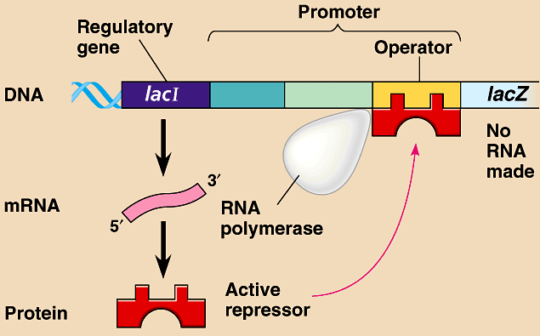

RNA interference

- Eukaryotic specific
- RNA controls DNA
- Mediated inhibition of gene expression
- Can control whether DNA is transcribed in the first place or not
- DNA is read by RNA polymerase to form mRNA, but if if DNA is tightly coiled, DNA polymerase can’t fit in there and therefore can’t produce mRNA, transcription can’t occur
- Additionally, in translation, mRNA is read by tRNA to produce polypeptides, but if there is no mRNA there there is no translation
- RNAi can be used to repress transposons
- Transposons are jumping genes (Segments of DNA) that can get up and move around between chromosomes
- Thus can repress them
- RNAi important for immunity: viruses integrated into host’s genome
- Cells have RNAi which goes in and prevents viral DNA from reproducing
- double stranded RNA, recognized by protein called dicer
- Dicer cuts out pieces from double stranded RNA
- These pieces= sRNA
- siRNA couples with RISC proteins
- Together they interact with mRNA from central dogma= complementary bind to mRNA
- Cleaves mRNA into 2 pieces: this cleaving gets rid of all functionality of mRNA = no translation

