9.1 Portfolio Choices b/w Money & Other Assets

- A financial portfolio is a collection of financial assets
- It might include money balances, bonds, equities, mortgages, & mutual funds
- The structure of a portfolio, the proportion held in each type of asset, reflects 2 main characteristics of the assets involved:
- The returns paid by diff financial assets
- The risks arising from changes in the market prices of assets
- Wealth & institutional portfolio managers for pension funds & insurance companies like their portfolios to pay high returns w/ low risk
- To achieve this, they hold mixed portfolios of money & other financial assets

- Money holdings are an important part of the portfolio
- Money is the medium of exchange
- It can be used directly to make payments for goods/services or to settle debts
- Other assets cannot be used as a means of pmt
- Furthermore, money has a fixed nominal price
- It is a “safe asset”
- Wealth held as money does not rise or fall w/ the rise or fall in financial asset prices on stock & bond markets. However, money is exposed to the risk that inflation will lower its real purchasing power
- Other financial assets differ from money in 3 ways
- 1st, they cannot be used as a means of pmt
- 2nd, they offer a return in the form of an interest pmt, a dividend pmt, or a rise in price that provides income to the portfolio holder
- 3rd, b/c the prices of financial assets like bonds or stocks fluctuate daily on financial markets, these assets carry the risk that their values may decline significantly from time to time

Bond Prices, Yields, & Interest Rates

- The demand for money comes from an understanding of the relationship b/w interest rates, bonds, bond coupons, the prices of financial assets, & yields on financial assets
- To keep simple, assume only 1 type of financial asset, a bond
- However, the prices & yields of other financial assets are related to interest rates in the same way as bond prices

- A bond is an asset that makes 1 or more fixed money pmts to its holder each year until its maturity date
- On its maturity date, it also repays its principal value
- Govs & businesses issue & sell bonds on financial markets to raise funds to finance expenditure
- Bond: a financial contract that makes 1 or more fixed money pmts at specific dates in the future
- Interest rate: the current market rate, expressed as a percentage, paid to lenders or charged to borrowers
- Bond coupon: the fixed money pmt made annually to the holders of the bond from the date of issue until the date of maturity
- The coupon rate is a fixed percentage of the principal value of the bond at the time of issue
- Ex: a 3% bond pays $3.00 annually per $100 of principal until its maturity date

- The price of a marketable bond is the current price at which it can be bought or sold on the open bond market at any time b/w its date of issue & its maturity date
- Price of a marketable bond: the current price at which the bond trades in the bond market

- Yield on a bond: the return to a bond holder expressed as an annual percentage rate, which is a combination of the coupon pmts & any change in the market price of the bond during the period in which it is held

- Bond prices depend on current market interest rates
- The current price of a bond is the present value of the future pmts it will provide
- Bond price: the present value of future pmts of interest & principal
- The present value is the discounted value of those future pmts. It recognizes that money pmts in the future are worth less than money pmts today.

- Ex: If someone promises to give you $1,000, would you rather have it today or a year from now? Notice that $1,000 lent at an interest rate of 3% would give a sum of:
- one year from today. In the same way, the amount of money you need to lend today to have $1,000 one year from today is:
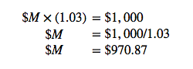
- When the market rate of interest is 3%, the present value of $1,000 to be received 1 year in the future is $970.87

- Higher interest rates reduce present values while lower rates increase them
- Ex: if the current marjet rate is 5% the PV of $1,000 to be received 1 year from today is:
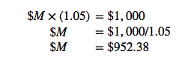
- This relationship is the key to understanding bond prices & how they fluctuate over time
- A rise in market interest rates lowers the PV of fixed future pmts
- A fall in market rates increases PVs of fixed future pmts

- In gen, b/c the future pmts offered by bonds are fixed in dollar terms, the prices of marketable bonds vary inversely to market rates of interest
- Rising interest rates mean falling bond prices, & falling interest rates mean rising bond prices
- Relationship b/w prices, yields, & interest rates remains the same b/c bond prices are the PV of future pmts, prices & interest rates move in opposite directions

- The size of the change in the price of a bond as a result of a change in the interest rate depends on the bond’s term to maturity
- The prices of longer-term bonds are more volatile than those of shorter-term bonds
- This is an important consideration for bond portfolio managers concerned w/ trade-offs b/w risk & return

9.2 The Demand for Money Balances

- Canadians held M2 money balances of $1,326 billion in July 2015
- 3 variables that may explain the size of these holdings are: the interest rate, the price level, & real income
- Together they provide the basis for a theory of the demand for money

Why Hold Money?

- Income is a flow of funds over a period of time
- In CH8 money was a means of pmt & a store of value
- These 2 functions motivate the demand to hold at least some wealth in money balances
- There are alternative stores of value
- Bonds, equities, precious metals, real estate, & art are a few exs
- The qty of money ppl choose to hold is part of the portfolio decision they make about their wealth

- To develop the demand for money balances it is useful to simplify the portfolio decisions by assuming there are only 2 assets:
- Money, which has a constant money price, pays no interest income but does serve as the means of pmt
- Bonds, representing all interest-earning assets, have money prices that change if market rates change, but are not means of pmt

- If the expected return to holding bonds is positive (due to the interest rate together w/ any change in price) why would ppl hold any money balances?
- The demand for money comes in 3 parts, namely:
- The transactions demand
- The precautionary demand
- The asset or speculative demand

The Transactions Demand

- Based on money being the means of pmt
- Ppl & businesses hold some money to pay for their purchases of goods/services/assets
- This demand reflects the lack of coordination of receipts & pmts
- Income is paid bi-weekly or monthly but purchases are made more frequently & in smaller amounts
- If all income receipts were used on paydays to buy bonds to earn interest income it would be costly & inconvenient to sell bond holdings bit by bit as pmts were made
- The costs of frequent switching b/w money, bonds, & money would more than offset any interest income earned from very-short-term bond holdings

The Precautionary Demand

- Uncertainty about the timing of receipts & pmts creates a precautionary demand for money balances
- 2 sides to this uncertainty
- 1. There may be some unexpected changes in the timing or size of income receipts
- Regular pmts can still be made if enough money is available, over & above that need for usual expenses & pmts
- 2. Unexpected or emergency expenses in terms of appliance, computer, or car breakdowns or unexpected opportunities for bargains or travel can be covered by precautionary money holdings
- Money balances cover the unexpected gaps b/w income receipts & pmt requirements w/out the costs & inconvenience of selling bonds on short notice

The Asset or Speculative Demand

- Comes from financial portfolio decisions rather than the lack of coordination & uncertainty behind the 2 preceding demands
- Businesses & professional portfolio managers use money balances to take advantage of expected changes in interest rates
- Essentially they speculate by switching b/w bonds & money based on their own forecasts of future interest rates

- Bond prices & interest rates vary inversely
- If while holding money balances you predict a fall in interest rates, you buy bonds
- If your prediction is right & interest rates do fall, the prices of your bonds rise
- Now you can sell & harvest the capital gain you earned by speculating in the bond market
- Alternatively, if you correctly predict a rise in interest rates & act before it happens you can avoid a capital loss on your bond holds by selling & holding money before the interest rate rises

- The money component has a stable market price while the bond component provides interest income along w/ the risk of a variable price
- Rising interest rates reduce the asset demand for money balances

The Demand for Money Function

- Let the size of the real money balances ppl wish to hold for transactions & precautionary reasons (L_{t}) be a fraction k of GDP
- W/ nominal GDP defined as RGDP(Y) times the GDP deflator (P), nominal GDP=PY
- Using this notation, the demand for nominal money balances for transactions & precautionary reasons is kPY, & the demand for real balances is kY, where k is a positive fraction
- When real income changes, bringing w/ it changes in spending, the change in the demand for real money balances changes is determined by k
- This makes a link b/w part of the demand for money balances (L_{t}) & income, namely L_{t}=kY

- Value of k in Canada? 2nd quarter of 2015, Canadians held money balances measured by M2 of $1,325 billion
- Nominal GDP in that quarter was $1,364 billion measured at an annual rate
- If we divide M2 holdings by GDP, we get k=1325/1364=0.97, 97% of annual income
- This value of k suggests that a rise in GDP of $100 will increase the demand for money balances by $97, measured in either nominal or real terms

- Changes in nominal interest rates also change the size of the money balances ppl wish to hold, based on the asset motive
- A rise in interest rates increases the opportunity cost of holding money balances rather than bonds
- It may also create the expectation that interest rates in the future will fall back to previous levels
- As a result, ppl will want to use some of their money balances to buy bonds, changing the mix of money & bonds in their wealth holdings
- A fall in interest rates has opposite effect

- The way ppl adjust their portfolios in response to changes in interest rates results in a negative relationship b/w the asset demand for money balances & the nominal interest rate
- Then using –h to measure the change in money balances in response to a change in interest rates can be written as –h=∆L/∆i
- If individual & institutional portfolio managers’ decisions are very sensitive to the current interest rates, h, will be a large negative #
- A small rise in interest rates will cause a large shift from money to bonds
- Alternatively, if portfolio decisions are not at all sensitive to interest rate changes, h would be zero
- Putting these components of the demand for real money balances together gives the demand for money function, which is the demand to hold real money balances L:
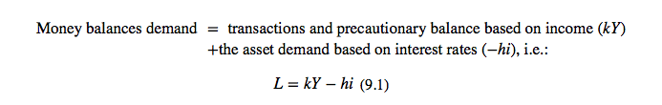
- Fig 9.1
- At higher interest rates the opportunity cost of holding money balances is higher b/c the expected return from holding bonds is positive
- The slope of the demand curve for money is –1/h
- A change in real income would require us to draw a new demand for money function, to the right of L₀ if Y increased, to the left if Y decreased
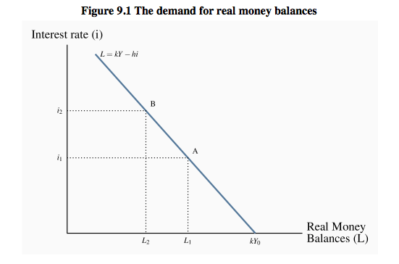
- More realistic to draw a non-linear line for demand
- Decreasing slope as interest rates decline
- Captures 2 ideas
- 1st, as interest rates fall, & fall relative to the costs of buying & selling bonds, opportunity costs decline faster than interest rates
- 2nd, consider the speculative demand for money
- As interest rates fall, the riskiness of bonds increases
- A subsequent rise in interest rates has a larger negative effect on bond prices
- Expectations of future increases in interest rates may strengthen as interest rates decline
- As a result, portfolio managers may shift funds increasingly from bonds to money as interests fall
- If their expectations are confirmed by events they avoid the capital losses caused by falling bond prices

9.3 Financial Market Equilib & Interest Rates

- The money supply & the demand for money in the financial market determine nominal interest rates
- From CH8 a nominal money supply depends primarily on the monetary base & the money multiplier, namely:
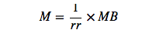
- The demand for money is a demand for real money balances as determined by real income & interest rates
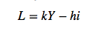
- The real money supply is simply the nominal money supply M divided by the price level P, M/P, which measures its purchasing power in terms of goods & services
- Real money supply (M/P): the nominal money supply M divided by the price level P

- The central bank, as the source of the monetary base MB, controls the nominal money supply, as long as the reserve ratio rr & the public’s holding of cash are constant
- Next CH explains how the central bank manages the monetary base
- If the price level is fixed, the central bank also controls the real money supply
- Changes in nominal money tend to lead eventually to changes in price
- However, the central bank can still control the real money supply in the SR—it can change M faster than prices P respond—but in the LR other forces determine real money M/P
- For now assume the price level is fixed

- The qty of real money demanded rises when real income rises, but falls when nominal interest rates rise

Money Market Equilib

- Fig 9.2 combines the demand curve for real money balances from Fig 9.1 w/ the money supply function in Fig 8.2 to give a money market diagram
- The demand curve is drawn for a given level of real income, Y₀, & the supply curve for a given monetary base MB₀
- W/ a given price level, the central bank controls the supply of nominal & real money
- The supply curve is vertical at M₀/P₀
- At the interest rate i₀, the real money balances ppl wish to hold just = the money supplied by the central bank & the banking system

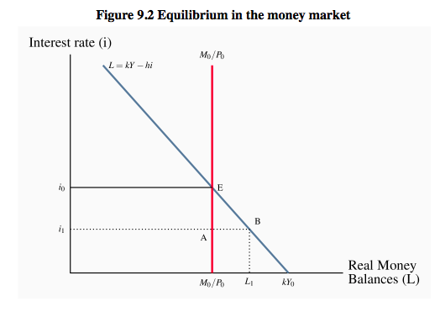
- To see how this market operates, suppose the interest rate is at i₁, lower than equilb
- There is excess demand for money in the amount AB
- Ppl want to hold money balances = to B at the interest rate i₀, but only A is available
- How to remove excess demand? Answer lies in the portfolio decisions that distribute wealth b/w money holdings & bonds

- Consider the interaction b/w the bond & money markets
- When portfolio managers want to restructure their holdings of bonds & money they do so by buying or selling bonds on the bond market
- Their actions cannot change the supply of money balances
- That is fixed by the monetary base & the money supply multiplier
- As a result, bond prices & interest rates change to maintain money market equilib

- In Fig 9.2, the excess demand at i₁ will result in a rise in interest rates
- W/ an excess demand for money, ppl sell bonds to adjust their money balances
- There is an excess supply of bonds
- Bond prices fall
- Lower bond prices mean higher bond yields & interest rates
- The higher interest rates reduce both the excess supply of bonds & the excess demand for money
- The money market adjusts by moving along the L curve from B to E, as ppl want smaller money balances relative to their bond holdings at high interest rates

- This inverse rate – bond price relationship is the key to adjustments in the money market caused by changes in either the demand for or supply of money balances
- Those adjustments involve trades in bonds that change bond prices & interest rates to maintain money market equilib

Changes in Financial Market Equilib

- A shift in either money supply or money demand changes equilib in the money market (& bond market)
- Interest rates move to restore equilib

The Effect of a Change in the Money Supply

- Suppose central bank lowers the monetary base & the money supply contracts
- For a fixed price level, lower nominal money reduces the real money supply
- Fig 9.3 shows this leftward shift in the money supply curve from M₀/P₀ to M₁/P₀
- Equilib interest rate rises from i₀ to i₁ as ppl sell bonds
- A higher interest rate reduces the qty of real money balances demanded, moving along the demand curve L(Y₀), bringing qty of balances demanded into line w/ the reduced supply
- .:. a lower money supply raises equilib interest rates
- Conversely, a rise in the money supply lowers the equilib interest rate
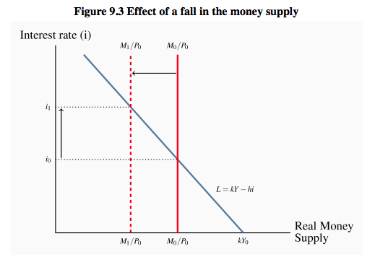

The Effect of a Change in Real Income

- Fig 9.4
- A rise in real income increases the qty of real money balances demanded at each interest rate, shifting line to the right
- Equilib interest rate rises as portfolio managers sell bonds in an attempt to increase their money holdings
- Rise in interest rate lowers the qty of real balances demanded, moving along the money demand function L(Y₁), & keeps demand for money = to the unchanged supply
- Conversely a fall in real income would shift the demand for money to the left & reduce the equilib interest rate
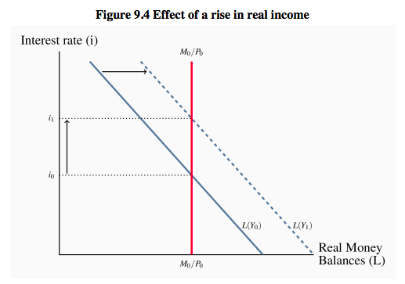

9.4 Interest Rates & FX rates

- Interest rates determined in the money market have important effects on the FX rate
- Portfolio managers can hold some bonds issued by domestic borrowers & some issued by foreign borrowers
- These choices are made on the basis of the yields on bonds established by conditions in diff national money & bond markets
- Foreign exchange rate (FX rate): the domestic currency price of a unit of foreign currency

- To achieve the highest return on the bond portion of their portfolios, managers buy bonds that offer the highest rate of return for a given level of risk
- If interest rates are constant in other financial markets, a rise in Canadian interest rates & bond yields makes Canadian bonds more attractive to both domestic & foreign bondholders
- The demand for Canadian bonds increases
- A fall in Canadian interest rates has the opposite effect

- If Canadians want to buy bonds on foreign bond markets they need foreign currency to make pmt. Vice versa w/ other countries for ours
- These FX requirements for trading in financial assets are the same as those for trading in goods/services
- The FX market is the market in which currencies of diff countries are bought & sold & FX rates are determined

- For now its enough to consider the effects of changes in domestic interest rates on the FX rate

- Consider an increase in the domestic money supply in Canada
- Money & bond market adjustments to this increased money supply lower the Canadian interest rate
- At these lower interest rates domestic bond yields are lower relative to foreign bond yields than they were before
- This provides the incentive for domestic portfolio managers to switch their purchases from domestic bonds to foreign (US) bonds
- To pay for foreign bonds they need foreign currency
- The demand for US dollars increases

- Simultaneously, bond holders in the US shift their purchases from the now relatively low-yield Canadian bonds to US bonds
- Lower sales of Canadian securities in the US market reduce the supply of US dollars
- This drop in the supply of US dollars combined w/ the increase in demand raises the Canadian dollar price of US dollars
- This is a depreciation of the Canadian currency
- Depreciation of the national currency: a decline in the value of the currency relative to other national currencies, which results in a rise in the domestic price of foreign currencies
- In this ex, a fall in domestic interest rates, other things constant, causes depreciation in the domestic currency relative to foreign currencies
- This interest rate-exchange rate linkage is symmetrical
- Rises in domestic interest rates cause appreciation of the national currency
- Appreciation of the national currency: an increase in the value of the currency relative to other national currencies, which results in a fall in the domestic currency price of foreign currencies

9.5 Interest Rates, Exchange Rates, & AD

- Interest rates &exchange rates link the changes in money & financial markets to the expenditure decisions that determine AD
- The impact of financial markets, interest rates, exchange rates on AE, AD, & real output is described by the transmission mechanism. It has 3 important channels:
- The effect of interest rate changes on consumption expenditure
- The effect of interest rate changes on investment expenditure
- The effect of interest rate changes on FX rates & net exports
- Transmission mechanism: links money, interest rates, & exchange rates through financial markets to output & employment & prices

Interest Rates & Consumption Expenditure

- Consider the basic consumption function in CH6
- Changes in income moved HHs along the consumption function. Changes in autonomous consumption expenditure changed the vertical intercept, up or down
- Changes in interest rates affect autonomous consumption in 2 ways:
- Through the wealth effect from changes in the prices of financial assets
- Through a cost of credit effect

- Wealth effect: the change in expenditure caused by a change in real wealth
- Cost of credit: the cost of financing expenditures by borrowing at market interest rates

- The market prices of bonds are the PVs of expected future interest & principal pmts
- Current market interest rates are the key factor in this relationship
- Similarly, interest rates & the expected stream of profits & dividend pmts determine the PVs & prices of company shares
- Lower discount rates give higher PVs & higher interest rates reduce PVs
- As a result, falling interest rates raise financial asset prices & rising interest rates reduce financial asset prices

- This means that changes in interest rates, by changing prices of financial assets, change the wealth held in HH portfolios
- A fall in market interest rates raise HH financial wealth which increases HH consumption expenditure
- Autonomous consumption expenditure increases as a result of this wealth effect
- A rise in interest rates would reduce autonomous consumption expenditure

- Changes in interest rates also have important effects on house prices by lowering the cost of credit, increasing the PVs of rental incomes, & increasing the market prices of residential real estate
- HHs often used the increased market values & equity in their housing to set up home equity lines of credit w/ relatively low borrowing rates
- His borrowing is used to finance other expenditures
- Autonomous consumption expenditures change as interest rate changes change the cost & extent of this financing

- .:. 2 forces—wealth effects, & availability & cost of credit—explain the effects of money on planned consumption expenditure
- This is 1 part of the transmission mechanism through which money & interest rates affect expenditure
- Operating through wealth effects & the supply & cost of credit, changes in money supply & interest rates shift the consumption function
- We can recognize the effects of both income & interest rates on consumption by using an equation:
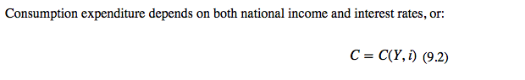
- The mpc out of national income is a positive fraction, 0 < (∆C/∆Y) < 1, & the relationship b/w consumption & interest rates is negative, ∆C/∆i < 0
- When the consumption expenditure is plotted relative to national income as in the 45 degree line diagrams of CH 6&7, a change in the interest rate shifts the consumption function but does not change its slope

Interest Rates & Investment Expenditure

- Assume investment is independent of current income & .:. an autonomous component of AE. However, the interest rates determined in money & financial markets affect investment expenditure.
- Although the total change in inventories is small, this component of total investment is volatile & contributes to the fluctuations in the total level of investment
- Interest rate changes are responsible for some part of the volatility in investment spending

- Gov capital expenditures on buildings, roads, bridges, & machinery & equipment are treated as gov capital expenditures as part of fiscal policy & included in G not in I

- Businesses spend on fixed capital, plant, & equipment to expand their output capacity if they expect growth in demand for their output, or if they see opportunities to reduce costs by adopting new tech & production techniques
- The firm’s decision to invest is based on its expectation of future markets & profits that will justify the estimated cost of new plant & equipment
- Financial markets provide some important guidance

- The current market values of existing firms are the PVs of their expected profits
- A firm thinking about entering an industry or expanding its current capacity can compare the cost of building a new plant & buying equipment w/ the market value of capital already in the industry
- There might also be the opportunity to enter the industry, or expand by taking over an existing business

- The PV of expected profits depends on the interest rate
- Changes in interest rates change both the values the market puts on existing businesses & productive capacity & the costs of financing new investment
- A rise in interest rates lowers the market value of existing firms & increases the costs of financing new investment. Vice versa.
- .:. investment expenditures are inversely related to interest rates

- Inventory mgmt. is another important part of investment expenditure
- Some companies keep inventories full while others organize their production & coordinate w/ suppliers to minimize inventories to achieve “just in time” delivery of inputs
- Financial services hold inventories of bonds & other assets

- As demand fluctuates, it can be more efficient to allow inventories of finished goods to fluctuate than to try to adjust production to volatile market conditions

- Inventories involve costs
- These costs have to be financed, either by borrowing or tying up internal funds
- .:. interest rates determine the important finance costs of holding inventories
- If we assume prices are constant & interest rates rise, producers/retailers will want smaller inventories
- Alternatively, if prices are rising, the difference b/w the nominal interest rate & the rate of inflation is the real cost of carrying inventories

- Investment function is based on these explanations of expenditure on fixed capital & inventories
- The negative effect of interest rates in the investment function, (∆I/∆i)<0, shows that higher interest rates cause lower levels of planned investment expenditure.
- But how sensitive are investment plans to financing costs?
- If these financing costs were not a large factor in the investment decision, ∆I/∆i would be small
- A rise in the interest rate from i₀ to i₁ would still lower planned investment, but by only a small amount
- Alternatively, a larger value for ∆I/∆i would mean that investment plans are sensitive to interest rates

- Investment expenditure depends on the interest rates:

- A rise in the interest rate lowers investment expenditure: ∆I/∆i < 0
- Investment function, I = I(i): explains the level of planned investment expenditure at each interest rate

- When plotted in a diagram w/ interest rate on the vertical & investment on the horizontal, the slope of the investment function, I=I(i), is –(∆i/∆I)
- The position of the investment function reflects the effect of all factors (other than i) that affect investment decisions
- The price of new capital equipment, optimism/pessimism about future markets & market growth, the intro of new techs embodied in newly available equipment, & many other factors underlie investment decisions

- The volatility of investment that causes business cycle fluctuations in output & national income comes from volatility in business profit expectations, rather than i
- Changes in investment, a result of changes in interest rates or as a result of other factors, shift AE & work through the multiplier to change AD, output, & employment

Exchange Rates & Net Exports

- The changes in FX rates caused by changes in interest rates affect the competitiveness & profitability of imports & exports relative to domestically produced goods & services
- A rise in interest rates leads to an appreciation of the domestic currency
- Import prices fall relative to the prices of domestic goods/services
- Exports become less competitive & less profitable
- Imports rise & exports fall, lowering the net export component of AE & D
- Alternatively, a fall in interest rates leads to a depreciation of the domestic currency
- Prices of imported goods/services rise relative to the prices of domestic goods/services
- Exports are more competitive & more profitable
- Net exports increase

- Now dropping the assumption that the exchange rate is constant makes the important 3rd link b/w interest rates & AE through net exports
- Exchange rate effects reinforce the negative relationship b/w interest rates & expenditures in the consumption & investment functions
- If interest rates rise, other things constant, the domestic currency appreciates & the exchange rate, er, falls
- Exports fall, & imports rise, reducing net exports & AE
- A net export function that describes this relationship would be:
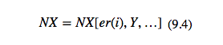
- In equation 9.4, the variable er(i) captures the effect of interest rates on exchange rates, & exchange rates on net exports
- The Y captures the effect of changes in Y through the mpm
- From the FX market we know that a rise in interest rates leads to an appreciation of the domestic currency that lowers the exchange rate, (∆er/∆i) < 0
- Also, a fall in the exchange rate lowers net exports, ∆NX/∆er) > 0

- The appreciation of the Canadian dollar that reduced the Canadian/US dollar exchange rate illustrates the point above
- Although due more to the rise in commodity & energy prices than to interest rate differentials, the lower exchange rate increased imports & reduced the viability of manufacturing based on exports to the US market, or competition w/ imports
- To the extent that interest rate changes affect exchange rates, they also change NXs & AE

- Depreciation of Canadian dollar following the collapse of energy & commodity prices
- This lower dollar makes exports more competitive & profitable & imports more expensive
- Over time, NXs should increase & increase AD
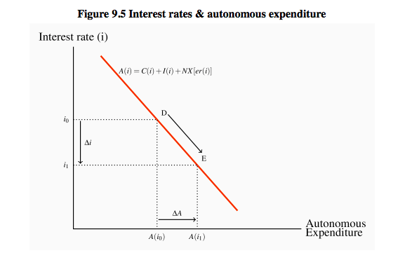
- Fig 9.5 summarizes relationship b/w interest rates & expenditures
- Downward sloping A(i) shows the inverse relationship b/w the consumption, investment, & NX components of autonomous expenditure & the interest rate
- Lower interest rates increase consumption & investment expenditure directly through wealth & cost & availability of finance effects
- Lower interest rates also increase NXs through the effects of lower interest rates on the FX rate
- A rise in interest rates would have the opposite effect
- The changes in interest rates & exchange rates are the key linkages b/w the monetary & financial sector & AD

9.6 The Transmission Mechanism

- We can now summarize & illustrate the relationships that transmit changes in money, financial markets, & interest rates to AD, output, & employment
- There are 4 linkages in the transmission mechanism:
- W/ prices constant, changes in money supply change interest rates
- Changes in interest rates change consumption expenditure through wealth effect & the cost & availability of credit
- Changes in interest rates also cause changes in planned investment expenditure through the cost & availability of credit to finance the purchase of capital equipment & to carry inventories
- Changes in interest rates also cause changes in exchange rates, which change the price competitiveness & profitability of trade goods & services

- Working through these linkages, the effects of changes in money & interest rates on AE, AD, & equilib RGDP is shown as follows:
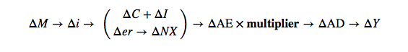
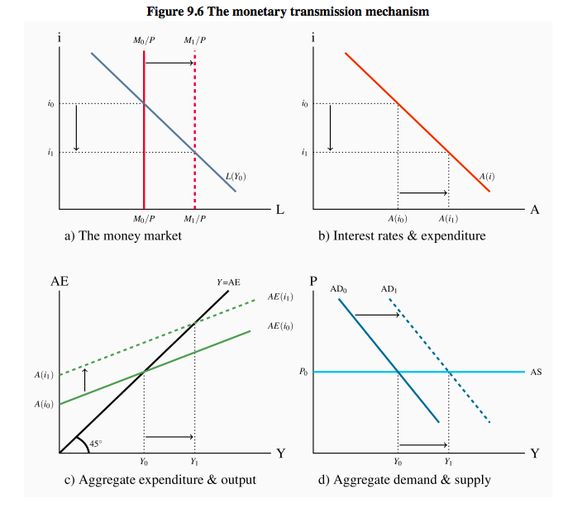
- Fig 9.6 shows the transmission mechanism using 4 interrelated diagrams
- We continue to assume a constant price level
- Changes in the money & financial sector affect AD & output, to add another dimension to our understanding of the sources of AD & fluctuations in AD

- To see the linkages in the transmission mechanism start in (a) w/ an equilib i₀ determined by the initial money supply M₀/P₀ & demand for money L(Y₀)
- This i₀ induces autonomous expenditure A(i₀) in (b)
- That autonomous expenditure is the vertical intercept A(i₀) of the AE function AE(i₀) in (c), & through the multiplier the equilib GDP, Y₀
- In (d) the corresponding AD curve AD₀ shifts right

- There are several key aspects to these linkages b/w money, interest rates, & expenditure
- The effect of changes in the money supply on interest rates in the money market depends on the slope of the demand curve for real money balances
- A steep curve would show that portfolio managers do not react strongly to changes in market interest rates
- It would take large changes in rates to get them to change their money balances
- Alternatively, if their decisions were very sensitive to interest rates, the L function would be flat
- The difference is important to the volatility of financial markets & interest rates, which in turn affect the volatility of expenditure

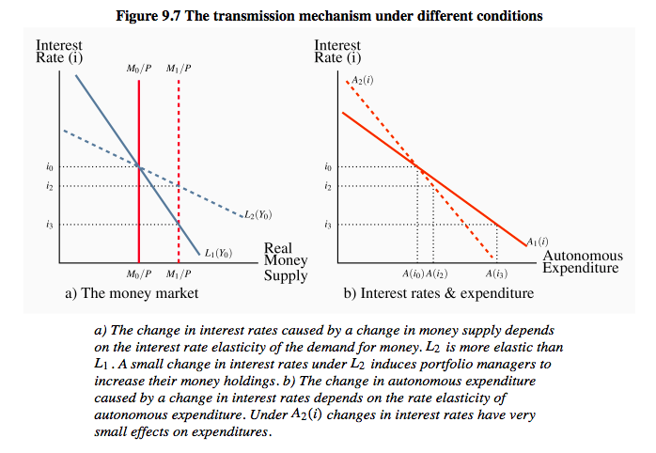
Business Cycles, Output Gaps, & Policy Issues

- The effect of money & financial markets on expenditure, output, & employment raises 2 issues for macro policy
- 1st, fluctuations in money supply & financial conditions are an important source of business cycle fluctuations in output & employment
- These effects are strong & important when the small changes in money supply have big impacts on interest rates & expenditure
- A steep L(i) function & a flat expenditure/interest rate function would create these conditions
- Stabilization policy would then need to control & stabilize the money supply, a policy approach advocated by monetarists, who see money supply disturbances as the major source of business cycles
- If you can fix money supply at M₀ in Fig 9.6, & the demand for money L(Y,i) & the interest rate/expenditure function are stable, you remove monetary disturbances as a source of business cycles

- This Monetarist approach to money & the financial sector concentrates on the “automatic” stabilization effects of money supply control
- W/ the money supply fixed, any tendency for the economy to experience a recessionary or inflationary gap changes the demand for money, & interest rates change in an offsetting direction
- A fall in real output that creates a recessionary gap reduces the demand for money L(Y,i) &, w/ a fixed money supply, interest rates fall to induce additional expenditure
- An inflationary gap would produce an automatic rise in interest rates
- The monetary sector automatically resists fluctuations in expenditure output

- The 2nd policy issue is the alternative to this approach
- Discretionary monetary policy would attempt to manage money supply or interest rates or financial conditions more broadly
- The objective would be to counter persistent autonomous expenditure & financial disturbances that create output gaps
- The intent is to manage AD in an active way
- .:., if business cycles were caused by shifts & fluctuations in the interest rate/expenditure function in panel (b) of 9.6, monetary policy would react by changing interest rates & money supply & move the economy along the new expenditure function to stabilize autonomous expenditure & AD
- Keynesian & New-Keynesian economists advocate this active approach to policy in the money & financial sector, based on a diff & broader view of the sources of business cycles in the economy

