High-Level Overview of Information Systems

What is an Information System?
Technology comes from the word tool. It supports your system, so it is the tool that makes your system works IS is a subset of IT. If someone asks about IS- How are people using the technology to aces sand work on tasks.
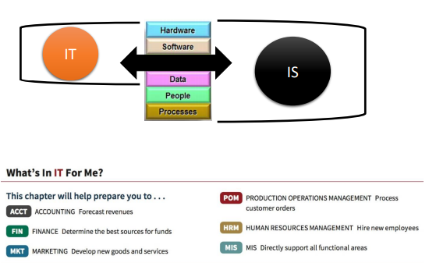

IT : is Physical (Buy, sell…), ex: it can be your IPAD
IS : is something you cannot own as there are people. The people are the ones that are making the IT working by using certain process. IS is the SUM.
MIS: Management information system

The other one that exists LMS (Learning Management systems)- Electronic book we’re using for the class
What is an Information System?
Purpose: To provide accurate, timely and useful information
▪ Each element must be present and all of the elements must work together

-An Information System consists of FIVE PARTS, including:
- People,
- Procedures,
- Software,
- Hardware,
- Data.
Information system (IS) = IT + procedures, and people that produce & utilize information.
-An Information Technology consists of THREE PARTS, including:
IT = hardware + software + data
- Products
- Methods
- Inventions
- Standards
Avoid a common mistake:
Do not try to buy an IS; you cannot do it.
You can buy IT:
Buy or lease hardware, license programs and databases, even obtain predesigned procedures. Ultimately, people execute those procedures to employ that new IT.
Any new system requires:
- training tasks,
- overcoming employees’ resistance to change (It depends on the point of the view of the people are, when you have people involved, you have to involve the heart)
- Managing employees as they utilize new system.
Information Systems aid the Decision-Making Process:
- Improve productivity
- Monitor organizational performance
- Planning and decision-making
- Enhance Competitive Advantage

Information Systems Elements: Data & Information
Information system:
- Set of interrelated components (input)
- Collect, process, store, and distribute information (process)
- Support decision-making, coordination, and control (output)
Data versus Information:
- Data are streams of raw facts (You collect it and it stays so that you can use whenever)
- Information is data shaped into meaningful form
Example: Raw data from a supermarket checkout counter can be processed and organized to produce meaningful information, such as the total unit sales of dish detergent or the total sales revenue from dish detergent for a specific store or sales territory.
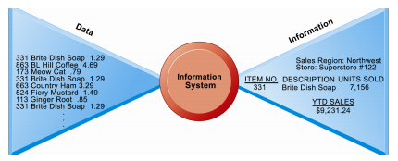

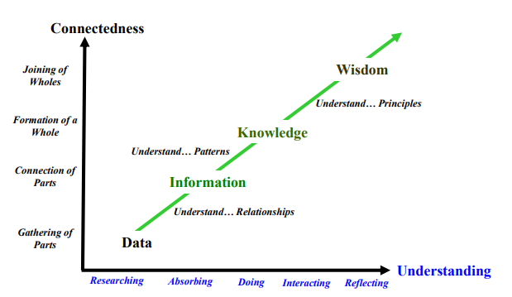

You research Data to be able to turn it into information. You start to get knowledge about the study based on the information that was collected from the Data.
Example: Dating a Girl
- Data: Is she cute or Noooo
- Information: what class is she in, can I register in the same class as her?
- Knowledge: She likes this kind of movie movie because she talks about it
- Wisdom: final decision, do i make her my girlfriend? Can I live with this person. The mistake is always to ask yourself : if I can live WITHOUT her. Very human approach to IT.

A “Systems” Perspective of IS
Three core activities of information systems:
- Input: Captures raw data from organization or external environment
- Processing: Converts raw data into meaningful form
- Output: Transfers processed information to people or activities that use it
Advanced information systems also incorporate one additional functionality:
Feedback:
Output returned to appropriate members of organization to help evaluate or correct input stage

It is important to remember that these functionalities are not limited to technologies:
Can you think of these activities in a management context?
- IS managers DO NOT only work with the IT dept.IS will be part of your job in other business functions such as Marketing, Operations, HR, Finance, Accounting etc.
***Remember**
Using information systems effectively requires understanding of the:
  - Organization,
  - Management,
  - Information Technology shaping the systems.
An information system (IS) creates value for the firm as an organizational and management solution to challenges posed by the environment.

Information Systems (IS)
Information Technology

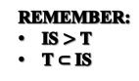
Management
Organization

Management Information Systems & Analytics:
- MIS: Study of People, Technology & Organizations
- Analytics: Tools & Techniques for Data-Driven Decision Making, your IT can be Analytics

Why Study Information Systems?
Benefits of an MIS education for a management student:
- In today’s workplace, it is imperative that IS work effectively and reliably.
- IS managers DO NOT only work with the IT dept.:
    - IS will be part of your job in other business functions such as Marketing, Operations,HR, Finance, Accounting etc.
  - As an IS manager for your business function, you will play a vital role in the implementation and administration of technology within your divisions and for the benefit of your organization.
    - You will plan, coordinate, and direct research on the computer-related activities of firms.
    - You will consult with other managers, help determine the goals of an organization and then implement technology to meet those goals.
    - You will coordinate with pertinent people about the technical aspects such as software development, network security, and Internet operations.
But…
- How is a Management Information Systems education different from Computer Science? or Information Technology?
- I’m in Business School!
MIS as a Business Computing Discipline
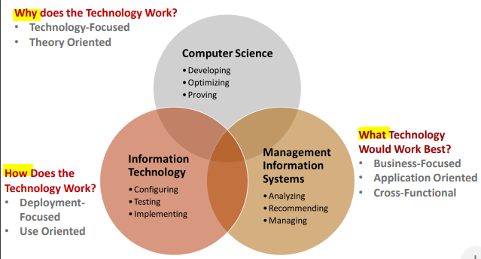

“Information technology and business are becoming inextricably interwoven. I don't think anybody can talk meaningfully about one without the talking about the other.” Bill Gates
MIS & Analytics degrees considered to be among the most valuable University Majors today.
IS Courses Map Well to Various Learning Goals in a Business Education:
- LG2:
- Demonstrate Critical Thinking and Decision Making Skills
- LG7:
- Provide Value to the Business Community in a chosen Area of Specialization
Based on Robert Reich (former US Secretary of Labour):
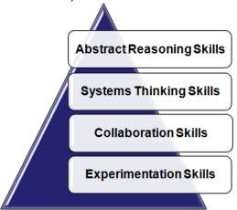
- Four Skills required for most future job roles:
- Abstracts Reasoning Skills
- Systems Thinking Skills
- Collaboration Skills
- Exprimentation skills
- A good IS education is comprehensive across these skills.
Try to Map Your ADM1370 Course Experience to these skills:
- Reflect upon your day-to-day learning through lectures, discussions, and assignments.

Class 2
SOCIAL MEDIA STRATEGIES & THE SOCIAL ENTERPRISE
MANAGING THE SOCIAL ENTERPRISE
Review:
- Information Systems & the Digital Economy
Social Media Business Strategy:
- Definitions
- Trends
- Business Implications
- Strategy Considerations
- Strategy Components
SOCIAL MEDIA STRATEGIES AND THE SOCIAL ENTERPRISE
IS in Organizations
- IS
  - Types of Information Systems
  - Managing Information Resources
  - Role of the IS Department
  - Computer-Based IS
- Social Media (cont.)
- Social Media vs Big Data
Social Computing in Business
- Social Commerce
- Integrated Social Media Strategy
- (ISM) Components
- Social Media Metrics

Digital firms use information systems to enable the seamless flow of information between different parts of the organization as well as between the organization and its suppliers and customers.
Technology ‹ Information Systems
▪ Using information systems effectively requires an understanding of the organization, management, and information technology shaping the systems. An information system creates value for the firm as an organizational and management solution to challenges posed by the environment.
Conducting business electronically enables new levels of efficiency, competitiveness, and profitability (i.e. strategy): ‘Digital Economy’
‘Digital Persona’ of Business
- How businesses, customers, suppliers etc. interact in the digital era,
- Often changes the landscape of how business processes are done,
- Impacts many things including marketing, branding, communicating and
- relationship building
Socio-Technical View of Information Systems
Socio-Technical View of Information Systems:
▪ Includes issues and insights contributed from technical and behavioral disciplines.
Technical Approach:
- Emphasizes mathematically based models,
- Computer science, management science, operations research.
Behavioral Approach:
- Behavioral issues (strategic business integration, implementation, etc.)
- Psychology, Economics, Sociology
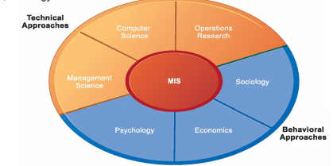
This is another picture of IS because it has the people and the technology. The technology is brought by the people to serve the people. It’s a way of managing the IS in your organisation.
- Economics: whatever your economic needs are whatever will set your organisation’s standards.
- Psychology: how to deal with the person individually
- Sociology: how do you put all those people in the same social circle

Social Media & Business Strategy
-Social Media platforms and applications have changed how we communicate, socialize, access and use information, and shop.
-but… these tools are the means to doing things and not the ends.
-As business managers we need to know how to leverage their potential toachieve strategic advantage
Ex: Trump on social media, all his social media affects his surroundings ( good or bad)

What is Social Media?
Social Media:
- Social Media is a group of Internet-based applications that build on the ideological and technological foundations of Web 2.0, and that allow the creation and exchange of User Generated Content. (Kaplan & Haenlein, 2010)
- 2.0 created the ability to communicate (2 way communication)
- 1.0 is one way communication
Web 2.0 & User-Generated Content as a foundation:
Web 2.0:
- term first used in 2004
- software as a continually-updated service that gets better the more people use it, consuming and remixing data from multiple sources, including individual users, while providing their own data and services in a form that allows remixing by others, creating network effects through an architecture of participation. (O’Reilly, 2005)
User-Generated Content (UGC)
- term popularized in 2005
- various forms of media content that are publicly available and created by end-users.
- 3 basic requirements for UGC: (OECD, 2007)
- needs to be published either on a publicly accessible website or on a social networking site accessible to a selected group of people
- needs to show a certain amount of creative effort (prove with citations)
- needs to have been created outside of professional routines and practices( sharing your own believes or thoughts without involving your working environement.

Characteristics of Web 2.0:
- The ability to tap into the collective intelligence of users. (ex: followers)
- Data is made available in new or never-intended ways. (having your own opinion on news)
- Relies on user-generated and user-controlled content and data. (you make it, you post it. There are ways that if you post bad content, you can get it removed)
- Lightweight programming techniques and tools let nearly anyone act as a Web site developer.
- The virtual elimination of software-upgrade cycles makes everything a perpetual beta or work-in-progress. Application can be designed quickly to meet changing needs.
Types of Social Media:
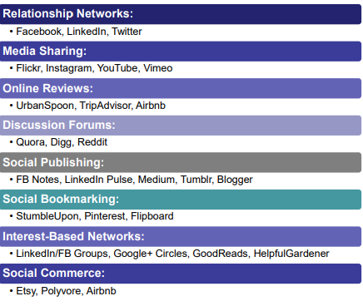
It’S important to find the difference between them.
Bookmarking (interest based network)
Question: It will ask you on what kind of type of social media for the exam
Social Media Trends
Trend:
- Social media has led to the Convergence of Information and Communication:
- More Channels for Communication as well as Media Consumption ( we want more ways to communicate)- CBC page( our twitter, our instagram, etc) many channels of communication. RSS ** Make more research on it
- Lines between personal communication and media consumption becoming blurry.
- Social media being used for many other purposes than were originally intended or envisioned

Social Media for News:
- 60% get “some” news through social media.
- It manipulates
- 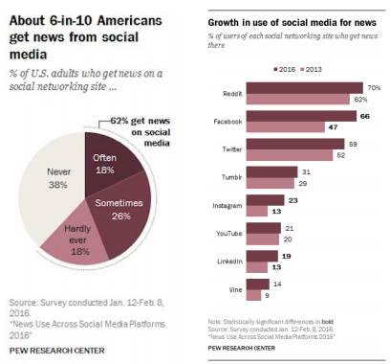

Breaking News on Twitter:
News Stories that broke on Twitter before the mainstream news media:
- The Hudson River Landing…
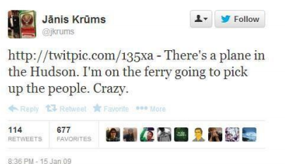

News Stories that broke on Twitter before the mainstream news media:
- The Bin Laden Raid…


What’s the Downside to all this?
- SOCIAL MEDIA is: websites and applications that enable users to create and share content or to participate in social networking.
- SOCIAL MEDIA is: the collective of online communications channels dedicated to community- based I
- SOCIAL MEDIA are: computer-mediated technologies that facilitate the creation and sharing of information, ideas, career interests and other forms of expression via virtual communities and networks.
- SOCIAL MEDIA are: interactive Web 2.0 Internet-based applications - input, interaction, contentsharingand collaboration.
Social Media Implications for Business
Trend:
- Social media has led to the Convergence of Information and Communication.
Implications for Business:
- Reach out and engage with customers, prospects, partners, and your network.
- Create opportunity by communicating and sharing information.
- Manage your reputation and discover new business through monitoring information

Adopting a Social Business Aptitude (ability to do something):
- Maximize the potential of social media by using it across business functions.
- Rather than using social media as an inside-out promotional medium, leverage the
outside-in conversations as well.
- Harness big social data to glean insights for product research, competitive analysis
and prediction of customer needs.
- Update corporate governance policies and guidelines
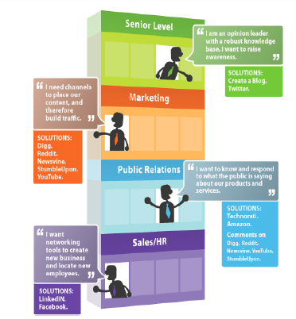
Social Media Strategy: Key Considerations
Social Media is always in a flux due to three factors:
- End-Users ( person who’s using the product because he’S at the end of the creation)
- Use Cases
- Functionality (all the inbetween)
Implications:
- Strategies and tactics used to manage social media have to constantly adapt
-Strategy needs to be formulated in terms of objectives, tactics, and metrics.
-Corporate governance issues such as policies and guidelines need to be considered.

Social Media Strategy: Components
Components of a Social Media Strategy:
- Objectives
- Tactics
- Metrics
PDCA Framework: Framework for any MIS
- Plan:
  - ▪ Creating a social media strategy.
- Do:
  - ▪ Implementing tactics and campaigns aligned with the social media strategy.
- Check:
  - Regular (daily, weekly, monthly, quarterly, etc.) review of metrics created as part of the strategy todetermine if business ROI in social media has been sufficiently achieved or not.
- Act:
  - (or Adjust) Fine-tuning the social media strategy, tactics, plans for campaigns, and even potentially refining or changing metrics or how measurements are performed.
It is a never-ending cycle because of the changing nature of social media sites and services, and how we use them.
Objectives: what
- Link to corporate strategy
- Ways to extend brand’s strengths online
Customers: who
- Target demographic group and focus
- Assess type of users
Sharing: what
- ▪ What social tools will be used
- ▪ What type of content will be shared
Who:
- ▪ Who will lead the effort
Brand Alignment: if you create your own tool, you need to brand it
- ▪ Guidelines, Tone of voice, Media usage
Monitor:
- ▪ Listening to customers, Activities monitoring, Measuring success

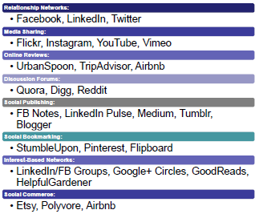
In Class activity
List some possible Social Media Tactics and Metrics for the following strategic objectives:
(Use some of the components discussed in the previous slides)
1. Customer Acquisition/Learning/Developing of particular skill(s): Online reviews
2. Product Development & Innovation: Social commerce
3. Customer Experience & Service

Strategic Social Media Management: Key Success Factors
Strategy:
- A comprehensive, company-wide social media strategy, and all functions and business units adhere to a uniform set of strategic directives.
Organization:
- employ dedicated FTEs in different functions and set aside budgets specifically for social media activities.
Criteria-based platform selection:
- select appropriate social media platforms based on clear criteria to match social media strategy.
Integration:
- integrate and leverage social media activities along the entire value chain.
Awareness:
- created a significantly higher awareness for social media throughout the company.
Leadership:
- make social media activities a priority for top management and ensure senior executives are highly involved.

Types of Information Systems
Intra-Organizational and Inter-Organizational Information Systems
This is how an organization works
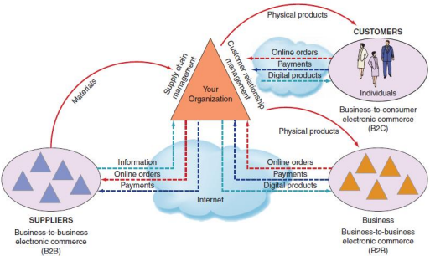
-Two (2) clouds: the internet (B2B and Business to customer)
-Information technology among organizations

Types of Information Systems Managing Information Resources
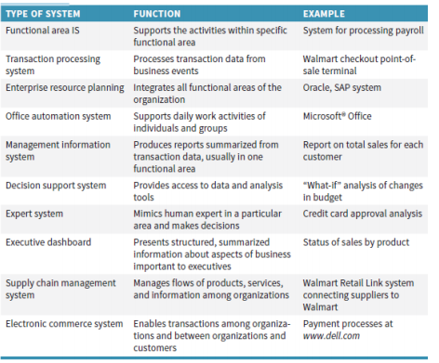
Don’t memorize it but just understand it.
Types of Information Systems Role of the MIS Department
Traditional Functions of the MIS Department:
  - Managing systems development and systems project management.
  - Managing computer operations, including the computer centre.
  - Staffing, training, and developing IS skills. Providing technical services. Make sure the people that you have are able to work with that technology
  - Infrastructure planning, development, and control.
New (Consultative) Functions of the MIS Department:
  - Install and design specific strategic IS,
  - Manage system integration (internet, intranet and extranet)
  - Training non-MIS managers about IT.
  - Training the MIS staff about IT,
  - Tracks innovative ideas,
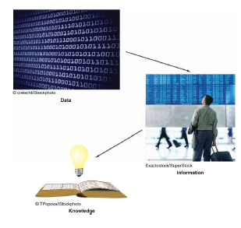
  - Create alliances with other business partners.
Computer-Based IS MIS Functions
MIS Department =
- IS Department
- Information Technology Department;
- Information Services Department;

Data… Information… Knowledge

MIS = information system which collects, processes, stores, analyzes, and disseminates information for a specific purpose;
Computer –Based IS (CBIS) = IS that uses computer technology to perform its tasks.
Computer –Based IS components= components of IT:
  - Hardware,
  - Software,
  - Data (Database),
  - Network,
  - Procedures,
  - People
Typical Computer-Based IS (CBIS) Components
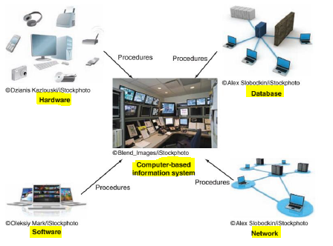
Integrating Typical Computer-Based IS (CBIS) Components
Information technology inside the organization
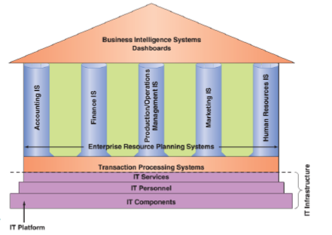
Once you start your business starts, you want to know what kind of IT you need. All of the elements will do the wisdom approach to see what went right and what went wrong so that you can work on it.

Major Capabilities of IS
- Perform high-speed, high volume numerical computations
- Provide fast, accurate communication and collaboration within and among organizations
- Store huge amounts of information in an easy-to-access, yet small space
- Allow quick and inexpensive access to vast amounts of information worldwide
- Interpret vast amounts of data quickly and efficiently
- Automate both semi-automatic business processes and manual tasks
Your data has to be accurate when you do analysis. Always make sure you have enough storage (maybe clouds)
Social Media & Big Data
Structured vs Unstructured Data:
- Structured data refers to information with a high degree of organization, such that inclusion in a relational database is seamless and readily searchable by simple, straightforward search engine algorithms or other search operations
- Unstructured data is essentially the opposite
- The lack of structure makes compilation and analysis a time and energy-consuming task.
-You should know everything about your business (every single aspect of it so that you understand how everything is going.
-No structure data: data that becomes people are overloaded (personal mistakes)
Big data: A lot of information

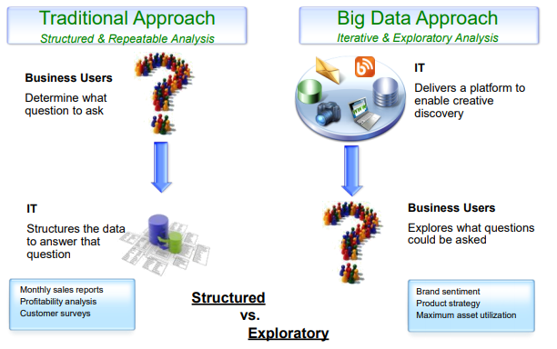
Challenges to overcome:
The 4 Vs
- Volume
- Variety
- Velocity
- Veracity (accuracy)
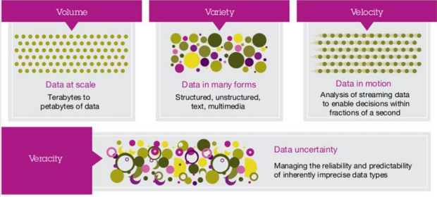

Social Network Analysis (SNA):
- The mapping and measuring of relationships and flows between people, groups, organizations, computers, or other information or knowledge processing entities.
- The nodes in the network are the people and groups, whereas the links show relationships or flows between the nodes.
- SNA provides both visual and mathematical analyses of relationships

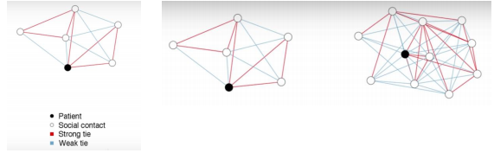
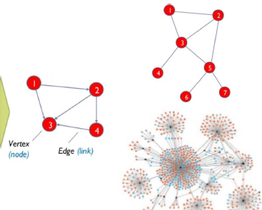
Social Network Analysis (SNA):
The nodes in the network are the people and groups, whereas the links show relationships or flows between the nodes.

Social Media & Business Strategy
- Social Media platforms and applications have changed how we communicate, socialize, access and use information, and shop.
- but… these tools are the means to doing things and not the ends
- As business managers we need to know how to leverage their potential to achieve strategic advantage
Social Computing in Business: Social Commerce
Social Commerce =
- the activity of buying and selling, especially on a large scale
- social dealings between people
- Use of social computing by businesses in innovative ways
- Delivery of electronic commerce activities and transactions through social computing.
- Social interactions and user contributions allow customers to participate actively in the marketing and selling of products and services in online marketplaces and communities.
- Individuals can collaborate online, obtain advice from trusted individuals, and find and purchase goods and services.
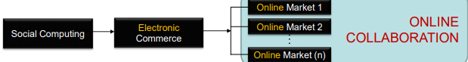
The social uses the ecommerce to create an online collaboration.

Social Media Strategy: Key Considerations
Social Media Strategy:
- Strategy needs to be formulated in terms of objectives, tactics, and metrics.
- Corporate governance issues such as policies and guidelines need to be considered.
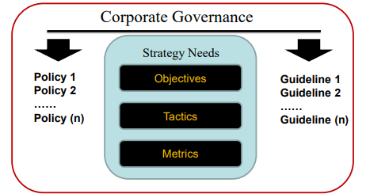

Objective: Something we want to achieve, difference between goal (the big picture)
Tactic: Steps you are going to follow
Metrics: how will you measure the success or failure?

Social Media Strategy Examples:
Mercedes-Benz’s #mbphotopass campaign:
- Company “passes” access to their Instagram feed to social influencers, journalists, photographers and team members to curate content for the account for certain periods.
- Influencers are also given the keys to a Benz to drive around while they are taking pictures and curating the company's Instagram account.

Social Media Strategy: Components REVIEW
Components of a Social Media Strategy:
PDCA Framework:
Plan: creating a social media strategy.
Do: Implementing tactics and campaigns aligned with the social media strategy.
Check: Regular (daily, weekly, monthly, quarterly, etc.) review of metrics created as part of the strategy to determine if business ROI in social media has been sufficiently achieved or not.
Act: (or Adjust) Fine-tuning the social media strategy, tactics, plans for campaigns, and even potentially refining or changing metrics or how measurements are performed.
It is a never-ending cycle because of the changing nature of social media sites and services, and how we use them.

Objectives:
- Link to corporate strategy
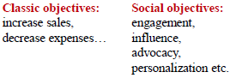
- Ways to extend brand’s strengths online

Customers:
- Target demographic group and focus
- Assess type of users

Sharing:
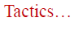
- What social tools will be used
- What type of content will be shared

Who:
- Who will lead the effort

Brand Alignment:
- Guidelines, Tone of voice, Media usage

Monitor:
- Listening to customers, Activities monitoring, Measuring success

Social Media Metrics
Effective Social Media Management depends on data-driven measurements, or metrics (activity metrics, ROI, tactical, strategic).
- Activity Metrics Page views
Unique number of visitors; Posts; Comments and trackbacks; Time spent on site. .
- ROI (Return of Investments
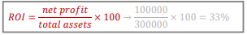
Sales and marketing: Cost per number of prospects Number of leads per period Cost of lead Conversion of leads to customers Customer lifetime value (CLV)
Product Development: Number of new product ideas; Idea to development initiation cycle time
HR: Hiring and training costs; Employee attrition.
3. Tactical Metrics
- Increase traffic to our Web site by 10%
- Increase requests for product information via our Web site by 15%
- Increase number of people who create a user account on our Web site by 12%
4. Strategic Metrics
- Listening: Pay attention to what customers are saying online
- Talking: Communicate with your customers by engaging in conversations
- Energizing: Encourage customers and fans to spread the word through ratings, reviews and other positive “buzz”
- Support: Provide information and online resources, such as user forums, knowledge bases and other tools
- Embracing: Invite customers to generate ideas for new products and services
Example of Social Media Strategic Metrics:
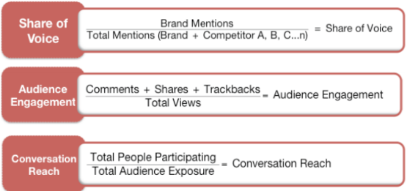
- Customer Dialog Metrics:
  - Genuine Dialog provides the basis for building awareness and word of mouth

Social Media Strategy: Criterion-based Selection of Tools
Honeycomb of Social Media (Functionality & Implications) (Kietzmann et al., 2011)
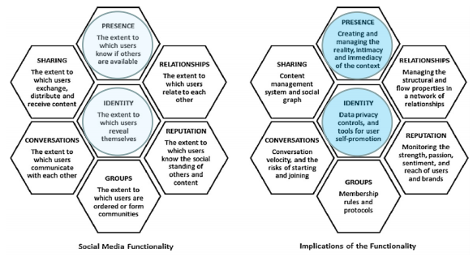
To explain and justify and control the social media. That we for every social media we should use all seven of them. The first one was the researcher and the other one is for the business. How would you describe Twitter and Google+ using the Honeycomb framework? Try to work one for the YouTube.
Strategic Social Media Management: Key Success Factors

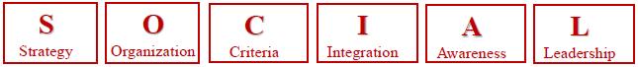
Strategy: Acomprehensive, company-wide social media strategy, and all functions and business units adhere to a uniform set of strategic directives.

Organization: Employ dedicated FTEs in different functions and set aside budgets specifically for social media activities.

Criteria-based platform selection: Select appropriate social media platforms based on clear criteria to match social media strategy.

Integration: Integrate and leverage social media activities along the entire value chain.

Awareness: Created a significantly higher awareness for social media throughout the company.

Leadership: Make social media activities a priority for top management and ensure senior executives are highly involved.

Class 3
SOCIAL COMPUTING IN BUSINESS
- Social Media Strategy Key Success Factors
- Web 2.0 Applications
- Introduction to Wikis
Web 2.0
What is Web 2.0?
How is it different from Web 1.0?
What is the difference between Web 2.0 and Social Media?
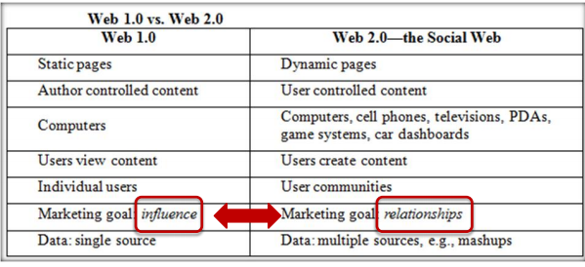
Web 2.0 (coordinating or discussing with someone through a machine). It becomes user control center.
The PAST of www…… Web 1.0
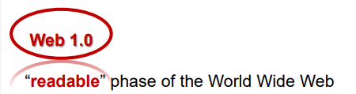
Characteristics:
- with flat data; there’s no movement (has not been modified)
- limited interaction between sites and web users;
- simply an information portal where users passively receive information without being given the opportunity to post reviews, comments, or feedback.
The PRESENT of www…… Web 2.0
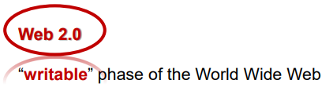
Characteristics:
- with interactive data;
- facilitates interaction between web users and sites, so it allows users to interact more freely with each other, i.e. “user-to-user” interaction; encourages participation, collaboration, and information sharing.
- Examples: Wiki, Flickr, Facebook…

The FUTURE of www…… Web 3.0
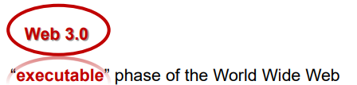
Characteristics:
- with dynamic applications, interactive services;
- “machine-to-machine” interaction;
- Computers can interpret information like humans and intelligently generate and distribute useful content tailored to the needs of users.
- Examples: TiVo (digital video recorder that searches the web and reads to user what was found): You had a recorder, you can record anything at the specific time
Wb 1.o 1996-2004

Look up for definition
Web 4.0 2018 structured knowledge and web 7.0

Web 2.0
What is Web 2.0?
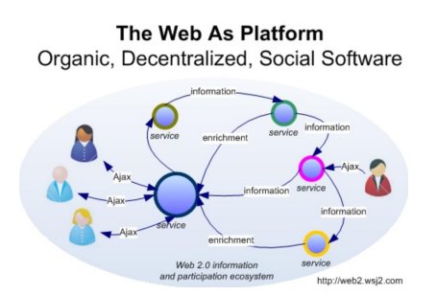
Person using a service and getting information and someone else can share their info. It’S all about collaboarion
More Web 2.0 Applications (Examples)
Important Features of Web 2.0:
- Information sharing, collaboration and interactive functionality of the web: Interconnectivity and Interactivity of web-delivered content!
- Architecture based on participation
Popular Examples of Web 2.0 based Applications:
- social networking sites,
- video sharing sites,
- wikis,
- blogs,
- Folksonomies,
- Mashups and APIs (Application Programming Interfaces). *TRIVAGO is a good idea*
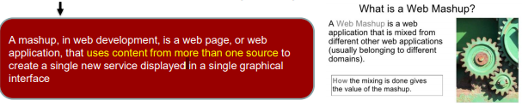

Application Programming Interface (API)
API is a specification intended to be used as an interface by software components to communicate with each other.
Any leak of data can be tracked by security
Data API Types
- Indexed data
- Cartographic and geographic data;
- Feeds, podcasts;
- Data converters;
- Communication;
- Visual data rendering;
- Security related;
- Editors.
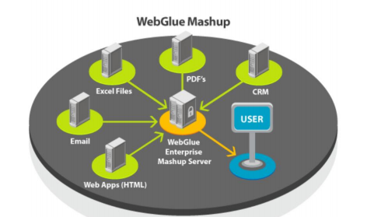
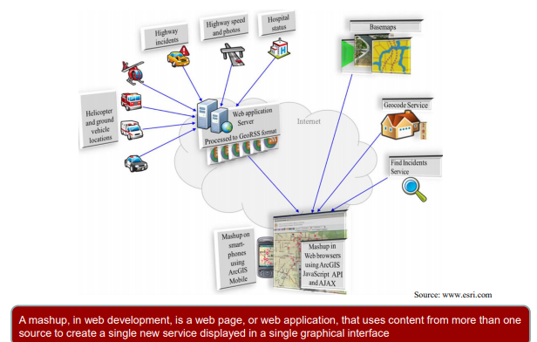

Mashup- Google Map: Mashup of City search and Google Maps will help you find the best restaurants

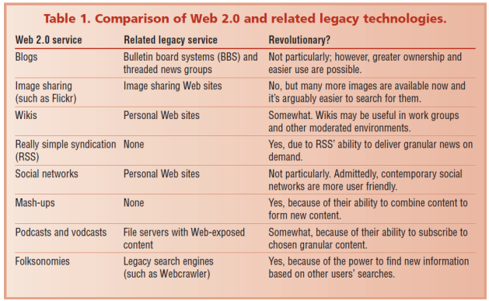

Web 2.0 & Rich Internet Applications
Rich Internet Applications are a predominant feature of Web 2.0
Attributes:
- web applications that have many of the characteristics of desktop software;
- Typically delivered either through specialized browsers, browser plug-ins, or client virtual machines.
Uses:
- ▪ rendering multiple forms of content (text, audio, video etc.) in an integrated fashion
- ▪ engaging users via interactive user-friendly interfaces
- ▪ performing complex data visualization, including dynamic charting or graphical presentation of data.
Example of an Enabling Technology:
Ajax (Asynchronous JavaScript and XML) is a method of building interactive applications for the Web that process user requests immediately. Ajax combines several programming tools including JavaScript, dynamic HTML (DHTML), Extensible Markup Language (XML), cascading style sheets (CSS), the Document Object Model (DOM), and the Microsoft object, XMLHttpRequest.
Enterprise 2.0 Tools
Enterprise 2.0 refers to Web 2.0 technologies used for some business purpose:
- Promote collaboration and knowledge exchange among employees, consultants and company partners
Business use of Web 2.0 technologies (examples):
- Recruiting and professional networking
- Marketing, promotion, and sales
- Internal collaboration and communication
- Supply chain management 2.0

Web 2.0 Technologies: Wikis
- “wiki” means “quick" or “fast” in the Hawaiian language
- Wiki-Wiki is the name of the bus line at the Honolulu Intl Airport
- A wiki is a website or similar online resource which allows users to add and edit content collectively
Example: www.wikipedia.com

WIKI = What I Know Is….
Invented in 1995 by Ward Cunningham to facilitate online collaboration.
DEFINITION:
Wiki = dynamic, collectively authored set of web pages.
PURPOSE:
- Collectively share and edit a body of knowledge;
- Ongoing process of creation and collaboration;
- Knowledge Management – e.g. Wikipedia, Enterprise wikis…
CHARACTERISTICS:
- Web-based
- Interactive
- Collaborative
- Iterative
THINGS TO REMEMBER ABOUT WIKIS
Wikis are collaboration tools
- Blogs and chats are more turned towards conversation
Wikis are intended to maintain a series of unique documents as their content evolves
Wikis have built-in version control
- No changes can be made without creating a record of who made those changes
- Reversion to an earlier version is always possible
Functions & Features:
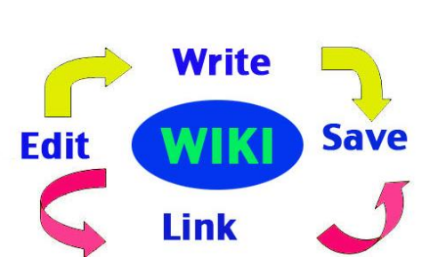
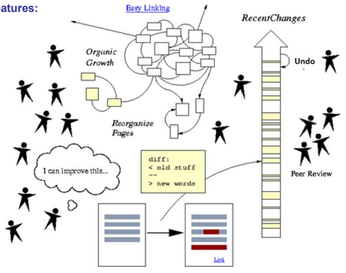

RSS (Rich Site Summary) (Really Simple Syndication):

-A standardized data format to publish frequently updated works such as blog entries and news headlines.
-Website material is made available to end-users or other sites through web feeds.
- A web feed (or news feed) is a data format used for providing users with frequently updated content.
- Content distributors syndicate a web feed, thereby allowing users to subscribe to it.
RSS (Web) Feeds are usually accessed through an aggregator tool:
- Making a collection of web feeds accessible in one spot is known as aggregation, which is performed by an aggregator.
- Aggregators can be scheduled to check for new content periodically. Web feeds are an example of pull technology, although they may appear to push content to the user.
Web 2.0 technologies: Web Widget
Widgets= plugins:
- Mini web application or Web add-ons
- When embedded in other websites, they allow those websites to access content or functionality from other widget provider website (third party site)
- Snippets of code from third-party sites that are included on you own website or web application
- Examples:
  - Wealthier information Widget
  - Calculator Widget
  - Currency converter widget
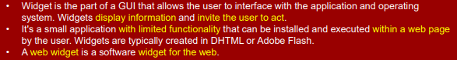
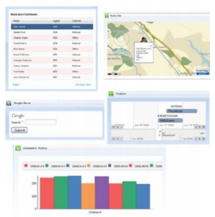
Widget example: IBM
- A widget is a small application or piece of dynamic content that can be easily placed into a web page
- Widgets are called different names by different vendors: Gadgets, blocks, flakes
- Widgets can be written in any language or and can be simply HTML
- ‘’Mashable’’ widget pass events, so that they can be wired together to create something new

