Experiment 2: A Tall Cold Drink of Water
James Blanchard 300001975
Sarah Rolston 300006718
Paulina Hanzelova 300015952
Jay Wang 300006737
Aaron Quetua 300015352
CHM 1311 – A03
October 3, 2017

Introduction/Theory
Whenever chemical reactions occur, the reactants becoming the products is not the only thing happening inside the reaction. Molecules of different substances have varying potential energies depending on the elements that make them up or what type of bonds hold the molecule together (among other factors), and as a result, when certain molecules react to form different sets of products, those products might not have the same potential energy as the reactants. According to the laws of thermodynamics (namely the first law of thermodynamics), energy is conserved, meaning energy from reactions in neither created from nothing or disappears completely. Thanks to this law, we know that the potential energy contained in molecules goes somewhere or comes from somewhere in a reaction. Reactions that give off energy as heat are called exothermic reactions and they occur when the products have less potential energy than the reactants. Reactions that absorb heat are called endothermic reaction and they occur when the products have a higher potential energy than the reactants. As a result of these reactions happening, there are noticeable temperature changes that can be measured and compared with other factors to calculate values for these types of reactions.
q = cm∆T
∆T = (T₁ – T₂)
The above formulas can be used to determine values for different types of reactions and temperature changes. (q = heat energy in Joules, c = specific heat in J/kg∙K (a constant depending on substance being heated), m = mass of substance in kg, and ∆T = the change in temperature in kelvin. Using this formula, one can easily find theoretical quantities for chemical reactions involving temperature changes. By combining knowledge from the above formulas and other formulas it is possible to find out nearly everything about certain chemical reactions.
∆H = q / n
m = n ∙ mm
If values for mass and what substances are reacting are already known, it is possible to find how many moles of the reactant or product are present using m = n∙ mm (m = mass in grams, n = number of moles and mm = molar mass of the substance). It is also possible to find values representing the molar enthalpy (∆H in units kJ/mol) of a substance in a reaction. When taking into account what type of reactants are being used, it is also possible to manufacture a desired temperature change by utilizing certain reactions. For example, salts dissolving in water can create endothermic reactions because it takes energy for the atomic lattice of the salt to fall apart, creating a reaction which absorbs heat.
These calculations are accurate under ideal conditions, however, some problems do arise where in a chemical reaction may not react perfectly due to imperfect measurements or the reaction not happening all at once (gradually) or certain smaller variables are not taken into account during calculations such as temperature from outside the experiment coming in over a period of time. Despite this, by being as accurate as possible, controlling experimentation and knowing what substances are being used, it is possible to calculate theoretical enthalpy or energy or any number of values for most chemical reactions and use this knowledge to use chemicals to do useful things such as cool or heat objects (fluids) to certain desired temperatures.
Procedure
- Gather all required materials. This includes a calorimeter, a stopwatch, a pop can with the top removed and the water and ammonium chloride required.
- Set up calorimeter. Place the can in the calorimeter. Set up the LabQuest 2 and calibrate the calorimeter by placing the calorimeter in the can and closing the lid of the calorimeter. This will ensure the calorimeter is registering data correctly and give the initial temperature for the data.
- Using the formula Q=mcΔT, calculate the mass of ammonium chloride and ammonium nitrate required.
- Place 100 g of water in the can and 100 g of water around the can in the calorimeter. Add 6.57 g of the salt to the water around the can and close the calorimeter. Swirl the calorimeter to continue the reaction. Start the timer for 5 minutes. Continue to swirl the calorimeter to continue the reaction to completion.
- When 5 minutes has passed stop the reaction by stopping moving the calorimeter and removing the lid.
- Repeat trials for 15 g of salt and 1 g of salt.
- Calculate theoretical values for ammonium nitrate as this experiment cannot be completed with the safety present in the lab.
Safety
Always wear a lab coat and protective eyewear during the laboratory.
NH₄Cl reacts violently with NH₄NO₃, keep both substances away.
NH₄NO₃ reacts with water to create NO, a gas that should not be breathed in, all calculations with NH₄NO₃ are theoretical.
Data
Graph 1: Temperature Changes Over Time for 1.0g
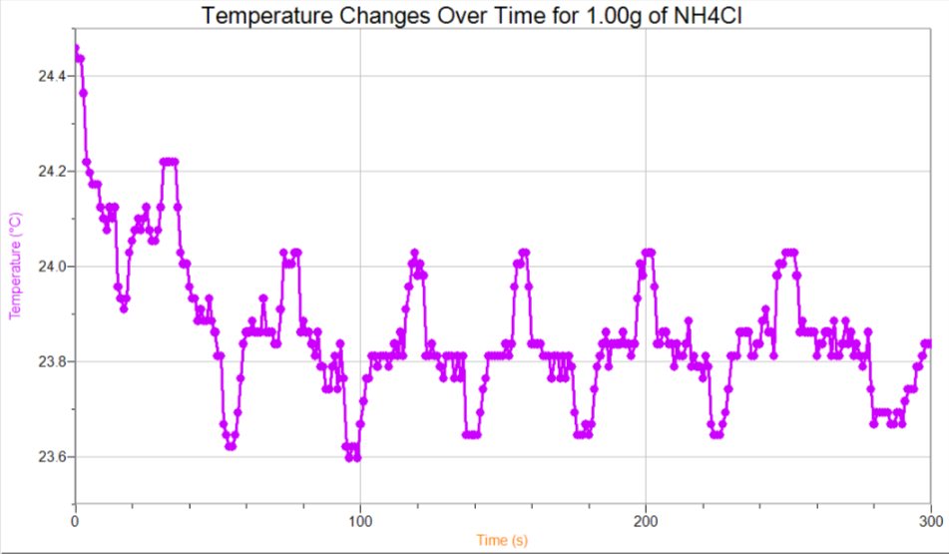

Graph 2: Temperature Changes Over Time for 6.50 g of NH₄Cl
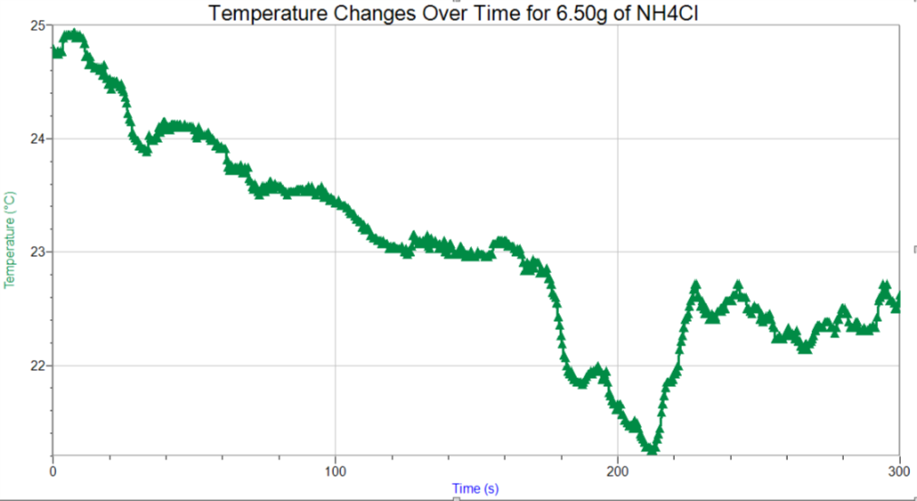

Graph 3: Temperature Changes Over Time for 15.00g of NH₄Cl
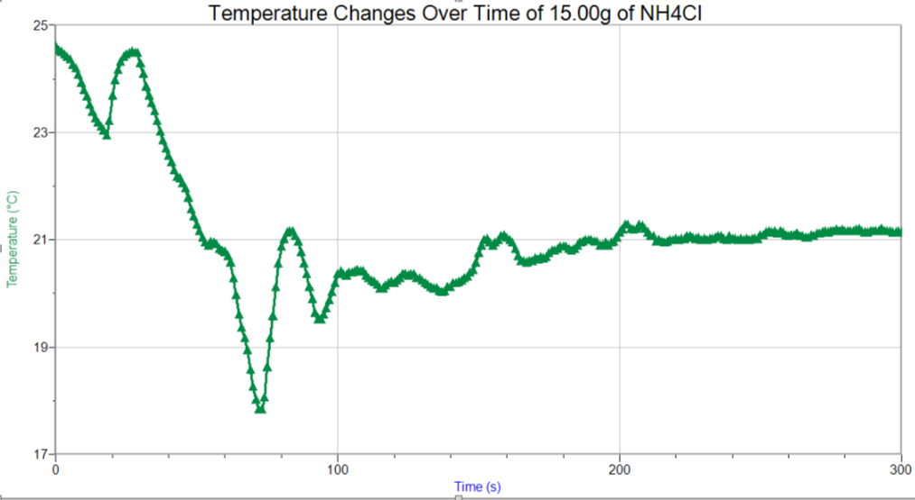

Table 1: Change in temperature of different masses of NH₄Cl in a calorimeter
 | Temperature (°C) at 60 second intervals
Mass (g) | t₀ (s) | T₁ (s) | T₂ (s) | T₃ (s) | T₄ (s) | T₅ (s)
1.00 | 24.3 | 23.9 | 24.0 | 23.6 | 23.8 | 23.8
6.50 | 24.7 | 23.9 | 23.0 | 22.2 | 22.6 | 22.6
15.00 | 24.7 | 20.8 | 20.2 | 20.9 | 21.0 | 21.1

Calculations
Given:
NH₄Cl (s): ∆H = 17 kJ/mol (from pre-lab exercise) → 17 000 J/mol, MM = 53.5 g/mol
H₂O (l): V = 100cm³ → m = 100g, c = 4.18 J/g•C
∆T = 5°C
Calculating heat energy for the reaction:
q = mc∆T
q = 100g (4.18 J/g•C) (5°C)
q = 2090 J
Calculating moles of NH₄Cl required:
∆H = $\frac{q}{n}$
n = $\frac{q}{∆H}$
n = $\frac{2090 J}{17 000 J/mol}$
n = 0.1229 mol
Converting moles into mass:
m = nM
m = 0.1229 mol (53.5 g/mol)
m = 6.57 g

Discussion
Theoretically, the calculated 6.5 g of NH₄Cl should have lowered the temperature of the water by 5ºC in 5 minutes (see calculation above). Experimentally, 6.5 g of NH₄Cl only decreased the temperature by 2.1°C (T₀-T₅ from Table 1).
$\%error=\frac{|experimental value-|theoretical value|}{theoretical value} ×100\%$
$\%error=\frac{|2.1-5|}{5}×100\%$
$\%error=58\%$
The experimental value deviated from the calculated value by 58%, as seen by the percent error calculation. Because this mass did not cool the water sufficiently, a greater mass will be required. 15 g however, is still not sufficient to cool down the temperature to 5°C in 5 minutes, as it only decreased the temperature of the water by 3.6°C in 5 minutes. Therefore, more than 15 g of NH₄Cl must be used. In conclusion, 6.5 g is not sufficient to decrease the temperature of water by 5°C in 5 minutes, and neither is 15 g. The mass must be determined by further experimental testing, as the discrepancy between theoretical and experimental values is so great.
This discrepancy may be the result of apparatus limitations; the Styrofoam calorimeter used in the experiment is a closed system; it does not allow for escape of matter, however, it does allow for loss of heat energy. Although Styrofoam is an insulator, it is still a closed system apparatus, which is inferior to an isolated system, such as a thermos. The use of a quality thermos would decrease the percent error, as neither mass nor heat energy will be lost to the surroundings, due to a vacuum surrounding the system. A decreased percent error also decreased the excess product that must be used to compensate for heat loss; thus, conserving product, and lowering product cost. However, exact product cost cannot be determined because exact mass to decrease the temperature of the water must be determined with further testing. However, it can be determined that NH₄Cl will definitely be used, as NH₄NO₃ is highly explosive, and therefore not safe.
In order to achieve accurate results the experiment must be performed with an abundant amount of NH₄Cl. Since there was an insufficient amount of NH₄Cl there was not enough tests to be performed in order to analyse how much solute was needed to bring the temperature down 5°C. It would have been more accurate if there were multiple trials using the same amount of solute. Another way to improve the lab is to make sure that the calorimeter is not to be shaken too much. This results in kinetic energy within the solution. This could be the result of the temperature not being able to drop since the kinetic energy would have been converted to thermal energy since thermal energy is equal to all internal kinetic energy. Error that could have been prevented was the pouring of the solute. Not all of the solute of was able to make it into the system and this could have been a significant effect towards the data. Since there was a lack of solute we were not able to perform another trial to get better results.
To conclude, the calculated mass of ammonium chloride is insufficient to decrease the temperature of water by 5°C in 5 minutes. Further tests must be performed with the apparatus to determine the correct mass.

References
“CDC – Ammonium Chloride.” NIOSH, July 2014. https://www.cdc.gov/niosh/ipcsneng/neng1051.html. Accessed 30 September 2017.
Tinoco, Ignacio, Sauer, Kenneth, Wang James, “Physical Chemistry Principles and Applications in Biological Sciences”, Chapter 2, Prentice Hall, Pages 25 – 47, 1995.
Spencer, James, Bodner, George, Rickard, Lyman, “Chemistry Structure and Dynamics Fifth Edition”, Chapter 7, John Wiley & Sons, Pages 265 – 304, 2012.

Raw Data
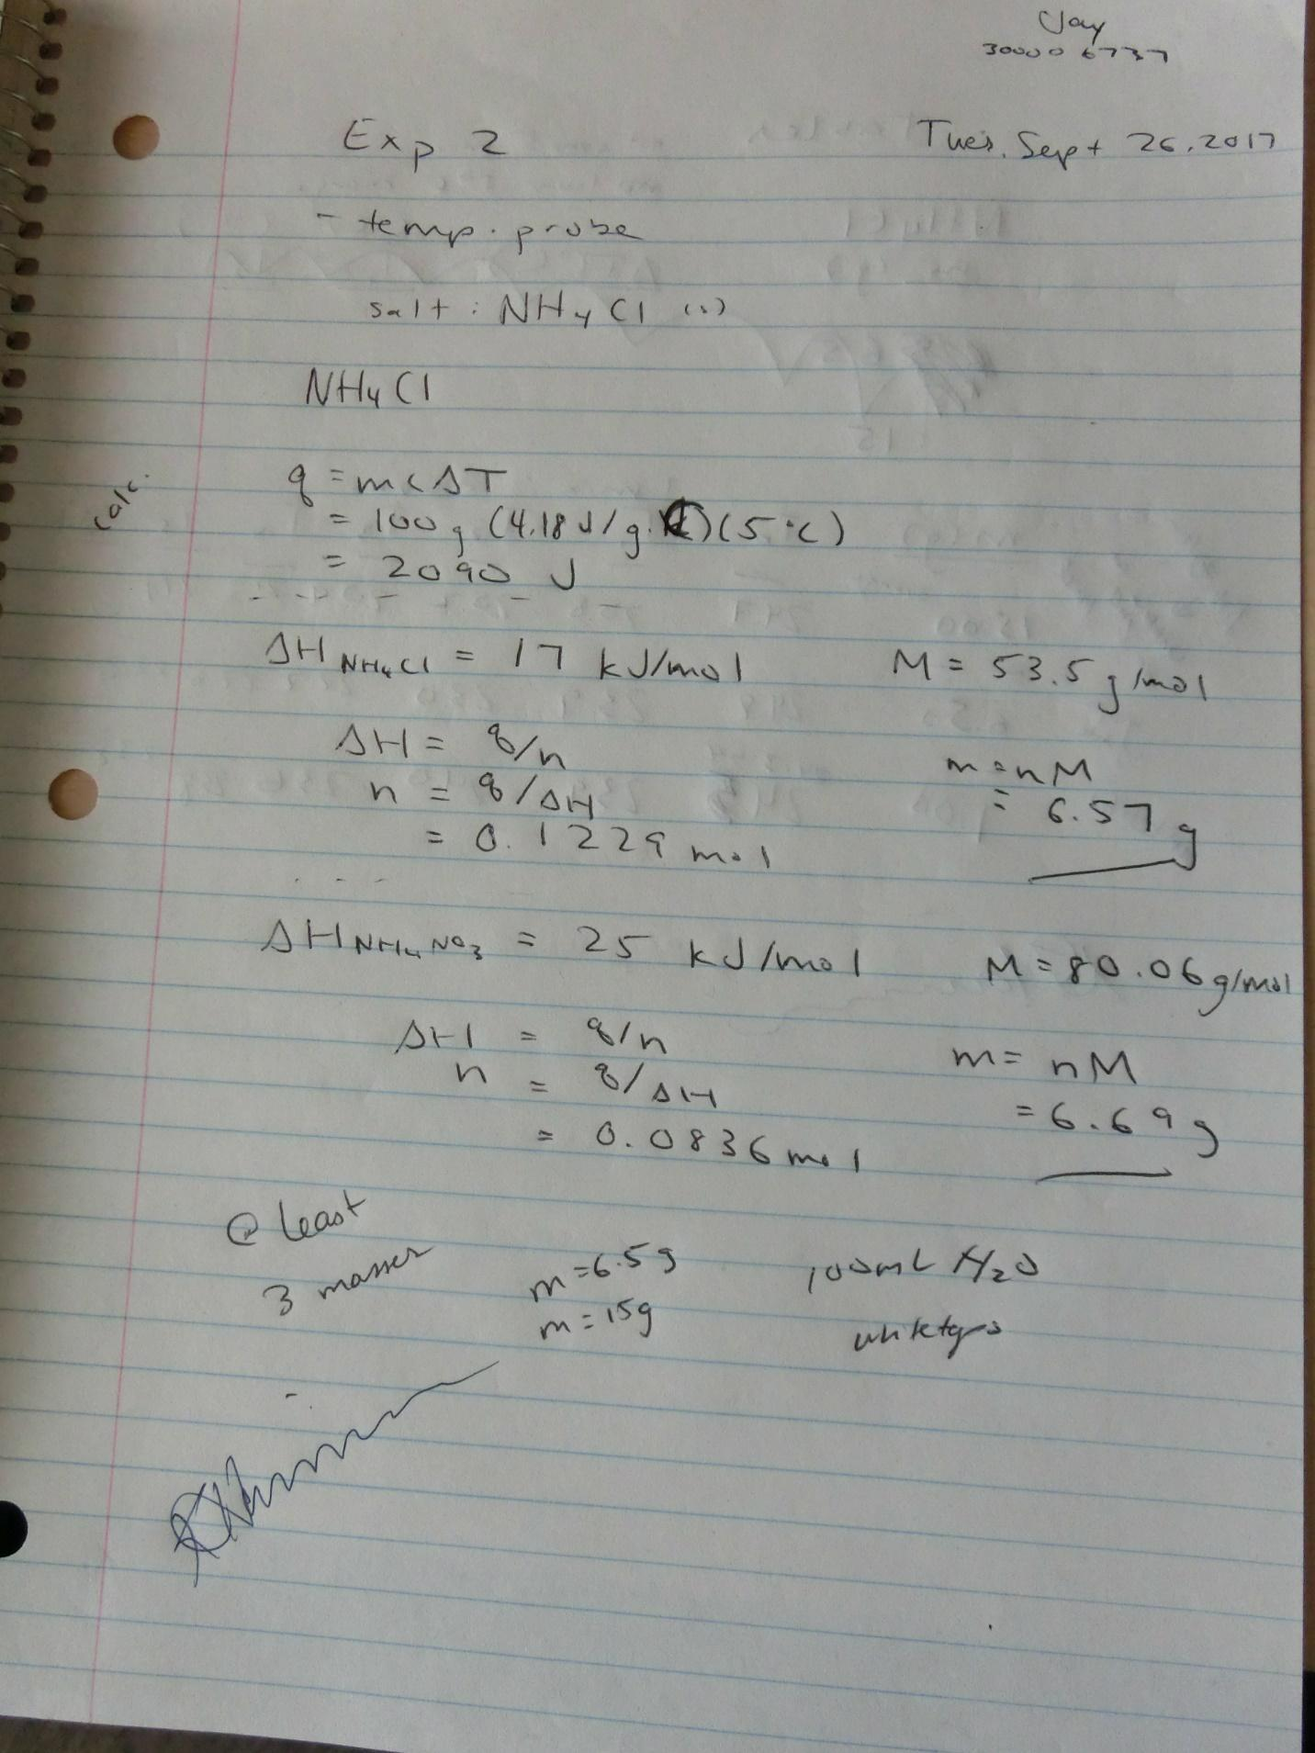
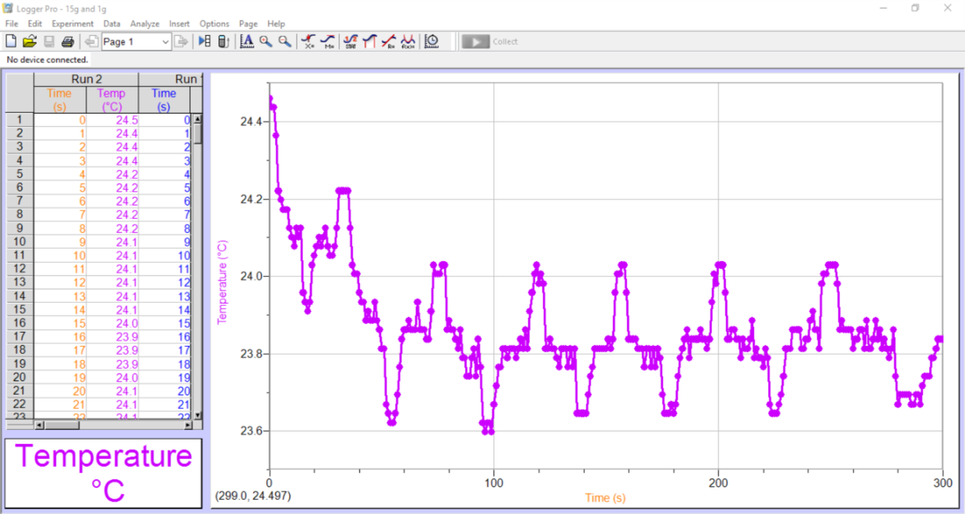
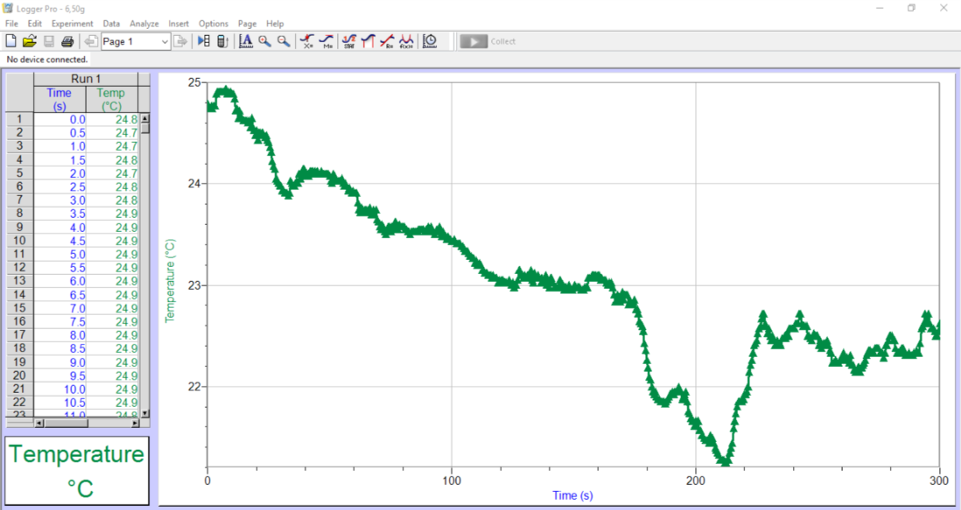
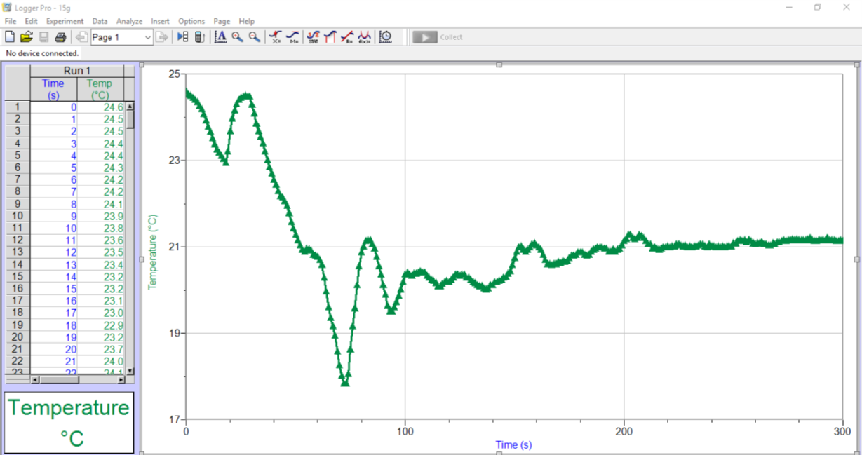
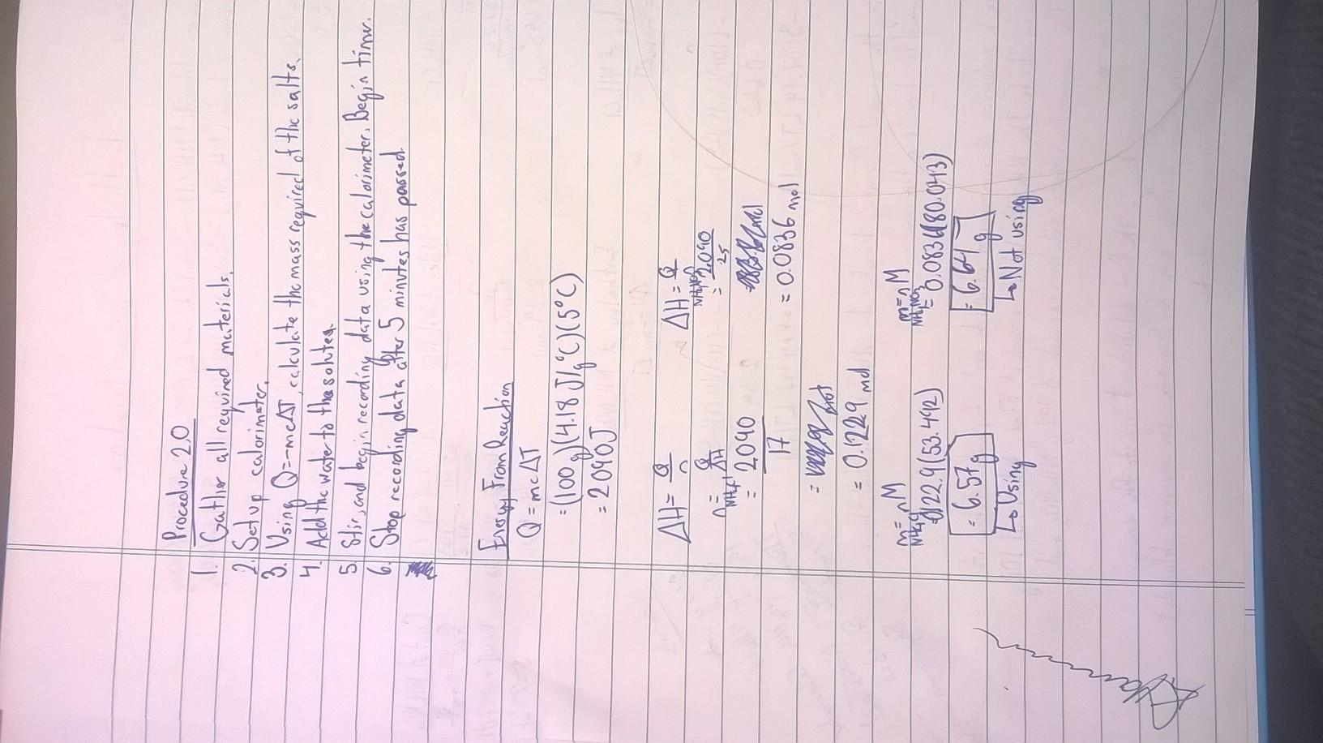

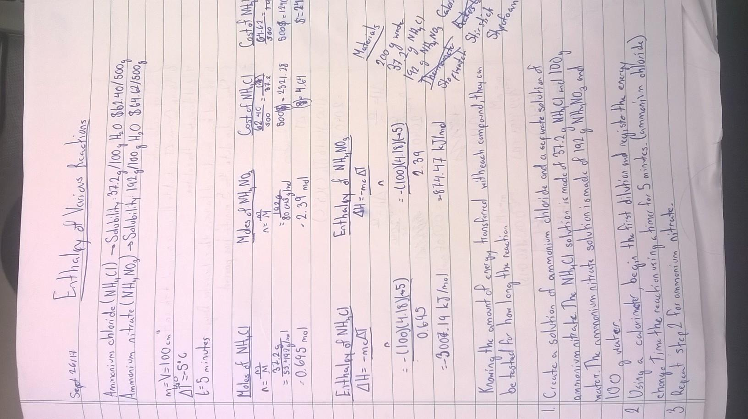

Assessment Criteria for Planning A Tall Cold Drink of Water
TA Name: Katie (substituted for Yixin Zhang) |  | Names of Students in Group: | a. James Blanchard 300001975  b. Sarah Rolston 300006718  c. Paulina Hanzelova 300015952  d. Jay Wang 300006737  e. Aaron Quetua  300015352
 |  | Date: October 3, 2017
Criteria: | Marks | Assessment
 | Possible | Self | TA
1. Identify the problem and state it clearly in a way that can be tested. | 1 | 1
2. Use proper apparatus, techniques and safety precautions. | 1 | 1
3. Materials are easily available. | 1 | 1
4. Plan to vary only one independent variable at a time. | 1 | 1
5. Controls on other variables are clearly stated. | 1 | 1
6. Measurement errors are minimized by appropriate procedures or apparatus. | 1 | 1
7. The methods are clear enough to be followed by other students. | 1 | 1
8. No invalid assumptions are made. | 1 | 1
9. Reagents that need accurate measurement are identified. | 1 | 1
10. Lab trials are stated. | 1 | 1
11. Repeats are stated. | 1 | 1
12. Chemistry vocabulary is used correctly. | 1 | 1
13. Limitations of the experimental design are described. | 1 | 1
TOTAL: | 13 | 13

COURSE: ___________________ TA Name: ______________________________
YOUR NAME (PRINT): ________ _________SIGNATURE: ___ ______

CONFIDENTIAL PEER EVALUATION FORM FOR EXPERIMENT ____
Each team member must submit one assessment. Teams may consist of 2-18 members.
Do not share or discuss the contents or possible contents of this assessment with others.

In assessing the work of your fellow team members, consider the following aspects:
- Quality of work • Ability to get along with others
- Contribution to the work as a whole • Improvements when asked to correct

Team member name | Comments | Grade
A – Excellent (5) B: Great (4) C: Good (3) D: Fair (2) F: Poor (1)
Note: Do not evaluate yourself on this form

