Verification of Boyle’s Law

Sarah Rolston 300006718 and James Blanchard 300001975

CHM1311

September 18, 2017

Introduction/Theory
Of all the states of matter, gases have the unique property of being able to have a varying pressure. If the pressure of a gas were to change, however, other factors would need to change as well. The most important variables to take into account when considering the pressure of a gas include that gasses temperature and volume (however these are not the only variables). As long as certain measurements of a gas are already known, it is possible to use mathematics to determine unknown variables of a gas, as long as enough other variables are already known. As a result of this, there are multiple laws to determine these unknown variables. One such law, which takes into account a gas’s specific pressure and volume is Boyle’s Law.
PV = k
This law is not perfect, as by examination other factors previously mentioned (temperature specifically) are not taken into account in Boyle’s Law. That is because Boyle’s Law assumes that the gas being measured is an ideal gas. For the purposes of Boyle’s Law, the ideal gas would remain at a constant temperature and have a constant number of gas molecules while only pressure and volume change and affect each other throughout the calculation process. If one were trying to find a value using Boyle’s Law and the temperature of the gas being used was changing or the number of molecules were changing, the law would no longer be applicable. As temperature is very easily changeable, there is a formula known as the ideal gas law which takes into account temperature as well as number of molecules, pressure and volume.
PV = nRT
The ideal gas law works under most circumstances with the exception of cases where a gas is at a very low temperature or a very high temperature. Although the ideal gas law can account for more variables that other laws, in controlled lab experiments, it is possible to maintain constant temperatures and number of molecules so simpler formulas with less variables, such as Boyle’s Law, can be used with considerable accuracy. With this simple formula, it is possible to calculate the constant (k) in Boyle’s law, by measuring both the changing pressure and volume of a gas trapped in a syringe, and to analyze the relation between these variables in a controlled setting.

Procedure
- Prepare the Gas Pressure sensor as described in the lab manual (Do I Dare Disturb the Universe, Dr. Rashmi Venkateswaran, 2017, Exp. 1, p. 4). Move the plunger to the 4 mL volume mark, aligning the top seal of the plunger with the mark on the syringe.
- Set up the LabQuest 2 data collection as described in the lab manual (Do I Dare Disturb the Universe, Dr. Rashmi Venkateswaran, 2017, Exp. 1, p. 4).
- Begin data collection as described in the lab manual (Do I Dare Disturb the Universe, Dr. Rashmi Venkateswaran, 2017, Exp. 1, p. 4). Recall that when entering the volume in the syringe to add 0.8 mL as there is 0.8 mL inside the sensor, as described in the lab manual (Do I Dare Disturb the Universe, Dr. Rashmi Venkateswaran, 2017, Exp. 1, p. 4-5). Increase the volume in the syringe by 1 mL for each volume. After the collection of each data point, release the syringe to return the pressure the original volume.
- As described in the lab manual (Do I Dare Disturb the Universe, Dr. Rashmi Venkateswaran, 2017, Exp. 1, p. 5), remove one of the data points from the original volume.
- Analyze the graph using the LabQuest 2 as described in the lab manual (Do I Dare Disturb the Universe, Dr. Rashmi Venkateswaran, 2017, Exp. 1, p. 5).

Data
Volume (mL) | Pressure (kPa)
4.8 | 101.04
5.8 | 84.34
6.8 | 70.59
7.8 | 60.37
8.8 | 53.11
9.8 | 47.43
10.8 | 42.59
11.8 | 39.11
Table 1: Volume and Pressure Measurements Collected

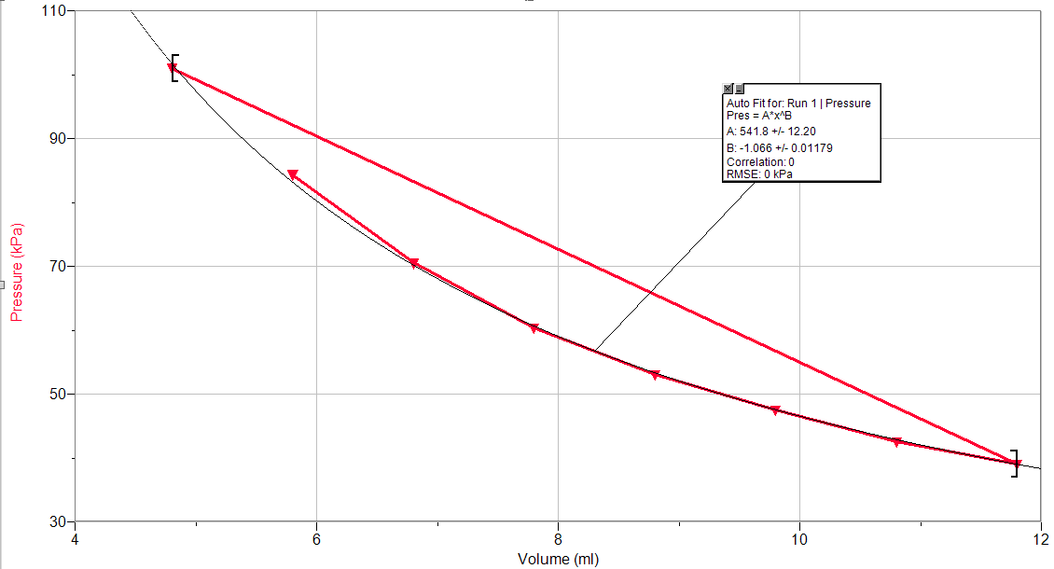
Graph 1: Correlation Between Increasing Volume and Pressure

Analysis
1.
Volume (mL) | Pressure (kPa) | Boyle’s Law Constant
4.8 | 101.04 | 484.992
5.8 | 84.34 | 489.172
6.8 | 70.59 | 480.012
7.8 | 60.37 | 470.886
8.8 | 53.11 | 467.368
9.8 | 47.43 | 464.814
10.8 | 42.59 | 459.972
11.8 | 39.11 | 461.498
Table 2: Constant Developed From Data Points

Average Constant: 472.339

2. As the pressure increases, the volume decreases. The inverse is also true, making the two measurements taken proportional to each other.

Let x be the volume of gas and let y be the pressure of the gas
k = xy
y = k/x
y = kx-1
y = 480x-1

3. Taking the original measurement twice would ensure that there was not large amounts of error present in the apparatus or the procedure. The second measurement confirms that the original measurement is without error. If the two measurements are exact or very similar to each other then the apparatus and the procedure do not have significant error.

4. Other variables that must be kept constant for Boyle’s Law are temperature and the number of moles in the sample. The number of moles was kept constant by not allowing the syringe to disengage from the sensor during and between trials and by ensuring that there weren’t leaks in the syringe. The temperature was kept constant by performing the experiment in one location and not exposing the apparatus to other apparatus that could change the temperature of the apparatus or the molecules in the apparatus. If the number of molecules was not kept constant the sample would have a different density based on the moles in the sample and the pressure would increase differently because of the density and the moles in the sample. The temperature had to be kept constant because molecules react differently at different temperatures, moving faster or slower depending on the temperature they are exposed to. If the molecules are moving at different speeds they will interact differently to the pressure exerted on them.

Calculations
PV = k
k =PV
k = xy
k = (4.8 mL)(101.04 kPa)
k = 484.992
k = 480

Discussion
In the process used for this experiment, air was trapped in a syringe and attached to an air pressure sensor. The syringe was gradually pulled out to different levels and the pressure inside the syringe was measured. After examination of the results of the experiment, the graph created using the data was not linear as previously expected based on Boyle’s Law. By rearranging Boyle’s Law it is possible to reach the formula P₁ V₁ = P₂ V₂, which means the ratios between the different volumes and pressures are constant so the product of the volume and pressure should always be the same. Based on the results obtained, this is untrue.
There are many ways error could have occurred in this experiment to skew results throughout the experiment. One of the more likely possibilities is that as a result of the syringe having to be held at a value for a certain amount of time to prevent the pressure of the room from pushing the syringe plunger back in, the plunger might have been moving slightly throughout the measure of the pressure. It is also possible that the body heat being produced by the syringe holder’s hands warmed the temperature of the captured air slightly as the experiment progressed, skewing the results and changing the result for Boyle’s Law constant between measurements. There are also other possibilities for error including some air escaping through the plunger of seal between the air pressure sensor and slightly incorrect measurements of volume due to human error or (less likely) something being incorrect with the technology measuring pressure and making the graph (if so as a result of improperly chosen settings). As a result of one or more of these reasons there was error in our measurements.
Conclusion
The average for Boyle’s Law constant calculated in this experiment was calculated as 472.339. The values obtained for Boyle’s constant ranged from a maximum of 489.172 and a minimum of 459.972. This provides a range of 29.2 between the most extreme of measurements, being significantly inaccurate if one would try to use the calculated Boyle’s Law constant in a mathematical formula.

Reference: Myers, Richard, “The Basics of Chemistry”, Chapter 9, Greenwood Press, Pages 99-103, 2003.


