ADM 1300 midterm 1

- Importance of quality relationships between employees and supervisors (managers).

The relationship between the manager and the employee is very important because if the manager and employee relations are bad then the employee will be less productive in the workplace than if they had a better relationship. The employee will look at other alternatives such as resigning.

2. Scientific Management/ Administrative Management/ Behavioural theories and history of management, scientific management vs. management science.

The principles of Scientific Management developed by Frederick Taylor in 1911 focused on making the workplace more efficient. It replaced the ‘’old rule of thumb’’ with ‘’one best way to do a job’’.

- Scientifically select, train, and employ the worker.
- Replace the ‘’old rule of thumb’’ with one best way to do a job.
- Heartily cooperate with the workers to ensure that all work is done in accordance with the principles of the science that had been developed.
- Divide work and responsibility almost equally between managers and employees. Management does all work for which is better suited than the workers.

Administrative Management is the study of good management practice, known as general administrative theory which was developed by Henri Fayol. He came up with the 14 principles of management that should be taught in schools and applied to the workplace. He also came up with the four functions of management: Planning, leading, organizing and controlling.

Planning: Defining goals, establishing strategy, and developing sub-plans to coordinate activities.

Organizing: Determining what needs to be done, how it will be done, and who is to do it.

Leading: Directing and motivating all involved parties and resolving conflicts.

Controlling: Monitoring activities to ensure that they are accomplished as planned.

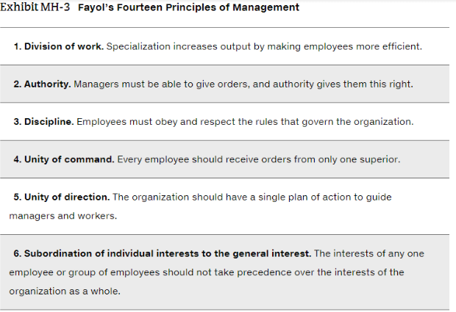
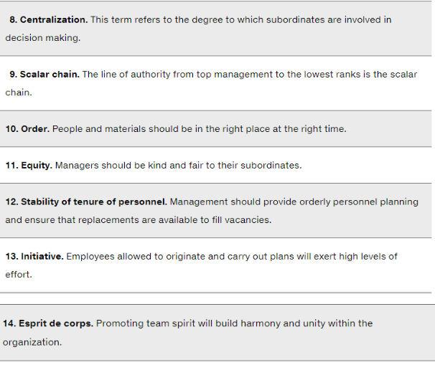
7. Rewards for employees.

Organizational Behaviour: The field of study that researches the action or behaviour of people. Much of what managers do today (motivating, leading, building trust, working with a team, managing conflict, and so forth has come out of OB research).

Four people stand out of Organizational Behaviour Research:

Robert Owen, Hugo Munsterburg, Mary Parker Follett, and Chester Barnard.

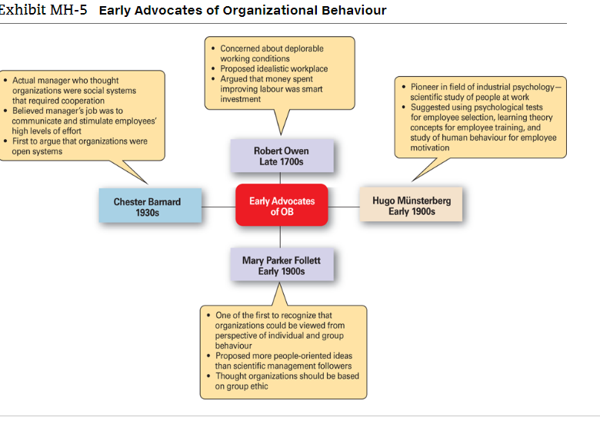
Hawthorne Studies were a set of Studies conducted at the Western Electric Company to increase productivity and efficiency. In 1924, they first used lighting to do it but it failed to actually work. Scientists thought that increased lighting would increase worker productivity but actually decreased it. In 1927, they returned with Harvard Professor Elton Mayo, and introduced ethical things such as breaks, workday length and workweeth which ultimately stimulated productivity. This lasted until 1932.

History of Management:

In The Ancient Days, Egypt and China were global dominant. Pyramids and The Great Wall of China can be seen by astronauts from the sky and employed over 100, 000 slaves or eunuch’s. It took over 20 years to construct a single pyramid. Eunuch’s and Slaves were basically property by poor families sold off the wealthier individuals or even the monarch to do hard work with a bad living condition. They were not treated as human.

City of Venice manufactured warships in the early 1400’s and became very rich from this. They engaged in many common business practices used in the twenty-first century. They had inventory systems, human resources management, and an accounting system to keep track of revenue systems and cost. They also had Europe’s first pension plan for providing alcohol to their employees.

In 1776, Adam Smith published The Wealth of Nations which concluded that productivity would increase by specialization of labour (break down labour into small and repetitive tasks). This was adopted by Henry Ford in the 1920’s which made his cars competitive.

Starting in the late eighteenth century, machine power slowly started to be substituted for human power. It became more economical to manufacture goods in factories than in households. These large and efficient factories needed a formal way of management.

*The difference between scientific management and management science is that scientific management is focused on making the workplace more efficient while management science is the study of problem solving and decision making in human organizations.*

4. The levels of management in an organization and the difference between the work and the decisions conducted at these levels.

First are Front-line managers who are typically involved in producing the organization’s products or servicing the organization’s customers. Examples include supervisors, department managers, and office managers. This includes operational management from day to day situations.

Middle managers manage the work of front-line managers. Titles include district manager, store manager, project leader, regional manager, and division manager.

Upper levels are top managers, who make organizational wide decisions. Includes CEO and Founder. This involves strategic decision making and decisions that affects the whole organization.

5. The perspectives (or attitudes) of doing global business: parochialism, ethnocentrism, polycentrism, and geocentrism.

Parochialism: Viewing the world solely from your own perspective. Monoguilism is when a nation suffers from parochialism since it is unfamiliar with other cultures around the world.

Ethnocentric: Believes that the best work approaches are done from the home country (the country in which the current headquarters are located).

Polycentric: The view that managers in the host country are better at doing the job.

Geocentric: A world orientated view which means that you choose the best candidates from the globe regardless of racial background.

6. Regional trading alliances: EU, NAFTA, and ASEAN.

European Union: The European Union (EU) is an economic partnership of 28 democratic nations. Originally formed in 1992, the primary reason was to reassert dominance against The United States and Japan. Previously, each European nation had border controls, taxes, and subsidies; nationalistic policies, and protected industries. These barriers to travel, employment, investment, and trade prevented European companies from developing economic efficiencies.

Currently, England left The European Union with Brexit in 2017. Spain, Greece, and Italy are in massive financial issues which warns foreign investors. They are in huge debt. Despite that, it has 31% of the global output with a population of around 500 million (7% of the world’s population). The economy is not doing very well which is why it is not a good place for investors.

North American Free Trade Agreement: In August of 1992, Canada, Mexico, and The United States settled on agreements to remove trade barriers. It is the world’s second largest trading bloc. It represents 28% of the world’s GDP and 7% of the world’s population.

It went into effect in 1994 and results got better in 2007 since more and more Canadian industries were in Mexico and vice versa.

Association of Southeast Asian Nations: A trade alliance of 10 Southeast Asian Nations. The population is 592 million people and $1.5 trillion global output, which makes it the world’s third largest trading bloc.

China, Japan, South Korea, India, Australia, and New Zealand have participated in talks. In 2010, China launched a Free Trade Agreement with them and it started in the 2008-2009 Financial Crisis as a motive.

7. Global trade mechanisms or systems: WTO, IMF, The World Bank Group, and OECD.

World Trade Organization: Was formed in 1995 from the GATT (General Agreements on Tariffs and Trade), an agreement from the Second World War until 1994. The goal is to help importing and exporting between countries without undesired side effects.

International Monetary Fund: An organization of 188 countries that promotes international monetary cooperation and provides member countries with policy advice, temporary loans, and technical assistance to establish and maintain financial stabilities and economies.

The World Bank: It finances money to the world for capital projects. It is a group of five closely related institutions, all owned by its member countries, that provides vital financial and technical assistance to developing countries around the world.

The International Monetary Fund and The World Bank are different; The IMF exists to primarily stabilize exchange rates while The World Bank aims to reduce poverty.

Organization for Economic Cooperation and Development: The OECD was formed in 1947 to administer Canadian and American aid under The Marshall Plan for the reconstruction of Europe During World War Two.

Today, it is a Paris based international economic organization whose mission is to help it’s 34 member countries stimulate economic progress and trade.

Their current focus is against small scale bribery in overseas commerce.

8. Techniques used to do International Business: Global sourcing, importing/exporting, licensing, franchising, strategic alliances, joint ventures, and foreign subsidiaries.

Managers who want to get into the global market with minimal investment may start with global sourcing (also called global outsourcing), which is purchasing material from around the world where it is cheapest. The goal is to take advantage of whatever costs is cheaper.

This is the first step to go international, and each successive step requires a higher investment.

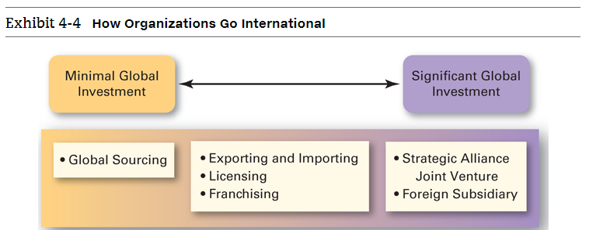
Importing/exporting:

An organization can go international by exporting its products to other countries—that is, by making products at home and selling them overseas. In addition, an organization can go international by importing products—that is, by selling products at home that are made abroad. Both exporting and importing are small steps toward being a global business and usually involve minimal investment and minimal risk.
Licensing and Franchising:
Licensing is the right to sell another company’s products, while franchising is the right to use their name brand and operating methods. For example, fast food companies use franchising and licensing. Take a look at McDonalds. Franchisees have to pay licensing fees to sell their products, while they franchise to use their name brand and manufacturing practices for their fast food products.
Strategic Alliance:
When an organization has been doing business internationally for a while and has gained experience in international trade markets, managers may decide to take a more direct investment. One way is through strategic alliance, which is a partnership between a domestic organization and a foreign company in which both share resources and knowledge in developing new products or building new production facilities. A specific type of strategic alliance in which partners form a separate, independent organization, called a joint venture. A good example is that Bell contracted Cintel customer service company in 2006 in the Philippines.
Foreign subsidiary: Managers may choose to invest in a foreign country by setting up a foreign subsidiary, a separate or independent production facility or office. This can be managed as a multidomestic corporation (local control), a global organization (centralized control), or transnational/borderless organization.

9. What is entrepreneurship, ideas vs. opportunities, profit organizations vs. social enterprises, feasibility study, applied research, creative destruction, fear of failure vs. learning and discovery culture, entrepreneurial venture vs. small business.

Entrepreneurship: The process of starting new organizations, generally in response to opportunities. These new organizations may be for traditional for-profit purposes, but more and more often they are being started in response to needs within the community is known as social entrepreneurship/venturing.

Applied research accesses, rather than generates, new knowledge and techniques for commercial purposes.

Creative destruction: The process of characterizing technological changes that leads to growth and increased employment. Innovation is the process of cleaning, revolutionizing, and changing how things are currently done.

Entrepreneurial Venture: Organizations that pursue opportunities, that are characterized by innovative practices, and that have growth and profitability as their main goals.

Small business: A business that is independently owned, operated, and financed; has fewer than 100 employees and does not necessarily engage in new and innovative practices. A good example is family owned fast food franchise location that only engages in innovative practices established by the company.

A fear of failure culture has made managers stagnant of trying new things which leaves the status of their organizations stagnant. In business individuals must be willing to take risks. High reward high risk culture lies in The United States.

A learning and discovery culture embraces failure and failing often early leads to more success in the future. Learning and discovery is searching for a viable business model. It also allows a company to grow more since they are willing to try new things.

Feasibility study: An analysis of the various aspects of a proposed entrepreneurial venture, designed to determine its feasibility. Feasibility is the study of how easily things are done.

How it works:

Researching competitors:

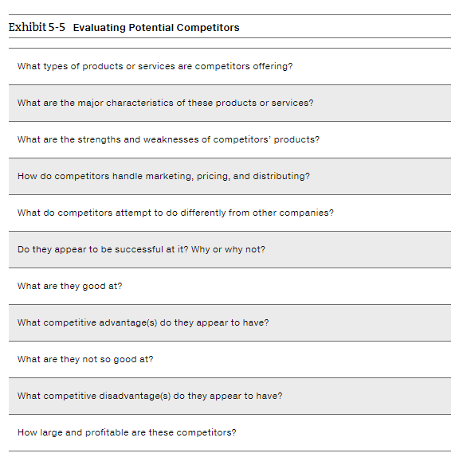

10. Who makes decisions in an organization? Decision making and managerial levels, the decision-making biases of
hindsight, confirmation, overconfidence, self-serving, selective perception, representation).

Decision-making and managerial levels:
- Top managers
  - Make organization-wide decisions
  - Establish goals and plans that affect the entire organization
- Middle managers
  - Manage the work of 1st line managers
- 1st Line managers
  - Manager the work of non-managerial employees
- Non-managerial employees do not manage
- Not all organizations use this hierarchy, but all organizations have a co-ordinator

Decision-making biases
- Hindsight, tendency for decision makers to falsely believe that they would have accurately predicted the outcome is actually known.
- Confirmation reaffirms their past choice and discount information that contradicts past judgment.
- Overconfidence
  - When decision-makers tend to think they know more than they do or hold unrealistically positive views of themselves and their performance
- Self-serving, who are quick to take credit for their success and to blame failure on the outside factors.
- Selective perception
  - When decision-makers selectively organize and interpret events
- Representation when the decision makers success the likelihood of an event based on how closely it resembles other events or sets of events

Value proposition: An analysis of the benefits, costs, and value to the target customer and other groups within and outside the organization. Basically evaluating if a customer’s product is attractive to the consumer eyes.

Research Financing:

As the venture starts out they can get financing from their friends and family but as time goes by they will need other areas of financing such as banks professional venture capital firms and angel investors. A venture capitalist is a person who finances the start-up or expansions. An angel investor is a wealthy individual who finances the startup and asks for debt payments or share of the company in return.

Developing a Business Plan:

Once a feasibility study has been completed, then you have to develop a business plan: a written document that summarizes a business opportunity and defines and articulates how the identified opportunity is to be seized or exploited.

It is a tiring task but could be valuable. It helps narrow the entrepreneur’s vision into a single coherent document. It serves a blueprint and an operating roadmap of our business. It basically makes you think a purpose of your business. For example, the purpose of McDonald’s was to provide food fast for people in comparison to traditional sit down restaurants.

It can guide organizational decisions as a ‘’living plan’’ not from start-up stage, but at any stage.

10. Who makes decisions in an organization, decision making and managerial levels, the decision making biases of hindsight, confirmation, overconfidence, self-serving, selective perception, and representation.

Making decision is the act of choosing between alternatives. For instance, top level managers make decisions about their organizational goals, where to locate manufacturing facilities, or what new markets to move into. Middle and lower level managers make decisions about production schedules, product quality problems, pay raises, and employee discipline.

Decision making process: A set of eight steps that includes identifying a problem, selecting an alternative, and evaluating a decision’s effectiveness.

It involves identifying a problem and decision criteria, allocating weights to those criteria, moves to developing, analyzing, and selecting an alternative that can resolve the problem; then moves to implementing an alternative, and concludes to evaluating the decision’s effectiveness.

Step one: Identify the problem

Problem: A discrepancy between an existing and desired state of affairs.

Step two: Having a decision criteria

Decision Criteria: Criteria for what is relevant for making a decision.

Every decision has criteria as their guidance even if they are not explicitly stated.

Step three: Allocating weights to criteria

They must weigh the items since each criteria is not equally important.

Step four: Evaluate the alternatives.

List viable alternatives that could solve the problem.

Step five: Analyzing alternatives

A decision maker evaluates each criteria by using the criteria established in step 2. You add the weighing on each alternative. When you multiply each alternative by the weighing, you get a total score for the alternative. For example:

-40
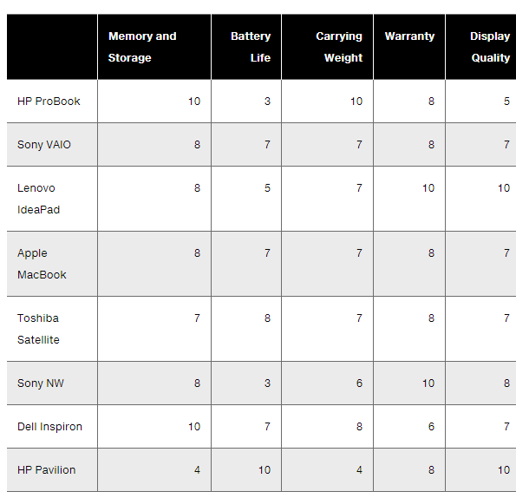

Step 6: Developing an alternative

This is the only step when you choose the best fitted alternative. Sometimes, they fail because the weights for the criteria was misassigned so they have to go back. Maybe it could be the same thing for the alternative.

Step 7: Implement the Alternative

This is concerned with putting the decision into action. This requires participation by those who are affected by it and willing to change the alternative. You also have to persuade them which influences nonmanagerial employees to do it.
Step 8: Evaluate Decision Effectiveness

This involves evaluating the outcome and if it really solved the problem.

Many employees have different decision making styles. When managers do this, they use their old ‘’rule of thumb’’ or heuristics to simplify their decision making. Even if they do it, it may not always be reliable. This is because biases lead to errors in processing and evaluating information.

Decision making biases: When decision makers think they know more than they really do or they do or hold unrealistically positive views of themselves and their performance, they are using the overconfident bias. They are only subject to their point of view for making a decision. In simpler terms, only doing things from their own point of view because it seems cooler or easier.

tendency for decision makers to falsely believe that they
Hindsight is the understanding of the situation only after it has happened or developed, not before it has developed.

Selective perception is the process by which individuals perceive what they want to in media messages while ignoring opposing viewpoints.

11. Big Data, Heuristics, Risk, Uncertainty, Decision making under uncertainty: maximax, maximin, Strengths, Weaknesses, Opportunities, and Threats (SWOT) Analysis.

Big Data: The vast amount of quantifiable information that can be analyzed by highly sophisticated data processing technology.

Big data is using math modelling, predictive algorithms, and artificial intelligence software to measure people and machines like never before. Data always needs to be analyzed by good judgement since theories can make mistakes too.

Heuristics: Rules of thumb that managers use to simplify decision making. Allowing your employees to learn on their own (learning from their mistakes). Trial and error procedure for solving problems.

Decision making under uncertainty and risk: The way of thinking is important since most of us are more rational and logical in the way we have for decision making.

Uncertainty and risk is when you are not totally sure about the outcomes and there are a limited amount of ways managers make decision making under uncertainty. The optimistic manager will follow a maximax choice (maximizing the total amount of playoff in highest return) while a pessimist will do maximin (maximizing the minimum possible playoff) to have the best in case the worst happens.

12. What is planning, relationship between planning and organizational performance, benefits of employee participation in planning, classic planning vs. management objectives.

Planning involves defining goals, establishing an overall strategy to achieve those goals, and developing a comprehensive set of plans to integrate and coordinate work needed to achieve the goals. It is concerned with ends (what’s to be done) and means (how it’s to be done).

Relationship between planning and organizational performance:
First, generally speaking, formal planning is associated with generally positive results: higher profits, higher return on assets, and so forth. Second, it seems that doing a good job planning and implementing those plans plays a bigger part in high performance than how much planning is done. Next, in those studies where higher planning did not lead to organizational performance, the external environment often was culprit. When external forces, think government regulations or powerful labour unions, constrain managers options, it reduces the impact it reduces the impact planning has on an organizational performance. Finally, the planning-performance relationship seems to be influenced by the planning time frame. It seems that at least four years of formal planning is required before it begins to affect performance.

If you are not planning, your are planning to fail. By planning, you can set measurable objectives and have certain steps to take to reach your goal. Furthermore, it reduces uncertainty and when things go wrong it is easier to deal with.

Management By Objectives (MBO) is a process of setting up mutually agreed upon goals and using these goals to evaluate employee performance.

Four elements: Goal specificity, participative decision making, an explicit time period, and performance feedback.

Employees contribute, feel more like family, and work more productively.

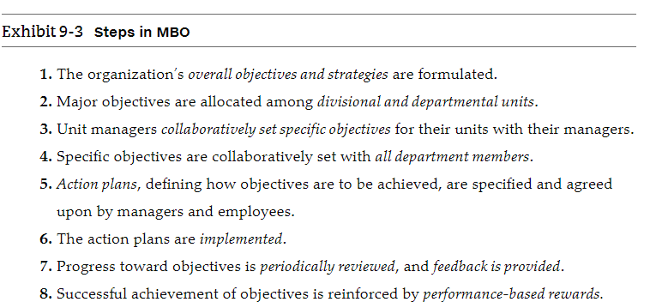

Classic Planning, Known as Traditional Management often encourages a management with a strict and formal strategy of hierarchy. This is the assumption that ‘’top managers’’ know everything such as the founder.

Always decentralizing the management do people below down you can cause a lot of frustration since it does not always work.

Another problem is that everyone has their own interpretation. If the Founder passes their goal to CEO (make higher profits), the CEO passes it down to marketing department, etc. Since every manager has their own perspective from their biases of hindsight then this can lead to a lot of confusion since you are decentralizing the decision.

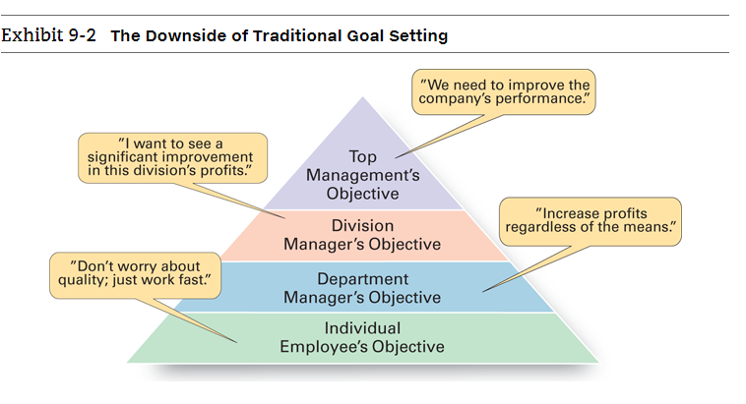
13. Types of corporate strategies: growth, stability, and renewal.

Corporate strategy: A strategy that evaluates what business an organization is in, should be in, or wants to be in, and what it wants to do with those businesses.

Growth strategy: Is when an organization expands its products or services offered, either through current businesses or new businesses.

Growth through concentration is achieved when an organization concentrates on its primary line of business and increases the number of products offered or markets served in his primary business. This is how Tim Horton’s opens more locations in emerging markets such as China.

Another strategy is vertical integration, either backward, forward, or both. In backward vertical integration, an organization becomes its own supplier and controls its own inputs. For example, eBay owns an online payment system because it is more secure for transactions. In forward integration, it can control its own outputs. For example, Apple has over 80 locations for its retail products.

In horizontal integration, the company grows by combining with other organizations in the same industry, that is, combining operations with its competitors. For example, Hewlett Packard acquired Compaq in 2002 after their defunk. In 2007, the Compaq brand name was officially abolished.

Stability strategy: Characterized by an absence of significant change in what the organization is currently doing. The organization does not grow, nor does it fall behind. A good example is Beavertails.

Renewal strategy: When an organization is in trouble, renewal strategies are established. Renewal strategies address declining performance. Two types: Retrenchments and turnaround.

14. Effectiveness, efficiency, Hawthorne Studies, contingency management, value proposition, bounded rationality, a start-up, managerial skills, corporate portfolio matrix - BCG matrix, cash cows, stars, question marks, and dogs.

Efficiency refers to getting the most output from the least amount of i
nputs, or as management expert Peter Drucker explained, ‘’doing things right’’.

Effectiveness in this case means completing the organizational goals. In simpler terms, ‘’doing the right things’’.

Hawthorne Studies were a series of studies conducted by the Western Electric Company in Cicero, Illinois. These studies, which started in 1924, were initially designed by Western Electric industrial engineers as a scientific management experiment. They wanted to examine lighting levels of productivity. Control groups were set up as part of any basic scientific experiment. They realized it decreased productivity when it increased lighting and scientists did not know the case.

When light got darker, productivity increased. The were not sure so they went back in 1927. In 1927, they asked Harvard Professor Elton Mayo and his associates to join the study as consultants. They began a study that lasted until 1932 and introduced things like breaks, workday and work length, group productivity which changed everything. Group productivity had no effect on output but breaks did and ultimately stimulated productivity.

Contingency approach is when organizations face different situations (contingencies) and requires different ways of managing.

Value proposition: An analysis of the benefits, costs, and value to the target customer and other groups within that organization. In other words, an innovation or feature intended to make it more appealing to consumers.

Bounded rationality: Managers make decisions rationally but are limited. That is, they accept solutions that are ‘’good enough’’.

Start-up: A temporary organization that is designed to search for repeatable (the ability to do the same thing more than once and achieve the same result) and scalable (the ability to generate revenue faster than the rate of your incurring costs).

Three skills: technical, human, and conceptual skills.

Technical Skills: Include knowledge and expertise of a specialized field, such as engineering, finance, and accounting. These skills are more important at lower levels of management since they deal with employees directly doing the organization’s work.

Human Skills: Involves the ability to work with other people, both individually and in a group. Because managers deal directly with people, this skill is crucial for all managers at all levels! Managers with good human skills are able to get the best out of their people.

Conceptual Skills: The mental ability to analyze and generate ideas about abstract and complex situations.

The Boston Consulting Group identified the BCG matrix, which is a 2 by 2 matrix that introduced how the organization’s business ideas could be identified. The horizontal axis represents market share: either low or high, and the vertical axis is market growth: which could be either low or high.

CASH COWS (low growth and high market share): Businesses in this category generates large amounts of cash, but their prospects for the future growth is limited.

STARS (high growth, high market share): These businesses are in a fast growing market and hold a dominant share of the market. Their contribution to cash flow depends on their needs for resources.

QUESTION MARKS (high growth and low market share): These businesses are in an attractive market but hold a small share of that market. Therefore, they have the promise of performance but need to be developed for that to happen.

DOGS (low growth, low market share): Businesses in this category do not produce, or consume, much cash. However, they hold no promise for improved performance.

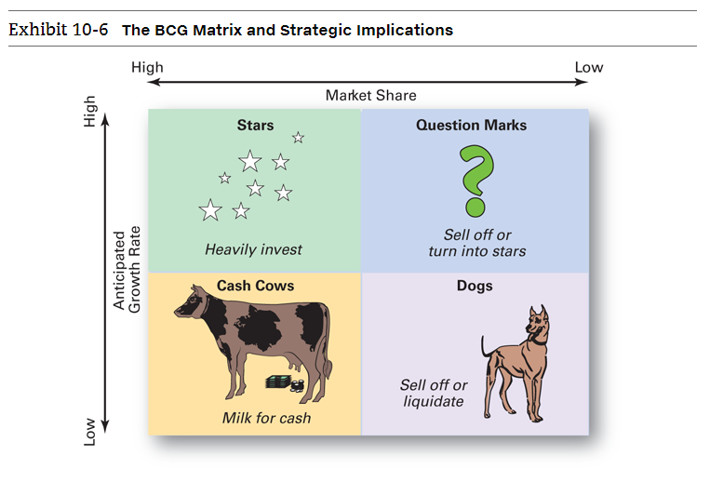

What are the strategic implications of the BCG matrix? Managers should “milk” cash cows for as much as they can, limit any new investment in them, and use the large amounts of cash generated to invest in stars and question marks with strong potential to improve market share. Heavy investment in stars will help take advantage of the market’s growth and help maintain high market share. The stars, of course, will eventually develop into cash cows as their markets mature and sales growth slows. The hardest decision for managers is related to the question marks. After careful analysis, some will be sold off and others turned into stars. The dogs should be sold off or liquidated as they have low market share in markets with low growth potential.
A corporate portfolio matrix, such as the BCG matrix, can be a useful strategic management tool. It provides a framework for understanding diverse businesses and helps managers establish priorities for making resource allocation decisions.

