This lab worksheet can be submitted either on an individual basis or in pairs. If only one name is mentioned, it will be presumed that the document was submitted on an individual basis.

The assessment criteria are provided for each required task. It is recommended to carefully read the provided assessment criteria.

Once completed, the present worksheet is to be submitted in the appropriate submission box of your Virtual Campus as a PDF format (if you use Word, select File Save As, Save As Type then PDF).

Due to technical constrains with the Virtual Campus, each of the two partners MUST individually submit a copy of the same worksheet, though the TA’s will be correcting only one of the two submitted copies. The same grade will be assigned to each of the two partners and only one of the two partners will be given access to the filled out assessment rubric. If you cannot access to the assessment rubric on your Virtual Campus, it is your responsibility to contact your partner to consult the completed assessment rubric. Once the worksheets and reports have been evaluated by the TA’s, the assessment rubrics with comments will be available via the section Class Progress of your Virtual Campus.

PART 1 - Phylum Chytridiomycota
Observation of prepared slides.

Observe each of the two prepared slides of Allomyces arbusculus and, for each one, take a first microscope photo at low magnification (100X) and another at higher magnification (400X). Annotate the distinctive characteristics of the sporophyte and gametophyte on the corresponding microscope photo taken at 400X. Clearly annotate the sporangia and the gametangia producing male gametes (antheridia) and female gametes (oogonia). Prepare a composite figure combining your four microscope photos with the requested annotations for the two photos at 400X. Include one single caption. Do the gametophytes and sporophytes display similar (isomorphic alternation of generations) or dissimilar (heteromorphic alternation of generations) characteristics?

Insert your composite figure and insert your answer.
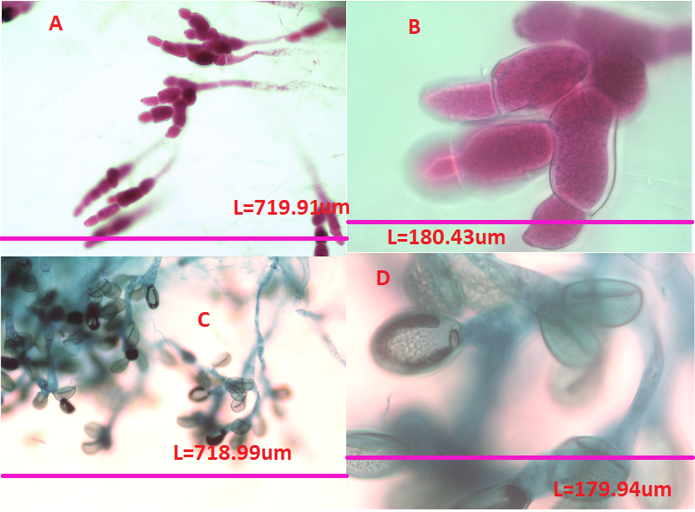
Fig. 1:slides of Allomyces arbusculus showing the gametophytes seen at 100X (A)and at 400X (B) and the sporophytes seen at 100X (C)and at 400X (D)
The gametophytes and sporophytes display dissimilar (heteromorphic alternation of generations) characteristics, clearly seen on these slides their morphology is obviously different.

If you were able to see female and male gametes of Allomyces arbusculus, could you distinguish amongst the two? Do both gametes have a flagellum? Are both gametes similar in size?

Insert your answers.
I would be able to distinguish between the two both have flagellum but they differ greatly in size, to the point where there is a visible difference.

Assessment criteria
Task | All items included and well done (3/3) | One missing or unsatisfying item (2/3) | Two missing or unsatisfying item (1/3) | Doesn`t meet expectations (0/3)
One composite figure with four requested microscope photos of Allomyces arbusculus. Proper annotations of gametophyte, sporophyte, antheridia and oogonia on the photos at 400X. Reference bars and one caption are included.
Quality of the individual photos (adequate light intensity, contrast and focus).
Do the gametophytes and sporophytes display similar or dissimilar characteristics?
Could you distinguish female from male gametes? Do both gametes have a flagellum? Are both gametes similar in size?

PART 2 - Phylum Zygomycota
Observation of prepared slides of Rhizopus sp.

Take two microscope photos, one at 40X and one at 400X, with the one at higher magnification displaying a zygosporangium. On your miscrope photo at 400X, annotate any structures associated with sexual reproduction and any structures that are diploid. Prepare onse single composite figure combining your two microscope photos.

Insert your composite figure with the requested annotations along with a caption.
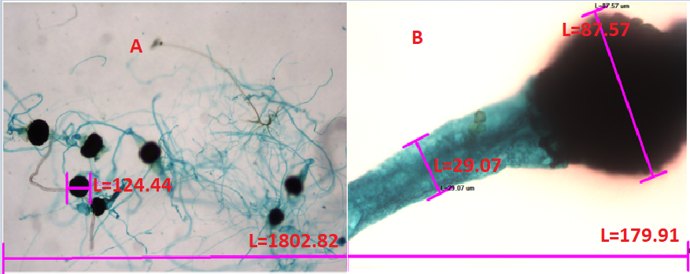
Fig 2. : slides of Rhizopus sp. seen at 40X (A)and at 400X (B), (all measurements are in um)
Assessment criteria
Task | All items included and well done (3/3) | One missing or unsatisfying item (2/3) | Two missing or unsatisfying item (1/3) | Doesn`t meet expectations (0/3)
One composite figure with the two requested microscope photos. Proper annotations of characteristics associated with sexual reproduction and diploid structures on the photo at 400X. Reference bars and one caption are included.
Quality of the individual photos (adequate light intensity, contrast and focus).

PART 3 - Phylum Glomeromycota
Observation of prepared slides and fresh endomycorrhizae.

Observe the prepared slide of an endomycorrhizal association and take one microscope photo at 100X and another one at 400X. Annotate the structures that are unique to endomycorrhizae on your photo at 400X. Prepare a composite figure combining your two photos and the requested annotations.

Insert your composite figure with a caption.
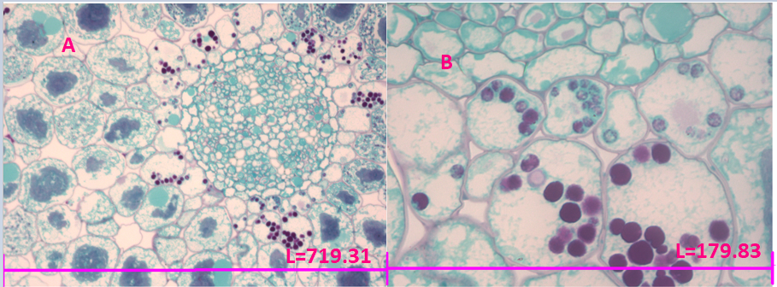
Fig. 3:slides of endomycorrhizae seen at 100X (A)and at 400X (B), (all measurements are in um)

Assessment criteria
Task | All items included and well done (3/3) | One missing or unsatisfying item (2/3) | Two missing or unsatisfying item (1/3) | Doesn`t meet expectations (0/3)
One composite figure with the two requested microscope photos. Proper annotations of characteristics associated with endomycorrhizae on the photo at 400X. Reference bars and one caption are included.
Quality of the individual photos (adequate light intensity, contrast and focus).

PART 4 - Phylum Ascomycota
Observation of prepared slides.

Observe and take two microscope photos at 100X and 400X of the prepared slide of Peziza sp., which is a representative cup fungus. On the photo at higher magnification, annotate the structures that are distinctive of the Phylum Ascomycota. Prepare a composite figure.

Insert your composite figure and your caption.
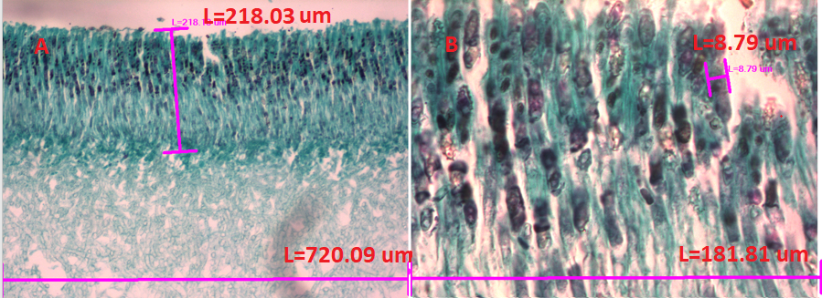
Fig. 4: slides of Peziza sp. seen at 100X (A)and at 400X (B)
Observation of live specimens.
Prepare a microscope slide of the liquid culture of the baking yeast, Saccharomyces cerevisiae. Add Vaseline on each of the four edges of your coverslip before covering your sample. Observe carefully the budding process, which is an asexual mode of reproduction involving the formation of a new cell from an outgrowth or bud on another cell. Take three photos at 400X displaying three intermediate steps of the division by budding in S. cerevisiae. When you take your photos, adjust the focus on the nuclei. Prepare a composite figure of your three combined photos. In your legend, indicate when the DNA is transferred from the mother cell into the daughter cell.

Insert your composite figure along with a caption and briefly explain the main steps of the reproduction mode by budding in S. cerevisiae.
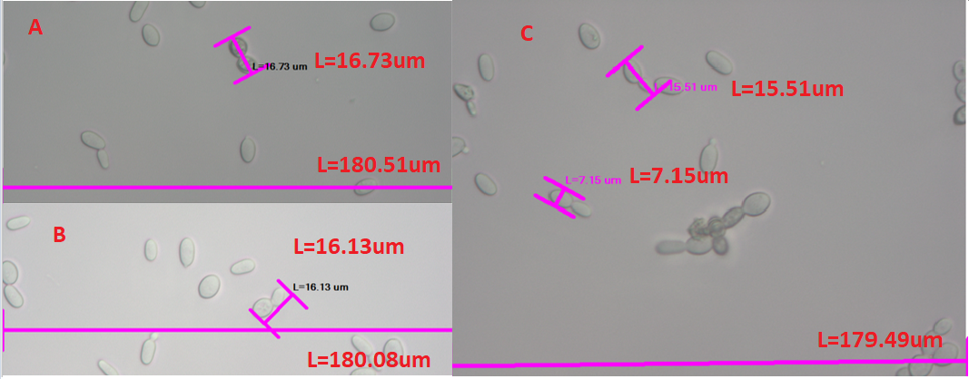
Fig. 5: slides of Saccharomyces cerevisiae seen at 400X
The budding process is a follows: In the parent cell the nucleus divides, then the cytoplasm divides, then finally the cells divide. The bud is the new cell in formation attaches to the parent cell, this process happens more or less fast depending on how well the bud is nourished.

The cell-division cycle in S. cerevisiae takes about 90 minutes under optimal growth conditions. Estimate the expected number of S. cerevisiae cells if one single cell was maintained under culture for 24 hours.

Insert and justify your answer with explicit calculation details.
24 x 60= 1440 minutes
1440/90= 16 (cell divisions)
1 x 2= 2 (1st cell division)
2^(15 rest of cell divisions) =32768 total amount of cells after 24 hours

Sordaria fimicola is a model species that is commonly used in genetics research – if you take the genetics lab, BIO2133, you will indeed be required to complete an experiment with S. fimicola to assess the frequency of gene recombination. This ascomycete fungus sequesters several asci, which are elongated pouches each containing eight ascospores, within larger bags or perithecia that look like dark pepper grains. Use a toothpick to gently transfer not more than four or five ‘grains’ onto a drop of water previously added on a microscope slide, then put a coverslip and observe your preparation under the compound microscope. Take two microscope photos, one at 100X showing a burst perithecium and a close-up at 400X showing asci and ascospores. On your two photos annotate the structures that are unique to the Phylum Ascomycota, then prepare a composite figure.

Insert your composite figure along with a caption.
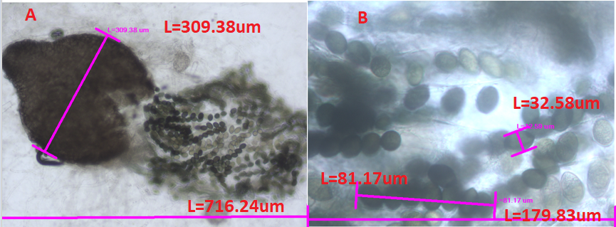
Fig. 6: slides of S. fimicola seen at 100X (A)and at 400X (B) both the asci and ascospores are visible in photo (B)
Assessment criteria
Task | All items included and well done (3/3) | One missing or unsatisfying item (2/3) | Two missing or unsatisfying item (1/3) | Doesn`t meet expectations (0/3)
One composite figure with the two requested microscope photos of Peziza sp. Proper annotations of characteristics that are unique to Ascomycota. Reference bars and one caption are included.
One composite figure with three microscope photos at 400X displaying different stages of budding in S. cerevisiae. Photos are taken with focus on the nuclei. Reference bars and one caption with information on timing of DNA transfer are included.
Estimate the expected number of S. cerevisiae cells if one single cell was maintained under culture for 24 hours. Explicit calculation and reasoning are provided.
One composite figure with the two requested microscope photos of Sordaria fimicola. Proper annotations of characteristics of Ascomycota. Reference bars and one caption are included.
Quality of the individual photos (adequate light intensity, contrast and focus).

Part 5. Phylum Basidiomycota

Observation of prepared slides.

Observe the prepared slide of Coprinus sp. displaying a section through the gills. Take a photo at 100X and another at 400X and annotate the distinctive characteristics of the Phylum Basidiomycota. Prepare a composite figure.

Insert your composite figure along with a caption.
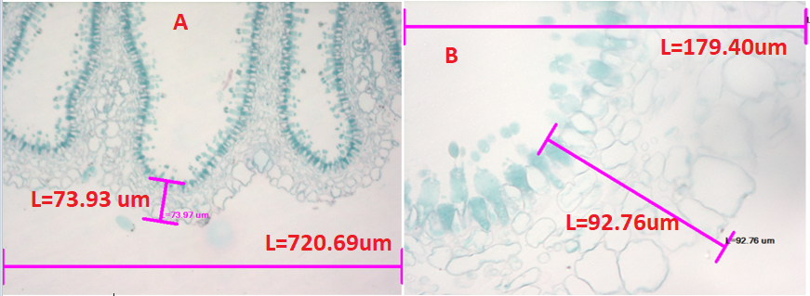
Fig. 7: slides of Coprinus sp. seen at 100X (A)and at 400X (B)

Observe the prepared slide of an ectomycorrhizal association of a basidiomycete fungus onto the roots of the white pine, Pinus strobus. Take two microscope photos, one at 100X and another at 400X and, on the one at the higher magnification, annotate the distinctive structures of an ectomycorrhizal association. Prepare a composite figure.
Insert your composite figure along with a caption.
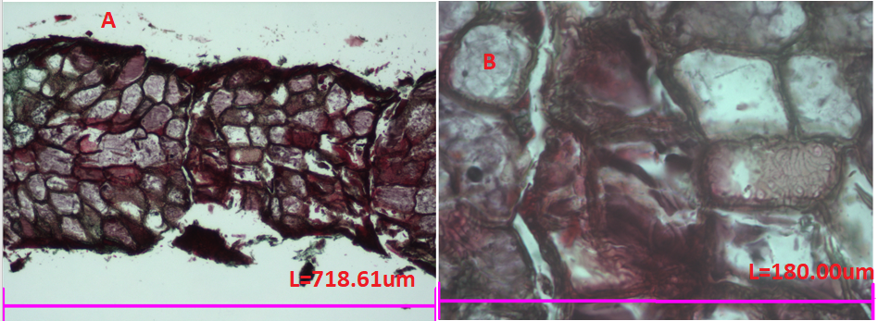
Fig. 8: slides of an ectomycorrhizal association seen at 100X (A)and at 400X (B)

Puccinia graminis, a fungus associated with wheat stem rust, interestingly produce four types of spores. The rust was once the most feared disease of cereal crops, but not anymore due to the development and commercialization of wheat varieties that are resistant to P. graminis. Fill up the summary table provided below to identify some criteria that may be used to distinguish among the four types of spores.

 | Host plant | Color | Location on upper or lower side of leaves | Size, shape and other peculiar spore features
Pycniospore | barberry | dark brown | upper | dark brown spot
Aeciospores | barberry | white/brown | lower | sparse groupings, small and round
Urediniospores | wheat | dark brown | lower (stem) | long blotches
Teliospores | wheat | black | lower (stem) | small thin specs of discoloration

What might be the benefits for Puccinia graminis to produce four different types of spores? You do not have to ‘google’ this question, but simply think about the complex lifestyle of this fungus and kindly explain how different spores might be beneficial to P. graminis.

Insert and justify your answer.
The benefits for Puccinia graminis to produce multiples types of spores would be to further propagate and to infect more hosts. Puccinia graminis infects different species in different ways, by using different spores, and propagates in different ways depending on which host it is attached to, by again using different spores. Producing multiple types of spores then benefits its complex lifestyle and methods of propagation.

Observation of live specimens.

Prepare cross sections of the gills of the common edible white mushroom, Agaricus bisporus, and take two microscope photos at 100X and 400X. Annotate one basidium and one basidiospore on the photo taken at 400X. Prepare a composite figure combining your two microscope photos.

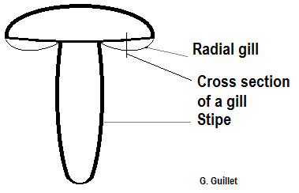

Insert your composite figure along with a caption.
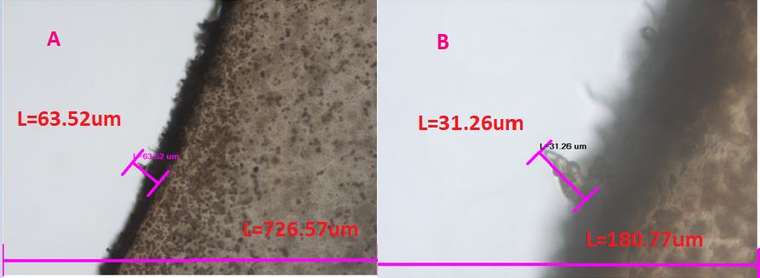
Fig. 9: slides of Agaricus bisporus seen at 100X (A)and at 400X (B)

Assessment criteria
Task | All items included and well done (3/3) | One missing or unsatisfying item (2/3) | Two missing or unsatisfying item (1/3) | Doesn`t meet expectations (0/3)
One composite figure with the two requested microscope photos of Coprinus sp. Proper annotations of the characteristics of Basidiomycota. Reference bars and one caption are included.
One composite figure with the two requested microscope photos of an ectomycorrhizal association of a basidiomycete fungus onto the roots of the white pine, Pinus strobus. Proper annotations of the characteristics of an ectomycorrhizal association. Reference bars and one caption are included.
Table of different types of spores of Puccinia graminis was completed and information is correct.
What might be the benefits for Puccinia graminis to produce four different types of spores? Explain your reasoning.
One composite figure with the two requested microscope photos of cross sections of gills of Agaricus bisporus with annotation of basidium and basidiospores on the photo at 400X. Reference bars and one caption are included.
Quality of the individual photos (adequate light intensity, contrast and focus).

Part 6. Mutualistic Symbioses
Observation of live specimens.
Observe the specimens of lichens in demonstration. One fresh specimen is also available for microscope observation.

Take a small fragment of the fresh lichen available for microscope observation. Depending on the specimen and its conditions, it might be difficult to make thin sections. If possible, prepare some thin sections and take two microscope photos at 100X and 400X. If the specimen is too dry to prepare some thin sections, you may fragment it into smaller crumbs by rubbing it between your fingers. Prepare a wet mount of your sections or crumbs and take two microscope photos at 100X and 400X. Annotate the main structures and prepare a composite figure combining your two microscope photos.

Insert your composite figure along with a caption.

Assessment criteria
Task | All items included and well done (3/3) | One missing or unsatisfying item (2/3) | Two missing or unsatisfying item (1/3) | Doesn`t meet expectations (0/3)
One composite figure with the two requested microscope photos of a fresh lichen with annotations. Reference bars and one caption are included.
Quality of the individual photos (adequate light intensity, contrast and focus).

