Learning Outcomes
By completing this assignment, you will gain skills in:
Using strings and substrings in Java,
Using Stacks in Java and
Drawing beautiful fractal images
Description
Fractals are infinitely complex patterns generated by simple algorithms, that are self-similar across different scales. They are created by repeating a simple process over and over again. Fractal algorithms can produce very beautiful and quite bizarre geometric shapes. To create a fractal, you can start with a simple pattern and repeat it at smaller scales, over and over again, forever. In real life, of course, it is impossible to draw fractals with infinitely smaller patterns. However we can draw shapes which look just like fractals. In this assignment, we use fractal formulae to generate images of some interesting curves.
Functional Specifications
An L-system (first described by a Hungarian biologist, Aristid Lindenmayer at the University of Utrecht in 1968) can be used to generate self-similar fractals of plant like structures (among other structures). Plant models and object models "grow" and becomes more complex at each iteration level of the form.
The system consists of 5 items:
an alphabet of symbols that can be used to make strings,
a collection of production rules that expand each symbol into some larger string of symbols,
an initial "axiom" string from which to begin construction,
a mechanism for translating the generated strings into geometric structures and
some constants, namely "-", "+", "[" and "]", that help with the evolution of the model fractal.
We use turtle graphics to draw the structures. Our drawing canvas will be a 1024*1024 colour image, where each background pixel in initially white. The symbols, "F" or "G", draw a line of some length in some drawing direction (that can be modified by constants "-" and "+" which add or subtract some angle from the drawing direction). "F" and "G" do the same thing but using "F" and "G" allows multiple rules for the fractals to be combined. Other symbols, such as "X" and "Y" have rules associated with them (to make the fractal curve evolve in some interesting ways) but cause no line printing. "[" and "]" push or pop the current location, the current drawing direction and the current drawing length, which can be changed (usually smaller for pushes and larger for pops). Thus "[" and "]" allow branching in the fractal curve (needed for branches in trees for example).
The L system for a Koch curve can be given as

alphabet: F
constants: + -
axiom: F
rule: (F+F-F-F+F)
angle: 90 degrees
Here, the letter F means "draw forward by length 1" in the current direction (initially 0 degrees, along the positive X axis), + means "turn left by angle degrees (90 degrees)" and - means "turn right by angle degrees (90 degrees)". The direction always specifies a relative direction, i.e. add or subtract the current angle to the current drawing direction to get the new direction.
Each letter in the alphabet must have a production rule. Starting with the axiom string (iteration 0), we generate all subsequent strings by replacing the letters with copies of their production rules.
For iteration n=0, we get F: (the axiom is a straight line starting at (x,y)=(0,0) and oriented at 0 degrees with length=1, i.e. along the positive X axis). Although, each line segment has length 1.0 we scale this later to fit the fractal curve into our canvas dimensions.
For iteration n=1 we get: F+F-F-F+F, where F is replaced by 1 occurrence of the rule. For this string we move forward in the leftward direction, change the direction by +90 degrees, move forward in this degree direction (upwards), change the direction by -90 degrees, move forward in this direction (leftward), change the direction by -90 degrees, move forward in this direction (downward), change the direction the direction by +90 degrees again and finally move forward in this direction (leftward).
For iteration n=2 we get: F+F-F-F+F + F+F-F-F+F - F+F-F-F+F - F+F-F-F+F + F+F-F-F+F, where each F in iteration n=1 is replaced by F+F-F-F+F. Notes the + and - symbols are never changed. It is now to tedious to specify all the drawing actions that need to be performed!
For iteration n=3 we get:
F+F-F-F+F+F+F-F-F+F-F+F-F-F+F-F+F-F-F+F+F+F-F-F+F +
F+F-F-F+F+F+F-F-F+F-F+F-F-F+F-F+F-F-F+F+F+F-F-F+F -
F+F-F-F+F+F+F-F-F+F-F+F-F-F+F-F+F-F-F+F+F+F-F-F+F -
F+F-F-F+F+F+F-F-F+F-F+F-F-F+F-F+F-F-F+F+F+F-F-F+F +
F+F-F-F+F+F+F-F-F+F-F+F-F-F+F-F+F-F-F+F+F+F-F-F+F
We can use a prettyPrint method in the DrawFractal.java DrawFractal.java class to print such strings. For higher values of n it becomes takes considerable more space to write out the result string.
The turtle moves about the screen drawing straight lines at various orientations. The turtle interprets a character string as a sequence of line segments, connected "head to tail" to each other. Depending on the segment lengths and angles between them, the resulting figure can become quite complex but always consists of multiple single lines drawn at different orientations.
We can use a stack to build these complex strings in an iterative fashion. At each iteration, we parse a string (the axion initially at iteration 0) and do the following for each character, going left to right:
If a character is a "-", "+", "[" or "]" push it unto the stack.
If the character is a F or G or X or Y, replace these characters by pushing the characters in the corresponding production rule(s) for those symbols onto the stack in the correct order.
Once the complex string has been processed in this way from the left to the right, we build a new string, s, by popping the stack one string at a time and concatenating the popped string to the left of the string variable s, that is initially the empty string.
To allow for the branching structures found in many plants (trees and bushes), two new constants, "[" and "]", are used to denote a branch. They are interpreted by the turtle as follows:
If "[" is encountered, four pieces of information giving the current position (the x and y coordinates) and drawing angle and line length (relative direction and length) are pushed onto a stack as floating point numbers (doubles).
If "]" is encountered, the current position and drawing angle and line length are popped off the stack and used to reset by the current position and angle/length variables. The turtle now begin drawing from this position.
After a number of iterations we have built a (quite possibly) very complex string of symbols. Then we use a second stack to draw the stack. We process the characters in the string from left to right. We ignore blanks and non-drawable symbols like X and Y. Drawable symbols like "F" and "G" cause a straight line of some length to be printed in some direction. Each line is output as an object. These objects are maintained in an array. Each line (see the class LineInfo.java) has double variables for x1 and y1 and x2 and y2 (the line endpoints) and are represented via line objects. We compute an array of these line objects. We also compute the minimum and maximum x and y values as we process this string. We do this via an update method UpdateXminYminXmaxYmax(x1,y1,x2,y2) as we process each character in the string. The first x1 and y1 we encounter can be used to initialize the minimum and maximum x and y variables. Subsequent x1 and y1 and x2 and y2 values can be used to update these minimum and maximum x and y variables. Note that this method is supplied to you in DrawFractal.java The x and y values can be negative as well as positive and can be quite large. As all lines are computed, we compute the minimum and maximum x and y values to scale these lines so that they fit on a window with lower left coordinates (lowerX,lowerY)=(0,0) and upper right coordinates (upperX,upperY)=(1023,1023) [for a 1024*1024 image). When symbol "[" is encountered the current drawing x and y coordinates, the current drawing direction (angle) and the current drawing length are used to generate an object holding this information and that object is pushed onto a stack. Drawing continues with next symbols, maybe after scaling the current drawing length. When symbol "]" is encountered the top object if popped from the stack and the current location, current drawing length and current drawing direction (angle) are restored.
The Main.java class is provided for you. Its main method contains the Java code needed to setup 6 fractal curves and prints them on a large canvas and to save them as jpg images. The canvas class is given by the class Canvas.java. The main method requires 4 line arguments, see Tutorial 2 on the course web page to see how to do this in Eclipse.
You need to write methods for 2 classes for this assignment, a shell class given in MakeFractal.java and another shell program given in DrawFractal.java
You need to write a method buildFractal() for MakeFractal.java. This method uses a stack to perform the iterations to build the final complex fractal string You process symbols (as Strings) left to right, symbols with production rules are replaced with those rules (and these symbols are pushed onto the stack) while other symbols are just pushed without substitution. At the end of iterations we pop the stack and concatenate it to the front (of an initially empty) string to represent the fractal.
You also need to write a method computeLines in the class DrawFractal.java that takes the string representing the fractal and produces an array of line objects that draw the fractal. A stack is needed to process the symbols "[" and "]" (push and pop) via a stack to handle branching.
The class for storing line information as objects is given in LineInfo.java. Instances of this class are the objects representing all the lines to be drawn for the fractal. We can maintain these in an array of these objects with an extendCapacity helper class (to expand the array size as needed). Another class for storing the current pixel information (coordinates, current drawing length and current drawing direction) when pushing or popping to get branching (necessary for trees and bushes) is given in CurrentPointInfo.java. Class definitions for the Linked List Stack, that we can use without being concerned with its implementation, are given here: EmptyCollectionException.java (needed by the pop method), LinearNode.java , LinkedStack.java and StackADT.java .
The Koch snowflake (see fractal1 in Main.java) can be generated using the L system:
alphabet: F
constants: + - [ ]
axiom: +F--F--F
rules: (F-F--F+F)
angle: 25 degrees
n: 4 iterations
cmd1: java Main kochSnowflake.jpg 1024 1024 1
The Koch curve (see fractal2 in Main.java) can be generated using the L system:
alphabet: F
constants: + -
axiom: F
rules: (F+F-F-F+F
angle: 90 degrees
n: 5 iterations
cmd2: java Main kochcurve.jpg 1024 1024 2
The Sierpinski Triangle (see fractal3 in Main.java) can be generated using L system: pre>
alphabet: F G
li> constants: + -
axiom: F-G-G
rules: (F-G+F+G-F),(G-GG)
angle: 120 degrees
n: 8 iterations
cmd3: java Main sierpinskiTriangle.jpg 1024 1024 3
A Dragon curve (see fractal4 in Main.java) can be generated using L system:
alphabet: X Y
constants: + -
axiom: FX
rules: (X+YF)(FX-Y)li>
angle: 90 degrees
n: 12 iterations
cmd4: java Main dragonCurve.jpg 1024 1024 4
A fractal plant (see fractal5 in Main.java) can be generated using the L system:
alphabet: X F
constants: + - [ ]
axiom: -X
rules: (F-[[X]+X]+F[+FX]-X)(FF)
angle: 25 degrees
n: 8 iterations
cmd5: java Main fractalPlant.jpg 1024 1024 5
A fractal bush (see fractal6 in Main.java) can be generated using the L system:
alphabet: F
constants: + - [ ]
axiom: +++++++++++++++++F
rules: (FF-[-F+F+F]+[+F-F-F])
angle: 16 degrees
n: 6 iterations
cmd6: java Main fractalBush.jpg 1024 1024 6
The last 3 tree fractals (see http://www.kevs3d.co.uk/dev/lsystems/) are made from:
alphabet: F X
constants: + - [ ]
axiom: ----FX
rules: (FF-[-F+F]+[+F-F]), (FF+[+F]+[-F])
angle: 22.5 degrees
n: 5 iterations
cmd7: java Main tree1.jpg 1024 1024 7
alphabet: X F
constants: + - [ ]
axiom: ----X
rules: (F-[[X]+X]+F[+FX]-X),(FF)
angle: 22.5 degrees
n: 6 iterations
cmd8: java Main tree2.jpg 1024 1024 8
alphabet: X F
constants: + - [ ]
axiom: F
rules: (FF[-F++F][+F--F]++F--F)
angle: 25 degrees
n: 6 iterations
cmd9: java Main tree3.jpg 1024 1024 9
The images generated by these 9 fractal curves follows:
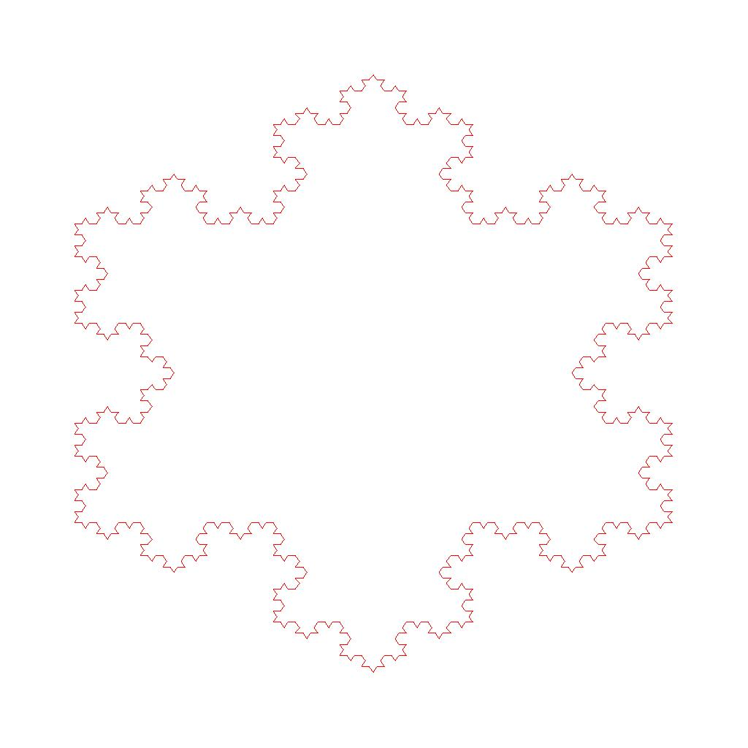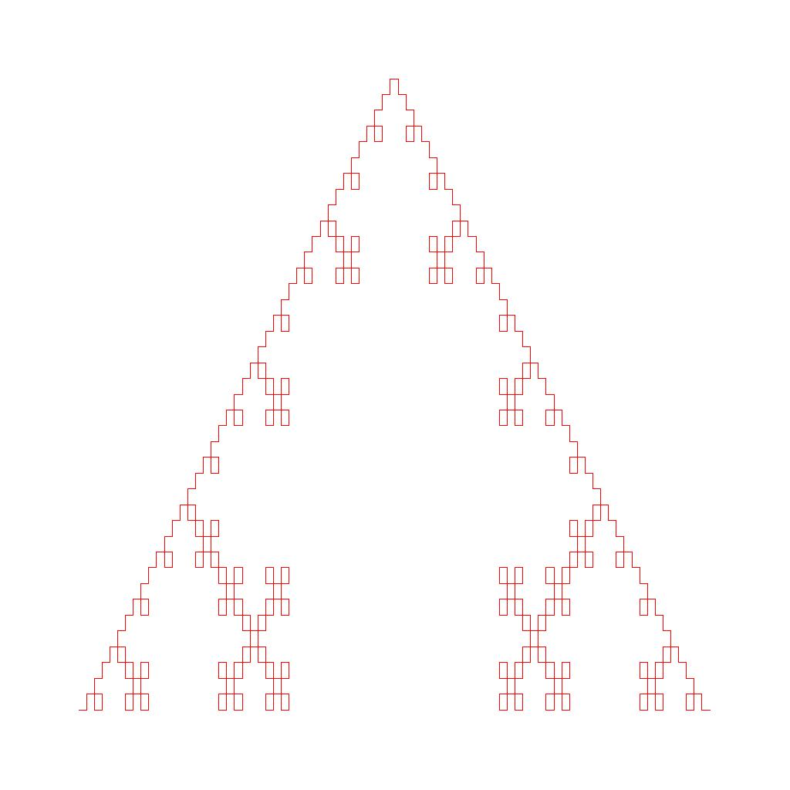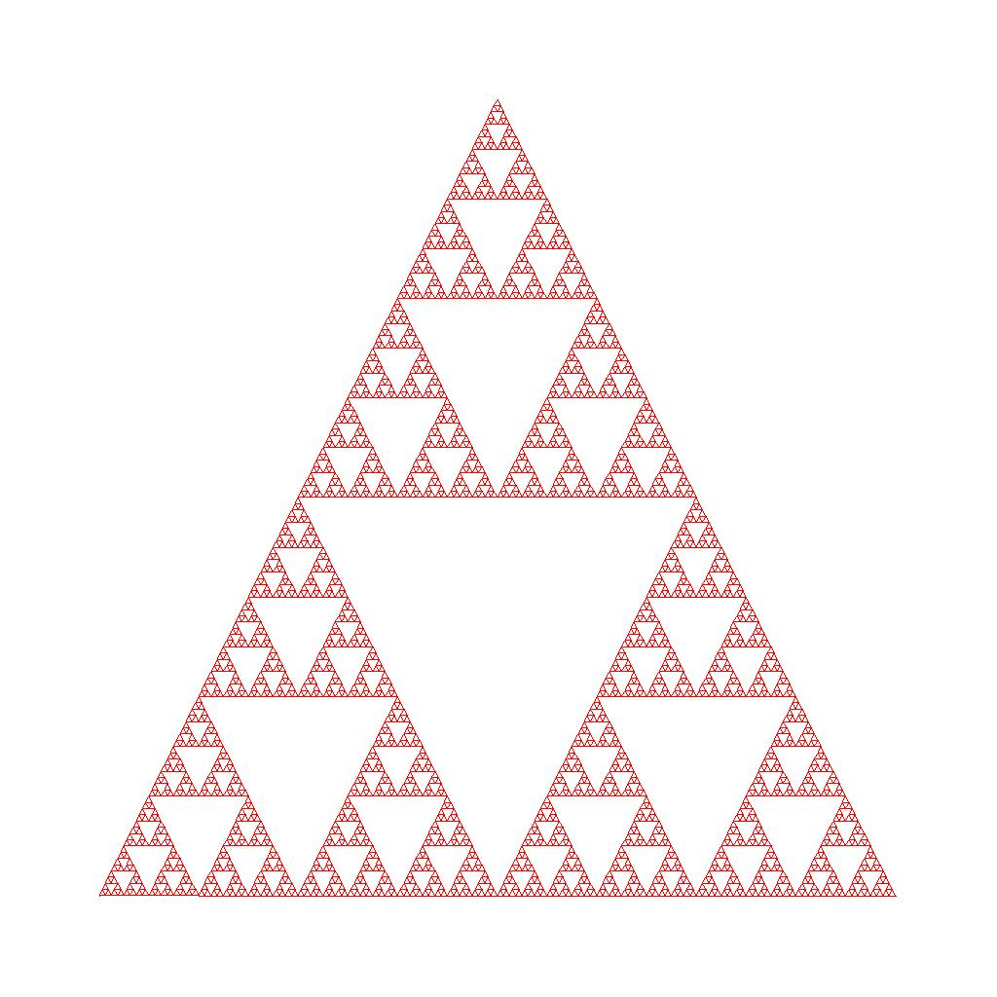
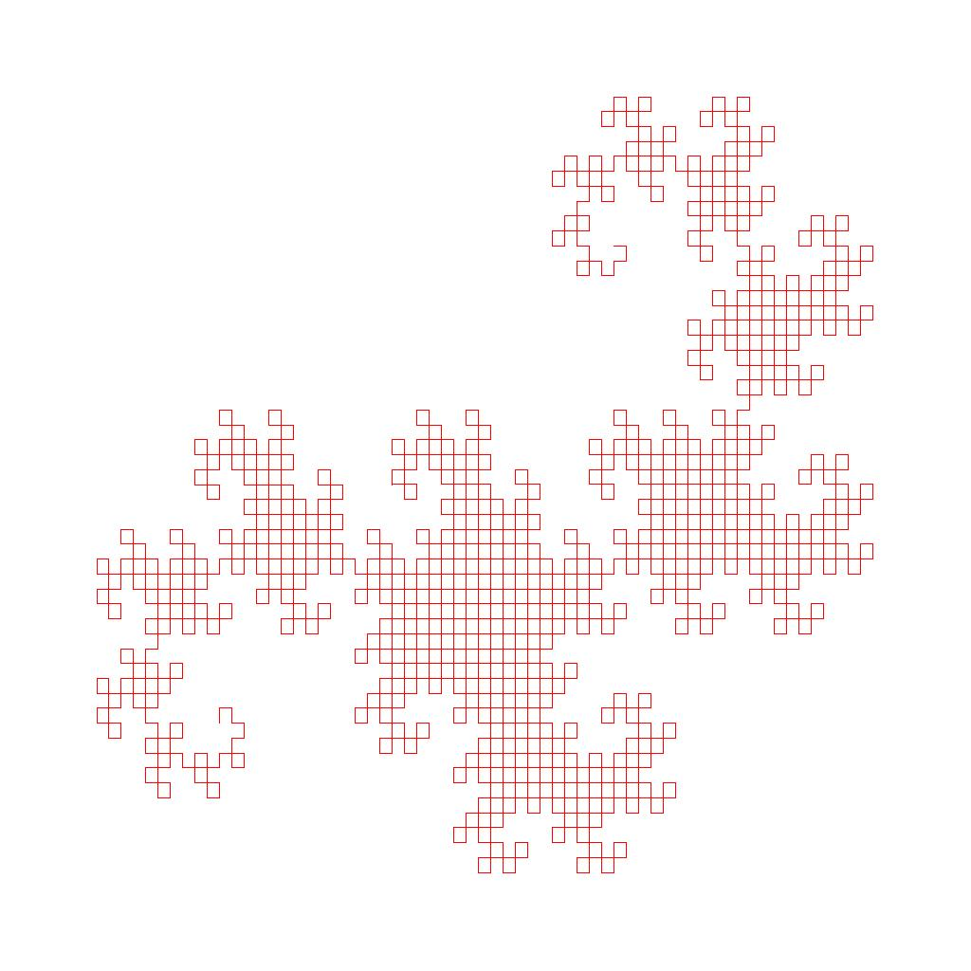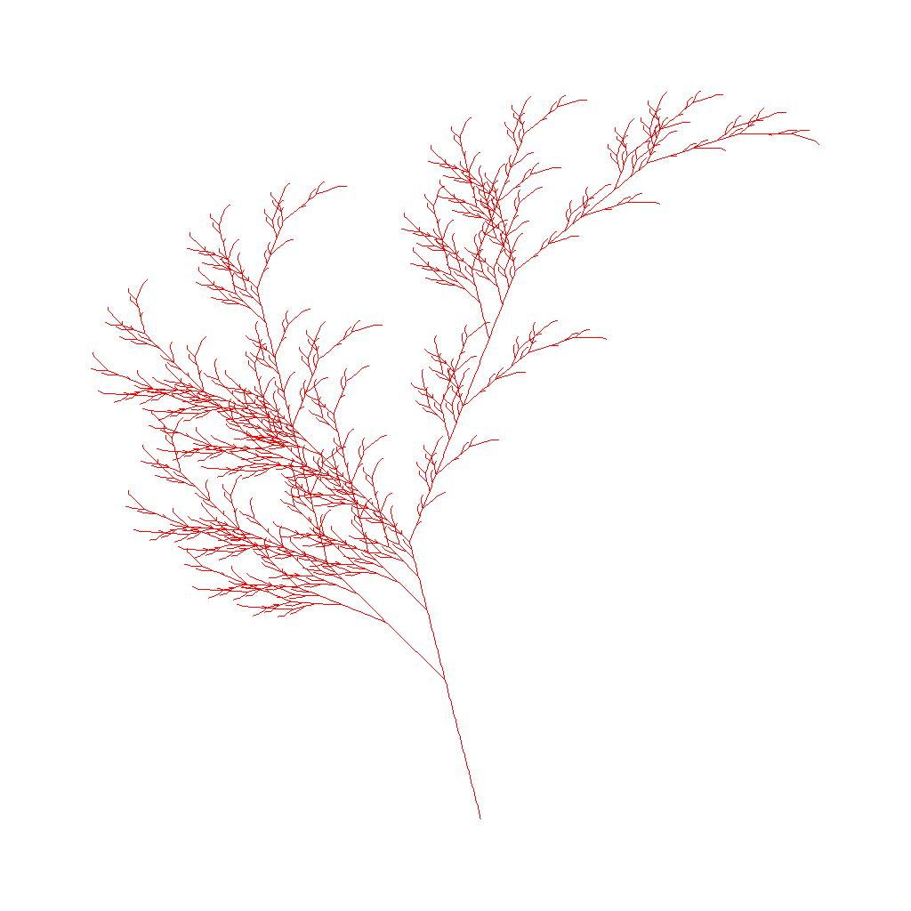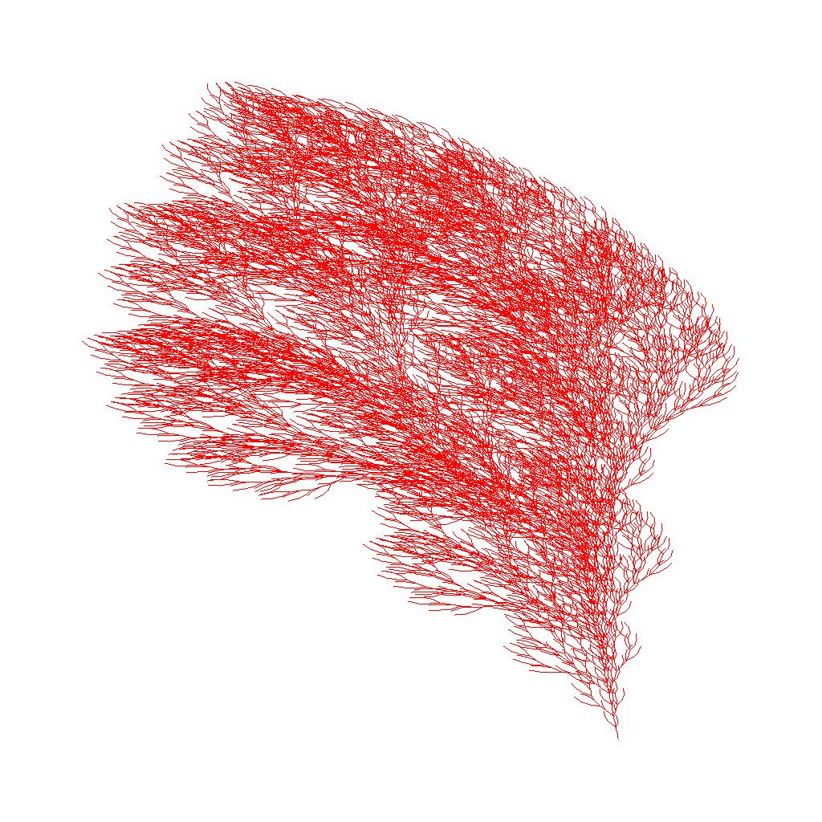
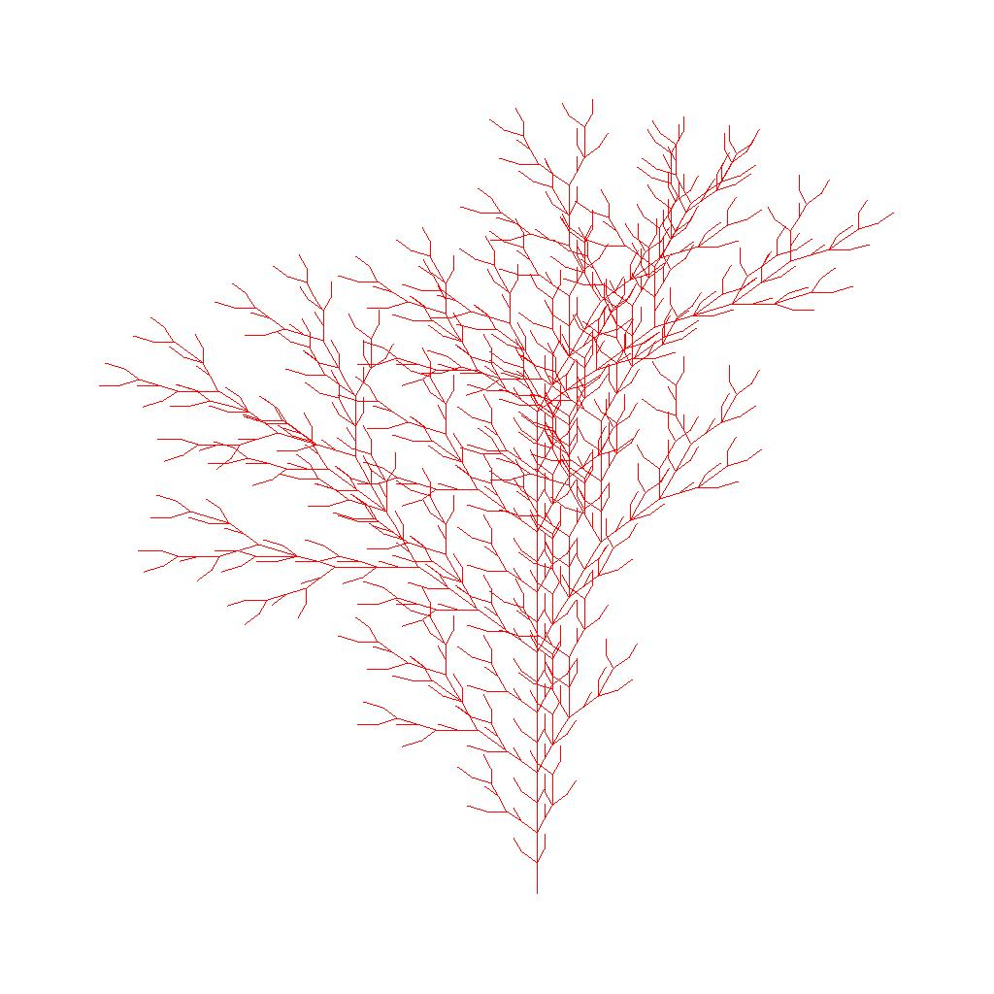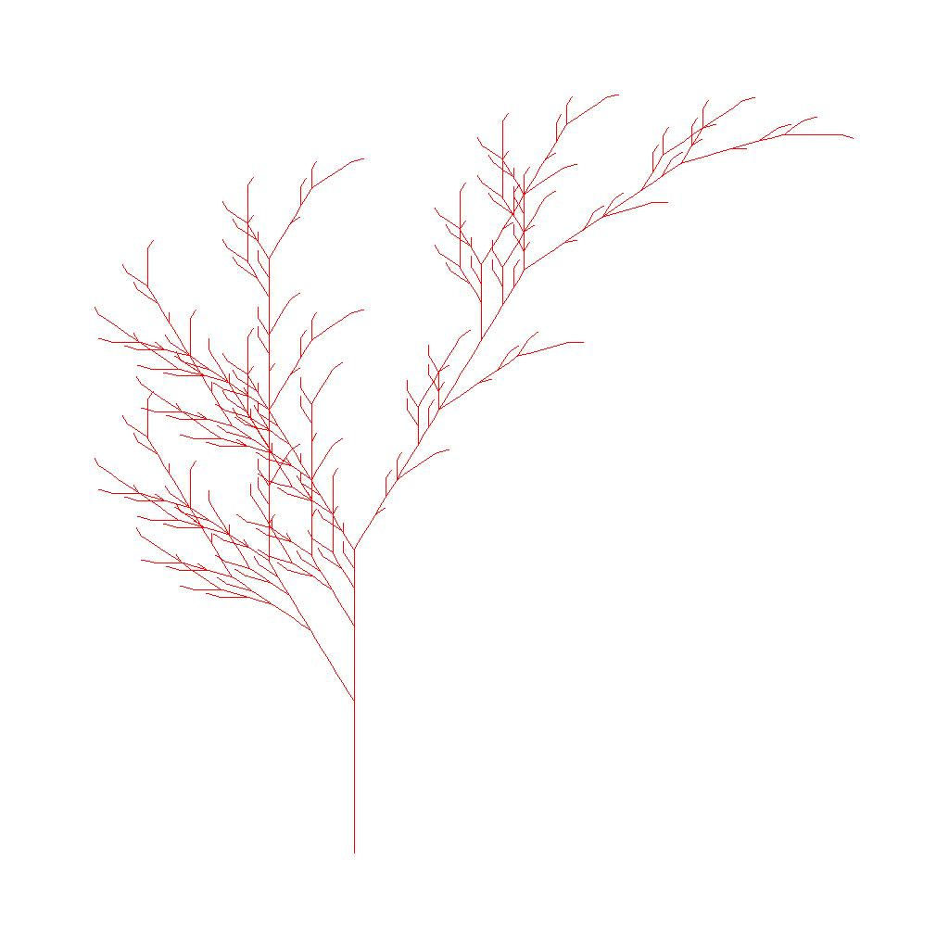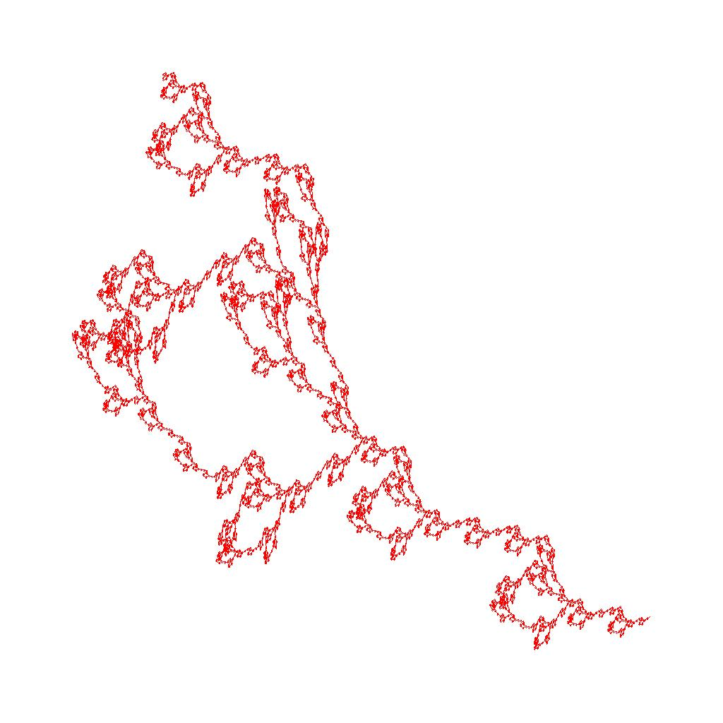
DrawFractal.java
public class DrawFractal
{
private double x1=0.0;
private double y1=0.0;
private double drawingDir=0.0;
private double length=1.0;
private double angle;
private double scalingFactor;
private double x2,y2;
private final static int DEFAULT = 1000;
private LineInfo[] lines;
private Integer lineCount=0;
private CurrentPointInfo CP;
private double Xmin=0.0;
private double Xmax=0.0;
private double Ymin=0.0;
private double Ymax=0.0;
private String symbol;
private String fractalString;

// constructor
public DrawFractal(String fractalString,double scalingFactor,double angle) {
this.fractalString=fractalString;
this.scalingFactor=scalingFactor;
this.angle=angle;
}

// Compute all lines of fractal
public void computeLines() {
angle*=Math.PI/180.0; // convert to radians
// Array of line objects
lines=new LineInfo[DEFAULT];
double mag;

StackADT<CurrentPointInfo> s = new LinkedStack<CurrentPointInfo>();

************************
**** YOUR CODE HERE ****
************************

}

public void printAllLines() {
int i=0;
for(i=0;i<lineCount;i++)
{
System.out.println("Line " + i + " (x1,y1)=("
+ lines[i].getX1() + ","
+ lines[i].getY1() + ") to" + " (x2,y2)=("
+ lines[i].getX2() + ","
+ lines[i].getY2() + ")");
}
}

// Draw all the computed line stored as LineInfo objects and saved
// in the lines array.Compute offset x and y values so that 10%
// of the image is reserved for non-drawing (the fractal looks better
// if there is some white space around it). Parameters lowerx,lowerY,upperX,upperY
// with values (0,0,1023,1023) most likely
// denote the canvas size (and are using in the saling of the line
// coordinate points before drawing)
public void drawAllLines(Canvas canvas,int lowerX,int lowerY,int upperX,int upperY) {
double xOffset=0.1*upperX;
double yOffset=0.1*upperY;
lowerX+=xOffset;
lowerY+=yOffset;
upperX-=xOffset;
upperY-=yOffset;
int intX1,intX2;
int intY1,intY2;
// Information for scaling: width/height of image
// and width/height of computed coordinates for lines objects
double xFractalLimit=(Xmax-Xmin);
double yFractalLimit=(Ymax-Ymin);
double xImageLimit=upperX-lowerX;
double yImageLimit=upperY-lowerY;
double xRatio=(xImageLimit/xFractalLimit);
double yRatio=(yImageLimit/yFractalLimit);

for(int i=0;i<lineCount;i++)
{
// Substract maximum X and Y lines coordinates, scale
// and then add back in the maximum image coordinates (upperX and upperY)
intX1=(int) (upperX+xRatio*(lines[i].getX1()-Xmax));
intY1=(int) (upperY+yRatio*(lines[i].getY1()-Ymax));
intX2=(int) (upperX+xRatio*(lines[i].getX2()-Xmax));
intY2=(int) (upperY+yRatio*(lines[i].getY2()-Ymax));
// draw red (255,0,0) line on canvas
canvas.drawLine(intX1,intY1,intX2,intY2,255,0,0);
}
canvas.show();
}

// Keep track of the minimum and maximum x and y values (for scaling purposes)
public void UpdateXminYminXmaxYmax(Double x1,Double y1,Double x2,Double y2) {
if(x1 < Xmin) Xmin=x1;
if(x2 < Xmin) Xmin=x2;
if(x1 > Xmax) Xmax=x1;
if(x2 > Xmax) Xmax=x2;
if(y1 < Ymin) Ymin=y1;
if(y2 < Ymin) Ymin=y2;
if(y1 > Ymax) Ymax=y1;
if(y2 > Ymax) Ymax=y2;
}

// Double the size of the lines array of type LineInfo
public void expandCapacity() {
LineInfo newLines[]= new LineInfo[lines.length*2];
for (int i=0;i < lines.length;i++) {
newLines[i] = lines[i];
}
lines=newLines;
}

} // DrawFractal
LineInfo.java
public class LineInfo {

private double x1;
private double x2;
private double y1;
private double y2;

public LineInfo(double x1,double y1,double x2,double y2) {
this.x1=x1;
this.y1=y1;
this.x2=x2;
this.y2=y2;
}

public void setX1(double x1) {
this.x1=x1;
}
public void setX2(double x2) {
this.x2=x2;
}
public void setY1(double y1) {
this.y1=y1;
}
public void setY2(double y2) {
this.y2=y2;
}

public double getX1() {
return this.x1;
}
public double getX2() {
return this.x2;
}
public double getY1() {
return this.y1;
}
public double getY2() {
return this.y2;
}

public String toString() {
return "Line from (" + this.x1 + "," + this.y1 + ")" +
" to (" + this.x2 + "," + this.y2 + ")";
}
} // LineInfo class
Main.java
import java.util.*;
import java.io.*;

import java.awt.Color;

public class Main
{

public static void main(String[] args)
{
if(args.length!=4)
{
System.out.println("Incorrect number of arguments: " + args.length + " supplied, 4 needed");
System.out.println("Usage: required argments are " + " jpeg filename " +
"X dimension " + "Y dimension " + "Fractal number [1,9]");
System.out.println("Examples:");
System.out.println("java Main kochSnowflake.jpg 1024 1024 1");
System.out.println("java Main kochCurve.jpg 1024 1024 2");
System.out.println("java Main sierpinskiTriangle.jpg 1024 1024 3");
System.out.println("java Main dragonCurve.jpg 1024 1024 4");
System.out.println("java Main fractalPlant.jpg 1024 1024 5");
System.out.println("java Main fractalBush.jpg 1024 1024 6");
System.out.println("java Main tree1.jpg 1024 1024 7");
System.out.println("java Main tree2.jpg 1024 1024 8");
System.out.println("java Main tree3.jpg 1024 1024 9");
System.exit(0);
}

String filename=args[0];
Integer sizeX=Integer.parseInt(args[1]);
Integer sizeY=Integer.parseInt(args[2]);
int fractalNumber=Integer.parseInt(args[3]);

System.out.println("filename:" + args[0] +
" sizeX=" + args[1] + " sizeY=" + args[2] +
" fractalNumber=" + fractalNumber);
// Allocate the canvas
Canvas canvas = new Canvas(sizeX,sizeY);
canvas.setOriginLowerLeft();
canvas.show();

Boolean fractal1,fractal2,fractal3,fractal4,fractal5,fractal6,fractal7,fractal8,fractal9;
fractal1=false;
fractal2=false;
fractal3=false;
fractal4=false;
fractal5=false;
fractal6=false;
fractal7=false;
fractal8=false;
fractal9=false;
switch (fractalNumber) {
case 1: fractal1=true;
break;
case 2: fractal2=true;
break;
case 3: fractal3=true;
break;
case 4: fractal4=true;
break;
case 5: fractal5=true;
break;
case 6: fractal6=true;
break;
case 7: fractal7=true;
break;
case 8: fractal8=true;
break;
case 9: fractal9=true;
break;
default: System.out.println("Incompatible fractal number entered, not in [1,9]");
System.exit(1);
break;
}

// Koch Snowflake
if(fractal1)
{
int n=5; // number of iterations
double angle=60.0; // angle
int numSymbols=1; // number of symbols in alphabet
String[] symbols=new String[numSymbols]; // symbols that can be used to make strings
String[] rules=new String[numSymbols]; // rules that expand each symbol
System.out.println("length of symbols:" + symbols.length);
symbols[0]=new String("F"); // symbols in alphabet
rules[0]=new String("F+F--F+F"); // One rule per symbol
String axion="+F--F--F";
double scalingFactor=1.0;

MakeFractal kochSnowFlake = new MakeFractal(symbols,numSymbols,axion,rules,n);
String computedFractal=kochSnowFlake.buildFractal();
kochSnowFlake.prettyPrint();
DrawFractal frac1 = new DrawFractal(computedFractal,scalingFactor,angle);
frac1.computeLines();
frac1.drawAllLines(canvas,0,0,sizeX-1,sizeY-1);
canvas.save(filename);
}

if(fractal2)
{
// Koch Curve
int n=5;
double angle=90.0;
int numSymbols=1;
String[] symbols=new String[numSymbols]; // symbols that can be used to make strings
String[] rules=new String[numSymbols]; // rules that expand each symbol
System.out.println("length of symbols:" + symbols.length);
symbols[0]=new String("F"); // symbols in alphabet
rules[0]=new String("F+F-F-F+F"); // One rule per symbol
String axion="--F";
double scalingFactor=1.0;

MakeFractal kochCurve = new MakeFractal(symbols,numSymbols,axion,rules,n);
String computedFractal=kochCurve.buildFractal();
kochCurve.prettyPrint();
DrawFractal frac2 = new DrawFractal(computedFractal,scalingFactor,angle);
frac2.computeLines();
frac2.drawAllLines(canvas,0,0,sizeX-1,sizeY-1);
canvas.save(filename);
}

if(fractal3)
{
// Sierpinski Triangle
int n=8;
double angle=120.0;
int numSymbols=2;
String[] symbols=new String[numSymbols]; // symbols that can be used to make strings
String[] rules=new String[numSymbols]; // rules that expand each symbol
System.out.println("length of symbols:" + symbols.length);
// G and F are the same
symbols[0]=new String("F"); // symbols in alphabet
symbols[1]=new String("G"); // symbols in alphabet
rules[0]=new String("F-G+F+G-F"); // One rule per symbol
rules[1]=new String("GG"); // One rule per symbol
String axion="F-G-G";
double scalingFactor=1.0;

MakeFractal serpinskiTriangle=new MakeFractal(symbols,numSymbols,axion,rules,n);
String computedFractal=serpinskiTriangle.buildFractal();
serpinskiTriangle.prettyPrint();
DrawFractal frac3 = new DrawFractal(computedFractal,scalingFactor,angle);
frac3.computeLines();
frac3.drawAllLines(canvas,0,0,sizeX-1,sizeY-1);
canvas.save(filename);
}

if(fractal4)
{
// Dragon curve
int n=12;
double angle=90.0;
int numSymbols=2;
String[] symbols=new String[numSymbols]; // symbols that can be used to make strings
String[] rules=new String[numSymbols]; // rules that expand each symbol
System.out.println("length of symbols:" + symbols.length);
// G and F are the same
symbols[0]=new String("X"); // symbols in alphabet
symbols[1]=new String("Y"); // symbols in alphabet
rules[0]=new String("X+YF"); // One rule per symbol
rules[1]=new String("FX-Y"); // One rule per symbol
String axion="FX";
double scalingFactor=1.0;

MakeFractal dragonCurve= new MakeFractal(symbols,numSymbols,axion,rules,n);
String computedFractal=dragonCurve.buildFractal();
dragonCurve.prettyPrint();
DrawFractal frac4 = new DrawFractal(computedFractal,scalingFactor,angle);
frac4.computeLines();
frac4.drawAllLines(canvas,0,0,sizeX-1,sizeY-1);
canvas.save(filename);
}

if(fractal5)
{
// Fractal Plant
int n=7;
double angle=25.0;
int numSymbols=2;
String[] symbols=new String[numSymbols]; // symbols that can be used to make strings
String[] rules=new String[numSymbols]; // rules that expand each symbol
System.out.println("length of symbols:" + symbols.length);
symbols[0]=new String("X"); // symbols in alphabet
symbols[1]=new String("F"); // symbols in alphabet
rules[0]=new String("F-[[X]+X]+F[+FX]-X"); // One rule per symbol
rules[1]=new String("FF"); // One rule per symbol
String axion="----X";
double scalingFactor=1.0;

MakeFractal fractalPlant= new MakeFractal(symbols,numSymbols,axion,rules,n);
String computedFractal=fractalPlant.buildFractal();
fractalPlant.prettyPrint();
DrawFractal frac5 = new DrawFractal(computedFractal,scalingFactor,angle);
frac5.computeLines();
frac5.drawAllLines(canvas,0,0,sizeX-1,sizeY-1);
canvas.save(filename);
}

if(fractal6)
{
// Fractal Plant
int n=6;
double angle=16.0;
int numSymbols=1;
String[] symbols=new String[numSymbols]; // symbols that can be used to make strings
String[] rules=new String[numSymbols]; // rules that expand each symbol
System.out.println("length of symbols:" + symbols.length);
symbols[0]=new String("F"); // symbols in alphabet
rules[0]=new String("FF-[-F+F+F]+[+F-F-F]"); // One rule per symbol
String axion="------F";
double scalingFactor=1.0;

MakeFractal fractalBush=new MakeFractal(symbols,numSymbols,axion,rules,n);
String computedFractal=fractalBush.buildFractal();
fractalBush.prettyPrint();
DrawFractal frac6 = new DrawFractal(computedFractal,scalingFactor,angle);
frac6.computeLines();
frac6.drawAllLines(canvas,0,0,sizeX-1,sizeY-1);
canvas.save(filename);
}

if(fractal7)
{
// Fractal tree1
int n=5;
double angle=22.5;
int numSymbols=2;
String[] symbols=new String[numSymbols]; // symbols that can be used to make strings
String[] rules=new String[numSymbols]; // rules that expand each symbol
System.out.println("length of symbols:" + symbols.length);
symbols[0]=new String("F"); // symbols in alphabet
symbols[1]=new String("X"); // symbols in alphabet
rules[0]=new String("FF-[-F+F]+[+F-F]"); // One rule per symbol
rules[1]=new String("FF+[+F]+[-F]"); // One rule per symbol
String axion="----FX";
double scalingFactor=1.0;

MakeFractal fractalBush=new MakeFractal(symbols,numSymbols,axion,rules,n);
String computedFractal=fractalBush.buildFractal();
fractalBush.prettyPrint();
DrawFractal frac7 = new DrawFractal(computedFractal,scalingFactor,angle);
frac7.computeLines();
frac7.drawAllLines(canvas,0,0,sizeX-1,sizeY-1);
canvas.save(filename);
}

if(fractal8)
{
// Fractal tree2
int n=6;
double angle=22.5;
int numSymbols=2;
String[] symbols=new String[numSymbols]; // symbols that can be used to make strings
String[] rules=new String[numSymbols]; // rules that expand each symbol
System.out.println("length of symbols:" + symbols.length);
symbols[0]=new String("X"); // symbols in alphabet
symbols[1]=new String("F"); // symbols in alphabet
rules[0]=new String("F-[[X]+X]+F[+FX]-X"); // One rule per symbol
rules[1]=new String("FF"); // One rule per symbol
String axion="----X";
double scalingFactor=1.0;

MakeFractal fractalBush=new MakeFractal(symbols,numSymbols,axion,rules,n);
String computedFractal=fractalBush.buildFractal();
fractalBush.prettyPrint();
DrawFractal frac8 = new DrawFractal(computedFractal,scalingFactor,angle);
frac8.computeLines();
frac8.drawAllLines(canvas,0,0,sizeX-1,sizeY-1);
canvas.save(filename);
}

if(fractal9)
{
// Fractal tree3
int n=6;
double angle=25.0;
int numSymbols=1;
String[] symbols=new String[numSymbols]; // symbols that can be used to make strings
String[] rules=new String[numSymbols]; // rules that expand each symbol
System.out.println("length of symbols:" + symbols.length);
symbols[0]=new String("F"); // symbols in alphabet
rules[0]=new String("FF[-F++F][+F--F]++F--F"); // One rule per symbol
String axion="++++++F";
double scalingFactor=1.0;

MakeFractal fractalBush=new MakeFractal(symbols,numSymbols,axion,rules,n);
String computedFractal=fractalBush.buildFractal();
fractalBush.prettyPrint();
DrawFractal frac9= new DrawFractal(computedFractal,scalingFactor,angle);
frac9.computeLines();
frac9.drawAllLines(canvas,0,0,sizeX-1,sizeY-1);
canvas.save(filename);
}

} // main method
} // Main class
Canvas.java
import java.awt.Color;
import java.awt.FileDialog;
import java.awt.Toolkit;
import java.awt.event.ActionEvent;
import java.awt.event.ActionListener;
import java.awt.event.KeyEvent;
import java.awt.image.BufferedImage;
import java.io.File;
import java.io.IOException;
import java.net.URL;
import javax.imageio.ImageIO;
import javax.swing.ImageIcon;
import javax.swing.JFrame;
import javax.swing.JLabel;
import javax.swing.JMenu;
import javax.swing.JMenuBar;
import javax.swing.JMenuItem;
import javax.swing.KeyStroke;

/**
* This class provides methods for manipulating individual pixels of
* an image. The original image can be read from a file in JPEG, GIF,
* or PNG format, or the user can create a blank image of a given size.
* This class includes methods for displaying the image in a window on
* the screen or saving to a file.
* <p>
* By default, pixel (x, y) is column x, row y, where (0, 0) is upper left.
* The method setOriginLowerLeft() change the origin to the lower left.
* <p>
* For additional documentation, see
* <a href="http://introcs.cs.princeton.edu/31datatype">Section 3.1</a> of
* <i>Introduction to Programming in Java: An Interdisciplinary Approach</i>
* by Robert Sedgewick and Kevin Wayne.
*/
public final class Canvas implements ActionListener {
private BufferedImage image; // the rasterized image
private JFrame frame; // on-screen view
private String filename; // name of file
private boolean isOriginUpperLeft = false; // location of origin
private boolean isOriginLowerLeft = false; // location of origin
private final int width, height; // width and height

/**
* Create a blank w-by-h picture, where each pixel is black.
*/
public Canvas(int w, int h) {
width = w;
height = h;
image = new BufferedImage(w, h, BufferedImage.TYPE_INT_RGB);
// set to TYPE_INT_ARGB to support transparency
for(int i=0;i<h;i++)
for(int j=0;j<w;j++)
this.drawPixel(i,j,255,255,255);
}

/**
* Copy constructor.
*/
public Canvas(Canvas pic) {
width = pic.width();
height = pic.height();
image = new BufferedImage(width, height, BufferedImage.TYPE_INT_RGB);
filename = pic.filename;
for (int i = 0; i < width(); i++)
for (int j = 0; j < height(); j++)
image.setRGB(i, j, pic.get(i, j).getRGB());
}

/**
* Create a picture by reading in a .png, .gif, or .jpg from
* the given filename or URL name.
*/
public Canvas(String filename) {
this.filename = filename;
try {
// try to read from file in working directory
File file = new File(filename);
if (file.isFile()) {
image = ImageIO.read(file);
}

// now try to read from file in same directory as this .class file
else {
URL url = getClass().getResource(filename);
if (url == null) { url = new URL(filename); }
image = ImageIO.read(url);
}
width = image.getWidth(null);
height = image.getHeight(null);
}
catch (IOException e) {
// e.printStackTrace();
throw new RuntimeException("Could not open file: " + filename);
}
}

/**
* Create a picture by reading in a .png, .gif, or .jpg from a File.
*/
public Canvas(File file) {
try { image = ImageIO.read(file); }
catch (IOException e) {
e.printStackTrace();
throw new RuntimeException("Could not open file: " + file);
}
if (image == null) {
throw new RuntimeException("Invalid image file: " + file);
}
width = image.getWidth(null);
height = image.getHeight(null);
filename = file.getName();
}

public int getHeight1(){
return(this.height);
}
public int getWidth1(){
return(this.width);
}

/**
* Return a JLabel containing this Picture, for embedding in a JPanel,
* JFrame or other GUI widget.
*/
public JLabel getJLabel() {
if (image == null) { return null; } // no image available
ImageIcon icon = new ImageIcon(image);
return new JLabel(icon);
}

/**
* Set the origin to be the upper left pixel.
*/
public void setOriginUpperLeft() {
isOriginUpperLeft = true;
}

/**
* Set the origin to be the lower left pixel.
*/
public void setOriginLowerLeft() {
isOriginLowerLeft = true;
}

/**
* Display the picture in a window on the screen.
*/
public void show() {

// create the GUI for viewing the image if needed
if (frame == null) {
frame = new JFrame();

JMenuBar menuBar = new JMenuBar();
JMenu menu = new JMenu("File");
menuBar.add(menu);
JMenuItem menuItem1 = new JMenuItem(" Save... ");
menuItem1.addActionListener(this);
menuItem1.setAccelerator(KeyStroke.getKeyStroke(KeyEvent.VK_S,
Toolkit.getDefaultToolkit().getMenuShortcutKeyMask()));
menu.add(menuItem1);
frame.setJMenuBar(menuBar);

frame.setContentPane(getJLabel());
// f.setDefaultCloseOperation(JFrame.EXIT_ON_CLOSE);
frame.setDefaultCloseOperation(JFrame.DISPOSE_ON_CLOSE);
frame.setTitle(filename);
frame.setResizable(false);
frame.pack();
frame.setVisible(true);
}

// draw
frame.repaint();
}

/**
* Return the height of the picture in pixels.
*/
public int height() {
return height;
}

/**
* Return the width of the picture in pixels.
*/
public int width() {
return width;
}

/**
* Return the color of pixel (i, j).
*/
public Color get(int i, int j) {
if (isOriginUpperLeft) return new Color(image.getRGB(i, j));
else return new Color(image.getRGB(i, height - j - 1));
}

/**
* Set the color of pixel (i, j) to c.
*/
public void set(int i, int j, Color c) {
if (c == null) { throw new RuntimeException("can't set Color to null"); }
if (isOriginUpperLeft) image.setRGB(i, j, c.getRGB());
else
image.setRGB(i, height - j - 1, c.getRGB());
}

// new added methods for CS1027b, 2013
public void drawPixel(int x,int y,int red,int green,int blue){
Color myColor = new Color(red,green,blue);
int rgb=myColor.getRGB();
// Get right and bottom lines squares adjacent to these border to draw
if(x==this.height) x=height-1;
if(y==this.width) y=width-1;
if(isOriginUpperLeft)
{
if(x<this.width() && y<this.height) image.setRGB(x,y,rgb);
}
else
{
if(x<this.width() && (height-y-1)<this.height) image.setRGB(x,height-y-1,rgb);
}
}

public void drawLine(int x1,int y1,int x2,int y2,int red,int green,int blue)
{
int i,j;

//System.out.println("\nDraw line from " + x1 + "," + y1 + " to " + x2 + "," + y2);
// Draw a pixel
if(x1==x2 && y1==y2)
{
if(isOriginUpperLeft) drawPixel(x1,y1,red,green,blue);
else drawPixel(x1,height-y1-1,red,green,blue);
}
else
if(y1==y2) // Horizontal line
{
//System.out.println("Horizontal line");
for(i=Math.min(x1,x2);i<=Math.max(x1,x2);i++)
{
if(isOriginUpperLeft) drawPixel(i,y1,red,green,blue); //image.setRGB(i,y1,rgb);
else drawPixel(i,height-y1-1,red,green,blue); //image.setRGB(i,height-y1-1,rgb);
}
}
else
if(x1==x2) // Vertical line
{
//System.out.println("Vertical line");
for(j=Math.min(y1,y2);j<=Math.max(y1,y2);j++)
{
if(isOriginUpperLeft) drawPixel(x1,j,red,green,blue); //image.setRGB(x1,j,rgb);
else drawPixel(x1,height-j-1,red,green,blue); //image.setRGB(x1,height-j-1,rgb);
}
}
else
// Line is not a single pixel not a vertical/horizontal line
{
if(Math.abs(x1-x2) >= Math.abs(y1-y2))
{
double slope=((double) (y2-y1))/((double) (x2-x1));
for(i=Math.min(x1,x2);i<=Math.max(x1,x2);i++)
{
j = (int) (slope*(i-x1) + y1);
if(isOriginUpperLeft) drawPixel(i,j,red,green,blue);
else drawPixel(i,height-j-1,red,green,blue);
}
}
else if(Math.abs(y1-y2) > Math.abs(x1-x2))
{
double inverseSlope=((double) (x2-x1))/((double) (y2-y1));
for(j=Math.min(y1,y2);j<=Math.max(y1,y2);j++)
{
i = (int) (inverseSlope*(j-y1) + x1);
if(isOriginUpperLeft) drawPixel(i,j,red,green,blue);
else drawPixel(i,height-j-1,red,green,blue);
}
}
}
} // drawLine

/**
* Is this Picture equal to obj?
*/
public boolean equals(Object obj) {
if (obj == this) return true;
if (obj == null) return false;
if (obj.getClass() != this.getClass()) return false;
Canvas that = (Canvas) obj;
if (this.width() != that.width()) return false;
if (this.height() != that.height()) return false;
for (int x = 0; x < width(); x++)
for (int y = 0; y < height(); y++)
if (!this.get(x, y).equals(that.get(x, y))) return false;
return true;
}

/**
* Save the picture to a file in a standard image format.
* The filetype must be .png or .jpg.
*/
public void save(String name) {
filesave(new File(name));
return;
}

/**
* Save the picture to a file in a standard image format.
*/
public void filesave(File file) {
this.filename = file.getName();
if (frame != null) { frame.setTitle(filename); }
String suffix = filename.substring(filename.lastIndexOf('.') + 1);
suffix = suffix.toLowerCase();
if (suffix.equals("jpg") || suffix.equals("png")) {
try { ImageIO.write(image, suffix, file); }
catch (IOException e) { e.printStackTrace(); }
}
else {
System.out.println("Error: filename must end in .jpg or .png");
}
}

/**
* Opens a save dialog box when the user selects "Save As" from the menu.
*/
public void actionPerformed(ActionEvent e) {
FileDialog chooser = new FileDialog(frame,
"Use a .png or .jpg extension", FileDialog.SAVE);
chooser.setVisible(true);
if (chooser.getFile() != null) {
save(chooser.getDirectory() + File.separator + chooser.getFile());
}
}
}

class TestCanvas {
/**
* Test client. Reads a picture specified by the command-line argument,
* and shows it in a window on the screen.
*/
public static void main(String[] args) {
Canvas pic = new Canvas(Integer.parseInt(args[0]),Integer.parseInt(args[1]));
pic.show();
System.out.printf("%d-by-%d", pic.width(), pic.height());
pic.setOriginLowerLeft();

// Box image
int x1=pic.getWidth1()/2-256;
int x2=pic.getWidth1()/2+256;
int y1=pic.getHeight1()/2-256;
int y2=pic.getHeight1()/2+256;
System.out.println("\nHeight=" + pic.getHeight1() + " Width=" + pic.getWidth1());
System.out.println("(x1,y1)=(" + x1 + "," + y1 + ")");
System.out.println("(x2,y2)=(" + x2 + "," + y2 + ")");
// Draw the box
pic.drawLine(x1,y1,x2,y1,0,0,0);
pic.drawLine(x1,y2,x2,y2,0,0,0);
pic.drawLine(x1,y1,x1,y2,0,0,0);
pic.drawLine(x2,y1,x2,y2,0,0,0);
// left and right diagonal lines
pic.drawLine(x1,y2,x2,y1,0,0,0);
pic.drawLine(x1,y1,x2,y2,0,0,0);
// left and right angles at non 45 degrees
pic.drawLine(x1,y2-100,x2,y1,0,0,0);
pic.drawLine(x1,y1+100,x2,y2,0,0,0);
System.out.println("Data from Kock snowflake");
pic.drawLine(374,214,404,214,0,0,0);
pic.drawLine(404,214,420,237,0,0,0);
pic.drawLine(420,237,404,260,0,0,0);
pic.drawLine(404,260,374,260,0,0,0);
pic.show();
String filename="test.jpg";
pic.save(filename);
System.out.println("File: " + filename + " saved");
System.out.println("TesTCanvas completed");
}
}
MakeFractal.java
import java.util.Arrays;

public class MakeFractal {
private final static int NOT_FOUND=-1;
private String alphaNumeric;
private String computedFractal; // the initial string is the axion
private String initialAxion; // the initial string is the axion
private Integer index,numSymbols,n,size;
private String[] symbols;
private String[] rules;
private Integer charsPerLine=60;

// constructor
public MakeFractal(String[] symbols,Integer numSymbols,
String initialAxion,String[] rules,Integer n) {
this.numSymbols=numSymbols;
this.symbols=new String[this.numSymbols];
this.rules=new String[this.numSymbols];
for(int i=0;i<this.numSymbols;i++) {
this.symbols[i]=symbols[i];
this.rules[i]=rules[i];
}
this.computedFractal=initialAxion; // the initial string is the axion
this.n=n;
}

public String buildFractal() {
System.out.println("In buildFractal\n");
// print out symbols and their production rules
System.out.println("Symbol Table");
for(int i=0;i<numSymbols;i++) {
System.out.println("symbol(" + i + ")=" + symbols[i] +
" rule(" + i +")=" + rules[i] + "\n");
}

// s is a stack
StackADT<String> s = new LinkedStack<String>();

************************
**** YOUR CODE HERE ****
************************

return computedFractal;
}

// Return the index of the character in symbols
// or -1 if it is not there
public Integer in(String alphaNumeric,String[] symbols) {
for(int i=0;i<symbols.length;i++)
{
if(alphaNumeric.equals(symbols[i])) return(i);
}
return(NOT_FOUND);
}

// Pretty print the computed fractal
public void prettyPrint() {
String str=computedFractal;
size=str.length();
System.out.println("\nPretty print the final fractal (60 characters per line)\n");
System.out.println("-------------------------------------------------------\n");
while(charsPerLine < size) {
// print out substrings of str of length charsPerLine
System.out.println(str.substring(0,charsPerLine-1));
str=str.substring(charsPerLine,size);
size=str.length();
}
// print last bit of str
System.out.println(str);
}

} // MakeFractal
DrawFractal.java
public class DrawFractal
{
private double x1=0.0;
private double y1=0.0;
private double drawingDir=0.0;
private double length=1.0;
private double angle;
private double scalingFactor;
private double x2,y2;
private final static int DEFAULT = 1000;
private LineInfo[] lines;
private Integer lineCount=0;
private CurrentPointInfo CP;
private double Xmin=0.0;
private double Xmax=0.0;
private double Ymin=0.0;
private double Ymax=0.0;
private String symbol;
private String fractalString;

// constructor
public DrawFractal(String fractalString,double scalingFactor,double angle) {
this.fractalString=fractalString;
this.scalingFactor=scalingFactor;
this.angle=angle;
}

// Compute all lines of fractal
public void computeLines() {
angle*=Math.PI/180.0; // convert to radians
// Array of line objects
lines=new LineInfo[DEFAULT];
double mag;

StackADT<CurrentPointInfo> s = new LinkedStack<CurrentPointInfo>();

************************
**** YOUR CODE HERE ****
************************

}

public void printAllLines() {
int i=0;
for(i=0;i<lineCount;i++)
{
System.out.println("Line " + i + " (x1,y1)=("
+ lines[i].getX1() + ","
+ lines[i].getY1() + ") to" + " (x2,y2)=("
+ lines[i].getX2() + ","
+ lines[i].getY2() + ")");
}
}

// Draw all the computed line stored as LineInfo objects and saved
// in the lines array.Compute offset x and y values so that 10%
// of the image is reserved for non-drawing (the fractal looks better
// if there is some white space around it). Parameters lowerx,lowerY,upperX,upperY
// with values (0,0,1023,1023) most likely
// denote the canvas size (and are using in the saling of the line
// coordinate points before drawing)
public void drawAllLines(Canvas canvas,int lowerX,int lowerY,int upperX,int upperY) {
double xOffset=0.1*upperX;
double yOffset=0.1*upperY;
lowerX+=xOffset;
lowerY+=yOffset;
upperX-=xOffset;
upperY-=yOffset;
int intX1,intX2;
int intY1,intY2;
// Information for scaling: width/height of image
// and width/height of computed coordinates for lines objects
double xFractalLimit=(Xmax-Xmin);
double yFractalLimit=(Ymax-Ymin);
double xImageLimit=upperX-lowerX;
double yImageLimit=upperY-lowerY;
double xRatio=(xImageLimit/xFractalLimit);
double yRatio=(yImageLimit/yFractalLimit);

for(int i=0;i<lineCount;i++)
{
// Substract maximum X and Y lines coordinates, scale
// and then add back in the maximum image coordinates (upperX and upperY)
intX1=(int) (upperX+xRatio*(lines[i].getX1()-Xmax));
intY1=(int) (upperY+yRatio*(lines[i].getY1()-Ymax));
intX2=(int) (upperX+xRatio*(lines[i].getX2()-Xmax));
intY2=(int) (upperY+yRatio*(lines[i].getY2()-Ymax));
// draw red (255,0,0) line on canvas
canvas.drawLine(intX1,intY1,intX2,intY2,255,0,0);
}
canvas.show();
}

// Keep track of the minimum and maximum x and y values (for scaling purposes)
public void UpdateXminYminXmaxYmax(Double x1,Double y1,Double x2,Double y2) {
if(x1 < Xmin) Xmin=x1;
if(x2 < Xmin) Xmin=x2;
if(x1 > Xmax) Xmax=x1;
if(x2 > Xmax) Xmax=x2;
if(y1 < Ymin) Ymin=y1;
if(y2 < Ymin) Ymin=y2;
if(y1 > Ymax) Ymax=y1;
if(y2 > Ymax) Ymax=y2;
}

// Double the size of the lines array of type LineInfo
public void expandCapacity() {
LineInfo newLines[]= new LineInfo[lines.length*2];
for (int i=0;i < lines.length;i++) {
newLines[i] = lines[i];
}
lines=newLines;
}

} // DrawFractal
LineInfo.java
public class LineInfo {

private double x1;
private double x2;
private double y1;
private double y2;

public LineInfo(double x1,double y1,double x2,double y2) {
this.x1=x1;
this.y1=y1;
this.x2=x2;
this.y2=y2;
}

public void setX1(double x1) {
this.x1=x1;
}
public void setX2(double x2) {
this.x2=x2;
}
public void setY1(double y1) {
this.y1=y1;
}
public void setY2(double y2) {
this.y2=y2;
}

public double getX1() {
return this.x1;
}
public double getX2() {
return this.x2;
}
public double getY1() {
return this.y1;
}
public double getY2() {
return this.y2;
}

public String toString() {
return "Line from (" + this.x1 + "," + this.y1 + ")" +
" to (" + this.x2 + "," + this.y2 + ")";
}
} // LineInfo class
CurrentPointInfo.java
import java.util.*;
import java.io.*;

public class CurrentPointInfo {
private double x;
private double y;
private double drawingDirection;
private double drawingLength;

public CurrentPointInfo(double x,double y,double drawingDirection,double drawingLength) {
this.x=x;
this.y=y;
this.drawingDirection=drawingDirection;
this.drawingLength=drawingLength;
}

public double getX() {
return this.x;
}

public double getY() {
return this.y;
}

public void setX(double x) {
this.x=x;
}

public void setY(double y) {
this.y=y;
}

public double getCurrentDrawingDirection() {
return this.drawingDirection;
}

public void setCurrentDrawingDirection(double drawingDirection) {
this.drawingDirection=drawingDirection;
}

public double getCurrentLength() {
return this.drawingLength;
}

public void setCurrentLength(double drawingLength) {
this.drawingLength=drawingLength;
}

}
EmptyCollectionException.java
/**
* @author Lewis and Chase
*
* Represents the situation in which a collection is empty.
*/

public class EmptyCollectionException extends RuntimeException
{
/**
* Sets up this exception with an appropriate message.
* @param collection String representing the name of the collection
*/
public EmptyCollectionException (String collection)
{
super ("The " + collection + " is empty.");
}
}
LinearNode.java
/**
* LinearNode represents a node in a linked list.
*
* @author Dr. Lewis
* @author Dr. Chase
* @version 1.0, 08/13/08
*/

public class LinearNode<E>
{
private LinearNode<E> next;
private E element;

/**
* Creates an empty node.
*/
public LinearNode()
{
next = null;
element = null;
}

/**
* Creates a node storing the specified element.
*
* @param elem the element to be stored within the new node
*/
public LinearNode (E elem)
{
next = null;
element = elem;
}

/**
* Returns the node that follows this one.
*
* @return the node that follows the current one
*/
public LinearNode<E> getNext()
{
return next;
}

/**
* Sets the node that follows this one.
*
* @param node the node to be set to follow the current one
*/
public void setNext (LinearNode<E> node)
{
next = node;
}

/**
* Returns the element stored in this node.
*
* @return the element stored in this node
*/
public E getElement()
{
return element;
}

/**
* Sets the element stored in this node.
*
* @param elem the element to be stored in this node
*/
public void setElement (E elem)
{
element = elem;
}
}
LinkedStack.java
public class LinkedStack<T> implements StackADT<T>
{
/** indicates number of elements stored */
private int count;
/** pointer to top of stack */
private LinearNode<T> top;

/**
* Creates an empty stack.
*/
public LinkedStack()
{
count = 0;
top = null;
}

/**
* Adds the specified element to the top of this stack.
* @param element element to be pushed on stack
*/
public void push (T element)
{
LinearNode<T> temp = new LinearNode<T> (element);

temp.setNext(top);
top = temp;
count++;
}

/**
* Removes the element at the top of this stack and returns a
* reference to it. Throws an EmptyCollectionException if the stack
* is empty.
* @return T element from top of stack
* @throws EmptyCollectionException on pop from empty stack
*/
public T pop(){
if (isEmpty())
throw new EmptyCollectionException("Stack");

T result = top.getElement();
top = top.getNext();
count--;

return result;
}

/**
* Returns a reference to the element at the top of this stack.
* The element is not removed from the stack. Throws an
* EmptyCollectionException if the stack is empty.
* @return T element on top of stack
* @throws EmptyCollectionException on peek at empty stack
*/
public T peek() {
if (isEmpty())
throw new EmptyCollectionException("Stack");

return top.getElement();
}

/**
* Returns true if this stack is empty and false otherwise.
* @return boolean true if stack is empty
*/
public boolean isEmpty()
{
return count == 0;
}

/**
* Returns the number of elements in this stack.
* @return int number of elements in this stack
*/
public int size()
{
return count;
}

/**
* Returns a string representation of this stack.
* @return String representation of this stack
*/
public String toString()
{
return "";
}
}
StackADT.java
public interface StackADT<T>
{
/** Adds one element to the top of this stack.
* @param element element to be pushed onto stack
*/
public void push (T element);

/** Removes and returns the top element from this stack.
* @return T element removed from the top of the stack
*/
public T pop();

/** Returns without removing the top element of this stack.
* @return T element on top of the stack
*/
public T peek();

/** Returns true if this stack contains no elements.
* @return boolean whether or not this stack is empty
*/
public boolean isEmpty();

/** Returns the number of elements in this stack.
* @return int number of elements in this stack
*/
public int size();

/** Returns a string representation of this stack.
* @return String representation of this stack
*/
public String toString();
}

