Notes

List of names, terms, concepts and films for identification, definition or association (multiple choice/mix and match questions)

Image Track : what appears on screen, the things that the viewer sees

Sound track : what one hears through the speakers
Dialogue, speech, sound effects, general effects, music

Narrative films : films that tell a story through actions and interactions of characters

Clarity :the quality of being easy to see or hear; sharpness of image or sound.

Fidelity :The principle of recording how something actually sounds, Rarely the dominant principle

Dialogue : ⅓ components of the sound track ; human speech in language, elements of spoken sound

Sound effects : sfx, effects, fx, or noise (ie. grunts); all sounds other than music or speech

Music : in silent film - the principle sound element
In sound film - ⅓ components of the soundtrack
Dialogue traditionally takes priority- foreground, while music and effects are in the background

Foreground/background : distinction of visual staging carried over into film

Voice-over : a person not seen (and may not belong to the physical world) directly by the viewer, providing additional info/speaking

Ambient sound:means the background sounds which are present in a scene or location. Common ambient sounds include wind, water, birds, crowds, office noises, traffic, etc.

Foley : relating to or concerned with the addition of recorded sound effects after the shooting of a film (sound of cars, sword swing, a clothing so on)

Stinger: Sudden and sharp accent, often applied to music (loud chord or cymbal crash) but equally appropriate to speech (shout or loud cry) or effects (dun shot or slamming door)

Musical topic: Conventional music figures
- Evoke, represent, or signify a particular mood, place, emotion or other character trait
- The significance of a musical topic is general (not unique to film)

Leitmotif: Term derived by 19th century opera
- A short musical idea is developed (varied, re-orchestrated) with in a film
- An idea that acquires some of the properties of a word or symbol
- Opposed to the musical topic -> is specific to a particular film or set of films
- Can fill in the gaps

Rhythm : Organization of time in music into distinct time unit patterns
- Divides long spans of time into smaller, more easily comprehensible units
- Gives shape to the melody (tune)

Beat :a regularly recurring sound that divides the passing to time into
equal units; the basic pulse of music.
– The dialogue/action often has a beat of its own, often synchronized with the music
– Meter: groups of 2 or 3 beats, gives a regular accent to the beat.

Tempo: Perceived rate of the beat or pulse of sound or musical events, some measure of fast or slow. In non-musical contexts, tempo is often used interchangeably with pace.

Accelerando: with a gradual increase of speed

Ritardando :is an indication to gradually decrease the tempo of the music (opposite of accelerando)

Dynamics :the variation in loudness between notes or phrases. Dynamics are indicated by specific musical notation, often in some detail.

Crescendo :is a way for composers to indicate that a passage of music should gradually increase in loudness over time

Decrescendo: s an indication to gradually decrease the volume of the music.

Timbre :the perceived sound quality of a musical note, sound or tone. Timbre distinguishes different types of sound production, such as choir voices and musical instruments, such as string instruments, wind instruments, and percussion instruments

Pitch: the pitch of a note means how high or low the note is.

Major (scale/key): A seven-note scale, Usually associated with joy, confidence, tranquility, etc

Minor (scale/key): A seven-note scale,Usually associated with fear, anxiety, sorrow, despair, longing, etc.

Interval: the difference in pitch between two sounds. An interval may be described as horizontal, linear, or melodic if it refers to successively sounding tones, such as two adjacent pitches in a melody, and vertical or harmonic if it pertains to simultaneously sounding tones, such as in a chord.

Melody :is a linear succession of musical tones that the listener perceives as a single entity

Cadences : is "a melodic or harmonic configuration that creates a sense of resolution [finality or pause]." A harmonic cadence is a progression of two chords that concludes a phrase, section, or piece of music.

Harmony: considers the process by which the composition of individual sounds, or superpositions of sounds, is analysed by hearing. Usually, this means simultaneously occurring frequencies, pitches, or chords.

Chord:s any harmonic set of pitches consisting of two or more notes that are heard as if sounding simultaneously.

Consonance : intervals are usually described as pleasant and agreeable. In music theory, consonances are traditionally divided into two groups: perfect and imperfect.

Dissonance: intervals are those that cause tension and desire to be resolved to consonant intervals.

String instruments:

Woodwinds:

Brasses:

Percussion: Piano

Texture: Functional relation of musical lines to one another; the number of musical strands/layers occurring simultaneously
- Adding sound texture = layering

Monophony: is the simplest of musical textures, consisting of a melody, typically sung by a single singer or played by a single instrument player without accompanying harmony or chords. Many folk songs and traditional songs are monophonic.
- Single line of music, no accompaniment
- Background is absent

Homophony: is a texture in which a primary part is supported by one or more additional strands that flesh out the harmony and often provide rhythmic contrast. This differentiation of roles contrasts with equal-voice polyphony and monophony.
- Texture with one or more line, each line moves with more or less the same rhythm
- Draws attention to melody
- Hymns, christmas songs, folk songs

Melody and Accompaniment: Probably the most common texture in music. A tune is supported by its accompaniment, making for a strong functional separation of foreground and background.
– Accompaniment has a different rhythm than the melody (vs. Homophony) – Parallel to the overall sound design of film: dialogue in the foreground, music and ambient sound in the background.

Polyphony:Two or more simultaneously sounding lines
– Exhibits a relatively shallow hierarchy between foreground
and background (not as dramatic as other types of texture).
– Counterpoint: Harmonious opposition of independent musical lines
– “Contrapuntal texture” and “Polyphonic Texture” mean the same thing
– Example: Singing “Are You Sleeping” in a round
– Sound example: Overlapping dialogue or multiple sound effects occurring at the same time. No one sound has priority or is more important than the others.

A-melodic texture: Accompaniment without melody
– Similar to monophony in diminishing the foreground/background distinction, but monophony occupies only a foreground, where an a-melodic texture has only background.
– Sound example: sound effects only, no dialogue
– Music example: chords, strong rhythms, no melody (tune)
– Often used to introduce an accompaniment texture that is repeated, called a vamp. Can appear at the end of a scene as well.
– A vamp typically precedes the appearance of a melody (foreground music), then continues as the melody enters.
Citizen Kane : (1941; director Orson Wells; composer Bernard Herrmann) 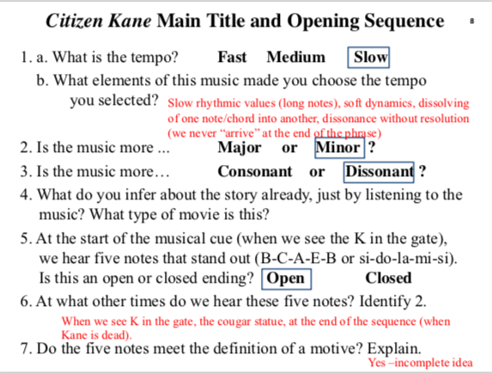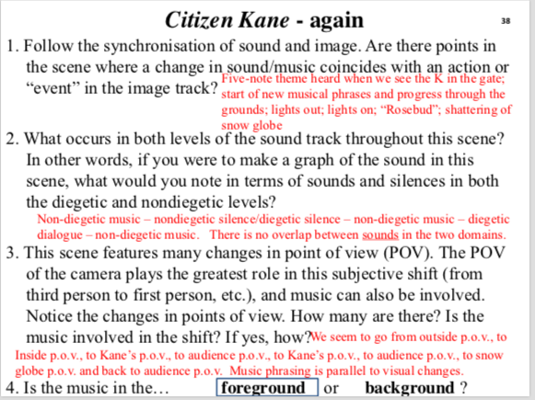
Citizen Kane = Bernard Hermann and Alfred Hitchcock

Diegetic / source music : One way to explain the music played or sung within a scene aka source music music
Ex: Piano in casablanca, Carl’s radio in catch me if you can

Nondiegetic / On screen: Not commonly, used for remembered/ imagines scenes ala imagined sounds
- Characters inner soundtrack, we hear it but someone else on screen would not
- Voice over
- Ex: emma, deadpool
Nondiegetic / Offscreen: Typical space/level combination for the underscore and voice over. We hear it but characters do not
- No physical source for the music within the narrative/ film

Offscreen and Onscreen (d or nd)

Sound-off : Sound offscreen
- Offscreen sound is localizable as an object that could be shown but is not
- This sound suggest an object that is more than simply big noise not ambient sounds
- Music that leads us to a location
- Broadway melody/ casablanca

Voice-off: Offscreen sound that highlights the voice
- Links to place or characters, hear them before we see them

Point-of-view sound : Sound rendered from the perspective of a character in the film aka point of audition sound
- Diegetic sound where the source is offscreen, or when parts of a convo are not clear, giving the impression that we hear what the character hears from their point of view
- Ex: sleepless in seattle convo switching point of view

Imagined sound : Special case of point of view sound, sound track presents what a character is hearing in their head
- Non-diegetic on screen sound, but someone's imagination not flashback
- Ex amadeus, when mozart is composing music in his head

Audio dissolve : Transition from diegetic sound to non-diegetic sound
- Transition to song + dance in which diegetic accompaniment becomes non diegetic or is sweetened by non-diegetic elements
- Is used in narrative films as a way into an idealized world
- Ex pippins lament in LOTR

Acousmêtre /Acoustical being - special character who exists in diegetic space but is placed consistently offscreen and is heard but not seen (ie. shark from jaws, wizard form wizard of oz, sauron from lord of the rings)

Mickey-Mousing: From early Disney cartoons
- Synchronization within a shot or short series of shots where music closely mimics screen action
- Ex : Princes bride duel scenes + action scenes where music goes with actors movements

Sweetening: Sound effect rendered so it seems to violate the conditions of verisimilitude (low fidelity)
- High volume above expected levels
- Adding unmotivated distortion
- Altering expected timber or sound through overdubbing

Synchronization: Appropriate temporal linking of sound to image; aids the impression that sound emanates from the world of the screen
- Lights music in citizen kane
- Relationship of the music to the emotional content on screen (of the central character or general mood)

Empathetic: The default for synchronization of sound + image; the sound track is coordinated with image track, following + emphasizing the mood of on screen characters + action. Gives empathetic/ engaged effect
- Ex sleepless in seattle with annies feelings

Counterpoint: sound that plays against a scene
- The failure of temporal synchronizing of image track + sound track elements + distancing that creates
- Far device of Quentin tarantino

Anempathetic: sounds or music that are emotionally distanced or not in empathy with image track (either through bad synchronization, or deliberate miss match of sounds + images
- Ex catch me if you can - Frank finds out his father died and escape

Neutral Music: Music indifferent to the scene, neither significant to its narrative nor emotionally engaged - in other words, music that functions much like ambient or environmental noise
- Can change quickly to empathetic or counterpoint
- Ex casablanca performance at rick’s

Act: Several sequences gathered in a broad narrative grouping, using the same general criterion of unity of time and place as for a scene. Typically, a film would not have more than three or four acts. Alternatively, “chapter.”

Sequence: A series of scenes related as a narrative unit. In common usage, “sequence” is short for “sequence of shots” and thus can refer to any series of shots that are related by some criteria that is important to the person doing the analysis.

Scene: A number of shots (or, rarely, a single very long shot, or “long take”) gathered together in terms of unity of time and space. Scenes, like shots, can vary greatly in length; on average, however, scenes typically last from 1 to 5 min.

Shot: A single strip of film, the basic unit of continuity editing; can vary greatly, from 1 to 100 sec (or more).

Theme: A clearly defined musical idea (usually made up of two phrases) which sounds complete – it has a proper closed ending. We could call it a musical sentence.

Phrase: More or less aligned with short-term memory, phrases are typically medium length segments, often comprised of motives. The musical phrase is like a written phrase, usually an incomplete grammatical unit.

Motive/Motif: Musical fragment; incomplete musical thought (made up of several pitches)

Pitch: Individual musical note

Atonement: reparation for a wrong or injury.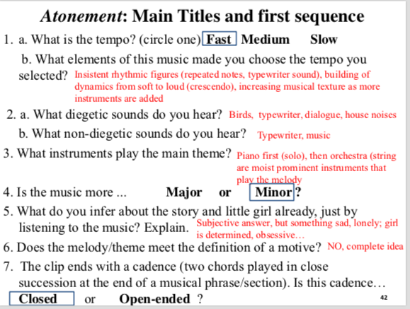
Commutation test : Substituting new soundtrack for a scene to ask questions
- How is original music related to scene action
- What does original music tell us
- Synchronized or empathetic or play against

Masking test: Watching a scene without sound, or listening to a score without images
- Ex psycho murder scene

Silent Film: Was never silent , music, sound effects, narration

Early cinema: music/ film art part of an evening of entertainment
- Music was adapted to the situation: Vaudeville play or lecture scenes with slides
- Thomas Edison
- 1880’s kinetograph (camera) kinetoscope (projector)

Nickelodeon era Nickelodeon:
-5 cents = nickel
-Modified storefront theatre (200-300 audience members)
-Combination of short reels (2-3 reels, 10-18 minutes each) with live entertainment between reels (illustrated songs)
-Music: piano, organ or small ensemble of instruments (or a phonograph)
Not closely matched to the screen action, could be improvised or “compilation scores”
-“Draw” for more elite classes (classical music)
-Playing the picture”: music reflects general content of film 1910: compilation scores or improvisation.
- Compilation score: not original music for one film. Mostly pre- existing works gathered and ordered for a particular performance.
-New types of music – early music topics
-Three types of music used for compilation scores:
-Songs (titles linked to the story)
-Classical music for drama and musical topics “Moods” taken from melodramas (musical plays)
-Primary music used for silent films
-More easily adapted to narrative
-“Musical suggestions” - a new marketing opportunity
• Collections of music suitable for a variety of scenes, aimed at
local nickelodeons
Music for every scene type
-“Make your own compilation score”
-The Edison Company were among the first to release
these
• Also released single-film “cue sheets” for a single
movie (i.e. for Frankenstein of 1910)
-Cue sheets quickly became outdated, but musical
suggestions lists could be used over and over again.

“Playing the picture”
Musical topics/moods
Musical suggestions
The Edison Company
Frankenstein
Cue sheet - Taylor-made music for a scene-by-scene playing
The Edison Kinetogram
Musical Mood anthologies

Picture Palace: -Stratification of exhibition: big city, bit theatre
-3-4 thousand spectators
-Orchestra (20-40 musicians) and organ in large cities
-Smaller, more modest theatres in smaller towns or rural areas (much like a nickelodeon)
-“The Show” : not just a movie!
• Included the picture, the live entertainment, but also the hall,
ushers, lobby... The idea was to “pamper” the spectator
-Strict rules governed the behaviour of all theatre employees, including musicians
-Theatres: Roxy Theatre and Radio City Music Hall, owned by Samuel “Roxy” Rothafel

Samuel “Roxy” Rothafel “The Show”
Mighty Wurlitzer organ “Fitting the Picture”

Compilation scores Improvisation: Still in use
- Theatres with both orchestra + organ often split the duties between both ensembles
- C scores in 1920s
- More prestigious + reliable than improv
- Reflect mood of scene based on actions of characters

Photoplay music: New commissioned music for use in movies
- Collection of moods were printed + sold
- Ex: Erno Erno Rapee’s Encyclopedia of Music for Pictures

Special Scores: Exception to the rule
- Music composed for specific films + distributed by studios along with films
- A feature of extended-run or road shows
- A commissioned score for that particular film
- Ex Metropolis
- Dominant type of score continued to be partly compilation

Cultural musical codes Cinematic musical codes:
- Claudia gorbman terms
- Coined the film music terms diegetic + non diegetic music

Musical Topics:
- Conventional musical figures that represent general moods/character types
- General love theme is a topic with a specific style
- orchestration , tempa, texture all contribute to style, making the music a particular topic
- Affirm our impression of the scene
- Creates expectations on the point of the viewer

Love theme topic:
- Violins (orchestra)
- Melody + accompaniment (slow + long sustained tones)
- Tempo is slower to andante
- Prominent in the score

Erno Rapee’s Motion picture Moods: provided the whole range of topics possible moods, affects, music for specific characters, scenes, dances

Mysterioso topic Villain topic Heroic topic
Lady Windermere’s Fan
Ernst Lubitsch Martin Marks
Mrs. Erlynne:
- The only girl overture waltz

Intertitle: Dialogue + narration cards

Transition to sound film Kinetograph:
- Jazz singer
- Broadway melody

Gaumont Chronophone:
- Defect, amplified sound was insufficient

Vitaphone:
- First viable, commercial system for sound synchronization
- Developed by warner bros

Vitophone shorts:
- Short song + dance films starring well known singers

Synchronised sound film:
- Film with record orchestral accompaniment + sound effects (no dialogue)
- Ex Don Juan

Part-talkie:
- Film with synchronized record orchestra accompaniment interspersed with talking sequences (not all talkie)
- Vitaphone shorts, ex Jazz singer

100% talkie (sound film):
- A film with a complete soundtrack (music, sound effects, dialogue) becomes synonymous with sound film
- Ex broadway melody
The Jazz Singer
Alan Crosland
Al Jolson

“You ain’t heard nothin’ yet!” : Ad- lib dialogue

“Dirty Hands, Dirty Faces” “Toot, Toot, Tootsie Goodbye” : Musical cues

100% talking film:
- 1st one
- First sound film to win academy award for best [pictures
- Broadway melody

Harry Beaumont Nacio Herb Brown
Freed Unit :
- Arthur Freed
- Integrated musicals
- Musical where numbers are presented in the context of the narrative (part of the story)
- ex . Meet me in St. Louis, easter parade, and america in paris
- 4 part opening musical design (establishing shot or text intertitle)

“Give my regards to Broadway” :
- Credits feature the famous George m. Cohan, situestes us in NY

“You were meant for me”

Classical Studio Era:
- Dialogue clarity was given priority, realism won out
- Sound + music was used to heighten reality

Underscoring Debate:
- Against synchronized music - Sergei Einstein
- Against using 19th century music - Aaron Copland - advocates film music as an art form
- Arnold Schoenburg + Igor Stravinsky - Modernist composers of concert music. Both composers felt that film was “bad, meaningless, degraded music”

Judy Garland : Meet me in st louis

Audio- Visual phrasing : (casablanca)
- The films form (changes in shots + locations) responds (or at least coincides with changes in the particularities of music phrasing
- This is fairly typical in musical sequences especially in musicals.

Sync point:
- Moments where action/ image and music are synchronised, or when changes in location are synchronized with changes in music

7 “placements” of music
- Main title /Prologue /Establishing sequence
- End credits
- Performance scenes
- Montage/Fantasy scenes
- Dialogue scenes
- Action scenes
- Love scenes

Sound bridges (all types):
- Sound lag: sound from one scene lingers as we see images for the next (main title or star wars setting sun music before luke exits)
- Sound advance: Hear a sound before seeing its image (sleepless dialogue)
- Soundlink: Use of sound to bridge a sense of cuts transforming what may seem unrelated ( Return of the Jedi - shows multiple wounds)
- Sound match: Sounds belonging to one scene followed by a similar/ distinction sound belonging to the next scene (ex. Jurassic park 2. Scream vs subway car screech)

Rick Blain: Humphrey Bogart (casablanca)

Ilsa Lund: Ingrid Bergamn (casablanca)

Sam: Pianist

Hard cut: Abrupt change

Sound of Music:
- Julie Andrews
- director - Robert wise
- Composer = Richard Rogers + Oscar Hammerstein
- About maria bringing music into Von Trupp Family
- Do, Re, Mi : Kids + Maria (learning solfege- syllable names for different notes), Best known numbers from the film/musical
Lavender Dance - Folk dance common in Austria - Staple of dance halls in 19th century
Post-Classical era :
- Scores dominated by pop songs
- Traditional scoring was “old fashioned”
- Modernist orchestral writing was ultimate route by thurman north + Rosenman (composers)
- Non diegetic use of popular songs
Example the graduate by Simon + Garfunkel

Vertigo:
- The impression that you or objects around you are moving when they are not
- Scottie - falls in love with madeleine but she dies from jumping of church bell tower

Potential terms for definitions (supply definition and example)

Soundtrack: a recording of the musical accompaniment to a movie. What one hears through the speakers. It is made up of dialogue/speech, sound effects and music
Example: sound track from gaurdians of the galaxy: including musics from the 80s, humorous dialogue/speech and space like sound effects to further the experience of the film

Stinger: A sudden and sharp accent; most often applied to music (ie. a loud chord or cymbal crash) but equally appropriate to speech (a shout or loud cry) or effects (ie. gun shot or door slamming).

Musical topics:
– Conventional musical figures
– Evoke, represent, or signify a particular mood, place, emotion, or some other character trait in the narrative.
– The significance of a musical topic is general (not unique to the film)
Examples: fast music for a chase sequence, ominous music for a villain, etc.
National anthems to suggest specific places (specific geographic regions)

Leitmotif: Term derived from nineteenth-century opera and applied to film music.
– A musical idea (usually short) is developed (varied, re- orchestrated) within a film
– An idea that acquires some of the properties of a word or symbol
– The significance of a leitmotif is specific to a particular film (or set of films) and is opposed in that sense to the musical topic, whose signification is more general.
– Trait of early silent films, but also a trait of the new epic genres, revived by John Williams in Star Wars, and used extensively by Howard Shore in The Lord of the Rings and The Hobbit trilogies.
– Leitmotifs can “fill in the gaps” for an audience, recalling a character or event that is not on screen or occurred in a previous scene. It can also explain an important narrative point.
Example: “Imperial March” in Star Wars Episode II.

Musical textures: the functional relation of musical lines to one another, the number of musical strands or layers occurring simultaneously. Consists of Monophony (Happy Birthday song), Homophony (hymn), Polyphony (singing “are you sleeping” in a round), Melody & Accompaniment, and A-melodic (chords/strong rhythms with no tune) textures.

Diegetic / source music:term borrowed from literary theory to refer to the world of the narrative, the screen world or world of the film (what the characters hear).
Example.: Catch Me If You Can the music from the radio

Nondiegetic music (also called the underscore): refers to the level of narration: voice-over narration is nondiegetic— and so is underscoring (what the audience hears and the characters do not).
Example: Sleepless in Seattle the music heard throughout the “Second botched meeting” scene

Point-of-view sound: sound rendered from the perspective of a character in the film. Like point of view camera work or shots.
-Also called point-of-audition sound.
-A diegetic sound for which the source is offscreen (telephone conversation in which the other character is not seen but the voice is very clear), or when certain parts of a conversation are clearly audible, while others are not, giving the impression that we hear what the character hears from their point of view.
Example: the conversation in Sleepless in Seattle switches points of view

Imagined sound:is a special case of point-of-view sound: the sound track presents what a character is hearing in his or her head.
-Technically “nondiegetic onscreen sound,” but more precisely, from someone’s imagination, not a flashback
-Flashback sequences, internal monologue...often used in Emma, Bridget Jones’ Diary
Example: Amadeus (1984, dir. Miloš Forman). When Mozart is “composing” the music in his head, or Salieri is “hearing” the music while reading the score

Audio dissolve:transition from diegetic sound to nondeigetic sound
-Traditionally, by analogy to image dissolve, a transition to song and dance in which diegetic accompaniment becomes nondiegetic or is sweetened by nondiegetic elements.
-Typical of musicals, but also used in narrative films as a way into an “idealized” world: from the mundane to the “song and dance” world.
-In non-musicals, the effects can be different and more complex.
-The transition is often less clear, or abrupt
Example: Pippin’s Lament in LOTR: The Return of the King (2003)

Sweetening:Sound effect rendered so that it seems to violate the conditions of verisimilitude (has low fidelity)
Examples:
-Increasing volume above expected levels
-Adding unmotivated distortion
-Altering the expected timbre (or adding instruments in music)
-Also the alteration of sound (or music) through the use of “overdubbing.”

Synchronization: is a music license granted by the holder of the copyright of a particular composition, allowing the licensee to synchronize ("sync") music with some kind of visual media output (film, television shows, advertisements, video games, accompanying website music)
- Empathetic music: Empathy or emotional engagement is the default for synchronization of sound and image; the sound track is coordinated with the image track, following and emphasizing the mood of onscreen characters and action— the effect is empathetic or engaged.
Example: Sleepless in Seattle nondiegetic music is empathetic with Annie’s feelings

Counterpoint:(not to be confused with the same word used for musical textures: we prefer to reserve “polyphonic” for references to a lively, complex musical texture).
-Sound that plays “against” a scene; the failure of temporal synchronizing of image track and sound track elements, and the distancing effect that creates. Favourite device of director Quentin Tarantino.
- Anempathetic music:Sounds or music that are emotionally distanced, or not in empathy with the image track (either through bad synchronization, or deliberate miss-match of sounds and images).
Example: Catch Me If You Can when Frank finds out his father died, and his final escape

Neutral music:Music indifferent to the scene, neither significant to its narrative nor emotionally engaged—in other words, music that functions much like ambient or environmental noise. Can change quickly to empathetic or counterpoint.
Example: Casablanca (1942) performance scenes at Rick’s.

Compilation scores:not original music for one film. Mostly pre- existing works gathered and ordered for a particular performance.
-New types of music – early music topics
-Three types of music used for compilation scores:
-Songs (titles linked to the story)
-Classical music for drama and musical topics “Moods” taken from melodramas (musical plays)
-Primary music used for silent films
-More easily adapted to narrative

Special Scores: exception to the rule, it is music composed for specific films and distributed by studios along with the film
Example: Metropolis (1927)

Audio visual phrasing: The patterning of sync points in a structured sequence, or, coordination of visual and musical structural points.
Sync point: moments where action/image and music are synchronised, or when changes in location are synchronized with changes in music.
-Audiovisual phrasing is an important feature of this film, especially in the first half. This is one element we will follow as we watch.
Example: Casablanca

Viewing questions

Three types of questions: all questions will pertain to films shown in class. Be prepared to provide the name of the film and composer for each film.

- Sound and image techniques: Identify 1 or more sound/music techniques from a given clip. You will have a term bank for these questions.

- Sound track domains: Identify sounds in the different domains of the soundtrack. You will have a term bank for these questions.

- Scene analysis: answer questions about a scene we watched and analysed together in class.

Below is a list of films discussed in class that could be included on the midterm exam in the written section or listening/viewing section. Relevant scenes are available on our streaming site.

Catch Me If You Can (2 scenes: Frank calls Carl; Frank escapes from the plane)
Sleepless in Seattle (2 scenes: 2nd botched meeting; watching Father and son at the beach)
The Secret Life of Walter Mitty (you are not responsible for the composer name) Citizen Kane
Atonement (you are not responsible for the composer name)
Amadeus (you are not responsible for the composer name)
For Me and My Gal (you are not responsible for the composer name)
Lady Windermere’s Fan (Martin Marks version: Main title and first sequence)
The Broadway Melody (3 scenes: opening sequence, rehearsal scene, Eddie and Queenie love scene)
Casablanca (first 56 minutes - some excerpts available on the streaming site)
Meet Me in St. Louis (1 sequence: Main titles and first scene only - not the trolley song clip)
The Sound of Music (2 scenes: Do, re, mi song and laendler dance)
Vertigo (3 sequences: Opening credits and first scene; following Madeline; Fake-Madeline sequence)
Movies and Their Composers

- Catch Me if You Can
Composer = John Williams
Director = Steven Spielberg
Starring: Leonardo DiCaprio & Tom Hanks
- Sleepless in Seattle
Composer = Mark Shaiman
Director = Nora Ephron
- Lady Windermere’s Fan
Composer = Martin Marks
Director = Ernst Lubitsch
- The Jazz Singer
Composer = Louis Silvers
Director = Alan Crosland
Starring: Al Johnson
- The Broadway Melody
Composer = Nacio Herb Brown, credit song by George M Cohan “give my regards to broadway”
Director = Harry Beaumont
- Casablanca
Composer = Max Steiner
Director = Michael Curtiz
Starring: Humphrey Bogart, Ingrid Bergman and Paul Henreid
- Meet Me in St. Louis
Composer = George Stoll
Director = Vincente Minnelli
Starring: Judy Garland
- The Sound of Music
Composer = Richard Rogers & Oscar Hammerstein 2
Director = Robert Wise
- Vertigo
Composer = Bernard Herrmann
Director = Alfred Hitchcock
- Psycho
Composer = Bernard Herrmann
Director = Alfred Hitchcock
- Citizen Kane
Composer = Bernard Herrmann
Director = Alfred Hitchcock

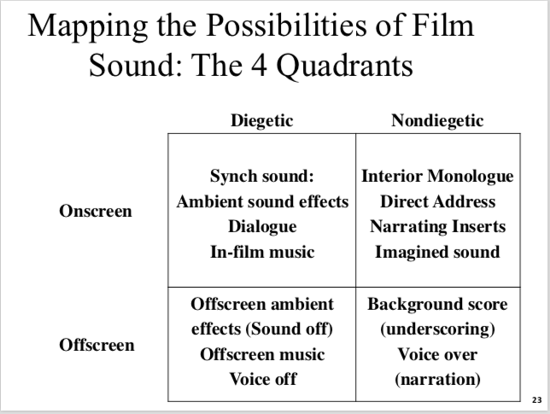

Analyses of Clips/Scenes



