Engineering Materials
MCG 2360

LAB. 2: IMPACT TEST ON METALLIC MATERIALS

Lab section A03

Table of Contents

Abstract…………………………………………………………………...…...………3
Introduction …………………………………………………….…………………...4
Methodology …………………………………………………...……………………..5
Results ………………………………………………………………………..……..5
Discussion …………………………………………………………………………….…7
Conclusion ……………………………………………………………………………....9
References ……………………………………………………………………………....9

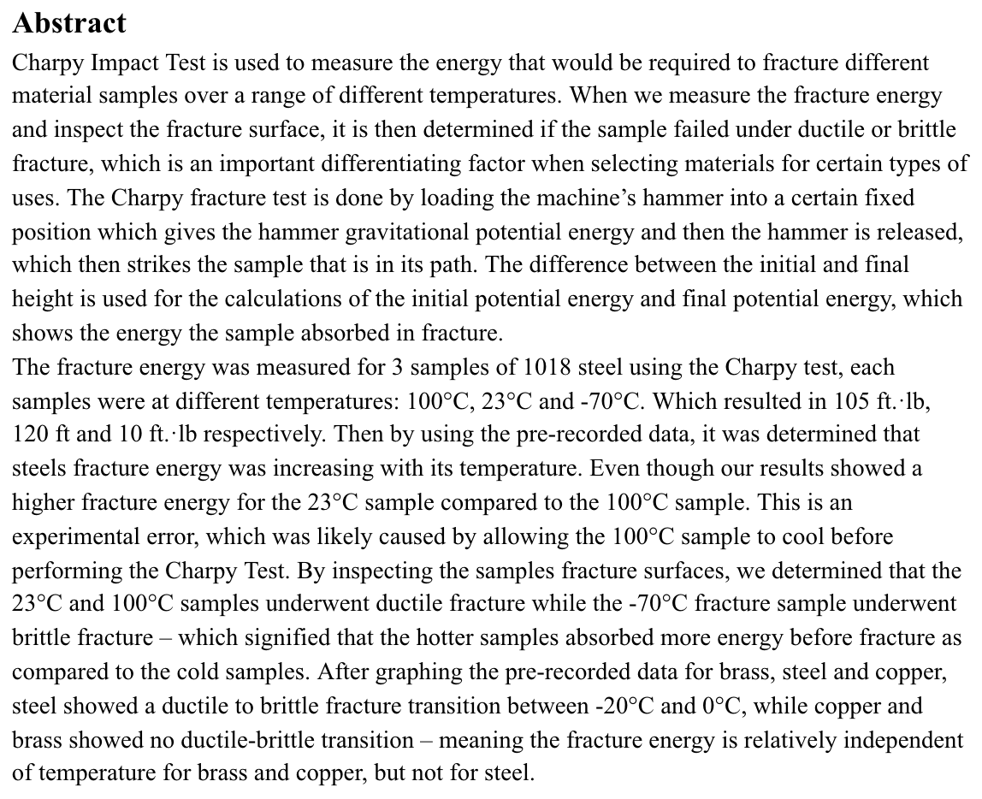

Introduction

Impact energy is a measure of work done to fracture a material. The charpy test is used to find relative/impact toughness of materials. This test determines amount of energy absorbed by a material upon fracture.
For the Charpy test, the material is struck with a controlled weight pendulum. The material is supported on two ends and struck opposite the face to the notch by the pendulum. Amount of energy absorbed in fracturing material is recorded which gives indication on the notch toughness. The height of the pendulum achieved after fracture is measure of the amount of energy absorbed in fracturing the material. These tests are done at different temperatures to provide a ductile to brittle transition curve.

Metals that are ductile at room temperature become brittle at lower temperatures. This is known as ductile to brittle transition. The metals composition strongly affects the ductile to brittle transition temperature. In our lab we will be testing steel. Steel is a very common metal that is able to show the transition behaviour. Steel is expected to have a transition temperature of around 0 degrees celsius. FCC materials are mostly ductile and the high strength materials are usually more brittle in nature. These Brittle materials do not work well under stress. which is why it's important to consider the ductile and brittle properties of these materials

In this lab the Charpy test will be done on Steel for various temperatures. These results are plotted on a graph and the ductile to brittle transition is found.

Methodelogy

The test starts with three samples at three different temperatures. Samples 1, 2 and 3 had temperatures of -70℃, 23℃ and 100℃. All of the samples had a notch and were struck by a pendulum on the opposite side of where the notch was located. The pendulum has a given potential energy that is then transferred to kinetic energy and the lost energy after the impact is calculated. The samples are then visually analyzed. Then this process is repeated until all the samples have been tested.

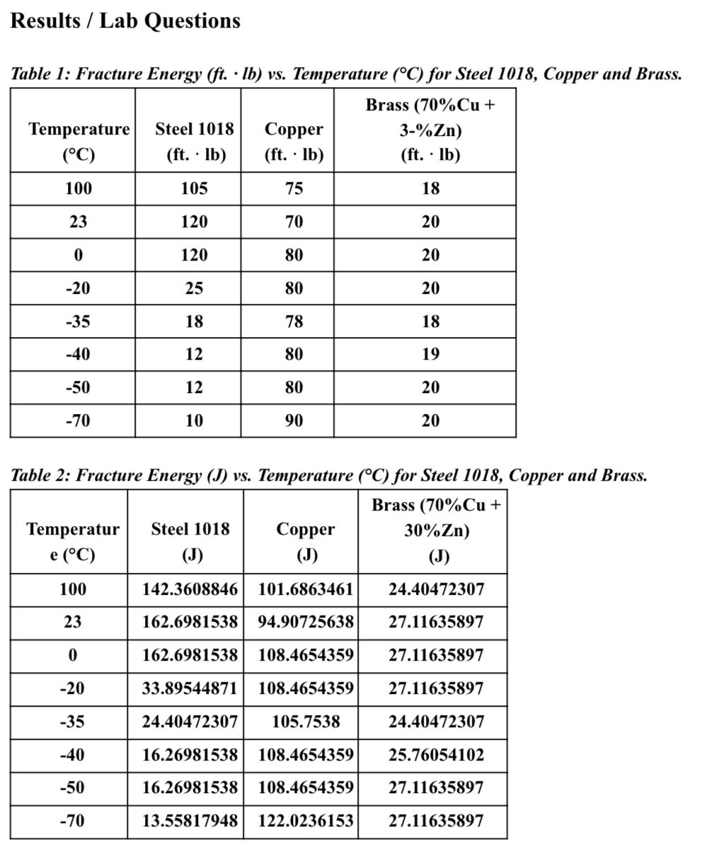

- Fracture resistance is the ability of the material to absorb energy up to point of fracture.
The energy absorption at 23 and -70 is 162 and 13.56 which is a large difference especially compared to the 23 and 100 degree celsius trials. So when the material is in between the two stated of ductile and brittle the steel has highest fracture toughness.

Discussion:

The impact test uses a swinging arm with a given amount of potential energy. When the arm swings down and hits the material, the lost energy is measured and toughness is calculated using the change in energy. The test was conducted using AISI 1018 steel which is a body-centered crystal at room temperature. This means steel has less close neighbors; therefore having a higher energy state which requires greater energy to maintain its position. In addition body-centered crystals have larger spacing, so greater distances are required to move dislocations. Therefore, the energy required to move dislocations in steel is greater than normal.

Energy to move dislocations and temperature are positively correlated with each other. The ductile to brittle temperature is the temperature at which the probability of dislocation moving is equivalent to the probability of lattice slipping. Below that temperature, materials are more likely to show brittle characteristics due to a greater likelihood of dislocations causing slip and creating cracks. Above that temperature, the dislocation is more likely to move and plastically deform which leads to ductile characteristics. At exactly the ductile to brittle temperature when the crack reaches the grain boundary, it propagates in the path that is the least resistance.

There is a large drop off in the energy required below 20℃ which signifies that this material should be used at around 20℃ or higher. This temperature signifies the greatest fracture toughness for steel and occurs when the material is in a moderate ductile state.

When the steel samples were examined the break in the cold steel sample had a clean cut. This signified that crack propagation did not occur and that the sample broke at a very fast rate when compared to the other samples.

Surface energy is the energy required to create a new surface of a material. When the more ductile samples absorbed more energy during testing, it was evident that the surface energy of a material is directly proportional to the material’s toughness.
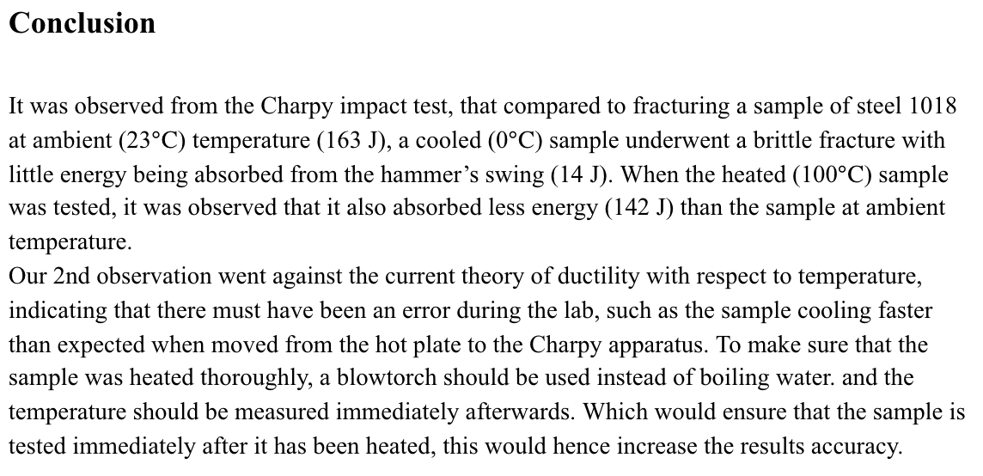

References

[1] The Welding Institute. Fig.2. Charpy Testing Machine. Digital image. TWI Group Websites. TWI Ltd., n.d. Web. 30 Oct. 2016. <http://www.twi-global.com/_resources/assets/inline/full/0/9757.gif>.
[2] Davis, H. E., Hauck G., & Troxell G. (1982). The Testing of Engineering Materials.
Boston: Mcgraw-Hill College
[3 ]Callister, W. D., & Rethwisch, D. G. (2018). Materials Science and Engineering: An
Introduction (9th ed.). Hoboken, NJ: Wiley

