Nelumbo nucifera environmental profile

Chloe Clarkson
8665205

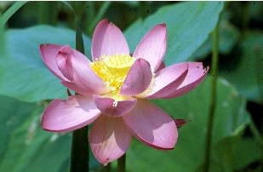
Figure 1. Nelumbo nucifera (USDA, 2018).

Abstract:

Nelumbo nucifera is known as the sacred lotus with many economic important (Han et al, 2009). There are many medical studies that are being done on the different extracts that are can be produced from this lotus (Mukherjee et al, 2009).

Keywords: Nelumbo nucifera, reproduction, variation, treatment, Cretaceous era, angiosperm

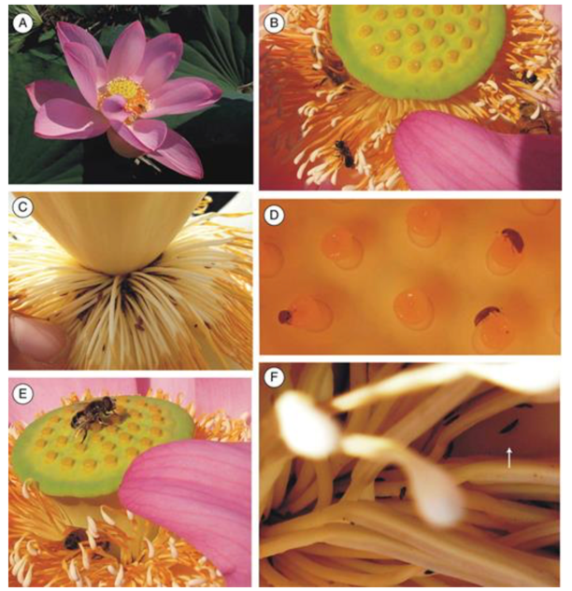
Life Cycle:

Nelumbo nucifera reproduces sexually through seeds and asexually through rhizomes (Han et al 2009). Sexual reproduction is done through the attraction of insects. The insects are attracted to the flower from the scent that is produced. Theses insects consist of beetles, flies, thrips and bees (Figure 2). The insect with then collect the pollen from the stamens and go to another flower. When the insect goes to another flower the stigma will receive the male gametes during fertilization (Li & Huang 2009). When flower reproduces sexually it results in an increase in the clonal diversity. However, when producing asexually there is a low genetic diversity within the population from being dominant (Yang et al 2013).
Figure 2. Nelumbo nucifera with the different types of pollinators (A, B) Bee, (C, D) beetles (E) Fly and (F) is a thrips (Li & Huang, 2009).

Ecological notes:

The floral development from their leaves has
been identified in the late Cretaceous era (Hang et al 2009). This is from the seeds of the plant having the ability to be dominate for decades (Evert & Eichhorn, 2013). Nelumbo nucifera have been on earth for 135 Ma (Xue et al 2006). However, from human activity there has been a decrease in the genetic variation (Yang et al, 2013). An example of human activity is global warming. These activities have caused a bottle neck effect on the plant (Xue et al 2006).
Kingdom | Plantae
Division | Magnoliophyta
Class | Magnoliopsida
Order | Nymphaeales
Family | Nelumbonaceae
Genus | Nelumbo
Species | Nelumbo nucifera

Taxonomic affiliation:
Table 2. Classification of Nelumbo nucifera (Li & Huang, 2009).

Part of the small family of perennial, aquatic angiosperms called
nelumnonacae with Nelumbo nucifera (Table 2). That are characterized
by their simple, peltate leaves that lack stipules and borne on the surface of water (Han et al 2009).

Habitat:
This lotus is found throughout Asia and Australia (Han et al 2009) in tropic wetlands (Xue et al 2006) with eutrophic water (Nohara & Kimura, 1997). Seeds grow into a plant in the benthic zone by the adaptation of green shots which helps in the production of chlorophyll (Ushimaru et al, 2003). When plant is formed it grows optimally in a shallow environment, depth less than 0.5 m. The plant grows the fastest in September due their being less rain (Nohara & Kimura, 1997).

Religion:

Nelumbo nucifera is associated with Buddhism and symbolizes spiritual ideals. When becoming a Buddhist priest, one will cut their hair in the leaves which symbolizes vitality, purity and virtue. There also is a ceremony called Loy Katong ceremony which is the floating of the flower on the water which symbolizes apologizing to the river (La-Ongsri, et al 2009).
Table 1. Nutrient value of per 100g edible rhizome (Sheikh, 2014).
Phytochemistry:

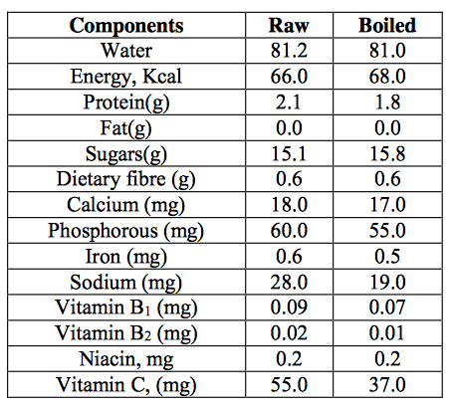
There are several nutritional values that come from
Nelumbo nucifera (Table 1). The rhizomes of the lotus are consumed as a vegetable in Asian countries (Sheikh, 2014). The seeds are also rich in protein, amino acids, unsaturated fatty acids and minerals (Mukherjee et al, 2009). In Asian culture this lotus is considered to be like a starch (Sheikh, 2014).

Medicine:

Nelumbo nucifera has a variety of pharmacological activities from the different extracts of rhizomes, seeds, leaves and flowers. There are traditional, phytochemistry and therapeutic treatments on using this plant (Mukherjee et al 2009).
The use of Nelumbo nucifera extract is beneficial for Alzheimer’s patients. This treatment is a traditional Chinese treatment used for nervous systems disorders is ingesting the embryo (Mukherjee et al, 2009). Another treatment is therapeutic application from the extract from the fruit (Khan et al, 2018). Also, rhizome extract helps with learning and the memory function in the dentate gyrus of the hippocampus (Yang et al, 2008). Therefore, the extract of the plant helps cure nervous system diseases.

Another use is for cancer treatments. Traditionally the seeds and fruits are used in Asia food to help treat cancer. Also, the rhizome extract is used as a tonic to help treat cancer (Mukherjee et al, 2009). However, it is also used in therapeutic treatments for aggressive malignant tumors like hepatocellular carcinoma. Neferine is used to help treat the tumors. It is a alkaloid which is derived from the embryo. The alkaloid attacks the Hep3B cells which arrest the cell cycle (Yoon et al, 2013). Therefore, the extract is useful for the innovation of cancer treatments.

Lastly, the lotus helps with cardiovascular diseases. Traditionally the embryo of the lotus helps with hypertension and arrhythmia (Sridhar & Bhat, 2007). Also, from the ingestion of the leaf it helps with the vascularity of smooth muscle cells. The molecular mechanism inhibits the migration of vascular smooth muscle cells and helps with anti-atherogenic agents (Ho, et al 2010). Therefore, the different parts of the plant have helped with cardiovascular diseases.

Reference
Evert, R.F., Eichhorn, S.E. 2013. Raven Biology of Plants. 676. W.H. Freeman and Company Publisher, New York.
Han, Y. C., et al. (2009). Mating system and genetic diversity in natural populations of Nelumbo nucifera (Nelumbonaceae) detected by ISSR markers. Plant Systematics and Evolution.
Ho, H.-H., et al. (2010). Extract from the leaf of nucifera reduced the development of atherosclerosis via inhibition of vascular smooth muscle cell proliferation and migration. Food and Chemical Toxicology : An International Journal Published for the British Industrial Biological Research Association.
Khan, R.A et al. 2018. Effects of Nelumbo nucifera fruit on scopolamine induced memory deficits and motor coordination. Springer US.
La-Ongsri, W.,et al . (2009). Management and use of Nelumbo nucifera Gaertn. in Thai wetlands. Wetlands Ecology and Management. https://doi.org/10.1007/s11273-008-9106-6
Li, J.K., Huang, S.Q. 2009. Effective pollinators of Asian sacred lotus (Nelumbo nucifera): contemporary pollinators may not reflect the historical pollination syndrome, Annals of Botany.104:5: 845–851.
Mukherjee, P. K., et al (2009). The sacred lotus (&lt;I&gt;Nelumbo nucifera&lt;/I&gt;) - phytochemical and therapeutic profile. Journal of Pharmacy and Pharmacology.
Nohara, S., & Kimura, M. (1997). Growth characteristics of Nelumbo nucifera Gaertn. in response to water depth and flooding. Ecological Research.
Sheikh, S. A. (2014). Ethno-medicinal uses and pharmacological activities of lotus (Nelumbo nucifera). Journal of Medicinal Plants Studies JMPS.
Sridhar, K. R., & Bhat, R. (2007). Lotus – A potential nutraceutical source. Journal of Agricultural TechnologyR. and Bhat Journal of Agricultural Technology.
Xue, J., et al. (2006). Genetic diversity and geographic pattern of wild lotus (Nelumbo nucifera) in Heilongjiang Province. Chinese Science Bulletin.
USDA, NRCS. 2018. The PLANTS Database (http://plants.usda.gov, 11 October 2018). National Plant Data Team, Greensboro, NC 27401-4901 USA.
Ushimaru, T., et al (2003). Chloroplasts in seeds and dark-grown seedlings of lotus. Journal of Plant Physiology.
Yang, M., et al. 2013. Genetic diversity and structure in populations of Nelumbo from America, Thailand and China: Implications for conservation and breeding. 4.
Yang, W. M., et al. (2008). Novel effects of Nelumbo nucifera rhizome extract on memory and neurogenesis in the dentate gyrus of the rat hippocampus. Neuroscience Letters.
Yoon, J. S., et al. (2013). Neferine isolated from Nelumbo nucifera enhances anti-cancer activities in Hep3B cells: Molecular mechanisms of cell cycle arrest, ER stress induced apoptosis and anti-angiogenic response. Phytomedicine.

