ECE Assignment One

Question 1
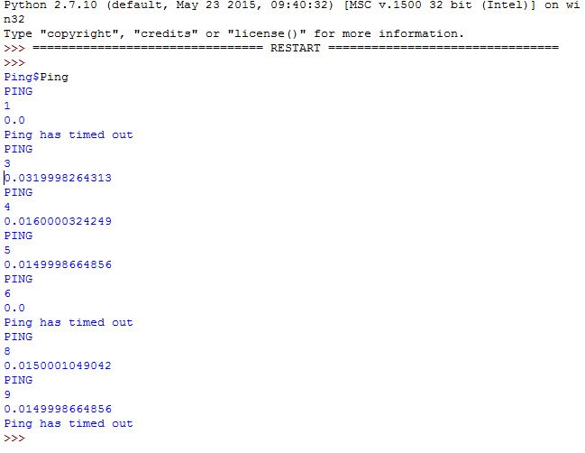
Figure 1 Functioning Ping before statistics
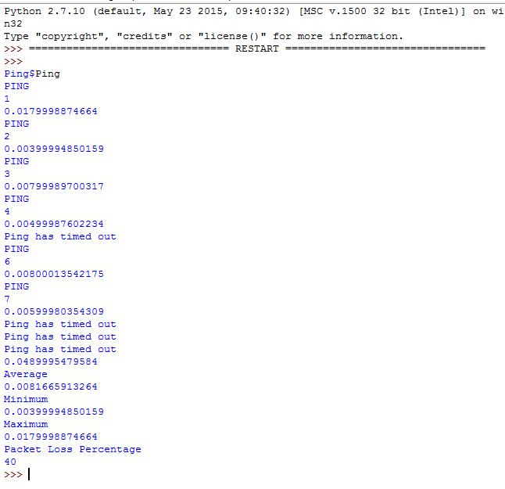
Figure 2 Function Ping with added statics about response time and packet loss

Question 2
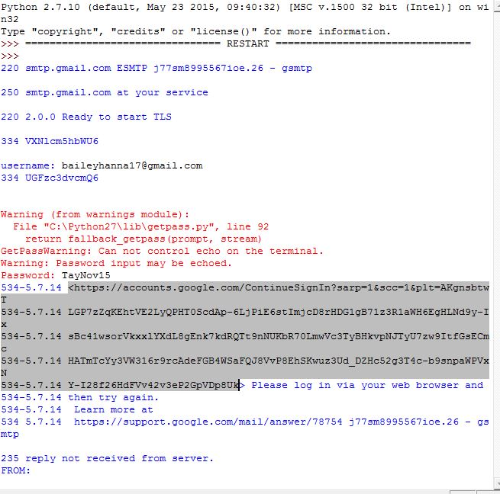
Figure 3 Here we can see my code running then encountering an error from Google Mail where it blocked it from connecting to the server
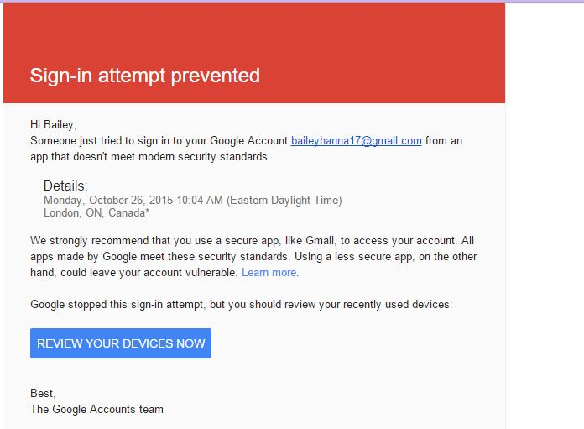
Figure 4 Here we can see that Google has determined my program is not safe enough to allow it to run hence why it blocked

As you can see my code should have run through itself properly if it weren’t for google blocking my request. Due to increased security measures since this exercise was created our programs can no longer access gmail. In order for it to access gmail would have meant compromising the security standards of my personal email account which I am highly uncomfortable doing. We can see however that the requests to connect to the server and my account were completed in full as I was notified by google of this attempted login.

Question 3
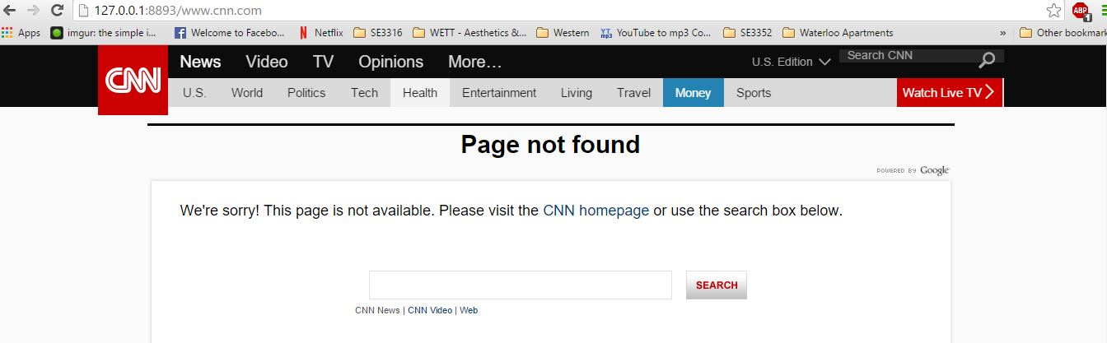
Figure 5 Here we can see that my proxy did connect us to the internet, I was simply trying to access a URL that did not actually exist
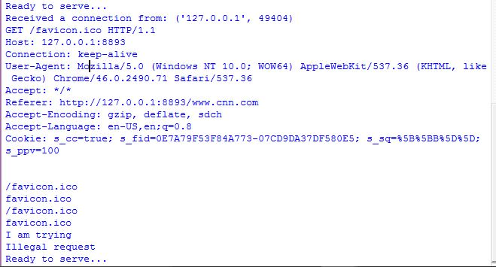
Figure 6 Shown are 2 of the ten attempts, as you can see some objects did not load and came back as an illegal request while some did work

