CVG 2141- Civil Engineering Materials

Lab #2- Sieve Analysis

Mohamed Mustafa
Oct 13, 2015
Benoit.P
Group D2
Abstract
This lab can be divided into two sections. For the first part of the lab the purpose is to calculate the fineness modulus of a fine aggregate as well as learn more about the particle distribution in a sample of fine aggregate, and a sample of coarse aggregate, by calculating properties such as percent passing, percent retained and cumulative percent retained. The second part of this lab consist of finding the bulk specific gravity, the apparent specific gravity and the moisture content of a sample of fine aggregate. The first part will be accomplished by using a large sieve shaker, and a small sieve shaker, as well as a scale. For the second part of the lab, a pycnometer will be used with water, to calculate the relative density of a sample of fine aggregate. The results of this lab are as follows…

The particle size distribution for the fine aggregate, and the coarse aggregate are appropriate by the standards set by CSA A23.1.

F.M. = 3.64

BSG = 2.48

ASG = 2.69

M.C. = 3.2%

In conclusion, all values meet, or are extremely close to meeting, their theoretical counterparts, and so the lab was successful.

Table of contents

Abstract…………………………………………………………………………………….……2

Table of contents……………………………………………………………………..…...3

Table of figures………………………………………………………………………….....4

Objective………………………………………….……………………………………………5

Theoretical background………………………….…………………………………….5-6

Materials and equipment………………………..……………………………………..7

Procedure………………………………………………..……………………….……………7

Analysis of data……………………………………………………………..….…………..7-12

Discussion……………………………………….……………….…………………….……12-13

Conclusion…………………………………………..……………………………..………..13

References…………………………………………………………………………….……..13

Table of figures

Tables

Table1…………………………………………………………………………………………………………………8
Table2…………………………………………………………………………………………………………………8
Table3…………………………………………………………………………………………………………………10
Table4…………………………………………………………………………………………………………………10
Table5…………………………………………………………………………………………………………………11
Table6…………………………………………………………………………………………………………………12

Graphs

Graph1…………………………………………………………………………………………………………………9
Graph2…………………………………………………………………………………………………………………9
Graph3…………………………………………………………………………………………………………………10
Graph4…………………………………………………………………………………………………………………11
Objective
The purpose of this lab is to determine the fineness modulus for both a sample of fine aggregate and a sample of coarse aggregate, as well as finding the relative density (or specific gravity) of the sample of fine aggregate. Understanding the distribution of particle size in an aggregate is useful for the mixing concrete. As learned in class the size of aggregate used in a mix of concrete is restricted by the dimension between forms, the spacing between bars and forms, and the slab depth among other things. The fineness modulus is also needed to find the bulk volume of a sample of aggregate which is needed to find the mass to be used in the mix. The lab will allow us to determine the fineness modulus of two samples of aggregates. This lab is will also give us a better overall understanding of aggregates and aggregate particle size distribution. The specific gravity will be found for the fine aggregate only. Both the bulk specific gravity and the apparent specific gravity will be calculated. These values are necessary for mix design lab that will take place in the future (Lab# 3 casting concrete). The moisture content of the sand will also be calculated. Specific gravity can be used to determine the volume of any ingredient in a mix given the mass. This lab will allow us to calculate specific gravity using only the mass of an aggregate two different states, a pycnometer and water; which is a very useful skill.

Theoretical background
Aggregates are samples of granular material that is mixed with cementing medium to make motor or concrete, or used alone as foundation material or filler. Aggregates can be separated into two categories by size. Fine aggregates are composed of particles less than 5mm in size. Contrarily coarse aggregates contain particles larger than 5mm in size. In fact coarse aggregate usually contains particles between 10mm and 40mm in size. However in both fine and coarse aggregates, the size of the particles varies greatly within the sample. Engineers quantify the distribution of particle size in an aggregate using several methods. Four of these methods will be used during this lab, and all of these methods will require the use of a sieve shaker and sieves of predetermined size. These methods include…

- Percent retained on each sieve: The percent that remains on each sieve after the sieve shaker stops shaking. Calculated as a percent of the total mass of the aggregate.

% retained= Mass of aggregate in sieve x 100%
Total mass of aggregate

- Percent passing for each sieve: The percent of the aggregate that passes through each sieve. Calculated by subtracting the total mass by the mass retained on each sieve, and is therefore also calculated as a percent of the total mass of the aggregate.

% passing= Total mass of aggregate - Mass of aggregate in sieve x 100%
Total mass of aggregate

Or

% passing= 100% - %retained

- Cumulative percent retained: Calculated as the percent retained on the first sieve plus percent retained on the first and second sieve plus the percent retained on the first three sieve, and so on until the sieve in question is reached and the sum so far is added to the percent retained on all sieves up to that point.

Ex: Cumulative% retained for final sieve= %retained for 1st sieve + %retained for 1st and 2nd sieves +…+ %retained for all sieves

- Fineness modulus: Calculated as the sum of cumulative percent retained for all sieves, over 100.

F.M.=ƩCumulative% retained
100

A sieve shaker contains sieves of predetermined size arranged one on top of another. The sieves decrease in size from top to bottom. Aggregate is poured on top of the first sieve, the sieve with the largest mesh size, and the sieve shaker then will vibrated for a period of time, in our lab this period of time approximately 5 minutes. As the sieve shakes any particles smaller than the mesh size for a given sieve will fall through the mesh on to the next sieve. At the end of the process the particles will be separated based on their size into the different sieves. Because the size of each sieve is predetermined we can use the percent retained on each sieve to calculate the fineness modulus, a quantitative description of the particle size distribution for an aggregate.

“Specific gravity is the ratio of the mass of a substance relative to the mass of an equal volume of water at a specified temperature.” ( text book, chapter 1.3 , page 21). In this lab the specific gravity of a sample of fine aggregate, sand, will be calculated using mass of the aggregate in oven-dry state, the mass of a pycnometer filled with water, the mass of the aggregate in saturated surface-dry state and the mass of the pycnometer filled with sand and water to the calibration mark (60ml). The bulk specific gravity and the apparent specific gravity will be calculated with the following formulas…

- BSG_{OD} = A / (B + S – C)

- ASG = A / (B + A – C)

Where
A = mass of the oven-dry sand (g)
B = mass of the pycnometer filled with water (g)
S = mass of the assumed saturated surface-dry sand (g)
C = mass of the pycnometer filled with sand and water to the calibration mark (g)

Using these values moister content can also be calculated.

- MC% = (S – A) x 100%
A

Materials and equipment

Materials
- Sand
- 20-mm crushed limestone aggregate
Equipment
- Scales
- Small sieves
- Large sieves
- Sieve shaker
- Pycnometer or other suitable container into which the fine aggregate sample can be introduced
- Oven

Procedure

Sieve analysis
500g of sand is poured into the small sieve shaker then the sieve shaker is turned on for five minutes. After five minutes the sieve shaker is turned off. The sieves are taken out of the sieve shaker one at a time, and the amount of aggregate retained on each sieve is weighed. Once all the sieves have been taken out and their contents weighed, the sand is discarded. The same process will take place with the large sieve shaker and 5kg of coarse aggregate.

Relative density of fine aggregate
A pycnometer is filled with water to the 60ml mark and its mass is recorded as mass “B”. Sand from a stock pile assumed to be in saturated surface dry condition is measured and its mass is confirmed to be 500g. The 500g of sand is recorded as mass “S”. Water is added to the pyncnometer, and then the 500g of sand is added before the pynometer is filled with more water to the point of covering the sand. The mixture of sand and water is agitated and stirred so no air bubbles are left. The pynometer is filled with more water until the 60 ml mark. The weight of the pynometer filled with the sand/water mixture is mesureed and recorded as mass “C”. The mass of a drying pan is recorded, and the sand is removed from the pynometer and placed on the drying pan. Both the drying pan and the wet sand are place in an oven to dry until the sand reaches oven dry state. The mass of the drying pan with the oven dry sand on it recorded. By subtracting the mass of the drying pan from the mass the mass of the drying pan with the oven dry sand on top, the mass of the oven dry sand is found and designated mass “A”.

Analysis of data

Sieve analysis
The mass retained for each sieve was recorded. The mass of fine aggregate retained for each sieve of the small sieve shaker was recorded in the second column of Table1. The mass of coarse aggregate retained on each sieve of the large sieve shaker was recorded in the second column of Table 2.

The percent retained on each sieve was calculated using equation1.
The percent passing was calculated using equation2.
The cumulative percent retained for each sieve was calculated using equation3.

All equations can be found in the “Theoretical background”.

Table1: Fine aggregate
Sieve size(mm) | Mass Retained(g) | Percent Retained(%) | Cumulative Percent Retained(%) | Percent Passing(%)
4.75 | 3.0 | 0.6 | 0.6 | 99.4
2.36 | 71.5 | 14.3 | 14.9 | 85.7
1.18 | 95.0 | 19.0 | 33.9 | 81.0
0.60 | 85.0 | 17.0 | 50.9 | 83.0
0.30 | 102.0 | 20.4 | 71.3 | 79.6
0.15 | 111.0 | 22.2 | 93.5 | 77.8
Pan | 28.0 | 5.6 | 99.1

Table2: Coarse aggregate
Sieve size(mm) | Mass Retained(kg) | Percent Retained(%) | Cumulative Percent Retained(%) | Percent Passing(%)
20.0 | 0.4 | 8.0 | 8.0 | 92.0
12.5 | 1.6 | 32.8 | 40.8 | 67.2
10.0 | 1.2 | 24.4 | 65.2 | 75.6
5.0 | 1.4 | 27.2 | 92.4 | 72.8
2.5 | 0.2 | 3.6 | 96.0 | 96.4
Pan | 0.2 | 4.0 | 100.0

Fineness modulus of the fine aggregate was found using equation4.

F.M.=ƩCumulative% retained
100

F.M. = (364.1)/100

F.M. = 3.64

The percent passing for each sieve was plotted versus the sieve size, for both the fine aggregate and the coarse aggregate. Percent of fine aggregate passing versus sieve size was plotted on Graph1. Also plotted on Graph1 was the upper and lower grading limits for FA2. FA2 was used because the fineness modulus of the sand was found to be 3.64.

Graph1: Percent passing versus sieve size (Fine aggregate)
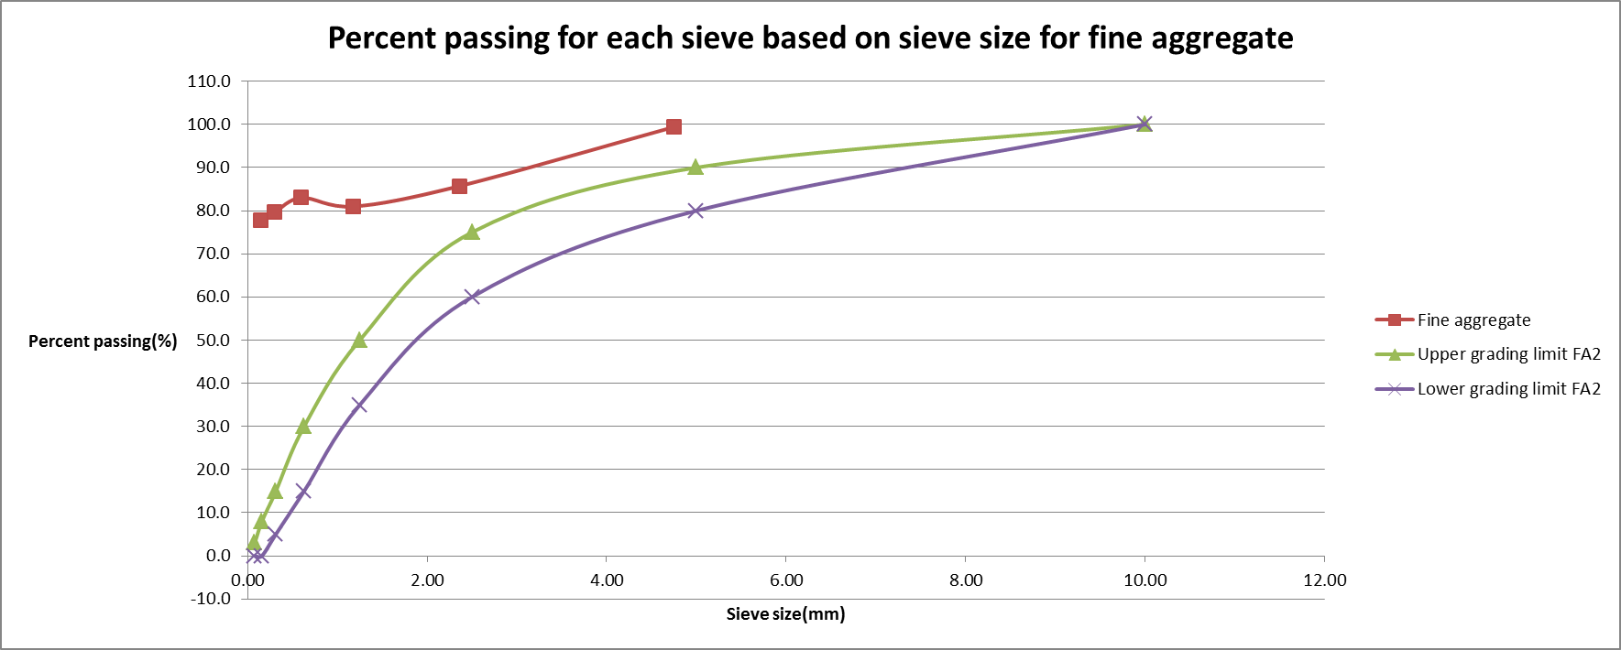

Percent of coarse aggregate passing versus sieve size was plotted on Gaph2. Also plotted on this graph was the upper and lower grading limits for the coarse aggregate.

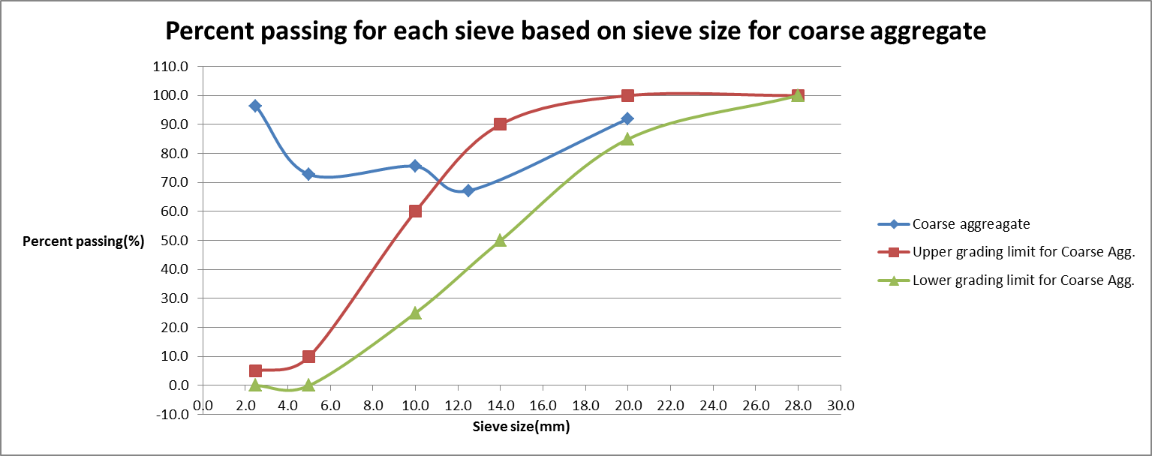
Graph2: Percent passing versus sieve size (Coarse aggregate)

However in neither case did the curve produce by my experimental values lay in between the theoretical grading limits.

I believe that there was a misunderstanding on my part, and that the percent passing was to be cumulative in a sense. I found a new value for percent passing that a named “Cumulative percent passing”. It is calculated as follows…

Cumulative %passing = 100% - Cumulative %
The cumulative percent passing was found and recorded in the two new tables; Table3 for the fine aggregate, Table4 for the course aggregate.

Table3: Fine aggregate
Sieve size(mm) | Cumulative percent passing(%)
4.75 | 99.4
2.36 | 85.1
1.18 | 66.1
0.60 | 49.1
0.30 | 28.7
0.15 | 6.5

Table4: Coarse aggregate
Sieve size(mm) | Cumulative percent passing(%)
20.0 | 92.0
12.5 | 59.2
10.0 | 34.8
5.0 | 7.6
2.5 | 4.0

I then plotted cumulative percent passing versus sieve size, and added the upper and lower limits for both FA2 and the coarse aggregate. The new data for the fine aggregate was plotted on Graph3. The new data for the coarse aggregate was plotted on Graph4.

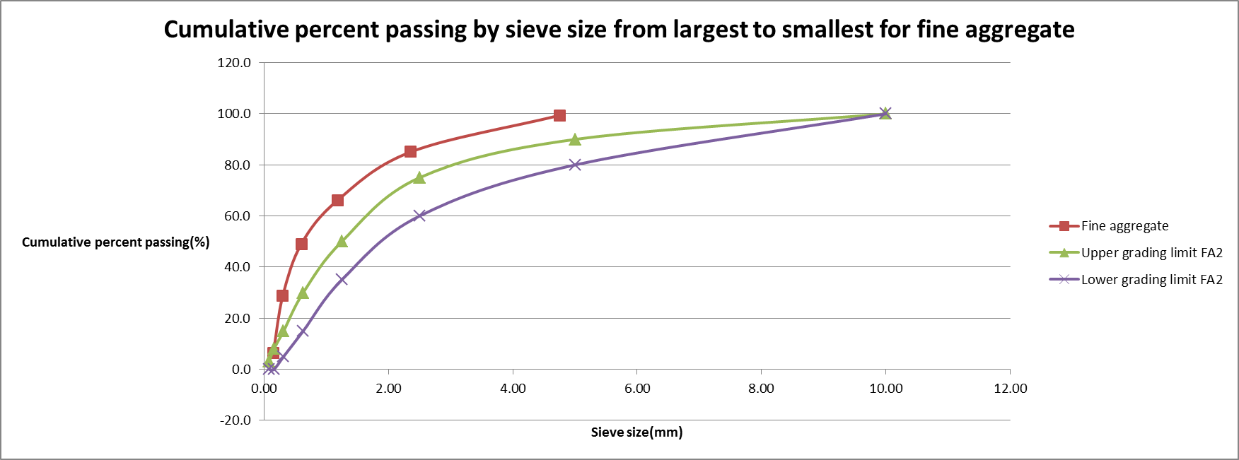
Graph3: Fine aggregate

Although the curve for cumulative percent passing for fine aggregate does not lie between the upper and lower grading limits for FA2, the slope of this curve resembles the slope of the upper and lower grading limits much more closely than the curve in Graph1.
Graph4: Coarse aggregate
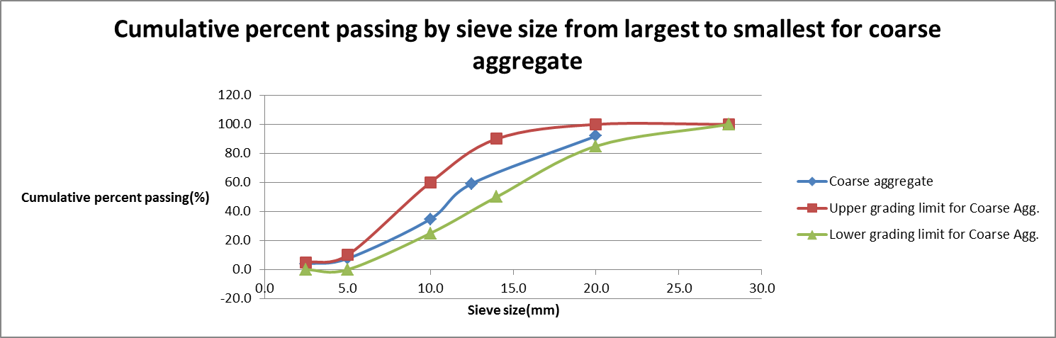

The curve created by using the cumulative percent passing for the coarse aggregate lies in between the upper grading limit for the coarse aggregate, and the lower grading limit for the coarse aggregate.

I believe this is what the lab originally asked for.

Relative density of fine aggregate

The mass of sand in SSD condition was found to be=500.0g
The mass of the Pyncometer + Sand + Water=1099.5g
The mass of the Pyncometer + Water=795.0g
The mass of the drying pan=312.5g
The mass of drying pan + sand in OD condition=796.5g

Mass of OD sand= (The mass of drying pan + sand in OD condition) – (The mass of the drying pan)
= 796.5g – 312g
= 484.5g
The values and their corresponding variables have been tabulated in Table5

Table5: Mass for the values of S, C, B and A
Mass(g) | Variable
500.0 | S
1099.5 | C
795.0 | B
484.5 | A

With these values, the bulk specific gravity, the apparent specific gravity, and the moisture content can now be calculated using equation5, equation6, and equation7.

BSG_{OD} = A / (B + S – C)
= 484.5 / (795.0 + 500.0 – 1099.5)
= 2.48

ASG = A / (B + A – C)
= 484.5 / (795.0 + 484.5 – 1099.5)
= 2.69

MC% = (S – A) x 100%
A
= (500.0 – 484.5) x 100%
484.5

= 3.20%

All three of the above values can be found in Table6

Table6: Values for specific gravity of fine aggregate
Bulk specific gravity = 2.48
Apparent specific gravity = 2.69
Moisture content = 3.2%

Discussion
By looking at Graph3 and Graph4 it can be said that the lab achieved limited success. The fine aggregate failed to meet the gradation specifications given in CSA A23.1 and landed just above the upper grading limit for FA2, but because the slope of this curve is appropriate it can be assumed that this deviation is the result of the sources of error that will be discussed later. The coarse aggregate fully met the required specifications given in CSA A23.1. These results indicate that the particle size distribution for the fine and coarse aggregates is normal by theoretical standards. In other words the particle size distribution for both samples in neither too sporadic, nor is it too uniform to be considered normal. The fineness modulus for the sample of fine aggregate was found to be 3.64, which lies directly within the range described in table10 of CSA A23.1. This is a good indication that the fineness modulus is accurate.

The bulk specific gravity was found to be 2.48, calculated using equation5. The apparent specific gravity was found to be 2.69, calculated using equation6. This seems accurate because bulk specific gravity is typically less than the apparent specific gravity. The moisture content of the sample of fine aggregate was found to be 3.2%
One major source of error is that as the mesh size for the sieves became smaller and smaller, more particles became trapped in the sieve despite efforts to remove them. Specifically for the sand, many particles were lost entirely before they could be weighed; either because they were trapped in the sieve or they fell while trying to remove them from the sieve. This would have resulted in incorrect data for Table1-Tables4 as well as all the graphs. However the error would not cause a large deviation as only a small amount of particles was lost. If particles caught in the sieve were not weighed, it would artificially reduce the %retained for that sieve. As a result, the present passing would be artificially exaggerated. This perfectly explains way the curve for the cumulative percent passing of fine aggregate lies slightly above the upper grading limit for FA2. This is the only major source of error in this lab. To fix this I would recommend calculating the mass of each sieve before any aggregate is introduced, and then measure the mass of the aggregate and the sieve. After words, subtraction can be used to fine the mass retained on each sieve.

Conclusion
In conclusion the coarse aggregate sample landed in between the upper and lower limits stated in CSA A23.1. The sample of fine aggregate landed just above the upper grading limit of FA2 stated in CSA A23.1, and the fineness modulus for the sand was found to be 3.64.

The bulk specific gravity of the sand was found to be 2.48 and the apparent specific gravity was found to be 2.69. The moisture content of the sand was found to be 3.2%

Throughout the course of this lab I learned to calculate quantitative value of all the above mentioned properties of aggregates, and I have a deeper understanding of aggregates in general.

References
CVG2142 Class notes

CVG2141 Lab #2 Manuel

Materials-for-Civil-and-Construction-Engineers-3rd-Ed-M-Mamlouk-J-Zaniewski-Pearson-2011

