GLOBAL LAND-USE AND LAND-COVER CHANGE: PART 1
- What is the distinction between land use and land cover? Can you give an example that illustrates the differences in their definitions?
Land-use and land-cover change (LULCC) – or land change – is a general term for the human modification of Earth’s terrestrial surface. Land change happens locally, but these local changes can accumulate to have global impacts (e.g. tropical forest clearing reduces carbon sequestration, which affects global atmospheric CO2).
Land Cover: the physical and biological characteristics of the land surface (including water, vegetation, bare soil and artificial structures)
Land Use: human activities on the land (e.g. agriculture, forestry and development) that affect land surface processes. Can also encompass the socioeconomic purposes or contexts within which lands are managed (e.g. subsistence versus commercial agriculture, rented vs. owned, or private vs. public land).
- In what ways might we assess land-use and land-cover change?
Many-to-one relationship: One land cover could be used for multiple purposes or objectives
“Land use is characterized by the arrangements, activities and inputs people undertake in a certain land cover type to produce, change or maintain it”
What: the purpose of activities undertaken (e.g. the specific products or services sought, such as crops)
Where: the geographic location and spatial extent
When: the temporal aspects of various activities undertaken and how they change over time
How/ How much: quantitative measures (e.g. area used, production, inputs and technology)
Why: the reasons underlying the current land use (e.g. ownership and economic forcers, etc)
- Can you name one type of remote sensing image or platform and give an example of how scientists might apply this technique to understanding changes in global land use?
Remote Sensing: An essential tool for monitoring land change
Facilitates observations across larger extents of Earth’s surface than feasible with ground-based observation
Wide Vies, Consistent, repeatable, discreet
Accomplished by use of cameras, multi-spectral scanners, RADAR and LiDAR sensors mounted on air- and space-borne platforms, yielding aerial photographs, satellite imagery, RADAR and LiDAR datasets
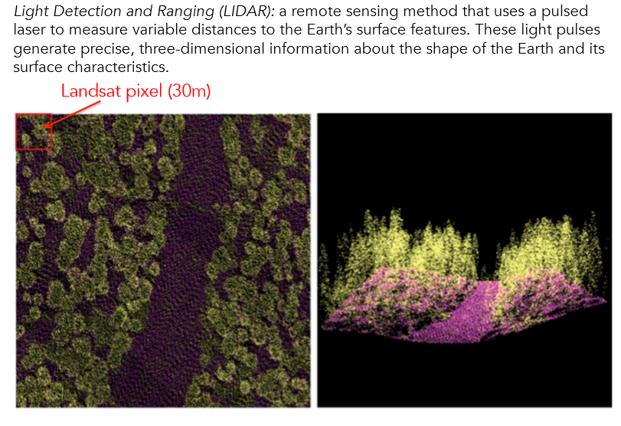
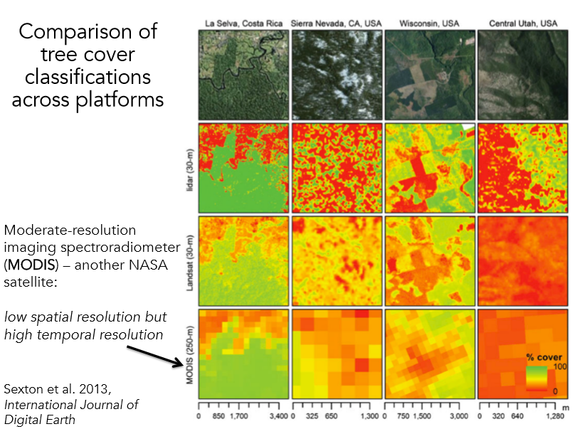
Landsat:
NASA’s Landsat program offers the longest continuous global record of the Earth’s surface: More than 40 years worth of spectral information about Earth’s surface, creating a historical record “unmatched in quality, detail, coverage, and length.”
Optical remote sensing makes use of the electromagnetic spectrum (reflected solar radiation: visible, near infrared, short-wave).
Vegetation, soil and water have a specific ‘spectral response.’
- How does agriculture shape global land use and land cover?
  - We use about 38% of the Earth’s ice-free surface for agriculture.
  - About 24% of Earth’s terrestrial surface is occupied by croplands and other cultivated systems.
  - Cropland continues to expand in some areas but is shrinking in others (agricultural abandonment).
  - We can assess the spatial extent of most crops, and their yields, using a fusion of satellite observation and government statistics.
- How do we define a “forest” and what is the extent of forest globally?
  - In 2010, just over 4 billion ha, roughly 30% of global land area.
  - FAO(United Nations Food and Agriculture Organization)-FRA(Forest Resources Assessment) Forest Definition
    - Forest are defined as land spanning:
      - More than 0.5 hectares
      - With trees higher than 5 metres
      - Canopy cover of more than 10%
      - Does not include land under agricultural or urban land use
- How do we define urban? Approximately how much land cover is devoted to cities worldwide?
  - Less than 0.5% of the Earth’s total land area
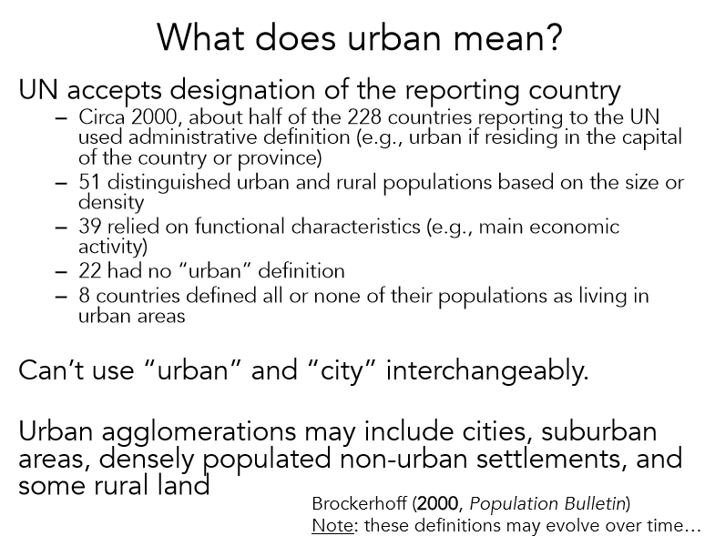
- What does “urbanization” mean, and what do urbanization trends look like?
  - Urbanization: the process by which a large number of people becomes permanently concentrated in relatively small areas, forming cities
  - Urbanization often connotes a change in land use or land cover
  - 150 Years of Global Urbanization
    - 1900: 14%
    - 2008: 50%
    - 2050: 70%
- How much of the Earth’s surface is ‘urban’ (give a range, in %) and what fraction of the global population lives in urban areas this decade?
  - 50% of the world’s population is now urban.
  - The world’s urban population is 3.7 billion people – the number will double by 2050.
  - By 2030, 96% of all urbanization will occur in the developing world.
  - Cities generate over 80% of the world’s GDP.


