PSYC 351 FUNDAMENTALS OF LEARNING
CHAPTER 4: Classical Conditioning Mechanisms

Thus far what makes an effective CS and US:
- US is effective in eliciting a response from the outset (unconditionally) without any training required.
- CS does not elicit the CR initially, but does so after being associated with the US.
- Identification of CS and US is relative:
  - What is used as a CS in one context can be used as a US in another context.
  - I.e. conditioned taste aversion study: CS = saccharin, US = radiation
  - Sign tracking study: CS = light cue, US = saccharin

What makes effective conditioned and unconditioned stimuli?
- 1. CS and US novelty
  - CS preexposure
  - US preexpusure
- 2. CS and US intensity and salience
- 3. CS-US relevance, or belongingness

Novelty of Conditioned and Unconditioned Stimuli:
- The behavioural impact of a stimulus depends on its novelty.
- Highly familiar stimuli elicit less vigorous reactions than do novel stimuli.
- If either the conditioned or the unconditioned stimulus is highly familiar, learning occurs more slowly than if the CS and US are novel.
- 1. Latent-Inhibition (CS pre-exposure effect):
  - Interference with conditioning produced by the repeated exposure to the CS before conditioning trials.
  - Novel stimuli are more effective than familiar stimuli.
  - Involves two phases:
  - Phase 1: P’s are first given repeated presentations of the CS by itself this is called the preexposure phase because it comes before the conditioning trials.
    - CS preexposure makes the CS highly familiar and insignificant because the CS is presented alone.
  - Phase 2: CS is paired with US using classical conditioning trials.
    - Common result is that p’s are slower to acquire responding because of the CS preexposure.
    - The effect is called latent inhibition (to distinguish it from conditioned inhibition)
  - Latent inhibition appears to protect the organism from information overload by attenuating the processing of previously irrelevant stimuli.
    - Learning too much about environment learning that it means nothing (CS-) causes latent inhibition/CS preexposure effect.
  - Has become of great interest in analyses of human behaviour, especially schizophrenia.
- 2. US pre-exposure effect:
  - Interference with conditioning due to repeated exposures to the US before the conditioning trial.
    - Exposure to US too often becomes difficult to condition.
  - Conditioning proceeds faster for novel stimuli than familiar stimuli.
  - Works for both aversive (fear conditioning, taste aversion learning, and drug conditioning) and appetitive conditioning

CS and US intensity/salience (obviousness):
- More vigorous conditioned responding occurs when more intense conditioned and unconditioned stimuli are used.
  - Most biological and physiological effects of stimulation are related to the intensity of the stimulus input also true of Pavlovian conditioning.
- Stimulus intensity is one factor that contributes to stimulus salience.
- Stimulus salience: significance, noticeability or obviousness.
- Learning will occur more rapidly with more salient stimuli.
- Can make a stimulus more salient/significant:
  - By making it more intense, more attention-getting.
  - By making it more relevant to the biological needs of the organism.
    - Animals become more attentive to the taste of salt if they suffer a nutritional salt deficiency.
  - By making it more similar to the kinds of stimuli an animal is likely to encounter in its natural environment.
  - I.e. sexual conditioning in mail quails: the more a fake quail looks like a quail, the more effective the sexual conditioning will be more natural looking; works better.
  - Access to female quail serves as the sexual reinforcer, or US, for a male bird add this sexual opportunity is signaled by the presentation of a CS.
  - The CS can be an arbitrary cue like a light or block of wood.
  - Alternatively, the CS can be made more natural or salient by adding partial cues of a female if a naturalistic CS is used in sexual conditioning, the learning proceeds more rapidly, more components of sexual behaviour become conditioned, and the learning is not as easily disrupted by increasing the CS-US interval.

CS-US relevance, or belongingness:
- The extent to which the CS is relevant to or belongs with the US.
  - The kind of stimuli presented with the US is important.
- I.e. Garcia and Koelling’s experiment with rats:
  - Compared learning about peripheral pain (induced by foot shock) and learning about illness (induced by irradiation or drug injection)
  - In natural environment: rats are likely to get sick after eating poisonous food, and are likely to encounter peripheral pain after being chased and bitten by a predator that they can hear and see.
  - To represent food-related cues: used a flavoured solution of water.
  - To represent predator-related cues: used an audiovisual CS.
  - Rats drank from a drinking tube before administration of either the shock or illness US.
  - Drinking tube was filled salty or sweet flavored water.
  - Each lick on the tube activated a brief audiovisual stimulus (a click and a flash of light) rats encountered taste and audiovisual stimuli at the same time.
  - After exposure to these CSs, the animals either received a brief shock through the grid floor or were made sick.
  - US: shock or illness
    - Since both USs were aversive, the rats were expected to learn an aversion.
  - CS: taste + audiovisual
    - To observe aversions the taste and audiovisual CSs were presented individually after conditioning.
  - Conditioning:
    - Group 1: Taste + audiovisual shock
    - Group 2: Taste + audiovisual sickness
  - Test:
    - During tests of the taste CS: the water was flavored as before but now licks did not activate the audiovisual cue.
    - During tests of the audiovisual CS: the water was not flavored, but the audiovisual cue was briefly turned on each time rat licked spout.
  - Results:
    - Conditioned aversions were inferred from the suppression of drinking.
    - Group 1: rats conditioned with shock suppressed drinking more when tested with audiovisual stimulus.
    - Group 2: rats conditioned with sickness suppressed drinking more when tested with taste CS.
    - Learning depended on the relevance/belongingness or the CS to the US.
    - Taste = became associated with illness
    - Audiovisual cues = became associated with peripheral pain.
    - Rapid learning occurred only if the CS was combined with the appropriate US.
- Biological preparedness/genetic predisposition: the phenomenon appears to reflect a genetic predisposition for the selective learning of certain combinations of CS and US.

Learning without an unconditioned stimulus (US)
- We’ve discussed classical conditioning in situations that include a US: a stimulus that has a large behavioural impact unconditionally, without prior training.
- If Pavlovian conditioning wee only applicable to situations that involve a US it would be somewhat limited…
- There are two different forms of classical conditioning without a US: higher order conditioning, and sensory preconditioning.
  - 1. Higher order conditioning
    - Irrational fears are often learned through higher order conditioning.
    - I.e. developed fear of crowds:
      - Being in a crowd was a CS that elicited conditioned fear.
      - Perhaps was pushed and shoved in crowd (CS) and suffered injury (US).
      - To avoid fear, goes to movies during daytime; suddenly theater becomes crowded results in avoiding theaters.
      - One CS (crowds) had conditioned fear to another CS (movie theater) that previously elicited no fear.
    - Process for higher-order conditioning:
      - Occurs in two phases.
      - Phase 1: a cue, CS₁ is first paired with a US often enough, and conditions a strong conditioned response to CS₁
        - First-order conditioning: CS₁ + US = CR
      - Phase 2: once CS₁ elicits the CR, pairing CS₁ with a new stimulus, CS₂, conditions CS₂, to elicit the CR.
        - Second-order conditioning: CS₂ + CS₁, CS₂ CR.
      - The conditioning of CS₂ occurs in the absence of the US.
      - If after becoming conditioned CS₂ were used to condition another stimulus, that would be third-order conditioning.
    - Similar to conditioned inhibition… Why does such a procedure produce conditioned inhibition in some cases and excitatory second-order conditioning under in other circumstance?
      - One important factor appears to be the number of noUS or nonreinforced trials.
        - With relatively few noUs trials, second-order excitatory conditioning occurs.
        - With extensive training, conditioned inhibition develops.
      - Another important factor is whether the first and second-order stimuli are presented simultaneously or sequentially.
        - Simultaneous presentations of CS₁ andCS₂ on nonreinforced trials favor the development of conditioned inhibition to CS₁.
  - 2. Sensory pre-conditioning:
    - Associations can also be learned between two stimuli, each of which elicits only a mild orienting response before conditioning.
    - I.e. consider vanilla and cinnamon that you often encounter together in pastries without ill effects.
      - Because of these pairings the vanilla and cinnamon might become associated with one another.
      - What would happen if you acquired an aversion to cinnamon through food poisoning or illness?
      - Chances are the acquired aversion to cinnamon would lead to also reject things with the taste of vanilla because of prior association of vanilla with cinnamon.
      - Phase 1: vanilla and cinnamon flavors become associated with one another when there is no illness or US.
        - CS₂ + CS₁ = sensory preconditioning phase.
        - Association is usually not evident in any behavioural responses because neither CS has been paired with a US yet, so there’s no reason to respond.
      - Phase 2: cinnamon (CS₁) is paired with illness (US) and a conditioned aversion (CR) develops to CS₁.
        - CS₁ + US = CR CS₁.
      - Test: Once first order conditioning has been completed, participants are tested with CS₂ and now show an aversion to CS₂ for the first time.
        - CS₂ CR
        - The response to CS₂ is noteworthy because CS₂ was never directly paired with a US.
    - NOTE: second-order conditioning and sensory preconditioning are similar, but the order of associations is different.
    - Second-order conditioning: CS₂ + CS₁, CS₂ CR.
      - Once CS₁ elicits the CR, pairing CS₁ with a new stimulus, CS₂, conditions CS₂, to elicit the CR.
    - Sensory preconditioning: CS₂ is never directly paired with a US.
- Higher-order conditioning and sensory preconditioning help us make sense of things we seem to like or dislike for “no apparent reason” these stimuli were not directly associated with a positive or negative US.

What determines the nature of the CR?
- 1. US affects CR:
  - The most obvious factor that determines the nature of the conditioned response is the unconditioned stimulus that’s used.
  - Even small variations in the nature of the US can produce changes in the nature of the CR.
  - Stimulus substitution model: association of CS with US turns CS into a surrogate US, eliciting the same underlying neural pathways.
    - CS comes to function much like the US previously did.
    - Thus, the CS is assumed to activate neural circuits previously activated only by the US and elicit responses similar to those elicited by the US.
    - Emphasizes that the nature of the conditioned response depends a great deal on the US that is used in a conditioning procedure however in many cases the CR does not resemble the UR.
      - Foot shock = causes rats to leap into the air.
      - CR to a tone + foot shock is freezing and immobility.
    - The biologically important consequence of Pavlovian conditioning is not a change in responding to the CS but a change in how the organism responds to the US.
  - CS pathway US pathway: pathway created through association
  - CS pathway US pathway Response pathway: established pathway.
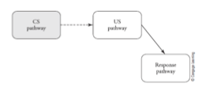
- 2. CS affects CR:
  - Another factor that determines the form of the CR is the nature of the CS.
  - Study of classical conditioning in rats with food as US:
    - Instead of a conventional light or tone, presented another rat as the CS before the food delivery.
    - Ten seconds before delivery of food, CS rat was moved into the experimental chamber through the flap door.
    - The stimulus substitution model predicts that CS-US pairings will generate responses to the CS that are similar to responses elicited by the food US.
    - Rats should therefore start salivating or biting in response to a CS that predicts a food reward.
    - Contrary to this prediction, rats displayed social behaviours upon presentation of the rat CS as the CS rat was repeatedly paired with food, it came to elicit social affiliative responses (orientation, approach, sniffing and social contacts)
    - Such responses did not develop if the CS was presented at times unrelated to food.
      - Chapter 3: if the extension of a response lever into the experimental chamber serves as the CS for food, rats either contact and gnaw the lever (showing sign tracking) or go to the food cup (showing goal tracking)
      - They do not respond to the lever with social affiliative responses.
      - A CS object that male quail can mount and copulate with is more likely to elicit conditioned copulatory responses than a light or wood block CS.
- 3. Altering the CS-US interval:
  - What kind of responses become conditioned is also determined by the CS-US interval (interstimulus interval)
  - I.e. Seeing a car coming toward you is a CS for potential injury how you react to this danger depends on how quickly the car will reach you (CS-US interval)
  - Conditioning with a short CS-US interval activates responses appropriate for immediately dealing with the US.
    - If the car is within 1-2 seconds of reaching you, you will panic and ump out of the way.
    - Conditioned fear or panic: is more likely with a short CS-US interval
  - Conditioning with a long CS-US interval activates responses that prepare for US over longer time period.
    - If the car is within 15-20 seconds of reaching you, you will be concerned, and take evasive action, but you will not panic and jump.
    - Conditioned anxiety: is more likely with a long CS-US interval
  - The CS-US interval determines where the CS becomes incorporated into the behavioural sequence.
    - Long CS-US interval between general search behaviour (CS) and consummatory behaviour (US)
    - Short CS-US interval between focal search behaviour (CS) and consummatory behaviour (US)
    - Different CSs different CS-US intervals.
  - Sexual conditioning in quails:
    - Most studies of sexual conditioning employ a rather short CS-US interval (1 min or less) and measure approach (CR) to the CS or sign tracking.
    - When sexually motivated, the male quail will engage in a general search response that brings it into an area where a female may be located.
    - Once he is in the female’s territory, the male will engage a more focal search response to locate the female.
    - Once he finds her, the male will engage in courtship and copulatory responses.
    - Different groups were training with a CS-US interval that was either short (1 min) or long (20 min).
    - With a short CS-US interval, the CS occurs just before the female is available, and is incorporated into the behaviour system at the focal search stage.
      - CS right before female = focal search behaviour.
      - The CS is predicted to elicit focal search behaviour.
      - The male should approach and remain near the CS.
      - Conditioned CS approach but not general locomotor behaviour.
    - With a long CS-US interval, the CS becomes incorporated into an earlier portion of the behaviour system and elicits general search behaviour.
      - CS long before female = general search behaviour
      - The general search behaviour is manifest in increased nondirected locomotion.
      - Conditioned locomotor behaviour but not CS approach.
  - The conditioned response that reflects the anticipation of the US depends on how long one has to wait before the US is presented.
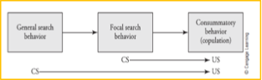
- 4. Behaviour systems theory:
  - A behaviour system consists of a series of response modes, each with its own controlling stimuli and responses, arranged spatially and/or temporally.
  - Responding depends not only on the US but also on the CS and CS-US interval.
  - Theory assumes that: the presentation of a US in a classical conditioning procedure activates the behaviour system relevant to that US.
  - Classical conditioning procedures involve superimposing a CS-US relationship on the behavioural system activated by the US.
  - As a CS becomes associated with the US, it becomes integrated into the behavioural system and elicits components of that system.
  - It readily explains why the US is an important determinant of the CR.
  - It is also consistent with the fact that the nature of the CR depends on the type of CS employed.
    - The nature of the CS will determine what kinds of conditioned responses can develop.
  - The most innovative prediction of behaviour systems theory is that the form of the CR will also depend on the CS-US interval used.
- 5. SS vs. SR learning:
  - How does a conditioned stimulus produce responding?
  - Historically, a conditioned behavioural response, was viewed as a response elicited directly by the CS.
  - Original view of classical conditioning is stimulus-response learning:
    - Conditioning elicits a new stimulus-response connection between the CS and CR.
    - CS CR
    - CS gets response on its own; doesn’t need US anymore.
  - Alternate view is that subjects learn a new stimulus-stimulus connection between the CS and the US.
    - S-S learning: p’s respond to CS (not because it elicits a CR directly) but because it represents the US.
    - CS substitutes for US
    - CS US representation CR
    - US is necessary, if it’s changed or devalued, conditioning changes/weakens.
    - If CS is substituting US, then different USs should elicit different CRs.
  - How to decide between S-R learning and S-S learning: US devaluation paradigm
    - A method that has been used to decide between these alternatives involves the technique of US devaluation.
    - US devaluation: reduction in the attractiveness of an unconditioned stimulus, usually achieved by aversion conditioning or satiation.
    - Makes US less valued (i.e. make animals eat before you test them; full so food as an unconditioned stimulus doesn’t mean as much)
    - If the US doesn’t mean anything, it should respond just as strongly when it’s devalued S-R learning.
    - US devaluation reduces responding to the CS S-S learning.
    - Study:
      - Phase 1: Two groups of food deprived rats received conditioning where a tone was paired with pellets of food.
        - This initial phase was assumed to establish association between the tone CS and the food US, as well as to get the rats to form a representation of the US (food).
      - Phase 2:
      - Experimental group: received a treatment designed to make the US less valuable to them.
        - US devaluation was accomplished by giving the rats sufficient free food to completely satisfy their hunger.
        - Satiation (being full/satisfied) reduced the value of food and devalued the US representation.
      - Control group: deprivation state was not change in phase 2 for the control group, and the US representation remained intact.
      - Test:
      - Both groups received a series of test trials with the tone CS.
      - During these tests the experimental group showed less of a CR than the control group.
      - If conditioning has established a new S-R connection between the CS and CR, the CR would have been elicited whenever the CS occurred regardless of the value of the US (food)>
      - That didn’t happen US devaluation reduced conditioned responding to the CS (tone).
      - This suggests that conditioning resulted in an association between the CS and a representation of the US S-S learning.
      - Presentation of the CS activated the US representation, and the CR was determined by the current status of that US representation.

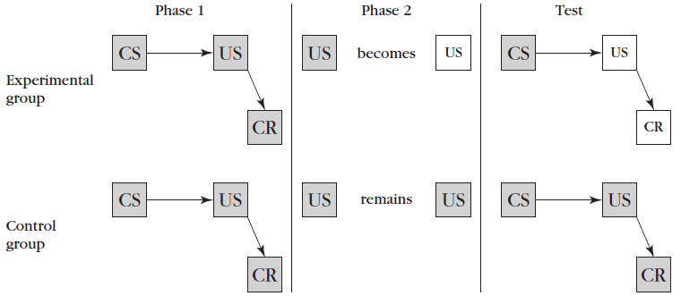

- 6. Modification of responses to the US:
  - The standard definition of CC emphasize that the conditioned stimulus (CS) comes to elicit a new response as a result of being paired with an unconditioned stimulus (US).
  - Learning to respond to a conditioned stimulus (CS) is useful to an organism only if the conditioned response (CR) helps it cope with the unconditioned stimulus (US)
  - Conditioning should also enable the organism to interact with the US more effectively the conditioned salivation in pavlov’s dogs helped his dogs prepare for the food that was coming and enable them to digest the food more efficiently if the food was not delivered the conditioned salivation was useless.
  - Two different experimental designs used to demonstrate conditioned modification of the UR:
    - 1. Common testing design:
      - Two groups are compared.
      - Conditioning phase:
        - One group receives a conditioned stimulus (A) paired with the US.
          - Experimental group: A US (paired)
        - The other group gets stimulus (A) and the US unpaired.
          - Control group: A/US (unpaired)
      - Test phase: both groups receive stimulus A followed by the US.
        - A US
      - Instead of focusing on how the organism responds to the CS (A), they measure responding during the US.
2. Common training design:
      - Conditioning phase: all p’s receive a procedure where stimulus A is paired with the US and stimulus B is presented unpaired with the US.
        - A US (paired)
        - B/US (unpaired)
      - Test phase: responding to the US is evaluated following presentations of stimuli A and B.
        - A US
        - B US
  - Research has shown that CC modifies responding to the US in a wide range of situations.
    - The effect was reported in an eyeblink conditioning experiment:
    - Conditioning trials: consisted of presentation of the CS light before delivery of a puff of air to the eyes.
    - Once the CS became conditioned, presentation of the CS reduced how vigorously the p’s had blinked (UR) when they received the air puff (US).
    - Intensity of blink (UR) is reduced by CS-US pairings This phenomenon is called conditioned diminution of the UR.
  - Conditioned analgesia:
    - Conditioned diminution of the UR is a prominent phenomenon in aversive conditioning and in conditioning experiments where pharmacological agents serve as unconditioned stimuli.
    - A conditioned stimulus (CS) elicits physiological processes that serve to counteract the effects of the US.
    - An aversive stimulus activates the defensive behaviour system.
      - To engage in active defensive responses, the organism cannot be debilitated by pain.
    - Exposure to an aversive stimulus or physical injury results in the release of endogenous opiates which counteract the pain induced by the injury.
      - Endogenous opiates are produced internally by the body and function like morphine or heroin to reduce pain sensitivity and provide analgesia.
    - Release of endogenous opiates can become conditioned to cues associated with an aversive stimulus or injury (pain tolerance)
      - A CS that has been paired with foot-shock will stimulate the release of opiates, resulting in conditioned analgesia.
      - Through this process, the foot shock becomes less and less painful with successive conditioning trials reduction in UR.
      - Body prepares for pain when exposed to conditioned cues.
  - Conditioned drug tolerance:
    - Drug tolerance: one develops tolerance when repeated administrations of the drug have progressively less effect.
      - Because of this increasing doses become necessary to produce the same results.
    - Evidence that drug tolerance can result from Pavlovian conditioning:
      - CC is involved because each administration of the drug are paired with the pharmacological effects of the drug.
      - Drug administration cues constitute the CS and the pharmacological effects are the US.
      - I.e. caffeine commonly used drug whose pharmacological effects are preceded by the smell and taste of coffee.
        - The taste and smell of coffee can serve as a conditioned stimulus that is predictive of the physiological effects of caffeine.
      - Given that each drug-taking episode it a conditioning trial, the conditioned stimuli that precede each drug administration become associated with the physiological effects of the drug.
      - One consequence of this learning: the CS elicits physiological processes that counteract the drug effect related to the opponent process theory of motivation.
    - Emotion arousing events (including drugs that induce emotion) trigger a sequence of two processes.
      - Primary a process: represents the initial effects of the drug first time you take the drug, it has a big effect.
        - I.e. for alcohol symptoms of intoxication and sedation.
      - Opponent b process: opposite to and counteracts the a process.
        - I.e. alcohol irritability and malaise of a hangover.
    - According to the mechanisms of conditioned drug tolerance, the opponent process is elicited by a drug-predictive conditioned stimulus, and that’s why the drug effect is substantially reduced if the drug is administered following the CS.
    - (A) Primary reaction of the drug before conditioning, illustrating initial effects of the drug a process (peak)
    - (B) The homeostatic opponent drug reaction, that becomes conditioned to the drug-predictive CS, after repeated administration b process (negative feeling)
    - (C) The net attenuated drug response that’s observed when the drug is administered with the drug-conditioned CS.
      - This net attenuated drug response illustrates the phenomenon of drug tolerance peak way lower.
    - Environmental cues serve as CSs and can produce strong drug craving (CR) and increase relapse vulnerability.

How do conditioned and unconditioned stimuli become associated?
- Classical conditioning is not merely dependent on contiguity.
  - Expectations are important.
- The Blocking Effect:
  - Once an association has been formed, it’s difficult to learn a new one.
  - Interference with the conditioning of a novel stimulus because of the presence of a previously conditioned stimulus.
  - Prevents new CS to evoke a response, when that response was already evoked by a different CS.
  - Basic sequence of events that produce the blocking effect:
    - Two conditioned stimuli are employed.
    - Phase 1:
      - Experimental group: receives repeated pairings of one of the stimuli (A) with the US.
      - This phase of training continues until a strong CR develops to stimulus A.
        - A US
      - Control group: receives stimulus A presented unpaired with the US.
        - A/US unpaired
    - Phase 2:
      - Experimental & control group: both receive stimulus B presented simultaneously with stimulus A, and paired with the US.
        - [A+B] US
    - Test phase:
      - After several conditioning trials, stimulus B is presented alone to see if it also elicits the CR.
      - Very little conditioned responding occurs to stimulus B, even though B was repeatedly paired with the US during phase 2, in the experimental group.
  - Blocking effect was initially investigated in fear conditioning using the conditioned suppression technique with rats.
    - Example:
    - Phase 1: Dog (CS₁) + bite (US) fear (CR)
      - Dog (CS₁) fear (CR)
    - Phase 2: Dog (CS₁) + collar (CS₂) + bite (US) fear (CR)
      - Collar (CS₂) will NOT elicit fear (CR)
      - Learning about CS₂ is blocked by CS₁
  - Study: blocking in human learning about geometric cues
    - The CS were geometric cues provided by two different triangles, A and B.
    - The triangles depicted the floor plan of a room that had food in one of the corners, that p’s had to find.
    - Phase 1:
      - Blocking group: received training with triangle A/CS1 (isosceles)
      - One of the angles of this triangle was designated as correct; clicking on this angle produced a clapping sound.
      - Clicking on either of the other corners produced the sound of an explosion, indicating the response was incorrect.
      - The triangle was presented in different orientations so that a particular location on screen wasn’t correlated with the correct response.
    - Phase 2:
      - Blocking group: received the previously conditioned stimulus CS₁ (A) with a new triangle CS₂(B), with the correct corner indicated in the picture.
      - Control group 1: received training only with the combination of triangles A and B without any prior training with A.
      - Control group 2: received training only with triangle B.
      - The orientation of the triangles varied across trials.
    - Testing: all 3 groups were tested to see if they learned which was the correct corner for finding food in triangle B.
      - Control group 2: trained only with B, responded (92% correct)
      - Control group 1: responded 79% correct the high performance of control group 1 indicates that learning the correct location in triangle B was not disrupted by presenting triangle B with A during training.
      - Blocking group: A major disruption in performance occurred if triangle A was pre-trained before being presented with B responded correct 20% of the time.
      - Learning about CS₂ (B), is blocked by prior learning of CS₁ (A).
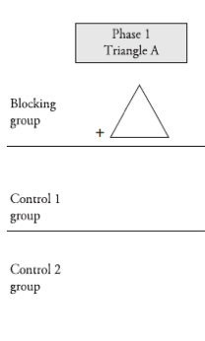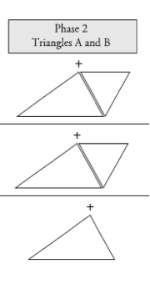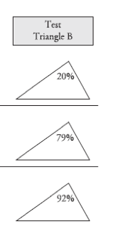
  - Temporal contiguity has been considered the primary means by which stimuli become associated.
    - Blocking effect is a landmark phenomenon because it calls into question the assumption that temporal contiguity is sufficient for learning.
    - Clearly shows that pairings of a CS with a US are not enough for conditioned responding to develop.
- The Unblocking Effect:
  - Once an association has been formed, it’s difficult to learn a new one UNLESS the magnitude of the US is much greater unblocking effect.
    - Example:
    - Phase 1: Dog (CS₁) + bite (US) fear (CR)
      - Dog (CS₁) fear (CR)
    - Phase 2: Dog (CS₁) + collar (CS₂) + mauled (US) fear (CR)
      - Collar (CS₂) fear (CR)
  - Note: different from sensory preconditioning and higher-order conditioning
    - In blocking: both CS₁ and CS₂ have to be paired when the US occurs.
    - Higher-order conditioning/sensory preconditioning: CS₂ is never paired with the US, but the stimulus still has effect.
- Why does blocking occur?
  - Why does the presence of the previously conditioned stimulus, block the acquisition of responding to the added cue?
  - A US has to be surprising to be effective in producing learning.
  - If the US is signaled by a previously conditioned stimulus, it will not be surprising.
  - If the US is not surprising, it will not activate the “mental effort” required for learning if something’s not surprising, we already know a lot about t and therefore have little to learn.

- Rescorla-Wagner Model (US)
  - Classical conditioning is not merely dependent on contiguity.
    - Expectations are important.
  - The effectiveness of a US is determined by how surprising it is, forms the basis of the mathematical model of conditioning proposed by Robert Rescorla, and Allan Wagner.
  - RW model has become a reference point for all subsequent learning theories and its basic assumptions are being identified in studies of the neural mechanisms of learning.
  - RW model: a mathematical model of conditioning whereby the surprisingness of the US determines how much conditioning will occur.
  - How might we measure the level of surprise of a US?
    - An event is surprising if it is different from what is expected.
    - The level of surprise, and hence the effectiveness of the US depends on how different the stimulus is from what the individual expects.
    - If you expect a small gift for your bday and get a car you’ll be very surprised.
      - Analogous to an unexpectedly large US.
      - An unexpectedly large US is the basis for excitatory conditioning.
    - If you expect a car and receive a box of candy you’ll also be surprised.
      - Analogous to an unexpectedly small US.
      - An unexpectedly small US (or the absence of the US) is the basis for inhibitory conditioning.
  - Assumptions of the RW model:
    - 1. Learning will occur if what occurs does not match the expectation.
    - 2. The expectation is based on the predictive value of all the stimuli present and on what you have already learned.
      - The expectation of the US is based on the conditioned/associative properties of the stimuli that precede the US.
      - Strong conditioned responding indicates strong expectation of the US.
      - Weak conditioned responding indicates a low expectation of the US.
  - The delta rule = ∆V = k (λ–V)
    - λ: maximal association strength.
      - Represents the value of the US that’s delivered on a given trial.
      - What actually occurs
    - V: strength of association.
      - Represents the associative value of the stimuli that precede the US.
      - What is expected to happen.
    - Level of surprise will then be (λ–V), or the difference between what occurs (λ) and what is expected (V).
      - On the first conditioning trial, what occurs (λ) is much larger than what is expected (V)., and the surprise factor (λ–V) will be large.
      - As learning proceeds, expectations (V) will come in line with what occurs (λ), and the surprise factor (λ–V) will get smaller and smaller.
      - Eventually V will grow to match λ.
    - At the limit or asymptote of learning, V = λ, and the level of surprise (λ–V) = 0.
    - The delta rule indicates that the amount of learning ∆V, is proportional to how far the predictions/expectations of the US (V) differ from what really occurs λ, or how big the error is in predicting the US.
      - Prediction error is large at first, but is gradually eliminated as learning proceeds.
      - This equation is an error correction mechanism.
    - ∆V: change of associative value of a stimulus.
      - Amount of learning on a given conditioning trial is the change of the associative value ∆V.
    - k: a constant related to the salience of the CS and the US
      - Noticeability of US
  - By convention λ is usually set between 0 and 1
    - If the US is present λ = 1
    - If the US is not present (As in extinction λ = 0
    - If the US decreases in magnitude λ ~ 0.5
    - If the US increases in magnitude λ ~ 2
  - During acquisition:
    - When a CS and US are paired, an association will be formed.
      - V = strength of association represents the associative value of the stimuli that precede the US.
    - The acquisition curve:
      - Learning of the CS-US association is a curvilinear function. (increasing over trials, but at a declining rate)
      - At the limit or asymptote of learning, V = λ, and the level of surprise, or prediction error (λ–V) = is equal to 0.
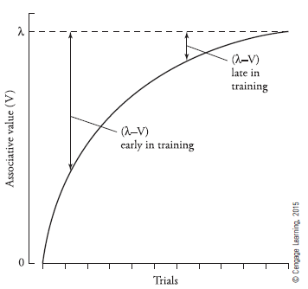
      - The amount of learning ∆V is not consistent over trials, but becomes progressively smaller (as the US becomes less surprising), until reaching a stable value (λ or V_{max})
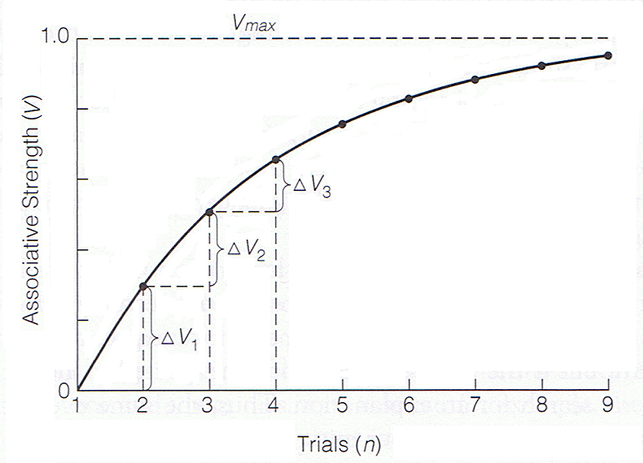
    - The expectation (V) of the US is related to the conditioned properties of all the stimuli that precede the US.
      - The learning for each trial depends on prior learning.
      - The equation must be applied for every trial.
      - The strength of the associative value (V) per trial, depends on prior learning.
      - The general shape of acquisition curves is curvilinear increasing over trials, but at a declining rate.
      - However, rate of learning can depend on the conditioning procedure.
        - Taste aversion conditioning happens quickly, salivary conditioning happens more slowly.
        - This is accounted for by the constant k.
      - k: general noticeability of the stimuli.
        - The value of k is between 0 and 1.
        - The value of k may differ from procedure to procedure, but remains constant within a given conditioning procedure.
  - Applying the RW model to the blocking effect:
    - RW model clearly predicts the blocking effect.
    - Expectations of the US are based on all of the cues available during the conditioning trial.
    - I.e. in the blocking design example
      - Phase 1: the experimental group receives extensive conditioning of stimulus A so that it acquires a perfect expectation that the US will occur whenever it encounters stimulus A.
        - By the end of phase 1, V_{A} will be equal to the asymptote of learning or V_{A} = λ
      - Phase 2: stimulus B is presented together with stimulus A, and the two CSs are followed by the US.
        - To predict what will be learned about stimulus B, the RW equation has to be applied to stimulus B: ∆V_{B} = k (λ–V)
        - Remember: V is based on ALL of the stimuli present on a trial
        - In phase 2, there are two cues (CSs): A and B.
          - V = V_{A} + V_{B}
          - Because of its phase 1 training V_{A} = λ at the start of phase 2.
          - V_{B} starts at 0
          - At the start of phase 2 V_{A} + V_{B} is equal to λ + 0, or λ.
        - Substituting this value into the equation for ∆V_{B} gives a value of ∆V_{B} = k (λ– λ) or k (0) which is equal to 0.
        - This indicates that stimulus B will not acquire associative value in Phase 2, thus the conditioning of stimulus B will be blocked.
    - Example from lecture slides:
    - Phase 1: tone (CS₁) and food (US) salivation UR/CR
    - Phase 2: tone (CS₁) + light (CS₂) and food (US) salivation UR/CR
      - Phase 1: normal conditioning
        - ∆V_{T} = k (λ–V_{T})
        - Eventually the tone will become a perfect predictor of the food: V_{T} = λ
      - Phase 2: Add CS₂
        - ∆V_{L} = k (λ–V_{TOTALl})
        - V_{TOTAL} = V_{T} + V_{L}
        - V_{T} = λ
        - V_{L} = 0
        - Therefore: V_{TOTAL} = λ + 0 = λ
        - ∆V_{L} = k (λ–V_{TOTALl})
        - = k (λ – λ)
        - = k (0)
        - = 0
        - Conclusion: no learning about CS₂ (the light) occurs no CR develops.
  - Applying the RW model to the unblocking effect:
    - Example from lecture slides:
    - Phase 1: tone (CS₁) and food (US) salivation UR/CR
    - Phase 2: tone (CS₁) + light (CS₂) and food (US) salivation UR/CR
      - Phase 1: normal conditioning
        - ∆V_{T} = k (λ–V_{T})
        - Eventually the tone will become a perfect predictor of the food: V_{T} = λ
      - Phase 2: Add CS₂ and MAGNIFY the US
        - ∆V_{L} = k (λ–V_{TOTALl})
        - V_{TOTAL} = V_{T} + V_{L}
        - V_{T} = λ
        - V_{L} = 0
        - Therefore: V_{TOTAL} = λ + 0 = λ
          - However, there is more food so λ in phase 2 is greater than λ in phase 1
        - ∆V_{L} = k (2λ–V_{TOTALl})
        - = k (2λ – λ)
        - = k (λ)
        - = λ
        - k λ is a positive value, meaning that V_{L} will gain associative strength.
        - Conclusion: learning about CS₂ (the light) occurs a CR develops.
  - Loss of associative value (V) of a CS despite pairings with the US:
    - Basis of overexpectation:
    - Associative value of a CS can decrease despite continued pairings with US.
    - This happens because stimuli are predicted to lose associative value if they’re presented together on a conditioning trial, after having been trained separately.
    - I.e. Phase 1: stimuli A and B are paired with the same US (one pellet of food) on separate trials.
      - This continues until both A and B predict the one food pellet US perfectly.
      - At the end of phase 1 V_{A} and V_{B} are equal to λ
    - Phase 2: stimuli A and B are presented simultaneously for the first time, and this stimulus compound is followed by the usual single food pellet.
    - What happens to the conditioned properties of A and B as a result of the Phase 2 training?
      - RW model predicts that the conditioned properties of the individual cues A and B will decrease in phase 2.
      - ∆V = k (λ–V)
      - V = V_{A} + V_{B} = λ + λ = 2 λ expectancy has doubled because the expectations based on the individual stimuli are added together, with the result of two food pellets predicted rather than one.
      - This is an overexpectation because the US remains only one food pellet.
      - ∆V = k (λ–2 λ)
      - = k (-λ)
      - = -k λ
      - -k λ is a negative value, meaning that V will decrease in associative strength.
      - The US in phase 2 is surprisingly small.
      - To bring the US expectancy in line with that actually occurs in phase 2 the p’s have to decrease their expectancy of the US based on stimuli A and B.
      - Thus A and B are predicted to lose associative value despite continued presentations of the same US.
      - This loss will continue until the sum of expectancies based on A and B equals one food pellet.
    - In phase 3: A and B are tested individually and found to have lost associative value because of the overexpectation.
  - Extinction of Excitation and Inhibition:
    - In an extinction procedure: the CS is presented repeatedly without the US.
      - If a CS has acquired excitatory properties, there will be an overexpectation of the US the first time the CS+ is presented without the US in extinction.
      - Repeated nonreinforced presentations of the CS+ will result in a progressive reduction of the associative value of the CS+ until V_{CS+} reaches zero.
    - Analogous scenario for extinction of conditioned inhibition:
      - At the start of extinction, the CS- has negative associative value.
      - This may be thought of as creating an underprediction of the US: the organism predicts less than the zero US that occurs on extinction trials.
      - To align expectations with the absence of the US, the negative associative value of the CS- is gradually reduced and the CS- ends up with zero associative strength.
  - Conditioned Inhibition:
    - Pavlov’s procedure for inhibitory conditioning involves two kinds of trials.
      - Reinforced trials: one in which the US is presented.
        - A conditioned excitatory stimulus (CS+) is presented and paired with the US.
      - Non-reinforced trials: one in which the US is omitted.
        - The CS+ is presented together with the conditioned inhibitory stimulus (CS-) and the compound is followed by the absence of the US.
    - Application of the RW model to such a procedure involves considering the trials separately.
      - Reinforced trials: to accurately anticipate the US, the CS+ has to gain excitatory properties.
        - Excitatory conditioning involves the acquisition of positive associative value (V) for CS+ until the organism predicts the US (V_{MAX}) perfectly on each reinforced trial.
        - In phase 1, associative value for CS+ increases until animal perfectly predicts the US (V_{MAX})
      - On nonreinforced trials: the CS+ and CS- are presented together. Once the CS+ acquired some degree of conditioned excitation (bc of its presentation on reinforced trials) the organism will expect the US whenever the CS+ occurs, including nonreinforced trials.
        - However the US does not happen on nonreinforced trials therefore this is a case of overexpectation.
        - Overexpectation in phase 2 leads to a decrease in total associative value V decreases until the animal perfectly predicts the absence of the US.
      - To accurately predict the absence of the US on nonreinforced trials, the associative value of the CS+ and the CS- have to sum to 0 (the value represented by no US)
        - This can be achieved given the positive associative value of the CS+ the only way to achieve a net zero expectation of the US on nonreinforced trials is to make the associative value of the CS- negative.
        - RW model explains conditioned inhibition by assuming that the CS- acquires negative associative value.
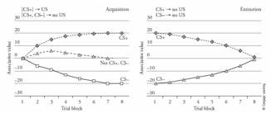

  - Limitations of the model:
    - Does not accurately predict extinction of conditioned inhibition.
    - Model predicts that repeated presentations of the conditioned inhibitor (CS-) by itself, will lead to loss of conditioned inhibition.
      - This does not happen in practice.
    - Some investigators have found that repeated non-reinforcement of a CS-can enhance its conditioned inhibitory properties.
    - An effective procedure for reducing conditioned inhibitory properties of a CS- does not involve presenting the CS- at all.
      - It involves extinguishing the excitatory properties of the CS+ with which the CS- was presented during inhibitory training.
    - Model views extinction as the reverse of acquisition, or the return of the associative value of a CS to zero.
  - RW Model summary:
    - We can quantify the surprisingess of a stimulus using the RW model:
      - The RW model can predict the basic effects of classical conditioning:
        - I.e. acquisition; good for explaining how associations are acquired.
      - The RW model can predict some usual aspects of conditioning:
        - Why blocking occurs, why unblocking works, overexpectation, etc.
      - The RW model does not accurately predict some things, such as the extinction of conditioned inhibition.
Other models of conditioning:
- Attentional models (CS)
  - British psychologists have approached phenomena such as the blocking effect, emphasizing changes in how well the CS commands attention.
  - Assumes that:
    - Increased attention facilitates learning about stimulus.
    - Procedures that disrupt attention to CS disrupt learning.
  - Attentional theories differ in their assumptions about what determines how much attention a CS commands on a conditioning trial.
  - Pearce-Hall attentional model: single category theories
    - Also based on concept of surprise amount of attention is determined by how surprising the US was on the preceding trial.
    - Animals have a lot to learn if the US was surprising and that increases attention to the CS on the next trial.
      - If the US was not predicted, then attention to CS increases on next trial.
    - If a CS was followed by an expected US, not much learning is necessary and the CS commands less attention on the next trial.
      - If the US was predicted, then attention to CS declines on next trial.
  - Three types of attention:
    - Looking for action: CS already predicts US
      - The attention a CS commands after it has become a good predictor of the US and generates a CR with min. cognitive effort.
    - Looking for learning: US was surprising much to be learned about predictors.
      - The attention that’s involved in processing cues that are not yet good predictors of the US and have much to be learned about.
    - Looking for liking: US is salient so attend to any possible predictors.
      - The attention stimuli command because of their emotional value, or rather, how much they’re liked or disliked.
  - Important feature of attentional models:
    - They assume that the outcome of a given trial alters the degree of attention commanded by the CS on future trials.
      - If trial 10 ends in a surprising US, it will increase the looking for learning form of attention on trial 11.
      - US surprise is assumed to have a prospective, or proactive influence on attention and conditioning.
    - This is a contrast in US-reduction models (RW), where the surprisingness of the US on a given trial determines what’s learned on that same trial.
  - Problem with all attentional models: they cannot explain one-trial blocking.
    - Presence of previously conditioned CS_{A} in phase 2 of the blocking design makes the US fully expected.
    - Any reduction in attention to CS_{B} that results from this would only manifest on trials following Phase 2.
    - CS_{B} should command full attention on the first trial of Phase 2 and learning should occur normally but this does not happen, because the conditioning of CS_{B} is blocked by CS_{A} even on the first trial of Phase 2.

- Timing and information theory models (CS-US interval)
  - Explains the effects of time in conditioning.
  - One important temporal variable: is the CS-US interval (interstimulus interval)
    - Focal search: responses become conditioned with a short CS-US interval
    - General search: responses become conditioned with a long CS-US interval
  - P’s learn not only that a CS is paired with a US but when that US will occur.
  - Based on findings (Williams and colleagues) claimed that learning when the US occurs trumps learning whether it occurs.
  - Temporal coding hypothesis: the idea that participants learn when the US occurs in relation to a CS, and use this information.
    - Use it in blocking, second-order conditioning, and other paradigms in which what is learned in one phase of training influences what’s learned in following phases.
  - Another important temporal variable: is the interval between successive trials (intertial interval)
    - More of a CR is observed with longer intertrial intervals.
  - The intertrial interval and the CS duration (CS-US interval) act in combination to determine conditioned responding.
    - Ratio of ISI to ITI can predict the magnitude of the CR ratio suggests comparison between events during intertrial interval (I) and conditioning trial/CS-US interval (T)
    - Critical factor: the relative duration of both temporal intervals, rather than the absolute value of either one by itself.
    - Relative waiting time hypothesis: the idea that conditioned responding depends on how long one has to wait for the US in the presence of the CS, versus how long one has to wait for the US during the intertrial interval (the interval from one US presentation to the next: the experimental situation).
      - How long is the wait between CS-US (ISI) compared to US-US (ITI)?
      - High I/T ratio: when the US waiting time during the CS is much shorter than during the intertrial interval it’s high.
        - CS is highly informative about the next occurrence of the US; high levels of CR occur.
      - Low I/T ratio: when the US waiting time during the intertrial interval is similar to the US waiting time during the CS.
        - CS provides little new information about next US; not much CR develops.
      - CS is only informative about US if you spend less time waiting for US when the CS is present/during the CS.

- Comparator hypothesis (CS vs. context)
  - The idea that conditioned responding depends on a comparison between the associative strength of the conditioned stimulus (CS), and the associative strength of other cues present during training of the target CS.
    - CR depends not only on what happens during conditioning (CS), but also on what happens in other aspects of the experimental situation.
  - Motivated by a set of findings known as the revaluation effects.
    - RW model interprets blocking effect a failure of learning to CS_{B} presence of CS_{A} blocks conditioning of CS_{B}.
    - Comparator hypothesis assumes that what’s blocked is responding to CS_{B}, not learning about CS_{B}.
    - CS_{B} should therefore become evident if block is removed one way to remove block is to eliminate responding to CS_{A} after compound conditioning by presenting CS_{A} repeatedly without the US.
    - Studies have shown that such extinction of CS_{A} unmasks CR to CS_{B}.
    - Called revaluation effect bc it involves changing the conditioned value of a stimulus that was present during the training of target stimulus.
    - Unmasking of responding to CS_{B} shows that blocking did not prevent conditioning of CS_{B} but disrupted performance of the response to CS_{B.}
  - A theory of performance, not learning.
    - Assumes that CR depends on associations not only on associations between target CS and US, but also on associations that may be learned between the US and other stimuli present when the target CS was being conditioned.
      - These other stimuli = comparator cues
        - Include the experimental context and other discrete CSs.
        - I.e. in blocking experiment: target stimulus is CS_{B} and the primary comparator cue is the previously trained CS_{A} that’s present during conditioning of CS_{B}.
        - Theory predicts that the new stimulus CS_{B} is outweighed by the excitatory value of the old stimulus CS_{A} (which is now considered a comparator cue)
        - Thus, no excitatory responding is displayed towards CS_{B}
    - Assumes that it only allows for the formation of excitatory associations with the US.
      - Whether conditioned responding reflects excitation or inhibition:
      - Determined by the relative strengths of excitatory value conditioned to the target CS versus the excitatory value of the comparator stimuli/cues that are present during the training of the target CS.
      - If excitatory value of the target CS exceeds > excitatory value of comparator cues, the balance of the comparison will be tipped in favor of an excitatory CR.
      - If the excitatory value of the comparator cues exceeds > excitatory value of the target CS, the balance will be tipped in favor of an inhibitory CR.
      - Comparator hypothesis emphasizes associations rather than time.
  - The theory assumes that there are 3 associations learned during conditioning:
    - 1. Association between target CS and US.
    - 2. Association between target CS and comparator cues.
    - 3. Association between comparator cues and US.
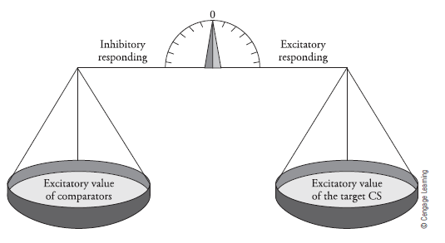
The role of the Amygdala in conditioning:
- The role of the limbic system in conditioning: regulates emotion and motivated behaviour.
  - Amygdala: implicated in emotional responses.
    - Important in fear responses.
    - Leisure to the amygdala shows abnormal fear responses.
    - The amygdala is highly conserved across species.
    - Unexpected aversive events elicit more activity in the amygdala.
    - Lesioning or chemically inactivating the amygdala disrupts fear conditioning.
    - Specific lesions can cause very specific deficits:
      - I.e. lesioning the PAG disrupts freezing behaviour, but does not disrupt other fear-elicited behaviours.
    - In appetitive conditioning, the nuclei of the amygdala have different roles.
    - Proposed circuitry for the mediation of conditioned fear responses.
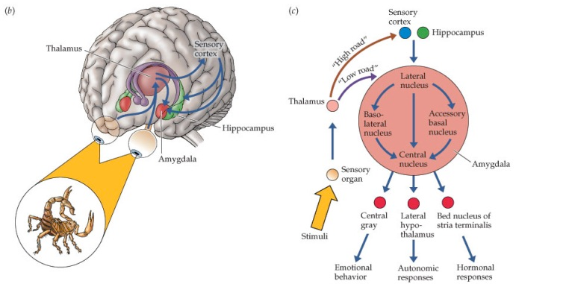
    - Different levels of fear correspond to activity in different areas of the amygdala.
  - Hippocampus: implicated in learning, memory, and spatial navigation.
  - Cingulate cortex: receives input from thalamus and neocortex.
- The amygdala has a number of important connections for fear conditioning:
  - Sensory cortices: send info about the features of the CS
  - Perirhinal cortex: sends info about timing
  - Hippocampus: sends info about environmental context and/or spatial location
- The amygdala has a number of important nuclei:
  - Lateral nucleus: encodes the association between the specific stimuli and aversive events and activates the central nucleus.
  - Basolateral nucleus: has important connections to memory areas.
  - Central nucleus: transmits information to various brain stem centers to evoke emotional responses.
- Fear conditioning in a rat model:
  - CS and US converge on cells in the LA (lateral amygdala), which then activates the CE (central nucleus of amygdala).
  - Output from the CE allows response to be tuned to the context and level of danger.
  - CG: central gray, LH: lateral hypothalamus, PVN: paraventricular hypothalamus.


