PSYC 351 FUNDAMENTALS OF LEARNING
CHAPTER 3: Classical Conditioning Foundations

Behaviourism:
- Behaviourism: is a school of thought that explains human learning and behaviour as a product of associations between stimuli.
- Two theories of learning:
  - 1. Classical conditioning: is a form of learning in which an association is formed between one stimulus and another.
  - 2. Operant conditioning: is a form of learning where behaviour is controlled by consequences.
    - Positive reinforcement
    - Negative reinforcement
    - Positive punishment
    - Negative punishment
- Assumptions of behaviourism:
  - 1. Principles of learning apply across species.
    - Equipotentiality: humans and other animals learn the same way.
    - Apply research findings from animal studies to human learns.
  - 2. Focus on observable behaviours.
    - Psychology should be an objective science based on observable (measurable) behaviour.
    - Stimulus-Response (S-R) Psychology:
      - Focus on what can be measured and observed.
      - Mental processes and thought are unimportant.
    - Stimulus-Organism-Response (S-O-R)
      - The belief that mental processes (motivation) are important in understanding learning.
  - 3. Organisms are blank slates.
    - Aside from hard-wired reflexes, we are born without predispositions.
    - The environment shapes us.
    - Watson…
  - 4. Learning is largely the result of the environment.
    - Learning happens to an organism.
    - Learning is beyond our control.
    - If we have complete knowledge of an organism’s past, we can predict their behaviour.
Introduction:
- Environmental events can elicit behaviour and how much elicited behaviour can be modified by sensitization and habituation.
- These processes help bring the behaviour of organisms in tune with their environment.
- If organisms only had the behavioural mechanisms described in Ch. 2, they’d remain limited in the kinds of things they could do.
- Habituation and sensitization involve learning about just one stimulus; but events in the world do not occur in isolation.
- Much of our experience consists of predictable and organized sequences of stimuli.
  - Every event (i.e. a hug from a friend) is preceded by other events (your friend approaching with extended arms) that are part of what leads to the target outcome.
- Cause-and-effect relationships in the world ensure that certain things occur in combination with others.
- Learning to predict events in the environment and learning what stimuli tend to occur together help us interact more effectively with our environment.
- The simplest mechanism whereby organisms learn about relations between one event and another is classical conditioning.
  - Allows organisms to take advantage of the orderly sequence of events in their world to take appropriate action in anticipation of what is about to happen.
  - It’s the process whereby we learn to predict when and what we might eat, when we’re likely to face danger, and when we’re safe.
  - It is integrally involved in the learning of new emotional reactions (i.e. fear or pleasure) to stimuli that have become associated with a significant event.

The Early Years of Classical Conditioning:
- Twitmyer repeatedly tested the knee jerk reflex of college student by sounding a bell .5 seconds before hitting the patellar tendon just below the knee cap.
- After several trials the bell was sufficient to elicit the kne jerk reflex in some of the students.
- But Twitmyer didn’t explore the broader implications of his discoveries and his findings didn’t initially attract much attention.
- Pavlov’s studies of classical conditioning:
  - Were an extension of his research on the process of digestion (digestive physiology research)
  - Created a surgical method to observe the function of various organs in their natural environment and under normal function.
    - Enabled dogs to survive with artificial fistulae, that permitted the collection of various digestive juices.
  - Awarded the Nobel prize in 1904.
  - Famous for his later experiments on associative learning:
    - New reflexes to stimuli can be acquired through learned associations.
    - Reflexes can be modified through mechanisms of association.
  - Lab technicians discovered the dogs secreted stomach juices in response to the sight of food and just upon seeing the person who usually fed them.
    - But these are two features of the same object (the food) it’s hard to separate visual food presentations and orosensory response.
    - Psychic Secretions: stomach secretions elicited by food-related stimuli; they seemed to be a response to the expectation or thought of food.
    - Pavlov recognized this could be used to study the mechanisms of associative learning and could inform us about the functions of the nervous system.
Object learning: the association of one feature of an object with another.
- I.e. Dog learned to associate visual features of sand with its orosensory features.
- Associative learning: when a subject creates a relationship between stimuli or behavior, and the original stimulus.
- The acquisition of associations is the basis for learning.
  - This learning is seen in classical and operant conditioning.
- To study the mechanisms of associative learning, the stimuli to be associated have to be manipulated independently of one another.
  - This is difficult to do when the two stimuli are properties of the same object.
  - Therefore, Pavlov used procedures in which the stimuli to b associated came from different sources; the procedure involves two stimuli.
Pavlov’s classical Conditioning Paradigm:
- Classical conditioning: is a form of learning in which an association is formed between one stimulus and another.
  - 3 steps of classical conditioning: Pavlov’s Experiment
    - Natural response (before conditioning) bell (NS: neutral stimulus)
    - Step 1 natural response: food (UCS) salivation (UCR)
    - Step 2 conditioning: food (UCS) + bell (NS) salivation (UCR)
    - Step 3 after conditioning: bell (CS) salivation (CR)
  - Can occur quickly with a few conditioning trials.
  - Most likely to occur if the CS is presented before the US.
    - Less likely if CS and US occur at the same time.
    - Almost never if the CS is presented after the US.
  - Involves involuntary responses: i.e. salivation, startle, etc.
  - The tone or light is referred as the conditioned stimulus because the effectiveness of this stimulus in eliciting salivation depended on (or was conditioned on) pairing it several times with the presentation of food.
  - The food or sour taste was called the unconditioned stimulus because its effectiveness in eliciting salivation didn’t depend on prior training.
  - The salivation that came to be elicited by the tone or light was called the conditioned response.
  - The salivation that was always elicited by the food or sour taste was called the unconditioned response.
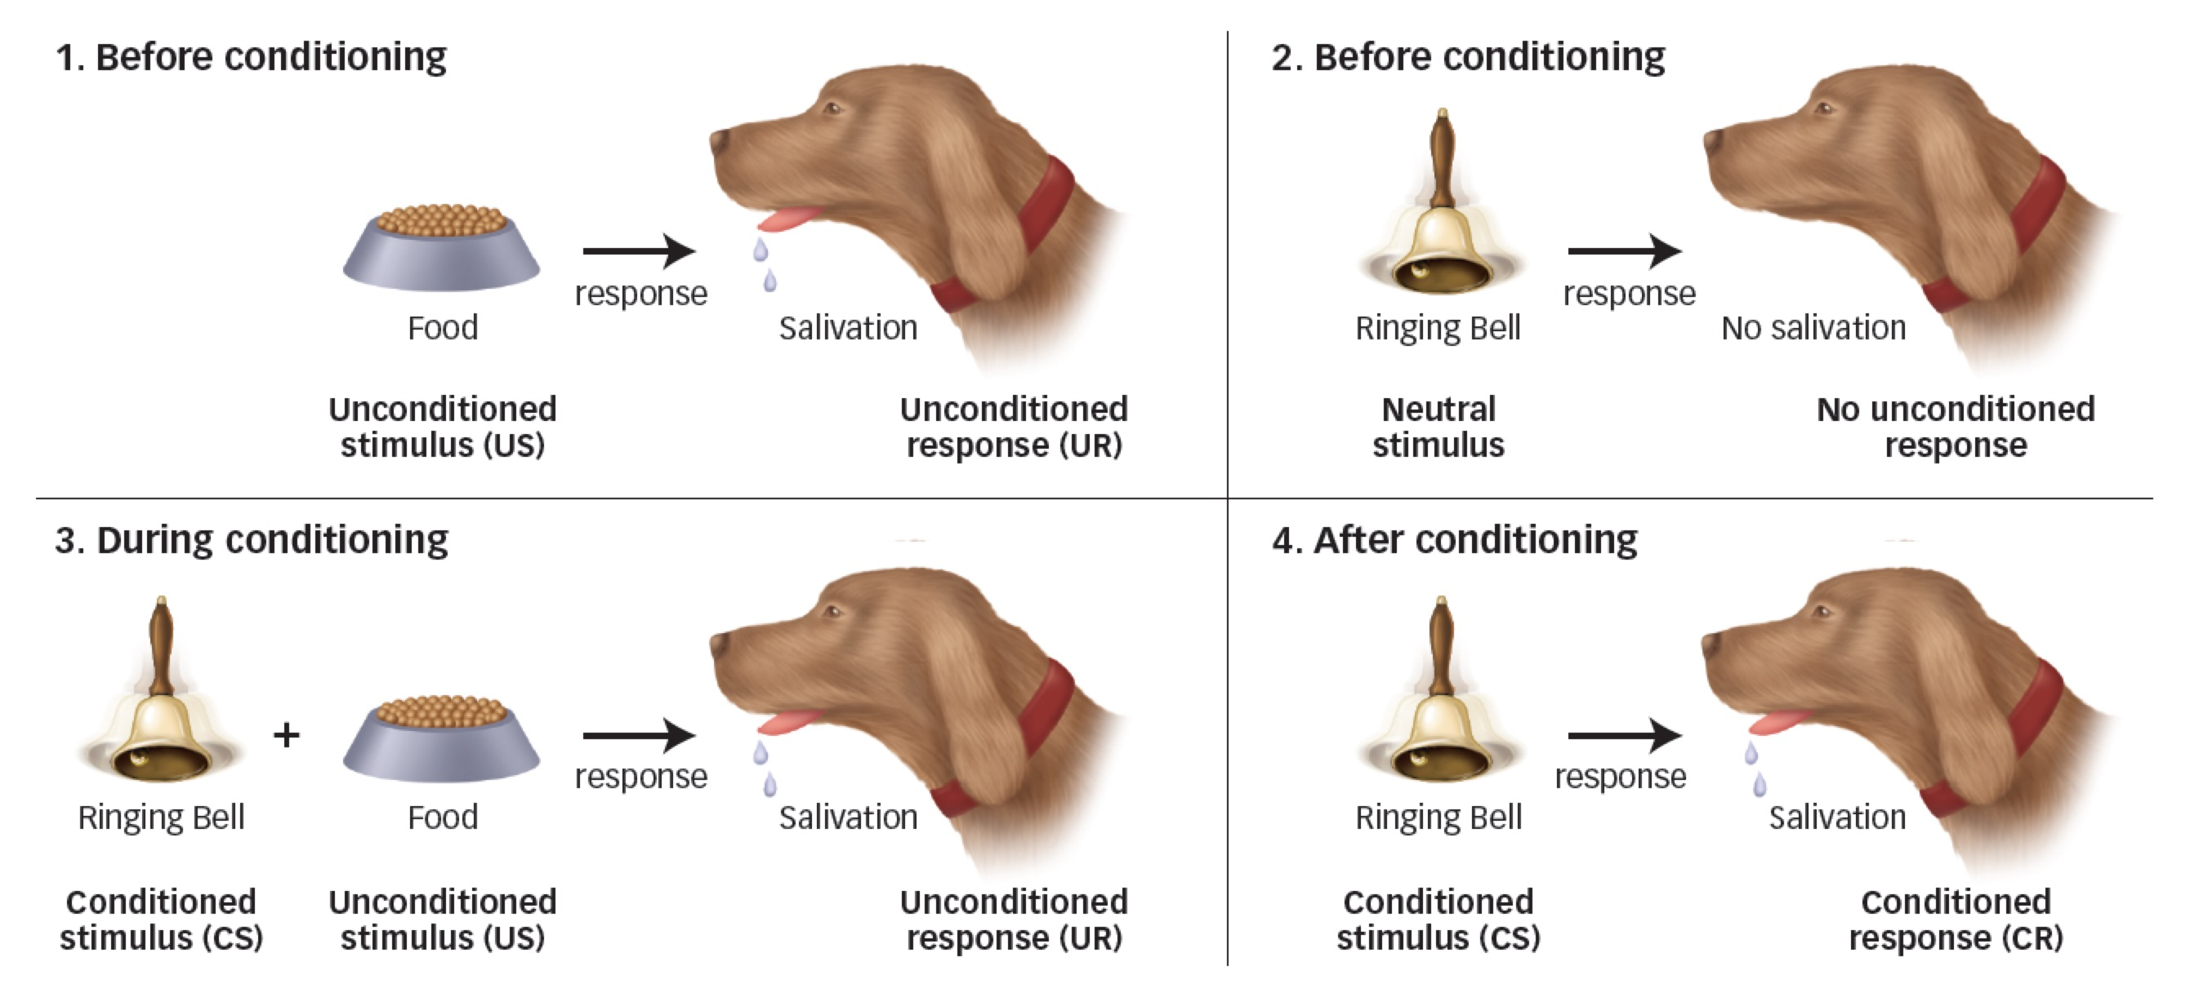

- How specific is the conditioned response CR to the conditioned stimulus CS?
- Generalization: occurs when a stimulus similar to (but not exactly the same as) the original CS elicits the CR.
  - I.e. fear of dogs
  - You might be afraid of a dog and that might generalize to all dogs.
  - Got bit by dog I’m afraid of small dogs, got bit by dog could be all cats as well (anything small and furry)
  - The more generalized the response is the less discriminatory it is.
- Discrimination: occurs when one stimulus triggers a CR but another does not; the individual responds differently to two different stimuli animal has shown to respond to a specific stimuli.
  - I.e. fear of dogs, but not to cats.
  - Got bit by dog afraid of THAT dog, got bit by dog afraid of all dogs, but not cats.

Experimental Situations:
Aversive conditioning: any learning that occurs when one learns to predict an upcoming negative event.
  - Can sometimes be used to help people curb addictions.
  - Can be used to make or break habits wake up with your alarm, stop smoking.
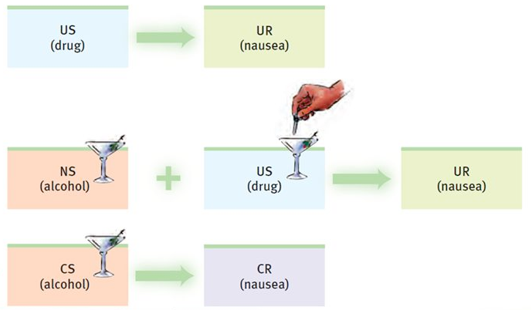

Fear conditioning:
- Very easy to measure freezing response as an indicator of fear conditioning.
- Conditioning of emotional reactions:
- I.e. Watson and Rayner.
  - Believed infants were limited in emotional reactivity.
  - Little Albert experiment: conditioned a fear response to the presence of a docile white laboratory rat in 9 month old infant named Albert.
  - Reacted with alarm when he heard the loud noise of a steel bar being hit by a hammer behind his head.
  - They used this unconditioned alarming noise to condition fear to a white rat.
  - Each conditioning trial consisted of presenting the rat to Albert and then striking the steel bar.
  - Start: At first Albert reached out to touch the rat when it was presented to him.
  - After 2x: Albert was reluctant to touch the rat.
  - After 5x: Showed strong fear responses that were not evident when he was shown his toy blocks; Albert cries and leans away from rat when it’s presented.
  - End: Albert is now afraid of rabbits, fur coats, cotton, etc. stimulus generalization to other furry things.
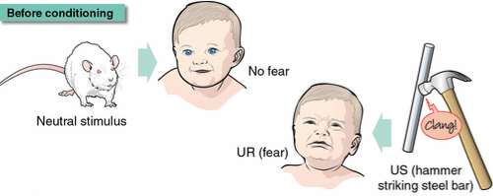
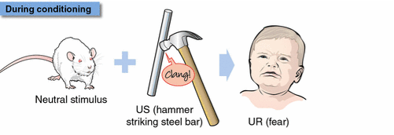
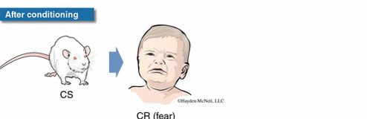

- Fear conditioning in Rats: measuring freezing response as an indicator of fear conditioning.
  - Rats show fear by freezing:
    - Freezing: defined as immobility of the body (except breathing) and absence of movement of whiskers associated with sniffing.
    - Freezing probably evolved as a defensive behavior bc animals that are motionless are not easily seen by their predators.
  - Aversive US: a brief electric shock delivered through a metal grid floor aversive because its startling (unlike anything the animal has encountered before).
  - CS: may be a discrete stimulus such as a tone or light or the contextual cues of the place where the aversive stimulus is encountered.
  - An example of the acquisition of fear in response to an auditory CS (white noise) in lab rats, during noise-shock conditioning trials:
    - Rats received 10 conditioning trials.
    - CS for 46 seconds (white noise) + ending in a 2 second mild shock
    - CS (white noise) + shock = freezing behaviour
    - Conditioning trial were separated by an intertrial interval of 210 seconds.
    - There was little freezing during the first presentation of the noise CS, before the rats received their first shock.
    - The percentage of time the rats spent freezing during subsequent conditioning trials increased quickly.
    - By the 3rd conditioning trial: the rats were freezing about 70% of the time, which was the asymptote or limit of learning in this experiment.
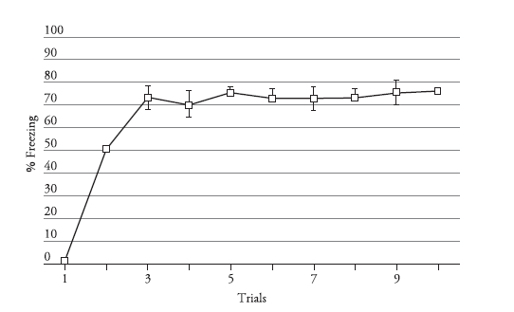
    - In addition to freezing: 2 other indirect measures of fear induced immobility are also used in investigations of fear conditioning.
      - Conditioned suppression procedures: the suppression of ongoing behaviour.
      - In one experiment: the ongoing behaviour is licking a drinking spout containing water.
        - The rats are slightly water deprived and therefore lick readily when placed in experimental chamber.
        - If a fear CS (tone) is presented, their licking behaviour is suppressed, and they take longer to make a specified number of licks lick-suppression procedure.
      - In another variation of the conditioned suppression technique: rats are trained to press a response lever for food reward in an experimental chamber.
        - Lever-press activity provides the behavioural baseline for the measurement of fear.
        - Once the rats are lever-pressing at a steady rate, fear conditioning is conducted by pairing a tone or light with a brief shock.
        - As the p’s acquire the conditioned fear, they come to suppress their lever pressing during the CS.
        - Phase 1: trained to press lever for food
        - Phase 2: trained to associated the CS (tone/light) with US (shock)
        - Phase 3: CS presented during lever pressing
        - DV: suppression ratio (indirect) or freezing (direct)
  - Conditioned suppression: suppression of ongoing behaviour (i.e. drinking or lever pressing for food) produced by the presentation of a CS that has been conditioned to elicit fear through association with an aversive US.
  - Lick-suppression: a procedure for testing fear conditioning in which presentation of a fear-conditioned CS slows down the rate of drinking.

Eye-blink conditioning:
- Eye-blink reflex is part of the startle response and occurs in a variety of species.
- To get someone to blink all you do is clap your hands close to the person’s head or blow a puff of air toward the eyes.
- If each air puff is preceded by a brief tone, the blink response will become conditioned and the person will blink in response to the tone.
- I.e. experiment with 5-month-old infants:
  - CS: 1000 cps tone presented for 750 milliseconds.
  - US: gentle puff of air to the right eye through a plastic tube.
  - Group 1: Given a short tone (CS) before the puff of air (US) CS always ended with US, puff of air occurred 12 seconds apart.
  - Group 2 (control group): Also presented with tone but it had no relationship with when the puff of air was coming received the same number and distribution of CS and US presentations, but the CS and US were spaced 4-8 seconds apart in an unpaired fashion.
  - Learning (rate of eyeblinks) was not evident in first session… but in session 2, group 1 who had tone paired with puff of air, showed a much stronger response to the CS from the beginning of second session, than group 2 who were presented with a tone at random periods.
  - This is a good example of latent learning.
  - Results show that:
  - First, classical conditioning requires: the pairing of a CS and US.
    - Responding to the CS did not develop in the unpaired control group.
  - Second, learning was not observable at first:
    - The infants in paired group didn’t response in the first session but showed a dramatic increase when they were returned to the experimental situation for the second session provides an example of the learning/performance distinction.
    - The babies started to learn that the CS was related to the US during the first session, but their learning was not evident until the beginning of the second session.

Learning Taste Preferences and Taste Aversions
- Conditioned taste aversion: is the reluctance to consume a food or liquid flavor that was associated with an aversive consequence.
  - Learned if ingestion of a novel flavor is followed by an aversive consequence such as indigestion or food poisoning.
- Each eating “episode” is a conditioning trial.
- The sensory aspects of the food serve as a CS (sight, taste, smell, texture) that become associated with the postingestional consequences of eating (swallowing, digesting) which serve as a US.
- Through this process food cues come to signal what, when and how much we eat.
- The typical taste aversion learning experience involves eating a novel food and then getting sick.
- Such an aversion can be produced in just one trial.
- The timing of the CS-US interval matters the learning can occur even if the illness is delayed several hours after ingestion of the food.
- Interesting finding: 20% of people were certain their illness wasn’t caused by the food they ate but learned he aversion to the food.
  - Indicates that food aversion learning can be independent of rational thought processes and can go against a person’s own conclusions about the causes of the illness.
- Systematic experimental research is required to isolate the mechanism of food-aversion learning.
  - Can occur even if:
    - The person knows the food didn’t cause the illness (i.e. chemotherapy patients)
    - The illness does not occur until several hours after exposure.
    - There is no direct feeling of nausea.
  - Common sources for humans:
    - Overconsumption
    - Food poisoning
    - Motion sickness
    - Forced consumption (cognitive taste aversions)
    - Disgust (cognitive taste aversions)
  - Taste aversion examples:
    - A heavy night of drinking may lead to avoidance of a specific alcohol.
    - A bad experience with oysters may lead to a life-long aversion.
    - Chemotherapy often causes intense nausea as a side effect:
      - Chemotherapy patients often develop aversions to food eaten before a chemo session and may develop an aversion to the hospital such conditioned aversions may contribute to the lack of appetite that is a common side effect of chemo.
      - Patients are advised not to eat prior to chemotherapy sessions.
    - May also contribute to anorexia nervosa: a disorder characterized by severe and chronic weightloss.
      - Suggestive evidence indicates that people suffering from anorexia experience digestive disorders that may increase their likelihood of learning food aversions.
    - Increased susceptibility to food aversion learning may also contribute to loss of appetite seen in people suffering from severe depression.
  - In typical experiments to study food-aversion learning through animals: p’s receive a distinctive flavored food/drink and are made to feel sick by the injection of a drug or exposure to radiation.
  - As a result of taste-illness pairing; animals acquire an aversion to the taste and suppress their subsequent intake of that flavor.
  - Taste aversion is similar to other forms of classical conditioning but has some special features:
    - Strong taste aversions can be learned with just 1 pairing of the flavor and illness.
      - Although one trial learning also occurs in fear conditioning, such rapid learning is rarely observed in eyeblink conditioning, salivary conditioning or sign tracking.
    - It occurs even if the illness does not occur until several hours after exposure to the novel taste.
      - Long-delay learning of taste aversions probably evolved to enable organisms to avoid poisonous foods that have delayed ill effects.
- Conditioning saccharin aversion in rats:
  - Long-delay taste aversion learning was reported.
  - Rats were adapted to water deprivation schedule so they’d readily rink when a water bottle was placed on their cage.
    - On conditioning day: water was flavored with the artificial sweetener saccharin.
  - After saccharin exposure, at various times ranging from 0 to 24 hours, different groups of rats were exposed to radiation from an X-ray machine to induce illness.
  - Control groups of rats (aka sham irradiated group) were also taken to the X-ray machine but were not irradiated.
  - A day after the radiation or sham treatment, each rat was given a choice of the saccharin solution or normal water to drink for 2 days.
  - Sickness induced after saccharin exposure.
    - Rats exposed to radiation within 6 hours after tasting saccharin solution: showed a profound aversion to the saccharin flavor in the postconditioing test they drank less than 20% of their total fluid intake from the saccharin drinking tube.
    - Much less of an aversion was evident in rats exposed to radiation 12 hours after the saccharin exposure.
    - Hardly any aversion was observed in rats irradiated 24 hours after taste exposure.
    - Sham-irradiated groups: strongly preferred the saccharin solution they drank more than 70% of their total fluid intake from the saccharin drinking tube.
  - Two groups of rats both given saccharin of water:
    - Group 1: saccharin water radiation
    - Group 2 (control group): saccharin water taken to X-ray machine but were not irradiated.
  - Are they going to drink saccharin water vs normal water presented in cage the next day? No.
    - However, it depends on when the X-rays happened (anytime within 6 hours that they’re exposed to X-rays)
    - You will see a huge decrease in their response to the saccharin water.
    - If you wait a day, they don’t show an aversion to the saccharin at all.
  - The closer you have the exposure to the food or drink and the feeling of nausea the more likely you are to see the conditioning.
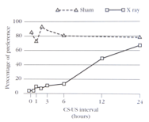
- Conditioned taste preference: a taste preference can be learned if a novel flavor is paired with nutritional repletion or other positive consequences.
- Evaluative conditioning: liking of an initially neutral stimulus changes by virtue of having that stimulus associated with something we already like or dislike.
    - A neutral flavor that is already liked will increase preference for that flavor.
    - I.e. Study with undergraduate students: banana and vanilla were used as neutral flavors.
    - To induce either a flavor aversion or preference, the students received these flavors mixed with a bitter substance (to condition an aversion) or sugar (to condition a preference).
    - In subsequent tests with the CS flavors, the students reported increased liking of the flavor paired with sugar, and decreased liking of the flavor that had been paired with the bitter taste.
    - Evaluative conditioning is responsible for many of our likes and dislikes.
    - It’s the basis of much of what is done in the advertising industry the product the advertiser is promoting is paired with things people already like in an effort to induce a preference for the product.
    - Companies take advantage of associative learning in their marketing campaigns.

Sign Tracking/Autoshaping Paradigm:
- Pavlov’s research concentrated on salivation and other highly reflexive responses.
  - This encouraged the belief that classical conditioning occurs only in reflex response systems.
- Sign tracking aka autoshaping: is the tendency to move towards/approach and possible contact a stimulus that signals the availability of a positive reinforcer (such as food).
  - Tracking stimulus that you perceive is making something happen.
  - Happens in classical conditioning when the animal or person doesn’t need to do anything in order to make something happen what happens is that an association is made and direct their behaviour toward what they perceive is making something happen.
  - Tracking sign that stimulus is coming not tracking stimulus itself.
  - Although sign tracking is a frequent outcome in classical conditioning, it’s not always observed:
    - There can be variability in which animals develop sign tracking and the degree of sign tracking exhibited.
    - Individual differences in conditioned responding were ignored in studies bc they were attributed to poor experimental control.
    - Not the case individual differences in sign tracking are correlated with individual differences in impulsivity and vulnerability to drug abuse.
    - This made sign tracking a valuable model system for studying learning processes and neural mechanisms that contribute to the development of drug addiction.
  - US substitution: CS takes on properties of US i.e. light becomes food somewhere in the brain.
  - Examples:
    - I.e. Pigeon has been conditioned to peck when the light is on, in order to receive a food reward; eventually pecking may be directed at the light (even though it has nothing to do with getting the food).
    - I.e. rat doesn’t need to press lever to get food reward presence of lever means that food is coming/don’t need to produce any sort of behaviour to make the food come what happens is that an association is made and when in the presence of the lever, and in turn the rat starts to direct behaviour to lever.
    - I.e. CS can predict availability of a female to a mail quail.
  - CS takes on properties of US (US substitution) i.e. light becomes food somewhere in the brain.
  - Other examples of sign tracking: drug addiction
  - Going back to the same places where they took the drug relapse
- Goal tracking: is the tendency to track the goal object (rather than the conditioned stimulus).
  - I.e. Approaching the location where the US is usually present.
- Individual differences in sign tracking and goal tracking are of considerable interest:
  - Correlation with susceptibility (impulsivity and vulnerability) to drug abuse.
  - Individual differences are genetic.
    - Sign trackers are more likely to become drug addicts because they respond heavier to cues (genetic predisposition)

Excitatory Pavlovian Conditioning:
- The process by which a CS comes to predict the presence of a US.
- Organisms learn a relation between a CS and US.
- As a result of this learning, presentation of the conditioned stimulus, activates behavioural and neural activity related to the unconditioned stimulus, in the absence of the actual presentation of that unconditioned stimulus.
  - Pigeons learn to approach and peck a key light that was paired with food.
  - Rats learn to freeze (CR) at the sound of a tone (CS), that preceded a foot shock, without the foot shock (US).
  - Babies learn to blink in response to a tone that preceded a puff of air.
  - People learn to avoid a flavor that was followed by illness on an earlier occasion.
  - Pavlov’s dogs salivate (CR) at the sound of the bell (CS), without the presentation of the food (US).
- Excitatory conditioning can be appetitive or aversive.
- One of the major factors that determines the course of classical conditioning:
  - The timing of the CS and US.
  - Small and trivial variations in how a CS is paired with a US can have profound effects on how vigorously the p’s exhibit a conditioned response and when the CR occurs.
  - Inter-stimulus interval: time between presentation of CS and US the time from the start of the CS to the start of the US (CS-US interval)
  - Inter-trial interval: time between successive trials the timing from the end of one conditioning trial to the start of the next.
  - Each configuration of CS and US represents a single conditioning trial.
  - Conditioning trial: a training episode involving presentation of a CS with (or without) a US.
  - For conditioned responding to develop, it is advisable to make the inter-stimulus interval much shorter
Five Excitatory Conditioning Procedures:
- First order conditioning
- 1. Short-delayed conditioning: CS-US interval < 1 minute.
  - Most commonly used procedure.
  - Involves delaying the start of the US slightly after the start of the CS on each trial.
- 2. Trace conditioning: gap between CS-US
  - Similar to short-delayed in that the CS is presented first and is followed by the US.
  - US is not presented until some time after the CS has ended.
  - This leaves a gap between the CS and US gap is called the trace interval.
- 3. Long-delayed conditioning: CS-US interval > 5 minutes.
  - CS still starts before the US.
  - US is delayed much longer (510 minutes or more) than in the short-delayed.
  - Does not include trace interval.
- 4. Simultaneous conditioning:
  - Expose subjects to CS and US at the same time.
- 5. Backward conditioning:
  - US occurs shortly before the CS rather than after.
  - Called backward because the CS and US are presented in a backward order compared to the other procedures.
- Similar results can be obtained with all types (except backwards conditioning)
- Different types of conditioning may involve different brain regions and can elicit different behaviours.
  - I.e. short-delayed conditioning elicits freezing, simultaneous conditioning elicits movement away from the CS.
Measuring the Conditioned Response: (CR)
- Pavlov and others after him have conducted systematic investigations of procedures to find out: how the conditioning of a CS depends on the temporal relation between the CS and US presentations.
- To make comparisons among the various procedures, one has to use a method for measuring conditioning that is equally applicable to all procedures.
  - This is done with a test trial.
  - Consists of presenting the CS by itself (without the US).
  - Responses elicited by the CS can then be observed without contamination from responses elicited by the US.
- Magnitude of the CR: one aspect of conditioned behaviour is how much of it occurs (i.e. how many drops of saliva that were elicited by a CS?)
- Probability of the CR: how likely it is to occur (i.e. % of freezing response)
  - The vigor of responding can also be measured by how often the CS elicits a CR.
  - I.e. we can measure the percentage of trials on which a CR is elicited by the CS.
  - This measuring is frequently used in studies of eyeblink conditioning and reflects the likelihood, or probability, of responding.
- Latency of the CR: how soon the CR occurs after onset of CS (i.e. when does the eyeblink occur?)
- Test trials are critical for assessing learning in simultaneous and backward conditioning.
Control Procedures for Classical Conditioning:
- Devising an effective test trial is not enough to obtain conclusive evidence of classical conditioning.
- Learning is an inference about the causes of behaviour based on a comparison of at least two conditions.
- In studies of classical conditioning our interest is in how the CS and US become associated.
- An association between a CS and US implies that the two events have become connected in some way.
  - An association requires more than just familiarity with the CS and US
  - IT depends on having two stimuli presented in a special way that leads to a connection between them.
  - To conclude that an association has been established, one has to make sure that the observed change in behaviour could not have been produced by prior separate presentations of the CS or the US.
- Increased responding to a stimulus can be a result of sensitization which is not an associative process.
- Pseudo-conditioning: increased responding that may occur to a stimulus, whose presentations are intermixed with presentations of a US, in the absence of the establishment of an association between the stimulus and the US.
  - Increases in responding observed with repeated CS-US pairings can sometimes result from exposure to just the US.
  - If exposure to just the US produces increased responding to a previously ineffective stimulus this is called pseudo-conditioning.
  - Control procedures are required to determine whether responses that develop to a CS represent a genuine CS-US association rather than just pseudo-conditioning.
- A control procedure should involve the same number and distribution of CS and US presentations as the experimental procedure, but with the CSs and USs arranged so that they do not become associated.
- Random control procedure: a procedure in which the CS and US are presented at random times with respect to each other.
  - Present the US at random times during both the CS and the intertrial interval, making sure that the probability of the US is the same during the intertrial interval as it is during the CS.
  - Has not turned out to be a useful method bc it does not prevent the development of conditioned responding.
- Explicitly unpaired control: a procedure in which both CS and US are presented, but with sufficient time between them so that they do not become associated with each other.
  - A more successful control procedure involves presenting the CS and US on separate trials.
  - The CS and US are presented far enough apart to prevent their association, but the total number of CS and US presentations is the same as in the conditioned or paired group.
- How much time separates CS and US presentations depends on the response system.
  - In taste-aversion learning much longer separation is necessary between the CS and US than in other forms of conditioning.
Effectiveness of Common Conditioning Procedures:
- There’s been considerable interest in determining which of the procedures depicted produces the strongest evidence for learning.
- This interest was motivated by a search to find the best procedure for producing Pavlovian conditioning.
- Research has shown that delayed, simultaneous, trace, and backward conditioning can all produce strong learning and vigorous conditioned responding.
- However, different behavioural and neural mechanisms are engaged by these different procedures.
- One reason why there is no best procedure for Pavlovian conditioning is that instead of learning just a CS-US association, participants also learn WHEN the US occurs in relation to the CS.
- Some have suggested that learning WHEN the US occurs may be more important than learning that a CS is paired with a US.
- The view that classical conditioning involves not only learning WHAT to expect but WHEN to expect it is called the temporal coding hypothesis.
  - Two peaks in CR magnitude develop with training these peaks correspond to WHEN the US was presented.
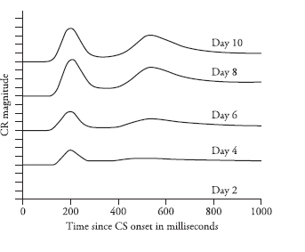
Inhibitory Pavlovian Conditioning:
- Learning to predict the absence of a US
- Inhibitory conditioning can only occur if there is an excitatory context for the US in question (i.e. there must be an expectation).
  - CS⁺ = excitatory CS
    - CS⁺ predicts presence of US
  - CS⁻ = inhibitory CS
    - CS⁻ predicts absence of US
- Study of individuals who experienced both predictable and unpredictable panic attacks:
  - Measured the general anxiety of the participants before and after each type of attack.
  - Before the attack, anxiety ratings were similar whether the attack was predictable or not.
  - However, anxiety significantly increased after an unpredicted panic attack and decreased after a predicted attack.
  - Such results indicate that the distress generated by the experience of a panic attack occurs primarily because of the unpredictability of the attack.
- A conditioned inhibitor: is a signal for the absence of the US.
  - For the absence of the US to be signification, it means the US must occur periodically.
  - 1. Aversive conditioning:
    - Excitatory CS: CS⁺ associated with shock freezing
    - Inhibitory CS: CS⁻ associated with period of no shock inhibits fear
  - 2. Appetitive conditioning:
    - Excitatory CS: CS⁺ associated with food salivation
    - Inhibitory CS: CS⁻ associated with absence of food frustration
Two Procedures for Inhibitory Conditioning:
- 1. Pavlov’s procedure for conditioned inhibition:
  - Standard conditioned inhibition by Pavlov: requires two CSs and two kinds of trials, one for excitatory conditioning and the other for inhibitory conditioning, alternated randomly.
  - The US is presented on excitatory conditioning trials (type A trials) and whenever the US occurs, it is announced by a stimulus labeled CS⁺ (i.e. a tone).
  - Because of its pairings with the US, the CS⁺ becomes a signal for the US and can then provide the excitatory context for the development of conditioned inhibition.
  - During inhibitory conditioning trials (type B trials), the CS⁺ is presented together with the second stimulus called the CS⁻ (i.e. a light), and the US does not occur.
  - Thus, the CS⁻ is presented in the excitatory context provided by the CS⁺, but the CS⁻ is not paired with the US this makes the CS⁻ a conditioned inhibitor or signal for the absence of the US.
  - During the course of training, A-type and B-type trials are alternated randomly.
  - As the p’s receives repeated trials of CS⁺ followed by the US, and CS⁺/CS⁻ followed by no US, the CS⁻ gradually acquires inhibitory properties.
  - Analogous to a situation in which something is introduced that prevents an outcome that would occur otherwise.
    - Type A trials (excitatory conditioning): CS⁺ is paired with the US
    - Type B trials (inhibitory conditioning): CS⁺ is paired with CS⁻ and US is omitted
    - A CS⁻ acts as a safety signal in the context of danger.
- 2. Negative CS-US Contingency or Correlation: involves just CS⁻
  - Does not involve an explicit excitatory stimulus or CS⁺, the environmental cues provide the excitatory context.
    - It involves just a CS- that is negatively correlated with the US.
    - A negative correlation or contingency: means that the US is less likely to occur after the CS⁻ than at other times.
    - Thus, the CS⁻ signals a reduction in the probability that the US will occur.
  - The US is periodically presented by itself however each occurrence of the CS⁻ is followed by the predictable absence of the US for a while.
  - Conditioned inhibition is reliably observed in procedures in which the only explicit CS is negatively correlated with the US…
    - What provides the excitatory context for this inhibition?
    - In this case, the environmental cues of the experimental chamber provide the excitatory context.
    - Because the US occurs periodically in the experimental situation, the contextual cues of the experimental chamber acquire excitatory properties in turn permits the acquisition of inhibitory properties by the CS.
  - Even in the absence of the CS⁻, the exact timing of the US cannot be predicted exactly in this procedure, because the US occurs at various times probabilistically.
  - In Pavlov’s procedure: the US always occurs at the end of the CS⁺, but never occurs when the CS⁻ is presented together with the CS⁺.
    - Because Pavlov’s procedure permits predicting the exact timing of the US, it also permits predicting exactly when the US will NOT occur.
    - The US will not occur at the end of CS⁺ if the CS⁺ is presented with the CS⁻.
- Applications:
  - Learned safety in an animal model:
    - Possibility of studying learned safety in animal models of mental disease (especially anxiety disorders)
Measuring Conditioned Inhibition:
- Because inhibitory conditioning is difficult to measure, researchers often use more than one test.
- Three ways to measure inhibitory conditioning:
  - 1. Bidirectional Response Systems:
    - Identification of an opposing response tendency is easy with response systems that can change in opposite directions from baseline or normal performance.
      - Heart rate, respiration, and temperature can all increase or decrease from a baseline level.
    - Certain behavioural responses are also bidirectional:
      - I.e. animals can either approach or withdraw from a stimulus or drink more or less of a flavored solution.
      - In these cases, conditioned excitation results in a change in behavior in one direction, and conditioned inhibition results in a change in behaviour in the opposite direction.
    - Many responses are not bidirectional…Because of these limitations, conditioned inhibition is typically measured indirectly using the compound-stimulus test, and the retardation of acquisition test.
  - 2. Compound-Stimulus, or Summation, Test:
    - One of the most widely accepted procedures for the measurement of conditioned inhibition.
    - Conditioned inhibition counteracts/inhibits conditioned excitation.
    - Therefore, to observe conditioned inhibition, one has to measure how the presentation of a CS- disrupts or suppresses responding that would normally be elicited by a CS+.
      - CS- in compound with CS+ should reduce the size of the CR.
    - I.e. Lick suppression in rats: conditioned fear response:
      - Rats received inhibitory conditioning in which the presentation of a flashing light by itself always ended in a brief shock (A+), and the presentation of an auditory cue (X) together with the light ended without shock (AX-) conditioned inhibition was used, X was expected to become an inhibitor of fear.
      - Rats received training with another auditory stimulus (B), in a different experimental chamber, which always ended in a brief shock (B+).
        - Procedures established conditioned excitation to A and B and inhibition to X.
      - It was then asked whether presumed inhibitor X would suppress responding to the excitatory stimuli A and B.
        - How long the rats took to accumulate 5 seconds of uninterrupted drinking was measured.
      - Conditioned fear was expected to slow the rate of drinking.
      - When the excitatory stimuli, A and B, were presented by themselves, the rats required substantial amounts of time to complete the 5-second drinking criterion.
      - In contrast, when the excitatory stimuli were presented together with the conditioned inhibitor (AX and BX tests), the drinking requirement was completed much faster.
        - Thus, presenting X with A or B reduced the drinking suppression that occurred when A and B were presented alone X inhibited conditioned fear elicited by A and B.
      - Another test condition: stimulus B tested with another auditory cue, Y.
      - Stimulus Y was not previously conditioned as an inhibitor and was presented to be sure that introducing a new stimulus with B would not cause disruption of the conditioned fear response just because of novelty.
      - No such disruption occurred with stimulus Y the inhibition of conditioned fear not only to the excited with which it was trained (A) but also to another exciter (B), that had never been presented with X during training thus X became a general safety signal.
      - The compound-stimulus test for conditioned inhibition indicates that the presentation of a conditioned inhibitor or safety signal can reduce the stressful effects of an aversive experience.
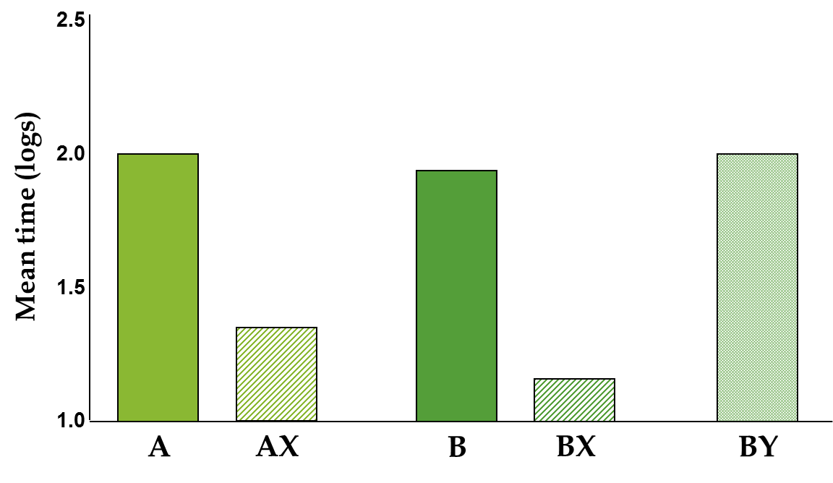
  - 3. Retardation of Acquisition test:
    - If a CS- actively inhibits a particular response, then it should be difficult to turn that stimulus into a conditioned excitatory CS+.
      - The rate of acquisition of excitatory conditioning should be retarded/slower, if the CS- was previously established as a conditioned inhibitor, than for a neutral stimulus.
    - In only 3 trials, fear conditioning to a new stimulus (Y) can be acquired.
    - The initial inhibitory training of stimulus X makes it difficult to change that stimulus to an excitatory conditioned fear.
      - X: previously CS-
      - Y: stimulus with no prior training.
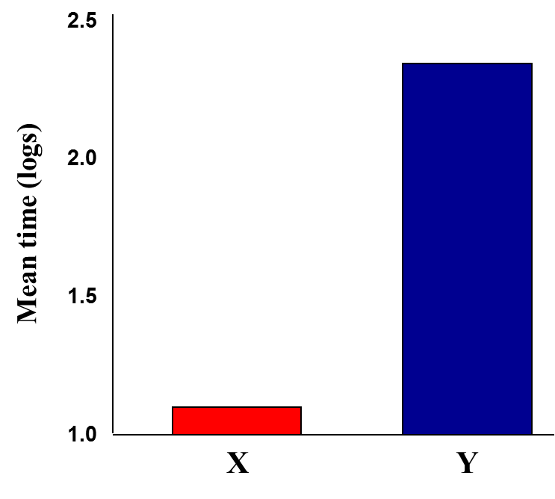
Prevalence of Classical Conditioning:
- Classical conditioning is most likely to develop when one event reliably precedes another in a short-delayed CS-US pairing.
  - Whenever one stimulus reliably precedes another, classical conditioning may occur.
- Studies of human casual judgment are analogous to studies of Pavlovian conditioning in that both involve repeated experiences with two events, and responses based on the extent to which those two events become linked to each other.
  - Finding and eating food
  - Fear conditioning (phobias and other anxiety disorders)
  - Taste conditioning (learned taste preferences or aversions)
Natural Selection at work?
- Humans seem naturally disposed to learn the associations between the colour red and sexuality.
- Female primates display red when nearing ovulation
- We frequently associate red with sex (valentine’s day hearts, red-light district, red lipstick, “the woman in red” from the Matrix...)

