PSYC 351 FUNDAMENTALS OF LEARNING
CHAPTER 1: Introduction

FORMS OF KNOWLEDGE
  - Declarative learning: facts, able to speak about it and declare what you know.
    - “Knowing that”
    - Easy to forget
    - Attributes
    - Past events
    - General info
    - Meaning of concepts
    - Significance of things
  - Procedural learning: acquire through experience.
    - “Knowing how”
    - Hard to un-learn
    - Skilled actions
    - Cognitive abilities

THE DEFINITION OF LEARNING
- An enduring change in the mechanisms of behaviour, involving specific stimuli and/or responses, that result from prior experience with similar stimuli and responses.
- Philosophical definition: learning is the process of accumulating knowledge.
- Biological definition: learning is a biological process that facilitates adaptation to one’s environment.
  - Biology dictates learning
  - Experience alters biology
  - Learning is constrained by biology
- Psychological definition version 1: learning is the acquisition of a new behaviour due to exposure to a similar situation in the past.
  - Behaviour: is any activity of an organism that can be observed or somehow measured.
  - The activity may be in response to stimuli that are either internal or external.
  - Problems with this definition of learning:
    - Learning is not always “acquisition” of new behaviour.
      - Learning to withhold response is just as important.
    - Changes in behaviour may not always be due to learning.
    - Definition does not account for latent learning.
      - Latent learning: is learning which is not apparent at the time of learning, but which can be shown later when suitable motivation and circumstances appear, i.e. Tolman’s Maze.
        - Group 1: food reward
        - Group 2: no reward
        - Group 3: no reward days 1-10, rewarded on day 11

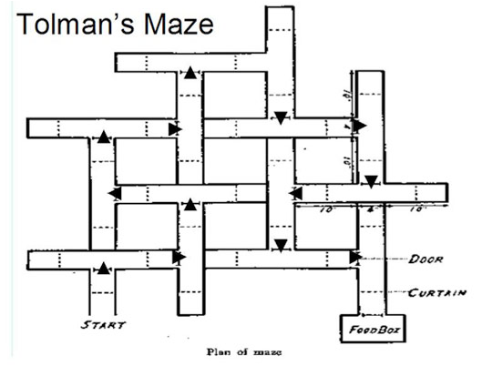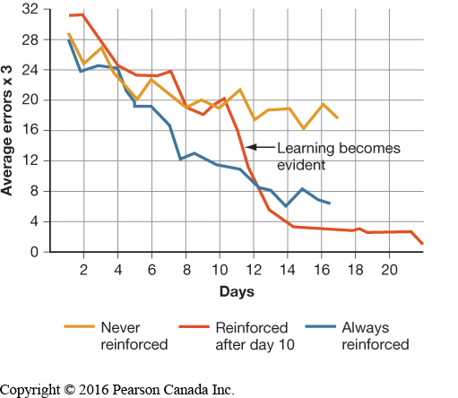

- Psychological definition version 2: behaviourist perspective: learning is a relatively long-lasting change in behaviour, or potential for behaviour, that occurs as a result of practice or experience.
  - This definition limits the role of consciousness in behaviour.
    - Many behaviours are habitual.
The Learning-Performance Distinction
- Whenever we see evidence of learning, we see the emergence of a change in behaviour:
  - The performance of a new response or suppression of a response that occurred previously.
  - However, not every change in behaviour is the result of learning.
    - I.e. a dog sniffs a fire hydrant, then sneezes.
    - I.e. a child is too short to reach something from a high shelf. Several months later, the child has had a growth spurt, and can now reach the shelf.
    - I.e. a person does not stop at a red light.
    - I.e. a child becomes skilled in snapping the buckles of their sandals.
    - I.e. a child becomes more patient when waiting for popcorn in microwave.
  - The preceding definition attributes learning to a change in the mechanisms of behaviour, but not a change in the behaviour directly.
- Can behaviour be indefinitely modified through learning, or is it constrained by an organism’s biology and genetics?
  - Learning is defined in terms of a change in the mechanisms of behaviour, because:
    - Behaviour is determined by many factors, and it allows us to emphasize the distinction between learning and performance.
  - I.e. eating whether you eat something depends on how hungry you are, how much effort is required to get the food, how much you like the food, etc. only some of these factors involve learning.
- Performance: refers to all of the actions of an organism at a particular time.
    - Whether someone does something or not (its performance) depends on many factors.
    - Factors: fear, hunger, thirst, exhaustion.
  - A change in performance cannot be automatically considered to reflect learning.
  - To confirm that the observed behaviour is a reflection of learning, we must control as many factors as possible.
Learning and other sources of behaviour change
- Several mechanisms produce changes in behaviour that are too short-lasting to be considered instances of learning.
  - Fatigue: a temporary decrease in behaviour caused by repeated or excessive use of the muscles involved in the behaviour.
    - Physical exertion may result in gradual reduction in the vigor of a response because the individual becomes tired.
    - This type of change is produced by experience however is not considered an instance of learning bc the decline in responding disappears if the individual is allowed to rest for a while.
  - Change in stimulus conditions: if the house lights in a movie theater suddenly come on in the middle of the show, the behaviour of the audience is likely to change dramatically.
    - Not an instance of learning bc the audience is likely to return to watching the movie when the lights are turned off again.
  - Change in the physiological or motivational state of organism:
    - I.e. hunger, thirst, sickness, drugs.
  - Maturation: a change in behaviour caused by physical or physiological development of the organism, in the absence of experience with particular environmental events.
    - A child cannot get something from a high shelf until they grow tall enough the change in behaviour is not an instance of learning bc it occurs with the mere passage of time.
    - The child does not have to be trained to reach high places as they become taller.
Learning and Levels of Analysis
- Choosing the Right Model System:
  - Levels of analysis:
    - Learning mechanisms may be investigated at the organismic level, at the level of neural circuits and transmitter systems, and at the level of never cells or neurons.
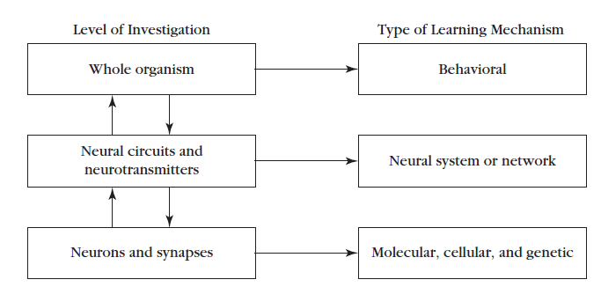

  - Our model must have validity:
    - Construct validity: we can gain insight into human behavior from animal models if the causal factors governing the behavior are similar.
    - Criterion validity: we can gain insight into human behavior from animal models if the laboratory animal behavior induced by an experimental manipulation predicts human behavior in the real world.
  - Focus on relevant features and functions:
    - I.e. why do people smoke?

HISTORICAL ANTECEDENTS
Historical Developments in the Study of the Mind
- Dualism: mind and body are distinct entities.
  - Rene Descartes (1596-1650)
    - Before Descartes, the view was that human behaviour is entirely determined by conscious intent and free will people’s actions were not to be considered automatic.
    - People do things automatically in response to external stimuli (didn’t abandon the idea of free will and conscious control entirely)
    - Formed the dualistic view of human behaviour known as Cartesian dualism.
      - Two classes of human behaviour: involuntary and voluntary.
        - Involuntary behaviour: consists of automatic reactions to external stimuli and is mediated by the reflex.
        - Voluntary behaviour: does not have to be triggered by external stimuli, and occurs because of the person’s conscious intent to act in that particular manner.
    - Mechanisms of involuntary/reflexive behaviour:
      - Stimuli in the environment are detected by the person’s sense organs Sensory info is relayed to the brain through the nerves From the brain the input for action is sent through nerves to the muscles that create the involuntary response.
      - Sensory input is reflected in the response output Descartes called involuntary behaviour reflexive.
    - Assumed that only one set of nerves was involved believed the same nerves transmitted info from sense organs to brain and from brain to muscles.
      - Believed this circuit permitted rapid reactions to external stimuli like the quick withdrawal of a finger from a hot stove.
    - Believed involuntary behaviour was the only one available to nonhuman animals all nonhuman animal behaviour occurs because of reflexive behaviour.
      - Believed nonhuman animals lacked free will and were incapable of voluntary, conscious action.
    - Believed the mind and body were separate.
      - Mind did not function in a predictable, orderly manner according to strict rules or laws that one could identify.
      - Mind was assumed to be a nonphysical entity believed the mind was connected to the physical body by the way of the pineal gland, at the base of the brain.
      - Bc of this connection the mind was aware of and could keep track of involuntary behaviour, and could also initiate voluntary actions.
      - Mind-body dualism: stimulated mentalism and reflexology.
        - Mentalism: concerned with contents and workings of the mind.
        - Reflexology: concerned with mechanisms of reflexive behavior.
        - These two intellectual traditions form the foundations of modern study of learning.
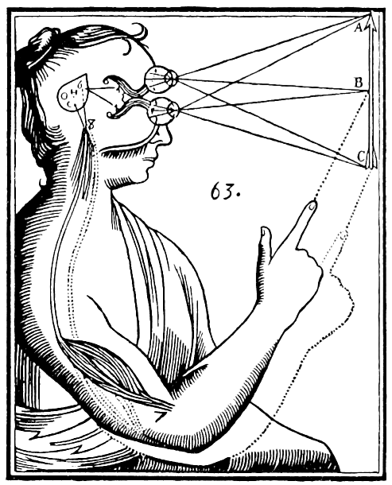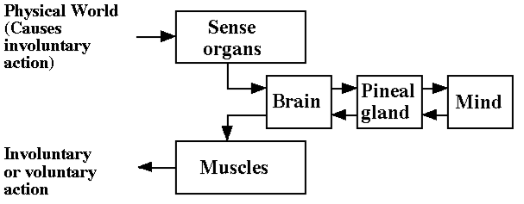

- Nativism: humans are born with innate ideas (certain skills, abilities, and ideas are hard-wired).
- Empiricism: humans are born as a blank slate (all ideas in the mind arise from experience).
- Nativists and empiricists disagreed not only about the contents of the mind at birth but also about how the mind works.
  - John Locke (1632-1704)
    - Tabula rasa blank slate.
    - All ideas people have are acquired directly or indirectly through experiences after birth.
    - Humans were born without any preconceptions about the world.
    - Mind is a blank slate to be gradually filled with ideas and info as the person encounters various sense experiences.
  - Rules of association: important aspect of how the mind works.
    - Primary laws of association: proposed by Aristotle.
      - Contiguity: if two events repeatedly occur together in space or time, they will become associated smell of sauce and pasta.
      - Similarity: if two things are similar in some aspect, they will become associated both things are red
      - Contrast: if two things are contrasting in some respect, they will become associated very tall vs. very short
        - No evidence found yet.
    - Secondary laws of association: proposed by Thomas Brown
      - Association between two stimuli depended on the intensity of those stimuli and how frequently or recently they occurred together.
      - Also depended on the number of other associations in which each event was already involved, and the similarity of these past associations to the current on being formed.
    - Empirical investigation of the mechanisms of associations: Hermann Ebbinghaus
      - Nonsense syllables: three-letter combinations (i.e. “bap”) that has no meaning, that might influence how someone might react to them.
- Hedonism: philosophy proposed by Hobbes, according to which the actions of organisms are determined by the pursuit of pleasure and avoidance of pain.
  - Thomas Hobbes (1588-1679)
    - First to propose alternative to Descartes position.
    - Accepted the distinction between voluntary/involuntary behaviour but also accepted the notion that voluntary behaviour was controlled by the mind.
    - Unlike Descartes, believe the mind operates just as predictably and lawfully like a reflex.
    - According to this principle, people do things in the pursuit of pleasure and avoidance of pain.
    - Was not concerned with whether the pursuit of pleasure and avoidance of pain was desirable or justified hedonism was simply a fact of life.
    - Notion that behavior is controlled by positive and negative consequences has remained with us to present day.

Historical Developments in the Study of Reflexes
- Reflexes:
  - Reflexes: are a kind of elicited behavior that are not consciously processed or under voluntary control.
    - Descartes believed sensory messages going from sense organs to the brain and motor messages going from the brain to the muscles traveled along the same nerves.
    - Believed nerves were hollow tubes and neural transmission involved the movement of gases called animal spirits.
    - Animal spirits released by the pineal gland, were assumed to flow through the neural tubes and enter the muscles, causing them to swell and create movement.
    - Considered all reflexive movement to be innate and to be fixed by the anatomy of the nervous system.
    - All of these ideas about reflexes have been proven wrong.
  - Charles Bell and Francois Magendie (1800s)
    - Separate nerves are involved in transmission of sensory information to the CNS and motor information from the CNS to the muscles.
    - If a sensory nerve is cut animal remains capable of muscle movements.
    - If a motor nerve is cut animal remains capable of registering sensory information.
  - John Swammerdam: showed that mechanical irritation of a nerve was enough to produce a muscle contraction infusion of animal spirits from pineal gland was not necessary.
  - Francis Glisson: tested whether muscle contractions were produced by the infusion of a gas into the muscle showed that the volume of a muscle does not increase when it is contracted demonstrating that a gas does not enter the muscle to produce motor movement.

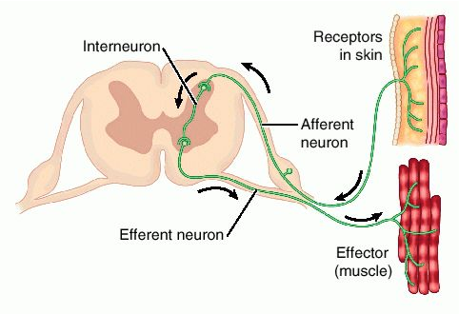

  - I.M. Sechenov (1829-1905)
    - Proposed that stimuli could elicit OR inhibit reflex responses.
    - Suggested that actions or thoughts that occurred in the absence of an obvious eliciting stimulus were in fact reflexive responses.
      - In these cases the eliciting stimuli are too faint for us to notice.
    - Proposed voluntary behavior and thoughts are actually elicited by faint stimuli that could generate a large response.
    - Did not address the question of how reflexes can account for the fact that the behavior of organisms is not fixed and invariant throughout an organisms life, but can be altered by experience.
  - Ivan Pavlov (1849-1936)
    - Showed experimentally that not all reflexes are innate.
    - New reflexes to stimuli can be established through association.

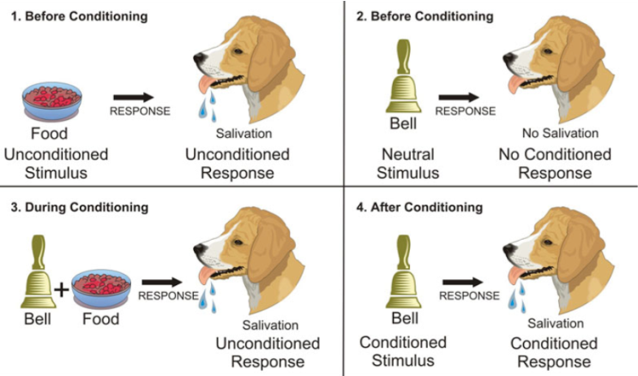
THE DAWN OF THE MODERN ERA
Comparative Cognition and the Evolution of Intelligence
- Evolution:
  - Charles Darwin (1809-1882)
    - “Man is descended from some lower form…”
    - Sought to characterize the evolution of physical and mental traits.
    - Argued that the human mind is a product of evolution.
    - Suggested that nonhuman animals also has mental abilities.
    - Rationale for functional neurology.
Functional Neurology
- The modern era in the study of learning processes was greatly stimulated by efforts to use studies of learning in nonhuman animals to gain insight into how the nervous system works.
- This line of research was initiated by Russian physiologist Ivan Pavlov.
- Pavlov became committed to the principle of nervism: according to which all behavioral and physiological processes are regulated by the nervous system.
- The behavioral studies of learning provide clues about the machinery of the nervous system.
- Studies can tell us what kinds of plasticity the nervous system is capable of, the conditions that learning can take place, how long learned responses persist, and the circumstances under which learned information become accessible or not.

METHODOLOGICAL ASPECTS OF THE STUDY OF LEARNING
How can we study learning?
- Learning as an Experimental Science
- Observation alone will not give us the answers
- To identify how experiences might cause long-term changes in behaviour we need to identify causal variables using an experimental approach
  - Experimental manipulation of important variables
  - Measurement (and comparison) of responses
  - Control conditions

- The General-Process Approach to the Study of Learning
- Driven by the search for commonalities and uniformities
- Assume that learning processes operate much the same way in different learning situations.
- Formulate general laws
- Implication: General rules of learning may be discovered by studying any species or response system that exhibits learning

- Animal Models
- Animal models of behavior:
  - Rats put in an operant chamber and implanted with a catheter that delivers a nicotine solution when the rat pokes the left nose hole, but not the right nose hole.
    - What questions could you ask next?
- Why do animal research?
  - To learn more about animals and their behaviors.
  - To develop new treatments and therapies for animals and/or humans.
- Why is animal research necessary in the field of learning?
  - Observation alone is not sufficient.
  - More control of variables allows for better experiments.
    - Control of prior experience
    - Knowledge of genetic sequence
    - Fewer extraneous variables
  - Can investigate questions that cannot be studies in humans for ethical or practical reasons.
- Animal research is subject to many policies to ensure the animal’s welfare:
  - National and institutional committees review all experimental proposals
  - Training of all animal handlers and researchers
  - Replacement of animal models where possible
  - Reduction of the number of animal models used
  - Refinement of techniques to ensure animal
  - S welfare ad experimental soundness
- Are animal models used in research really that similar to humans?

