ECO 1104
Chapter 1

Key Terms:
- Scarcity- the limited nature of society’s resources
- Economics- the study of how society manages its scarce resources
- Efficiency- the property of society getting the most it can from its scarce resources
- Equity- the property of distributing economic prosperity fairly among the members of society
- Opportunity Cost- whatever must be given up to obtain some item
- Rational People- people who systematically and purposefully do the best they can to achieve their objectives
- Marginal Changes- small incremental adjustments to a plan of action
- Incentive- something that induces a person to act
- Market Economy- an economy that allocates resources through the decentralized decisions of many firms and households as they interact in markets for goods and services
- Property Rights- the ability of an individual to own and exercise control over scarce resources
- Market Failure- a situation in which a market left on its own fails to allocate resources efficiently
- Externality- the impact of one person’s actions on the well-being of a bystander
- Market Power- the ability of a single economic actor (or small group of actors) to have a substantial influence on market prices
- Productivity- the quantity of goods and services produced from each hour of a worker’s time
- Inflation- an increase in the overall level of prices in the economy
- Business Cycle- fluctuations in economic activity, such as employment and production

Ten Principles of Economics
  - People face tradeoffs
  - The cost of something is what you give up to get it
  - Rational people think at the margin
  - People respond to incentives
  - Trade can make everyone better off
  - Markets are usually a good way to organize economic activity
  - Governments can sometimes improve market outcomes
  - A country’s standard of living depends on its ability to produce goods and services
  - Prices rise when the government prints too much money
  - Society faces a short-run tradeoff between inflation and unemployment

Summary
- The fundamental lessons about individual decision making are that people face tradeoffs among alternative goals, that the cost of any action is measured in terms of forgone opportunities, that rational people make decisions by comparing marginal costs and marginal benefits, and that people change their behaviour in response to the incentives they face.
- The fundamental lessons about interactions among people are that trade can be mutually beneficial, that markets are usually a good way of coordinating trade among people, and that the government can potentially improve market outcomes if there is some market failure or if the market outcome is inequitable.
- The fundamental lessons about the economy as a whole are that productivity is the ultimate source of living standards, that money growth is the ultimate source of inflation, and that society faces a short-run tradeoff between inflation and unemployment.

ECO 1104
Chapter 2

Two Roles of Economists
- Scientists- try to explain the world
- Policy Advisors- try to improve it

The Economist as a Scientist

- Assumptions simplify the complex world, make it easier to understand.
- Example: When studying international trade,
we might assume the world consists of
two countries and two goods.
- Very unrealistic, but simplifies the problem
and yields useful insights about the more complicated real world.
- Economists use models to study economic issues. A model is a highly simplified representation of a more complicated reality.

Types of Economic Models
Circular-Flow Diagram

Households
- own the factors of production,
sell/rent them to firms for income
- buy and consume goods & services

Firms
- buy/hire factors of production,
use them to produce goods and services
- sell goods & services
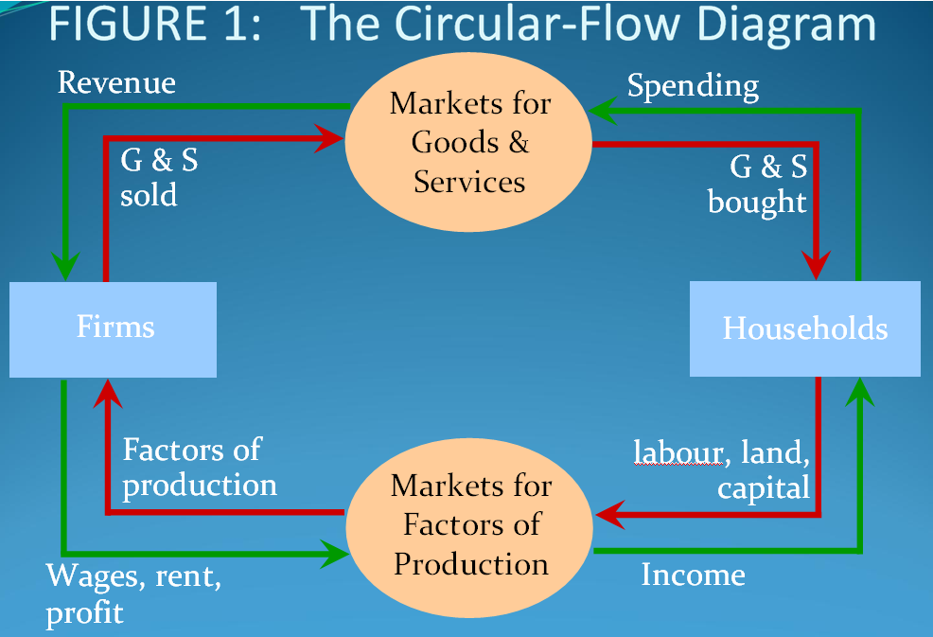

Production Possibility Frontier
Is a graph that shows the combinations of two goods the economy can possibly produce given the available factors of production and the available production technology.

 | Employment of labor hours |  | Production
 | Computers | Wheat | Computers | Wheat
A | 50,000 | 0 | 500 | 0
B | 40,000 | 10,000 | 400 | 1,000
C | 25,000 | 25,000 | 250 | 2,500
D | 10,000 | 40,000 | 100 | 4,000
E | 0 | 50,000 | 0 | 5,000
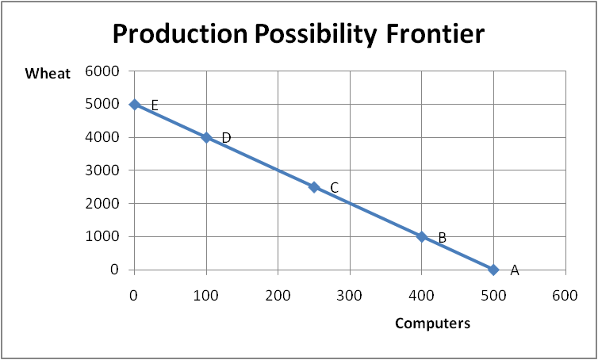

- PPF also shows the opportunity cost of one good in terms of the other.
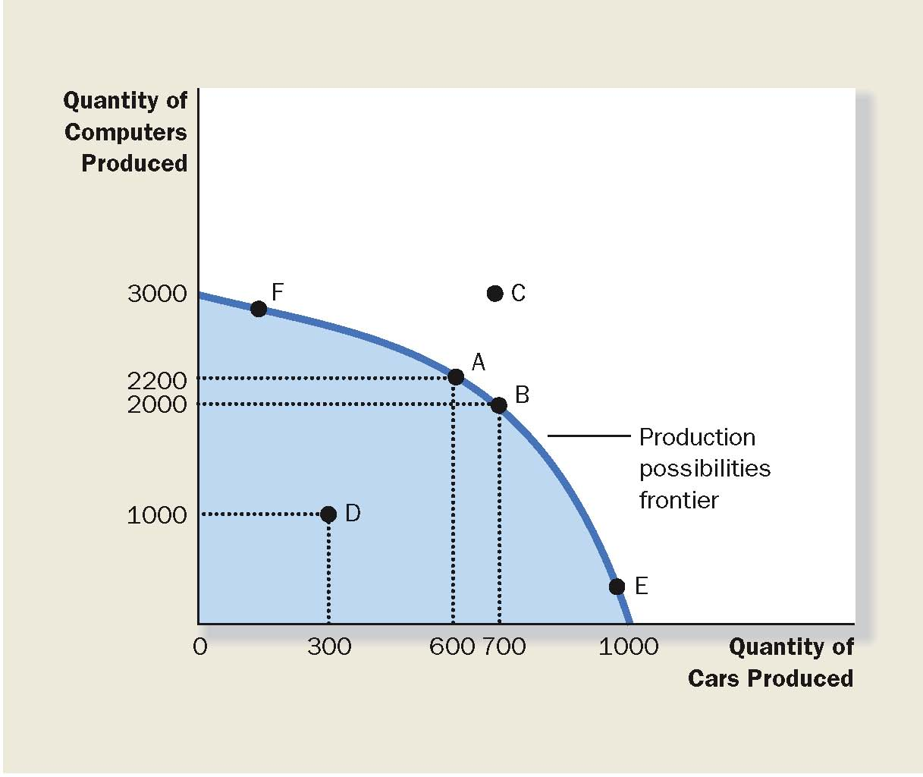

The Shape of the PPF

- The PPF could be a straight line, or bow-shaped
- Depends on what happens to opportunity cost
as the economy shifts resources from one industry
to the other.
- If the opportunity cost remains constant, the PPF is a straight line.
- If opportunity cost of a good rises as the economy produces more of the good, which is more likely the case, then the PPF is bow-shaped.

Summary

- The PPF shows all combinations of two goods that an economy can possibly produce, given its resources and technology.
- The PPF illustrates the concepts of tradeoff and opportunity cost, efficiency and inefficiency, unemployment, and economic growth.
- A bow-shaped PPF illustrates the concept of increasing opportunity cost.

The Economist as Policy Advisor
Positive vs. Normative

- Positive statements are statements that attempt to describe the world as it is.
- Can, in principle, be confirmed or refuted by examining evidence.

- Normative statements are statements about how the world should be—they are prescriptive.
- Normative statements may involve values as well as facts.

ECO 1104
Chapter 3

Absolute Advantage- country that needs smallest amount of input to produce for all goods.

Comparative Advantage- country with lowest opportunity cost to produce.

 | Minutes to produce 1 kg of: |  | Amount of meat/potatoes produced in 8 hours:
 | Meat | Potatoes | Meat | Potatoes
Farmer | 60min/kg | 15min/kg | 8kg | 32kg
Rancher | 20min/kg | 10min/kg | 24kg | 48kg

Rancher: absolute advantage
Farmer has comparative advantage in potatoes
Rancher has comparative advantage in meat

Principle: A country should specialize in what it does best. In other words, if it has a comparative advantage in a good, it should specialize in producing that good and trade.

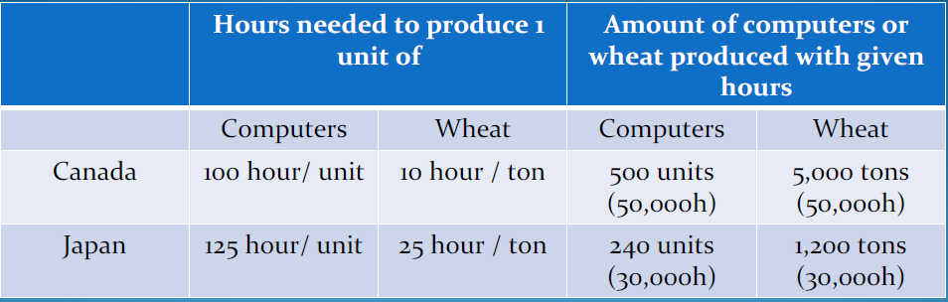

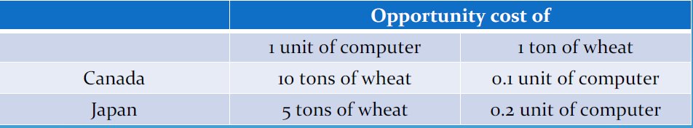

Gain s from Trade and Specialization

Canada should specialize in producing wheat, while Japan should specialize in producing computer
- When will Canada be interested in trading wheat for computers?
- When will Japan be interested in trading computers for wheat?
- The price range is between two opportunity costs
  - 1 comp/ 5 wheat < P < 1 comp / 10 wheat
  - 1 wheat / 0.1 comp < P < 1 wheat / 0.2 comp

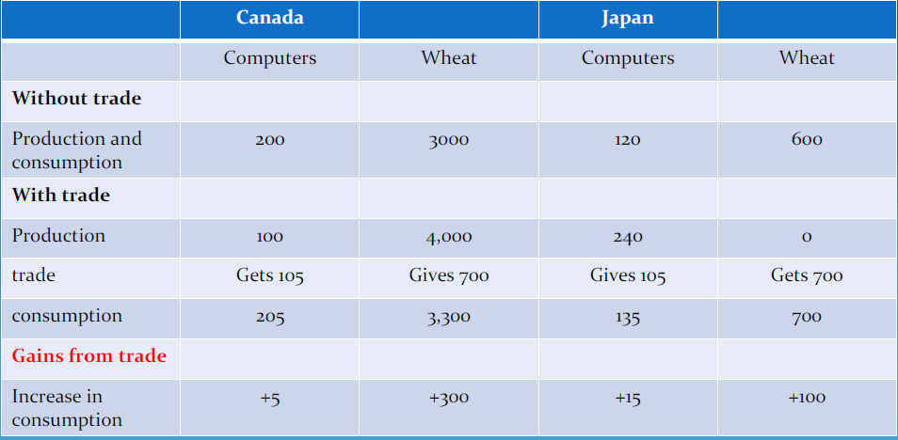

Conclusion

- All countries benefit from trade; even those that are less competitive in every way.
- This does not mean though that no one would loose his/her job if a country enters a free-trade agreement with another country (or that one country will not benefit more than another one from international trade).
- Some workers can loose their jobs but they should be able to find jobs in other sectors. The issue that the society as a whole is better-off when there is international trade.
- Economists generally agree that globally, international trade creates more jobs than it destroys.
- Trading with another country is conceptually equivalent to shifting the PPF to the right—it is equivalent to a technological advance.

ECO 1104
Chapter 4

What is a Market?
- A group of buyers and sellers of a particular good or service
- Buyers determine demand
- Sellers determine supply
- What is market competition?
- The struggle between individuals and firms to capture a larger portion of market

The Demand Curve
- The demand curve expresses the relationship between price and quantity demanded.
The Law of Demand
- Other things equal, when price of the good rises, quantity demanded of the good falls.
- Price and quantity demanded are negatively related

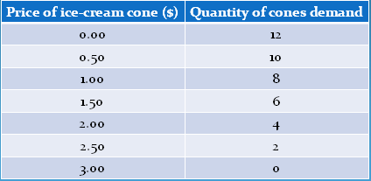
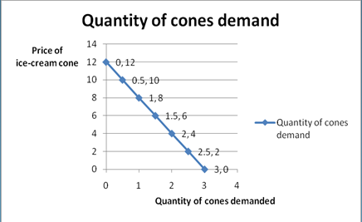
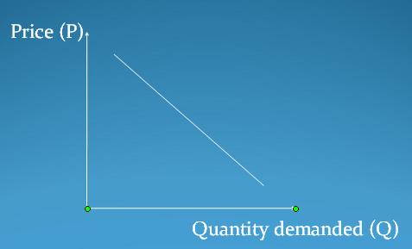

Shifts in Demand Curve
- A demand curve is derived holding all variables constant (except price and quantity).
- This means that changes in any variable other than price or quantity may shift the demand curve.
- More formally, any change that alters the quantity demanded at every price will shift the demand curve.
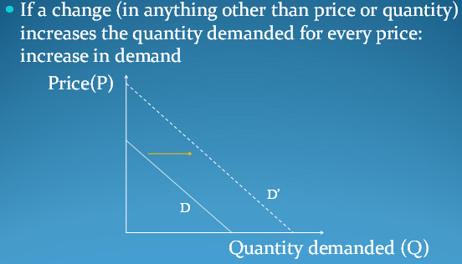
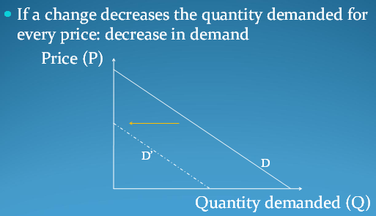
Different Type of Goods

- Normal goods vs. inferior goods
- Normal goods: income and quantity demand positively related
- Inferior goods: income and quantity demand negatively related:
- Example: inexpensive foods (hamburger, canned food), bus service
- Giffen goods: violate the law of demand
- Example: Potatoes during the Irish Great Famine

- Substitutes vs. Complements
- Two goods are substitutes when price increasing in one leads to demand increasing in the other.
- Example: margarine and butter

- Two good are complements when price increasing in one leads to demand decreasing in the other.
- Example: petroleum and cars

The Supply Curve
- The supply curve expresses the relationship between the price and the quantity supplied.
The Law of Supply
  - Other things are equal, the quantity supplied of a good rises when the price of the good rises
  - The price and the quantity supplied positively relate
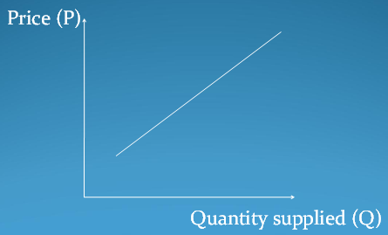

Shifts in the Supply Curve
- A supply curve is derived holding all variables constant (except price and quantity).
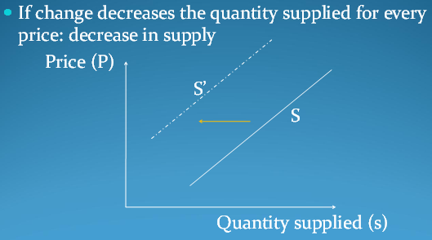
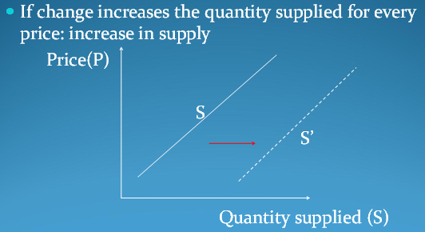
- This means that any change that alters the quantity supplied at every price will shift the supply curve.

Market Equilibrium
- Market equilibrium: a situation in which the price has reached the level where quantity supplied equals quantity demanded.
- Equilibrium price: the price that balances quantity supplied and quantity demanded.
- Equilibrium quantity: the quantity supplied and the quantity demanded at the equilibrium price.

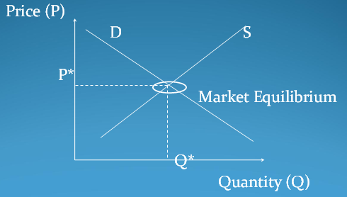
Excess Supply
- When price > equilibrium price, then quantity supplied > quantity demanded.
- There is excess supply or a surplus.
- Suppliers will lower the price to decrease sales, thereby moving toward equilibrium.
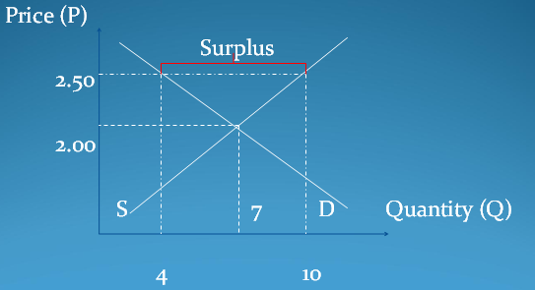

Excess Demand
- When price < equilibrium price, then quantity supplied < quantity demanded.
- There is excess demand or a shortage.
- Suppliers will raise the price due to too many buyers chasing too few goods, thereby moving toward equilibrium.


