Task 1: Knowledge/Understanding questions
- Simplify each of the following expressions. Express all answers in terms of positive exponents. (10 marks)
    - (4a³)(−9a⁵)
$$=-36a^{5}a^{3}$$
$$=-36a^{8}$$
    - $\frac{{9x}^{3}y^{8}z^{17}}{-{3x}^{5}y^{5}z^{10}}$
$$=-\frac{3x^{3}y^{8}z^{17}}{x^{5}y^{5}z^{10}}$$
$$=-3\frac{y^{3}z^{7}}{x^{2}}$$
    - $(-{7k}^{8})^{3}$
$$=-7^{3}k^{24}$$
$$=-343k^{24}$$
    - $\frac{({2a}^{3}b^{6})^{5}}{(-{3a}^{4}b^{4})^{2}}$
$$=\frac{2^{5}a^{15}b^{30}}{3^{2}a^{8}b^{8}}$$
$$=\frac{{32a}^{15}b^{22}}{{9a}^{8}}$$
$$=\frac{32a^{7}b^{22}}{9}$$

    - $\frac{(b^{2a})^{2a+3}}{(b^{3a})^{a-6}}$
$$=b^{2a\left(2a+3\right)-3a\left(a-6\right)}$$
$=\frac{b^{4a^{2}+6a}}{b^{3a^{2}-18a}}$ yes
$=b^{a^{2}}a^{24}$ no it should be $b^{a^{2}+24a}$
9/10
- Solve for the unknown value in each of the following equations. (6 marks)
    - $\log_{3}\frac{1}{81}=x$
$$=log_{3}\left(81\right)$$
$$=-log_{3}(3^{4})$$
=$-4log_{3}(3)$
=$-4*1$
=$-4$
    - $\log_{7}1=x$
$$\log\left(1\right)= 0$$
Therefore, $\log_{7}1=0$
    - $\log_{3}\left(x\right)=-2$
$$-2=\log_{3}(3^{(-2)})$$
$$\log_{3}\left(x\right)=\log_{3}(3^{(-2)})$$
$$x=3^{(-2)}$$
$$x=\frac{1}{9}$$
    - $\log_{x}\left(0.0625\right)=2$
$$2=\log_{x}(x^{2})$$
$$log_{x}\left(0.0265\right)= \log_{x}(x^{2})$$
$0$.0625=$x^{2}$
$x=-0.25, x=0.25$ ok but negative is extraneous.
    - $2\log_{4}4^{7}=x$
$$=2*7\log_{4}(4)$$
$$=1*2*7$$
$$=14$$
    - $\log_{9}9^{\log_{3}3}$=x
$$x=\log_{9}(9^{log_{3}3})$$
$$x=\log_{3}\left(3\right)\log_{9}(9)$$
$$log_{3}\left(3\right)=1$$
=1lo$g_{9}$(9)
=1*1
=1 good work
- Evaluate each of the following expressions. (9 marks)
    - 2$\log_{6}3+\log_{6}4$
$\log_{6}(3^{2}$)+$\log_{6}(4)$$$log_{6}⁡(3^{2}*4)$$
$$log_{6}(36)$$
$=2$ yes
    - $\log_{2}16\sqrt{8}$
$\sqrt{8}$=2*$\sqrt{2}$
$2*\sqrt{2}log_{2}$(16) no, as 2$\sqrt{2} is not in the exponent, we can^{'}tbring it out front like this$
$2*\sqrt{2}log_{2}$($2^{4}$)
$$log_{2}\left(2^{4}\right)=4\log_{2}\left(2\right)$$
=$2*\sqrt{2}*4\log_{2}\left(2\right)$
$$\log_{2}\left(2\right)= 1$$
$$=2*\sqrt{2}*4$$
$$=\sqrt{2}*8$$
$$=11.31$$
    - $\log_{8}1024-\log_{8}512+2\log_{8}2$
$$\log_{8}1024-\log_{8}512=\log_{8}(\frac{1024}{512})$$
=$2\log_{8}\left(2\right)+\log_{8}(2)$
=$2\frac{1}{3}+\log_{8}(2)$
$$=\frac{1}{3}+2\frac{1}{3}$$
$$=\frac{1}{3}+\frac{2}{3}$$
$$=\frac{1+2}{3}$$
$=1$ yes
$$\frac{7}{9}total$$
- Solve for the unknown value in each of the following equations. (10 marks)
    - ${16}^{5a-1}$*${256}^{3a}=128$
${16}^{5a-1}$*${256}^{3a}={16}^{5a-1}$(${16}^{2})^{3a}$
$${16}^{5a-1}{(16}^{2})^{3a}=128$$
${16}^{11a-1}$=128
$${\left(2^{4}\right)}^{11a-1}=2^{7}$$
$$4\left(11a-1\right)=7$$
$$4*11a-1*4$$
$$44a-4=7$$
$$44a-4+4=7+4$$
$$44a=11$$
$$\frac{44a}{44}=\frac{11}{44}$$
$a=\frac{1}{4}$ good

    - $3^{x+4}-5\left(3^{x}\right)=684$
$$3^{x+4}-53^{x}$$
$$76*3^{x}=684$$
$$\frac{76*3^{x}}{76}=\frac{648}{76}$$
$$3^{x}=9$$
$x=2$ good
    - 7($4^{2x}$)=28($4^{x}$)
$$\frac{7*4^{2x}}{7}=\frac{28*4^{x}}{7}$$
$$4^{2x}=4^{x+1}$$
$x=1$ yes 10/10

Task 2: Thinking questions
- Determine the logarithmic equation in base 2 that has been compressed vertically by a factor of 1/3, compressed horizontally by a factor of 1/8, reflected in the x-axis, and translated 4 units to the left. List the values for a, k, c, and d. (4 marks)
$$y=alog_{b}k\left(x-d\right)+c$$
$a=-\frac{1}{3} \left(reflected in the x-axis\right), k=8, c=0 (No vertical translation), d= -4$ so what is the final equation?
$\frac{3}{4}$ total
- (12 marks total)
  - Describe two methods that can be used to graph a function and its inverse. (2 marks)
To graph the inverse of a function, the x and y coordinates on the graph will switch places such as (1, 2) will become (2, 1). As a result, the graph of the inverse function will be a mirrored image to the original function.
Another method to graph a function and its inverse is to draw the line y=x of the graphed function. This line will represent a “two side’s mirror” which can help you “see” the inverse reflection. As a result, this will enable you to sketch the inverse function without having to manually switch all the (x, y) coordinates.good
  - Graph the equation y=($\frac{1}{3}$)x and its inverse on the same grid, along with the mirror line, y=x. (2 marks)
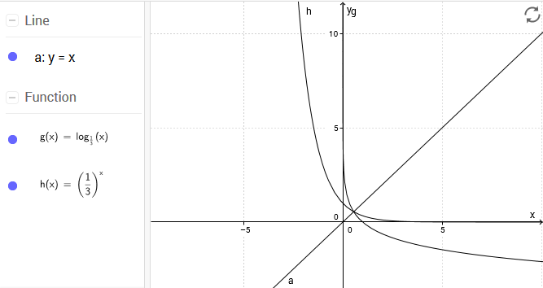
  - List the special features of the exponential function and its inverse. Include the domain, range, intercepts, and asymptotes. (6 marks)
 | $$y=(\frac{1}{2})^{x}$$ | $$y^{-1}=log_{(\frac{1}{2})}x$$
Domain | {$xϵ Ɍ$} | {$x>0,x ϵ Ɍ$}
Range | {$y>0, y ϵ Ɍ$} | {$y ϵ Ɍ$}
x-intercept | Does not exist | (1,0)
y-intercept | (0,1) | Does not exist
Vertical Asymptote | Does not exist | $$x=0 (the y-axis)$$
Horizontal Asymptote | $$y=0 (the x-axis)$$ | Does not exist
Excellent!
  - Is the inverse a function? Why or why not? (2 marks)
The inverse is not a function because it failed the vertical line test since it intersected at more than one point. No it is a function. It passes the vertical line test
11/12 total
- (12 marks total)
  - Graph y=5^{x} and y=−5^{−x} on the same grid. (2 marks)
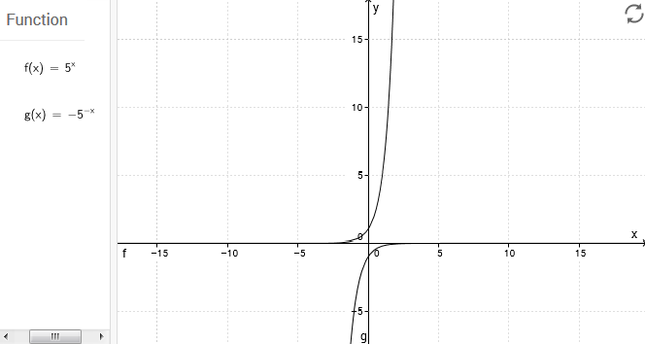
  - Describe how the equation y=−5^{−x} has been transformed from the parent function. (1 mark)
There is a vertical stretch by a factor of 5, and a reflection in the x-axis. It’s a reflection in the y axis as well
  - Determine the inverse of y=$5^{x}$. (1 mark)
$$y=5^{x}$$
$$x=5^{y}$$
$y=log_{5}x$ yes nice
$$y=\frac{logx}{log5}$$
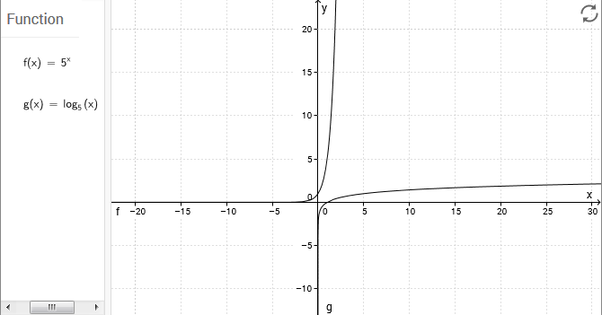
  - Graph y=5^{x} and its inverse on the same grid. (2 marks)

  - Describe how the transformed graph in part (a) of this question differs from the graph of the inverse in part (c) by comparing the major features. Include the domain, range, intercepts, and asymptotes in your discussion. (6 marks)

The transformation graph in part (a) domain is {$xϵ Ɍ$}(can use any real number), whereas the domain for (b) is that x must be greater than 0{$xϵ Ɍ$}. The range for (a) x must be less than 0 $\{y ϵ Ɍ\}$ and (b) graph is any real number on the y range {$y ϵ Ɍ$}. The x-intercept for (a) graph does not exist, whereas in (b) the intercept is at (1,0). Moreover, the y-intercept exists at the point of (0,1) in the (b) graph, though not in the (a) graph. The vertical asymptote does not exist in the (a) graph but the horizontal asymptote does exists at y=0 (the x-axis); whereas, the vertical asymptote in (b) graph does exist at x=0 (the y-axis). However, the horizontal asymptote does not exist.

In Summary:
 | $$y=(-5)^{-5}$$ | $$y^{-1}=log_{(5)}x$$
Domain | {$xϵ Ɍ$} | {$x>0,x ϵ Ɍ$}
Range | {$y<0, y ϵ Ɍ$} | {$y ϵ Ɍ$}
x-intercept | Does not exist | (1,0)
y-intercept | (0,1) | Does not exist
Vertical Asymptote | Does not exist | $$x=0 (the y-axis)$$
Horizontal Asymptote | $$y=0 (the x-axis)$$ | Does not exist good 11/12 total
The difference between graph (a) & (b)
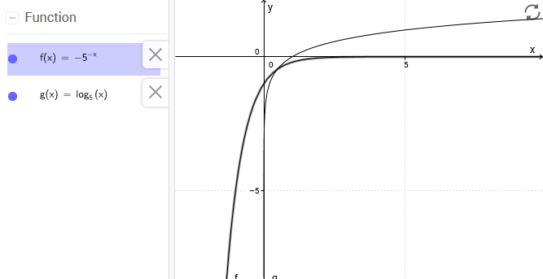
- Simplify the equation $y=\frac{1}{4}log2(8x-56)^{16}-12$ by applying the laws of logarithms. How are the original equation and the simplified equation related? (5 marks)
$$y=\frac{1}{4}log_{2}(8x-56)^{16}-12$$
$$y= \frac{log_{2}(8x-56)^{16}-12}{4}$$
$y=4log_{2}\left(8x-56\right)-12$ you need to factor the (8x-56) to 8(x-7) and simplify by breaking up the factored expression.
The original equation and the simplified equation are related because they represent the same function. Moreover, the original and simplified equations are equivalent when graphed.

yes

3/5 total

Task 3: Communication questions
- List the values for a, k, c, and d in the equation y=−4log₃ (3x+6) +7, and describe the transformations that apply. Graph the parent function and the transformed function. (10 marks)
$y=-4log$₃$(3x+6) +7$
$$y=alog_{b}k\left(x-d\right)+c$$
a= 4, k= 0, c=7, d=6
Transformations:
a= The graph is compressed no stretched vertically of 4 and reflection in the x-axis.
k = There is no k, therefore it is not affected by horizontal compression. No k is 3.
c= Moves upwards by 7 units in the graph which in turn, affects the y-value (vertical transformation). yes
d= The graph is moved 6 units to the left which affects the x-value of horizontal transformation. It’s 2 left, as we need to factor 3(x+2)

Parent Function vs. y=−4log₃ (3x+6) +7 Graph
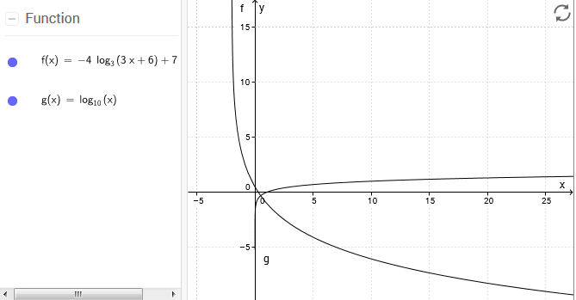
8/10 total
- A fellow classmate is having difficulty solving the following equation involving logarithms. List the steps (algebraically, and in words) that you would use to solve for the unknown value in the equation log₇ (9) +2log₇(x) =4log₇3. (6 marks)
Step 1: Apply the rule $a*log_{b}\left(x\right)=log_{b}⁡(x^{a})$
$$\log_{7}\left(9\right)+{2log}_{7}\left(x\right)=4\log_{7}(3)$$
$$\log_{7}\left(9\right)+\log_{7}\left(x^{2}\right)=\log_{7}(3^{4})$$
Step 2: For logs with the same base use the rule $\log_{b}\left(f\left(x\right)\right)+\log_{b}\left(g\left(x\right)\right)=\log_{b}(f\left(x\right)*g\left(x\right))$
$$log_{7}\left(9\right)+\log_{7}\left(x^{2}\right)=\log_{7}({9x}^{2})$$
$$\log_{7}\left({9x}^{2}\right)=\log_{7}(3^{4})$$
Step 3: When logs have the same base, we use the rule $\log_{b}\left(f\left(x\right)\right)=\log_{b}\left(g\left(x\right)\right)→f(x)=g(x)$
$$\log_{7}\left({9x}^{2}\right)=\log_{7}(3^{4})$$
$$9x^{2}=3^{4}$$
Step 4: Refine
$$9x^{2}=81$$
Step 5: Divide both sides
$$\frac{9x^{2}}{9}=\frac{81}{9}$$
$$x^{2}=9$$
Step 6: Square root both sides
$$\sqrt{x^{2}}=\sqrt{9}$$
$$x=x, x=-3$$
Therefore, since $-3$ is an extraneous root, the only valid answer is$x=3$. Well done
- Explain why there is no solution for log₃ (−4). Use a graph to justify your answer. (4 marks)
There is no solution for $\log_{3}\left(-4\right)$ because $\log_{a}\left(b\right),b$ cannot be less than zero. As a result, it cannot be graphed since the equation is undefined.
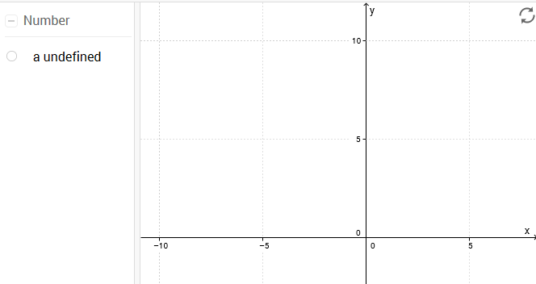good
- Define a function. How can you tell whether a relation is a function? Include two examples explaining how you can tell. (6 marks)
A function is a rule which relates to an input (x: independent variable) and an output (y: dependent variable).
In order to determine if a relation is a function, relations are set up in a table of ordered pairs to test if each element in the domain is paired and matched with exactly one element in the range. If a domain is repeated, then it cannot be a function.
Another way to determine if a relation is a function is to do a vertical line test. If the vertical line intersects only one point then it is a function. yes
- In your own words, define the following terms. (5 marks)
  - Domain: The domain is all the input (x) values that go into a function.
  - Asymptote: An asymptote is a line that approaches a given curve as it heads towards infinity.
  - Parent function: Parent function is a basic or the simplest form of an equation before any transformations have been applied.
  - Inverse functions: An inverse function is a function that reverses to another function. An example would be changing an equation from exponential to logarithm and vice versa.
  - Logarithm: Logarithm is an inverse operation to exponentials. It is also a quantity that represents the power to which a base must be raised to make another number. Well done1

Task 4: Application questions
- Calculate the time it would take for an investment of $1750 to double in size at an interest rate of 4.8%, compounded annually. Round your answer to one decimal place. (5 marks)
$$A= P(1+i)^{n}$$
$$3500=1750(1+0.048)^{n}$$
$$\frac{1750{\left(1+0.048\right)}^{n}}{1750}=\frac{3500}{1750}$$
$$1.048^{n}=2$$
$$\ln\left(1.048^{n}\right)=ln⁡(2)$$
$$nln(1.048)=ln(2)$$
$$n=\frac{ln(2)}{ln⁡(\frac{131}{125})}$$
$n$= 14.8
It will take 15 years for the investment of $1750 to double in size at an interest rate of 4.8%, compounded annually. yes
- A culture of E. coli bacteria doubles every 40 minutes. If there are 50 bacteria initially, how many will there be after 12 hours? Round your answer to the nearest whole number. (4 marks)
Conversion: 40 minutes = 0.67 hours we don’t want to round, so use minutes instead of hours.. Or 12 hours is 720 minutes.
$$A=I(2)^{\frac{t}{d}}$$
$A=50(2)^{\frac{12}{0.67}}$ so that our exponent is 720/40
$$A=12,318,335$$
Therefore, there will be $12,318,335$ of E. coli bacteria in 12 hours.
3/4
- A computer depreciates at a rate of 15% per year. If the computer is worth $324.50 when it is 5 years old, how much was it worth when it was new? Round your answer to two decimal places. (4 marks)
$$A=I(1-i)^{t}$$
$$324.50=I(1-0.15)^{5}$$
$$324.50=I(0.85)^{5}$$
$$I=\frac{324.50}{(0.85)^{5}}$$
$$I=731.34$$
The computer was worth $731.34 when it was brand new. good
- Determine the amount of water that must be added to a 2-litre solution of sulphuric acid to dilute it from a pH of 2.7 to a pH of 3. (4 marks)
$$\left[H+\right]=10^{-pH}$$
$\left[H+\right]=10^{-2.7}$= 0.0019953
$\left[H+\right]=10^{-3.0}$=0.001
$Ratio=\frac{0.0010000}{0.0019953} ≈$0.50
The solution with a pH of 2.7 is $1/2$of the strength of the original solution. In order to dilute the original solution to 1/2 of its strength, it must be 1/2 solution to 1/2 parts water. Therefore, we must add 2 liters of water to the original 2 liter of solution to create a new solution with a pH of 3.0.
good
- An earthquake with a magnitude of 6.3 is 25 times as intense as an aftershock that occurs 8 hours later. What is the magnitude of the aftershock? Round your answer to one decimal place. (5 marks)
$$M=log⁡(\frac{I}{I_{o}})$$
$$6.3= log⁡(\frac{I}{I_{o}})$$
$$6.3=log25-log⁡(\frac{I}{I_{o}})$$
x $=log25+6.3$
$$6.3-x=\frac{log25}{log10}$$
x=4.9
The magnitude of the aftershock is 4.9. yes
- People tend to speak more quietly in restaurants than they do when they are having an ordinary conversation. Restaurant conversation is about 45 dB. If ordinary conversation is 100 times greater than restaurant conversation, how loud is ordinary conversation? (6 marks)
$$10\log\left(\frac{I_{1}}{I_{0}}\right)=4.5$$
$$\log\left(\frac{I_{1}}{I_{0}}\right)=4.5$$
$$\frac{I_{1}}{I_{0}}={10}^{4.5}$$
$$I_{1}=I_{0}*{10}^{4.5}$$
$I_{2}$=${10}^{D}$
$$\frac{I_{2}}{I_{1}}=\frac{I*{10}^{D}}{I*{10}^{4.5}}=10^{D}=100$$
$log100=2$
${10}^{4.5}+10^{2}$= 1$0^{6.5}$
$10^{6.5}$= 65 dB
Therefore, ordinary conversation is 65 dB which is 100 times louder than restaurant conversation.
yes
- A population of rabbits triples every 2 months. If there are 2 rabbits initially, how long will it take for the population to increase to 500 rabbits? Round your answer to the nearest whole number. (5 marks)
$$500=2(3)^{\frac{t}{2}}$$
$$\frac{2*3^{\frac{t}{2}}}{2}=\frac{500}{2}$$
$3^{\frac{t}{2}}$=250
$3^{{t2}^{-1}}$=250
$$\ln\left(3^{{t2}^{-1}}\right)=ln⁡(250)$$
$$t2^{-1}\ln\left(3\right)=(250)$$
$$t=\frac{2ln⁡(250)}{ln⁡(3)}$$
$$t=10$$
It will take 10 months for the population to increase to 500 rabbits.
Yes

