ENTHALPY OF VARIOUS REACTIONS

Experiment #2: “A Tall Cold Drink of Water”
Written By:
Sabrina Capitani, 300096704
Gabrielle Dupont, 300061789
Katrina Tesic, 300060593
Jennie Nelson, 300080270

TA: K’M Taufiqur Rahman
Date: September 27th, 2018

INTRODUCTION
Theory

Heat of Formation:
The standard heat of formation, Δ_{f}H°, is represented as the change in enthalpy when one mole of a substance is formed from its elements in their standard states. The standard heat of formation of most simple compounds have already been calculated and are therefore given values throughout the experiment. (Enthalpy of Various Reactions)

Hess’s Law:
Hess’s Law is used to calculate the enthalpy of complex reactions. The law states that the total enthalpy change during the overall course of a chemical reaction is the same whether the reaction is made in one step or several steps. It represents the principle of conservation of energy. Reaction enthalpy changes can be determined by calorimetry for many reactions. Overall, Hess’s Law was used to determine the overall energy required for a chemical reaction. (Enthalpy of Various Reactions)

Calorimetry:
The mechanism used in the experiment is called a “calorimeter”. Calorimeters are used to measure the quantity of thermal energy gained or lost during a chemical change. A simple calorimeter was constructed out of two nested Styrofoam cup with a lid and digital thermometer. (Enthalpy of Various Reactions)

Designing the Drink: When given the task of designing a drink can that can cool the water it contains by 5℃ in no more than 5 minutes, there was a choice between the following two chemicals;

Ammonium chloride (NH₄Cl);solubility 37.2 g / 100 g water, $62.40 per 500 g

Ammonium nitrate (NH₄NO₃);solubility 192 g / 100 g water, $64.62 per 500 g

It was decided that ammonium chloride would be the safest option and would pass the requirements for Health and Safety imposed by Health Canada because even though it is an eye, skin, and respiratory system irritant it has a low-grade systemic toxicity by ingestion(AMMONIUM CHLORIDE). Ammonium chloride is also more cost effective than ammonium nitrate.

To determine the amount of NH₄Cl to drop the temperature of the water 5 degrees many calculations need to be done. 130 mL are added inside the calorimeter and 100mL of water in the tin can that will be cooled. First, the energy required to change the metal and water temperature must be determined to find the total energy change of the system, using the following equation, where c is the specific heat capacity of aluminum or water, m the mass of the substance and ΔT the change in temperature which is 5 degrees.

Q = mcΔT (Enthalpy of Various Reactions)
Q_{total}=Q_{water}+Q_{can} (Enthalpy of Various Reactions)

Specific Heat Capacity of Aluminum: 0.9 (Specific Heat Capacity Table)
Specific Heat Capacity of Water: 4.18 (Specific Heat Capacity Table)

After finding the energy change of the whole system the grams of NH₄Cl can be determined using the enthalpy of solution determined by the following equation and the table with the values;

ΔH = lattice enthalpy + hydration enthalpies (Enthalpy of Various Reactions)

Table #1: Enthalpy Changes of NH₄Cl and NH₄NO₃ (Enthalpy of Various Reactions)
QUANTITY | ENTHALPY CHANGE (kJ/mol)
Lattice energy of solid ammonium chloride | 705
Lattice energy of solid ammonium nitrate | 646
Enthalpy of hydration of the gaseous ammonium ion | -307
Enthalpy of hydration of the gaseous chloride ion | -381
Enthalpy of hydration of the gaseous nitrate ion | -314

Using the total energy change the enthalpy of solution and the molar mass of NH₄Cl the grams needed can be determined using the following equation:

m_{NH4Cl} = (Q_{total}(kJ) / enthalpy (kJ/mol)) ⋅ molar mass (g/mol)
(Enthalpy of Various Reactions)

MATERIALS
- Digital Thermometer
- Simple Calorimeter
  - Styrofoam cups with lid
- Ammonium chloride
- Lab Quest
- Water
- Beaker
- Aluminum Can
- Scale

PROCEDURE

- To begin, attach the thermometer to the Lab Quest.
- Next, fill the can with 100 mL of water. Record the temperature using the thermometer attached to the Lab Quest.
- Ensure to click on duration and set the Lab Quest to record the data for 300 seconds.
- Fill the calorimeter with 130 mL of water.
- Add 15.24g of NH₄Cl to the 130 mL of water in the calorimeter. Place the can in the calorimeter and seal the system having the thermometer in the hole at the top still in the water. Start the Lab Quest.
- Stir the calorimeter to help dissolve the salt.
- After 5 minutes, record the temperature of the water in the can.
- Repeat steps 2-7 with a different amount of salt until the temperature difference is decreased by 5 ℃ or the desired result is achieved

DATA AND OBSERVATIONS
Raw Data is Attached

Qualitative Observations for all 3 trials:
- Water is clear and odourless.
- NH₄Cl are fine white crystals and odourless.
- At the end of the five minutes not all the crystals were dissolved; there was quite a bit left on the bottom of the calorimeter.
Table #2: Data and Results for the Cooling of Water with NH₄Cl
TRIAL | MASS OF NH₄CL (g) | Ti (℃) | Tf (℃) | Tf (℃)
1 | 15.25 | 21.8 | 17.1 | 4.7
2 | 15.50 | 21.8 | 18.1 | 3.7
3 | 15.46 | 21.8 | 16.9 | 4.9

Graph #1: Temperature of Water vs Time (Trial 1)
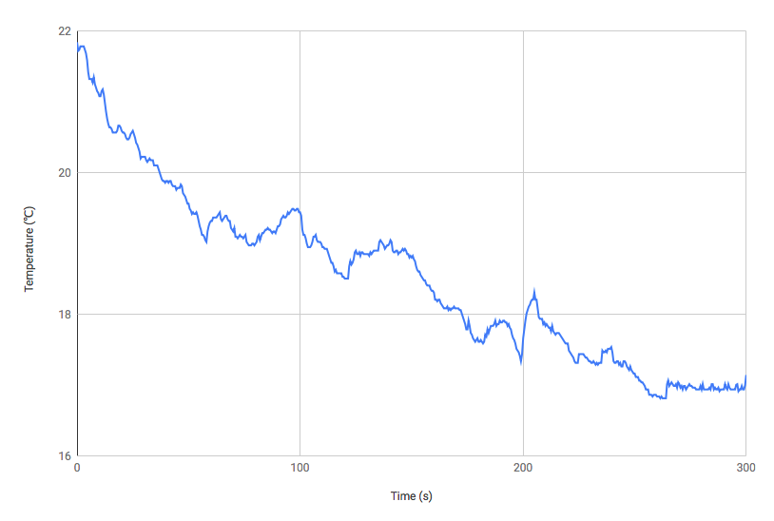

Graph #2: Temperature of Water vs Time (Trial 2)
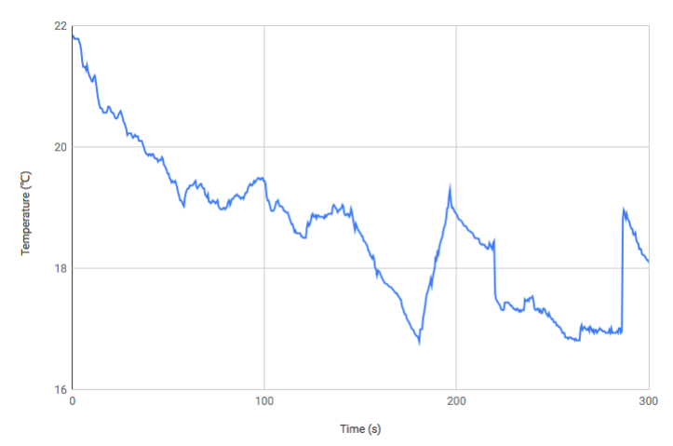

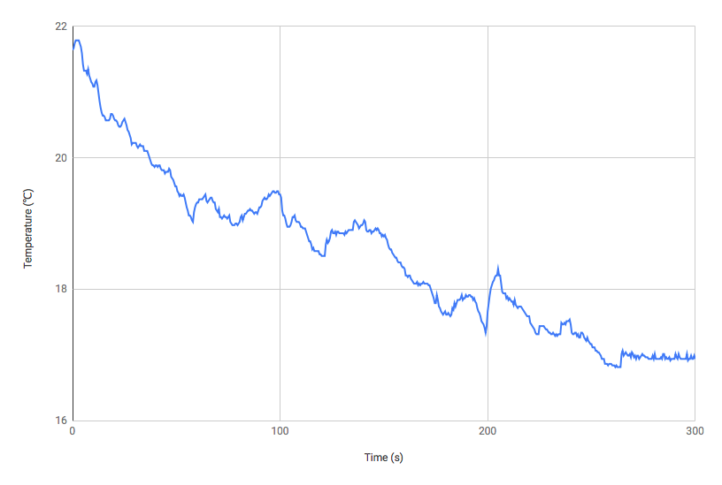
Graph #3: Temperature of Water vs Time (Trial 3)
CALCULATIONS
Table #3 : Calculations for the Cooling of Water with a NH₄Cl
DATA | VALUES
Q_{water} | 4807 J
Q_{can} | 38.7 J
Q_{Total} | 4845.7 J
ΔH | 17 KJ/mol
m_{NH4Cl} | 15.25g

Thermal Energy:

Q_{Water} = mcΔT
Q_{Water} = (100g + 130g) (4.18 J/g⋅K) (5 K)
Q_{Water} = 4807 J

Q_{Can} = mcΔT
Q_{Can} = (8.60g) (0.9 J/g⋅K) (5K)
Q_{Can} = 38.7 J

Q_{Total} = mcΔT
Q_{Total} = 4807 J + 38.7 J
Q_{Total} = 4845.7 J

Enthalpy of Solution of NH₄Cl:

ΔH = -(-705 KJ/mol) + (-307 KJ/mol) + (-314 KJ/mol)
ΔH = 17 kJ/mol

Mass of NH₄Cl:
- Molar mass NH₄Cl: 53.5 g/mol
m_{NH4Cl} = 4845.7 J ⋅ ($\frac{1 KJ}{1000 J}$) ⋅ ($\frac{1 mol}{17 KJ}$) ⋅ ($\frac{53.5g}{1 mo l}$)
m_{NH4Cl} = 15.25g

DISCUSSION
The initial trial of this experiment was conducted using 15.25g of ammonium chloride, which exhibited the ability to decrease the temperature approximately 4.7 ℃. Upon this trial, it was made apparent that a different mass of ammonium chloride would yield better results. Thus, the second trial was conducted using 15.50g of NH₄Cl. This trial resulted in a temperature change of merely 3.7 ℃; a temperature change strikingly lower than the goal of the experiment.The final trial was conducted using a mass of 15.46g of ammonium chloride, and using this mass the temperature exhibited a total decrease of 4.9 ℃.

It is clear that during the second trial errors may have been made that altered the data and results. Primarily, as the calorimeter was stirred, pressure was released from the lid therefore unsealing the system. In addition, the temperature from the surrounding environment may have affected the results of the second trial. Although the second trial exhibited the most dysfunctional result, another source of error that could have impacted all trials of the experiment as a whole would be the fact that not all of the NH₄Cl was dissolved after each trial. This means that the masses used in each trial were in excess with respect to the water and the solution became saturated to the point where the water was unable to dissolve any more of the salt. With this in mind, it is possible that smaller masses of solute could have been tested and these masses could potentially result in similar data. In fact, using less solute would improve the cost-effectiveness of the design. Furthermore, the experiment could be tested with less water added outside instead of 130 mL. Lowering the mass of water would result in the total energy change of the system being less. Therefore, less ammonium chloride would be needed making it less expensive.

Despite the few sources of error this design worked very effectively, as it resulted in a temperature change of 4.9 ℃, 0.1 ℃ short of the expected 5 ℃ temperature change. With additional trials, the accuracy of this model could have been improved by slight alterations in procedure and materials. For example, measurement precision in terms of collecting masses of salt or volume of water could be improved with instruments that provide exact values.

This design was the most cost-effective given the price for both ammonium chloride and ammonium nitrate. Additionally, ammonium chloride yielded highly accurate results in terms of temperature change. Therefore, ammonium chloride is the ideal salt for the purpose of this experiment.

CONCLUSION
It takes approximately 15.46 g of NH₄Cl to decrease the temperature of 100g of drinkable water by 5 ℃.

Work Cited:

“Enthalpy of Various Reactions”, Dr. Rashmi Venkateswaran, 2018, Exp. 2

“AMMONIUM CHLORIDE.” U.S. National Library of Medicine, National Institutes of Health, toxnet.nlm.nih.gov/cgi-bin/sis/search/a?dbs%2Bhsdb%3A%40term%2B%40DOCNO%2B483.

“Specific Heat Capacity Table.” Organic Compounds: Physical and Chemical Data, www2.ucdsb.on.ca/tiss/stretton/database/specific_heat_capacity_table.html.



