Do I dare Disturb the Universe?
Verification of Gas laws

Written by:
Katrina Tesic- 300060593

Lab Partner: Jennie Nelson

TA: KM Taufiqur Rahman

Date: September 13, 2018

Introduction:

Gases have many different volumes and shape therefore are affected by changes in temperature, pressure and volume. Boyle’s law explores the relationship between pressure and the volume of gas. Charles’s law explores the change in volume of gas due to temperature. (1)

Charles’s law specifically states that gasses contract when they are cooled and expand when heated and they expand or contract by the same amount for a certain temperature change. Therefore, Charles’s law is that the volume occupied by a fixed amount of gas is directly proportional to its absolute temperature resulting in the following equation. (2)

P₁/V₁=P₂/V₂.(1)

The Temperature must be in Kelvin when doing the calculation which is found by using the following equation
T_{k} = T_{c} + 273.15.(1)

Since Boyle’s law states that when gas in trapped in a container and the volume of the container changes the pressure on or by the gas will also change inversely which can be represented by the following equation. (3)

P₁V₁=P₂V₂.(1)

An ideal gas is defined by the following equation which puts together both Charles and Boyle’s law to explain how ideal gases should behave when the condition are high temperature and low pressure. (1) P is for pressure, V for volume, n for moles, R for universal gas constant and T is the temperature. With changes in temperature or pressure which does occur because gasses are real, gases become less ideal. (4)
PV=nRT(4)

Procedure:
Charles’s law Procedure:
As described in the lab manual (Do I dare Disturb the Universe? Verification of Gas laws, Dr. Rashmi Venkateswaran, 2018, Exp. 1, p. 7-8).

Boyle’s Law Procedure:
- Create a table with 2 columns and 11 rows. Name the first column “independent variable: volume of container (mL)” and the second column “dependent variable: Pressure (kPa)”
- Connect gas pressure sensor to lab quest 2.
- Move plunger of the plastic 20 mL syringe to 10 mL. Line the lower part of the tip of the syringe with the volume mark. (continue to use that part throughout the experiment when changing volumes.)
- Attach the syringe to the valve of the Gas pressure sensor and a half turn of the syringe will lock it in place.
- Set up the lab quest following the instructions as described in lab manual (Do I dare Disturb the Universe? Verification of Gas laws, Dr. Rashmi Venkateswaran, 2018, Exp. 1, p. 7-8)
- Start collecting data at the 10 mL volume mark. And record data in the table. To record the data on the lab quest follow instruction as described in lab manual (Do I dare Disturb the Universe? Verification of Gas laws, Dr. Rashmi Venkateswaran, 2018, Exp. 1, p. 7-8) step 3. *when recording data ensure to add .8 mL to the actual volume because that is the space inside the pressure sensor itself.
- Move to 8 mL mark on syringe. Record data.
- Move to 6 mL mark on syringe. Record data.
- Move to 4 mL mark on syringe. Record data.
- Move to 2 mL mark on syringe. Record data.
- Move to 12 mL mark on syringe. Record data.
- Move to 14 mL mark on syringe. Record data.
- Move to 16 mL mark on syringe. Record data.
- Move to 18 mL mark on syringe. Record data.
- Return to initial 10 mL volume mark on syringe. Record Data.
- Then follow the instructions as described in lab manual (Do I dare Disturb the Universe? Verification of Gas laws, Dr. Rashmi Venkateswaran, 2018, Exp. 1, p. 7-8) steps 4 and 5.

Data/ Observations/ Results:
Charles’ law.
Trial 1 Qualitative observations: when flask was put in the ice bath no bubbles came out and water started to fill in the flask.
Trial 2: Qualitative observation: when flask was put in the ice bath no bubbles came out and water shot into the flask more quickly than trial 1.

Table 1. Charles’s Law Quantitative Results
Trial # | V_{cw} (mL) | T₂ (ºC) | V₁(mL) | T₁(ºC) | V₂ (mL) | T₁ (K) | T₂(K) | % error
1 | 30 mL | 4 ºC | 157mL | 100 ºC | 127 mL | 373.15 | 277.15 | -0.089%
2 | 28 mL | 3 ºC | 157mL | 100ºC | 129 mL | 373.15 | 276.15 | -0.110%

Boyle’s Law
Table 2:Boyle’s Law results (Taken by hand) Table 3: Boyle’s Law results(LabQuest)
Independent variable: Volume of container (mL) | Dependent variable: Pressure (kPa)
10.8 | 101.04
8.8 | 123.1
6.8 | 165
4.8 | 223.48
2.8 | 224
12.8 | 84.55
14.8 | 73.95
16.8 | 64.82
18.8 | 58.34
10.8 | 102.40
*Note: The reading at 2.8 ml was not used in the graph because the pressure was the same as the pressure at 4.8 ml. Therefore, the prediction was made that that was the max pressure that could be exerted on or by the gas.

Qualitative observations: When trying to push to 2 mL it was very hard and reached the max pressure we could apply.
Graph 1:Boyle’s Law: Relationship Between Pressure and Volume
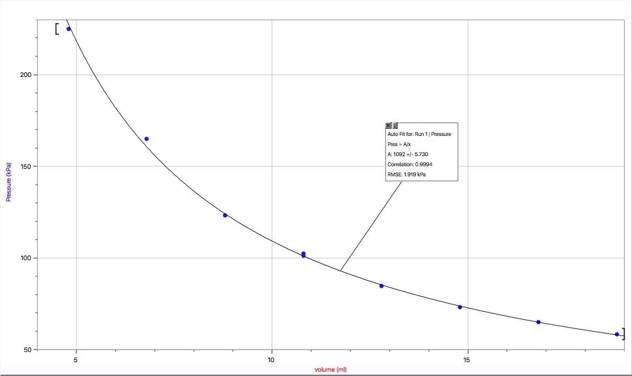

Table 4: k (Constant) for Each Volume and Pressure

Volume(mL) | K(mL*kPa) =VxP
10.8 | 1091
8.8 | 1083
6.8 | 1122
4.8 | 1073
12.8 | 1082
14.8 | 1094
16.8 | 1088
18.8 | 1097
10.8 | 1106

Calculations:
Trial 1: V₂ = 157mL- 30 mL T₁ in kelvin = 100 +273.15 T₂ in kelvin =3 + 273.15
= 127mL =373.15 K =277.15 K

% error= $(((157/373.15) -(127/277.15))/ (157/373.15)) × 100\%=-0.089\%$

Trial 2: V₂ = 157mL- 28 mL T₁ in kelvin = 373.15 K T₂ in kelvin = 276.15K
= 129mL
% error = $(((157/373.15) -(129/276.15))/ (157/373.15)) × 100\%=-0.110\%$

Trial # | V₂ (mL) | T₁ (K) | T₂(K) | % error
1 | 127 mL | 373.15 | 277.15 | -0.089
2 | 129 mL | 373.15 | 276.15 | -0.110

Verify Charles’ law (V1/T1=V2/T2):
Trial 1: 157/373.15 = 127/277.15 Trial 2: 157/373.15 = 129/276.15
0.421 = 0.458 0.421=0.467
k average trial 1 = (0.421+0.458)/2= .440 k average trial 2 = .444

Boyle’s law constant:
P1V1=P2V2
PV=k
10.08 mL x 101.4 kPa the constant is 1091.

Average Constant: sum of all constants (found in Table 4) / 9
= 9845/9
=1094ml*kPa

Discussion:
As expected gases are real therefore when performing both Charles’ and Boyle’s law and verifying them our results were slightly off but still in general followed the ideal gas law.

To verify Charles’ law we must use the equation V₁/T₁=V₂/T₂ and both values should have equaled the same. This is because gases expand and contract by the same amount for the given temperature change. In trial 1 the results were 0.421 mL/K =0.458 mL/K they are about .03 off from being the same and our percent error was -0.089. Similarly, for trial two the results were 0.421=0.467 they are about .04 off from being the same and our percent error was -0.110. This was expected because the gasses are not ideal. The pressure may not have remained constant as was intended. Furthermore, the temperature may have been lower in the ice bath when we took the flask out because we measured the temperature then took the flask out therefore dividing the volume by a smaller number making the V₂/T₂ bigger than V₁/T₁. Also, if water got into the flask from condensation or when taking it out of the ice bath and our finger was not covering the hole properly more water could have gotten in increasing the volume that when dividing V₂ by T₂ the number was bigger than V₁/T₁. The average constant for trial 1 is 0.440mL/K and the average constant for trial 2 is 0.444mL/K. The fact the averages from both trials are very close proves Charles’ law that gases expand and contract by the same amount for the given temperature change.

To determine the constant for Boyle’s law we must use the ideal gas law equation it states that PV=nRT and in Boyle’s experiment the n (moles), R universal gas constant and temperature(K) are constant therefore PV=k therefore theoretically any pressure and volume data point will give the constant. Using the initial starting volume to calculate the constant is most efficient because there is no increase or decrees of pressure on the gas; it is what sits in the syringe comfortably. Therefore, using the volume 10.08 mL x 101.4 kPa the constant is 1091mL*kPa. I verified this constant by finding the constants of each point which is shown in table 4 then found the average which is 1094mL*kPa, which is very close to the constant found by taking 10.08 mL x 101.4 kPa. In Boyle’s law the mathematical relationship between volume and pressure is inverse as volume increases the pressure decreases and as volume decreases pressure increases. An equation for Boyle’s law is PV=k and since the constant is k the equation: P=1094 mL*kPa/V describes Boyle’s law and will allow to determine the approximate pressure at any volume. This proves that Boyle’s law is in fact true that volume and pressure or inversely related and also proves that we are dealing with real gases resulting in the constant not being the exact same for each data points. Other factors that could have affected our results is that as more pressure was being applied it was harder to hold the syringe exactly on the right volume mark which will intern have affected the data by causing the constant to not be the same. Which proves that the gases are not ideal. The reason why it was important to take the first and last measurement at the same mark was to see if there was change in the dependent variable and since there was a slight difference it shows that gas is real not ideal because theoretically the pressure should have been the same at the same volume. The conditions that Boyle’s law required was that temperature and moles of gas in the syringe must remain constant. To ensure the volume of gas remained constant the syringe remained attached to the lab quest and the handle was never pulled out. However, air could still pass through the suction of the syringe increasing air particles which would ultimately increase the pressure. Temperature was harder to monitor as mentioned previously. The syringe was kept in the same location so that temperature would stay pretty constant however the temperature of the room could change with movement, doors opening and people in the room and with handling of the apparatus. With the increase of temperature, it would increase the kinetic energy of gas particles, thus increasing pressure. (1)

Conclusion:
This experiment proved Boyle’s law that volume and pressure are inversely proportional because V₁P₁ is very close to V₂P₂ proving that VP=k, the constant being 1094 mL*kPa. Charles’s law was also proven because in trial 1, V₁/T₁ is 0.421 mL/K which is very close to V₂/T₂ which is 0.456 mL/K with a percent error of -0.089%. In trial 2 V₁/T₁ is 0.421 mL/K which is very close to V₂/T₂ which is 0.467 mL/K with a percent error of -0.110. Furthermore, the average constant of trial 1 is 0.440 mL/K which is very close to that of trial 2 which is 0.444 mL/K. All of this indicates that Charles’ law is right that gases expand and contract by the same volume for the given temperature change. It was also evident that the gases used are real therefore will not act exactly like ideal gas however very similarly.

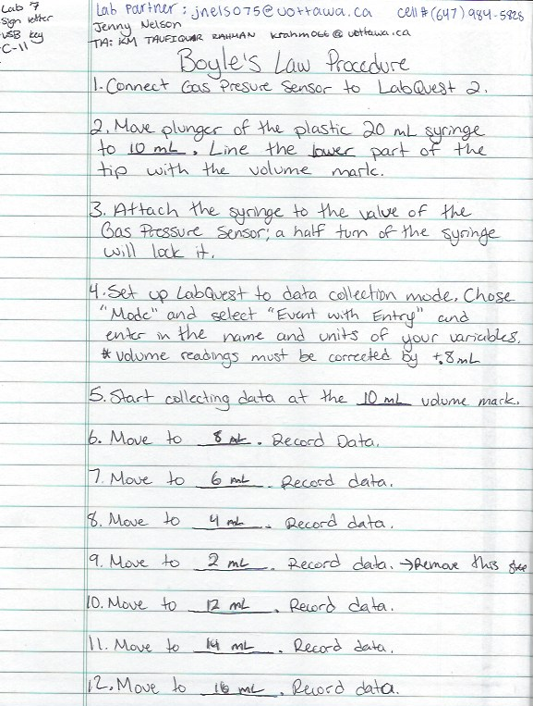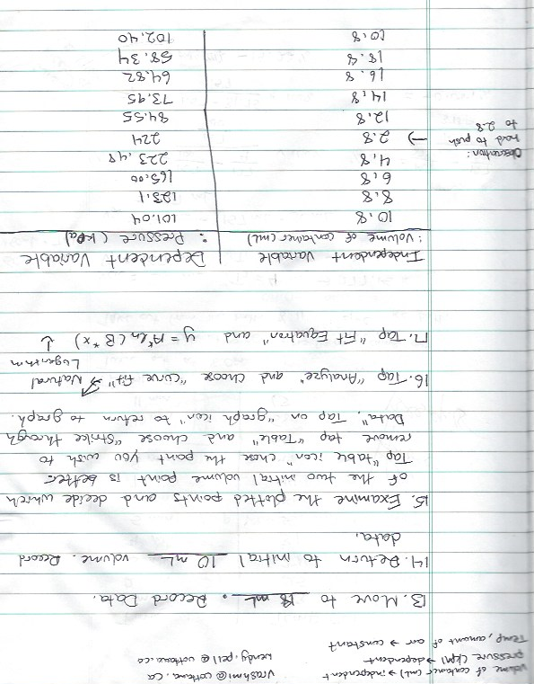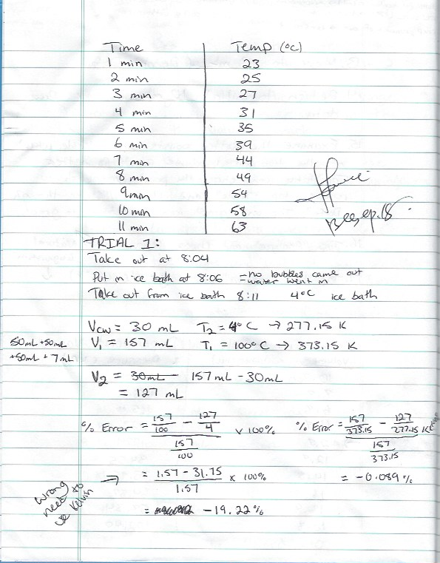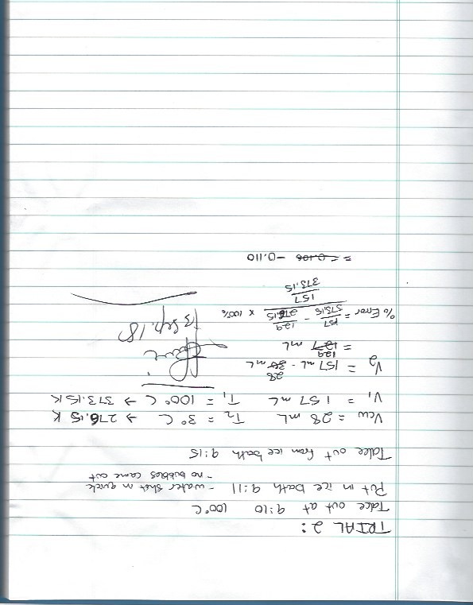

Sources
- Do I dare Disturb the Universe? Verification of Gas laws, Dr. Rashmi Venkateswaran, 2018, Exp. 1
- The Editors of Encyclopedia Britannica. (2018, July 27). Charles's law. Retrieved from https://www.britannica.com/science/Charless-law
- The Editors of Encyclopedia Britannica. (2018, July 27). Boyle's law. Retrieved from https://www.britannica.com/science/Boyles-law
- The Editors of Encyclopedia Britannica. (2011, June 24). Gas laws. Retrieved from https://www.britannica.com/science/gas-laws



