October 15th, 2012
Week 5: Globalization and Neoliberalism

- What is Globalization?
- Compression of time and space
- Linking of ‘localities’ around the globe: local events now are public global
- Enlargement of worldwide communication
- Expansion of international economic linkages (trade, finance, investment)
- “Extensity, intensity, velocity, and impact” of social relations and transactions (D.Held)
- Migration on global scale (dollar, product, people from developing world, to developing world vice versa)
- Intensification of a global consciousness
- Cultural diffusion/Cultural Imperialism/Disneyfication/McWorld Masala culture (fear that countries are homogenized)
- Continuing expansion of global capitalism in favour of the ruling classes, i/e/ a class project (Harvey)
- Understanding globalization by breaking it into distinct concepts (Steger):
- “Globality” refers to the social condition of tight economic, political, environmental and cultural interactions across national boarders, around the world. “the way it is”
- “Globalization refers to the expansion and intensification of social relations and consciousness across world-time and world-space.” “the ways its evolving” “
- “global imaginary” is the growing consciousness of belonging to a global community “The way people want it to go”
Condition, process, process/goal

- Proponents of Globalization
- Human solidarity networks
- One worldists, world federalists
- Cosmopolitans
- International business and finance (new markets, not limited to national markets)
- Exporters and importers (more global markets, the bigger the market is)
- IT Industry
- Mainstream (neo-liberal) economists
- Neo-liberals and libertarians and many more…
- There are many, very different, reasons to love globalization! Both Left and Right love it.

- The promise of Globalization, or the Neo-Liberal Dream
- Better allocation of resources: Freer movement of goods, people, capital => better global allocation of resources, greater efficiency, higher growth, greater prosperity
- Libertarian political argument: Greater diversity and choice of freedom
- Freer exchange of ideas
- Global (or at least international) cooperation to solve global problems

- Opponents of Globalizations
- Reactionaries and traditionalists (both religious and secular)
- Nationalists, especially the national security industry
- Xenophobes, racists, anti-immigrants
- Northern trade unions and associated firms
- Environmentalist
- Anti-capitalists
- Localists and communitarians
- There are many, very different reasons to hate globalization! Both Left and Right hate it!

- Anti-Globalization case:
Globalization has led to:
- Increased inequality
- Environmental degradation
- Cultural and social homogenization (McWorld)
- Exploitation of the weak by strong (sweat shops, porwerful MNC’s etc)
- Neo lib form of glob is a project of the ruling class

- Is Globalization New?
- Adam Smith, 1776
- K.Marx and F. Engels, 1848: the discovery of America, rounding of cape opened up fresh grounds for rising bourgeoisie. Ist chapter of communists manifesto
- J.M Keynes, 1919: glob is era leading up to WW1, (1870-1914) pro economic prgogess of man,
- Fernaud Braudel and the Annales School in 1950’s and 1960’s
- Dependency theory and World Systems Theory in 1970s and 1980s
- Terms “globalization” came into mainstream western media only in mid-1980s

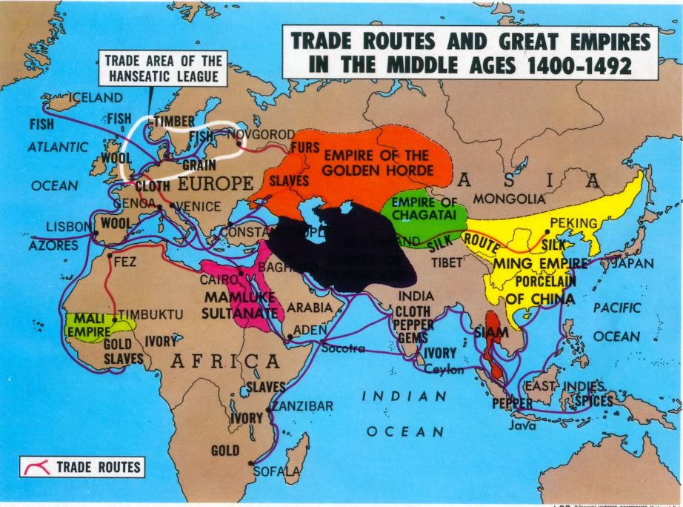
- Is Globalization inevitable?
“Yes”
- The technological determinists
- The economic inevitablists (There is no alternative –Margaret Thatcher)
“No”
- The (very diverse) anti-glob movement “It can be managed”
- Censors of the Great Firewall of China and other national security bureaucrats around the world
- Policy makers in the NICs, Asian Tigers, etc.
- Altermondialistes

- Is globalization post-1980 something new and different?
- In some dimensions huge intensifications (financial flows, capital flows,
- By some measure globalization has accelerated e.g. international capital flows, Internet, telecommunication costs, by some measures globalization is below its 1870-1913 heyday, e.g. immigration
- Globalization as hegemonic neo-lib project?
- Ebb and flow: post 9/11 obsession with national security blunted some aspects of globalization
- Not only increased over time, reactions over time that turn it backwards (9/11)
- An Intermediate View?
- Have both pro and anti-globalisationists oversold their case?
-Inequality, environmental degradation, violations of human rights not always linked to globalization
-Great variety of experiences between and within country
-Is globalization is everything, maybe it is nothing
- Globalization hasn’t been a one way street from north to south
-South ->North: Changing diets and cultural tastes in North
-South -> South exchanges, e.g. Bolly and Nollywood (Nigerian Bollywood)
How you manage glob matters, e.g. Malaysia vs. Ghana. Avoid Impossibilism
- Glob: Paradoxes, Risks and Threats
- Paradox: Steger on Osama Bin Laden
- Risks: Inequality as a threat to the globalization projects
- Threat: greater integration means co-related risks => systemic risks => fragile systems

