CHM1301
Principles of Chemistry

Lab 1: Verification of Gas Laws

Name
Student #:

Lab Date: Sept 2018
Report Date: Sept 2018
T.A.:
Lab Group: CHM1311[] Lab
Lab Partner:
Summary
This experiment was conducted to investigate the gas laws, Charles’ Law and Boyle’s Law. Charles’ Law states that, at constant pressure, the volume of a gas is proportional to its temperature in Kelvin. Conversely, Boyle’s Law states that, given a constant temperature, pressure will be inversely proportionate to its volume. Charles Law was tested using a change in air temperature and displacement of water, and Boyle’s Law was tested using a change in volume against a measured pressure. The Charles’ Law trials resulted in some unusual numbers that were due to poor understanding of lab procedures. The correlation between volume and temperature can still be seen by the data collected, with the volume and temperature being almost even. The Boyle’s Law trials also resulted in unusual numbers for what should have been a constant number.

Introduction
The objective of this experiment was to investigate different gas laws, Charles’ Law and Boyles Law, using two different procedures. Charles’ Law states that the volume of gas at a constant pressure is directly proportional to the temperature in Kelvin (V=mT_{k}). This correlation was tested by heating air within a flask and noting a displacement of water during cooling. As the gas cooled, the area inside the flask accommodated the water allowing it to flow inside. As such, the difference in temperature equaled the volume of water displaced into the flask. The hypothesis for Charles’ Law was that the difference in temperature between hot and cold would equal the volume of displaced water in the flask. The procedure for Boyles’ Law was carried out to show that given a constant mass and temperature, pressure was inversely proportional to volume (P=K/V). As the area in a syringe was incrementally increased in even amounts the pressure read by the gauge decreased proportional to the constant, K. The hypothesis for Boyle’s Law was that the constant K would be the same for every increment of volume with respect to pressure, resulting in an even pressure drop.

Procedure
The procedure and materials used were the same as those listed in the lab manual (Dr. Rashmi Venkateswaran, Verification of Gas Laws, 2018), with an added procedure for the measurements of Boyle’s Law listed below. This procedure is altered from the raw lab book to account for changes made during the experiment.

Boyles Law Procedure
Step 1 – Start with 2 mL volume of air in a syringe and attach it to the gas pressure sensor.
Step 2 – Record the pressure of air at 2 mL.
Step 3 – Adjust the syringe to 4 mL volume of air and record the pressure.
Step 4 – Continue adjusting the volume of air in the syringe in increments of 2 mL, recording pressure each time, until a volume of 14mL of air is reached, record this pressure.
Step 5 – Adjust syringe to 2 mL of air and record final pressure.
Step 6 – Repeat steps 1 through 5 to get a second recording of data.

Observations
Observations are broken down into two sections for their respective procedures.
Charles’ Law Observation Data Trial 1
Step 1-5 – No relevant observations noted
Step 6 – The water begins to boil. This means the temperature is approx. 100 C
Step 7 – The water is cold
Step 8 – The temperature of the air is approximately 100 C
Step - 9 When the hot (100 C) flask of air is placed into the ice bath and begins to cool water begins to fill the flask.
Step 10 - The level of water is low at first when the flask is hot, but as the flask cools the level rises.
Step 11 – The temperature of the water is about 1.9 C
Step 12/13 - When the temperature of the flask has stabilized to approximately that of the water the level within the flask seems to have risen to a level even with the exterior of the flask.
Step 14 – The volume of water in the flask is about 37.5 mL
Step 15 – The total volume within the flask is about 156.2 mL

Charles’ Law Observation Data Trial 2
Step 1-5 – No relevant observations noted
Step 6 – The water begins to boil. The temp is about 100 C
Step 7 – The water is cold
Step 8 – The temperature of the air is approximately 100 C
Step - 9 When the hot (100 C) flask of air is placed into the ice bath and begins to cool water begins to fill the flask.
Step 10 - The level of water is low at first when the flask is hot, but as the flask cools the level rises.
Step 11 – The temperature of the water is about 5.5 C
Step 12/13 - When the temperature of the flask has stabilized to approximately that of the water the level within the flask seems to have risen to a level even with the exterior of the flask.
Step 14 – The volume of water in the flask is about 48.5 mL
Step 15 – The total volume within the flask is about 153.8 mL

Boyle’s Law Verification
Boyle’s Law Observations Data Trial 1
Step 1-2 – At about 2mL of ail the pressure is 107.47 kPa
Step 3 – As the syringe is pulled back to 4mL the pressure drops until it gets to 57.71 kPa
Step 4 – For each even adjustment of volume the pressure drops fairly evenly. As the volume gets larger it gets more difficult to pull back and hold the plunger for the syringe.
Step 5 – As the syringe is put back to about 2mL of air it becomes easier to hold and the pressure goes back up to 103.2 kPa

Boyle’s Law Observations Data Trial 2
Step 1-2 – At about 2mL of ail the pressure is 101.85 kPa
Step 3 – As the syringe is pulled back to 4mL the pressure drops until it gets to 57.60 kPa
Step 4 – For each even adjustment of volume the pressure drops fairly evenly. As the volume gets larger it gets more difficult to pull back and hold the plunger for the syringe.
Step 5 – As the syringe is put back to about 2mL of air it becomes easier to hold and the pressure goes back up to 107.72 kPa

Calculations
Charles’ Law
V₂ = V1-Vcw = 156.2 – 37.5 = 118.7
T₁ = 100 C = 373.15 K
T₂ = 1.9 C = 274.05 K
Verify Charles’ Law
T_{K} = T₁ – T₂ = 99.1
V₂ = mT_{k}
V₂ = 118.7
T_{K} = 99.1
4. The average value for the verification of Charle’s Law:
V_{2(avg)} = (118.7 + 105.3)/2
= 112
T_{K(avg)} = (99.1 + 94.5)/2
=96.8
5. Percent Error:
Trial 1
%Error =((V1/T1)-(V2/T2))/(V1/T1)*100%
= ((156.2/373.15)-(118.7/274.05))/(156.2/373.15)*100%
= -3.47%

Boyle’s Law

- Finding Boyle’s Law constant (K) using data collected:
Trial 1
Finding Constant K
Avg K = (277.0 + 267.1 + 260.7 + 266.2 + 264.3 + 266.0 + 288)/7
= 270.0
Avg K between both trials = (270.0 + 275.5)/2
=272.8
Results
Charles Law Test 1
Variable | Measurement
T₁ | 373.15 K
V₁ | 156.2 mL
V_{cw} | 37.5 mL
V₂ | 118.7 mL
T₂ | 274.05 K
T_{K} | 99.1 K
%Error | -3.47%

Charles’ Law Test 2
Variable | Measurement
T₁ | 373.15 K
V₁ | 153.8 mL
V_{cw} | 48.5 mL
V₂ | 105.3 mL
T₂ | 278.65 K
T_{K} | 94.5 K
%Error | 8.32%

Boyle’s Law Test 1
Volume (mL) | Pressure (kPa) | K (Constant)
2.8 | 107.47 | 300.9
4.8 | 57.71 | 277.0
6.8 | 39.28 | 267.1
8.8 | 29.63 | 260.7
10.8 | 24.65 | 266.2
12.8 | 20.65 | 264.3
14.8 | 17.97 | 266
2.8 | 103.2 | 288
 |  | K_{avg} = 270.0

Boyle’s Law Test 2
Volume (mL) | Pressure (kPa) | K (Constant)
2.8 | 101.85 | 285.2
4.8 | 57.60 | 276.5
6.8 | 39.98 | 271.9
8.8 | 30.92 | 272.1
10.8 | 25.40 | 274.3
12.8 | 21.38 | 273.7
14.8 | 18.56 | 274.7
2.8 | 107.72 | 301.6
 |  | K_{avg} = 275.5

Boyle’s Law Test 1
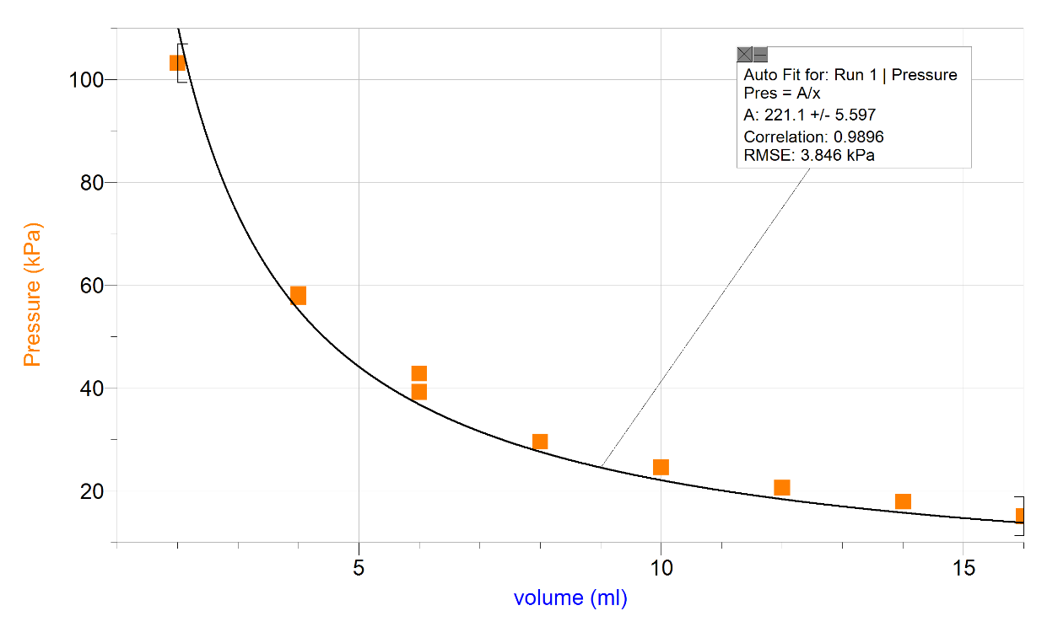
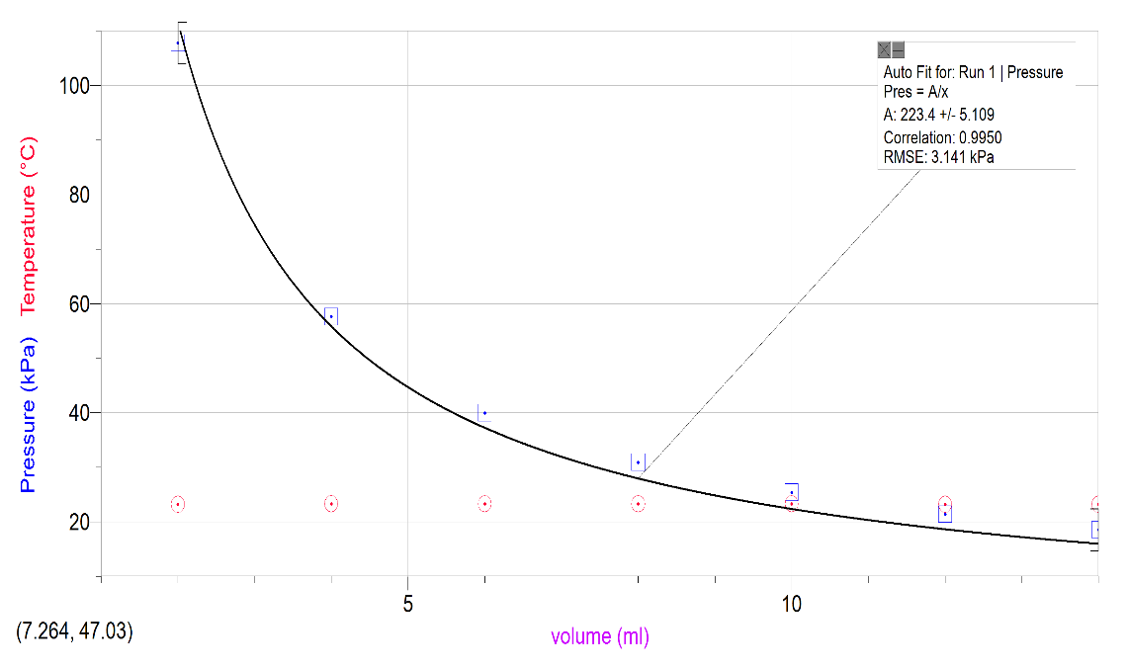
Boyle’s Law Test 2

Discussion
During the Charles’ Law verification, it is quite evident that the change in volume for the air with respect to temperature is taking place as seen by V₂, difference in volume. The gradual displacement in water as the gas cools is seen throughout the experiment. When the gas was heated to 100 C and then placed into the ice bath the water initially stayed out. As the gas cooled the water began to make its way into the flask, filling the area left by the contracting gas. Finally, when the temperature of the gas was the same or close to that of the water outside, the water level was even both outside and inside. This clearly shows the relationship of volume to temperature for gas that Charles’ Law is about. The final verification calculation showed that the volume and temperature difference were not the same, but close. This was due to improper measurement of temperature for the hot air. When the hot air was measured the temperature was not given time to stabilize and was most likely higher than the recorded number. This would have resulted in a closer verification and a lower error calculation.
During the Boyle’s Law procedure multiple measurements were taken at each volume. This redundancy was used to ensure consistent data and eliminate any unusual results, such as the 2.8 mL volumes with 300kPa pressures. Even with multiple tests the experiment resulted in more varying constants than anticipated, anywhere from 260.7 to 300.9. As seen in the test 2 graph the temperature was constant at around 23 C. This should have meant that for a given volume the resultant pressure should have given a closer constant each time. Although the volume was inversely proportional to the pressure, seen in both graphs, as anticipated, the constants ranged by a factor of 40. With temperature held constant this should be from a change in mass. As the syringe/pressure sensor system is not perfectly air tight, it may have introduced varying particles of air to the test. This would have resulted in a change of mass that could explain the difference in the constant K. Even with this varying constant, an average K can be used to approximate a pressure for any given volume, P = 272.8/V.

Conclusion
The Charles’ Law procedure showed, with some error, that temperature is directly proportional to volume given constant pressure, V/K=T. Boyle’s Law procedure showed, also with some error, that pressure is inversely proportional to volume given constant temperature and mass, P=K/T. The Boyle’s Law Procedure would benefit from being carried out again, but with a more air tight system using a gas composed of a single type of particle rather than many to ensure constant mass.
Both procedures verified the gas laws as expected, and even had a correlation between each other. The gas laws in general use temperature, mass, pressure and volume to calculate each of the respective variable while holding others as constant. This experiment verified not only that Charles’ Law and Boyle’s Law, but due to error showed that the gas laws work together to give a broader picture.

