Purpose:
This week’s lab requirement is to install Oracle 12c Release 1 Enterprise Edition dbms on your laptop. If you want you can install Oracle within a VMware virtual machine running Windows 7 Pro or Windows 10 so that you can both isolate CST82765 activities from your other uses, and also can recover your dbms state quickly by reverting to a previous snapshot. However, I will install oracle directly on my machine, it is much faster.
The general process you will follow is:
- Connect to Algonquin College's Plato Digital Resource Portal, sign in, download VMware Workstation and MS Windows 7 or 10.
- Install VMware, create a virtual machine, and install Windows as its operating system.
- Connect to Oracle, download Oracle 12 dbms for Windows, unzip the 2 compressed Oracle files into the same folder, run as administrator the Oracle install exec, respond appropriately to the customization prompts including setting the passwords for super user accounts.
Details of the process are provided later in this document.
NOTE: if you want to finish the installation early, download the two zipped files, “File1” and “File2” ahead before the lab. Do Not unzip them.

Deliverable:
To receive 2 marks, on or before Sat 15 Sept, at 11:59 p.m., submit via Brightspace a word file that contains the answers of the questions provided in section 4 parts: h, i, j, k, l, and m.

Process:
- Download Oracle 12c Enterprise Edition.
  - Go to the Oracle download site and download Oracle 12c for Windows from the Oracle site http://www.oracle.com/technetwork/database/enterprise-edition/downloads/index-092322.html
  - You will need to accept the license agreement and you may need to register.
  - Download 12c Release 1. The Windows download is 12.1.0.2.0 as shown below:
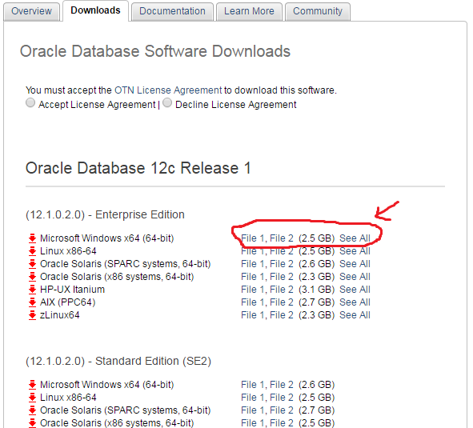

- Unzip the 2 Oracle compressed files into a single common folder (the two zipped files should be merged when they are unzipped)
- Run the Oracle install exec with admin privileges (i.e., run as administrator).
- Respond appropriately to the installation customization queries.
  - Step 1: Configure Security Updates:
    - Email option – leave blank, does not apply
    - Deselect the update notification option. You do NOT want to receive security updates.
    - Press 'Next'
    - Ignore the warning, press 'Yes'.
  - Step 2: Installation Option:
    - Select 'Create and configure a database', then press 'Next'
  - Step 3: System Class:
    - Select 'Desktop Class', then 'Next'
  - Step 4: Typical Installation Configuration:
    - Accept defaults EXCEPT for the following:
      - Create a new Oracle user.
      - Global DB name: change to 'orcl'
      - Admin (SYS) password: 'yourFirstNamesys' (e.g., mohamadsys)
        - If you receive a warning('INS-30011') that your password strength is poor, ignore it
        - 'Next' / 'Yes' to continue
      - Make sure to uncheck the ‘create as container database” checkbox
  - Step 5: Prerequisite Check is performed
  - Step 6: Summary of response is displayed. 'Finish' and save the response file.
  - Step 7: Install Product message is displayed. If you receive a Windows firewall message, allow access for Java
    - Several components are installed
    - In Password Management screen, make sure to take a note of the provided website, then change the password for user SYSTEM to : 'yourFirstNamesystem' (e.g., mohamadsystem)
    - 'OK'
    - Ignore any additional password standards warning message. 'Continue? Yes' / 'OK'
  - Step 8 Installation was Successful message is displayed. 'Close'
    - Upon successful installation, take a screen shot and save it for your submission.
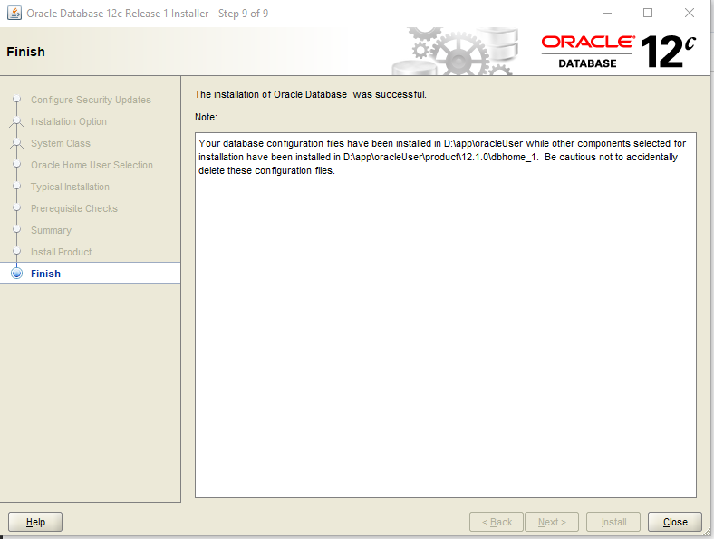

  - Confirm you are able to logon to account SYS.
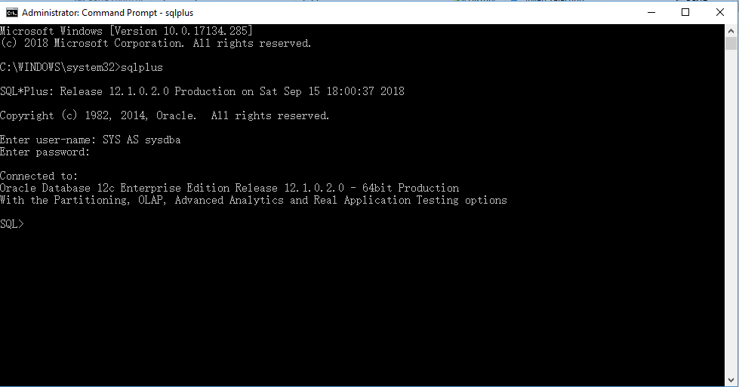

  - Enter: SHOW con_name. The result should be orcl.

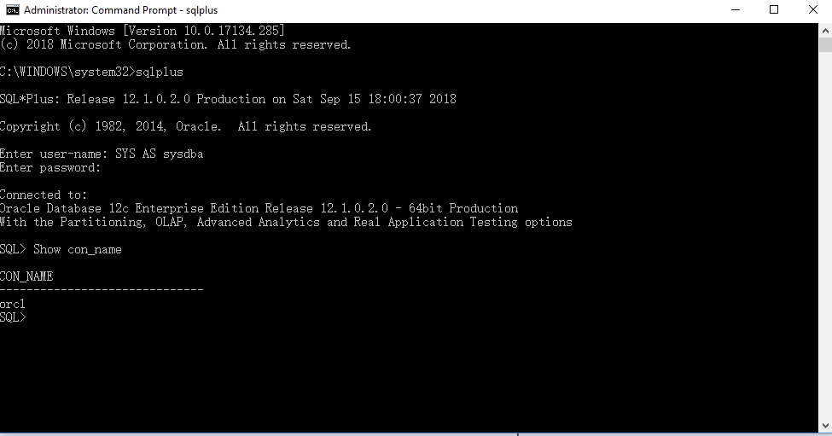

  - Copy the location of the init.ora text file to your submission document. This file is located by default here: C:\app\myoracle\admin\orcl\pfile\init.ora where myoracle would be a different value on your system.

D:\app\oracleUser\admin\orcl\pfile

  - Access the website that you have taken note of e.g (https://localhost:5500/em). Use the user sys and its password to access the website.
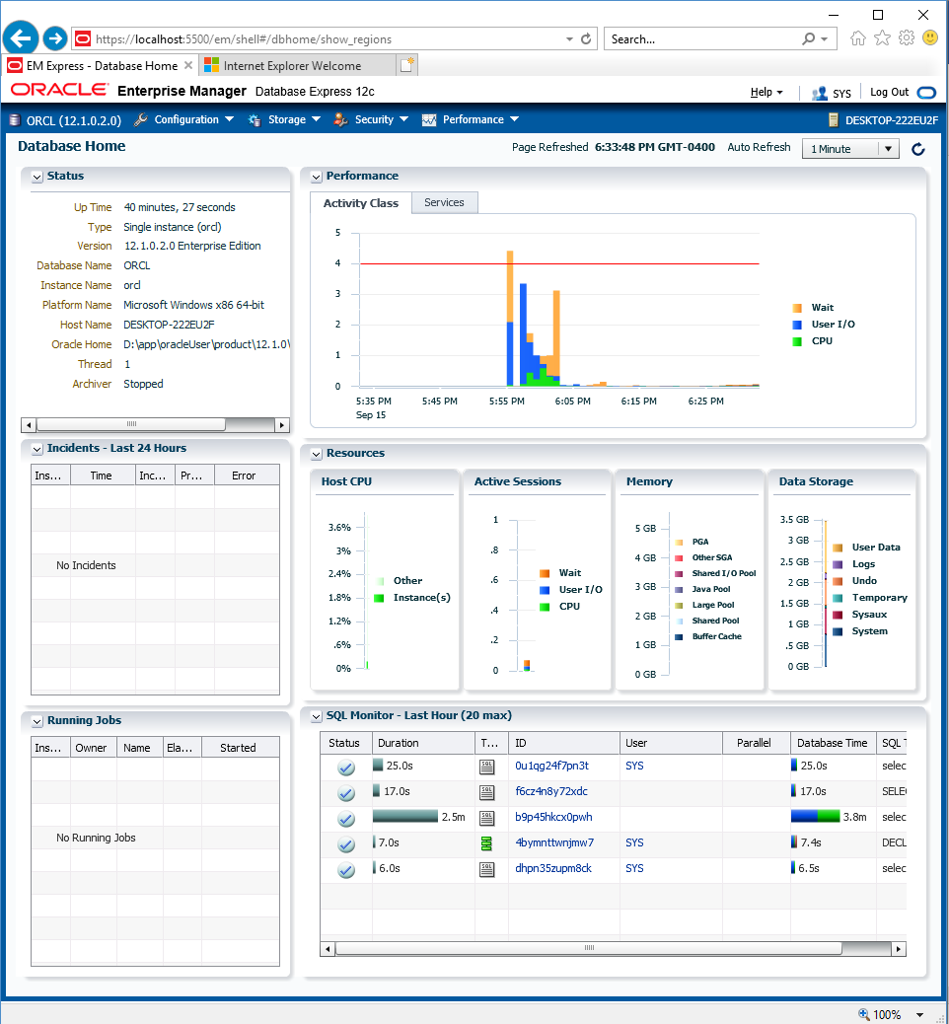

  - Make sure the below script can be executed without errors. Take a screen should of the output.
CREATE TABLE sales01
(prod_id NUMBER(6)
, time_id DATE
, quantity_sold NUMBER(3)
)
PARTITION BY RANGE (quantity_sold)
( PARTITION sales_p1 VALUES LESS THAN (35)
, PARTITION sales_p2 VALUES LESS THAN (76)
, PARTITION sales_p3 VALUES LESS THAN (MAXVALUE)
);

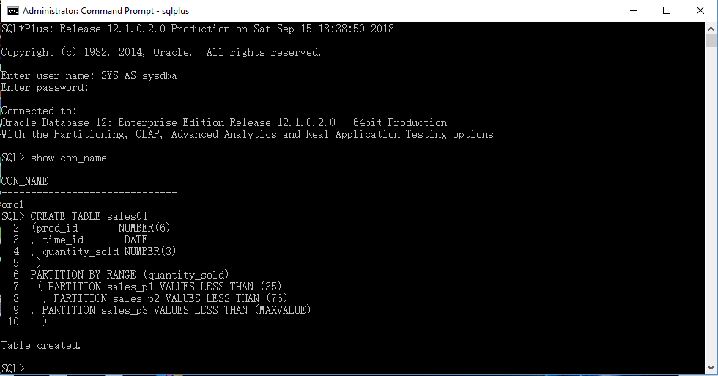

You're done!

