Chapter 1)
Information
- One of an organization’s most valuable resources
- Often confused with the term data
Data: raw facts
Information:
- collection of data organized in such a way that they have value beyond the facts themselves
Process:
- set of logically related tasks performed to achieve a defined outcome
- Turning data into information is a process
Knowledge:
- awareness and understanding of a set of information and the ways it can be made useful to support a task The process of defining relationships among data to create useful information requires knowledge
What is an Information System?
- An information system (IS) is a set of interrelated elements that:
- Collect (input)
- Process
- Store
- Disseminate data and information
- Provides a feedback mechanism to monitor and control its operation to make sure it continues to meet its goals and objectives
CBIS: (Computer Based Information System).
- A computer-based information system (CBIS) is a single set of hardware, software, databases, networks, people, and procedures
- That are configured to collect, manipulate, store, and process data into information
- An organization’s technology infrastructure includes all the hardware, software, databases, networks, people, and procedures
- That are configured to collect, manipulate, store, and process data into information
Three Fundamental Types of Information Systems
- Information systems can be divided into three types:
- Personal IS – includes information systems that improve the productivity of individual users
- Group IS –includes information systems that improve communications and support collaboration among members of a workgroup
- Enterprise IS – includes information systems that organizations use to define structured interactions among their own employees and/or external customers, suppliers, government agencies, etc.…
Information Systems in Organizations
- For each type of IS, certain key organizational complements must be in place:
- Well-trained workers
- System support
- Better teamwork
- Redesigned processes
- New decision rights
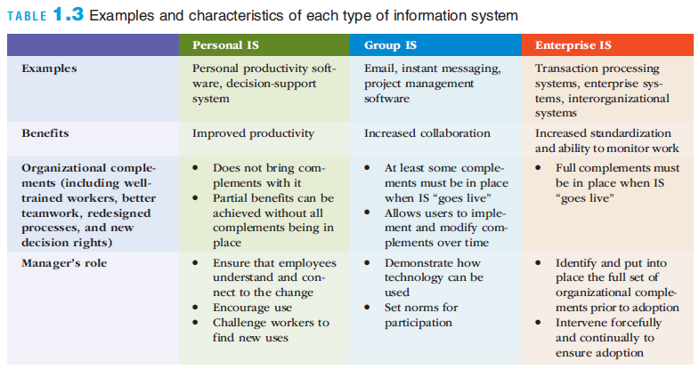
Information Systems in Organizations
- Organization: a group of people that is structured and managed to meet its mission or set of group goals
- There are relationships between members of the organization and their various activities
- Processes are defined that assign roles, responsibilities, and authority to complete the various activities
- Organizations are open systems
- They affect and are affected by their surrounding environments
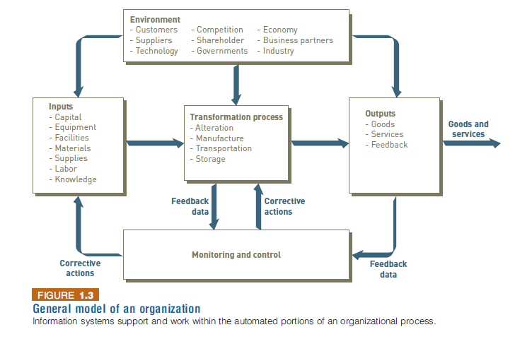
Value Chains
- Value chain: a series (chain) of activities that an organization performs to transform inputs into outputs
- The value of the input is increased
- Supply chain: key value chain in a manufacturing organization
- Supply chain management (SCM): encompasses all the activities required to get the right product into the right consumer’s hands in the right quantity at the right time and at the right cost
- Software: consist of the computer programs that govern the operation of the computer.
- Database: Organized collection of facts and information, typically consisting of two or more related data files.
- Telecommunication: the electronic transmission of signals for communications
- Networks: Connect computers and equipment to enable electronic communication. I
- Intranet: Internal Network that allows people within an organization to exchange information and work on projects.
- Extranet: Networks that allow selected outsiders, such as business partners and customers, to access authorized resources of a company intranet.
- Procedures: include strategies, policies, methods, and rules for using the CBIS.
Business Information Systems
- Support the activities of individuals in organizations have potential benefits at organizational and induvial levels.
- Types:
- Electronic commerce systems
- Transaction processing systems
- Enterprise systems
- Management Information Systems
- E-Commerce: Any business transactions executed electronically between companies etc.
- Enterprise systems: Integrated IS that manage a series of business operations which provide real time information which helps coordinate activities.
- Enterprise resource planning: a set of integrated programs that mange vital business operations for an entire multisite., global organization.
- transaction processing system
- (TPS): An organized collection of people, procedures, software, data-
- bases, and devices used to perform and record business transactions.
- Management Information System: organized collection of people, procedures, software, databases, and devices that provides routine information to managers and decision makers.
- DSS(Decision Support Systems): organized collection of people, procedures, software, databases and devices that support problem specific decision making, support all problem solving phrases, support different problem structures.
- Supply Chain Management: (SCM): determines what supplies required, quantities needed, supplies processed, shipment of supplies to customers should be scheduled monitored and control. .
Lewin’s change model consists of a three-stage approach for change
  - Unfreezing: preparing for change
  - Moving: making the change
  - Refreezing: institutionalizing
- Lewin’s Force Field Analysis
- Lewin extended his change model theory to include force field analysis
- Identifies both the driving (positive) and restraining (negative) forces that influence whether change can occur
- Driving forces: beliefs, expectations, and cultural norms that tend to encourage a change and give it momentum
- Restraining forces: those that make it difficult to accept a change or to work to implement a change
- Leavitt’s Diamond
- A theory that proposes that every organizational system is made up of four main components—people, tasks, structure, and technology—with an interaction among the four components
- Any change in one of these elements will necessitate a change in the other three elements

Diffusion of Innovation Theory
A theory developed by E.M. Rogers
Explains how a new idea or product gains acceptance and diffuses (or spreads) through a specific population or subset of an organization

Chapter 2

Hardware components include devices that perform:
- Input
- Processing
- Data storage
- Output

Central processing unit (CPU) components
- Arithmetic/logic unit, the control unit, and the register areas
- Part of the computer that sequences and executes instructions
Memory
- Provides the processor with a working storage area to hold program instructions and data
Input/output devices
- Provide data and instructions to the computer and receives results from it
Clock speed
- A series of electronic pulses produced at a predetermined rate that affects machine cycle time
- Often measured in gigahertz (GHz): billions of cycles per second
- Many of today’s computers operate in the 1 to 4 GHz range
Multiprocessing
- Involves the simultaneous execution of two or more instructions at the same time
- One form uses coprocessors

Coprocessor
- Speeds processing by executing specific types of instructions while the CPU works on another processing activity
Multicore processor
- Has two or more independent processing units, called cores
Parallel computing
- The simultaneous execution of the same task on multiple processors
Massively parallel processing systems
- Systems with thousands of such processors
- Links hundreds or even thousands of processors to operate at the same time
Grid computing
- The use of a collection of computers that work in a coordinated manner to solve a common problem
Main memory
- Provides the CPU with a working storage area for programs and data
- Rapidly provides data and instructions to the CPU
Storage capacity
- Byte (B): eight bits that together represent a single character of data
Random access memory (RAM) is temporary and volatile
- Types of RAM
- Static random access memory (SRAM) used for high-speed registers and caches
- Dynamic random access memory (DRAM) used for main memory
- Double data rate synchronous dynamic random access memory (DDR SDRAM)
Secondary storage
- Devices that store large amounts of data, instructions, and information more permanently than allowed with memory
Magnetic tape
- A type of sequential secondary storage medium
- Primarily for storing backups of critical organizational data
Hard disk drive (HDD)
- A direct access storage device; consists of rapidly rotating disks coated with magnetic material
Virtual tape
- A storage device for less frequently needed data
Solid state storage device (SSD)
- Stores data in memory chips rather than magnetic or optical media
Storage Area Networks (SAN)
- A high-speed, special-purpose network that integrates different types of data storage devices into a single storage system and connects that to computing resources across an entire organization
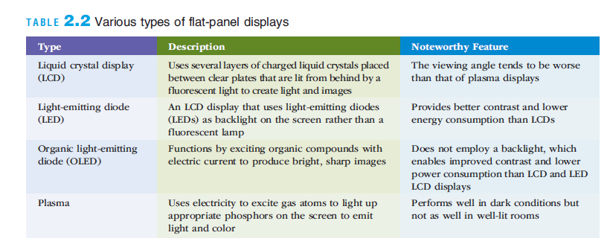
Software can be divided into two types:
System software – includes operating system (OS), utilities, and middleware that coordinate the activities and functions of the hardware and other programs
Application software – programs that help users solve computing problems

Middleware
Software that allows different systems to communicate and exchange data
Can also be used as an interface between the Internet and private corporate systems
Enterprise application integration (EAI): tying together of disparate applications
Service-oriented architecture (SOA): a software design approach using modules to provide specific functions as services to other applications

