IBUS 492 – NOTES

Chapter 1
Culture:
- Shared mental programs that control individual’s responses to their environment.
- Shared attitudes, values, beliefs and norms.
- Ways of thinking, feeling and reacting.
- Acquired and transmitted.
- Not consciously formulated.
- Mental programming, sunk in.

Culture determines how we see ourselves and how we see others.

When working with a different culture:
- Be aware that culture may differ (there are no right or wrong culture).
- Make sure not to impose judgement
- Seek to understand.

3 Levels of mental programming:

Features of culture:
- Culture is shared:
- At an intermediate level based on shared experiences within a particular society.
- Individuals within a society share an intuition for many of these cultural understandings not shared by outsiders

- Culture is learned:
- Transmitted through the process of learning and interacting with the social environment.
- Learning through stories

- Culture is systematic and organized (tricky to study and understand):
- An organized system of values, attitudes, beliefs and behavioral meanings related to each other, to a cultural group’s physical environment and to other cultural groups

3 Levels/Layers of culture:

- Artefacts and attitudes
- Behaviors
- Explicit level
- Easy to observe

- Norms, rules, beliefs and values

- Basic underlining assumptions
- Often unconscious
- Difficult to describe or explain

What affects culture (6):

- Social institutions:
Family, education, economic, religious and political systems that supports a culture’s orientation.

- Teach, promote and reward desired behaviors
- Punishes undesirable behaviors

- Language:
Artefact of culture that helps perpetuate its values, attitudes, beliefs and behavioral routines.

- Religion and ideology:
Cultural influence through their belief systems.

- Climate
- Economic systems and technology
- Political systems

Value:
Principals/standards of behaviors, one’s judgement of what is important in life.

4 Value systems:

- Traditional society
= Religion plays an important role

- Rational society
= Interests of the individuals come first

- Materialist society

- Post-modern society
= Tolerant and democratic

Culture in the Business Context

Culture and Nation
Macro Level:
- Laws and economic institutions
- The nation must be considered by organizations going about their business.
Micro level
The organization is influenced through a number of cultural elements relating to:
  - employer–employee relationships
  - behavior among employees

National Culture
Elements that contribute to the creation of a national culture:
- Physical environment
- History of the nation
Institutions that contribute to the establishment of a national culture
- Family/Religion/Education
- Mass communication media
- The multinational company as culture-building institution.

Organizational Culture
In organizations, culture affects the way:
- Strategy is determined
- Goals are established
- How the organization operates.
The personnel of the organization:
- Are influenced by their cultural backgrounds
- Share their own values and perceptions.

Corporate Culture
Combination of national and organizational culture.

Two differing views about the influence of corporate culture on a (multi-) national company:
Success depends on it having either
- A clearly defined corporate culture, OR
- A flexible culture

Professional Culture
Three professional cultures in management:
- Operators: involved in production (goods/services)
- Engineers: design and monitor the technology
- Executives: senior managers

Cross-Cultural Management
- Explains the behavior of people in organizations around the world
- Describes and compares organizational behavior across countries and cultures
- Seeks to understand and improve the interaction of: co-workers, managers, executives, clients, suppliers and alliance partners.
Why studying Culture in Management?
Emergence of cultural dilemmas:
- In communication across cultures
- In management across cultures
- In organizational design/implementation

Kluckhlon’s 6 Dimensions of Culture
Human Nature | Good | Neutral | Bad
Man’s relationship to nature | Mastery  = Man changes nature trough technology | Harmony  = Man coexist with nature | Subjugation  = Man accepts nature, doesn’t try to change it
Relationships among people | Individualistic  = People defines themselves through personal characteristics and achievement | Hierarchical  = People value group relationships, but also respect the relative rankings of groups | Collectivist  = People relate to and take responsibility for family, friends and the community
Activity orientation | Doing  = Emphasis on action, achievement and learning | Controlling  = Emphasis on rationality and logic | Being  = Emphasis on enjoying life
Privacy of Space | Private | Mixed | Public
Time orientation | Past | Present | Future

4 Trends of Globalization
- Uneven Development
- Influence of Transition Economies (from centrally-planned to market-based economies)
- Rise of Information and Communication technologies
- Pressure of Natural Environment

Chapter 2
Global Managers
- Deal with additional layers of complexity that globalization brings
- Operate within trends in cultures of the world
- Function effectively in cross-cultural context

Hofstede’s Model (National Culture)
- Power Distance
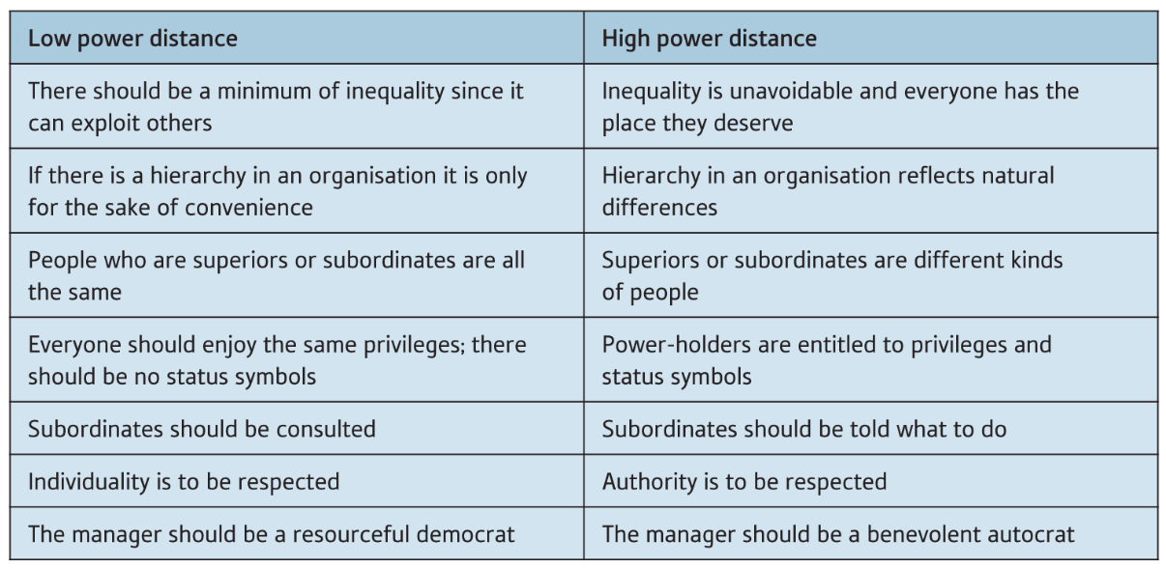
- Individualist VS Collectivist
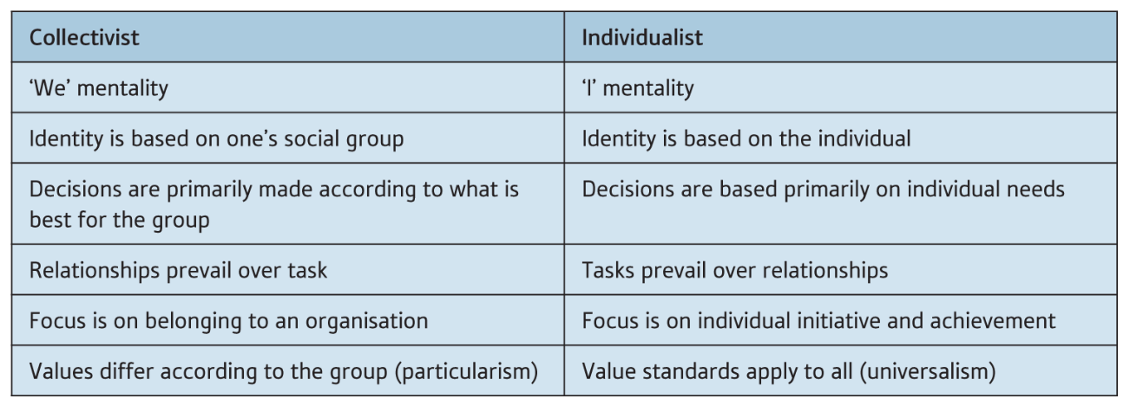

- Masculine VS Feminine
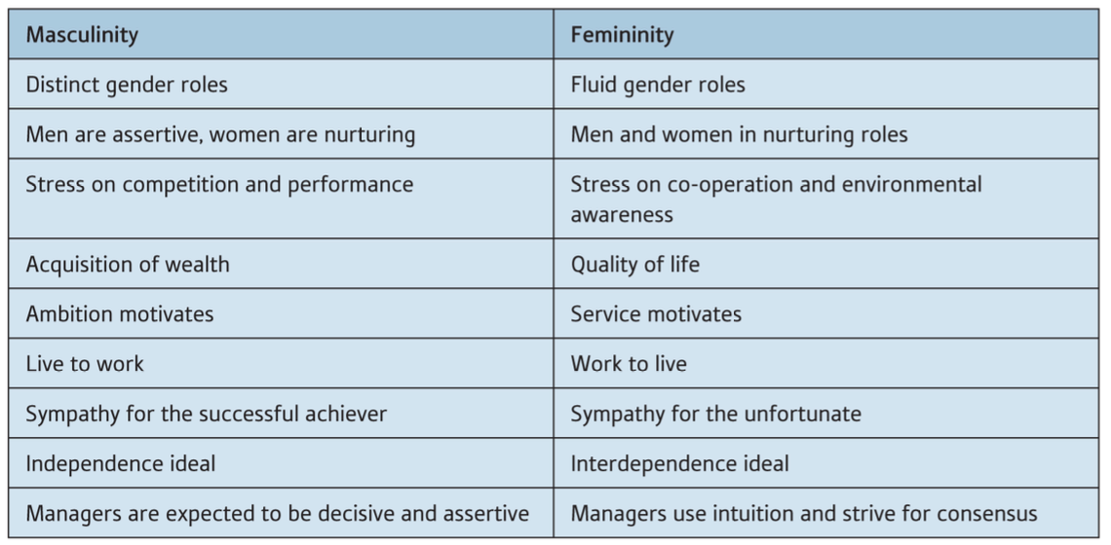

- Uncertainty Avoidance
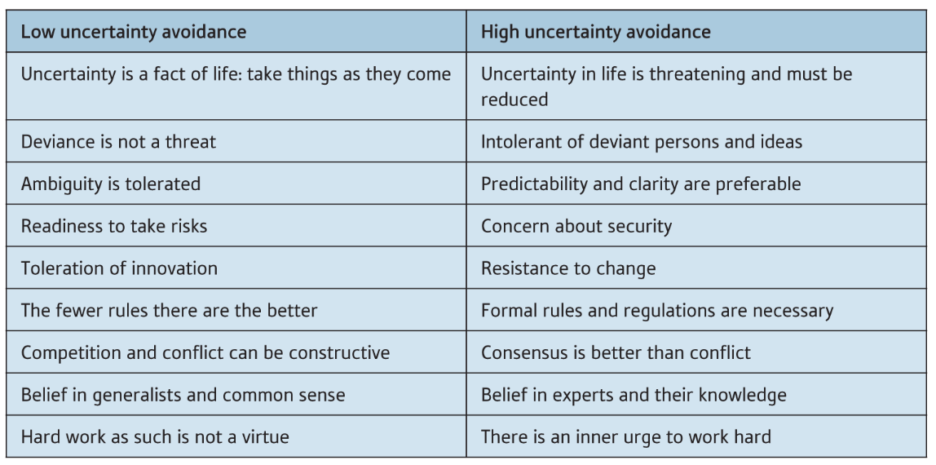

- Short-Term VS Long-Term Orientation
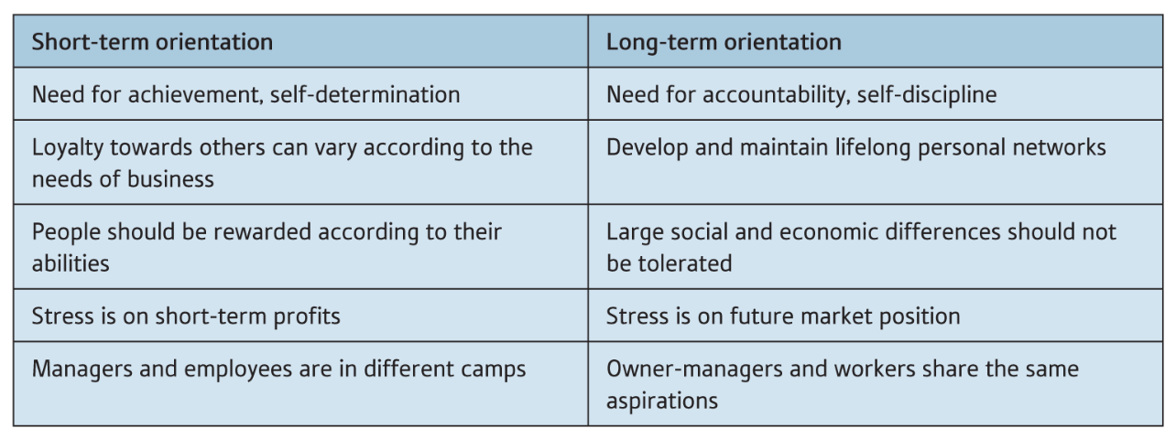

- Indulgence VS Restraint
Indulgence | Restraint
Basic needs are satisfied  Not motivated by material rewards  Enjoy moments  Objects must fulfil purpose and not status | Gratification is suppressed and regulated  Expect material rewards for job well done  Easily feels treated unfair  Status objects are important (e.g. nice car, big house)

GLOBE Model
Examines practices (the way things are) and values (the way things should be).
= Categorizes the World’s countries in 9 clusters.
- Anglo
- Latin Europe
- Nordic Europe
- Germanic Europe
- Eastern Europe
- Latin America
- Sub-Saharan Africa
- Middle East
- Southern Asia
- Confucian Asia
Dimension | definition | what it should be
Power Distance | Degree to which members of a group expect power to be distributed equally. | Followers are expected to obey their leaders without questions.
Uncertainty Avoidance | Extent to which a group relies on social norms, rules and procedures to deal with uncertain situations. | People live structured lives with few unexpected events.
Institutional Collectivism | Degree to which organizational and societal institutional practices encourage collective distribution of resources and collective action. | Leaders encourage group loyalty, even if individual goals suffer.
In-Group Collectivism | Degree to which individuals express pride, loyalty and cohesiveness in their organizations or families. | Individuals feel great loyalty towards their organizations.
Humane Orientation | Degree to a group encourages and rewards individuals for being fair, generous, caring and kind to others. | People are very tolerant of mistakes.
Assertiveness | Degree to which individuals are assertive, confrontational and aggressive in their relationships with others. | People are dominant in their relationships.
Gender Egalitarianism | Degree to which a group minimizes gender inequality. | Boys are encouraged more than girls to get a higher education.
Future Orientation | Extent to which individuals engage in future-oriented behaviors, such as delaying gratification, planning and investing in the future. | More people live in the present than in the future.
Performance Orientation | Degree to which a group encourages and rewards group members for performance improvement and excellence. | People are encourage to strive for continuously improved performance.

Limitations of the Models
- Failure to recognize differences among people (may lead to stereotyping)
- Lack flexibility
- Charactering (no in between)

- Ethnocentrism: evaluation of other cultures according to preconceptions originating in the standards and customs of one's own culture (my culture is the best way).

- Parochialism: Narrow perspective not even recognizing that cultural differences exists.

Chapter 4
Different cognitive approaches to management
Western managers use a deductive, top-down, thinking approach
i.e. draw logical consequences (outcomes) from premises (assumptions)

Eastern managers use an inductive, bottom-up, thinking approach
i.e. start with a generalization and conclude with a particular.

ASIAN CULTURES
Two Asian clusters:
- Confucian Asia: countries that have undergone influence of Confucian ideology
- Southern Asia: countries with different religions and ethnic groups living in peaceful co-existence.
Both clusters share similarities regarding the way relationships are managed: concern for respect and harmony.
- Doing business therefore involves establishing a good relationship.

- Confucian Asia: China

Guanxi = building a strong network of relationships
- Network provides information, expertise, enables new business partners and new deals
Mianzi = face: maintain your own dignity and that of others
- Helping friends within a network is a moral and social obligation.

- Confucian Asia: Japan

- Wa is the spirit of harmony, applied to all relationships, including those with nature
- Seen in collaborative behavior and consensus- building in an organization
- Reflected in mutual commitment and loyalty between company and employee
- Loyalty: individual > group > company > country.

- Confucian Asia: (South) Korea

- Focus on family life and enhancement of its fortunes has influenced the rapid development of the economy
- The role of the extended family in developing a network of conglomerates (chaebols)
- There are around 60 chaebols, held together by cross-ownership and cross-subsidies.

- Southern Asia: India

The Indians and family
- Every company employee works for the family to maintain and enhance its fortunes
- Loyalty to the (extended) family takes priority over loyalty to the company
- Success in your profession will give your family added status.
- The family business: material success is important more for the sake of maintaining the family’s honour and ensuring a sound future for the offspring.
- Being successful involves not just working long hours but also being creative.
- Failure possible, but this is less to do with personal competence, more to do with fate, so stigma.
- Indians accept social and business hierarchies, just as hierarchy of gods in their religion. They not only show considerable respect towards their seniors in all aspects of their lives, but also expect these to fulfil the obligations that power bestows.
- Ongoing changes in the nature of Indian society
  - weakening of the caste system
  - liberalization and restructuring of the economy.
- Manager has to contend with both collectivist and individualist values within a formal system of management.

- Southern Asia: Thailand

Thailand and karma
- Buddhism plays dominant role: Buddhists assert personal/social responsibilities to ensure peace and serenity.
- By doing so, accumulate sufficient positive karma (action and result) to ensure rebirth in another, happy, state of existence.
- Thai Buddhist economic model
  - Avoidance of extremes
  - Create sustainable profit.
- Karma leads to a particular kind of paternalism
- The leader is considered to have accumulated good rather than bad karma.
- Leadership requires exercising personal responsibility towards the community, being its leader and servant.
- Thai Buddhist economic model: creating sustainable profit.

- Chinese and Indian diasporas

- Diasporas (Dispersion of an ethnic community across the world) have played a significant role in rapid globalization of business, in particular China and India.
Both diasporas have helped connect mother countries to the world, thanks to:
- Modern communication channels
- Trust they place in their fellow-countrymen
  - E.g. of Chinese–American innovators who can foster trust during their company’s attempt to gain entry into Chinese market

- China and India, BRICS countries

- China and India belong to the BRICS group of emerging countries.
- Economic relations between these two countries helped by frequent meetings of BRICS conventions.
- But historical disagreements, including border disputes, are holding back creation of a full-blown trading partnership.

AFRICAN AND MIDDLE EAST CULTURES

- Sub-Saharan Africa

Fundamental African personality traits are (According to Shepherd Shonhiwa):
- Being non-discriminatory, not promoting prejudice, seeking reconciliation in politics and business.
- Having inherent trust and belief in human fairness.
- Having high standards of basic morality, based on historical precedent and bolstered by extended family system.
- Believing in a hierarchical political ideology, but based on an inclusive system of consultation.
- Perpetual optimism, mainly due to strong religious beliefs.

The culture base of Africa is characterized by its:
- Relationship to time;
- Organized work;
- Other people (family, hierarchy, colleagues, subordinates, outsiders).

This applies to regions either geographically very distant from each other, or very different to each other in terms of climate, religion or language.
Example: Ivory Coast and Ruanda have similar attitudes as to:
- how decisions should be made, how managers should give orders
- how employees behave towards the company (high absenteeism and lack of initiative).
- Majority of local companies reject interpersonal competition among employees (no bonuses), Reject contracts and other written directives, preferring verbal commitments.

- South Africa

- Huge cultural diversity: indigenous black peoples, white Europeans, Indians, Chinese and other immigrants from various countries in Asia.
- the country has promoted its multicultural society, trying to draw the diverse groups into the social and economic development of the country.
- Sharp urban/rural contrast: in rural areas, the head of the family determines how business is run. Important role of tribal/family connections.

Newest member of BRICS since 2011.
- Membership questioned by Jim O’Neill who originally devised the acronym: South Africa’s economy too small and growth rate low.
- But we may assume South Africa has a growth potential to allow it to equal the largest economies.

- Middle East and North Africa

The present Arab states were formed following the break-up of the Ottoman Empire during World War 1 (1914–1918).
- Islam religion provides an overarching body of belief and a strong sense of identity and community.
- The broader notion of family – a kin group or clan involving several households and cousins on the father’s side
  - Remains at the basis of Arab social structure.
  - Family welfare is of primary concern: Family ties not only bring security but also commitments.
  - The family is run by an authoritarian father and the family clan by the oldest, competent member.

- Arabs are highly sensitive towards traders – they may turn down a lucrative business deal because they dislike the people they are dealing with, particularly if these people do not enhance their personal reputation.
- The face or image conveyed to others, especially in public, is given considerable attention
- The Arabs are renowned for their generosity and hospitality, but these ‘duties’ may also be a prelude to seeking some kind of commitment or request.

Management paradox referred to by Hickson and Pugh (2001): Arabs handle authority centrally with high power distance, yet at the same time they aspire to an ‘open door’ for all-comers, high or low.

- Aspect of Western culture now in many Arab countries. But this process is being controlled to prevent abuse of civil/religious norms and values.
- Arabic companies are facing a dilemma that brings the globalization of the economy into conflict with affection for cultural values of the past.
• However, a growing middle class which is trying o reconcile the process of economic modernization with the development of new values, such as tolerance, individualism and concern for the future
Cross cultural interaction
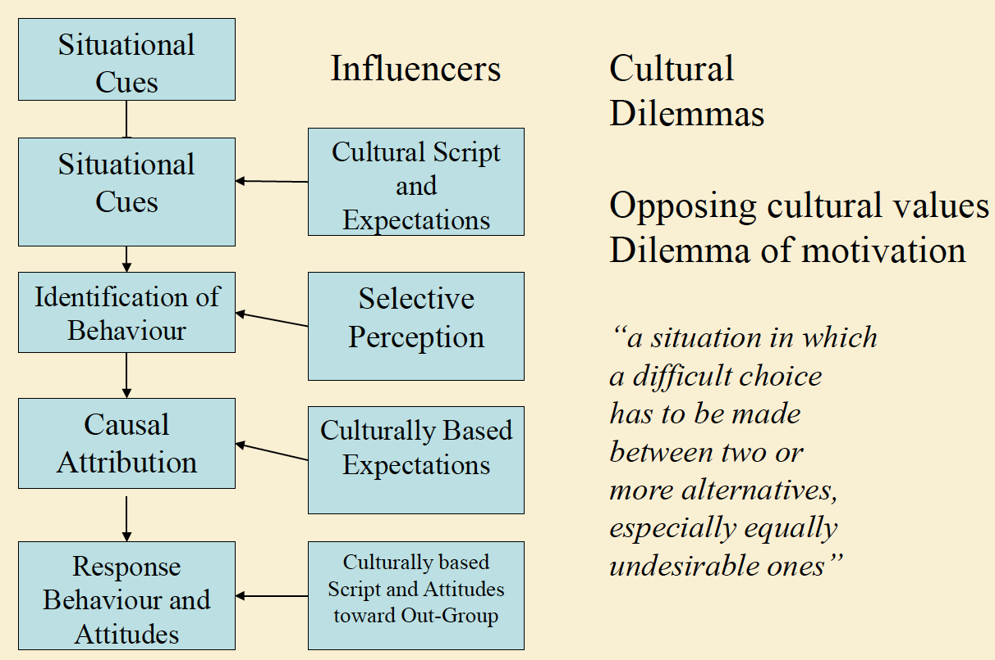

Reconciling cultural dilemmas
- Trompenaar’s methodology aims to reconcile what appear to be opposing values within the dimensions
e.g particularism (circumstances and relationships) vs. management’s universalist approach (absolute rules apply, dispute are resolved by written communication – no attempt for dialogue)
- The dilemmas in each of the seven dimensions require some kind of resolution
- Cultures are seen as dancing from one preferred end of a dimension to another

Management dilemmas and dimensions
- Universalism-particularism
Legal contracts or loose interpretation + low cost strat or premium strat + extending rules or discovering exceptions
- Individualism-collectivism
Perso project vs team project + differentiation from group or alignment with
- Neutral or affectivity
Being pro (rational or engaged (emotional/soulful)
- Specific-diffuse
Data and codification or concepts and models + being results-oriented or process-oriented
- Achieved or ascribed status
Pay for perf or vindication for worth + head-hunting or developing in-house
Framework form “millennium manager”
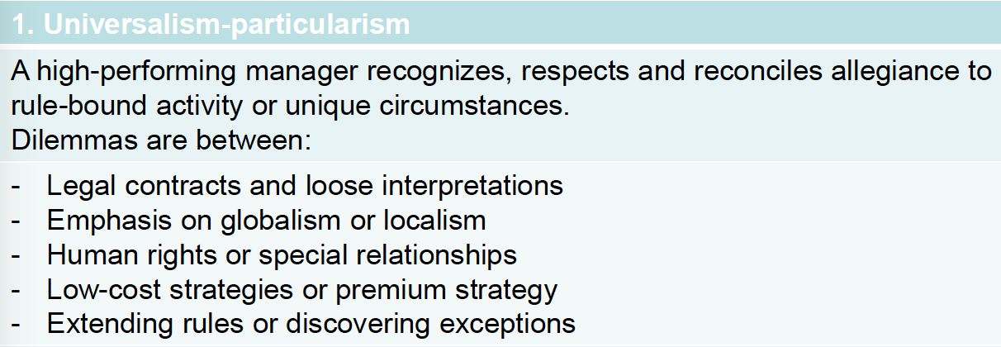
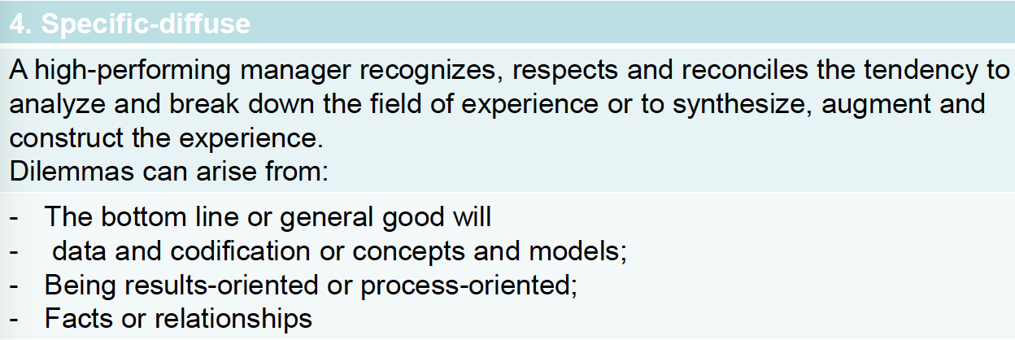

How does reconciliation work?
- It leads to a dynamic equilibrium between seemingly opposed values, which make up a cultural dilemma
- Reconciliation results in the integration of values through synergy
- “once aware of our own mental models and cultural predispositions, once one can respect and understand that those of another culture are legitimately different then it becomes possible to reconcile differences” (Trompenaars, 2000)
- Options for achieving synergy: 1. Processing (dilemma is made into 2 processes); 2. Contextualizing (decide what is text and what is context); 3. Sequencing (every process is a sequence {1st centralize and then decentralize}); 4. Synergizing (adding the word through between the 2 opposite alternative orientations

Stages of the reconciliation process 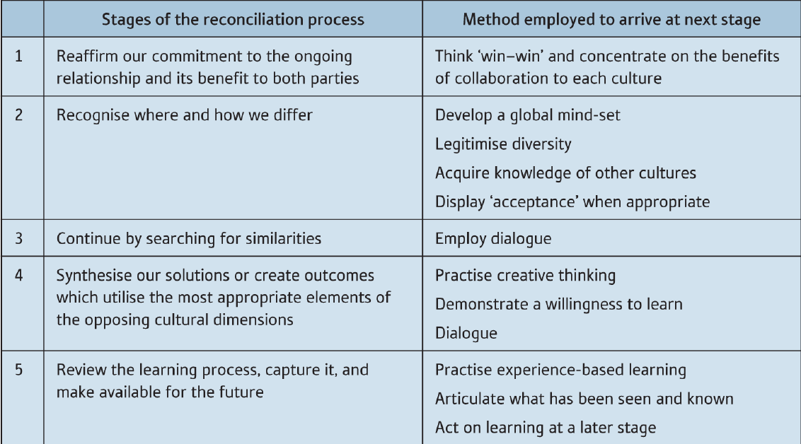

Conclusion
- Cross-cultural manager has to face universal dilemmas but the ay they are resolved is culturally determined
- Rather than the dimensions themselves, it is the concept of reconciliation that differentiate Hofstede from Trompenaars

Management tasks and cultural values
- Planning
Goals and objectives of a comp or department
- Organizing
Organizing actions needed to achieve the goals
- Staffing
Allocating employees to particular position
- Directing
Leading the organization and its employees towards its goals
- Controlling
Monitoring perf of the comp or dep

Effect of cultural values on management
- The way tasks and responsibilities are performed will be examined in the light of ket number of cultural values
- Cultural values emerged from cultural dimensions found scholars
- 8 cultural value orientations have a considerable influence on the way managers perform their activities
- These cultural value dimensions will be examined together with their impact on the management activities

Model of culture
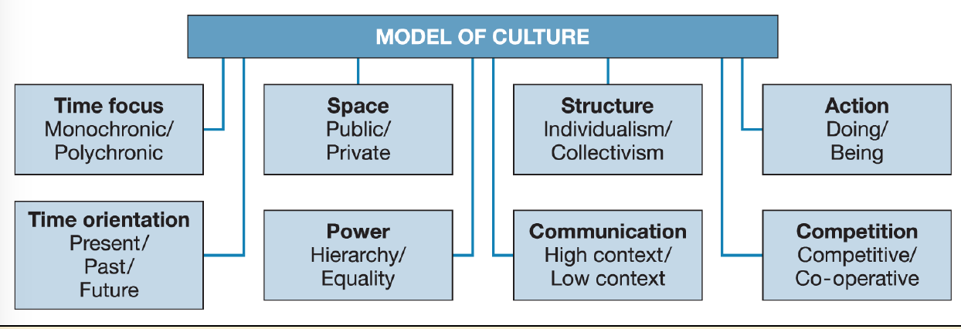

Time focus and management tasks
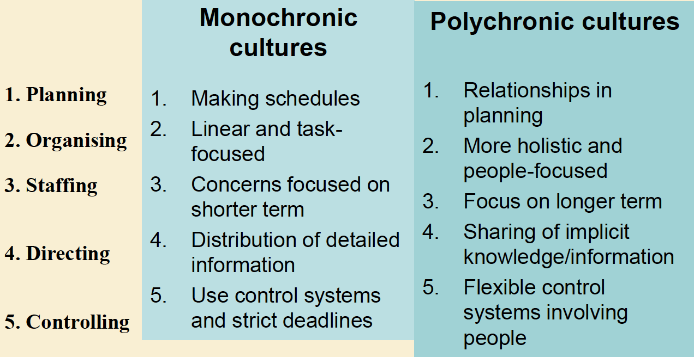

Time orientation
Past -> uphold tradition in line with the history of the company
Present -> aim for quick results and short-term gain
Future -> assess plans in the light of expected future benefit
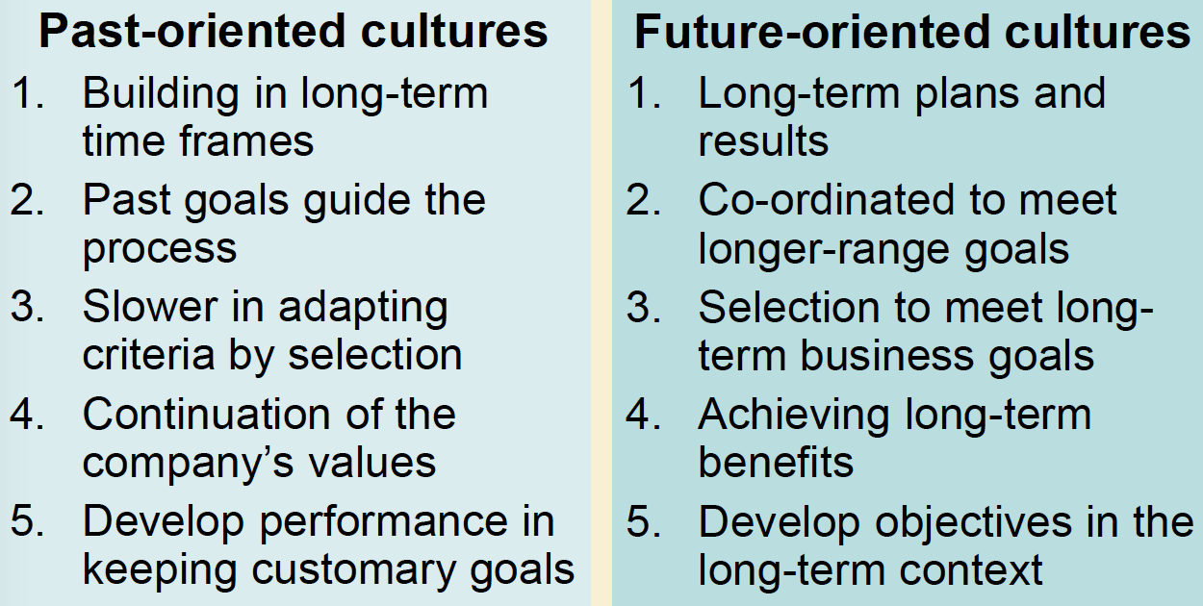
Power
- Power value orientation: the extent to which a society expect or accept that power is distributed unequally
- Hierarchy: level of power and authority are strictly marked
- Equally: status and formal position have less influence
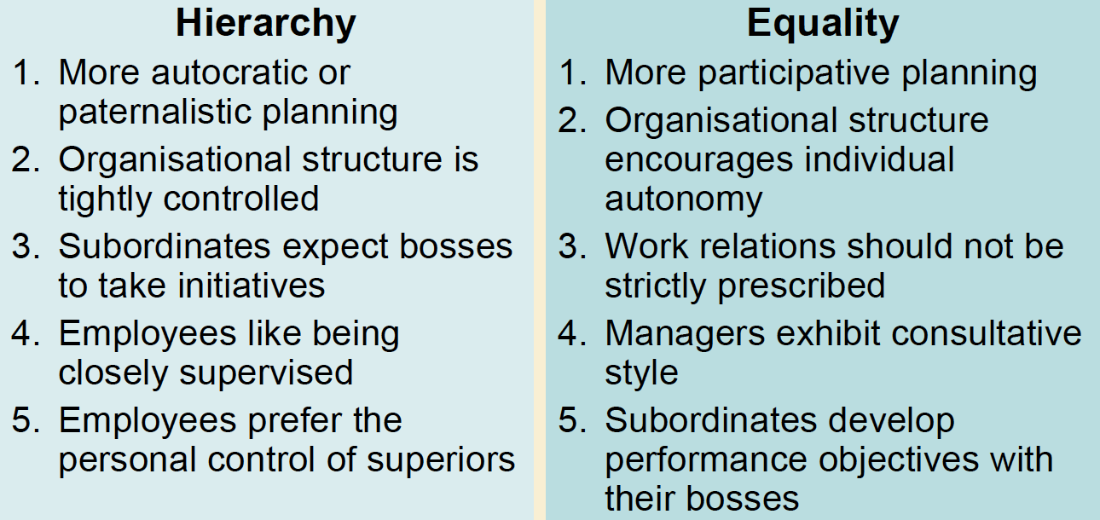

Competition
- Competitive
When competitiveness is valued the culture is focused on acquiring wealth, performing well, achieving ambitions
- Co-operative
Competition is not considered to be the main purpose of busi + stress is on quality of life, relationships and consensus
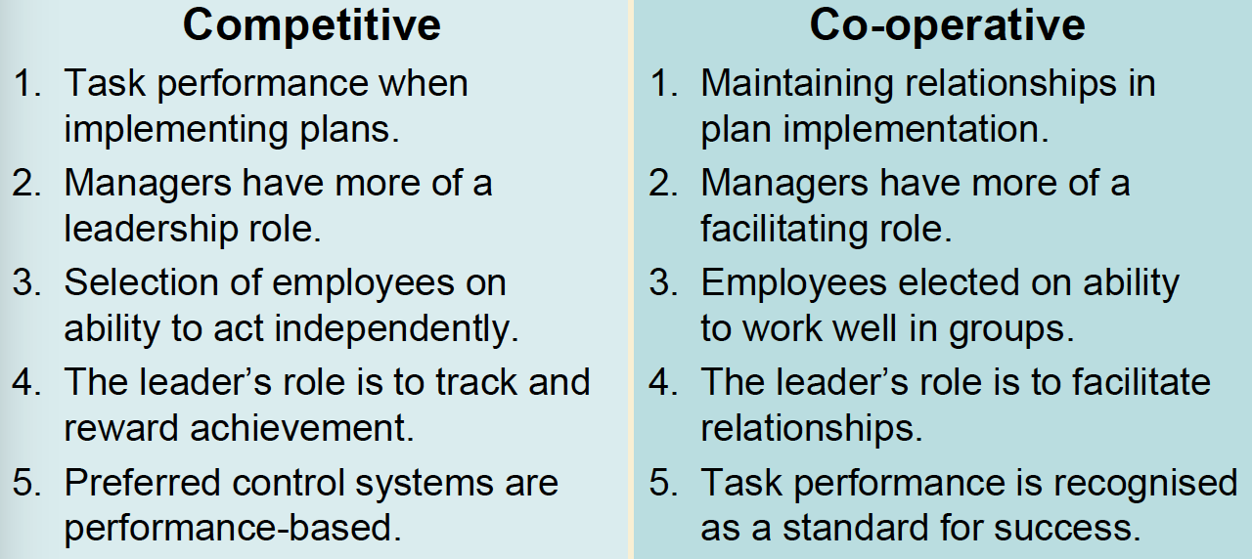

Action
- Doing -> action and achieving perso goals
- Being -> working for the moment and living experience
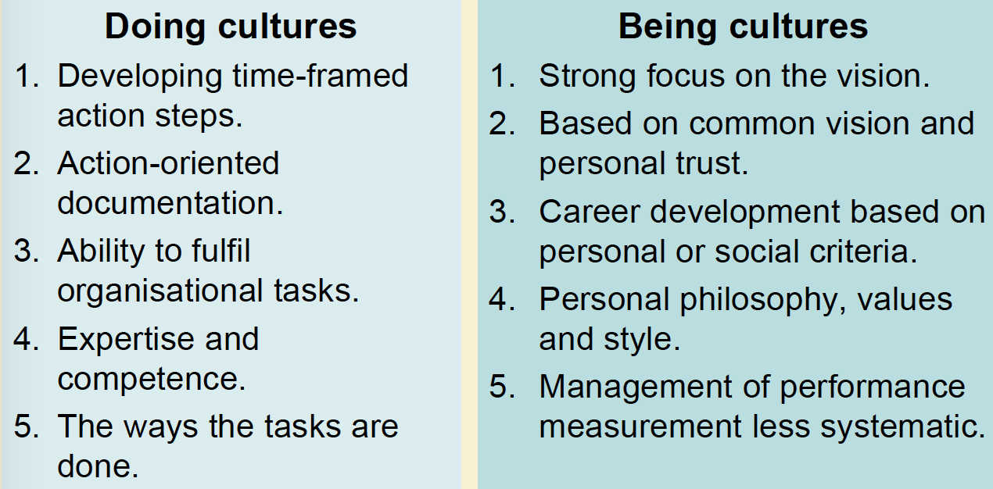

Space
- Private/public
Invisible boundaries around every person and can be seen in term of personality
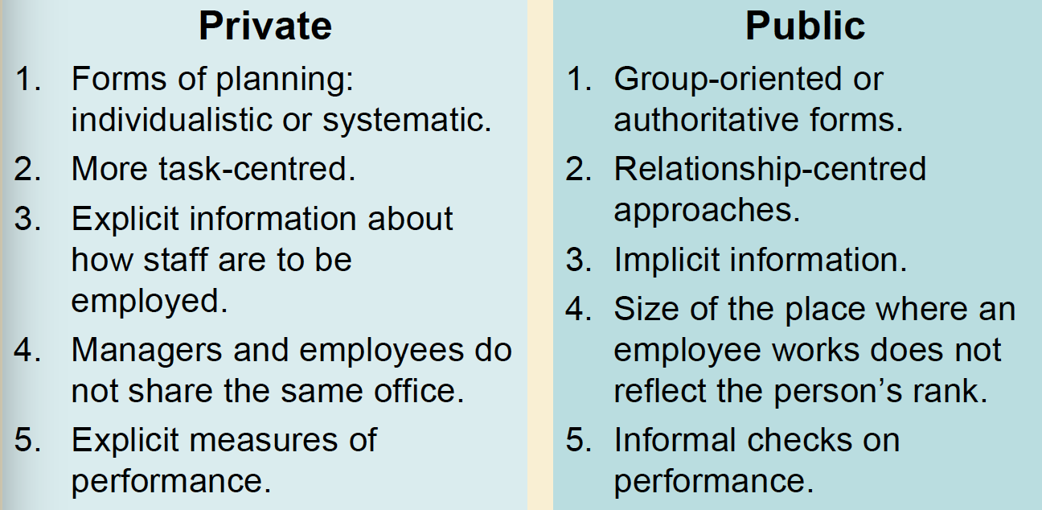

Communication
- High-context -> info hidden in the situation
- Low-context -> message is clear and explicit 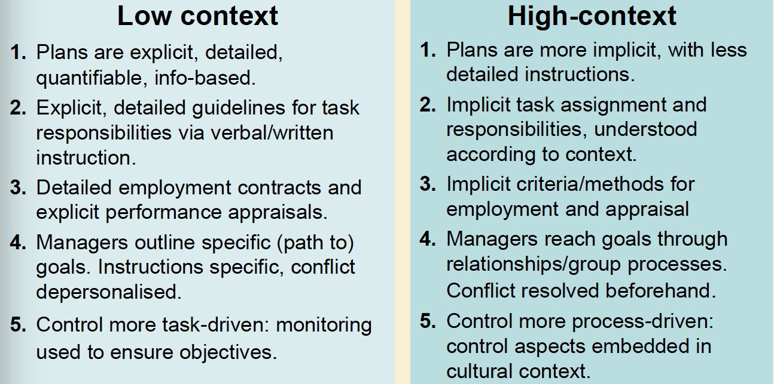

Messages and context
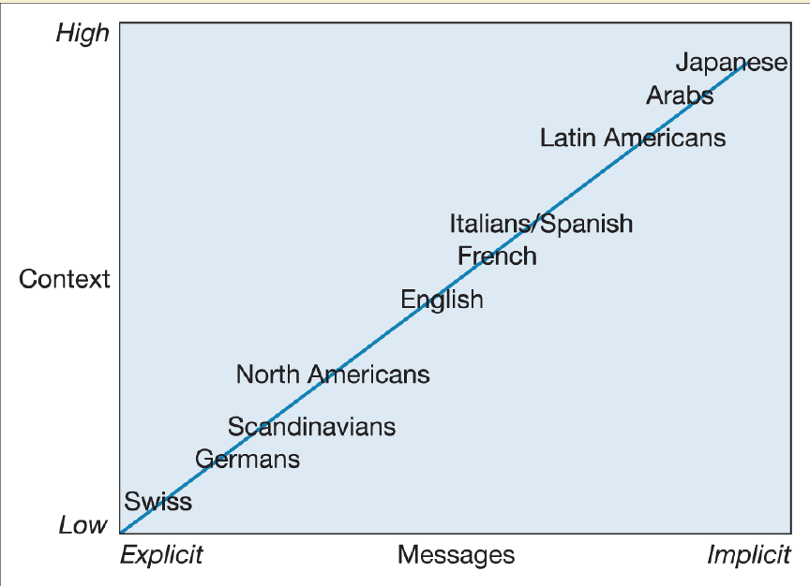
Structure
- Individualism -> I
- Collectivism -> We
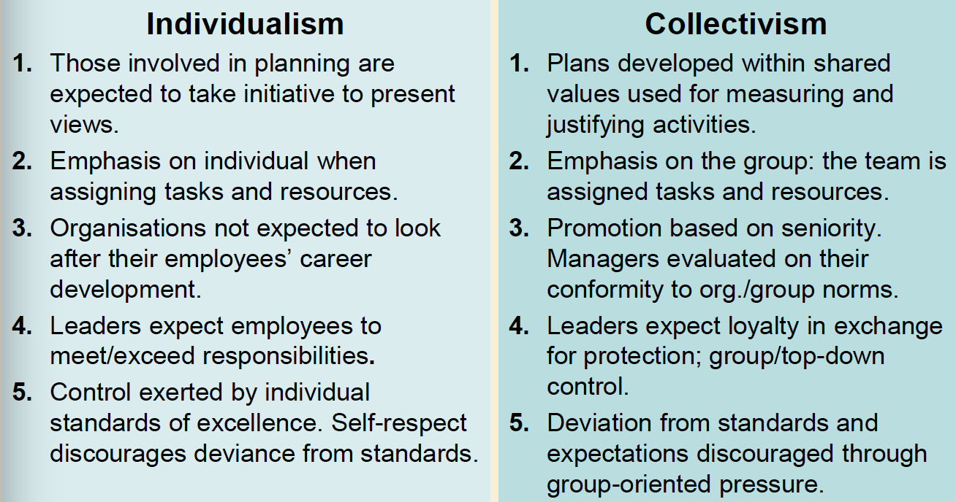

Chapter 5
Culture and corporate culture
Organizational structure: the way in which orga is set up to carry out its objectives and pursue its projects
Relation are formalized:
- Tasks, jobs, position of personnel, limits and responsibilities of the work unit
- Indicate the kind of hierarchy within orga, level of authority and power, formal lines of communication between the employees

Structure: frame of an organization and can be used to analyze its culture

Variables that influence structure:
- Size: small may have flexibility to engage all the staff or may not have enough staff to engage new opportunities
- Business envi: may require large-scale, decentralization if selling in may markets, regional/international structure
- Internal/external relationship: choice of technology, activity, strategy is determined by internal and eco conditions, host gov and prod-market characteristics is determined by external
EX: private technology college versus a gov funded CEGEP

Forms of organizational structure
Fatehi (1996) – classification of five orga structures:
- Geographic structure
- Functional “
- Product “
- Mixed “ (combination above)
- Matrix “ (the two lines – functional and project – share responsibility)

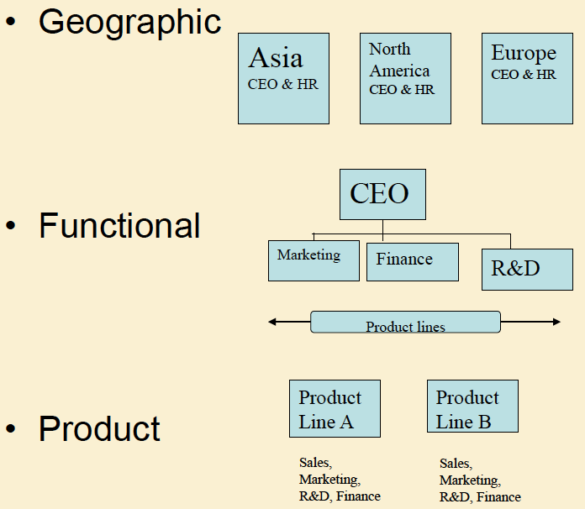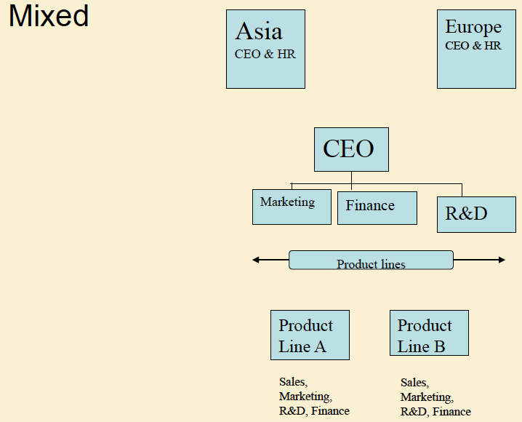
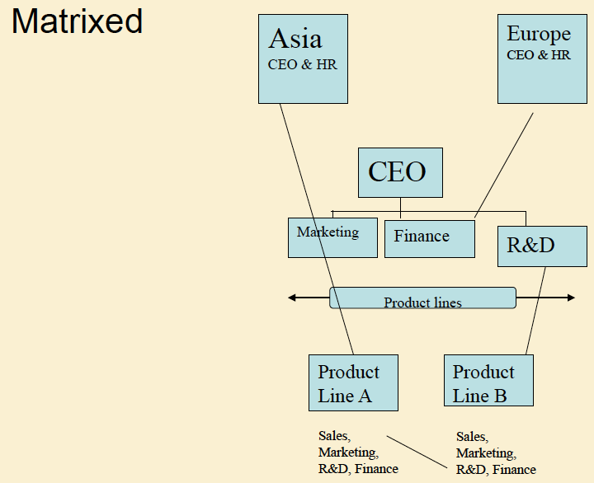

Other recent organizational structures (with globalization and new orga forms, adaptation are necessary to keep pace with eco reality)
- Network structure
- Network of a comp unit, which has horizontal system of communication
- Facilitates cross-cultural transfer and knowledge and orga learning
- Networking uses socio interactive communication to support strat and the mission of the orga
- Transnational structure
- Multi-faceted orga, which can respond to international and global envi
- Characteristics dispersed, interdependent, national unit make differentiated contributions to integrated worldwide operations, knowledge is developed jointly and shared worldwide

Cultural diversity and orga structure
Stages:
- Domestic: prod and service offered in domestic market and foreign customers express interest
- Multi-domestic: sub-units in several countries operating autonomously; particularities of each local market; cultural diversity affects rs external to the orga
- Multinational: internal orga whose culture is affected by cultural diversity within the firm
- Transnational: generates its own evolution without having to rely on forces external to the enterprise; heterogeneous, global HR strategies become essential
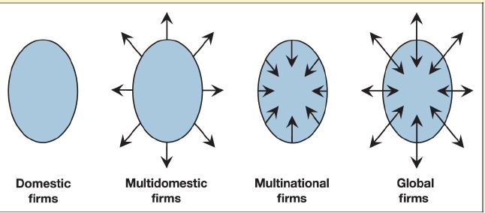
MNC vs Transnational
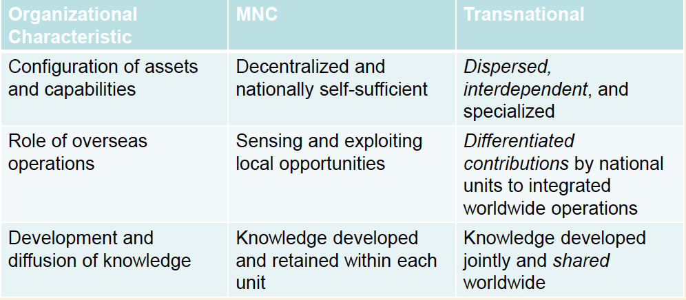

Corporate cultures
Corporate: unified body of individuals
Busi envi is the single gratest influence in shaping a corporate culture
National cult also has an influence on how companies manage their business

Culture and management
Culture is for strategy, human resources {framework of reference for change policies and the involvement of the people in the process}, marketing {commercial culture of the firm}, finance {relation bet cultural values and accounting system}

Culture influence mana
- Offers the possibility of increasing efficiency at various levels, finding behaviors which allow the best perf possible
- Helps to understand the orga as an entity, as a collection of individuals creating a heritage based on experience of the group – can serve as a framework of ref for situations in the future
- Allows the manager to explain how the organization works before deciding whether it needs to be changed

Level of corporate culture
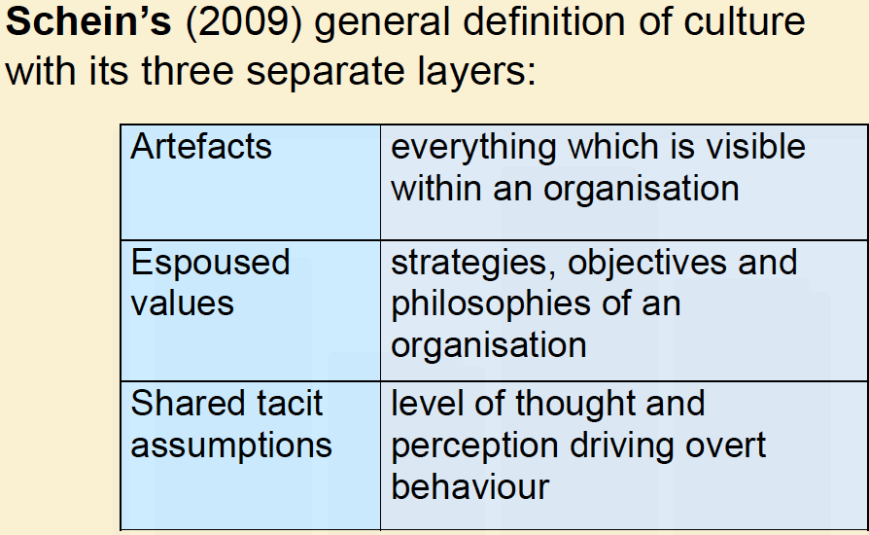
Cultural assumptions and culture content
Schein (2009): through a joint learning process, the beliefs and values tacit assumptions about the nature pf the world and how to succeed in it
- Cultural assumptions
- To do with internal workings of an orga
- How the orga sees itself in relation to its envi
- Culture content of the orga must
- Survive in the internal envi
- Integrate human aspects
- Take account of the national culture in which it is operating

Corporate values
Deal and Kennedy (2000) define values as being “the basic concepts and beliefs of an organization”
- Form the very basis of corporate culture
- Give direction and guidelines for a day-to-day beh
- Lack of concern can undermine leadership and commitment
- Values are an indispensable guide for making day-to-day choices

3 characteristics that distinguish comp from each other
- Orga have an explicit philosophy as to why they’re conducting busi
- Mana is intent on communicating the values which shape the company in terms of the eco choices and its business environment
- These values are shared at all levels of the orga from the shop floor to the board room

Identifying corporate culture
Deal and Kennedy identified a classification using 2 factors:
- How much risk is involved in the firm’s activity?
- How much time is needed before a company and its employees know how successful their decisions or strategies have been (feedback)?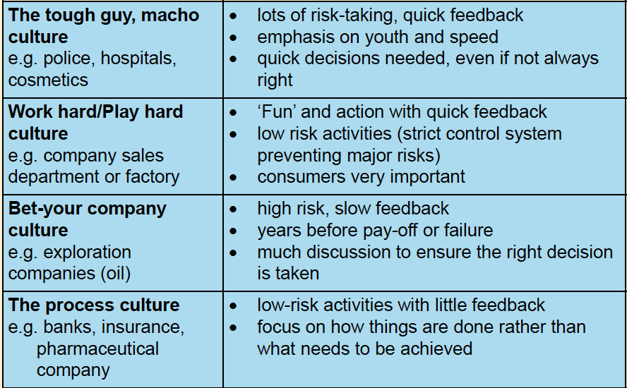

They come up with four cultural types:
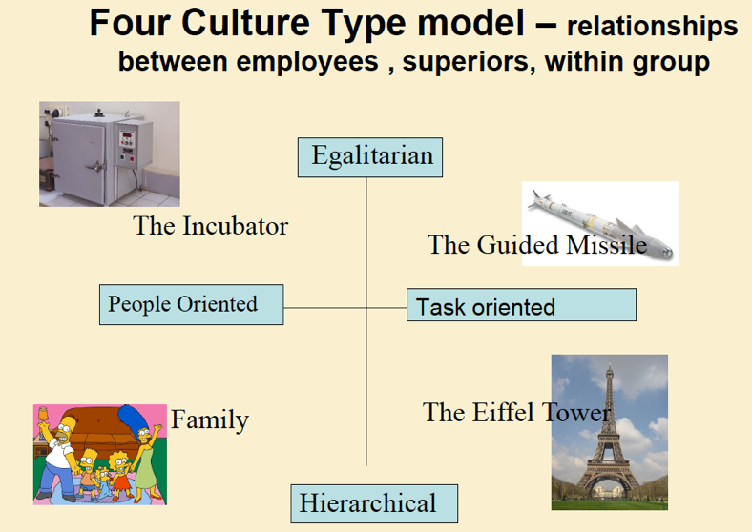

Trompenaars and Woolliams (2003) use a model that combines 2 dimensions:
- Task or person
- Hierarchical or egalitarian
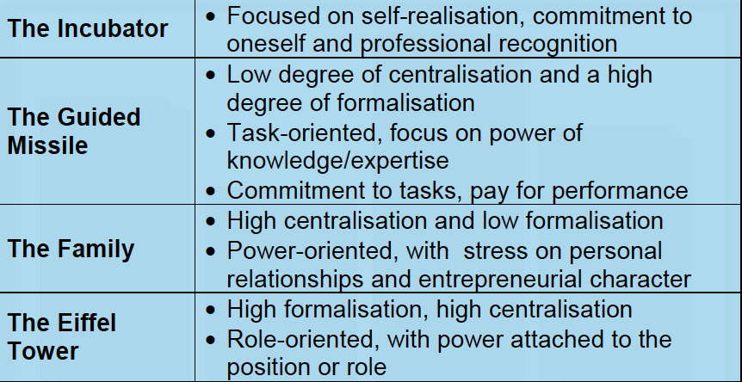

Analyzing orga cultures


