Psychology Midterm Review
45 questions total
Chapters 1,2,3
15 questions per chapter
12-14 questions are from slides, 1-3 are from the book directly

- Neurotransmitters is to receptor as: lock is to end, lock is to key, key is to lock, account is to password
- 3 questions of sympathetic, parasympathetic, somatic and central system. (Know their differences)
- 3 questions on thalamus, hypothalamus, hippocampus, amygdala
- CT scan, Pet scan, and something imaging, 1-2
- Which statement about REM sleep is true
- 2 questions on sleep disorders
  - Tommy is a long-distance truck driver, the sleep disorder that would be most dangerous to him is
- 2 questions on types of drugs; Depressants, stimulants, hallucinogens
- 4 bonus questions, dig deeper!

Midterm Hints:
- Question #10(or &) is a, Wundt
- What type of psychology explains mind and behavior in terms of the adaptive value of abilities, that are preserved over time by natural selection?
- Something studies the influence of peer pressure on adolescents. Which area of psychology does the research best represent? cognitive, social, chemical, or cultural psychology.
- 1-2 questions on research,
- Dependent variable, independent variable, control group, experimental group
- What is the difference between a survey, something study, a case study, and an experiment?

Chapter 1

Psychology: the scientific study of behavior and mental processes
- Scientific: answering questions objectively based on observable facts, data, and established methods
- Behavior: observable actions
- Mental processes: thoughts, feelings, sensations, perceptions, motivations, dreams, and subjective experiences
Rene Descartes: Dualism, idea that the mind and the body are separate entities that interact
Plato: Nativism, idea that certain kinds of knowledge are inborn or innate
Aristotle: Philosophical empiricism, idea that all knowledge is acquired through experience

Roots of Psychology

Physiology: branch of biology that studies the functions and parts of living organisms
- 1600s, physiologists studied the workings of the brain and its relation to behavior
- 1700s, physiologists found body functions can be traced to specific brain areas
- Ideas such as phrenology (a pseudo medicine primarily focused on measurements of the human skull, based on the concept that the brain is the organ of the mind, and that certain brain areas have localized, specific functions or modules) that did not stand
Wilhelm Wundt used scientific methods to study psychological processes and established the first psychology research laboratory. Founder of the psychology discipline. What is the best way to measure mental processes?
Edward Titchener was a student of Wundt and believed complex conscious experiences could be broken down into elemental parts or structures. He invented the “periodic table of psychology”, to determine the structure of the mind and how does it work. He had around 52000 instincts and he failed to identify the structure of the conscious. What are the structures of conscious experiences?
William James and some influences from Darwin advocated functionalism which focused on how behaviors function to allow people and animals to adapt to their environment. We act to ADAPT. What are the functions of behavior and mental experiences? How can psychology be applied to life?
Sigmund Freud believed that the unconscious is the part of the mind that operated outside of conscious awareness, and that the unconscious conflicts determine behavior and personality. He made his Psychoanalytic Theory which explains that unconscious mental processes shape feelings, thoughts, and behaviors.
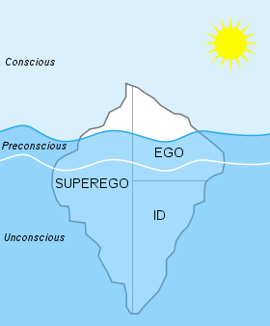
ID
- Life (Eros)
- Death (Thanatos)
Superego
- Laws, prohibited
- 19:1, no vs. yes

Ivan Pavlov, John Watson, and B.F. Skinner developed behaviorism where psychology is redefined as the scientific study of observable behaviors. Define illness by behaviors and NOT mental processes. Pavlov discovered conditioned reflexes; Watson extended the approach to human behavior; Skinner furthered experiments on learning, behavior, and conditioning.
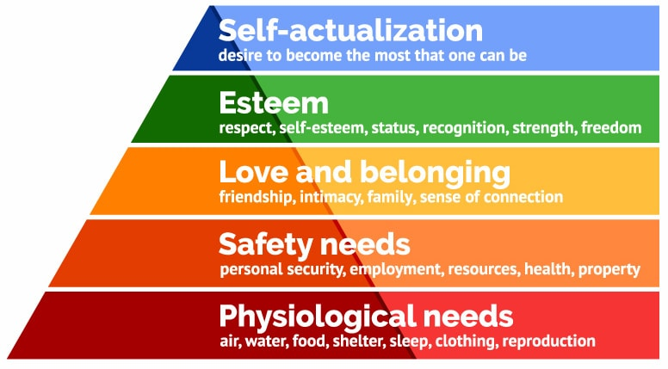
Carl Rogers and Abraham Maslow developed humanistic psychology where positive potential of human beings is assumed. There is an emphasis on self-determination, free will, and the importance of choice. There’s a reaction to negative implications of Freudian and emphasis on external influences of the behaviorist school.
Maslow’s Hierarchy of Needs

Perspective | Focus | Sample Questions
Neuroscience | How the body and brain enable emotions, memories, and sensory experiences | - How are messages transmitted within the body?  - How is blood chemistry linked with moods and motives?
Evolutionary | How the natural selection of traits promoted the survival of genes | - How does evolution influence behavior tendencies?
Cognitive Psychology is the most recent school of science which studies how perception, though, memory, and reasoning are processed. Returns to the emphasis on mental processes and how they influence behavior.

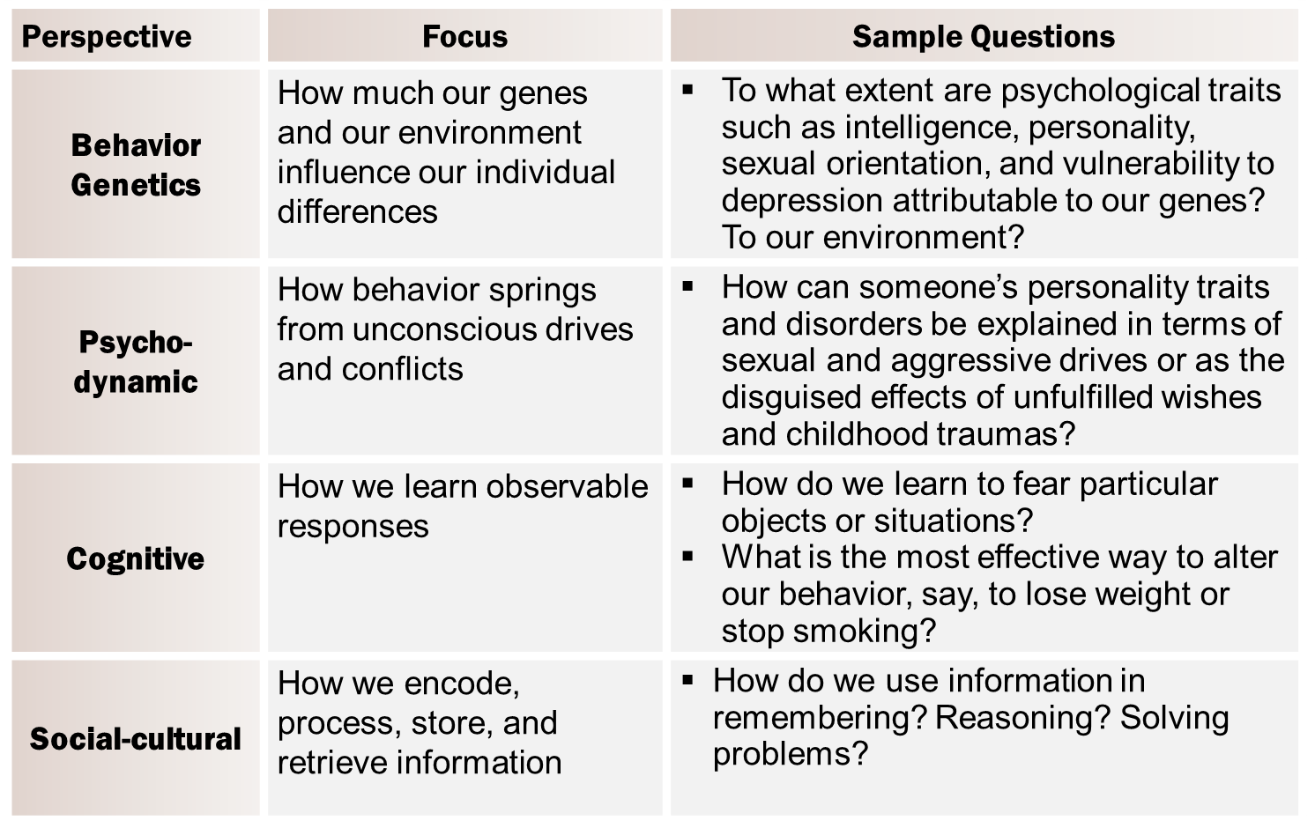
Basic Research builds psychology’s knowledge base through research and training
Applied Research tackles practical problems in industrial or other institutional/ organizational settings
A helping profession that involves counseling and clinical treatment
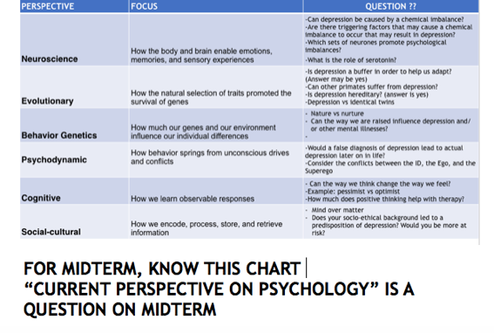
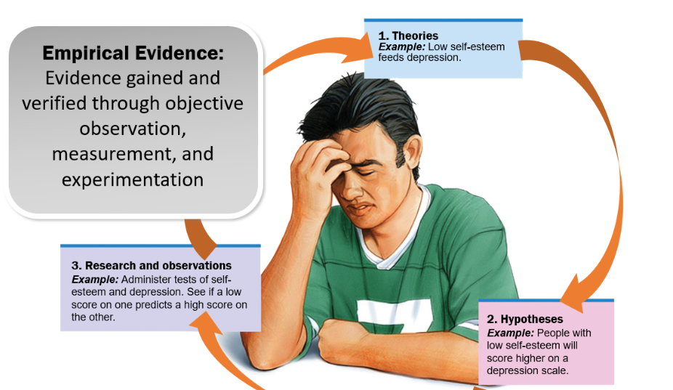
Critical thinking…
- Examines assumptions
- Discerns hidden values
- Evaluates evidence
- Assesses conclusions

Empirical Evidence: Evidence gained and verified through objective observation, measurement, and experimentation.

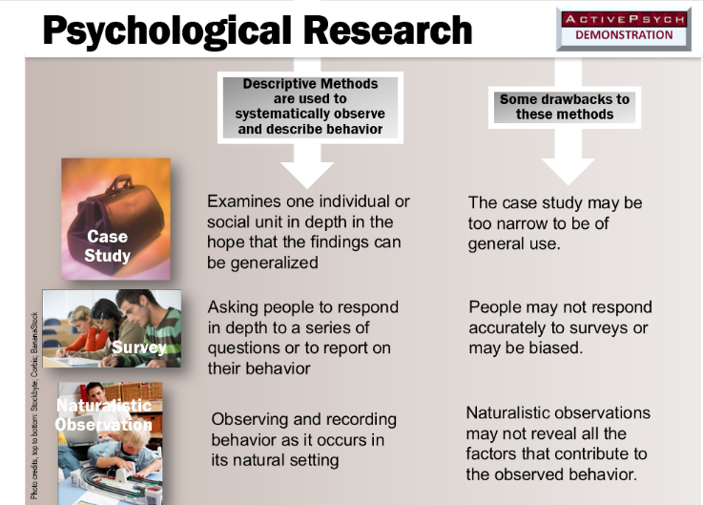
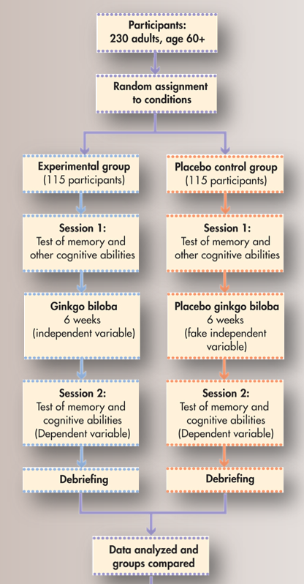
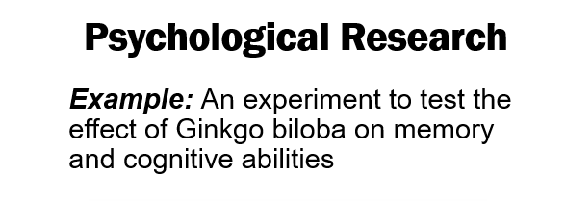

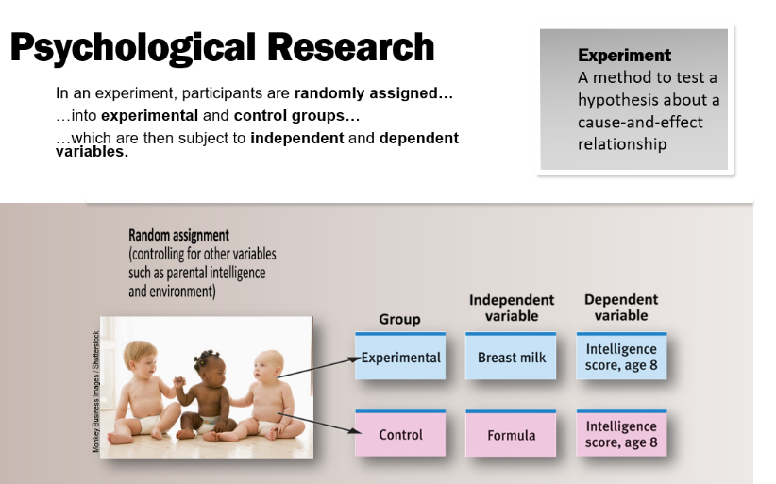

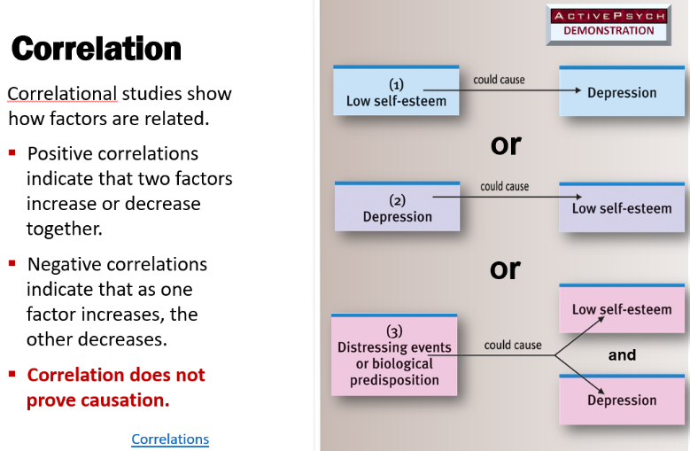

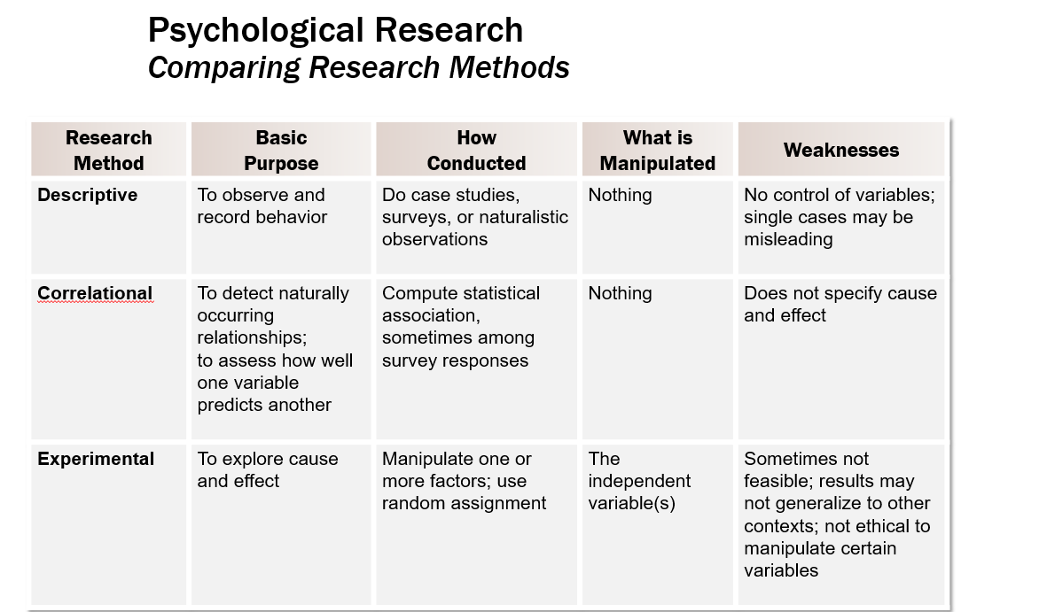

The Neuron
- Cell body, with nucleus at its core
- Dendrites, reception will occur
- Vesicles, each vesicle contains neurotransmitters
- Somatic gap/ cleft in between neurons
- One presynaptic neuron, one postsynaptic neuron
- Cell body (soma) – nucleus with chromosomes
- Dendrites – receive information from other neurons
- Axon – transmits information to other neurons, muscles, and glands

Myelin
- Boost
- Insulating layer of fatty material
- Helps efficient transmission of signals
- Electrical impulse will jump to next node of Ranvier
- Makes electrical impulse around 10 times faster
- 0.04s vs. 0.4s
- Composed of glial cells
- Gaps in sheath are nodes of Ranvier

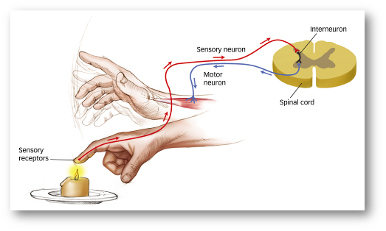
Types of Neurons
- Sensory receptors
- Motor
- Interneurons

The Action Potential
- Electrical charge gathered by dendrites and the cell body
- Electrical charge travels down the axon to the synapse
- Stimulates release of neurotransmitters into synapse

The Synapse
- Neurotransmitter can have diffusion (go away), reuse neurotransmitter in reuptake, breakdown and reuse materials and enzymes (destruction) to create new neurotransmitters
- Junction between axon and dendrites
- Keys are neurotransmitters, locks are receptor sites, can't unlock every door
- Neuron can fire 500times/s
- Presynaptic neuron’s axons end in terminal buttons
- Terminal buttons contain synaptic vesicles
- Synaptic vesicles contain neurotransmitters
- Neurotransmitters are chemicals that transmit information across the synaptic gap (cleft)
- Postsynaptic neuron’s dendrites contain receptor sites
- Receptor sites fit certain neurotransmitters
- Neurotransmitters bind to specific receptor sites in a lock-and-key system

The Refractory period
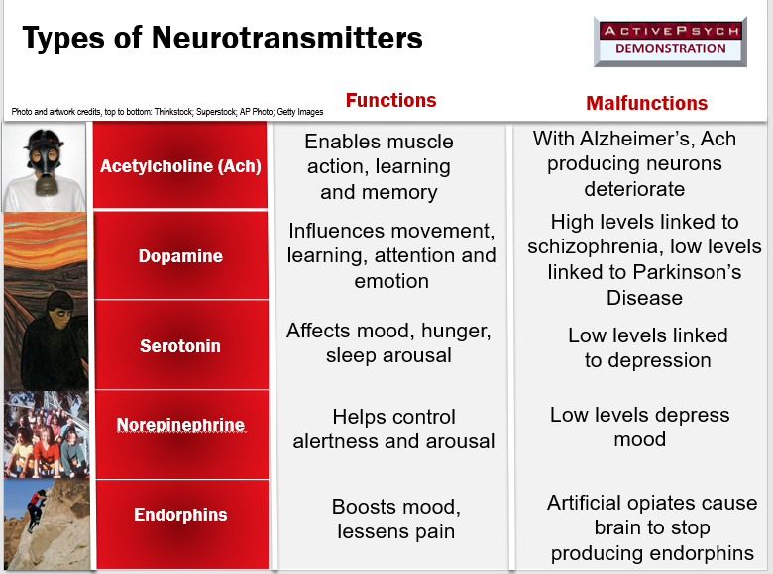
- Following action potential
- Short period of time lasting about 2 milliseconds
- Stimulus threshold: ions coming in
- When a good number of ions come in it spikes and fires, aka action potential
- Once 30 millivolts are reached, threshold is reached and there will be an action potential, neuron will fire
- Refractory period following action potential
- Back to resting potential

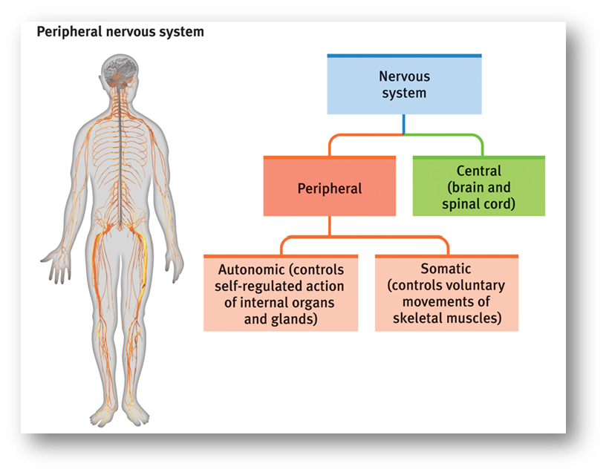
The Nervous System

Peripheral Nervous System (PNS)
- Connects CNS to body's organs and muscles
- In two categories:
  - Somatic (skeletal nervous system)
    - Somatic= body
    - Controls voluntary movements of skeletal muscles
  - Autonomic
    - Controls self-regulated action of internal organs and glands
      - Sympathetic (arousing)
        - Restoring body to its resting state
      - Parasympathetic (calming)

Central Nervous System (CNS)
- Brain, spinal chord
  - composed of interneurons
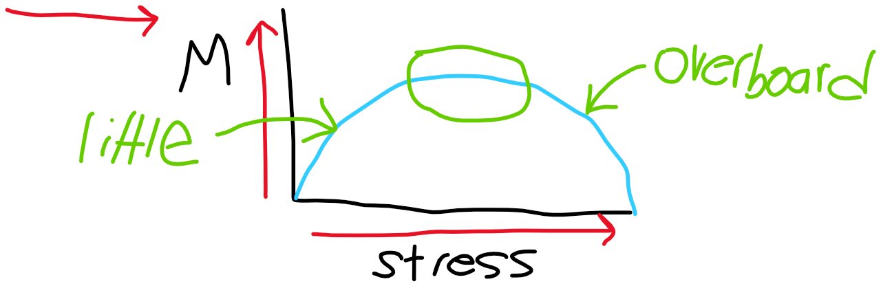

The Brain
- brains change to the result of experience; children’s brains are more plastic than adults
- Language disrupted in left hemisphere=right hemisphere will compensate
- Blind people will have a larger sensory cortex area for fingers
- Deaf people develop enhanced vision
Brainstem: supports life- sustaining bodily function
- If medulla was damaged, you would have trouble with basic bodily functions such as Christopher Reeves who needed support to breathe

Hindbrain
- Reticular formation: regulates sleep, wakefulness, and levels of arousal
  - Cat with cut to reticular formation goes into permanent coma
- Cerebellum: enables nonverbal learning, coordinates voluntary movements
  - If damaged, it would be hard to walk, and one wouldn’t respond to classical conditioning
Pituitary gland: master gland of the body’s endocrine system
- Receives hormone signals from hypothalamus
- Sends hormone signals to other glands to control stress. Digestive activities, and reproductive activities
Basal Ganglia: directs intentional movement
- Receives input from cerebral cortex
- Sends output to motor sensors in the brainstem
- Striatum involves control of posture and movements

Limbic system
- Hypothalamus, hippocampus, and amygdala are involved in motivation, emotion, learning, and memory
  - Hypothalamus: located below to thalamus and regulated body temperature, controls maintenance functions such as eating and drinking, and sets an internal clock for the body.
    - Helps govern the endocrine system
    - Houses “reward centers”
    - Uses light cues to regulate sleep-wake cycles
    - Secretes dopamine
    - Suprachiasmatic nuclei: internal clock
    - Hypothalamus receives signal from lights, example of sleeping and waking up at the same time every day but in the dark you will not wake up at that time due to hypothalamus not receiving light signals
    - Alcohol blocks signals hypothalamus would send, get the munchies
  - Hippocampus: responsible for memories
    - Creates new memories
    - Integrates memories into a network of knowledge
    - Consolidates and stores memories
    - Brenda miller, 100 years old, teaching at McGill, worked with guy named HM (Henry Molaison) who is famous in psychology,
      - removed hippocampus from HM and could not remember anything in life before the operation, couldn’t create new memories and learn anything new
  - Amygdala: plays central role in emotional processes, and a significant role in the formation of emotional memories
    - Located at the tip of each side of the hippocampus
    - Attaches significant events associated with fear, punishment, or reward
    - react to traumatic events, reacts by producing a stress response, higher level of stress= better memory, overboard stress (bad memory) you cannot remember ANYTHING
Cerebral Cortex: responsible for the most complex aspects of perception, emotion, movement, and thought
- outer covering of the two hemispheres of the brain
- Greek work for bark
- 20-23 billion neurons
- Highest level of the brain

Cerebral lobes:
- Occipital: visual information (visual cortex)
- Parietal: information about touch (sensory cortex),
- Temporal: hearing (auditory cortex), language (Wernicke’s area),
- Frontal: planning, judgment, memory, reasoning, abstract thinking, movement (motor cortex)

Cerebral hemispheres: brain is separated into two hemispheres, left and right
- Each control the opposite side of the body (contralateral control)
- Connected by the corpus callosum
- Functionally symmetrical in some respects such as the motor cortex and sensory cortex
- Each has specialized abilities
- Left Hemisphere:
  - Language
  - Logic
  - Grammar
  - Math
- Right hemisphere:
  - Interpretation of art and music
  - Perceptual tasks
  - Face recognition
  - Emotional expression
  - Spatial abilities
Sensory (somatosensory) cortex: represents skin areas on the contralateral side of the body
- Located at the front end of the parietal lobe
- Topographical representation of the body
- Body represented upside down in the sensory cortex
- Larger areas of sensory cortex are devoted to more sensitive body areas
Motor cortex: represents body parts on the contralateral side of the body
- Located at the back of the frontal lobe, next to the parietal lobe
- Topographical representation of the body
- Body represented upside down
- Larger areas pf motor cortex devoted to body areas requiring precise control

Neuroimaging techniques
- Structural neuroimaging technologies, produce images of the soft tissue of the brain
  - CT scan, MRI
- Functional neuroimaging technologies, shows brain activity in living participants
  - PET scan, fMRI

Consciousness
- When we are asleep, we are conscious, aka awareness of ourselves and our environment

Properties of consciousness:
- Intentionality: Consciousness is about something
- Unity: Consciousness resists being divided
- Selectivity: Capacity of consciousness to include some things but not others
- Transience: Consciousness tends to change its focus (the cube)

Dual processing and the two- track mind
- Dual processing: information is often simultaneously processed on separate conscious and unconscious levels
- Two-track mind:
  - Serial conscious processing: solving problems with focused attention
  - Unconscious parallel processing: “automatic pilot” taking care of routine business
Selective attention: the focusing of conscious awareness on a stimulus
- Cocktail party effect: tuning in one message while filtering out the other ones nearby
- Inattentional blindness: gorilla on the court
- Change blindness: detective scene
Biological rhythms
- Circadian rhythm: regular bodily rhythm that occurs over 24-hour period; biological clock
- Regulated by the suprachiasmatic nucleus, responding to light and triggers pineal gland to decrease melatonin
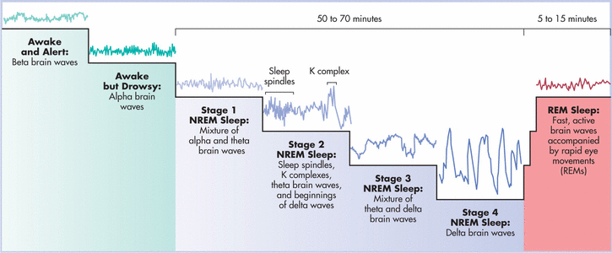

REM (rapid-eye movement)
- Dreaming sleep
- Voluntary muscle activity suppresses
- Fats brain wave activity
- Physiological arousal
- Lengthens as sleep progresses
Dream theories:
- Manifest Content: elements of a dream that are consciously experienced and remembered
- Latent Content: the unconscious thoughts, wishes, and urges that are concealed in the manifest content of a dream; its underlying meaning
- Freud: Dreams provide a psychic safety valve that discharges otherwise unacceptable feelings
We sleep to:
- Protective role in human evolution
- Brain restoration and repair of damaged neurons
- Store and rebuild memories of day’s experiences
- Promotes creative problem-solving
- Encourages growth through pituitary gland secretion of growth hormone
Sleep Deprivation:
- Fatigue
- Impairment of concentration, creativity, communication
- Can lead to obesity, hypertension, suppressed immune system
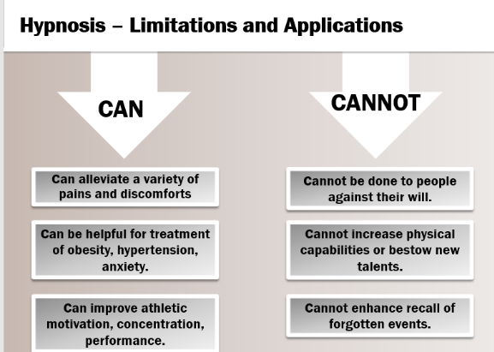
- Can lead to irritability and slowed performance
Sleep disorders:
- Insomnia
- Narcolepsy
- Sleep apnea
- Night terrors
- Sleepwalking
Depressants: reduces neural activity and slows body functions
- Alcohol
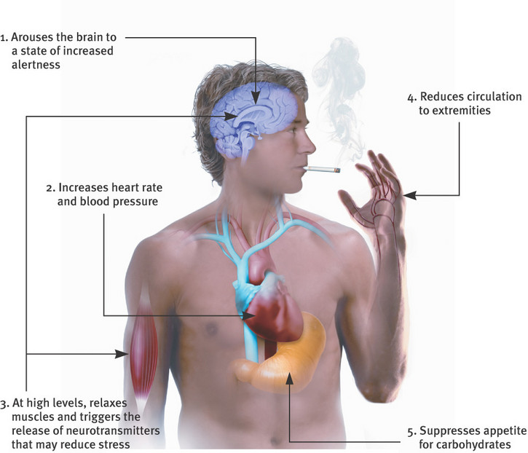
- Barbiturates
- Inhalants
- Tranquilizers
Stimulants: excite neural activity and speed body functions
- Caffeine
- Nicotine
- amphetamines
- methamphetamines
- cocaine
Opiates: depress neural activity, relieve pains, produces feelings of euphoria
- opium
- morphine
- heroin
- methadone
- prescription painkillers
Psychedelics: distort perceptions, alters mood and thinking
- marijuana
- LSD
- Mescaline
Club drugs: synthetic stimulants/ hallucinogens used at dance clubs, parties, and raves
- Ecstasy (MDMA)
- Dissociative anesthetics (PCP, ketamine)

