Personal Belief System
Watch iTonya
September 17, 2018
3:04 PM

What you need to know
- Your belief system is based on your expectations
  - Expectations of:
    - Your athletes
      - Are they all the same?
      - Are they all different?
      - Do you like some more than others?
      - Do you treat them all equally? (equitable support)
      - Do they all have the same potential? (what does potential mean?)
      - Do they all have the same goals?
    - Yourself
      - What type of coach are you? (depends on group)
      - How do you define success?
      - Is winning important to you? (winning = success??)
        - What's important for the individual? What are their goals?
      - How do you treat your athletes?
      - Are you a role model? Always in a leadership role
      - How important is sport in your life? Career or part time?
    - 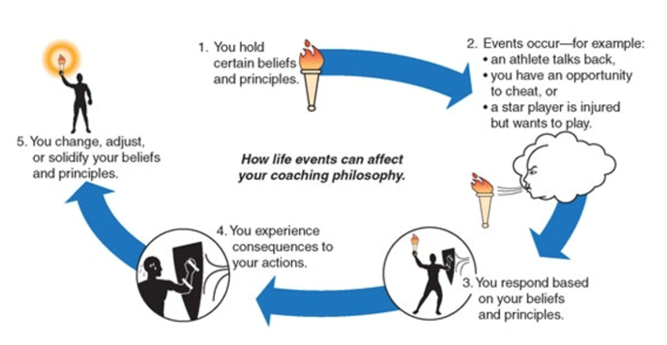
      - Coaching philosophies are organic -- they ebb and flow with events as you change and reconsider your non-negotiables
    - Others -- staff/parents/officials/admin
      - How do you treat the others?
        - You're always on stage: someone will witness it

If philosophy (non-negotiables) is at odds with:
- Other coaches: get rid of them
- Officials/administrators: don’t do anything (ref has final say)
- Parents/athletes: you go or they go

Questions to consider
- What makes a good coach?
- Have you had an excellent coach and why were they great based on class discussion?
- Have you had a really bad coach and why were they bad based on class discussion?

Do you know what you are/would like to be, as a coach?
- Reflect regularly
- Have you every been evaluated?
- What did you do with feedback in the past?
- What will you do with the feedback in the future?

Awareness
- Comes from experiences
- Process of all improvement and growth
- Transforms vagueness into specific action
  - Being aware of buttons and boundaries
- Positive or negative
- Physical, mental, and emotional
  - Physical: easier to see -- instant feedback and with appropriate can be correct for sport success
- We all have a dark side
- Mental and emotional is difficult to observe
  - Develop defense mechanisms
  - Identify more closely with our minds and emotions than with out bodies
  - Recognizing that emotional and mental feedback is harder to take than physical feedback
- Mental and emotional awareness leads to disillusion, humility, and compassion and freedom
- 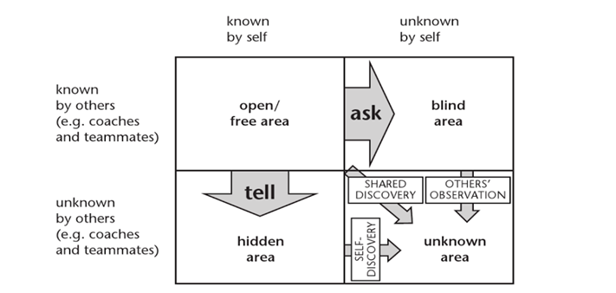
  - Self-awareness
    - Public self
    - Private self: sometimes share but not always
    - Blind self: not known to the self, but sometimes is observed by others
      - Anger, envy, selfishness
      - Ask for feedback
    - Unknown area: discover this area
      - Take feedback, resolve issues with others after conflict
  - The quadrants expand and shrink in relation to each other depending on what is going on in your life
    - The coach or player gains more knowledge about themselves through:
      - Experience
      - Observation
      - Feedback
      - Communication
      - Self-reflection
  - To operate more effectively and productively people need to develop their open area -- public area
    - Communication is good
    - Trust
    - Openness
  - Knowing yourself can shrink the unknown -- blind area and expand the private area you choose to keep private and are aware of it
- Knowing yourself is the beginning of all wisdom
  - Myers-briggs type inventory
    - Provides common cultural language about individual differences and relationship dynamics
    - Better understanding of strengths and how to apply them
    - To build more positive relationship with others
    - Improve self-understanding and working relationships
      - What does each athlete need in terms of instructions and feedback
        - More info? Brief signal and encouragement?
- Enhanced meaning within a sport contex creates value based coaching
  - Coaches and athletes are part of an organiziation

Selfish vs selfless
Selfishness: bad when they start to blame others for their shortcomings
- They have excuses for every fault
- Not excited for their teammates success even in individual sports
- Love the lime light of being on a team but they don’t want to put any work into it
- The know-it-alls
- Tired and busy all the time, not there to support their teammates
- The ones that don’t have time for their teammates, they just happen to be someone on the team
Selflessness
- Best for the team rather than the individual
- Give yourself over to the team and play your part
To create a selfless culture within your athletes
- Requires you to be mindful of everything:
  - You say
  - You think
  - You do
  - You expect
  - Practice what you preach
- We are all connect, any energy sent out of your body, as coach, will be received and imprinted on your athletes

Consider nonverbal communication
- Facial expression, arm waving
- Space and proximity (in your face)
  - Some people need more space
- Posture: slouching vs super erect
  - Too relaxed or too straight up
- Touch
  - Touchy subject: when its appropriate
- Articulation: speed and space between words
- Silence
  - Can be deafening
- Movement: quickness and direction of movements
- Image and appearance
  - Present yourself a certain way

Anger
- How you react is something you need to be cognizant of
- Part of our blind spot
- It’s a defense mechanism
- Not appropriate as a coach to be angry
- Ego trigger: its something about yourself, not someone else or the environment
- Own your anger: take a breath
  - Breathing is not balanced: difficult to be angry if breathing properly
  - Anger breathing: weak inhalation and forceful exhalation
  - Fear breathing: very little
- Psychologically: anger is an attack
  - Adrenalin
- What if you are?
  - Its fear based
    - You can never blame someone else for your anger
    - You decide how you're going to react
      - Denying this is to let others control your life
  - It’s a natural response, but how you react is your choice
    - Have a strategy so that you don’t end up acting out
- What to do if angry
  - Step back
  - Count to 10
  - Ask why am I triggered?
  - Let it go
  - Respond in peace or say you are absolutely right
  - As yourself:
    - Am I sure this is important?
    - Does this serve me or others well?
    - Will this help the situation?
    - Will this bring me/others joy?
- If someone is angry at you
  - They are being themselves and operating out of their own fears
  - Its their issues
    - You just happen to be standing in the way
  - It has nothing to do with you
  - Support them if appropriate
    - Listen/acknowledge/validate/appreciate their circumstances
- Avoiding anger
  - Its part of growth and awareness
  - The Four Agreements by Don Ruiz
    - Be the best you can be
    - Never make assumptions
    - Never take things personally
    - Be as good as your word
  - Take it as an opportunity to evaluate the vision
    - Is it a negotiable or a nonnegotiable? How important is it? Is it benefitting anyone by holding onto it?
    - Is it black and white or it more grey?

Winning/losing vs personal growth
- What is winning to you?
  - Cannot be the only goal
- Outcome vs process
  - Is it the destination or the journey
  - Developing athletes or Olympic athletes?
- What do you take away after a win?
  - Builds confidence
  - Motivates training
  - Validation for the coach: what we're doing is working
- What do you take away after a win?
  - Team is deflated
  - Need to work harder or change the strategy or it was just the luck or the draw and the other team was better
  - How do you coach a losing a team?
  - Team rules and consequences
    - Who makes them? Team? Coach? Together?
    - Are the nonnegotiable?
    - Who judges them?
      - Judgement can be egocentric

6 R's: have a plan after a win or a lose
- Recognize: this is part of the experience
- Release: anger/tension
- Relax: take a breath and accept
- Replay: learn from all the experiences
- Refocus: covert the learning into strategy
- Ready: apply learning strategy

Code of Conduct
- Develop
- Balance play time
- Practice being positive and patient
  - Don’t allow your feelings to cloud the situation
  - Role model

When should coaches be role models?
- Coaching style
  - Driver
  - Analytical
  - Expressive
  - Amiable

