Chapter 1:
The Scientific Method

SCIENCE: A coherent body of knowledge related to certain categories of facts, objects or phenomena obeying laws that are through experimental methods.
- Scientific inquiry aims to acquire new knowledge
- Two approaches:
  - Description (ex. describing nature)
- Describing nature
- May make generalizations
  - Hypothesis-based (ex. explaining nature)
- explaining nature

Inductive Approach
- look at fact and then make generalization
- linked to a descriptive-based approach
- Making a generalization often based on numerous specific observations
  - many observations to make a generalization
- particulargeneral
- Problems: may be false, no facts
- Might be right but it could be wrong, if you stop at generalization you could be wrong

Deductive Approach
- State hypothesizes and then after experimenting drawing conclusions
- Need to verify by experimentation, need to test hypothesizes (verification)
- generalparticular

- Both include:
-observation and statement
-but you need to go through with hypothesizes testing

Scientific Process
- Observation
- Question
- Hypothesis
  - statement about nature (need to test and retest) -> if you can get the same results over and over and you cannot falsify hypothesizes could become a fact
  - can be falsified or not falsified (theories)
- Prediction
  - Doing this will cause this
- Make experiment that is reproducible
- Test: to falsify or not falsify hypothesis
  - if hypothesis is falsified you need to rephrase your hypothesis and retest or falsify it
  - goal is always to prove hypothesis wrong

Clauses:
- Initial skepticism
  - ask questions and retest things that have already been found
  - hypothesize tangible and real things

- Realism
  - Filling empty space with ideas you have thought of before
  - In science, you need to think of the real world only -> no preconceived ideas that will taint the way you see science

- Rationality
  - process of explaining, result of coherent steps
  - Parsimony-> most simple explanation. in science we like simplicity, want to try to get most simple reasoning

- Methodological materialism
  - cannot explain supernatural, only that which is experimentally accessible in the real world

Examples of scientific process:
Case Studies
Mimicry
- Grouping of monarch butterflies that breed in north America
- Milk weed pollinators
  - Milk weed pollutant transfers to monarch and makes it toxic to predators
- Birds may eat them -> i.e. blue jay -> but then it will puke it up later
- Warning color -> I’m toxic, don’t eat me
- Batesian mimicry
  - Some species evolve colour that matches colour of toxic species
- Some scientist retested
  - Took wings off butterfly monarch butterfly and gave it to birds
  - Gave viceroy (non-toxic butterfly that looks almost the same as the monarch) to birds and they also spit it out
    - Might go on plants that are toxic, or may not
  - Scientists discovered that viceroy was as unpalatable to blue jay as monarch
    - Mullerian mimicry
      - Suggests that species that are toxic often tend to look alike to send a stronger sign of signal to possible predators
      - Stronger message of toxicity to predators
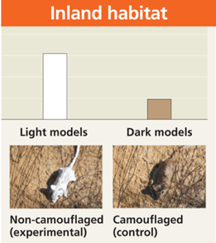
  - need to retest! May be accepted as scientific truth but have to retest to ensure that hypothesis explanation has not changed
Camouflage
- mouse mimics colour of its environment
- cream on beach, brown on island
- suggests that they camouflage in their environment
- Hypothesis: In this species, fur colouration patterns has evolved as
camouflage in their native environments.
- Prediction if mice have a coloration that does not match their habitat
then they will be preyed on more heavily than the native, well-matched mice.
- Test:
  - plasticine mice sprayed-painted in beach or inland colours.
  - Spread both control and experimental models in equal numbers in both habitats.
  - Put equal numbers in both environments of each colour
  - Count signs of attacks
- Outcome: beach -> darker models attacked more
Inland -> lighter models attacked more
- Showed that camouflage is a way of protecting oneself
- Other experimental factors:
  - Experimental
    - Variables: factors that vary in the experiment (coloured mice in beach for ie)
    - Controls: factor you can compare variables to
  - Variables
    - Independent factor manipulated by researchers
    - Dependent: factor measured in the experiment

Introduction of fish in Gatineau Park
- The introduction of species has an impact on fish biodiversity.
- In Canada, the « value » of a lake is often linked with the quality of recreational fishing.
- The introduction of species for recreational fishing are frequent to enhance the « value » of a lake.
- Fish species for recreational fishing are often piscivores (fish eating other fish) has an impact on biodiversity (they prey on other fish species, usually smaller)
- The impacts of piscivorous fish introductions on indigenous species have been the subject of few studies.
- Gatineau Park has dozens of small lakes where species were introduced for recreational fishing.

- Study:
- Observation: Small lakes in which recreational fishing species (piscivores) have been introduced do not have schools of small fish near shore.
  - Why in some lakes you have lots of fish and why in other lakes there are few or no fish
  - Trout were fished out so they introduced piscivores
    - In 20 lakes
    - But there were prob about 25 lakes that didn’t have piscavores
- Hypothesis: introduction of piscivore fish species in small lakes would result in a decline in the numbers of smaller species.
  - Piscavores will probably attack small species

- Prediction: in small lakes from the same region, if lakes contain introduced piscivorous species then they will have fewer smaller fish species than lakes without the piscivores.
- Testing the prediction: determine the number of fish species in both types of lakes.
  - Establish a sampling protocol, Identify fish, Number of individuals of each species, Same protocol for all lakes
  - No piscavore species in small lakes
  - At least 25 lakes did not have them

- Testing the prediction:
  - A comparative analysis of fish species diversity in a region with small lakes with and without introduced piscivores.
- Results:
  - Lakes without introduced piscivorous fish species have significantly more (50%) small-sized fish species than lakes where they were introduced
- Recommendation:
  - No piscivorous species introduction in Gatineau Park lakes to preserve the park’s biodiversity
- If you introduced piscavorous fish in small lakes you’ll wipe out most of the small fish species in that lake
- Could use streams as refutation
  - Not abundant

Conclusion
  - In this chapter, we have established the definition of science and the validity of the scientific method/process.
  - A valid scientific process needs to respect the clauses of the contract between the acquisition of knowledge and science.
  - Breaking one of the clauses invalidates the contract because the acquisition of knowledge does not correspond to an objective search for the scientific truth (which we can never say we have attained). Thus, the knowledge acquisition process in this instance is faulty and corrupted.
  - If you break one of the clauses you aren’t doing science

Chapter 2:
Evolutionary Thinking Before Darwin

- Page 492-495 in textbook
- Associate names with era and concept

Transformism in Antiquity
- Anaximander (610-546 BCE )
  - First philosopher to write his thoughts.
  - Water is the central element of this universe; life comes from water and humans hatched directly from fish to invade the earthly work
    - Thought everything came from water
  - “Animals are born from the sea, by solar heat on water. They were first wrapped in spiny bark...as they aged, they migrated on the mainland. When the bark burst, they survived briefly in their new lifestyle.”
    - Thus, humans originated from fishes that attempted to invade the mainland -> all living things that live on land came from water, came from sea then Shell broke then lived on land
  - Thought humans grew from fish
  - Transformation of being

- Empedocles (483-423)
- Matter is composed of four elements (water, earth, fire and air) and that love and hate act on these elements to form living things
  - Love: elements join: leads to random assembling of parts
  - Hate: monstrous beings disappear quickly
- Interaction of love and hate on 4 elements created organisms
    - Which became living beings
  - All structures of the world (matter) are made of four elements: Earth, water, air, fire. These elements are simple, eternal and unalterable
  - Random process, sandwich of these elements that created an organism

- Democritus (460-360)
  - Realties in universe are Atoms and emptiness
    - Perceived matter as an ensemble of moving atoms
    - These atoms could not be created or destroyed (atomic theory)
  - The most “scientific” of the Greek philosophers.
  - There is an intrinsic property, a force of atoms that creates shapes.
  - Humans and animals are born directly from dirt (spontaneous generation).
  - If you split any object in two over and over you should have two particles glued to one another -> atoms (permanent, smallest devisable unit)
    - Needed space for these elements to assemble w one another
  - Force that makes atoms assemble would be a force within the atoms itself

Conclusions
- Acts of creation are not due to gods but rather due to the innovative power of matter.
- The origin of all things is not teleological (with an ultimate goal), but is the result of chance or of an irrational need.

    - Forming a human isn’t for a reason, random process, irrational need, nothing directed here
    - Look at origin of life from material things

Classical Thinkers
- Socrates (469-399 A.D.)
  - Contemplation of soul
  - Variation of forms is not important, it is only the ideal form which is of value
    - Quest for beauty, wisdom, justice and sanctity
  - Nature was full of imperfections nature of justice was more important
  - Try to find within self what is important
  - The answers are not found in nature but within the self.

- Plato (427-347 A.D.)
- Theories of Ideal Forms (essentialism)
  - Essentialism: the view that every entity has a set of attributes that are necessary to its identity and function.
  - visible, imperfect and changing realm which surrounds us is a poor imitation of an:
    - Ideal World: permanent and perfect view of the world that we possess at birth: the world of Ideal Form
- Quest for essence of things
  - 2000 years -> nature is not perfect
  - god created everything, it’s our mission to find ideal forms
- modified the concept of spontaneous generation by adding the action of an external creative force

- Aristotle (384-322)
  - Does not believe in the innate world of Ideal Forms; first to look at hierarchy of souls in living beings
  - Observer: Important to describe the essence of living beings
    - this essence can be observed in nature.
  - Anti-evolution: species are static
    - Thus, morphological variability is illusion and imperfection.
  - Vitalist
    - Believed living beings had a soul
    - Hierarchy of soul
    - First attempt of organizing nature in some sort of fashion
      - Hierarchy of Soul:
- vegetal soul: ability to grow and reproduce
- animated soul: capacity to move around, grow and reproduce
- rational soul: only one species capable of thinking -> humans
  - Created the scala naturae: species are depicted in a static and unchangeable hierarchy.
  - Look at nature and define essence of things
  - Thought you can look at nature and define the essence
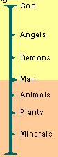
    - i.e what is essence of a cat?
  - Scale of being: --------------------------------------

The Impact of Christianism
- With the decline of the Roman empire, Christianity
becomes the main ideology in the western world
- Dark age for tranformism (evolutionary thought)
- God becomes the measure of all things
- The concept the great chain of beings became institutionalized in western thinking
  - Great chain of being -> god is on the top
  - God became the measure of all things
  - Could not be questioned
  - New species would just be “put on a shelf”
    - Order was set
From Fixity of Species to Transformism
- Religion was progressively challenged
- Free thought become more important
- Renaissance in Europe (14th to 17th century):
  - Back to nature (great expeditions + discoveries)
  - Power of religion is progressively challenged
- French Revolution (end of the 18th century)
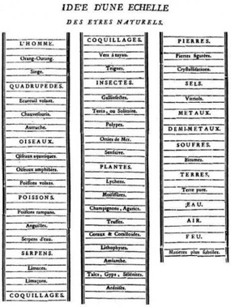
  - Challenge of ordered systems (monarchy) for an active pursuit of progress.
  - More open-mindedness towards science.
  - Industrial revolution
  - Quest for order -> quest for progress
    - New ideas had to be discussed
  - Realized earth could be older than they thought
Linnaeus (1707-1778)
- Created the binomial nomenclature system, and classified animals
According to a hierarchical classification system
- gave us our classification system
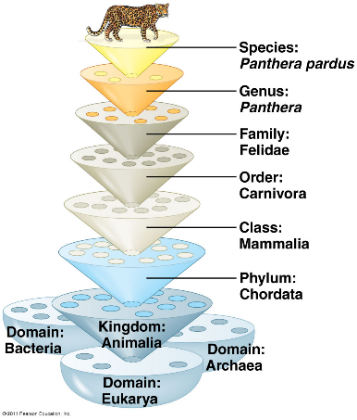
  - Hierarchical classification
  - Binomial system of nomenclature (e.g. Homo sapiens).

Buffon (1707-1788)
- Objective is to describe nature and the world
- Published 44 volumes on the subject
- Believes in form of evolution but had to retract because of religious countership
- Alluded to the notion of common ancestry
- In 1751 there were many censored parts in his writing because of conflicts with religion
  - So he stopped writing to avoid conflict
    - Which helped him in the long run because he then had a very successful career
- Best articulated theory of his time

William Paley (1743-1805)
- The father of the theology of nature and I believe that harmony in nature is the proof of the existence of god

Lamarck (1774-1829)
- Physical traits that your parents have obtained during their lives will be handed down from generation to generation. I have created the principle of use and non-use and the inheritance of characters
- First evolutionist species modify their morphology through time
- Uses the environment as a factor of change environmental determinism
  - And individual can actually evolve
- 2 principles (affects individuals):
  - Principle of use or disuse
    - During the lifetime of an individual sometimes will use the organ more and it will get stronger or it may not use the organ and it may get smaller or disappear
  - Principle of inheritance of acquired characteristics
    - The feature you develop could be transferred into the next generation
    - i.e giraffe if giraffe uses its neck to reach a high tree the neck may grow and then this longer neck will transfer to future generations
    - i.e tennis Player they have asymmetry (serving side is longer than other side of body) thus this asymmetry in morphology would be passed on to their kids
      - clearly doesn’t work this way
    - morphologic features are not transferred from one generation to the next
      - only ever be very minor small changes in DNA
    - morphologic characteristics are not passed on from generation to generation
    - example: bonsai tree (8:49)
      - if the bonsai tree were to produce trees
    - mixture of genetic material comes from parents, not changed during lifetime
- Spontaneous generation explains the presence of simple organisms
  - They gradually progress from simple to more complex transformism
- Theory not well received by his peers because:
  - it contradicted the religious view of the creation of life
  - He couldn’t really test it
- Environmental determinism environment determines everything
  - Idea is testable in the sense you can verify in various areas and see if the environment and climate conditions are similar you would have the same species in the same environments

Cuvier (1769-1832)
- Developed the concept of the correlation of organ and the basic concept of paleontology
  - The older the stratum, the more dissimilar its fossils were to current species
  - From one layer to the next, species appear and disappear
  - Deeper you go in start to the simpler the fossil
- From a few bones he could reconstruct the animal
  - From looking at a bone he could describe function and place
  - Hints in bone that tells animal and function
    - Shape: ie carnivore jaw
      - Jaw bone attaches to cranium
      - Creates scissor movement that allows carnivores to chew food and cut meat
      - Jaw joint: locks jaw so it can only go up and down not side to side
      - If you look at structures you can probably construct animal
    - Herbivore jaw
      - Want to chew plants enough to breakdown cell
      - High jaw joint so all teeth touch each other at the same time
      - Have a plate that attaches to cranium so jaw can move in all direction
    - Our jaw
      - Clearly our primates were herbivores
      - No scissor movements
      - Jaw pattern of a herbivore
      - Humans a long while ago decided to eat meat but that doesn’t mean our jaw needed to change
  - Believed in fixity of species so developed concepts in accordance to this:
    - Catastrophism
      - Why do you find mammals deep in the strata but never near the surface?
      - 9:05 Every time a new creation was created the old one disappeared
      - that’s why more complex species were higher up in the stratum
    - Progressionism
      - improved creation every time a catastrophe occurred
  - modified the concept of the great chain of beings

Hutton (1728-1797) and Lyell (1797-1875)
- Hutton
  - Geological changes are the result of a slow, gradual and continuous process
  - Thought earth was older than the believed 6000 years
    - i.e degrading rock face, to rocks, to sand, etc.
  - 9:10
  - Geological changes are the result of a slow, gradual and continuous process.
  - Principle of uniformity (uniformitarianism):
    - The laws of nature are not affected by the passage of time.
    - “the present is the key to the past”
    - what you observe today can help articulate the past
    - well-articulated in the work of Lyell
  - Vision of the world: “with respect to human observation, this world has neither a beginning nor an end”.
    - Processes are occurring and reoccurring always
    - One notion it needed: time

- Lyell
  - is the first to establish geology as a scientific discipline

  - I.e hoodoos
    - Process of erosion
    - Takes 100s if not 1000s of years
    - Specific erosion factors
    - Something that can be viewed during our lifetime can help describe what has happened in the past

Chapter 3:
Charles Darwin and Evolution

Charles Darwin: Education and Family
- Stops his studies in medicine and takes a more serious interest in religion
  - Prerequisite to become a pastor: Bachelor of Arts (CambridgeU)
- Developed an interest in nature: taxidermy, insect collecting, botany, etc.

The Voyage on the Beagle
- In 1831, he leaves on the Beagle to do the cartography of the coast of South America
- Darwin was invited on board
  - as a companion of the captain Fitzroy
    - to be able to discuss things at dinner and such to keep his sanity
  - but quickly became the naturalist of the voyage
    - did a crash course in geology
- He travels the world and spends most of his time on land to sample the fauna and flora and to study South-American geology.
  - Went from city to city doing in land expeditions
  - Collected samples and species
  - He’d mark them
  - Put specimens in barrels of rum to preserve
- The trip is planned for two years, lasted five years.
- Came back and wrote a book on the story of his travels

- During the voyage, two books had an impact on Darwin
  - William Paley (1743-1805): “Theology, or evidences of the existence and attributes of the deity”.
    - Paley is the father of the Theology of Nature. This theology advocated that harmony and design in nature are indicators of the existence and the acts of God (today = intelligent design)
    - Took examples in this book to test his own theories of evolution
  - Charles Lyell: “Principles of Geology”.
    - Believed in catastrophism and believed in Cuvier
    - Darwin began his expedition thinking like a good protestant: believing in the Great Flood and in Cuvier’s catastrophism.
    - When he returned five years later, he was in total agreement with Lyell and Hutton’s principle of uniformity
  - He travelled from England to all around
    - He touched all the continents
    - Was able to see the differences between all the continents and able to remark on their differences
    - When in Chile there was an earthquake
      - Realized the coast line had changed after the earthquake
      - Needed to recartigraph the island
      - If one earthquake does this imagine what 1000 earthquakes would do
      - Things aren’t that stable or certain
    - Saw that the fauna of South America was really different
      - Why did god create different faunas on different continents?
      - Why do the fauna and flora of Africa, Europe, Australia and South America have relatively few species in common?
      - Why are the animals and plants of the temperate zones of South America resemble the species living in the tropical zones of South America but not the species in temperate Europe?
      - Why are the mammal fossils of South America absent from the current fauna (e.g. Giant Sloth)? Why do these fossils show resemblance with current species found only in South America (e.g. Three-toed Sloth)?
        - No fossil of giant sloth in Africa
      - Discovered fossil of giant sloth: why is this fossil only found in south America?
    - Fauna on the Galápagos Islands surprises Darwin.
      - The fauna on the Islands is unique. Why?
      - Why does it show resemblance with species on the American continent?
      - All the islands had turtle with lots of shell variability
        - Didn’t match with Lamark’s view that environment affects everything
      - Finches
        - The birds had the same bodies but different beaks
        - Beaks had adapted to different ways of life
        - Why did every island have different species?

Evolution and Natural Selection
- If species look alike it’s probably because they share a common ancestor, not because of the environment
  - Why finches look alike but have different beaks
    - Why same species on different island?
      - Maybe wind storm carries birds over
  - Same with turtle shells
- In 1837, we find in Darwin's notes the first mention that species show resemblance to each other because they share a common ancestor (not a common environment):
  - Rejects the fixity of species and accepts the concept of descent with modifications (evolution).
    - Associates evolution with human change
  - Very materialistic view of life that is in contradiction to the religious dogma of the time.
  - Rejects Lamarck’s evolutionary mechanism (environmental determinism)
- Then, he begins the search for an evolutionary mechanism.
- Took him 20 years to publish his book
  - Wanted to test his theory and make sure it was right because it was so controversial
  - Interested in his other Works more
  - Clearly pushing his theory was something highly controversial and he did not like to debate
- Pattern: observe: look alike because common ancestor
  - 9:40
  - able to define relationship among finches comes down to a common ancestor
  - way to define order in nature
- importance of fossils
  - key to understand evolutionary pattern
  - clearly difference between species

Evolution and Natural Selection
- believed in common ancestry
- rejected that they look alike bc they share a common environment
- against religious dogma
  - planet was older than 6000 years old
  - species can change throughout time
- Rejects the fixity (no change) of species and accepts the concept of descent with modifications (evolution).
- Very materialistic view of life that is in contradiction to the religious dogma of the time.
- Rejects Lamarck’s evolutionary mechanism (environmental determinism)

- Species resemble each other because they share a common ancestry
- Darwin wanted to explain gaps in morphology
  - Since these groups are old, many of these species are extinct
  - Most of the evolutionary branches finish in a dead-end (extinction).
  - According to Darwin these gaps are filled by fossils filling morphological gaps
  - Fossils provided the gaps for missing links explained and confirmed patterns

- Darwin read Malthus’s book
  - Every human population has a tendency to increase geometrically whereas the available resources to feed these populations increase arithmetically
  - Malthus thought there was a crisis point: The human population increases faster than its capacity to feed itself. This leads to chaos (famine, sickness, war, etc.) and eventually to a substantial reduction in population size.
  - Winners and losers concept
    - Winners could get food to secure family
    - Losers could not
    - Struck Darwin as a principle he could apply to what he saw in nature
  - Darwin’s observations
- All species can produce more offspring than their environment can sustain and many of these offspring fail to survive and reproduce
- i.e puffball mushroom ruptures and millions of spores come out, spores can become mushrooms, but not all spores become mushrooms
- Members of a population often vary in their inherited traits
  - Characteristics pass from parents to kids genetic basis
  - Genetic variable was not rejected, instead genetic variability was seen as the key
  - He elaborated his theory of natural selection
    - Two inferences:
      - Individuals whose inherited traits gives them a higher probability of surviving and reproducing in a given environment tend to leave more offspring than other individuals
      - From generation to generation, this unequal capacity of survive and reproduce (differential reproductive success) results in an accumulation of favourable traits in a population
    - This is natural selection It enables the emergence of adaptations
      - Only evolutionary process that creates adaptation
      - INHERITED TRAITS THAT PASS DOWN FROM GENERATION TO GENERATION
      - i.e fish population with many coloured fish (red, blue, pink, orange) on red environment for example
        - fish that stand out more in environment would get eaten first
        - fish that blend in will reproduce and then there would be more red fish in the environment
        - being red would be an adaptation
        - trait will become more abundant
        - change in environment: blue environment
          - red would get attacked
          - higher proportion of blue fish
          - depends on selective pressure of the environment

  - Darwin receives long letter from Wallace
    - Shares natural selection
    - On the same day, in 1858, Darwin and Wallace presented a resume of their ideas on natural selection to the Linnean Society of London.
    - In 1859, Darwin publishes the first edition of his book “On the Origin of Species” The book became an instant bestseller and created great controversy
      - Most important book in natural history
      - Knew nothing about genes but provided lots of examples of common ancestry
      - Obeys four clauses in great fashion
      - Doesn’t need to involve god or supernatural forces to explain
    - The 6th and last edition of his book, published in 1872, contains a chapter dedicated to the most important arguments against his theory. Most of these arguments came from his creationist colleagues.
  - Important notions linked with natural selection
    - Individuals do not evolve, populations evolve
      - Measureable at population level
    - Only hereditary traits are subject to natural selection
      - Traits with no genetic basis can’t evolve
    - For evolution to occur, we need genetic variability
      - 10:32
    - Natural selection corresponds to differential reproductive success within a population from generation to generation
      - Only measure of fittest is your ability to transfer genes to the next generation
    - With time, natural selection enables individuals to become better adapted to their environment
      - Become more numerous and can reproduce
    - Environmental factors vary in time and space. Thus, the selective forces are variable
      - Space and time are important selective pressures
    - Traits in populations will change and can modify the species.

  - For Darwin this mechanism is valid because:
    - It respects the principle of uniformity of Lyell and Hutton.
    - The results of natural selection are visible in nature
      - Fit well with the principle of uniformity
    - The mechanism can be verified on current populations. (e.g. artificial selection)
    - It is a materialistic concept (no need for divine intervention):
      - The mechanism is not random Natural selection
        - enables individuals that are better adapted to their environment to become more abundant than those who are not (differential reproductive success)
      - Not a quest for perfection (evolution is not a directed process). It does not lead to the appearance of “perfect” traits. Organisms only adapt to their environment

  - Artificial selection
    - is finalized because the goal, fixed well in advance, precedes the causes
    - The end result can be obtained in a few generations

  - Natural Selection
    - is not finalized
    - It can take a long time for changes to occur (geological time scale).
    - Examples:
      - Peppered moth
        - Nocturnal
        - Grey and dark morph
        - City with Coal plants with no filter made surfaces sooty and dark
          - Dark moths become more abundant and pale moth population became lower
        - Country side with clean trees
          - Pale moths blended in better and therefor their genotype became more abundant
        - When filters were put on coal plants pale moths become more abundant and less dark moths
      - Darwin’s finches
      - Mountain guide
        - Adaptation to altitude
        - Acclimatized vs adaptation
          - Over 2 000m, the partial pressure of O₂ is insufficient for normal saturation of hemoglobin for a traveller in high altitudes.
          - Shortness of breath, altitude sickness
          - Physiological response (acclimatization) After a few days at high altitude, the body compensates the low partial pressure of O₂ by increasing the concentration of red blood cells in our blood. Serious health risks: thrombosis, pulmonary edema, etc.).
        - 1110
          - Adaptations
          - Andes
          - Increase in hemoglobin concentration (red blood cells).
          - Qinghai–Tibet Plateau
          - Deeper breath, larger pulmonary capacity and increased blood flow
          - Natural selection keeps the individuals with the genetic traits that allow adaptation to high altitude. This means that individuals that have the mutation are at an advantage for survival and reproduction (production of offsprings).
          - Larger lung capacity, higher blood flow
          - Low land source populations in asia and south America were different
          - Source population was different so adaptation was different

Conclusion
- In the three cases (moths, finches and humans), the hereditary traits that give a reproductive advantage (i.e. adaptation) to individuals in a population will be favoured.
- Thus, from generation to generation, there will be a higher percentage of individuals carrying the adaptation. This is natural selection It’s Darwin’s descent with modification. It’s evolution.
  - These adaptations can sometimes redefine a species and, in certain circumstances, define a new species.

3.4 Proof of Evolution: Homology
- Descent with modification theory (theory of evolution) explains the resemblance between certain traits even if the functions are different.
Homologous structures
- Alternative is all features have evolved independently too complicated
- i.e pharyngeal pouches is in check and human embryo
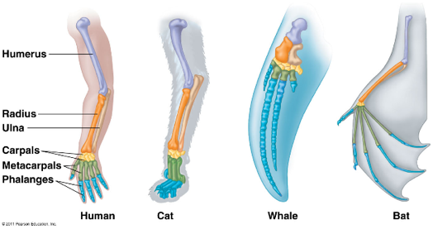
  - although present in embryo have different fates
- i.e post-anal tail
- digits homologous structure for all tetrapod’s
- think of life as a tree -> not a line
- horse evolution
  - linear thinking
    - i.e horse
    - teeth length increase
      - when moved to prairie environ they ate grass and ate grass with sand from soil so teeth adapted and become longer because of wear due to grazing
    - number of digits decreased
      - to become faster reduce mass
  - tree
    - reality is the evolution is more complex
- linear evolution is a false representation of the evolution of humans
  - share a common ancestor with chimpanzees
  - false representation of
    - size (height increases as species becomes more complex)
    - brain size (did not occur progressively but occurred a long time ago)
Proof of Evolution:
Fossils
- closest species to whales is hippo
- pakicetus example

Vestigial Structures
- Vestigial structure: anatomic structure that has lost almost all of its initial function.
- i.e pelvic girdle of whale
- examples
  - Nictitating membrane or third eyelid
    - Humans have little knob of flesh in corner of our eye
    - No real function in humans, but in human’s ancestor probably had use of protection of the eye
  - Appendix
    - Role in other species is the site of digestion of plant material
    - Storage of bacteria and microbes
    - Indication that at one point humans had a large appendix to facilitate digestions
    - We’ve now lost the need for this large pocket
    - Now not functional in humans
  - Goosebumps and hair
    - Each strand of hair has a muscle attached to it
      - Individual muscles contract when cold or they are stimulated
    - This in animals creates a layer of air between the tip of the hair and skin and this layer of air warms up and produces heat
      - How animals warm up
    - Humans lost our fur
      - Still have morphology associated with hair strands but no longer the density of fur
    - Shows Common ancestor had fur
  - Hiccups
    - Heritage from fishes and amphibians
    - Phrenic nerve (4TH cervical vertebra) attaches to diaphragm and epiglottis
    - This nerve gets pinched between two organs
      - To get rid of them you want to try to move these organs to unpinch the nerve
    - Whys the nerve so long? common ancestor with fish
      - Consequence of the fish’s respiratory system being right where nerve was attached in the front in fishes but moved down with evolution
      - Length increased the possibility of being pinched
    - Epiglottis
      - Evolved mainly in tadpoles
      - Allowed animal to actually use its gills without getting water in its lungs
  - Evolution is testable
    - Discovery of a fossil in the wrong place in the geological archives would be sufficient to refute our concept of evolution

Chapter 4:
Genetics, Neo-Darwinism and Modern Synthesis

September 24th -27th

4.1 Transmission of Traits (Inheritance): Pre-Mendel Perspectives
- Development of individuals: preformist theory until the 19th century
  - Simple view that we’re a mini person that gets nourished by the egg and we grow or sperm triggers the development of the mini person in the egg
- Accepted theory today: epigenesis
  - start from nothing transform into a being
- Theory of blending inheritance
  - universally accepted theory until the end of the 19th century.
  - Both parents participate equally in the genetic makeup of offspring.
  - For each trait the child would show an intermediate value between the traits of its parents.
    - Thus, rapidly, all individuals would become identical, or at least very similar, which is not consistent with what we observe.
    - After a few generations everybody would look alike

4.1.2 Darwin’s Pangenesis
- Theory of gemmules (hereditary particles) produced by each part of the body.
  - Travel through blood and end up in sex cells
  - Tested by putting blood of white rabbit in blood of black rabbit and seeing if the offspring showed signs of white
- When an organ is used, it grows, and the more gemmules it contains. The contrary is also applicable.
- The gemmules would be transported in the bloodstream from all parts of the body and assembled in the gametes when they are formed.
- Gemmules would be the particles associated with the transmission of heredity.
- Francis Galton’s (1822-1911) experiment refuted Darwin’s hypothesis.

4.1.3 August Weismann’s Theory (1834-1914)
- Weismann proposed that only the sex cells were responsible for heredity, whereas the rest of the organism was only a structure doomed to disappear with the death of the individual.
- Body itself was only a carrier of the sex cells
- Living beings are divided into two parts, with distinct outcomes: germline (gametes) and the soma (the remainder of the body)
  - The germline is impervious to environmental influences and heredity is simply the continuity of the germline.
  - Germline: can be modified on a population, not an individual
  - Thus, the germline and the environment can influence the phenotype, but the soma and the environment have no influence on the genotype.
    - Environment cannot change our sex cells
  - Natural selection is the only mechanism that can eventually modify the germline of a population.
- A chicken is the method by which an egg makes another egg

- Lantern fish
  - All female
    - Parasites attached to genital area of the fish males
    - They fuse to the female (lose their heart and organs and such)
    - Just keep sperm sack
    - Many males attach to female
    - Phenotype of males is pretty much gone
    - Suggests the soma of the germline are really independent

4.2 Mendelian Inheritance
  - Founder of genetics
  - Austrian monk
  - Formulated his laws on the creation of hybrids (laws of heredity) in 1866
    - Worked with peas
    - Afterwards didn’t do any science
  - His work was only recognized in 1900
  - Mendel’s work was made with exemplary scientific rigour
    - Lots of data and analysis, based on empirical evidence
  - The choice of the experimental material was judicious:
    - peas (many varieties available, possibility of crossbreeding, fairly cheap, generation time is short, descendants are plentiful. (see table 14.1)
    - genetic basis allowed him to explain his laws
  - Abundant data and the use of mathematical analysis to verify his hypotheses.
  - Mendel talks about “hereditary factors” (genes were still unknown at that time)
  - Didn’t know anything about gene or chromosomes

  - Variation of genetic traits is explained by the different shapes genes can have
    - Variability found in genes’
    - Genes on chromosomes
    - These are on a locus
    - Two pairs of chromosomes
    - Chromos form genes
  - Each gene occupies a specific locus on a given chromosome.
  - The DNA sequence of the locus can show variants (alleles).
  - For example, the alleles for white flowers and the alleles for purple flowers are situated on one of the peas' chromosome
  - All organisms inherit two copies of a gene (different or identical), one from the “father” and the other from the “mother”.
  - An individual possesses two alleles for one gene (hereditary factor)
  - 23 pairs of chromosomes in humans
  - First Law: Law of uniformity of hybrids of the first generation.
    - Dominant and recessive genes
    - Dominant is apparent in individual
      - If both alleles of a locus are different, one of them, the dominant allele determines the appearance of the organism; whereas the other, recessive allele, has no notable effect on the appearance.
      - If both hereditary factors are different, one of them, the dominant one determines the appearance of the organism; whereas the other, recessive factor, has no notable effect on the appearance.
  - Second Law: Law of segregation
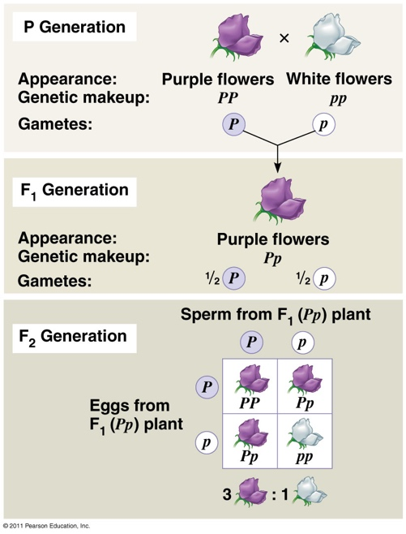
    - Two alleles for a heritable character segregate independently (separate from each other) during gamete formation and end up in different gametes. (see figure 13.7 for meiosis)
    - Only one copy of chromosomes in sex cells
    - 10:17
    - meiosis is a unique evolutionary event
    - a population may have many alleles associated with
one trait
    - and individual can only bear two alleles
    - number of alleles is an indicator of genetic variability
    - pp homozygous
    - f1 gen always made of heterozygous individuals
    - yet phenotype is identical to homozygous dominant
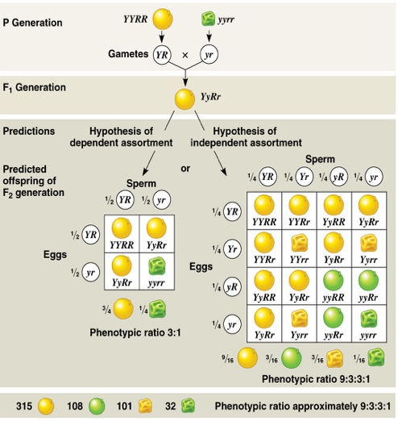
  - Understand these terms:
    - phenotype;
    - genotype
    - homozygous
    - heterozygous

  - Third Law: The law of independent assortment:
    - Every pair of allele separates independently from the other pairs when the gametes are formed
    - The character will segregate independently
    - Reality is that if two genes are situated really close to each other on a chromosome they are likely to be liked

  - i.e v shaped hair line
    - dominant will win over flat hair line
    - free ear lobes dominant
      - traits segregate independently
    - Every pair of allele separates independently of the other pairs when the gametes are formed
    - The alleles of the ear lobes and of the hairline separates independently when the gametes are formed

  - Initial Impacts of Mendel’s Theory
- Mendel’s works were resurfaced by three geneticists (Coreens, Tschermack and Hugo De vries) in early 1900s
- The discovery of Mendel’s work had, initially, a negative impact on the theory of natural selection
  - Why? The first geneticists put the emphasis on the discrete or discontinuitious aspects of the traits associated with Mendel’s ratios and rejected the continued variation observed in nature by claiming that it was non-Mendelian and without any evolutionary importance.
- Mendel’s law explained that these traits were passed down from parents to offspring
  - Explained between parents and progeny nothing to do with population like Darwin said
- Theory of mutation
  - Furthermore, Hugo de Vries (1838-1935) formulated a “Theory of Mutation” which indicated that new species can be formed in one or multiple steps (saltationism) through mutations that would cause substantial morphological modifications
  - New species can be created through mutation
  - During the 1920s, it was discovered that mutations are generally harmful or neutral and that only a few seemed to influence, although lightly, an organism traits.
  - In the case of the primrose it was just a naturally occurring chromosomal defect
    - Falsified when we learned more about genetics
    - Most mutations are neutral
    - Mutations role basically is the source of genetic variability but not a strong evolutionary motor
- The 1920s and the 1960s, genetics and the theory of natural selection were reconciled. It is the official creation of Neo- Darwinism and the “modern evolutionary synthesis”.
- The main impacts of Neo-Darwinism were:
  - Lamarckism was finally refuted
    - Not a strong evolutionary mechanism could never be provided a coherent explanation
  - We started to understand the effect of chance in the transmission of alleles from generation to generation (genetic drift)
    - Random effect can have important impact
    - Chance become and evolutionary factor
  - The genetic basis of evolutionary changes was established
    - Able to measure genetic variability
    - Number of alleles for a certain gene
  - The study of genetics shows the existence of an important and persistent variation (continuous or discrete) which creates the hereditary material on which evolution can act
    - Traits that are continuous height, skin colour, passed via parents
    - Traits are often linked to several genes
  - This continuous variation has a Mendelian basis, that is to say that it implies the segregation of hereditary particles having a minimal phenotypic effect.

  - Modern Additions to Mendel’s Laws
- Incomplete dominance
  - Dominance is not complete recessive trait still has impact on phenotype
  - Three phenotypes for two genotypes
  - i.e horses
- codominance

  - i.e black and white chicken checkered chicken (both traits visible)
- Polygenism:
  - When a phenotypic trait is under the combined action of two or multiple genes (very common)
  - Associated with continuous traits
  - About 20 genes involved in skin colour
  - Most traits that are continuous are because they are under the influence of genes
- Epistasis:
  - When the effect of a gene hides or blocks the expression of another gene.
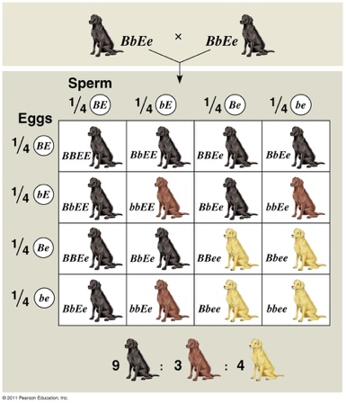
  - i.e Labradors
    - gene that makes yellow lab is an epistasis gene
    - black is dominant gene
    - chocolate will only appear in recessive
    - 10:48
- Pleiotropy:
  - When a gene influence more than one trait
  - i.e cats
    - Certain pleiotropic genes are lethal when homozygous.
    - Manx cat:
    - The Manx gene (M) shows an incomplete dominance compared to the normal gene (m) (with tail)
    - MM will not develop a vertebral column
    - The gene responsible for the lack of tail is lethal (embryo reabsorbed) when homozygous.
    - The heterozygous cat do not have tails or have short tails.

