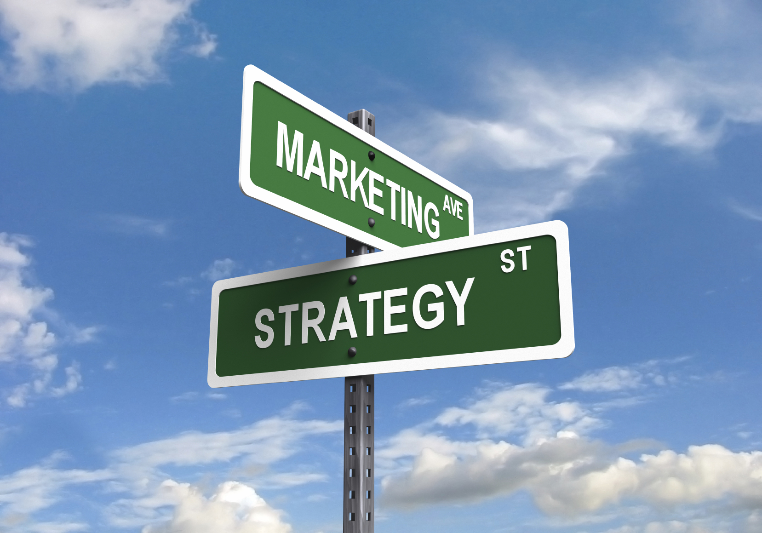
Services Marketing
ADM3322
Jordan Fitzgerald
116398223 | [Date] | [Course title]



Table of Contents
Chapter 1:
Introduction to service marketing…………………………………………………………………………..Page 3 – 7
- What is marketing?
- Challenges
- Characteristics & Categories of service
- Profit chain of service marketing
Chapter 2:
Consumer behaviour……………………………………………………………………………………………… Page 8 – 11
- Stages of service consumption
- Satisfaction vs Service quality
- The GAP model
Chapter 3:
Positioning………………………………………………………………………………………………………………Page 12 – 15
- Customer driven service marketing strategy
- Market segmentation
- Targeting service markets
- Positioning services
- Using positioning maps to analyse competitive strategy
Chapter 4:
Product……………………………………………………………………………………………………………………Page 16 – 18
- Flower of service
- Managerial implications
- Branding service products & experiences
- New service development
Chapter 5:
Place……………………………………………………………………………………………………………………….Page 19 – 22
-Distributing in a service context
-Place & Time decisions
-Delivering services in cyberspace
-The role of intermediates
Chapter 6:
Price……………………………………………………………………………………………………………………….Page 23 – 25
-The Pricing Tripod (Cost, Consumption, Value)
-Revenue management
-Ethical concerns in pricing
-Putting service pricing into practice
Chapter 7:
Promotion………………………….………………………………………………………………………………….Page 26 – 28
-Marketing Communications Planning
-Challenges of service communications
-Marketing communications mix
-Role of Corporate design
Chapter 8:
Designing service Processes…………………………………………………………………………………..Page 29 – 31
-Flowcharting service delivery
-Blueprinting
-Service process redesign
-The Customer as Co-creators
-Self-service technologies

- Introduction to service marketing
What is marketing?
A process by which companies create value for customers and build strong relationships. To capture value from customers in return.

4 P’s of marketing: 3 P’s of Service marketing:
- Product 1. People
- Price 2. Physical environment
- Promotion 3. Process
- Place

Framework for effective service marketing strategies:
- Understanding service products, customers & markets
↓↓↓
- Apply 4P’s
↓↓↓
- Design & Manage the customer interface
↓↓↓
- Developing customer relationships
↓↓↓
- Strive for service excellence
Services dominate most economies and are growing rapidly.
→ They account for >60% of GDP worldwide.
→ Most new employment coming from service sectors
→ Strongest growth area for marketing
Global GDP;
→ Services = 63%
→ Manufacturing = 31%
→ Agriculture = 6%
Estimated size of service sector in selected countries;
High reliance on services – Hong Kong (93%) , Bahamas (91%), Bermuda (94%), Jersey (96%)
Average reliance on services – UK (79%), Canada (70%), France (79%), Germany (74%), Japan (73%)
Low reliance on services – China (46%), Saudi Arabia (36%), Thailand (44%)
Powerful forces transforming service markets:
New markets + product categories.
Increase in demand for services
More intense competition
- Government polices
- Social changes
- Business trends →
- Advances in IT
- Globalisation

What drives success?
- Understanding customers + competition
- Viable business models
- Creation of value for customers + firm
- Increased focus on service marketing + management

What are services?
Services involve a form of rental, offering benefits without transferring ownership.
Services are economic activities offered by one party to another. They normally do not take ownership of any of the physical elements. Most commonly employ time-based performances to bring about desired results.

5 categories within non-ownership framework:
- Labour, skills & expertise (Hairdresser, Doctor)
- Rental goods services (Car rental)
- Defined space & facility rental (Aeroplane seat)
- Access to shared physical environment (Concert, Festival)
- Access to usage of systems + networks (Wifi, TV)
In exchange for their money time and effort service customers expect to obtain value (benefits) from
- Access to goods
- Labour
- Facilities
- Environments
- Professional skills
- Networks/Systems

Tangible vs Intangible (Challenge 1):

Salt
CD Player
Golf Clubs
Physical New Car
Elements
Plumbing Repair
Life assurance
Internet banking

Intangible elements

Difference, Implications & Market related tasks (Challenge 2):
Differences | Implications | Market related tasks
Most services cannot be inventoried | Customers may be turned away | Use pricing, promotion, reservations to smooth demand
Intangible elements usually dominate value creation | Harder to evaluate service + distinguish from competitors | Emphasise physical clues, employ metaphors and vivid images
Services often difficult to visualise + understand | Greater risk + uncertainty perceived | Educate customers on making good choices
People may be part of service experience | Behaviour of service personnel + customer can affect satisfaction | Recruit, train employees to reinforce service concept
Time factor | Time is money | Compete on speed of delivery
Distribution may take place through non-physical channels | Electronic channels | Create user friendly service website

Characteristics of a service (IHIP):
- Intangibility: Services cannot be seen, tasted, felt, heard or smelled before purchase
- Heterogeneity / Variability: Quality of services depends on who provides them and when where and how
- Inseparability: Services cannot be separated from their providers. Production + consumption occurs simultaneously.
- Perishability: Services cannot be stored for later sale or use. Most services cannot be inventoried.
Categories of services:
People | ←Tangible Assets→  ←Intangible Assets→ | Processes
People Processing: | ←Tangible Assets→  ←Intangible Assets→ | Possession processing:
Services on people’s bodies  - Hairdresser  - Health care  - Transport | ←Tangible Assets→  ←Intangible Assets→ | Services aimed at possessions  - Laundry + Dry cleaning  - Repair + Maintenance
Mental Stimulus processing: | ←Tangible Assets→  ←Intangible Assets→ | Information processing:
Services aimed at people’s minds  - Education  - Advertising PR  - Psychotherapy | ←Tangible Assets→  ←Intangible Assets→ | Services aimed at intangible assets  - Accounting  - Banking  - Legal services

Integration of marketing within other management functions:
- Operations: Involved in design of products + processes.
Implementation of programs for improving productivity + quality.
- Human Resource: Responsible for quality front line service providers.
- Information technology: Provides real-time information at every customer touch-point to create value within updated customer data.

Service Profit Chain:
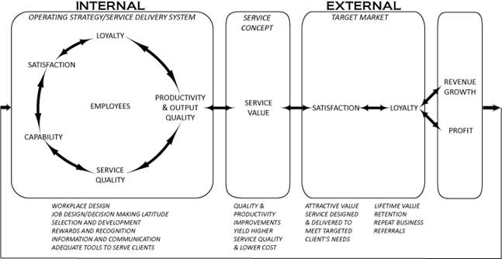

- Consumer Behaviour
3 Stages of Service Consumption:
- Pre-purchase stage:
- Need Awareness → A service purchase is triggered by an underlying need (arousal)
Needs may be due to; (1) Peoples unconscious minds (Aspirations)
(2) Physical conditions (Back pain)
(3) External sources (Marketing activities)
- Information search → When a need is recognised, people search for solutions.
Several alternatives may come to mind, and these form the ‘Evoked set’
The evoked set is a set of possible services or brands that a customer may
consider in decision making process.
- Evaluation of alternatives → (1) Search attributes – helps customers evaluate a product before
purchase (Style, colour, texture)
(2) Experience attributes – cannot be evaluated before purchase
(Vacations, sporting events, medical procedures)
(3) Credence attributes – are product characteristics that
consumers find impossible to evaluate confidently ever
after purchase + consumption (Quality of repair)
→ Types of risk considered;
Functional – unsatisfactory performance outcomes
Financial – monetary loss, unexpected costs
Temporal – wasting time, consequent of delays
Physical – personal injury or damage to possessions
Phycological – personal fears + emotions
Social – how others think + react
Sensory – unwanted effects on 5 senses
→ Service Expectations considered;
Customers evaluate service quality by comparing what they expect against what they perceive.
Situational + personal factors are considered
Expectations of good service vary from one business to another, and differently positioned service providers in same industry.
* Desired service level: Wished for level of service quality that customers believe can and should be delivered.
* Adequate service level: Minimum acceptance level of service
* Predicted service level: Level that customer believes firm will deliver.
* Zone of tolerance: Range within customers are willing to accept variations in service.
- Decision made on purchasing a service
- Service Encounter stage:
Service delivery is a series of events experienced as a performance.
Service facilities – stage on which dreams unfold.
- may change from one act to another.
Personnel – front stage personnel are like members of a cast
- backstage personnel are support, production team
Roles – Employees have roles to play like actors.
Scripts – Specifies the behaviour of customers + employees.

High Contact Services | Low Contact Services
Customers visit service facility + remain throughout service delivery (Dentist) | Little or no physical contact with service personnel
Active contact between customer and service personnel | Contract usually at arm’s length through electric or physical distribution channels
Includes most people processing services | New technologies reduce contact levels
Examples: Nursing home, Haircut, Airlines | Examples: Insurance, Internet banking, TV

Servuction System:
Visible frontstage + Invisible backstage
→ Service operations system: Technical care where inputs are processed, and service elements created. Includes facilities, equipment & personnel.
→ Service delivery system: Where final assembly of service elements take place and service is delivered to customers (Frontstage). Includes customer interactions with operations + other customers.

- Post Purchase Stage:
Performance expectations
+ Confirmation / Disconfirmation → Satisfaction level outcome
Perceived performance

Customers have expectations prior to consumption, observe service performance, compare it to expectations.

Satisfaction judgments:
- Positive disconfirmation – if better than expected
- Confirmation – if same as expected
- Negative disconfirmation – if worse than expected

Understanding service quality:
Satisfaction vs Service Quality;
Both customer satisfaction and service quality are determined by comparing customers expectations with their performance perceptions.
- Satisfaction: is an evaluation of a single consumption experience
- Service Quality: refers to relatively stable attitudes and beliefs about a firm
* Excellent service quality: is defined as the high standard of performance that consistently meets / exceeds customer expectations. Leading to loyalty.

Customer delight; Going beyond satisfaction:
Delight is a function of 3 components:
1. Unexpected high levels of performance
2. Arousal (Surprise, excitement)
3. Positive affect (Pleasure, joy or happiness)
Once customers are delighted their expectations are raised. If levels return to previous levels, this may lead to dissatisfaction and it will be more difficult to ‘delight’ customers in future.

Dimensions of service quality:
- Tangibles – Appearance of physical elements
- Reliability – Dependable + accurate performance
- Responsiveness – Promptness & helpfulness
- Assurance – Competence, courtesy, credibility, security
- Empathy – Easy access, good communication, understanding of customer.

The service GAP model:
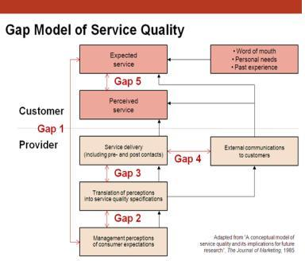
This Photo by Unknown Author is licensed under CC BY-SA-NC

(3) Positioning
Customer driven services marketing strategy:
Customer Analysis
- Market attractiveness –
(Size + Growth, Profitability, Trends)
- Customer needs –
(Unserved needs, more valuable benefits)

Define + Analyse Market Segments
- Needs-based segmentation followed by demographic, psychographic and behavioural segmentation
- Identify attributes and service levels valued by each segment

Competitor Analysis
- Current positioning
- Strengths
- Weaknesses

Select Target segments to serve
- Determine customers the firm can serve best
- Identify + Analyse possibilities for differentiation
- Decide on focus strategy (i.e. service, market, fully focused)
- Select benefits to emphasize to customers
- Must be meaningful to customers
- Must not be well met by competitors.

Company Analysis
- Current positioning + brand image
- Strengths
- Weaknesses
- Values

Determine Services Marketing strategy and action plan
- Positioning strategy
- 7 P’s of service marketing
- Customer relationship management strategy
- Service quality and productivity strategy

Articulate desired Position in market
- Positioning must address an attractive market
- Positioning must give a sustainable competitive advantage over competition

Segmenting Service Markets
Market Segmentation:
- Firms vary widely in ability to serve different types of customers
- Adopt strategy of market segmentation, identifying those parts of market can serve best
- A market segment is composed of a group of buyers sharing common needs, purchasing behaviour, consumption patterns, and other characteristics
- Various ways to segment markets:
- Demographic (On its own will not result in meaningful segments)
- Psychographic segmentation (Useful for strengthening brand identity + creating emotional connection
- Behavioural segmentation (Focuses on observable behaviour)
- Needs based segmentation (Focuses on what customers what)
Developing right service concept for a specific segment:
- Use research to identify & prioritize which attributes of a given service are important to specific market segments
- Individuals may set different priorities according to:
- Purpose of using the service
- Who makes decision
- Whether service is used alone or with a group (Composition of that group)
- Timing of use (Time of day/week/season)
Important vs Determinant Attributes:
- Consumers usually choose between alternative service offerings based on perceived difference between them
- Attributes that distinguish competing services from one another are not necessarily the most important ones
- Determinant attributes determine buyer’s choice between competing alternatives
- Service characteristics that are important to purchasers
- Customers see significant differences between competing alternatives on these attributes

Achieving Competitive advantage through focus:
 | Wide | Narrow
Few | Market Focused | Fully focused (Service + Market focused)
Many | Unfocused (Everything for everyone) | Service focused

Fully focused – Limited range of services to narrow and specific market
- Developing recognized expertise in a well-defined niche may provide protection
against competitors and allow firms to charge premium prices
Unfocused – Broad markets with wide range of services raises concern of becoming a jack of all
trades and master of none.
Market focused – Narrow market segments with wide range of services
- Need to make sure firms have operational capabilities to do and deliver each of
the different services selected
- Need to understand customer purchasing practices and preferences
Service focused – Narrow range of services to fairly broad market
- As new segments are added, firm needs to develop knowledge + skills in serving
each segment.

Positioning Services:
4 Principles of Positioning strategy:
- Must establish position for firm or product in minds of target customers
- Position should provide one simple, consistent message
- Position must set firm/product apart from competitors
- A company cannot be all things to all people must focus its efforts
Developing an Effective Positioning strategy:
- Segmentation, Target & Positioning integrates with Customer, Competitor and Company analyses to give us a positioning statement.
- Target audience – Specific group(s) of people that brand wants to sell to and serve
- Frame of reference – Category the brand is competing in
- Point of difference – Most compelling benefit offered by brand that stands out from competitors
- Reason to believe – Proof that brand can deliver the benefits that are promised

Using Positioning maps to analyse competitive strategy:
- Great tool to visualise competitive positioning and map developments of time
- Useful way to represent consumer perceptions of alternative products graphically
- Typically confined to 2 attributes but 3-D models can be used to portray positions on 3 attributed simultaneously
- Information about a product can be obtained from market date, derived from ratings by representative consumers, or both.
Positioning maps help managers to visualise strategy;
- Positioning maps display relative performance of competing firms on key attributes
- Research provides input to development of positioning maps – challenge is to ensure that
- Attributes employed in maps are important to target segments
- Performance of individual firms on each attribute accurately reflect perceptions of customers in target segments
- Predictions can be made of how positions may change considering future developments
- Simple graphic representations are often easier for managers to grasp than tables of data or paragraphs of prose
- Charts and maps can facilitate ‘visual awakening’ to threats and opportunities, suggest alternative strategic directions.

(4) Product
The Flower of Service
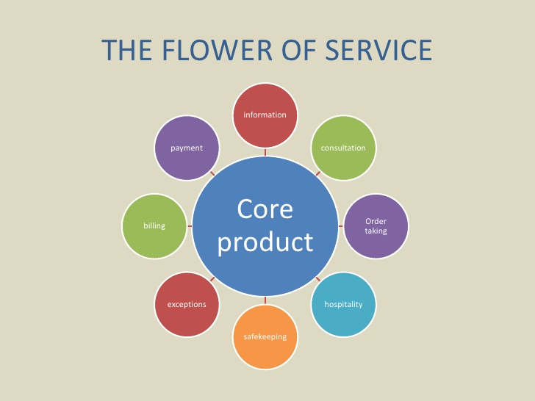

Facilitating Services: - Either needed for service delivery, or help in the use of the core product
- Information – Customers often require information about how to obtain and use a product or service (e.g. Prices, Warnings, Service hours, Receipts, Notifications)
- Order taking – Customers need to know what is available and may want to secure commitment to delivery. The process should be polite, fast and accurate (e.g. Subscription services, Web order, Equipment rental)
- Billing – Bills should b clear, accurate and intelligible (e.g. Invoices, Machine display of amount due)
- Payment – Customers may pay faster and more cheerfully if you make transactions simple and convenient for them (e.g. Enter card number online, Cash handling, Automates systems like ticket readers)
Enhancing Services: - Adds extra value for the customer
- Consultation – Value can be added to goods and services by offering advice and consultation tailored to each customer’s needs and situation (e.g. Customised advice, Tutoring)
- Hospitality – Customers who invest time and effort in visiting a business and using its services deserve to be treated as welcome guests (e.g. Greeting, Waiting facilities)
- Safekeeping – Customers prefer not to worry about looking after the personal possessions that they bring with them to a service site (e.g. Child care, Storage space, Installation)
- Exceptions – Customers appreciate some flexibility when they make special requests and expect responsiveness when things don’t go according to plan (e.g. Medical needs, Complaints, Warranties, Refunds + Compensation)

Managerial Implications for Enhancing supplementary services
- Not every product is surrounded by supplementary elements from all 8 petals
- Nature of product helps to determine which supplementary services must be offered
- People-processing and high contact services tend to have more supplementary services
- Firms that offer different levels of service often add extra supplementary services for each upgrade in service level

Branding Service Products & Experiences
Procut Lines and Brands:
Most service organisation offer a line of products rather than just a single product
They may choose among 3 broad alternatives;
1. Single brand to cover all products and services
2. A separate, stand alone brand for each offering
3. Some combination of these two extremes
Spectrum of branding alternatives:
Corporate branding Individual product branding
* Branded House *Sub-brands *Endorsed brands *House of brands
(Virgin Group) (Raffles Class @ (Starwood Hotels (Yum! Brands)
Singapore Airlines) & Resorts)

Building Brand Equity:
Company’s Presented Brand Awareness
Brand

External Brand Brand Equity
Communications

Customer Experience Brand Meaning
with Company

Offering a branded experience:
4 Key ways to build strong brands
1. Dare to be different
2. Determine your own fame
3. Make an emotional connection
4. Internalise the brand

New Service Development (NSD)
A hierarchy of new service categories:
- Style changes – Visible changes in service design
- Service improvements – Modest changes in the performance of current products
- Supplementary service innovations – Addition of new/improved facilitating/enhancing elements
- Process-line extensions – Alternative delivery procedures
- Product-line extensions – Additions to current product lines
- Major process innovations – Using new processes to deliver existing products with added benefit
- Major services innovations – New core products for previously undefined markets

- Place
Delivering a service to a customer involves decisions about;
-What?
-How?
-Where?
-When?
Distributing in a service context
- In a service context, we often move nothing
- Experiences, performances and solutions are not being physically shipped and stored
- More and more information transactions are conducted through electronic and not physical channels
Distinguishing between distribution of supplementary and core services:
- Most core services require physical locations
- Many supplementary services are informational; can be distributed widely and cost-effectively via other means (Telephone , Internet)

Distribution Options for serving customers
Determining the type of contact:
Interaction between customer & service org.
– (1) Customer goes to service organisation
Convenience of service factory locations and operational schedules important when customer must be physically present
- (2) Service organisation comes to customer
Object of service is immovable
Needed for remote areas
Greater likelihood of visiting corporate customers than individuals
- (3) Customer + service org. transact remotely (electronically)
Achieved with help of logistics & telecommunications

Channel preferences vary among customers:
Convenience is a key driver of channel choices
- Customers choose from:
- Personal
- Impersonal
- Self-service

People tend to rely on personal channels when:
- They perceive service as complex and risky
- They have social motives
Individuals with greater confidence and knowledge about a service/channel tend to use impersonal and self-service channels

Place & Time Decisions
Places of service delivery:
- Mini-stores
-Creating many small service factories to maximise geographic coverage (Automated kiosks)
-Separating front and backstage of operations (Taco Bell)
-Purchasing/sharing space from/with another provider in complementary area (Burger King & Dunkin Donuts)
- Location in Multiple facilities
-Proximity to where customers like or work (Service stations, Starbucks in DMS)

- Cost, productivity and access to labour are key determinants to locating a service facility

- Location constraints
-Need for economies of scale (Hospitals)
-Operations requirements (Airports)
-Geographic factors (Ski resorts)

- Traditionally, schedules were restricted (Service availability limited to daytime)

- Today
-For flexible responsive service operations (24/7 services, 7 days a week, around the world)

Delivering Services in Cyberspace
Distribution of supplementary services in cyberspace:
- 5 of the supplementary services are information-based
- These services can all be distributed electronically;
-Information
-Consulting
-Order-taking
-Billing
-Payment
- Distribution of information, consultation and order-taking has reached very sophisticated levels in global service industries (Hotels, Airlines, Car rental)

Service delivery innovations facilitated by technology:
- Technological Innovations
-Development of ‘smart’ mobile telephones and PDA’s and Wi-Fi high speed internet technology that links users to internet from almost anywhere
-Voice recognition technology
-Smart cards (Store detailed information about customers, Electronic wallet)
Electronic channels can be offered together with physical channels or take the place of physical channels.
E-Commerce: Move to cyberspace:
- Among the factors luring customers to virtual stores are
-Convenience
-Ease of search
-Broader selection
-Potential for better prices
-24-hour service with prompt delivery
- Recent Developments: websites, customer management systems and mobile telephony
- Integrating mobile devices into service delivery infrastructure can be used as means to;
-Access services
-Alert customers to opportunities/problems
-update information in real time

The Role of Intermediaries
Splitting responsibilities for supplementary service elements:
As created by originating firm
+ As experienced by customer
As enhanced by distributer

Franchising:
- Popular way to expand delivery of effective service concept, without a high level of monetary investments compared to rapid expansion of company-owned and managed sites
- Franchisor provides training, equipment and support marketing activities
- Franchisees invest time and finance, and follow copy and media guidelines of franchisor
- Growth-orientated firms like franchising because franchisees are motivated to ensure good customer service and high-quality service operations
- Study shows significant attrition rate among franchisors in the early years of a new franchise system
- 1/3 of all systems fail within first four years
-3/4 of all franchisors cease to exist after 12 years

- Disadvantages of franchising
-Some loss of control over delivery system and , thereby, over how customers experience actual service
-Effective quality control over is important but difficult
-Conflict between franchisees may arise especially as they gain experience

- Alternative: license another supplier to act on the original suppliers’ behalf to deliver core product
-Trucking companies
-Banks selling insurance products

(6) Price
The Pricing Tripod

Pricing Strategy

Costs Competition Value to customer

Cost-based Pricing:
- Traditional costing approach
-Emphasizes expense categories (Arbitrary overheads allocation)
-May result in reducing value generated for customers
- Activity based Costing (ABC) management systems
-Link resource expenses to variety and complexity of goods/services
-Yields accurate cost information
Value-based Pricing:
- Value exchange will not take place unless customer see positive net value in transaction
Net Value = All perceived benefits to customer (Gross) – All perceived outlays (Money, Time)
- Monetary price is not only perceived outlay in purchasing, using a service
- When looking at competing services, customers are mainly comparing relative net values

-Managing perception of Value;
Net Value = Perceived benefits – Perceived Costs
- Increase perception of benefits – Effective communication and personal explanation to convey results
- Reduce perception of costs – Monetary costs & Non-monetary costs (Time, Physical, Psychological, Sensory)
-Defining Total User Cost;
Purchase Price
Operating Costs
Incidental Expenses
Money
Time
Physical Effort
Psychological Burdens
Sensory Burdens
* Search Costs

*Purchase & Service
Encounter Costs
Necessary Follow-up
Problem Solving
*Post Purchase Costs
Competitive-based Pricing:
Price competition is reduced when;
-Non-price related costs of using competing alternatives are high
-Personal relationships matter
-Time and location specificity reduce choice
-Switching costs are high
Revenue Management
Maximizing revenue from available capacity at a given time
- Revenue management is price customisation
-Providing service at different price points based on price sensitivity
- Most effective when;
-Relatively high fixed capacity
-High fixed cost structure
-Perishable inventory
-Variable + Uncertain demand
-Varying customer price sensitivity
- Revenue management uses mathematical models to examine historical date and real time information to determine;
-What prices to change within each price bucket
-How many service units to allocate to each bucket
- Rate fences deter customers willing to pay more from trading down to lower prices (Minimize customer surplus)
Key Categories of Rate Fences:
Physical (Product-related);
- Basic Product – (Class of travel, Size of rental car, Seat location in cinema)
- Amenities – (Free breakfast at hotel, Valet parking, Airport pick up)
- Service level – (Priority waiting list, Personal butler, Dedicated service hotlines)
Non-Physical;-Transaction
- Time of booking/reservation – (Discount for advanced booking)
- Location of booking/reservation – (Online customers charged less than in person)
- Flexibility of ticket usage – (Fees for cancellation, Non-refundable reservation fees)
Non-Physical;- Consumption
- Time/Duration of use – (Early bird specials, Must stay at least 5 nights)
- Location of consumption – (Price depends on departure location, Variations between cities)
Non-Physical;- Buyer
- Frequency/Value of consumption – (Member of certain loyalty-tier, Priority pricing)
- Group membership – (Child, Student, OAP, Corporate rates)
- Size of customer group – (Group discounts based on size)
- Geographic location – (Local customers charged lower rates than tourists
Ethical Concerns in Service Pricing
- Customers are vulnerable when service is hard to evaluate as they assume that higher price indicates better quality
- Many services have complex pricing schedules
-Hard to understand
-Difficult to calculate full costs in advance of service
- Quoted prices not the only prices
-Hidden Charges
-Many kinds of fees
- Too many rules & regulations
-Customers feel constrained, exploited
-Customers face unfair fines + penalties

Putting service Pricing into practice
- How much to charge?
- What basis for pricing?
- Who should collect payment?
- Where should payment be made?
- When should payment be made?
- How should payment be made?
- How to communicate price?

(7) Promotion
Marketing Communication Planning
Checklist for marketing communications planning:
- Who is our target audience?
- What do we need to communicate and achieve (objectives)?
- How should we communicate this?
- Where should we communicate this?
- When do communications need to take place
Target Audience: 3 broad groups:
- Prospects – Employ traditional communication mix because prospects are not known in advance
- Users – More cost-effective channels
- Employees – Secondary audience for communication through public media
- Shape employee behaviour
- Part of internal marketing using company-specific channels
Strategic & Tactical service communications objectives:
- Strategic Objectives;
-Building a service brand + positioning it and its service products against competition
-Persuading target customers that their service product offers a better solution for customer needs
- Tactical Objectives;
-Pre-purchase stage (Need, perception, attributes, decision, rules, etc.)
-Encounter stage (perception, roles and scripts, etc.)
-Post-purchase stage (Evaluation, WOM, referrals, repurchase, loyalty, etc)
Specific objectives of marketing communication:
- Promote tangible cues to communicate quality
- Add value through communicate content
- Facilitate customer involvement in production
- Promote contribution of personnel + backstage operations
- Stimulate / dampen demand to match capacity
Challenges of service communications
Advertising strategies for overcoming intangibility:
- It is argued that in services, intangibility influences the nature of communication tasks
- Intangible nature of services presents problems to consumers
- Intangibility is considered as the root source of service advertising difficulty
-Abstractness: No one-to-one correspondence with physical objects
-Generality: Items that compromise a class of objects, persons or events
-Non-searchability: Cannot be searched or inspected before purchase
-Mental impalpability: Customers find it hard to grasp benefits of complex, multidimensional offers.

Intangibility Problem | Advertising Strategy | Description
Abstractness | Service consumption episode | Capture and show typical customers benefiting from the service (By smiling in satisfaction at a staff going out of his way to help)
Generality
- For objective claim | System documentation | Document facts and statistic about the service delivery system. For example, in the UPS website, they state that they have 216 aircraft in operation
- For subjective claim | Performance documentation  Service performance episode | Document & cite past service performance stats, such as the number of packages that have been delivered on time  Present actual service delivery being performed by the service personnel. The video mode is best for showing
Non-searchability | Consumption documentation  Reputation documentation | Obtain & present testimonials from customers who have experienced the service  If the service is high in credence attributes, then document the awards received or the qualifications of the service provider
Mental Impalpability | Service process episode  Case history episode  Service consumption episode | Present a clear step-by-step documentation of what exactly will happen during the service experience  Present an actual case history of what the firm did for a specific client and how it solved the client’s problem  A story of depiction of a customer’s experience with a service

Tangible cues & Metaphors to overcome intangibility:
- Use tangible cues in advertising
- Use metaphors to communicate benefits of service offerings

Marketing Communications Mix
Tools for service:
- Advertising – (Broadcast, Print, Outdoor, Direct marketing, Online marketing)
- Sales promotion – (Sampling, Coupons, Price promos)
- Personal Communication – (Personal selling, Training, Word-of-mouth)
- Publicity + Public relations – (Press releases, Special events, Sponsorships)
- Service delivery points – (Service outlets, Brochures, Frontline employees)
- Corporate design – (Signage, Interior décor, Vehicles, Equipment, Uniforms)

Role of corporate design
Strategies for corporate design:
- Many service firms employ a unified and distinctive visual appearance for all tangible elements – (Logos, Uniforms, Physical facilities)
- Useful in competitive markets to stand-out, be instantly recognisable in different locations, and strengthen brand image (Shell, McDonalds, Ford, Apple, Nike)
- How to stand out and be different?
-Use colours in corporate design
-Use name as central element in their corporate designs
-Use trademarked symbol rather than name as primary logo
-Create tangible recognisable symbols to connect with corporate brand names

(8) Designing Service Processes
Flowchart Service Delivery
Insights from Flowcharting:
- Technique for displaying the sequence of the difference steps in delivery to customers
- Offers way to understand total customer service experience
- Shows how nature of customer involvement with service organisations varies by type of service ; - People processing / Possession processing / Mental Stimulus / Info processing

(1) People Processing →

(2) Possession Processing →
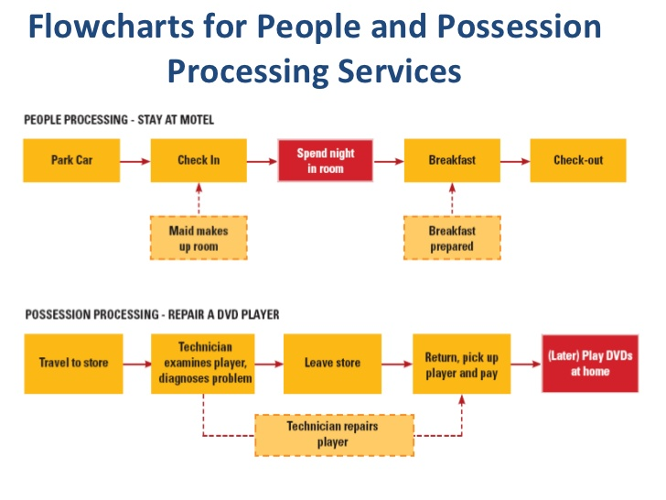

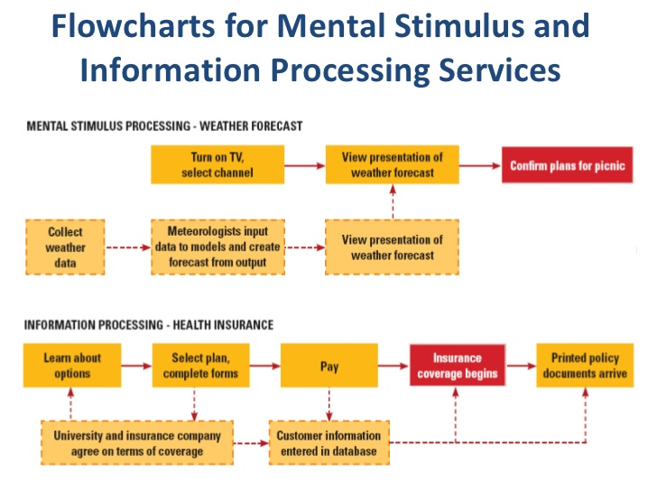

← (3)Mental Stimulus Processing

← (4) Information Processing

Use Blueprint to Document & Manage Service Processes
Blueprinting:
- Developing a blueprint
- Identify key activities in creating and delivering service
- Define big picture before drilling down to obtain a higher level of detail
- Advantages of blueprinting
- Distinguish between frontstage and backstage
- Clarify interactions between customers and staff, and support by backstage activities and systems
- Identify potential fail points; take preventive measures; prepare contingency
- Pinpoint stages in the process where customer commonly have to wait
Key Components of a Service Blueprint:
- Define standards for front-stage activities
- Specify physical evidence
- Identify main customer actions
- Line of interaction (Customer and front-stage personnel)
- Frontstage actions by customer-contact personnel
- Line of visibility (Between front and back stage)
- Backstage actions by customer-contact personnel
- Support processes involving other service personnel
- Support processes involving IT
Service Process Redesign
Why Redesign?
- Changes in external environment make existing practices obsolete and require redesign of underlying processes (to stay relevant)
- Internal erosion – deterioration of internal processes, creeping bureaucracy, and evolution of spurious standards
- Symptoms;
-Extensive information exchange
- Date that is not useful
- High ratio of checking/controlling activities to value adding activities
- Increased exception processing
- Customer complaints about inconvenient and unnecessary procedures
Approaches and Potential Benefits:
- Examining service blueprint with key stakeholders
- With goal of improving customer satisfaction & productivity reducing service failures + cycle time
- Eliminating non-value adding steps
- Simplify front-end and back-end processes by focusing on benefit-producing part of service encounter
- Shifting to self-service
- Increase in service quality and productivity
- Lower costs
- Enhance technology reputation
- Differentiates company
The Consumer as Co-Creators
Levels of customer participation:
Participation is the action and resources provided by the customer including physical, cognitive and even emotional inputs/involvement
- Low – Employees and systems do all the work
Often involves standardised service (Bus, Movie theatre)
- Medium – Customer helps firm create and deliver service
Provide needed information and instructions; make some personal effort; share physical possessions (Hairdresser, Vet, Accountant)
- High – Customer works with provider to co-produce/ co-create the service
Service is not created without the customers active participation (Weight loss)
Self-Service Technologies (SSTs)
- Ultimate form of customer involvement
- Customers undertake specific activities using facilities/systems provided
- Customers time and effort replace those of employees (ATM’s)
- Information-based services can easily be offered using SST’s
- Used in both supplementary services and delivery of core product (eBay)
- Many companies seek to encourage customers to serve themselves using internet-based services
People love when; ….
- Greater convenience including time savings, faster service, flexibility of timing and flexibility of location
- Greater control over service delivery , more information and higher perceived level of customisation
- Lower prices and fees
People hate when; ….
- SSTs fail , are down , pin numbers / passwords not accepted
- SSTs are poorly designed and make service processes difficult to understand and use
- People themselves mess up forgetting passwords, failing to provide information as requested.
Testing SST’s:
- Does the SST work reliably , dependable and user-friendly?
- Is the SST better than alternative interpersonal options? Convenience to customer
- If it fails what systems are in place to recover? Structures and back up systems to give security to customers if something goes wrong

