Experiment 2:
Spectrophotometric Determination of Nitrite and Nitrate
October 10, 2018

Kayla McKee
8688226

Partner: Alissa Ribich
TA: Kati Harriman

Experimental Objective

This experiment is designed to measure the absorbance of five concentrations of both nitrite and nitrate. This data was then compiled into two graphs and used to interpolate the concentration of two unknown samples of both nitrite and nitrate using their absorbance values. These results were then observed to determine the percent of nitrate converted to nitrite via an oxidation reaction.

Procedure

See Lab Manual: Experiment 2, for complete method (Hemmer).

Results

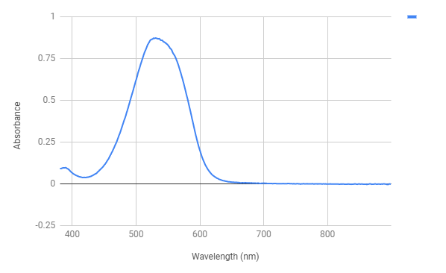
Graph 1: The relationship between the wavelengths (nm) of light emitted by the spectrophotometer and the level of absorbance (unitless) of Sample 2 of the Nitrite stock solution. Used to find the optimum wavelength (where the absorbance is at its maximum). This is example data, not the data used in this report.

Table 1. General information relevant to the nitrite analysis.
Sample Number | 12
Maximum Wavelength (nm) | 543.20
Minimum Wavelength (nm) | 399.20
Optimum Wavelength (nm) | 543.20

Table 2. Concentration of nitrite in the stock solution, volume of nitrite added to the stock solution to obtain the desired concentration, the absorbance (unitless) of the stock solution at 543.20nm, and visual appearance of each sample.
Sample | Nitrite Concentration (ppm) | Volume of Nitrite in Stock Solution (mL) | Absorbance (unitless) | Notes (qualitative)
Sample 1 | 0 | 0 | 0 | Clear
Sample 2 | 0.2 | 1 | 0.145 | Light pink
Sample 3 | 0.4 | 2 | 0.183 | Medium pink
Sample 4 | 0.6 | 3 | 0.253 | Medium pink
Sample 5 | 1.0 | 5 | 0.616 | Dark pink
Unknown A | 0.52207 | N/A | 0.287 | Magenta – medium pink
Unknown B | 0.3048 | N/A | 0.161 | Peachy - red

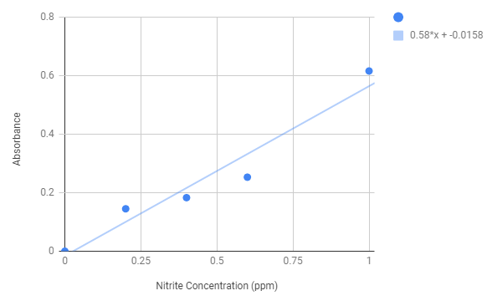
Graph 2. Relationship between the concentration of nitrite in ppm in the stock solution, and the absorbance (unitless) of the solution.

Table 3. General information relevant to the nitrate analysis.
Sample Number | 12
Maximum Wavelength (nm) | 542.50
Minimum Wavelength (nm) | 397.60
Optimum Wavelength (nm) | 542.52

Table 4. Concentration of nitrate in the stock solution, volume of nitrate added to the stock solution to obtain the desired concentration, and the absorbance of the stock solution at 542.52nm.
Sample | Nitrate Concentration before Zn Reduction (ppm) | Nitrate Concentration after Zn Reduction (ppm) | Volume of Nitrate in Stock Solution (mL) | Absorbance (unitless)
Sample 1 | 0 | N/A | 0 | 0.004
Sample 2 | 5 | N/A | 1 | 0.124
Sample 3 | 10 | N/A | 2 | 0.235
Sample 4 | 15 | N/A | 3 | 0.395
Sample 5 | 20 | N/A | 4 | 0.540
Unknown A | 19.5167 | 18.9946 | N/A | 0.516
Unknown B | 21.9703 | 21.6655 | N/A | 0.582

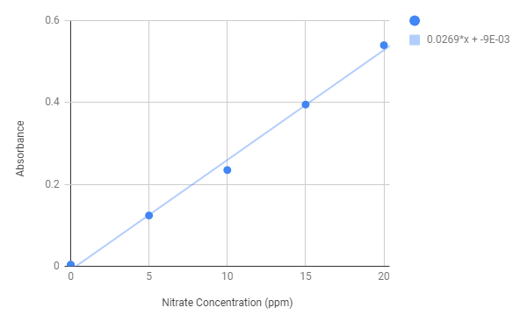
Graph 3. Relationship between the concentration of nitrate in ppm in the stock solution, and the absorbance (unitless) of the solution.

Observations

A higher concentration of nitrite in the stock solution correlated to a darker pink appearance.

Discussion
The results showed the concentrations of nitrite in sample 12 to be approximately 0.4135 ppm (See Table 2), and the nitrate concentrations to be approximately 20.7435 ppm (See Table 4). These results were interpolated from the graphs of known samples, thus they are within reason.
The optimum wavelength was found to be 543.20 nm (See Table 1). This is the wavelength at which the solution absorbs the most light. Since the solution was magenta, this value is reasonable because it falls into the range of green, 492-577nm (LivePhysics). Green is the opposite colour of magenta; therefore, the magenta solution absorbs most of the green light and emits the purple and red light to give it its magenta appearance (See Graph 1).
There is a positive linear relationship between the concentration of nitrite in the solution and the absorbance (See Graph 2 and Graph 3). There is also a positive linear relationship between the nitrate in the solution and the absorbance. This result is expected since the intensity of the azo dye is directly proportional to the amount of nitrite in the solution, and by extension, the amount of nitrate originally in the solution. The amount of nitrate in the solution before the reduction step, partly determines how much nitrite will form after the reduction. The azo dye is highly coloured which gives the solution its magenta colour; this is the component that causes the absorbance. Thus, it makes sense that the higher the concentration of either nitrite or nitrate, the higher the absorbance.
The average percent of nitrate converted to nitrite between the two unknowns was 2.0307%. This shows that there is a very small amount of nitrite compared to nitrate. The reaction was limited to only five minutes thus it makes sense that there are more reactants than products. Additionally, there is a 1:1 ratio of nitrite to nitrate in the products and a 0:4 ratio of nitrite to nitrate in the reactants.
Zn + 4HNO₃ Zn(NO₃)₂ + 2NO₂ + 2H₂O
Thus, even if the reaction continued to completion where there were exclusively products remaining, the percent of nitrate converted to nitrite would not be able to exceed 50%. Since the reaction time was limited and it could not go until completion, it is reasonable that the percentage is so low.
The unknown sample B was more red-peachy colour, this is possibly a result of left over soap in the glassware or another contaminant. This may explain the difference in the results between unknown sample A and B, particularly the lower absorbance at the optimum wavelength in the nitrite trials.
Other possible errors include improperly cleaned curvets resulting in affected absorbance reading. If the spectrophotometer was not calibrated correctly or the optimum wavelength was not measured correctly due to human or technological error, the baseline would be off and shift all of the results. If there were other technical errors when using the spectrophotometer, the absorbance values may be skewed, causing the trend line to not be a true representation, thus making the values calculated based on this line incorrect. Human error in the form of inaccurate measurement of chemicals, unintentionally different reaction times, or incorrect copying of data could also affect the results.
This experiment could be improved in a number of ways. By thoroughly cleaning all glassware and equipment to avoid contamination, an error would be less likely to appear in the results. By mechanizing the addition of zinc into the nitrate solutions and ensuring they have all had the exact same amount of reaction time, one could avoid discrepancies due to different reaction times. Through using more accurate equipment, one can know the results to a higher degree of precision. Had there been more time available, unknown sample B could have been remade when it became apparent that the solution was contaminated.

Calculations

Calculation 1: Nitrite concentration in unknown sample A
A ~ Absorbance
C ~ Concentration
A = 0.58*C-0.0158 ~ Equation of trend line in graph 1
C = (A + 0.0158) / 0.58
= (0.287 + 0.0158) / 0.58
= 0.52207 ppm

Calculation 2: Nitrate concentration after zinc reduction in unknown sample A
C₁ ~ Nitrite concentration of unknown sample A (ppm)
C₂ ~ Nitrate concentration before the zinc reduction of unknown sample A (ppm)
C ~ Nitrate concentration after the zinc reduction of unknown sample A (ppm)
C = C₂ – C₁
= 19.5167 - 0.52207
= 18.9946 ppm

Calculation 3: Percent nitrate converted to nitrite during the 5 minute exposure to zinc for unknown sample A
C₁ ~ Nitrite concentration of unknown sample A (ppm)
C₂ ~ Nitrate concentration before the zinc reduction of unknown sample A (ppm)
P ~ Percent nitrate converted to nitrite (%)
P = (C₁ / C₂) * 100%
= (0.52207 / 19.5167) * 100%
= 2.6740%

Conclusion

The results showed the concentrations of nitrite in sample 12 to be approximately 0.4135 ppm (See Table 2), and the nitrate concentration to be approximately 20.7435 ppm (See Table 4). The estimated percent of nitrate converted to nitrite during the 5 minute exposure to zinc for unknown sample A was 2.6740%, and for unknown sample B was 1.3873% (See Calculation 3).

References

Bodner Research Web. (n.d.). Oxidizing and Reducing Agents. Retrieved from Bodner Research Web: http://chemed.chem.purdue.edu/genchem/topicreview/bp/ch19/oxred_3.php
Elsevier B.V. (2018). Oxidation Reaction. Retrieved from ScienceDirect: https://www.sciencedirect.com/topics/materials-science/oxidation-reaction

Hemmer, E. (2018, Fall). CHM 2353 Descriptive Inorganic Chemistry Laboratory. Laboratory Manual. Ottawa, ON, Canada: University of Ottawa.

LibreTexts. (2018, July 16). Strength of Covalent Bonds. Retrieved from LibreTexts: https://chem.libretexts.org/Textbook_Maps/General_Chemistry/Map%3A_Chemistry_-_The_Central_Science_(Brown_et_al.)/08._Basic_Concepts_of_Chemical_Bonding/8.8%3A_Strength_of_Covalent_Bonds
LivePhysics. (n.d.). Wavelength for the various colors. Retrieved from LivePhysics: http://www.livephysics.com/physical-constants/optics-pc/wavelength-colors/

Questions

- The estimated percent of nitrate converted to nitrite during the 5 minute exposure to zinc for unknown sample A was 2.6740%, and for unknown sample B was 1.3873% (See Calculation 3).

- Both nitrite and nitrate have a formal charge of -1 thus their oxidation states are both -1. However, since nitrite is NO₂⁻ there is only one negative charge on one of the oxygens; nitrate is NO₃⁻ there is one negative charge on two of the oxygens and a positive charge on the nitrogen, resulting in a formal charge of -1. The nitrogen in the nitrate ion has an oxidation number of +5, where as in nitrite it is +3.
The bond energy of an N-O single bond is 201 kj/mol; the bond energy for N=O double bond is 607 kj/mol. Nitrite can be thought of as one single and one double bond making its bond strength 808 kj/mol, and nitrate can be thought of as two single and a double bond making its bond strength 1009 kj/mol (LibreTexts).
Oxidizing ability refers to a compound’s ability to remove electrons from another molecule. Since nitrate reacts and must steal an electron to form the less reactive nitrite, it is clear that the nitrate is the stronger oxidizing agent. The nitrogen in the nitrate has a positive charge and thus must be reduced to form nitrite (Bodner Research Web).
- The electropositive atom bonded to the nitrate (in this case hydrogen) was oxidized, thus it had its electron removed and given to the nitrogen.
Zn + 4HNO₃ Zn(NO₃)₂ + 2NO₂ + 2H₂O
- The time that the nitrate solution and zinc powder are in contact is important because a sufficient amount of time is needed for a significant conversion of nitrate to nitrite. It is important however, since the reaction is not complete, that all the samples be exposed to zinc for about the same amount of time so that they are all oxidized to the same extent (Elsevier B.V.).

Rough Data


